Section 1

Head of Information Governance (IG) Report

This report has been written by Geraint Hill, a member of the IG Team at Swansea Bay University Health Board (SBUHB) whose departmental responsibility is to enforce the Information Governance agenda, policies and procedures across the SBUHB estate. The estate covers all staff, Permanent, Temporary and Contractors.

Process and response to an incident

The Operational Manager response to the incident conforms with SBUHB policy. As soon as the Operational Manager realised that they had sent the subject data to a member of the public, they did respond immediately and reported the breach to myself an IG Manager.
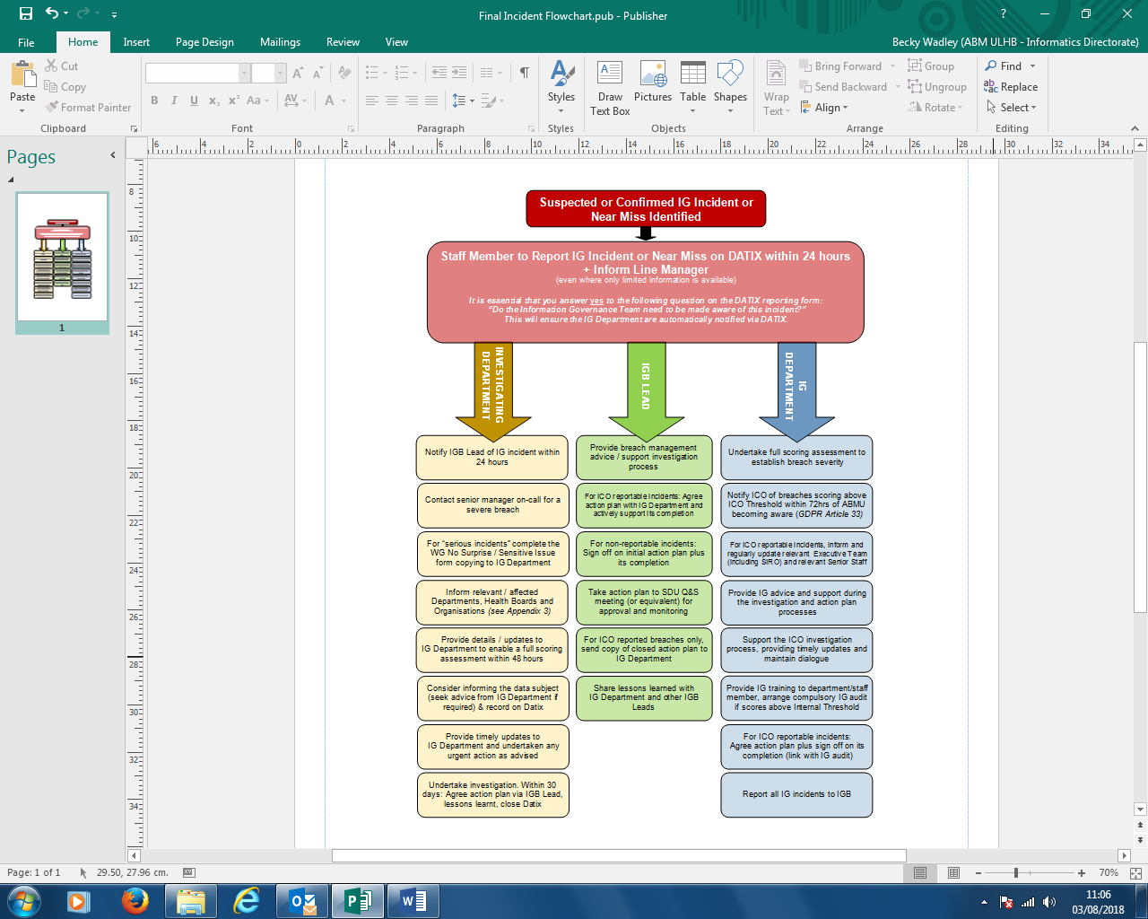
Figure 1: SBUHB Flow Chart that provides guidance to each department involved in incident reporting and handling.[1]

The SBUHB incident process is well documented in the guidance provided in the document “Information Governance Incident and Near Miss Procedure”[1] found on our organisations Intranet. In line with the process set out, the IG Department will:

- Assess and score the incident using the HSIC checklist,
- Will notify the Information Commissioners Office (ICO) of the data breach within 72 hours of a reported incident. This is a requirement set out in the General Data Protection Regulation (Article 33)[2],
- Inform and update the relevant departments within the organisation – the Executive Team, IG Lead, IG department, The Senior Information Risk Owner (SIRO),
- Provide the organisation with IG advice throughout the lifetime of the incident,
- Support and provide the ICO with any information required to progress the case,
- Provide the staff member with training, address any loopholes, and conduct an IG audit in relation to the incident,
- Agree an action plan with the ICO and complete the incident case,
- Report all IG incidents to the IGB board.

In response to any incidents, the IG board must audit the organisations IG framework. In order to comprehensively audit the framework, the organisation should adopt the GDPR Checklist[3] and actively respond to the following Accountability and governance section. SBUHB must demonstrate that measures are taken to fulfil this commitment to the Accountability principle of the Data Protection Act. [4]:

- Does our organisation comply with GDPR from our highest management and throughout our organisation?
- Keep evidence of the steps we take to comply with GDPR
- Adopt and implement data protection policies,
- Put data protection measures in place to prevent breaches,
- Maintain and document our processing activities,
- Implement security measures
- Record and report on data breaches,
- Carry out assessments on the impact for uses of personal data,
- Appointing a Data Protection Officer (DPO),
- Adhering to codes of conduct and sign up to certification schemes,
- Review and update our accountability measures.

Summary of Events

An Operational Manager that works in our organisation (SBUHB) has sent internal staff information (name and addresses), to a member of the public. The staff data (name and addresses) makes the members of staff identifiable and therefore has the potential to firstly put the individuals at risk, and secondly our organisation. We are unaware on the severity of the incident in relation to how many staff records have actually been sent out.

The Operational Manager utilised software to autonomously extract the staff data for a task, however the file was saved on their desktop and then mistakenly attached to a leaflet which was subsequently circulated to the member of the public as part of another task. We (The Information Governance Department) are of firm belief that this breach contravenes Article 5 of the Data Protection Act – Principles relating to processing of personal data[5], and therefore must be addressed immediately to safeguard the individuals in question and our organisation.

Further investigations carried out by our department have found personal health information of staff members held on the Operational Managers desktop. The risk and damage to the individuals and this organisation would be extremely high if this personal data was to be accidently circulated to any persons who weren’t authorised to have access to it, a breach of this nature would constitute a Special Category Personal Data (SCPD)[6] action, as in this case presents information that concerns an individual’s health record. A breach of SCPD would of course have more damaging consequences than the current evaluated level of Personal Data breach, we recommend that further steps are taken to mitigate this (discussed in later section of this document).

Due to the nature of this incident that has occurred, SBUHB cannot class this as a near miss incident as a clear breach has been initiated.

Article 5 – Principles relating to processing of personal data

SBUHB use the HSIC[7] Checklist for Reporting, Managing & Investigating Information Governance & Cyber Security Serious Incidents Requiring Investigation. The incident is categorised under Negligence and Human Error. We believe that this incident breaches Article 5, of the Data Protection Act 2018, in particular sections[5];
c) adequate, relevant and limited to what is necessary in relation to the purposes for which they are processed ('data minimisation');
e) kept in a form which permits identification of data subjects for no longer than is necessary for the purposes for which the personal data are processed; personal data may be stored for longer periods insofar as the personal data will be processed solely for archiving purposes in the public interest, scientific or historical research purposes or statistical purposes in accordance with Article 89(1) subject to implementation of the appropriate technical and organisational measures required by this Regulation in order to safeguard the rights and freedoms of the data subject ('storage limitation');
f) processed in a manner that ensures appropriate security of the personal data, including protection against unauthorised or unlawful processing and against accidental loss, destruction or damage, using appropriate technical or organisational measures ('integrity and confidentiality').
The data subject information saved on the desktop of the Operational Manager was done without care or attention. The reason to carry out a task more efficiently should not compromise the security of staff data. Although permissions are granted for the Operational Manager to access their staff records, they are inevitably responsible for its confidentiality and integrity if it is replicated on their own system.
Restrictions should be put in place to prevent Managers to carry out these tasks in batch form, any files that contain such information should be password encrypted to prevent unauthorised access to the data. Clear informational signage should be made available to inform data users to protect the information.
The Operational Manager, should not keep the data for longer than the purpose is intended. Once the task that requires the staff data is complete, the data should be correctly processed and then removed. The data for the staff sickness records should be accessed centrally and not stored on a desktop Personal Computer (PC).
SBU Data Protection Policy and Proceures
This policy and practice section is written in line with the current incident. Each breach in GDPR should be reviewed on a case by case basis as every case has its own Risk Assessment and mitigating circumstances.
SBU is a subset of NHS Wales, one of the seven health boards. Our Data Protection procedures are governed by NWIS, however as an organisation, we have a duty to manage all our GDPR / Data Protection Policies and Procedures.
The review date for SBU current Information Governance document has already passed its date of February 2020.
The known incident meets a three of the criteria set out in the SBU Data Protection incident and near miss policy, however we do not believe the risk of the incidents presents itself under our Serious Incident on this occasion. Unfortunately, as we are aware that further staff records were kept on the desktop and to our knowledge not sent, there is always possibility that these further records have been leaked, however we are unable to confirm at this stage. If a Serious Incident is confirmed, then of course, further action will need to be taken.
The Incident and near miss policy in SBU criteria states the following which allows us to categorise the breach[1]:
- An incident breaching one of the principles of the General Data Protection Regulation (GDPR), the Data Protection Act 2018 and/or the Common Law Duty of Confidentiality;

- Unlawful disclosure or misuse of confidential data, recording or sharing of inaccurate data and inappropriate invasion of people’s privacy (staff/patient/ other member of the public);

- Personal data breaches which could lead to identity fraud or have other significant impact on individuals;

As this does not currently meet the SCPD specification, a report to the ICO and an internal investigation is all that is required in this event.

SCPD Incident

It is worth evaluating the risk exposure if this incident does meet an SCPD on the Risk Assessment.

SPCD Data reveals the data subjects personal information that relates to, but not limited to, their[6]:

- Race or Ethnicity,
- Disabilities and Health records
- Sexual Orientation,
- Gender,
- Political views,
- Religious beliefs.

Typically SCPD categorised data requires further protection measures as it is considered sensitive. In this incident, only names and addresses were sent, however further discoveries were made containing staff Occupational Health record and illness records. These kinds are records are only released when explicit consent has been given by the individual to do so. An unauthorised release could have a serious adverse effect on an individual’s mental health, causing extreme embarrassment, feeling ashamed or vindicated in the event that this data is sent to an unauthorised party. In the case if this data was compromised, it opens the Health Board up to vulnerabilities, such as public backlash or legal action.

Record Management

The staff records held (names and address) are used to provide the organisation with information for different reasons, Contact details, Payroll, Eligibility, Correspondence, Emergency Contact. Sickness and Occupational health records are maintained for Risk Assessments, Staff records, Staff welfare.
In accordance with the Public Records Act 1958[8], the Operational Manager downloaded the information on their desktop, and became the data controller for the staff information on their desktop. It is evidential that the Operational Manager fell short of being accountable for the data. Further, as an organisation, we have fallen short of the General Data Protection Regulation (GDPR). Questions around our organisations Data Protection Policies need to be answered in relation to this circumstance.
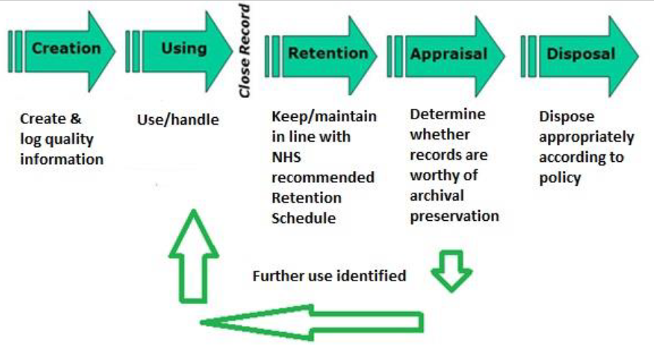
Figure 2: A Flow chart that depicts an effective record management approach for SBU[9].
The Figure 1 image shows a failure on the Operational Managers behalf at the Disposal phase of their record management process. The data was left stagnant on their desktop. SBUHB record management system should be reviewed and brought in line with the Design and Implementation of Records Keepings process[9]. The DIRKS process is an ISO standard that uses eight stages to design an effective record keeping infrastructure for our organisation:
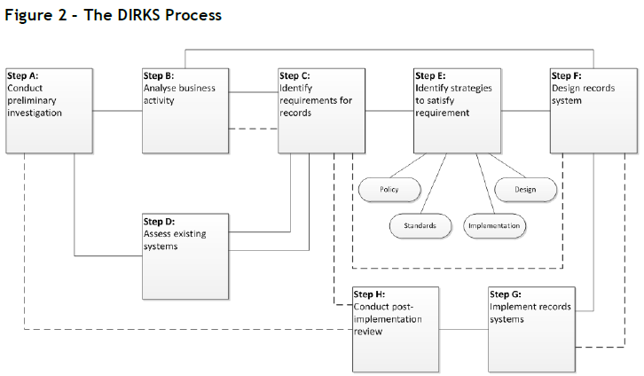
Figure 3 : The 8 stages of the DIRKS Process[9],
SBUHB have many record management systems in its estate, many of which would be legacy out of date systems. It is our recommendation that departments that use record management systems review them and bring them in line to an ISO standard.

What we are doing

Upon the incident being reported, SBUHB IG department has informed all relevant agencies and departments of the breach. We are actively investigating the breach and interrogating the process carried out by the Operational Manager. Damage caused by the incident is being evaluated, SBUHB have an obligatory duty to notify all affected individuals. A continued assessment will be carried out by Information Technology (IT) personnel to assess whether any further data breach has occurred on from the Operational Managers digital devices. The IT department, in particular Cyber Security, will need to engage with departments throughout the health board to ensure data integrity is maintained. The IG department will ensure that in light of this incident, regular reminders and correspondence to staff are made and maintained, ensuring that Data Protection is paramount to our organisations operation, and that ALL data held against individuals are protected.

Actions

The affected individuals must be informed about the breach without any delay.

For future records, this incident along with any others, will need to be brought forward to every Information Governance Board meeting for discussion and identifying trends.

A new campaign should be started to promote staff awareness to Data Protection responsibilities. Posters should be displayed around the estate, the Intranet resource should used to engage with staff and the IG departments contact details clearly visible for any questions or queries that staff have.

Staff need to know their responsibilities, how and who to report incidents or concerns.

Staff should be made to take a compliance course to ensure that they have read literature and answered questions based on what they have learned as confirmation of understanding. This should be made mandatory.

Engage with departments, in particular IT, to ensure systems are compliant with Data Protection and GDPR requirements.

A media contact should be made available if the incident requires reporting on by the press.

Section 2
Executive Board Report
This report has been created for the Executive Board by the Information Governance Department in relation to a recent data breach by an Operational Manager at SBUHB. The Chief Executive, supported by the Executive board is required to provide assurance, through the Annual Governance Statement, that all risk to SBUHB are effectively managed an mitigated[10].
Aim and Objectives
For the benefit of the Executive Board, this report is an essential requirement that is set in the SBUHB Data Protection Policy. The report will provide the Executive Board with a summary of events concerning the incident, a Risk Evaluation, exposure of risk if a SCPD incident occurred.
Summary of events
- On the 29th of August 2020 an Operational Manager based within the SBUHB approached an IG Manager in relation to a data protection breach.
- The circumstances of the breach are that the Operational Manager accidentally sent a record of their staff name and addresses to an unsuspecting member of the public who was part of a leaflet campaign.
- The data was sent as an attachment to the email of the unsuspecting public, not as intended.
- The origin of the data was from an in-house staff record management system, which was saved on the Operational Managers Desktop to provide ease of access to a different task, concerning their staff name and address record.
- On further investigation by the IT department, it is established that further staff records (not only name and addresses) have also accumulated on the Operational Managers desktop. Note: accumulated, the data contains staff sickness records and occupational health records. The accumulated date constitutes SPCD data, the risk of this breaching will be assessed later in this report.
- As per the SBUHB policy, a risk assessment has been carried out, and the threshold of a data breach has been declared.
- There has been a significant impact by the action of the individual which now requires immediate action from our organisation, as a result the Information Commissioners Office (ICO) must now be informed within 24 hours using the eIDAS breach notification form[11]

Risk Evaluation
In accordance to the risk assessment in Appenix 1, we assess this incident as medium risk.
We do not believe that any subjects will be harmed from this incident and that minimum disclosure has occurred. However, subjects and home addresses have been linked which could be sold to third party companies for marketing. The main risk is the in-house process that has failed to protect the information of our staff, which needs to be marked as medium risk.
There has been a significant impact by the action of the individual which now requires immediate action from our organisation, as a result the Information Commissioners Office (ICO) must now be informed within 24 hours using the eIDAS breach notification form[1].
All the subjects that have been affected or are likely to be affected must be informed immediately in accordance with the Data Protection policy[12]. The breach affects the subject as names and addresses of the individuals have been exposed without consent. This places the subjects at risk of crimes such as fraud or other crime. We are unsure of the number of individuals who have been affected by this incident, therefore the scale of the incident needs to be fully established. Through this investigation we will need to establish the key points below. SBUHB is a very large organisation that needs to respond to a data breach in line with the policy and procedures it has already set out.
- An Information Governance Official contact detail,
- The date of the incident,
- A summary of what has happened,
- How it may affect the organisation,
- How we are dealing with the issue,
- Advice for the subjects going forward to deal with the consequence.

The individuals affected must be informed that their personal data has been, albeit accidently, forwarded to an unknowing member of the public, who may, or may not utilise this data for their own gain. A data breach exposure will have a damaging affect to SBUHB.
There is potential that our organisation or the ICO will inform the public about the breach sustained. We must also be aware of the individuals affected taking their own action against SBUHB. Below are further reprisals against SBUHB:
- Embarrassment or damage or harm to our staff members,
- A loss of confidence in our service,
- Damage to SBUHB reputation,
- Litigation against SBUHB,
- A Financial Penalty from external agencies,
- Criminal liability.
Currently, we are only aware of internal staff records being compromised. Discussions should be held with the affected members of staff before any course of action is taken. Of course, any data breach returns the risk of negative action, at the time of writing this report, we are of the opinion that as we are only aware that the data breach contains names and addresses of our staff, no external bodies need to be aware. However we will act under the guidance of the ICO and act on their instruction. Any official release will raise public concern and subject to legal action as discussed earlier.
The breach does fall under electronic Identification, Authentication and trust Services (eiDAS) as there has been an accidental loss of integrity of personal data, however we will be unable to confirm the damage from the data breach until relevant authorities have investigated. A full investigation from our internal department will be underway imminently. We will require a full review of our organisations security protocols in relation to the Data Protection Act guidelines. The data breach was as a result of human error “Disclosed in Error”[12], which raises a number of questions surrounding staff training, awareness and competency. The individual in question is an Operational Manager, who should be setting an example to their members of staff.
The investigation so far has highlighted that only names and addresses of the users have been released to the member of the public.
Further Exposure
If the staff occupational records / health records were also sent to the member of the public, SBUHB could be facing a breach under the Serious Incident Requiring Investigation (SIRI) procedure.
If a SIRI incident is confirmed, this enhances the risk that is already posed to SBUHB. The Health Board could not only damage its reputation, but a fine of up to £500,000 by the ICO could be issued. Business continuity is key when an incident has happened, the health board should rely on its Incident Response Plan (IRP) [6].
The main exposure from a SIRI breach are[13]:
- Financial Impact
As previously stated, a fine of £500,000 could be payable to the ICO. However, the Board also need to take into consideration, a legal lawsuit from the subjects. In the case of a SIRI, the subjects are likely to be distressed as sensitive data about them has been exposed. Solicitors would likely represent a class action suit against our organisation, knowing that a judge would make a decision in favour of the claimants, as a clear breach has been identified. We have reported to the ICO, which is inevitably an acceptance of guilt. Further, solicitors would seek their legal expenses paid, along with any compensation.
- Reputational Damage
In todays world, with media available at everybody’s fingertips, it will not take long for the impact of an incident to circulate locally, nationwide or even internationally. Social media will play a very crucial part in this and we should expect some backlash. Not only do we look after staff, the news will be concerning to our patients within the footprint of our area of coverage.
- Operational Downtime
We can’t allow the system to continue with its flaws, until a resolution is in place concerning the security of our records management system, an alternative way of working should be adopted. Another breach so soon would seriously impact on public opinion and question our competency around data protection. We will need to get it right.
- Legal action
This has already been discussed at length.
- Loss of Sensitive Data
Data is very valuable to cyber criminals. Subjects could be susceptible to black mail, fraud etc.

Actions to reduce risk
- In order to reduce future risks, the IG department will need the approval of the Executive Board to fund an internal campaign to provide Data Protection Awareness throughout the Health Board,
- We suggest that training is made mandatory and that every new member of staff is enrolled on a Data Protection induction,
- A health board wide inclusive invitation for staff to attend that introduces them to the IG team, what we do, how important data protection is.
- An audit of all record management systems that provide the IG teams with a traffic light coded assessment of where our vulnerabilities are, to cover all IT servers, databases, once received and action plan to bring them inline with compliance,
- Regular meetings with the Executive Team to ensure data protection is kept as a priority subject within the organisations business agenda.

Section 3
Governance Committee Discussion Note
In lieu of the incident, every effort must be made to avoid re-occurrence. Every incident that takes place must be recorded in order for SBUHB to identify trends in data breaches and to know where to target IG training and compliance.
Please find below an agenda for our next meeting:
- Incident –
- Where did the fault lie, with our organisation or Operational Manager.
- If organisation, where did we fall short?
- How did the incident conclude –
- How did we as the IG Management perform and react inline with SBUHB policy>
- How we approached the subjects,
- How we approached the Operational Manager,
- Has the Operational Manager acknowledged any liability for action, have they now attended training since the incident?
- How do we as SBUHB prevent this from happening in the future?
- Do SBUHB IG department understand the root of the incident?
- Do SBUHB need to review our policy?
- Any other business?

Conclusion
The reports have covered an incident that constitutes a breach of the data protection principles. The reports were written in line with SBUHB data protection policy, therefore is limited to the information gathered from this organisations policy and procedure. The importance of action after an incident is highlighted in each report. In any case, if a breach of the data protection threshold has been made, it must be reported to the ICO. The results of the risk matrix will depend on the next course of action. In any instance, it is essential that the matter is addressed internally, the security of data is the forefront of any breach. It is imperative that the organisation prevent any further incidents. Data Protection is a sensitive matter, and since its amendment in 2018, has become a very serious topic that make organisations nervous. The simple concept that organisations need to understand is that everyone, who works within, has a part to play in data protection, no matter how big or small.
The reports have also highlighted the risk associated to a breach in DPA. Organisations stand to lose more than just the data if contravened. However, it is arguable if they will lose more than a subjects livelihood. The scenario, was a basic data breach, however the subject of data protection covers a vast array of scenarios that can prove overwhelming to any organisation (as most deal with data subjects). The reports highlights the importance of IG departments within organisations and the mammoth task they have to ensure data protection policies are ad heard to, especially in large organisations like health boards.
The evolving ways that data are now stored makes organisations more susceptible and vulnerable to incidents. Cyber criminals are always looking for ways into networks as they understand the value of the data that they hold. It is hard to imagine a world without data protection, it will always be around and everyone has a part to play from the Executives to the lower echelon.

Appendices
Appendix 1 – a risk matrix from the ICO website [14]
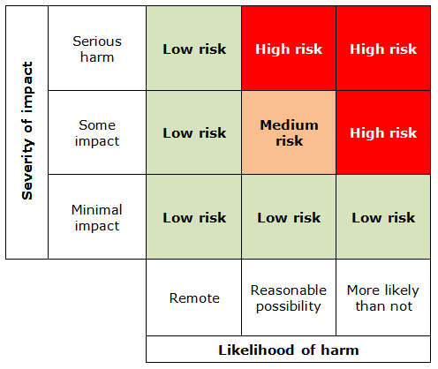

[1] “Information Governance Incident and Near Miss Procedure - Final.” p. 24,33, 2018.
[2] “Art. 33 GDPR – Notification of a personal data breach to the supervisory authority | General Data Protection Regulation (GDPR).” [Online]. Available: https://gdpr-info.eu/art-33-gdpr/. [Accessed: 29-Aug-2020].
[3] “Data protection self assessment | ICO.” [Online]. Available: https://ico.org.uk/for-organisations/data-protection-self-assessment/. [Accessed: 29-Aug-2020].
[4] “Guide to the General Data Protection Regulation (GDPR),” 2018.
[5] “Art. 5 GDPR – Principles relating to processing of personal data | General Data Protection Regulation (GDPR).” [Online]. Available: https://gdpr-info.eu/art-5-gdpr/. [Accessed: 29-Aug-2020].
[6] “Special category data | ICO.” [Online]. Available: https://ico.org.uk/for-organisations/guide-to-data-protection/guide-to-the-general-data-protection-regulation-gdpr/lawful-basis-for-processing/special-category-data/. [Accessed: 29-Aug-2020].
[7] “Information Governance - Technical, Physical and Organisational Measures - Key Resources.” [Online]. Available: https://www.wales.nhs.uk/sites3/page.cfm?orgid=950&pid=92071. [Accessed: 29-Aug-2020].
[8] “Public Records Act 1958.” [Online]. Available: https://www.legislation.gov.uk/ukpga/Eliz2/6-7/51. [Accessed: 29-Aug-2020].
[9] NHS Digital, “Records Management Code of Practice for Health and Social Care,” Gov.Uk Website, no. July, p. 13,15, 2016.
[10] Abertawe Bro Morgannwg University Health Board, “Information Governance Strategic Direction and Framework 2,” no. January 2017, pp. 1-20, 2017.
[11] “Breach reporting | ICO.” [Online]. Available: https://ico.org.uk/for-organisations/guide-to-eidas/breach-reporting/. [Accessed: 29-Aug-2020].
[12] “Personal data breaches | ICO.” [Online]. Available: https://ico.org.uk/for-organisations/guide-to-data-protection/guide-to-the-general-data-protection-regulation-gdpr/personal-data-breaches/. [Accessed: 29-Aug-2020].
[13] “5 Damaging Consequences of a Data Breach | MetaCompliance.” [Online]. Available: https://www.metacompliance.com/blog/5-damaging-consequences-of-a-data-breach/. [Accessed: 29-Aug-2020].
[14] “How do we do a DPIA? | ICO.” [Online]. Available: https://ico.org.uk/for-organisations/guide-to-data-protection/guide-to-the-general-data-protection-regulation-gdpr/data-protection-impact-assessments-dpias/how-do-we-do-a-dpia/. [Accessed: 29-Aug-2020].

