Managing Projects in the Organisation BMSW5104
Teacher:Keny Tang
Student: Faisal Abdi Yussuf 1712895.

Contents
Introduction: 4
Task 01: Project Background 5
1.1 Project Case: 5
1.2 Project Name: 5
1.3 Project Aim: 5
1.4 Project Objectives: 5
Task 02: Information Regarding the Project Sponsor, Project Stakeholders, and Scope 7
2.1 Project Sponsor: 7
2.2 Stakeholders of the Project: 7
2.3 Project Scope: 8
2.3.1 Project Milestones: 8
2.3.2 Project Assumptions: 8
2.3.2 Project Limitations: 9
Task 03: Project Management Tools and Techniques 10
3.1 WBS of the Project: 10
3.2 Gantt Chart: 11
3.3 Project Budget: 12
Task 04: Communication Methods for the Project 14
4.1 Push Method: 14
4.2 Pull Method: 14
4.3 Interactive communication method: 15
Task 05: Benefits Accruing from Project Management 15
5.1 Guidance of a Comprehensive Plan: 16
5.2 Asset Utilisation: 16
5.3 Increased Customer Satisfaction: 16
5.4 Controlled Quality of the Project: 17
5.5 Effective Communication: 17
5.6 Other Benefits: 18
Task 06: Key Characteristics of the Project Manager 19
Task 07: Organisational Structures to Support the Project 20
7.1 Line Structure: 20
7.2 Functional Structure: 21
7.3 Divisional Structure: 21
7.4 Matrix Structure: 22
Task 08: Project Type, Lifecycle, and Methodology 24
8.1 Project Type: 24
8.2 Project Lifecycle: 24
8.3 Project Methodology: 25
Task 09 Risk Management Techniques: Risk Matrix 26
9.1 Risk Mitigation Techniques: 26
Task 10: Appreciation of Soft Skills of the Manager 27
Task 11: Analysis of the Project Stakeholders 28
Conclusion: 30
References: 31

Introduction:
Project management refers to the planning, organising, implementing, and controlling of activities to accomplish some predetermined goals and objectives of the project. This report began with providing the introduction to the project case, title, project aims and objectives. The next segment discussed the project scope, sponsors, and stakeholders of the project, which will provide the reader with the information of the project boundaries and impact of the project decisions on different parties. Several sophisticated project management tools and techniques like work breakdown structure, Gantt chart, and project budget has been prepared to communicate the project schedule, specific project deliverables, and a fund set aside for a particular task. The different communication methods that will be used in the project have also been explained along with the parties involved in the communication. The reasons why project management is used to pursue goals have also been the topic of discussion in this report. The project manager needs to have some qualities to play the most important role and hence, these qualities have been described emphasizing the soft skills of the manager. The organisational structure that can be used has been outlined and a particular type has been chosen for the project, the justification of which has also been given. The project type, methodologies, and lifecycle also constituted an important part of the report. Lastly, the risk management techniques have been discussed and comprehensive stakeholder analysis has been conducted.

Task 01: Project Background

1.1 Project Case:
Standard Chartered Bank (SCB), founded in 1867 and headquartered in London, operates as an international bank with a presence in more than 70 countries. The major products and services that the company offers are savings account, loans, mortgages, credit cards, insurance, and investment services. One of the most concerning factors for the company is to ensure data security and transfer between a different party to smoothen the business activities and enrich the banking experience of the clients. To address this concern, the higher management of the company has decided to implement the blockchain technology at the bank to revolutionise banking and commerce. However, transforming the information management system and digital network is a cumbersome and complex task to undertake, which is why the company has decided to launch a separate project to work on the introduction of blockchain in the bank.

1.2 Project Name:
“The development of Blockchain-based Trade Finance Platform (Voltron) of Standard Chartered Bank securing the privacy of the data and real-time transactions.”

1.3 Project Aim:
To streamline complex banking transactions and making the experience of the business client more pleasant and comfortable while addressing the data security issues.

1.4 Project Objectives:
Though the project aim communicated the main purpose of the project, however, the project objectives will add specificity to the execution of the activities that need to be carried out to claim the success.
1. To Streamline the complex processes that are faced by the imported and exporter in the international trade by facilitating the parties with a common digitalised infrastructure, where transactions and contracts can be executed with greater efficiency.
2. To eliminate the middleman (central processing authority) for payment/ settlement, which will expedite the money transactions across the border saving both time and money.
3. To perform the cross-border transactions in real-time by creating a network, where the money will be transferred at the speed in which data moves.
4. To decrease the forgery and bank fraud incidents by moving to a decentralised database, which has a stringent data access mechanism where data can hardly be altered or manipulated,
5. To ensure the transparency of the data by tracking the source of the ledger to increase the trust that the customer puts on the bank.
6.To create a platform where the smart-contracts can be executed with pre-contractual agreements signed, which shows the data storage and order executioncapability of the system.
7. To automate the account reconciliation and reduce the costs of transactions in international trade.

Task 02: Information Regarding the Project Sponsor, Project Stakeholders, and Scope

2.1 Project Sponsor:
The responsibility and accountability of the whole project lie with the project sponsor, who has an enormous number of duties to fulfill in order to succeed. The Chief Information Officer (Michael Gorriz) has been selected as the project sponsor, whom the project manager will report to regarding the regular progress made in the project. The project sponsor will provide expertise, business context, and valuable guidance to the project to assist the manager to drive the performance of the project in the right direction. The CIO will be an intermediary between the project manager and the higher authority (project client) as he will communicate the project deliverables and milestones achieved after being informed by the project manager. The sponsor has vested the responsibility to align the project objectives with that of the organisation and has to define the KSFs accordingly(Brandon, 2016). The financial resources that are allocated to the project must be spent with caution to preclude fund embezzlement and the sponsor is accountable to bring transparency in the part of the project. Among the other responsibilities of the project sponsor, he will have to recheck the viability of the project, weigh the benefits and risks, establish deliverables that will be linked to the company’s vision and mission so that the company can get a step closer.

2.2 Stakeholders of the Project:
The project stakeholders are the parties that will be affected by the decisions taken in the project(Eskerod, Huemann, and Ringhofer, 2015) and hence, the project team should conduct a comprehensive stakeholder analysis to understand the impact of each decision on a different group of stakeholders and take decisions accordingly. The most important stakeholder of the project is its business clients, who must get the benefits of the new technology because the bank should not add complexity and inconvenience to the banking experience while trying to smoothen the transactions. The business partners of the bank should also not feel left out in the process, otherwise, it may affect the trust in their business environment and disrupt the ecosystem of the business. Hence, the project should consider this factor not to negatively influence their business relationships with other banks.The project sponsor is another type of stakeholder, which is the higher management and board of directors of the company, because, in an attempt to harness the technology to enhance the consumer experience, it should not squander the shareholder’s money, that is why the bank should conduct a cost-benefit analysis before jumping to any decision. The employees of the bank will also be affected if the extra burden of the project falls on them, hence, the company should plan the deployment of human resources and allocate enough budget so that the project does not end with some resented employees.

2.3 Project Scope:
The boundaries of the project are set by the project scope through defining and establishing the project goals/deliverables, key milestones, assumptions, constraints, etc. The scope statement works as a roadmap for the project manager, which helps to organise and assign tasks and responsibilities to the team members(Atkinson, Crawford and Ward, 2016). It is also a way of communication with the project stakeholders so that they can get to know what the project will bring and how it may affect their interest in the company. The scope statement enhances accountability and transparency in the project.

2.3.1 Project Milestones:
- Completing the comprehensive plan for the introduction of the Digital Trade Finance Platform (Voltron).
- Selecting and working with the best technology partners considering the quality they will bring for their services.
- Ensuring compatibility between the existing system and the new system through an extensive change management program.
- Educating the employees about how they can use the new platform to serve the cause of the customer in the new system.
- Encouraging the project team to adhere to the project schedule strictly so that the valuable resources are not wasted.
- Communicating the usage of the new platform to the customers and observe their response through a questionnaire to make any necessary changes.

2.3.2 Project Assumptions:
- The project will not be delayed because of any external factors like Coronavirus
- The manager and team will be allocated adequate amount of money so that project activities are not deferred due to fund shortage
- The manager and team will not suffer from motivational issues or will not engage in fraudulent activities.
- The project client will not influence the decisions of the project sponsor in any inappropriate manner that goes against the objectives.

2.3.2 Project Limitations:
- The project needs to be completed within 7 months from the project launch.
- The project scope is limited to develop the platform, however, the maintenance of the system lies with the project owner
- The project will entail several risks, which cannot be eliminated though they will be controlled as much as possible.

Task 03: Project Management Tools and Techniques

3.1 WBS of the Project:
A Work Breakdown Structure (WBS) refers to a deliverable-oriented hierarchical decomposition of the work to be executed by the project team to achieve the project objectives(Tinnirello, 2017). The WBS helps the project manager to assign specific tasks to a project team member to promote accountability for his/her activities. The WBS of this project has been prepared using the stage-oriented view of project management.

Figure 1: WBS of the Project, Source: Author

3.2 Gantt Chart:
The Gantt chart purposes to direct the project team regarding the timeline of each activity so that the project can be completed within the intended period.
Activities | Apr | May | Jun | July | Aug | Sept | Oct | Nov
Organising a meeting between the project manager, project sponsor and Project client
Setting the project aims and objectives
Developing and Training the Project Team
Defining the project scope
Conducting a stakeholder analysis
Outlining all the tasks
Preparing a resource utilisation plan
Carving the project schedule
Establishing the budget
Performing the risk assessment and management
Drawing the communication and transporatation plan
Setting benchmark for controlling activities
Assigning tasks to individual team members
Soliciting the technology partner to quote bids for their services
Evaluating offers and selecting the best offer
Procuring the required hardware and software
Developing the new system (Voltron)
Communicating the public and private key to access the blockchain
Convincing the employees to embrace the change
Training the employees to use the system
Conducting a test run
Making required changes
Assessing the performance
Tracing performance deficiencies
Bringing necessary amendments
Declaring the project success
Closing the Project
Table 1: Gantt Chart, Source: Author

3.3 Project Budget:
The project budget allocates the total funds among each activity, which increases the accountability of employees(Johnson and Melicher, 2019) so that no team member can usurp any fund allocated for the project or misspend the financial resources of the project.
 | Activities | Amount | Total
Initiation | Meeting costs | 4000
Initiation | Training costs | 11500
Initiation | Team development | 7600
Initiation | Communication | 6100 | 29200
Planning | Project Schedule costs | 2950
Planning | Budget preparation | 4300
Planning | Risk assessment and management | 11900
Planning | Preparation of communication plan | 1200
Planning | Resource management plan costs | 4200
Planning | Office supplies | 1500 | 26050
Execution | Required hardware and software | 150000
Execution | Payment to the technology partner | 358000
Execution | Installation and other development-related costs | 126600
Execution | Transportation | 8300
Execution | Test related costs | 12100
Execution | Training costs | 35600 | 690600
Controlling | Performance Assessment costs | 3200
Controlling | Costs for taking corrective measures | 5900
Other | Project manager's Salary | 63000
Other | Project Teams' Salary | 74100
Other | Payment to technicians | 8700
Other | Contract development costs | 3500
Other | Financing costs | 45900
Other | Other costs | 10400 | 214700
Total Cost |  |  | 960550
Table 2: Project Budget, Source: Author

Task 04: Communication Methods for the Project
Communication in the project is needed both for guiding the project manager and team so that they can perform their job activities that are intended to pursue the project objectives and for demonstrating accountability by informing the project client about the project progress. The communication methods used depend on the direction of the flow of information, and the parties involved in the process(Koskinen, 2017). The project will use the push, pull, and interactive communication to share information between different stakeholders of the project.

Figure 2: Communication Methods used in the Project. Source: Author

4.1 Push Method:
The method will be used by the project manager when it comes to providing instructions and the manager requires no feedback or when the project sponsor makes any press releases. The only thing the team members will have to do is to follow the orders without any objections. The manager usually uses the bulletin boards, company website, etc. to communicate the instructions and follow-up with the team members sheerly based on their performance.

4.2 Pull Method:
Under this method, the manager will simply store the information for a large audience, usually, for the team members, which they can use while carrying out their activities. However, before selecting the communication the project managers must check all their options and the number of audiences, and their locations.Information stored in slides, training lessons or study material can be shared on the intranet from where the team member can get the data whenever necessary. In addition, the manager must ensure the security of the data via a stringent user verification process.
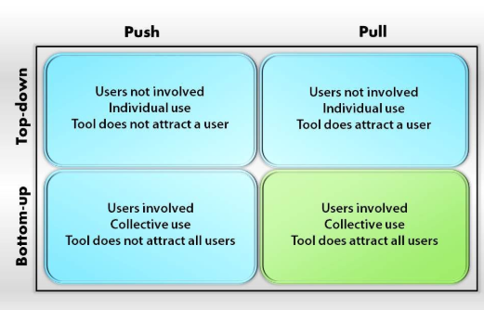
Figure 3: Push and pull communication methods, Source:

4.3 Interactive communication method:
The parties will simultaneously exchange information using this method and will be usually used for reporting and meeting purposes. The project sponsor will play a great part here because he will be communicating with the project manager for gathering information about the project progress, which he will report to the project client or the senior management of the company. Video conferencing, physical meetings, emails, etc. will be used for interactive communication.

Task 05: Benefits Accruing from Project Management
Project management refers to the execution of skills, experience, methods, processes, and resources by initiating, planning, executing, controlling, and terminating the project activities to achieve some predetermined objectives. The planning, organisation, and controlling of activities under the project management breed some advantages for the project owner, for which Standard Chartered Bank has resorted to project management to develop the new system (Voltron).

5.1 Guidance of a Comprehensive Plan:
The project management starts with drafting a complete plan for all the activities that need to be performed for unlocking the project deliverables and achieve the ultimate goal. The plan guides the team to set smaller and more specific tasks to stimulate accountability and responsibility among the project team(Craddock, Roberts, Stapleton and Godwin, 2017). The plan can also be used as a yardstick to assess the performance of each member and assist the controlling activities.

5.2 AssetUtilisation:
The project involves the commitment of different resources that is, human resources, money, time, effort, machinery, etc.Under the project management, a project schedule is developed using tools like Gantt chart, PERT, and critical path method, which aims at making the best use of the available resources because each involves costs. The project schedule evaluates the need for a particular resource in a task versus the importance of that task to accomplish the project to allocate that resource to that particular activity.

5.3 Increased Customer Satisfaction:
The communication part of the project shares valuable information with the customers, which can satisfy the customers as they will be fell involved and well-informed(Baguley, 2018). The information about the new system that is likely to enrich their banking experience will increase customer satisfaction and customer’s will to do more business with the bank while attracting new potential customers.

5.4 Controlled Quality of the Project:
The project keeps tight control on the quality of the project activities by tracking the performance regularly(Wolf, 2019) and making necessary changes to bring the performance back on track. The continuous monitoring, feedback, and control boosts the quality of the activities and raises the chances of success.
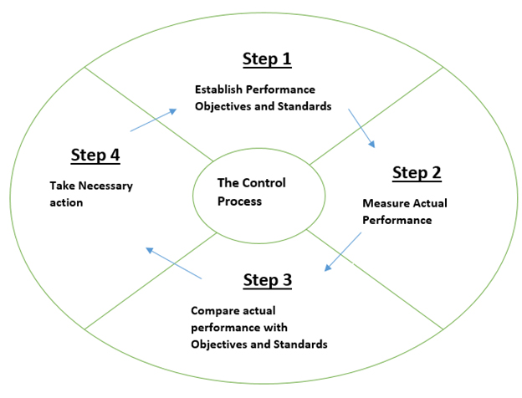
Figure 4: Controlling process, Source: (Wolf, 2019)

5.5 Effective Communication:
The project management draws a clearer organogram, which shows the line of authority and direction of the flow of information, which helps the different parties to communicate with the other effectively and efficiently. Effective communication reduces the chances of error and misunderstanding, which can prove very costly otherwise.

5.6 Other Benefits:
Project management adds some other benefits, for example, it helps the company to manage risks involved solely with the project in a very effective manner, which will be discussed in the other segments of this report. In addition, the project management addresses the stakeholder concerns and helps the organisation to take decisions after considering its impact.

Task 06: Key Characteristics of the Project Manager
The role of the project manager is perhaps the most important one because of acting as a link to information sharing between the project team and the project sponsor. The project manager has some other roles other than just passing the information and has to possess some qualities to execute those activities.
1. Leadership Qualities:
The project manager acts as a leader for the rest of the project manager because of being vested with the responsibility of managing the performance of the other members. The manager needs to influence and drive the performance of the team members to achieve project goals.
2. Team-Building Capabilities:
A project requires different types of skills and expertise, which are fulfilled by the project team members, however, the right mix of dexterity should be ensured, otherwise, the quality of the project deliverables may be questioned(Boxall and Purcell, 2016). The project manager must have the ability to understand the type of people that will be required for the project and what skills and experience they will bring and how those are important for the project’s success while developing the team.
3. Communicative:
The project manager needs to clearly communicate the roles of the individual members and clarify any misunderstanding so that project performance is driven towards the accomplishment of the project objectives. The project manager also has to report the true performance of the project to avoid any conflict of interest that may arise afterward.
4. Resilience, Stress Management, and a Decision-maker:
The project manager has to be a cool-tempered person, otherwise, stress coming from all the sides may break the morale of the manager, which will also affect the other members’ performance. The manager must be a decision-maker to direct the team members confidently in the right direction.

5. Other Characteristics:
The manager must also have some other qualities, for example, showing empathy towards team members, having a shared vision, being a good negotiation, etc.

Task 07: Organisational Structures to Support the Project
The organisational structure shows how the activities will be performed at different levels of the organisation and the chain of command, which also outlines who will report to whom(Takahara and Mesarovic, 2014). There exist different structures, which the project can adapt to achieve its objectives.

7.1 Line Structure:
Under this structure, the line of authority is set vertically from the top management to the subordinates and factory workers. The advantage of this structure is that the chain of command is pretty straightforward and simple(Hill and Jones, 2013), while the lengthy decision-making process is the major shortcoming.
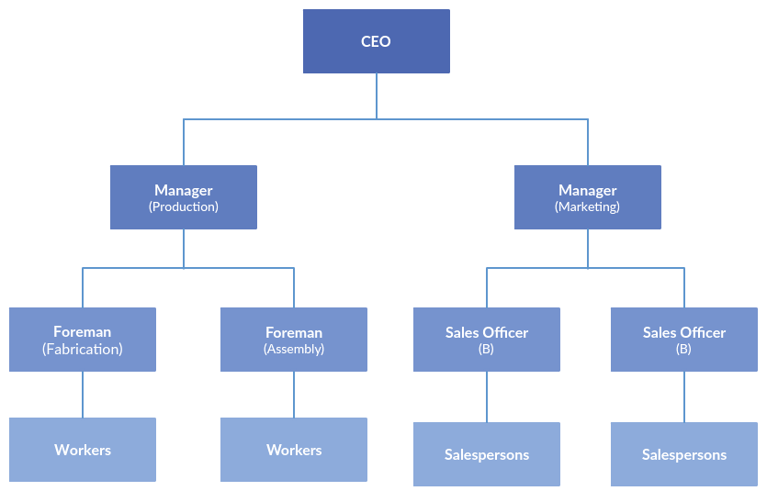
Figure 5: Line structure, Source: Author

7.2 Functional Structure:
The function structure divides the organisations hierarchy based on the different functions that the company engages in. The advantage of a functional structure is that individuals are dedicated to a single function. The downside is that it’s challenging to facilitate strong communication between different departments.

7.3 Divisional Structure:
The hierarchy and chain of command are established based on the divisions or the products of the company. This increases the focus on a particular product; however, it adds complexity to the overall structure of the group.
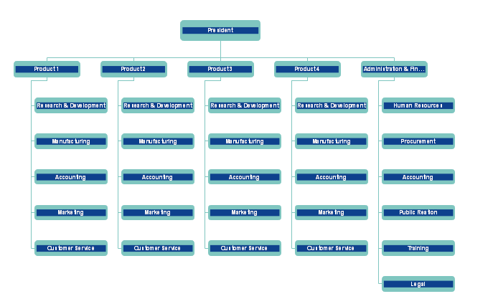
Figure 6: Divisional Structure, Source:(Hill and Jones, 2013)

7.4 Matrix Structure:
The employees under this structure have multiple reporting bosses and this structure is quite complex, however, the structure integrates the efforts of functional and project authority.The vertical and horizontal lines of authority are a combination of the authority flows both down and across.
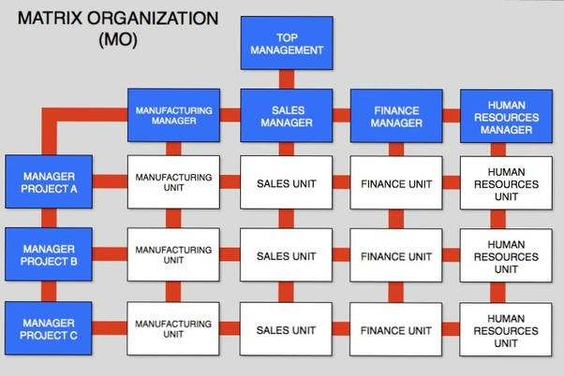
Figure 7: Matrix organization, Source: (Reiss, 2013)
For this project, the project sponsor and manager has agreed to use the functional structure to manage the project and the organogram will look like the following structure:

Figure 8:Organogram of the project, Source: Author

Task 08: Project Type, Lifecycle, and Methodology

8.1 Project Type:
There exist different types of projects based on the activities involved and the objectives the projects are aimed at achieving. For example, a manufacturing project relates to the production of some goods, construction project to develop the building, roads, etc., IT project to development and installation/up-gradation of the system, and research project to examining a hypothesis. The project of SCB can be categorised as an IT project as it involves creating a digital trade finance platform supported by blockchain technology.

8.2 Project Lifecycle:
A project usually goes through five different phases from project inception to the termination, which defines the tasks at each stage. The five stages are project initiation, planning, execution, controlling, and project closure.
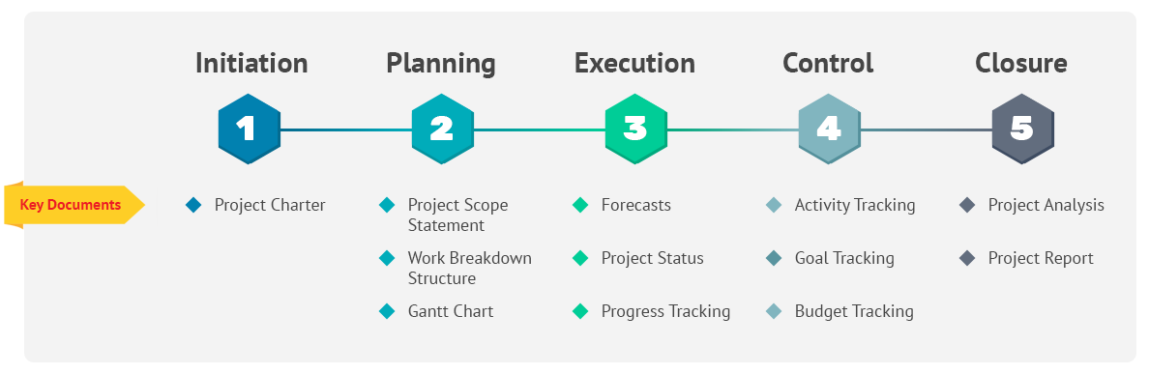
Figure 9: Project lifecycle, Source: (Brandon, 2016)
1. Project Initiation: This stage establishes the foundation of the whole project, where the initial activities of the project are carried out, for example, appointing the project manager and team, developing the scope statement, etc.
2. Planning: In this stage, all the activities that need to be performed are planned in advance and the information stored helps in the controlling stage(Hobbs, 2019). The preparation of the budget, risk management plan, project schedule, communication chart, etc. are part of this stage.
3. Execution: All the planned tasks are tried to execute in this stage, for example, collaborate with the technology partner, develop the platform, train the employees to use the new system, etc. will be done in this stage.
4. Controlling Stage: The quality of the project deliverables will be ensured by monitoring performance, tracking deficiencies, and taking corrective measures.
5. Closure: The project is finally terminated upon the successful completion of all the planned activities and achievement of the project objectives.

8.3 Project Methodology:
Project methodology defines the principles, processes, and themes used in a particular project, and based on these criteria, there are several project methodologies like Waterfall, Agile, Prince2, Lean, Scrumban, etc. However, in this project, the Prince2 methodology will be followed to carry out the activities. The Project InContrlled environment method is a product-based method(Vaníčková, 2017), which focuses on business justification, and the project activities are divided into smaller, manageable, and controllable stages considering the flexibility. The methodology is selected because of the mentioned reasons.

Task 09 Risk Management Techniques: Risk Matrix
Like any project, this project also entails some general and project-specific risks, which must be identified and assessed so that necessary actions can be taken to manage them that is, taking an adequate amount of risk given the return expected from the project.
Sl. No. | Risk | Impact | Probability/Chance | Risk Score
1 | Technical Failure | 5 | 2.5 | 7.5
2 | Information-share | 4 | 3 | 12
3 | Resource Embezzlement | 2 | 3 | 6
4 | Governance | 5 | 2 | 10
5 | Project Schedule | 3 | 3 | 9
6 | Legal | 4 | 1 | 4
7 | Transportation | 3 | 2 | 6
Table 3: Risk matrix, Source; Author

9.1 Risk Mitigation Techniques:
After identifying the types of this and their potential impact on the project activities, the next task is to manage the risk and there are several techniques that can be used for that purpose. One of the methods is risk transfer, which can be done via the means of the insurance contract(Holmes, 2018), for example, the transportation risk can be managed by transferring the risk. Another technique is risk share, that is, bearing a portion of risk rather than the complete risk, for example, the technical risk can be shared with the technology partner of the project.
The risk minimisation is another type of RM technique, which refers to undertaking activities to reduce the risk, for example, the regular controlling activities can be executed to minimize the governance and performance risk of the project. Under the risk accept technique, the project just simply accepts the as the other methods prove costlier than the maximum damage a particular risk might cause, for example, the company will just accept the project schedule risk.

Task 10: Appreciation of Soft Skills of the Manager
The hard skills like knowledge of the project management tools and techniques, blockchain technology and soft skills like communication, leadership, and management skills are equally important skills of a project manager. The soft skills of the manager help to guide, direct, and motivate the performance of the team members, boost their morale, make timely decisions, win the table for the project client, etc.
Thecommunication skill of the manager is essential for sharing the information with different relevant parties so that every party can make informed decisions(EL-Annan, 2015) and any confusion may not disrupt the performance of the project. The leaderless team is like a driverless car, which can never reach its destination, that is why the leadership skills of the manager are so crucial to the success of the project. Because the project manager needs to drive the performance of the members towards the goals of the project. The management skills of the manager will help to ensure the proper resource utilisation and make sure that the tasks that require a particular resource are getting that through preparing an exception project schedule.
The conflict management skills of the manager promote trust among the team members so that they all work in harmony with the common objectives of the project(Mascia, 2014). The negotiation skills bring the maximum out of the negotiation table for the company. Other important soft skills of the manager are team-building, sharing the vision, time management, etc.

Task 11: Analysis of the Project Stakeholders
The stakeholder’s interest in the company is likely to be affected by the project decisions, which is why this analysis is conducted to show the influence on the stakeholders and their objectives in the project, and how the project information will be communicated to them.
Type of Stakeholders | Respected Parties | Influence | Interest | Communication Method
Project Owner | Standard Chartered Bank | Medium | Pursuing growth by satisfying customer with improved services | Revenue and profit growth
Project Client | Senior Management and Board of Directors | High | Successful completion of the project | Reports, Inspection
Project Sponsor | Chief Information Officer | High | Proper resource utilisation | Emails, Meetings, Inspections, Reports
Steering Committee | CEO, Independent Director, and Auditor | Medium | Impacting the project by providing valuable advice | Video-conferencing, Meeting
Project Manager | Myself | High | Ensuring the quality of the project deliverables | Status report, Emails, Meetings, Inspections, Telephone
Project Team | Selected members from inside and outside the company | Medium | Carrying out the individual tasks | Emails, Meetings, Inspections, Telephone
Employees | Employees in the Trade Finance Department | Low | Streamlined business processes | Bulletin Board, Intranet, Company Website
Customers | Business Clients | Low | Getting a better banking experience | Company Website, Press Release
Table 4: Stakeholder Analysis, Source: Author

Conclusion:
The report involves providing valuable information regarding the project management of the development of the digital trade finance platform for international trade transactions. The project introduction set the objectives that will also be used for controlling purposes. The scope defined the boundaries of the project and project sponsor and stakeholder analysis identified the different parties of the project and their roles and responsibilities. The project management tools like WBS, Gantt Chart, and project budget have been developed to direct the project management team. The communication methods have also been analysed and the benefits of the project management have been discussed. The key characteristics of the manager like decision-making, communication and leadership skills, technical expertise have been discussed along with their importance for the project success. The risk management techniques and stakeholder analysis comprised the last segment of the report where the key risks are assessed and how they can be managed are discussed and the parties that will be influenced by the project decisionand their interest have also been explained.

References:
Atkinson, R., Crawford, L. and Ward, S., 2016. Fundamental uncertainties in projects and the scope of project management. International Journal of Project Management, 24(8), pp.687-698.
Baguley, P., 2018. Project Management. London: Hodder Education.
Boxall, P. and Purcell, J., 2016. Strategy And Human Resource Management. London: Macmillan Education.
Brandon, D., 2016. Project Management For Modern Information Systems. Hershey, PA: IRM Press.
Craddock, A., Roberts, B., Stapleton, J. and Godwin, J., 2017. Agile Project Management. Ashford: Agile Business Consortium Limited.
EL-Annan, S., 2015. The Relationship between Project Manager Skills and Leadership Skills in the Workplace. British Journal of Economics, Management & Trade, 8(1), pp.8-18.
Eskerod, P., Huemann, M. and Ringhofer, C., 2015. Stakeholder Inclusiveness: Enriching Project Management with General Stakeholder Theory1. Project Management Journal, 46(6), pp.42-53.
Hill, C. and Jones, G., 2013. Strategic Management. Mason, OH: South-Western, Cengage Learning.
Hobbs, P., 2019. Project Management.. London: Dorling Kindersley.
Holmes, A., 2018. Risk Management. Oxford, U.K.: Capstone Pub.
Johnson, R. and Melicher, R., 2019. Financial Management. Boston: Allyn and Bacon.
Koskinen, K., 2017. Knowledge Management to Improve Project Communication and Implementation. Project Management Journal, 35(2), pp.13-19.
Mascia, A., 2014. Project manager: leader, influencer e conflict manager. PROJECT MANAGER (IL), (20), pp.19-23.
Reiss, G., 2013. Project Management Demystified. Hoboken: Taylor and Francis.
Takahara, Y. and Mesarovic, M., 2014. Organization Structure. Boston, MA: Springer US.
Tinnirello, P., 2017. Project Management. Boca Raton: Auerbach.
Vaníčková, R., 2017. Application of PRINCE2 Project Management Methodology. StudiaCommercialiaBratislavensia, 10(38), pp.227-238.
Wolf, M., 2019. Project planning and controlling in software development. International Journal of Project Management, 7(4), pp.223-227.

