

HUMAN RESOURCE MANAGEMENT-ASSESSMENT 1

Student Name: CHARANJEET KAUR

Student ID: 2220279

Subject: HUMAN RESOURCE MANAGEMENT

Subject Code: LCMB7000

Lecturer name: Dr. Mohamed Asim

ASSIGNMENT TITLE: ASSESSMENT 1

SUBMISSION DATE: 10th MAY 2023

Executive Summary
The study demonstrates the current UK labour market valuation and helps to determine the major consistency of the UK labour force. Furthermore, the major changes due to the pandemic and Brexit affecting the UK firm especially verdant Leisure SME has been identified and explained.

Contents
Introduction 3
a) The current state of the labour market in the UK 3
Implications for recruitment strategies for UK firms 4
Supply and demand and the unemployment rate 5
Competitors 5
Social and legal environment 5
Challenges faced by the company due to Brexit and Pandemic 6
b) The emerging changes in Human Resourcing Strategies 7
Changes in the post Covid scenario 8
Changes in post Brexit external environment 9
Conclusion 10
Reference 11

Introduction
Human Resource Management is an essential part of business that determines recruitment strategies, company operations and supports business growth. Human resource strategies are the approaches and ways that help in identifying the appropriate talent from the labour market that meets jobs criteria appropriately. It not only helps bring positive outcomes for the firm but also helps in overcoming the internal and external challenges of the environment. The purpose of this study is to analyse the internal and external environmental issues such as Brexit and pandemic has on business HR strategies. This paper also demonstrates the current state of the labour market in the UK and signifies the strategy implications for recruitment in the UK. The study is developed through focusing on a SME verdant Leisure which is a holiday parking company offers holiday parks, self-catering holidays, caravans and lodges.

a) The current state of the labour market in the UK
The UK labour market is the major force for the UK firms to gather talent to support the missions and goals. The current state of the labour market of the UK is persistently tight. The UK labour market overall has plenty of job vacancies and opportunities, though there is a significant lack in effective employees and workers. However, average wage in the UK fell in recent three months by -3.5% excluding bonuses and including bonuses -4.3% with an annual change in the year 2023 (Researchbriefings.files.parliament.uk, 2023). In 2022- 2023 the estimated employment was 32.84 million, aged 16+. The employment rate in the UK for people aged between16-64 was 75.7% which is a significant increase from the previous year (Ons.gov.uk, 2022). It can be determined that the UK labour force is persistent and the employment rate is rapidly increasing through the years.
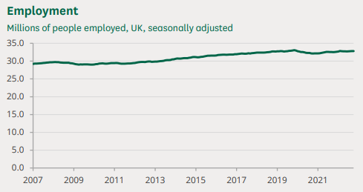
Figure 1: Labour market of the UK statistics
(Source: Ons.gov.uk, 2022)
The employment rate has gradually risen since 2011, and the UK business market has also observed a significant increase in emerging SMEs. At the start of 2022, approximately 5.5 million SMEs were accounted for in the UK. Furthermore, the numbers are rapidly increasing ever since. However, there was a significant decrease in the numbers of emerging SMEs during the pandemic and Brexit simultaneously affected the UK market. Additionally, there were 5.47 million small businesses that employed (5-49) employees in the year 2022 (Gov.uk, 2022). Furthermore, there were 35,900 medium-sized businesses that employed 50 to 249 and around 7700 large businesses with 250 or more than 250 businesses emerged in 2022. Thus, the numbers of employers, businesses and employment are majorly increasing with time which increases the competition and labour competency.
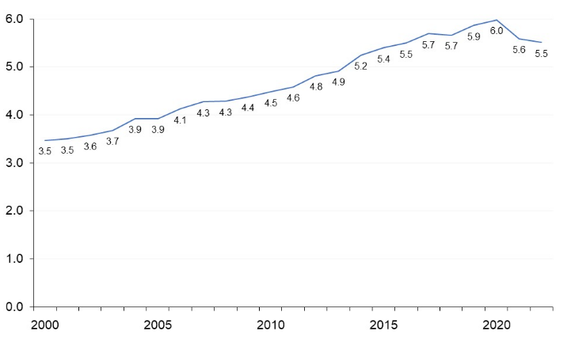
Figure 2: “Number of private sector businesses in the UK, 2000 to 2020”
(Source: Gov.uk, 2022)

Implications for recruitment strategies for UK firms
The recruitment strategies normally focused on creating an elaborated job role and descriptions and analysis resumes as per the job criteria. It has been identified that 85% of the UK firms, currently, are focused on recruiting candidates who have digital knowledge and are experienced with digital technological implications (Hbr.org, 2022). Furthermore, the combination of Brexit and pandemic has made the recruitment factors more challenging. The first and foremost criteria for the UK firms are to focus on diversity, equality and inclusion. Additionally, for the firms it is important to look out for the labour market trends and employ overseas workers in the UK. The labour market outlook surveys and resourcing and talent planning surveys help UK organisations to gather information and make decisions as per the surveys. Moreover, UK legal recruitment aspects are focused on recruiting employees based on promoting inclusive workforce and bringing diversity in their work environment. As per the view of Sethi et al. (2021), diverse work culture helps in managing talent more effectively and helps in brainstorming to gain competitive advantage. Therefore, it has been identified that creating compelling job descriptions helps in attracting effective employees who are interested in becoming a part of the organisation. Hybrid working arrangements are being made in the UK firms to overcome the challenges of pandemic and Brexit. Thus, UK firms are more considerate to deploy effective employees with the new emergence of industry 5.0, employees need to have effective skills and credibility in achieving success.

Supply and demand and the unemployment rate
The supply, demand and employment has a significant relation that interlinks with each other. It can be defined that when the unemployment rate is high the number of the people searching for jobs naturally exceeds the number of available jobs. Hence, it can be determined that the supply of the labour is higher than the demand for it. If the economy is knee deep in recession, unemployment resources are used to fulfil the demand for it. Furthermore, the unemployment rate of the UK is 3.7% which is unchanged from the previous year (Ons.gov.uk, 2023). The unemployment rate has slightly increased based on the three months. However, it has been analysed that the combined force of Brexit and pandemic has significantly affected the labour force of the UK market. The withdrawal with the EU has impacted massively in the UK labour force and created a significant vacancy of effective employees. Though the “UK labour force participation rate” has increased by 63.2 % in the year 2023 (Ceicdata.com, 2023). Migrant and immigrant workers facing great trouble due to restrictions of the pandemic also have a significant impact in the decreasing labour force supply. The UK market has a demand for effective and talented employees.

Competitors
Competition amongst the UK firms of SMEs and an increasing number of MNCs are increasing the demand for effective workers. It has been identified that between 2022 and 2023 there is a significant increase in SMEs and MNCs in the UK. Therefore, it can be determined that the competition is also high. Furthermore, with the rapid change in business dimensions the competition amongst firms and UK labour force is also significant. Businesses are majorly focused on globalisation and focused on expanding their business to gain long term sustainability which is also increasing the commission between peers.

Social and legal environment
The United Kingdom is a “constitutional monarchy based on parliamentary democracy”. It defines that the main law source of the country is the common law with the early roman and modern influences. Furthermore, it can be determined that the overall legal environment of the UK majorly supports emergence of new companies and has significant beneficiary legislations for the labour force. As the equality act 2011 and health and well-being legislation and health insurance policies help the labour force to maintain a stress free work life (Peoplepointhr.co.uk, 2020). Certain safety and protection is provided to the UK labour force and the legal environment of the UK supports employees and avails to use health insurance provided by the UK firms used by them after resignation for 18 months. Therefore, there are certain legislations such as; “Employment Rights Act 1996”, “National Minimum Wage Act 1998” and “Equality Act 2010” which helps in creating a safer and supportive social and legal environment for the labourers of the UK firms (Week 8, Slide 4). Thus, these acts help in enhancing the work performance considering the safety and satisfaction of the employees.

Challenges faced by the company due to Brexit and Pandemic
The company Verdant Leisure is a renowned UK SME which provides holiday parks. Therefore, the company has experienced certain challenges due to pandemic and Brexit. The company majorly was affected due to its lack of digital exposure and inflexibility and manual work processes. It has been identified that due to the major effects of pandemic and Brexit the company had turnover of £11M in 2021 which further increased by $32.4M in 2022 (Uk.globaldatabase.com, 2023). Thus, it can be determined that pandemic and Brexit influenced lack in demand for holiday stays and their services along with barriers of social restrictions and Brexit influence weak economy of the UK major affected the growth of the company.
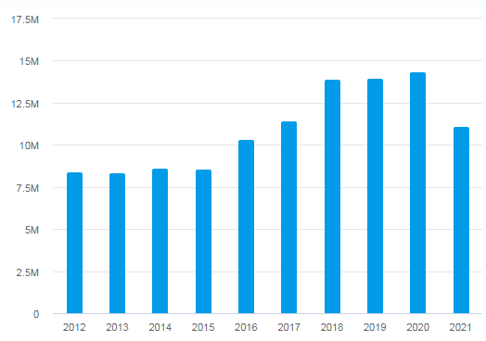
Figure 3: “Financial statements of Verdant Leisure Limited”
(Source: Uk.globaldatabase.com, 2023)

b) The emerging changes in Human Resourcing Strategies
Human Resourcing strategies initially were majorly focused on deploying employees that fit with the job criteria. The use of manual searching and using the platforms such as LinkedIn to identify appropriate candidates was popular. Furthermore, the emerging technologies and the advanced technological usages help human resourcing strategies to evolve and accelerate the search and identify proper candidates. Applicant Tracking System (ATS) is currently an emerging technological support for the UK firms which is helping employee tracking. Based on the study of Stone et al. (2020), human resource management is one of the major and important parts of an organisation that identifies appropriate talent for an organisation to support the goal and missions of the firm. Furthermore, currently the human reasoning strategies are to measure the flexibility and skill set of the employees to support various types of work and the intelligence of the employee to overcome critical situations. Previously human resource management was based on identifying employees and analysing them as per their IQ. Currently the dimension has changed and companies are majorly focused on identifying employees with high Emotional intelligence (Wen et al. 2019). Thus, deploying the current human resourcing strategies can help the company Verdant Leisure to increase their efficiency in adapting the current changes and bring revolutionary changes to the organisation.

Changes in the post Covid scenario

Pandemic has affected many organisations and is the cause of failure of businesses. The incompetence in adapting the changes of the current environment and the lack of adaptively with digital emergence caused major failures of companies. However, the company Verdant Leisure has also faced a significant decrease in revenue due to the challenges influenced by pandemic regarding decrease in demand for the service and increased consumer expectations. The company led through digital disruption to evolve and overcome the challenges. Effective application of digital technologies such as AI which is a major human resource tool and analytical tools helped the company to drive sales and customer loyalty (Stewart and Brown, 2019). Pandemic also influenced issues regarding restrictions and poor health conditions of the employees. Therefore, the company has created a hybrid work culture which not only helped the employees to have a more flexible work structure and it also helped the human resource department to manage the workforce more effectively. Thus, it majorly helped in continuing work without facing any disruptions.
Hybrid work culture is a major change which was imposed in order to incorporate with the restriction of the pandemic. Based on the study of Abdurakhmanova et al. (2020), major technological advances and digital implementations have changed the work dynamics of firms. Furthermore, the pandemic has expanded the role of the HR. Verdant Leisure in the post pandemic situation has changed their work culture and fostered holistic growth. It can be determined that the company has also brought the activities together with the use of HubSpot. HubSpot refers to the consolidation of essential data into a single consumer review. HubSpot also helped the company to work on and offline and enhanced effective reporting. Pandemic influenced hybrid culture of the firm Verdant Leisure also helped the company to support diversity and create a more inclusive workforce.
Pandemic has also increased the competition between firms and influenced the emergence of new technologies adaptations and becoming more digitally transformed. The company in this case has majorly focused on using advanced technologies to promote their company using Google Ads and also contacting employees through effective marketing. According to the study of Savić (2020), the pandemic has changed work culture and put more importance to the human resource. It has made people understand more about the importance of building proper communication and interpersonal relationships. Verdant Leisure might also focus on changing their work procedures and implement regular communication strategies to perceive a more effective and smooth flow of information. Furthermore, the pandemic has also influenced a constant change in consumer demands which needs to be understood by the companies in order to achieve growth and sustainability (Kaushik and Guleria, 2020). Thus, the company might consider changing their work procedures and implement big data analytics and invest more on research and development. Thus, it can help the company to monitor the changes in market trends and labour market trends to comply with their company policies and strategies.

Changes in post Brexit external environment

Brexit influenced major challenges for human resourcing strategies and employee freedom. It has majorly disrupted the freedom of movement of individuals within the EU to the UK. Therefore, it majorly disrupts the workforce of the UK firms as the majority of the UK effective employment workforce is from the EU. It has been identified that approximately 47% of the UK workforce were from the EU (Migrationobservatory.ox.ac.uk, 2022). Hence, the disruption in movement has increased issues for the UK firms to identify talents and effective employees. In this case the company Verdant leisure considers exploring a workforce focused on the UK to eliminate the issue brought by Brexit. Moreover, companies have also enhanced their human resource strategies to identify talents within the UK and are considering building a diversified workforce. Furthermore, it can be analysed that measuring the major workforce of the UK has to consider the policies to deploy workers outside from the UK majorly affected the environment. Policy changes such as; implementation of health and safety policies, hybrid work policy and employee beneficiary policies have implemented. However, human resourcing strategies have implemented work from home options which helped companies to eliminate the issue and also get the benefit of effective workers.
Alternative resourcing techniques and enhancing the search capabilities of the companies have evolved. In order to mitigate the issues brought by Berxit might be mitigated by the company through organising exclusive training that can help enhance the skills set of the employees and can maximise the productivity of the employee. Based on the study of Alshurideh et al. (2020), effective training sessions and reward programs can help firms to obtain employees and gain their trust. Furthermore, Brexit has changed the company’s outlook for their employees. The importance of keeping their employees safe and satisfied has become a major concern for the companies. Thus it can be determined that Brexit has changed the outlook for the employees and made the employees the most important assets of companies.

Conclusion
The study concludes that human resourcing strategies have majorly changed after pandemic and Brexit hit the UK. Employees are becoming a major asset for the companies and therefore UK firms are changing their outlook for their employees. Major application of advanced technologies such as big data analytics and cloud computing helped companies to achieve better performance and productivity out of their employees. The study also helps to identify the changes brought by pandemic and Brexit in the human resourcing strategies and the major factors of the current UK labour market to understand the growth of the businesses.

Reference
Abdurakhmanova, G., Shayusupova, N., Irmatova, A. and Rustamov, D., (2020). The role of the digital economy in the development of the human capital market. Архив научных исследований, (25).
Alshurideh, M., Gasaymeh, A., Ahmed, G., Alzoubi, H. and Kurd, B., (2020). Loyalty program effectiveness: Theoretical reviews and practical proofs. Uncertain Supply Chain Management, 8(3), pp.599-612.
Ceicdata.com (2023), United Kingdom Labour Force Participation Rate; Available at: https://www.ceicdata.com/en/indicator/united-kingdom/labour-force-participation-rate#:~:text=United%20Kingdom%20Labour%20Force%20Participation%20Rate%20increased%20to%2063.2%20%25%20in,63.2%20%25%20in%20the%20previous%20month. [Accessed on: 12th April, 2023]
Gov.uk (2022), Business population estimates for the UK and regions 2022: statistical release (HTML); Available at: https://www.gov.uk/government/statistics/business-population-estimates-2022/business-population-estimates-for-the-uk-and-regions-2022-statistical-release-html#:~:text=SMEs%20(small%20and%20medium%2Dsized,million%20UK%20private%20sector%20businesses [Accessed on: 12th April, 2023]c
Hbr.org (2022), In a Hybrid World, Your Tech Defines Employee Experience; Available at: https://hbr.org/2022/02/in-a-hybrid-world-your-tech-defines-employee-experience [Accessed on: 12th April, 2023]
Kaushik, M. and Guleria, N., (2020). The impact of pandemic COVID-19 in workplace. European Journal of Business and Management, 12(15), pp.1-10
Migrationobservatory.ox.ac.uk (2022), The Migration Observatory informs debates on international migration and public policy; Available at: https://migrationobservatory.ox.ac.uk/resources/briefings/migrants-in-the-uk-labour-market-an-overview/ [Accessed on: 12th April, 2023]
Ons.gov.uk (2022), ummary of labour market statistics; Available at: https://www.ons.gov.uk/employmentandlabourmarket/peopleinwork/employmentandemployeetypes/datasets/summaryoflabourmarketstatistics [Accessed on: 12th April, 2023]
Ons.gov.uk (2023), Unemployment; Available at: https://www.ons.gov.uk/employmentandlabourmarket/peoplenotinwork/unemployment#:~:text=The%20timeliest%20estimate%20of%20payrolled,on%20the%20quarter%20at%203.7%25. [Accessed on: 12th April, 2023]
Peoplepointhr.co.uk (2020), Equality and diversity policy assistance; Available at: https://peoplepointhr.co.uk/hr-solutions/equality-and-diversity-policy/[Accessed on: 12th April, 2023]
Researchbriefings.files.parliament.uk (2023), UK labour market statistics; Available at: https://researchbriefings.files.parliament.uk/documents/CBP-9366/CBP-9366.pdf [Accessed on: 12th April, 2023]
Savić, D., (2020). COVID-19 and work from home: Digital transformation of the workforce. Grey Journal (TGJ), 16(2), pp.101-104.
Sethi, B., Vito, R. and Ongbanouekeni, V., (2021). Organizational culture, diversity, and employees’ health in Social/Human Services: a systematic review. International Health Trends and Perspectives, 1(1), pp.74-95.
Stewart, G.L. and Brown, K.G., (2019). Human resource management. John Wiley & Sons.
Stone, R.J., Cox, A. and Gavin, M., (2020). Human resource management. John Wiley & Sons.
Uk.globaldatabase.com (2023), VERDANT LEISURE LIMITED; Available at: https://uk.globaldatabase.com/company/verdant-leisure-limited [Accessed on: 12th April, 2023]
Wen, J., Huang, S.S. and Hou, P., (2019). Emotional intelligence, emotional labor, perceived organizational support, and job satisfaction: A moderated mediation model. International Journal of Hospitality Management, 81, pp.120-130.

