

APPENDIX GA36c

LEVEL 6 ASSESSMENT SPECIFICATION

Student name: | Ethan Morgan | Student ID number:
Programme: | BSc Applied Computing
Module: | Big Data
Module code: |  | Contribution to Overall Module Assessment (%): | 50%
Lecturer: | John Williams | Internal Verifier: | Jeanette Adams
Assignment Title: | Big Data Report | Word count (or equivalent): | 3000
Submission deadline: | 19/04/2020 | Return date of provisional marks & written feedback: | 26/04/2020
Submission method: | All written assessments, where practical and possible, must be submitted via Turnitin unless otherwise instructed by the Lecturer. (Please DO NOT put this assessment specification into Turnitin or it will match many similarities with other students’ submissions.)  Alternative submission method (if applicable):  Late submission of the assessment will result in a late penalty mark. Penalties for late submission: Up to one week late, maximum mark of 40%. Over one week late, 0%. Only the Extenuating Circumstances Panel may approve a change to submission dates.
Academic honesty / referencing: | Academic honesty is required. In the main body of your submission you must give credit to authors on whose research and ideas your work is based. Append to your submission a reference list that indicates the books, articles, etc. that you have used, cited or quoted in order to complete this assessment.

Module Learning Outcomes
(from module syllabus)
Upon the successful completion of this module, the student should be able to demonstrate the ability to:

1. Develop a systematic understanding of the concepts, architecture and technologies required to manage and process Big Data.

2. Critically evaluate the technologies and applications of Big Data.

TASK DESCRIPTION

NPTC Power is a fast growing, welsh based power company. We are the leading provider of reliable, flexible and low carbon power units to the UK electricity market. With a portfolio of over 1GW of small-scale, local thermal power generation and battery storage units, we help keep the country’s electricity system running.
NPTC Power have a contract to supply 700 homes in the Neath Port Talbot area with electricity. The current project consists of three Bio fuelled units each providing 1GW of electricity per hour. Each home is fitted with smart meters that record power usage. Usage Data is calculated hourly and at the end of each day uploaded to the NPTC Power systems. Power demand varies considerably throughout the day and throughout the week, and in different weather conditions. All these elements have an effects on power usage and in-turn demand.
As it stands, all three power units are working to full capacity, irrespective of day, hour or weather conditions. As a consequence the power units often generate surplus power, incurring extra fuel costs and unnecessary were and tear on the units. In order to reduce costs the manager would like to analyse the data so that they can more accurately predict the days, times when power usage will be low, and therefore turn off some of the power units.
There are three systems used by NPTC power:
- Customer Database with customers address postcode, wards etc.
- Smart Meter Data: date address Id, 24 hourly data usage.
- Weather Data: Daily average temperature, Precipitation.
All three systems have very different data storage and data formats. As a result the Business analyst has requested that they develop a data warehouse to order to analyse the data and accurately predict times when units can be switched on and off.
Using this data you should do the following:
- Design and develop an appropriate data warehouse structure to store the data provided.
- You should justify all of your design decisions.
- Upload the data into your data warehouse, documenting the ETL process in a professional manner.
Design, develop and critically evaluate reports that can be run to retrieve and display the
Following data:
- Report: Power usage over time for each day of the week and by hour, highlighting peaks and troughs.
      - Tabular Data Report
      - Line graph
- Dashboard: Power usage
    - Ward,
    - District,
    - Postcode
- Report: The impact that weather has on power usage
    - Rain
    - Temperature
The reports should be appropriately referenced and should include the appropriate tables of contents, tables of figures and tables of tables. Any figures should have titles and identification labels. The document should also be spellchecked and grammar-checked.
The report should be submitted via Turnitin.

GUIDANCE FOR Students IN THE COMPLETION OF TASKS

NOTE: The guidance offered below is linked to the five generic assessment criteria overleaf.

- Engagement with Literature Skills
Your work must be informed and supported by scholarly material that is relevant to and focused on the task(s) set; you should make use of scholarly reviews and primary sources, where appropriate (for example, refereed research articles and/or original materials appropriate to the discipline). You should provide evidence that you have accessed a wide range of sources, which may be academic, governmental and industrial; these sources may include academic journal articles, textbooks, current news articles, organisational documents, and websites. You should consider the credibility of your sources; academic journals are normally highly credible sources while websites require careful consideration/selection and should be used sparingly. Any sources you use should be current and up-to-date, mostly published within the last five years or so, though seminal/important works in the field may be older. You must provide evidence of your research/own reading throughout your work, using a suitable referencing system, including in-text citations in the main body of your work and a reference list at the end of your work.

Guidance specific to this assessment:

- Knowledge and Understanding Skills
At level 6, you should be able to demonstrate coherent and detailed knowledge and a systematic understanding of the subject area, at least some of which is informed by the latest research and/or advanced scholarship within the discipline. You should be aware of the uncertainty, ambiguity and limits of knowledge. Your work must demonstrate the growing extent of your knowledge and systematic understanding of concepts and underlying principles associated with the subject area. Knowledge relates to the facts, information and skills you have acquired through your learning. You demonstrate your understanding by interpreting the meaning of the facts and information (knowledge). This means that you need to select and include in your work the concepts, techniques, models, theories, etc. appropriate to the task(s) set. You should be able to explain the theories, concepts, etc. meaningfully to show your understanding. Your mark/grade will also depend upon the extent to which you demonstrate your knowledge and understanding; ideally each should be complete and detailed, with comprehensive coverage.

Guidance specific to this assessment:

You will need to demonstrate detailed knowledge and understanding of the design and development strategies employed when building a data warehouse.

- Cognitive and Intellectual Skills
You should be able to: critically evaluate evidence, arguments, assumptions, abstract concepts and data some of which are at the forefront of a discipline (and that may be incomplete) to devise and sustain arguments, to make judgements and/or solve problems; describe and comment upon particular aspects of current research, or equivalent advanced scholarship, in the discipline Your work must contain evidence of logical, analytical thinking, evaluation and synthesis. For example, to examine and break information down into parts, make inferences, compile, compare and contrast information. This means not just describing what! But also justifying: Why? How? When? Who? Where? At what cost? At all times, you must provide justification for your arguments and judgements. Evidence that you have reflected upon the ideas of others within the subject area is crucial to you providing a reasoned and informed debate within your work. Furthermore, you should provide evidence that you are able to make sound judgements and convincing arguments using data and concepts. Sound, valid conclusions are necessary and must be derived from the content of your work. Where relevant, alternative solutions and recommendations may be proposed.

Guidance specific to this assessment:

- Practical Skills
At level 6, you should be able to apply the methods and techniques that you have learned to review, consolidate, extend and apply your knowledge and understanding, and to initiate and carry out projects. You will deploy accurately established techniques of analysis and enquiry relevant to the discipline, and apply them in complex and unpredictable contexts, to devise and sustain arguments and/or to solve problems. You should be able to frame appropriate questions to achieve a solution - or identify a range of solutions. You should be able to demonstrate how the subject-related concepts and ideas relate to real world situations and/or a particular context. How do they work in practice? You will deploy models, methods, techniques, and/or theories, in that context or circumstances, to assess current situations, perhaps to formulate plans or solutions to solve problems, or to create artefacts, some of which may be innovative and creative. This is likely to involve, for instance, the use of real world artefacts, examples and cases, the application of a model within an organisation and/or benchmarking one theory or organisation against others based on stated criteria. You should show awareness of the limitations of concepts and theories when applied in particular contexts.

Guidance specific to this assessment:
You should build your data warehouse using an appropriate large database platform such as Oracle. You will need to demonstrate advanced DDL and DML skills in order to effect the ETL process. You will deploy complex SQL queries to extract data to generate reports, data mining analysis and visualisation techniques.

- Transferable Skills for Life and Professional Practice
Your work must provide evidence of the qualities and transferable skills necessary for graduate-level employment requiring the exercise of initiative and personal responsibility and decision-making in complex and unpredictable circumstances. This includes demonstrating: the learning ability for professional development to advance existing skills and acquire new competences of a professional nature that will enable you to assume significant responsibility within organisations; that you can initiate and complete tasks and procedures, whether individually and/or collaboratively; that you can use appropriate media to effectively communicate information, arguments and analysis in a variety of forms to specialist and non-specialist audiences; fluency of expression; clarity and effectiveness in presentation and organisation. Work should be coherent and well-structured in presentation and organisation.

Guidance specific to this assessment:

Student FEEDBACK FORM

This section details the extent to which the assessment criteria are demonstrated by you, which in turn determines your mark. The marks available for each category of skill are shown. Lecturers will use the space provided to comment on the achievement of the task(s), including those areas in which you have performed well and areas that would benefit from development/improvement.

Generic Assessment Criteria | Marks available | Marks  awarded
1. Engagement with Literature Skills  . | 0
2. Knowledge and Understanding Skills | 10 | 7
Exhibits very good understanding of the breadth and depth of established views, and the work is, at least in part, well-informed by current research and scholarship.
3. Cognitive and Intellectual Skills | 20 | 14
Sound critical thinking, analysis, synthesis and evaluation demonstrating critical thinking. Ability to devise and sustain persuasive arguments, and to review the reliability, validity and significance of evidence (that may be incomplete visualisation: would expect charts, graphs following some data analysis or data mining process) to make mostly appropriate and valid judgements.

4. Practical Application Skills | 60 | 35
A good application of a range of methods, materials, tools and/or techniques. Can identify problems and propose appropriate solutions in complex and unpredictable contexts. Evidence of some innovation and creativity
5. Transferable Skills for Life and Professional Practice | 10 | 7

Assessment Mark (Assessment marks are subject to ratification at the Exam Board. These comments and marks are to give feedback on module work and are for guidance only until they are confirmed. ) | Late Submission Penalties (tick if appropriate) |  | 63%
 | Up to 1 week late (40% Max) |  | 63%
 | Over 1 week late (0%) |  | 63%



BSc (Hons) Applied Computing

Assignment 1

Database Design

&

Evaluation

By Ethan Morgan

Department of Applied Computing

University of Wales, Trinity Saint David
April 19th, 2020

Keywords

Database, Design, SQL, Schema

Contents
1. Introduction 2
2. Big Data 3
2.1. Big Data Criticisms 3
3. Requirements 4
4. Objectives 4
5. Design 4
5.1. Data Definitions 7
5.2. Queries 15
6. Reports 17
7. Results 17
8. Conclusion 17
References 17
Appendix 17

Introduction
Big Data is a dense and complex topic, that in this report will shine a light upon its ideas, conception and purpose, as well as the concepts behind it, the problems that it fixes and the problems that it creates. Later in the report requirements will be explained, as well as the objectives of the report and the practical aspect of this report which is the database implementation itself. Furthermore, a quick analysis of the current situation to provide perspective of the current reality. Then the Design and Justifications of those designs alongside the Data Definitions to simplify the representation of the data, queries I have used in order to communicate to my database for specific results and the reports that are the output of those queries and finally the results. Queries and Tables I have written will be presented in SQL format in their own section in the Appendix which will be appropriately referenced in the written sections.

Big Data
Big Data is a field that involves the analysis, management and process of large data sets that conventional software and methodologies cannot work with. As such these large data sets can be in any state, such as structured, unstructured and semi-structured, however a large portion of what Big Data tackles, involves unstructured data. The size of these datasets are ever changing whereby each day the world creates enough data each day to stack DVD’s to the moon and back [1]. Big Data follows rules and characteristics such as the five V’s.
These V’s are Volume being concerned with the quantity of the data and whether the size constitutes quality or whether it can be considered Big Data or not. Variety is the type and nature of the data, such as whether the data is chat-logs, images, videos, books or plain audio files such as ogg or mp3. Velocity is the speed of the data in terms of it being generated, processed, handling and recording the data and lastly Variability which is about the data or other notions of the data are different or shifting away from the context of what they’re generated from [2].

Big Data can be organized in their different schemas these schemas provide different benefits. Such as the Star Schema which consists of a Central Fact Table, which could be more than one with a few dimension tables which is where the data of each table lies. The Fact Table will contain the ID’s of these tables and the central Fact or important data to the whole data mart which is what the star schema is [3]. Another is the Snowflake Schema which is extremely similar with the major difference being normalization, to which the star schema is denormalized and snowflake uses normalization which results in more verbose queries as the data is more structured and less relaxed compared to the star schema.

Big Data Criticisms

Big Data has received plenty of criticisms but only a few are worth mentioning. One of the largest issues with Big Data is security. Data modelled either in the Star or Snowflake lack any form of security, and if any security is present it relies solely on the database vender. Those who wish to commit malicious actions upon a set of data within the data mart can do so easily, and with the fact table being the central table, if that table becomes affected then the rest of the database can become unusable and fail in its duty [4]. Another major criticism is privacy. Big Data is about the collection of large clumps of data sets, these data sets can contain sensitive information such as addresses, names, date of birth, financial and employment status and with the misuse by governments, media and companies has created a consequence of distrust. As there are no regulations as much as SQL is regulated by the International Standards Organization. Big Data is not regulated, meaning there are no ethical, professional or correct methods to handle the data that can protect the public and the companies, governments or media that are utilizing them.

Requirements
The system is place has been instigated by NPTC Power which is a fast-growing Welsh-based low-carbon power company. They provide up to 1GW of electricity per hour for over 700 homes and have 3 power units producing 1 GW each. It generates excess power which has the consequence of adding extra fuel cost and other unnecessary wear and tear on each powering unit. The manger has asked to reduce cost and analyse data for greater predication on times were power usage will be low therefore power units can be turned off or made to produce less power. They have 3 systems, Customer database with postcodes, wards and districts, smart meter data such as date address and 24-hour usage and lastly weather data on the average temperature and precipitation [5].

Objectives
The objectives based upon the requirements is to design and develop a data warehouse structure that conforms with the Star Schema for simplicity as the data can be retrieved swiftly. A hybrid of Star and Snowflake could be utilized but is largely un-required and is more work than worth. Therefore, Star Schema would suffice for fast data access and simple querying of data which may release the burden on non-computer literate users. Data will be organized, and the data warehouse will be constructed within Microsoft Access as it is a package that will allow extremely fast and productive creation of the data warehouse. Lastly oracle will be used to produce reports and query data that will be required for analysis, it should also be noted that these queries will be the basis of the reports so that users can accurately analyse data that conforms to their desired result. Justifications will be provided for reasoning behind certain design choices, but these design choices and their reasons will not fall far from a data warehouse.

Design
The design will follow the Star Schema for many different reasons. One of the reasons behind this choice is the query speed and performance, as there are a limited set of tables therefore querying data will be swift, especially with clear join paths. This method will be OLAP rather than OLTP, even joined queries that involve multiple tables would either be instant or take only a few seconds. Another reason for this choice is the structural simplicity, the simple nature of the structure means loading data especially new data would not slow down the whole system, if a new dimension table for a new dataset is added later, adding the foreign key in the fact table means the only part of the system that will be slow but quite unlikely unless the data is monstrous is the dimension table added, so querying other data from already existing tables would not be slowed down or be limited in performance. This idea also adds to the maintenance as the system will be a lot easier to maintain due to its simple structure and flexibility to add new datasets.

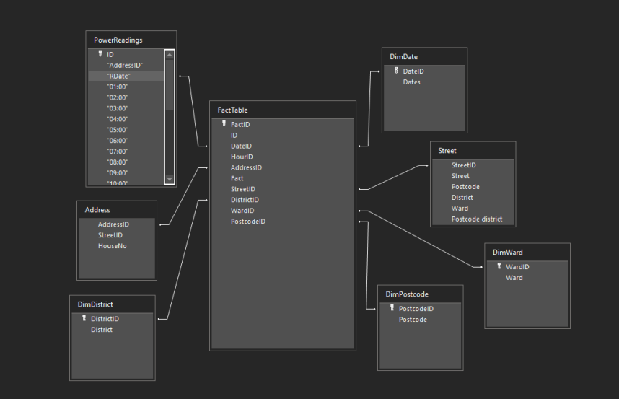

In this diagram there are a few parts that are somewhat different to an expected star schema even though it still follows the principles. Street and Address and PowerReadings are backup tables, whereby if data in the Dimension tables are faulty or can’t be queried then these database with the same dataset as the Dim tables except, they are the original tables. The reasoning behind this is mostly to maintain integrity and to further adapt the database towards flexibility. The Street table data is separated into DimWard, DimPostcode and DimDistrict while some elements are maintained within its own table so that it can be further expanded if necessary. The same case with Address except the address table is left as the original so that datasets can be accessed through a central table rather than further expanding more Dimension tables which could harbour performance bottlenecks in the database.

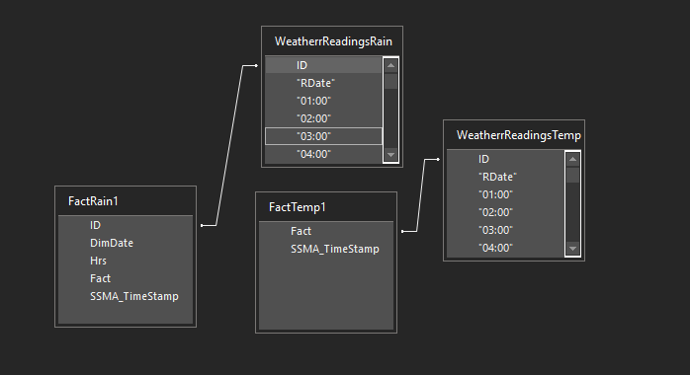
As this is a Star Schema, multiple Fact Tables is often present and has been created through a greater structure from the WeatherReadingsRain table and the WeatherReadingsTemp table so that data can be structured at a greater length, they are not joined to the main FactTable so that the heavy load of these two Fact Tables don’t harm the performance and integrity of the main Fact Table. It should be noted that the SSMA_TimeStamp are generated to show changes in the database, created by Oracle as backup procedure.

Data Definitions
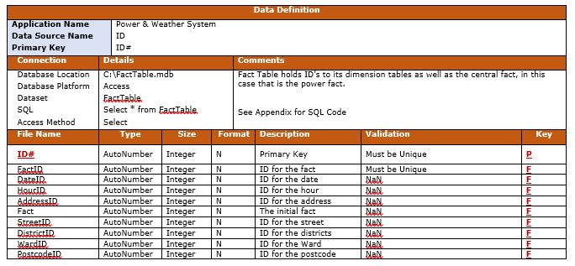

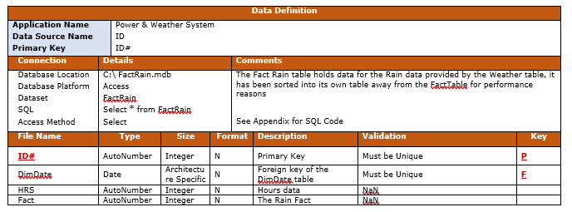

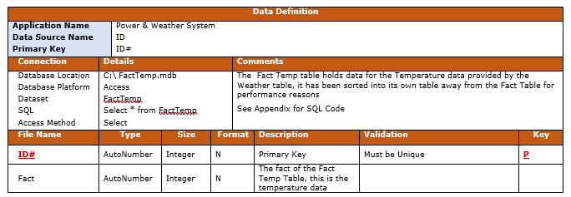

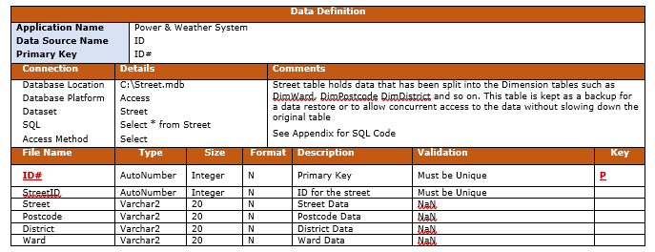

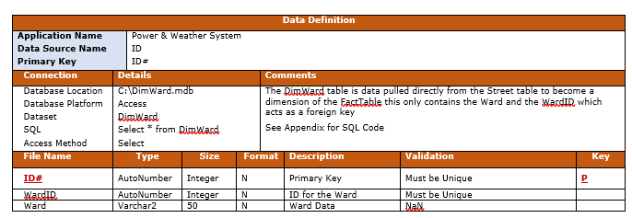

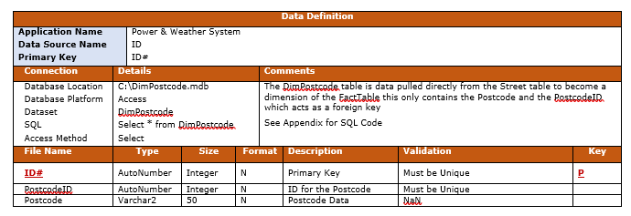

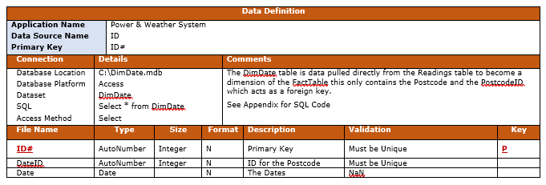

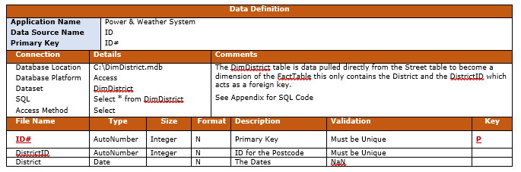

Queries

Queries were utilized to gather majority of the data for the reports. This made the process easier and allowed a more accurate and specific results as data could be queried through specific means. Some queries were simpler than others such as the one below, where we get the fact and the postcode where the fact is greater than one and the postcode starts with SA with the ‘%’ meaning continue regardless of the next character.

SELECT DISTINCT PostCode, Fact FROM DimPostcode, FactTable WHERE fact > 1 AND Postcode LIKE “SA%”

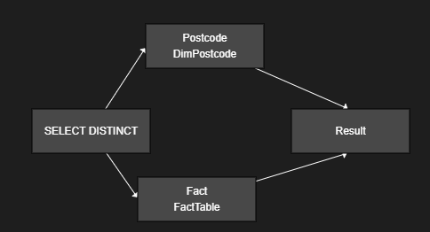

Acquired the data from the postcode table and the Fact Table specifically, this was a simple query, but complexity grew as tables had matching rows. Therefore, gathering data such as the dates for power usage, which is weekly a query such as

SELECT AVG(f.Fact) AS "fact", CAST(d.Dates AS DATE) AS "date" FROM FactTable f
INNER JOIN DimDate d ON f.DateID = d.DateID
WHERE CAST(Dates AS DATE) BETWEEN TO_DATE('2019-01-09', 'YYYY-MM-DD') AND TO_DATE('2019-01-24', 'YYYY-MM-DD')
GROUP BY d.Dates;

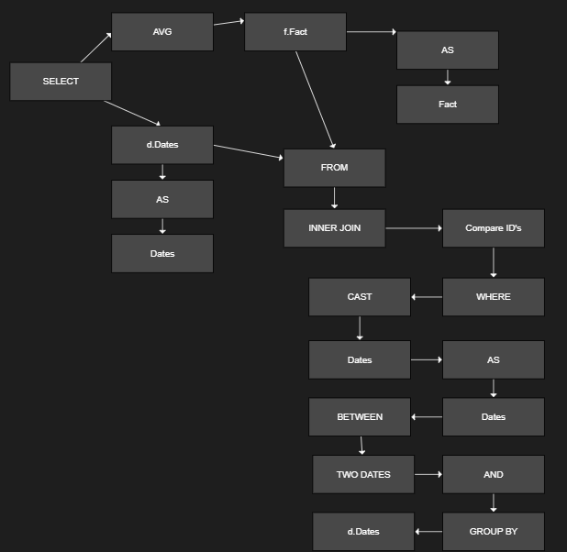

This query gathered dates specifically within the range of the start of the allowed month, and the end of the given month. Gathering Data within a 24-hour period for each day resulted in this SQL code

SELECT AVG(f.Fact) AS "FactAvg", MAX(f.Fact) AS "FactMax", d.Dates AS "Date", f.HourID AS "Hour" FROM FactTable f INNER JOIN DimDate d ON f.DateID = d.DateID GROUP BY d.Dates, f.HourID;

Dimension Table Queries

In order to create the FactTable and the Dimension tables queries were utilized, as such things such as to append the ID’s from the Street table into the Fact Table so it could be populated with the correct foreign ID’s a query like this was used

UPDATE (Address INNER JOIN FactTable ON Address.AddressID = FactTable.AddressID) INNER JOIN Street ON Address.StreetID = Street.StreetID SET FactTable.StreetID = [Street].[StreetID];

Even getting the power readings into the Fact table as the central fact required a similar query

UPDATE FactTable INNER JOIN PowerReadings ON FactTable.ID = PowerReadings.ID SET FactTable.AddressID = [PowerReadings].["AddressID"];

Creating Dimension tables and inserting the correct data was done as follows

INSERT INTO DimWard ( Ward )
SELECT Street.Ward
FROM Street INNER JOIN DimWard ON Street.Ward = DimWard.Ward;

Creating the Fact Temp table was done as follows, which also gets the Temperature from the power readings and inserts it into the Fact Temp table for a 24-hour period.

INSERT INTO FactTemp1 ( ID, ["AddressID"], ["RDate"], Hrs, Fact )
SELECT PowerReadings.ID, PowerReadings.["AddressID"], PowerReadings.["RDate"], 24 AS Hrs, PowerReadings.["24:00"] AS Fact
FROM PowerReadings;

DimDate was created using the similar SQL code, but with slight changes. This inserts RDate into the DimDate, thanks to Access DB these dates are then ordered rather than ordered, something with the query sadly doesn’t show.

INSERT INTO DimDate ( Dates )
SELECT PowerReadings.["RDate"]
FROM PowerReadings
GROUP BY PowerReadings.["RDate"];

The creation of the DimDistrict was much the same as the DimWard table
INSERT INTO DimDistrict ( District )
SELECT Street. District
FROM Street INNER JOIN DimDistrict ON Street.District = DimDistrict.District;

Reports
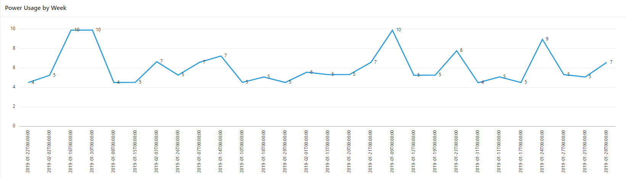

As shown in the report, data power usage is by week but showing every day within those weeks so that further analysis is possible, there are slight inclines during the end of a week as the weekend approaches, further data shows that there’s a decline in power usage of homes during the weekend, this could be due to the change in habits such as going out with family and friends and a lack of people in their houses. This is present three each week other than the second week which appears to be at a low point, but the 3rd and 4th week appear to have major spikes in power usage which could be down to weather where people are at homes more often.
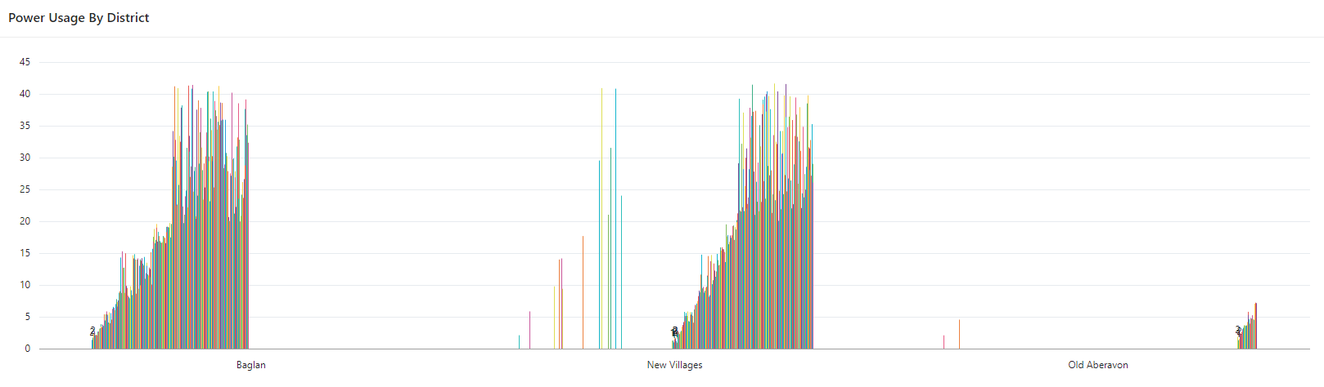

Data shown here shows that Baglan, New Villages have the highest spike in power usage, from the first section slowing down heavily, then during the rest of the month there’s a constant spike that gradually gets larger and larger. Old Aberavon appears to have a low amount of power users, as they are closet to the beach outside activities may be a part of this change, as data for house hold activities aren’t present it’s safe to assume that it is the cause.
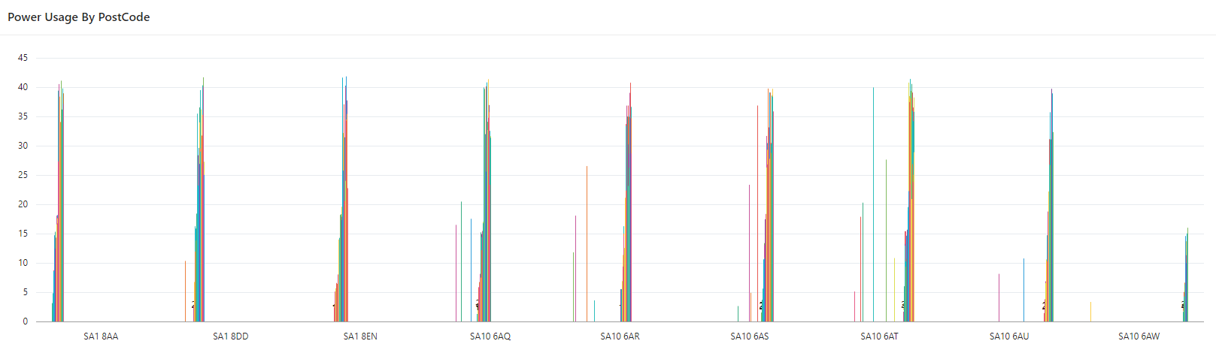

The power by postcode is similar all around, this was taken across a month period and shows changes from each postcode area with some having minor declines with a huge spike, while some are a constant spike. The final postcode appears to lack the same power usage as the rest, this could be down to a more active neighbouring that involves more outdoor actives or a lack of electrical devices that spike the usage of electrical power.

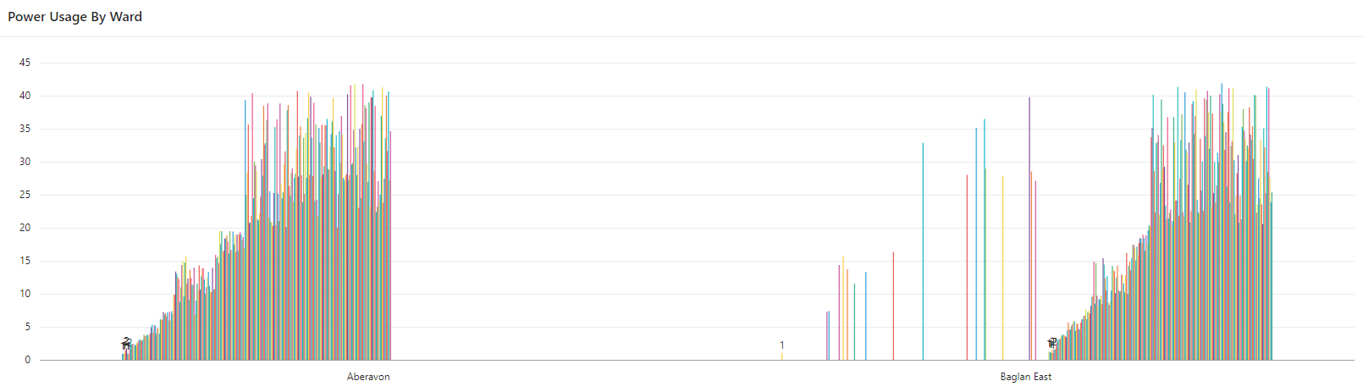

Aberavon and Baglan East show similarities, Baglan having more minor spikes in their usage compared to Aberavon being a constant incline while Baglan East showing numerous jumps in power usage.

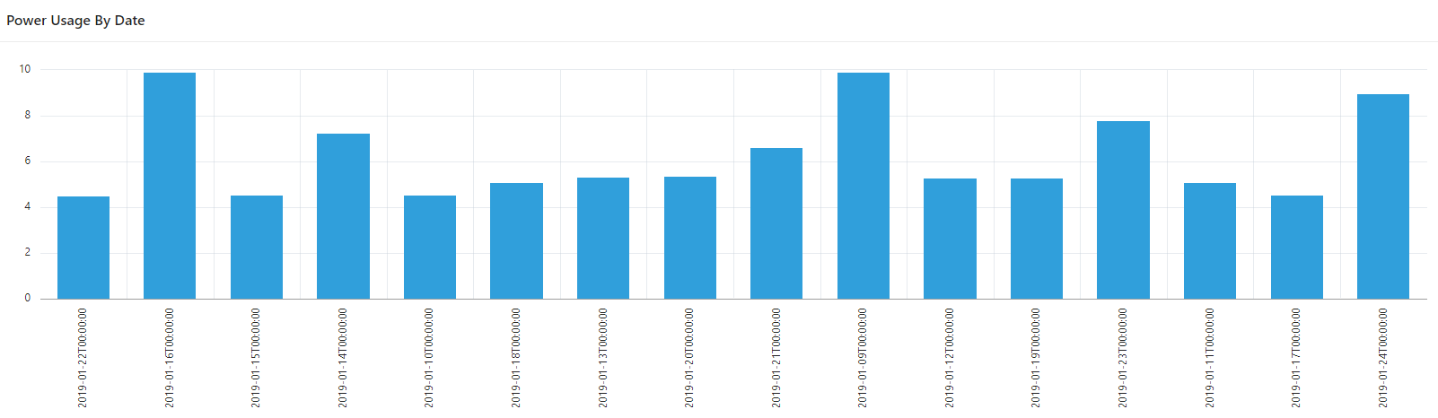

Different days of the week appear to show Specific inclination. as such that the 16th shows a quick spike, as well as the 9th and the 24th and 23rd all showing spikes in usage. These dates are weekdays which show the changes is power usage. This could largely be down to weather and temperature such as the increase in gas usage effects the usage of electricity

Conclusion

References
[1] Terence Craig, Mary E. Ludloff. Privacy and Big Data. O’Reilly Media. September 2011 [Cited 3 February 2020]. Available at: http://shop.oreilly.com/product/0636920020103.do

[2] O’Reilly Radar Team. Big Data Now 2012 Edition. O’Reilly Media. August 2012 [Cited 3 February 2020. Available at: https://www.oreilly.com/data/free/big-data-now-2012.csp

[3] Christopher Adamson. Star Schema the Complete Reference. McGraw-Hill Osborne Media. 25 June 2010 [Cited 3 February 2020].

[4] Hamid R. Ekbia. Big Data, Bigger Dilemmas: A Critical Review. Indiana University Bloomington. August 2015 [Cited 3 February 2020]. Available from: https://www.researchgate.net/publication/270345647_Big_Data_Bigger_Dilemmas_A_Critical_Review

[5] Zahir Irani. Critical Analysis of Big Data Challenges and Analytical Methods. Journal of Business Research. August 2016 [Cited 4 February 2020]. Available from:
https://www.researchgate.net/publication/306051907_Critical_analysis_of_Big_Data_challenges_and_analytical_methods

Appendix



