Module: Research Methods II

Module Code: ECPS5002

Title: Design and conduct a research study to explore the effect of emotional intelligence on memory for emotion-induced stimuli.

Abstract
The present study explored the effect emotional intelligence on memory for emotion induced stimuli. For this purpose, a mixed multi factorial design was used, with the analysis of Anova. The emotion induced stimuli was serially presented through a computer programme called Super lab and the SSEIT data was collected through a databased called Qualtrics. Although differences were noticed, participants recalled a higher number of the positive words that were shown than the other words. However, most participants are showing to have a low level of emotional intelligence. Further research is required to determine the effects of emotional intelligence on memory for emotion induced stimuli.

Introduction
Emotion and cognition are two concepts that are intertwined. However, little is known about the relationship between working memory capacity (WMC) and emotional intelligence (EI), as well as their impact on emotional vocabulary retrieval and production (Mavrou, 2021). Individuals with a higher trait of emotional intelligence may recollect more positive emotional words than those with a lower trait of emotional intelligence from memory tasks (Mavrou, 2021).
Influencing each other in a variety of ways, emotion and cognition are similarly related to teach other (Pessoa, 2008). As Swain (2013:195) pointed out, “Emotions . . . have a significant impact on what has happened in the past, what is happening now, and what will happen in the future. In fact, emotions are an integral part of cognition’’. Although, there is very little evidence about the cooperation between the two greatly studied models, a concept that connects emotion and cognition are emotional intelligence (Salovey and Pizarro, 2003) and the working memory (WM) which is traditionally seen as a cognitive mechanism supreme.
Emotional intelligence is regarded as a fundamental individual difference that is linked to positive behavioural outcomes in a variety of areas, including relationships, academic achievement, and occupational success (Petrides et al., 2016).
According to Sevdalis et al (2007) individuals often think about the emotions that the outcomes of their decisions are likely to trigger when they make decisions. The participants look for their emotions before a decision is set, they recall them from memory when they are looking back at decisions they have made before (good or bad) and experience them when they receive the outcomes of the decisions that they made. Evidence from behavioural research suggests that there are important factors of individuals behaviours which are their emotions that they expect to experience in the future or from the past because of their decisions (Mellers, Schwarts & Ritov, 1999).
Individuals with a high level of intelligence will demonstrate biased memory towards positive stimuli. Individuals with a low level of emotional intelligence will demonstrate biased memory towards negative stimuli.

Method
Participants
There were 30 participants that took part in this study, 12 of the participants were male and 17 of the participants were female. One of the participants chose the nonbinary/third gender option. The participants were aged between 19 and 51 (M = 29.50, SD = 9.183). The participants were recruited with the EMS (Experimental Management System).
Design
The design for this test is a mixed multi factorial design. The first independent variable was emotional intelligence which is a between subjects' factor with two levels: low and high EI. The second independent variable was emotion induced stimuli which is a within subjects' factor with three levels: positive, negative, and neutral words. Participants will be categorised as low or high in accordance with the mean score that will be calculated once all data is collected. Those scoring below the mean will be categorised as low, with those scoring above the mean categorised as high. The dependent variable is the number of words correctly recalled. The analysis used for this study was a mixed Anova.
Materials
All data was collected through the labs in UWTSD Swansea campus where participants were set up with a laptop provided with the Qualtrics survey system and the Super lab database. Participants were able to use the Qualtrics to complete the El task and with ease move onto the Super lab emotion-induced stimuli task.
Before the participants could take part in the study, the participants were presented with a consent form and information sheet that needed to be completed and signed before taking part in the study. The information sheet would have given the participant all the information that they needed to know about the study before taking part and what the participant needed to do. Information would also be provided about how long the study would take and the study location. The consent form would have included the participant’s consent to take part in the study and notified that the study is not compulsory and that they are free to withdraw at any time they wish. The participants were reminded that they had the right to withdraw from the study at any given time.
Part of the data in this study was collected through Qualtrics using The Schutte Self Report Emotional Intelligence Test (SSEIT) (Emmerling, 2011). This test was used to measure levels of emotional intelligence. The scale contained 33 questions and participants were required to give a response to each item according to how they felt about the statement/question given to them. Responses were given on a 5-point Likert scale with scores corresponding to; 1= strongly disagree 2 = disagree 3 = neither disagree or agree 4 = agree and 5 = strongly agree. Therefore, having a possible score ranging between one and five. Scores on the lower side of the Schutte test show a higher level of emotional intelligence and scores om the higher side of the test show a lower level of emotional intelligence. The scale used in the SSEIT was uploaded onto Qualtrics for administration purposes.
The other part of data collected for this study was collected through a specialist programme called Super lab. The task the participants completed through Super lab was used to assess memory recall of emotion-induced stimuli. There were three sets of words used to assess the participants memory recall which were positive, negative, and neutral words. Each trial the participant does consists of 20 words would be displayed individually for 200 miller seconds each. Each word that is shown would be separated by a blank screen that is displayed for 400 miller seconds each. The participants were then instructed to think of an example where they had to ‘imagine you are on your favourite beach’ which was carried out for one minute then the screen will automatically move on once the time is up. Once the one minute of thinking is up, the participant is then asked to recall as many of the words they could remember and enter them into the text box provided for them. These steps will be repeated three times for the different word groups.
Once all these tasks have been completed the participants will then be given a debrief sheet. they will receive a debrief from to ensure they are fully aware of what will happen with the data and that they can withdraw at any time. It will also be mentioned that any personal information that has been given like names etc will be changed and have complete anonymity and will be kept confidential in liaison with the Data Protection Act (1998). Lastly, the participant will be thanked for their time and patience.

Procedure
The participants were recruited through the university Experiment Management System (EMS). The link onto Qualtrics was sent through to the participants where the consent (appendix A) and information sheet (appendix B) were complete, and the participant was happy and comfortable to continue with the study. The participants would then have to fill out a demographic questionnaire consisting of gender and age. The participants were then shown the emotional intelligence (appendix C) questionnaire through Qualtrics. Once this had been complete the participants were directed to switch the computer screen to continue with the memory recall task (appendix D) using Super lab. Once the study had been completed the participants received a debrief form (appendix E) and were thanked for their participation.

Result
The data collected was the scores of the recalled words for each participant, for positive, negative, and neutral words resulting in high or low levels of emotional intelligence. The mean and standard deviations of these scores are displayed in Table 1.
Table 1
Means and standard deviations of the scores of the recalled words resulting in high or low levels of emotional intelligence.
Type of words | EI Groups | Mean | Std. Deviation
Positive | Low EI  High EI  Total | 12.74  11.36  12.23 | 2.83  3.75  3.20
Negative | Low EI  High EI  Total | 10.00  7.64  9.13 | 2.40  3.41  2.99
Neutral | Low EI  High EI  Total | 8.79  8.27  8.60 | 2.64  3.52  2.94

After looking at the means and standard deviations in Table 1, the results suggest that overall, participants recalled a higher number of the positive words that were shown than the other words. However, most participants are showing to have a low level of emotional intelligence.
A mixed Anova analysis was conducted to explore the effect of emotional intelligence (high/low) and emotion induced stimuli (positive, negative, and neutral words) The two-way interaction between emotional intelligence and memory recall was non-significant, F (2,56) = 0.93, p = .40, ${np}^{2}$ = .03. The main effect of emotional intelligence was also non-significant, F (1,28) = 3.0, p = 0.1, ${np}^{2}$ = 0.1. However, the main effect of the recall words (positive, negative, and neutral) was significant, F (2,56) = 16.6, p = <,001, ${np}^{2}$ = .37.

Discussion
The aim of the present study was to investigate differences in the recall performance between positive, negative, and neutral words and to examine the participants levels of emotional intelligence. The results showed that emotional intelligence had no effect on the recall performance and no significant differences were noticed with the emotional intelligence. Although there was a significant difference with the recall of the positive, negative, and neutral words.
The findings did not replicate those of previous studies (Mavrou, 2021). Research conflicts with previous findings regarding memory of emotional words, where those with a higher level of emotional perception and recognition had no differences to those with a low level of emotional intelligence and it is argued that task performance differences can be explained by other cognitive factors (Hildebrandt et al, 2015). Furthermore, in a meta-analysis that was carried out, Lindquist et al (2012) suggested that processing specific emotion categories was responsible by more general and overlapping brain networks and strongly questioned emotion category specificity from a neurobiological perspective.
Potential limitations of this study should be considered. To a degree, processing resources are responsible for age differences in performance on recall and recognition tasks. In the study written by Whiting and Smith (1997) a task was carried out where the results revealed that older adults compared to younger adults showed greater reduction in the task as the difficulty increased. As we focused our study on psychology student within the university, ages of all were able to complete the study and in fact did not take this into consideration.
Evidence from a variety of sources suggests that the human organism's ability to assimilate information is limited. Memory is made up of recalling a small number of chunks and retrieving the contents of these chunks (Mandler, 1967).
In conclusion, the findings of the present study only found a significant difference with the recall of the positive, negative, and neutral words that were displayed. The greatest number of words that were recalled were the positive words, but the data suggests that those were recalled more by the individuals who have a low level of emotional intelligence as shown in the Table above. There were also non-significant differences presented throughout. Future research should aim to consider the emotional connection behind some of the words that may be used in an experiment. For example, a study written by Toyota (2013) carried out a test where participants chose words that reminded them of a more positive time to relate back to and were observed in pleasant-pleasant and pleasant-unpleasant word pairs. The effects were detected in the unpleasant-unpleasant and pleasant-unpleasant word pairs for individuals who were asked to choose a word that elicited more unpleasant experiences. The extent of the self-choice effects was dictated by the emotional intelligence degree of the participants. To have a better understanding of emotional intelligence and memory recall performance, more studies with bigger and more typical samples are required.

Reference List
Data Protection Act, (2018). UK Public General Acts, Legislation Gov.
https://www.legislation.gov.uk/ukpga/2018/12/contents/enacted

Hildebrandt, A., Sommer, W., Schacht, A., & Wilhelm, O. (2015). Perceiving and remembering emotional facial expressions—A basic facet of emotional intelligence. Intelligence, 50, 52-67.

Lindquist, K. A., Wager, T. D., Kober, H., Bliss-Moreau, E., & Barrett, L. F. (2012). The brain basis of emotion: a meta-analytic review. The Behavioral and brain sciences, 35(3), 121.

Mandler, G. (1967). Organization and memory. In Psychology of learning and motivation (Vol. 1, pp. 327-372). Academic Press.

Mavrou, I. (2021). Emotional intelligence, working memory, and emotional vocabulary in L1 and L2: Interactions and dissociations. Lingua, 257, 103083.

Mellers, B., Schwartz, A., & Ritov, I. (1999). Emotion-based choice. Journal of Experimental Psychology: General, 128(3), 332.

Pessoa, L. (2008). On the relationship between emotion and cognition. Nature reviews neuroscience, 9(2), 148-158.

Petrides, K. V., Mikolajczak, M., Mavroveli, S., Sanchez-Ruiz, M. J., Furnham, A., & Pérez-González, J. C. (2016). Developments in trait emotional intelligence research. Emotion review, 8(4), 335-341.

Salovey, P., & Pizarro, D. A. (2003). The value of emotional intelligence (pp. 263-278). Na.

Sevdalis, N., Petrides, K. V., & Harvey, N. (2007). Trait emotional intelligence and decision-related emotions. Personality and Individual Differences, 42(7), 1347-1358.

Swain, M. (2013). The inseparability of cognition and emotion in second language learning. Language teaching, 46(2), 195-207.

Whiting IV, W. L., & Smith, A. D. (1997). Differential age-related processing limitations in recall and recognition tasks. Psychology and aging, 12(2), 216.

Appendix

Appendix A

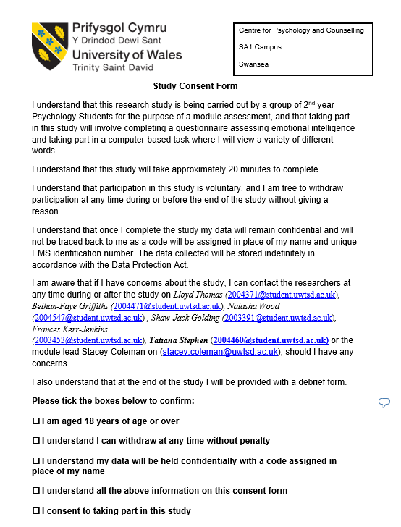

Appendix B
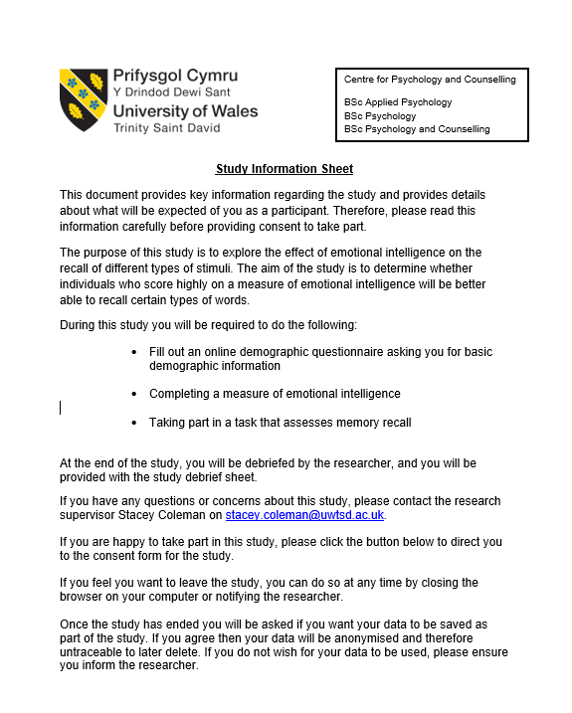

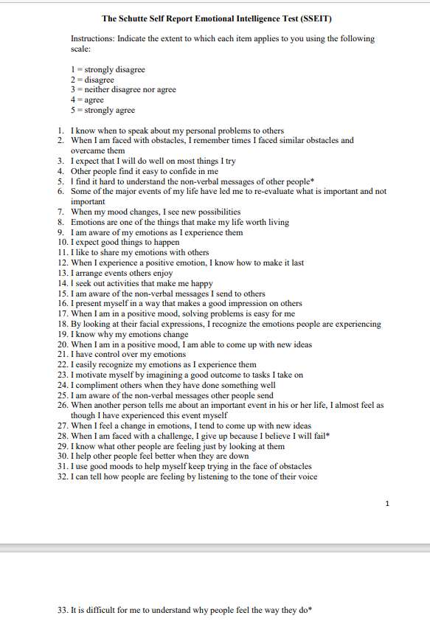
Appendix C

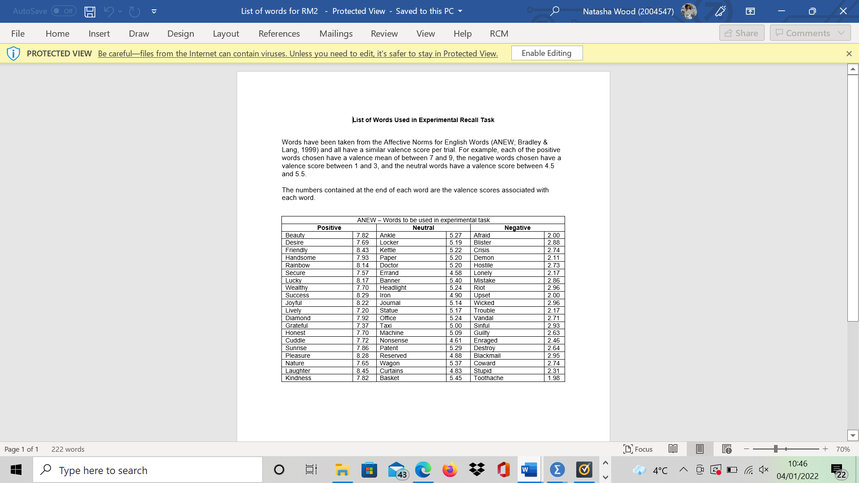
Appendix D

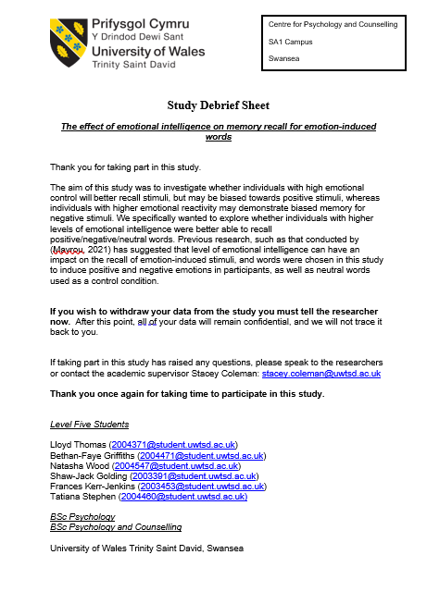
Appendix E

Appendix F



