Developing Professional Practice

CIPD Membership Number:

Date:

Table of Contents
Introduction 3
1.1 What is a HR Professional? 3
1.2 The CIPD Profession Map 5
2.0 Professional Development Plan 7
2.1 Learning Styles 8
2.2 Personal Development Plan 8
2.2.1. Coaching and Mentoring 9
2.2.2 Self-Study 9
2.2.3 Project Work 9
2.3 Reflective Summary 9
3.0 Understanding Group Dynamics 10
3.1 Group formation 10
3.2 Conflict Resolution 11
4.0 Project Management 12
4.1 Problem Solving 13
References 14

Introduction

This report will demonstrate my knowledge and understanding of what is means to be a HR Professional and apply CIPD techniques to construct and implement a Personal Development Plan (PDP) for review in May 2018.
(CIPD(d), 2015)

1.1 What is a HR Professional?

Defining what it is to be a professional is difficult and is argued by many theorists. A commonly held belief is that a professional is someone who makes proficient use of expert or specialist knowledge, exercises autonomous though and judgement, and makes a voluntary commitment to a set of principles (Lester, 2015). There are four key areas which are identified as being the core areas of HR professionalism:
- Managing Self
- Managing in groups/teams
- Managing upwards
- Managing across the organisation

It is a widely held belief that HR practitioners should strive for excellence. This is achieved by the practitioner being an innovative decision maker, project manager, influencer and negotiator, leader, be professional and ethical (Nankervis, 2014) (Mcdonnell & Sikander, 2017).
Professionalism, therefore is a commitment to excellence, combining professional knowledge and a sense of responsibility to arrive at an appropriate judgement. The profession is obliged to ensure that its members are worthy of the trust society places on them, by setting clear standards of conduct and competence (Khurana, et al., 2004) (CIPD(d), 2015)
The majority of HR practitioners in the UK are members of the CIPD which sets out the standard of conduct of the HR profession (Johns & Perkins, 2016). The CIPD Code of Professional Conduct, table 1, was developed to highlight the ethical and professional responsibilities of its members. Those professionals who embrace these standards use it as framework and the standards become a part of their normal working pattern (Alvesson & Willmott, 2000).

Table 1: CIPD Code of Professional Conduct (CIPD(a), 2016)

This code of professional conduct is also used to preserve the integrity of the HR profession.

An important aspect of being a HR professional is continuing professional development (CPD) as mentioned in the CIPD code of professional conduct. CPD is a process by which individuals take control of their own learning and development, by engaging in an on-going process of reflection and action. CPD can be seen as a virtuous circle of improvement and can gain momentum through the individuals self interest in improving professional performance and capability (Megginson & Whitaker, 2007).

The benefits of CPD for the professional is updating their knowledge, increasing competence and can further develop transferable skills (Sadler-Smith, et al., 2000); (Bradshaw, 1985).

A key tool which is used by professionals to measure their professional and behavioural competence is the CIPD profession map.

1.2 The CIPD Profession Map

The CIPD Profession Map as shown in Figure 1 is the foundation of great HR capability regardless of role, location or stage of career (CIPD(c), 2017).

This map defines the knowledge and behaviour the CIPD expects HR professionals to demonstrate in order to meet the criteria of its membership. As seen in figure 1 the map shows effective people management across ten professional areas and eight fundamental behaviours. A breakdown of these areas and behaviours can be seen in the table 1.

Figure 1: CIPD Profession Map (CIPD(b), 2015)

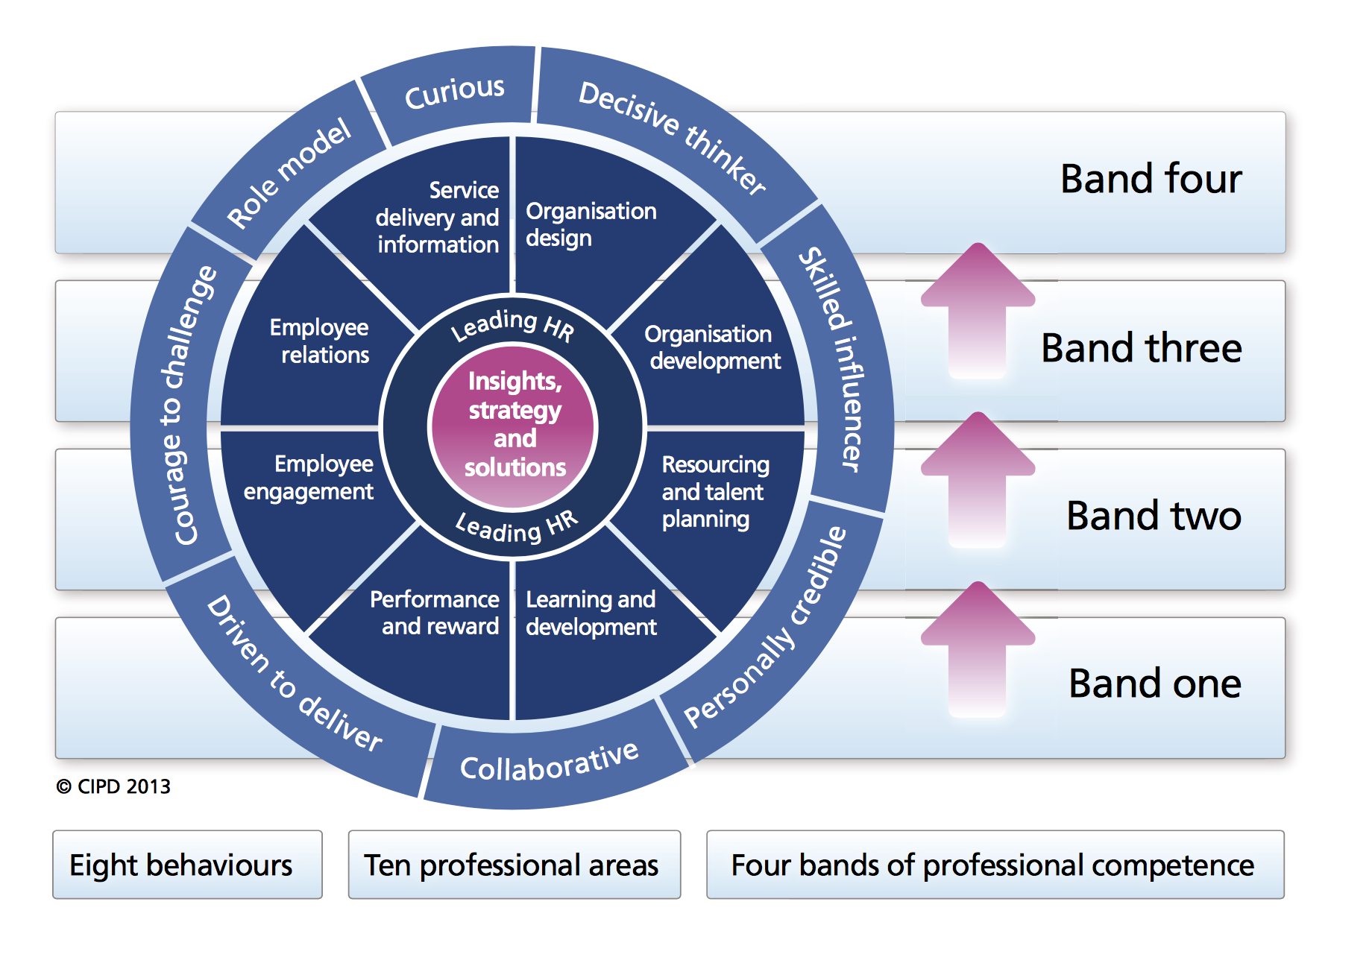

Table 2: Professional Areas (CIPD(b), 2015)

The knowledge and activities in the professional and behavioural areas are displayed in four bands. These bands clearly show the contribution the HR professional makes throughout their career and can be used to focus on developmental opportunities required to move bands. The professional areas highlight the areas in which members are confident in and identify the areas important to the organisation and their career as it stands. The behaviours category looks at which behaviours make the most difference to the organisation and to the individual. (CIPD(b), 2015)

Eighteen months ago, I joined the HR department at The Magstim Company, a medical device manufacturer, based in West Wales. Prior to joining the HR department, I had no experience within the profession.

By completing the CIPD Profession map I was able to discover that I currently work within Band 1 of the map which focuses on the delivering of the fundamentals of HR to the organisation. The results from this map, as shown in figure 2 and can be seen in further detail in Evidence XX, have shown me the areas which I need to develop in order to move up to band 2.

The areas identified requiring further learning and development can now be improved upon by the development of a Professional Development Plan.

Figure 2: CIPD Profession Map Assessment Results (CIPD(e), 2017)

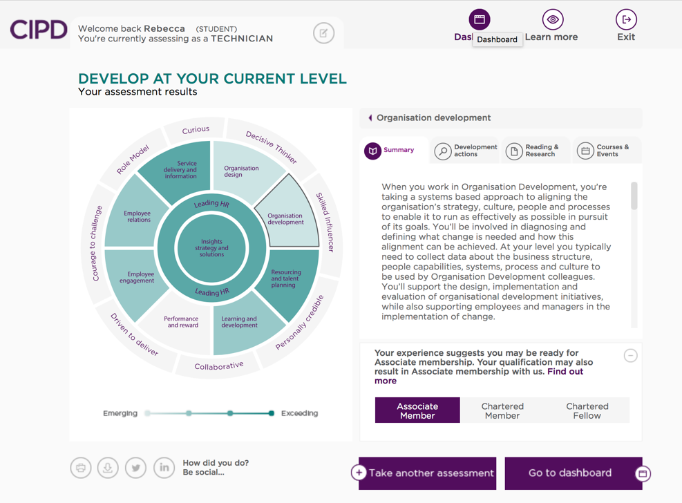

2.0 Professional Development Plan

A Professional Develop plan (PDP), is a developmental tool used by Human Resource Departments to identify employees’ formal (e.g. training) and informal (e.g., peer feedback discussions) learning which in turn is assumed to improve performance (Beausaert, et al., 2011).

After undertaking a self-assessment, using the CIPD Professional Map which is used to highlight competencies and highlight knowledge gaps, it was identified that the Learning and Development aspect of my job role required further development.
The results from this assessment, which can be seen in Evidence XX, indicated that my knowledge and skills are developing and were typical of someone with a limited exposure to learning and development at my level.

The development actions identified included:
- Researching different approaches to learning and development in a range of organisations.
- Talk to an L&D specialist to understand how the different stages of the learning and development cycle are implemented, and the processes and tools that underpin them (including training needs analysis, learning design, learning delivery and learning evaluation).
- Analyse an area of data relating to learning and development looking for specific trends (for example, access to learning, take- up of courses, delivery method, cost or evaluation) and share the results with your colleagues.
- Find out how your organisation conducts training needs analysis.
- Research traditional adult learning theories including learning styles and the importance of workplace and informal learning methods

In order develop myself further in the most practical way, it was imperative that I identified my preferred learning style to ensure I created an effective learning and development programme for myself.

2.1 Learning Styles

The learning styles questionnaire identifies four different learning styles or preferences – activists, reflectors, theorists and pragmatists (Honey & Mumford, 1986).
After completing the questionnaire, as seen in Evidence XX, I identified that I have three learning styles which are:
- Reflector
- Theorist
- Pragmatist

The advantage and disadvantages of having these three learning styles can be seen in table 3.

Table 3: Advantages and disadvantages of learning styles (Rosewell, 2005)

In order to create a suitable PDP for myself it is imperative that the learning methods I use in order to improve my knowledge gaps identified by the CIPD professional map are suitable for my learning style. A breakdown of the learning style studying preferences can be seen in table 4.

Table 4: Learning style studying preferences (Beevers & Rea, 2010)

2.2 Personal Development Plan

Evidence XX/ Table X

Following the completion of the learning styles questionnaire, which allowed me to understand the studying preferences of my learning style, and the CIPD Profession Map I have created a Personal Development Plan which details my knowledge gaps identified and the methods of learning I will use to reduce these gaps.

For the areas highlighted to me as my knowledge gaps I have chosen the following learning methods to aid my self-development:

2.2.1. Coaching and Mentoring

Coaching and mentoring will allow me to have one to one access with a specialist within learning and development and the learning can be tailored to me needs rather than a set programme. Which fits my Pragmatist learning style of emulating a role model (Beevers & Rea, 2010).

2.2.2 Self-Study

Self-studying such as e-learning and reading is an ideal learning style for a reflector as the studying can be undertaken in my own time without the need for deadlines and the learning can be self-managed through prepared modules (ibid).

2.2.3 Project Work

A Theorist like myself relishes an opportunity to question and probe an idea or subject area. A learning need for myself which was identified by the professional map, and which is current requirement for my organisation is conducting a skills gap analysis. By carrying out this project it will need to have a clear purpose and structure. It will also require me to understand the complexities of the skill requirements of the organisation and the gaps within it.

2.3 Reflective Summary

Reflective Practice is the foundation of professional development; it makes meaning from experience and transforms insights into practical strategies for personal growth and organisational impact (Owen & Fletcher, n.d.). It means:

- Learning to pay attention – listening to ourselves
- Coming face to face with our assumptions
- Noticing patterns
- Changing what we see
- Changing the way we see (ibid)

A key model used in reflection practice is David Kolb’s experiential learning theory. Kolb believed that learning is a cognitive process involving constant adaptation to, and engagement with, one’s environment (Bergsteiner, et al., 2010).

In order to carry out CPD a number of factors need to be considered. Such as, practical factors; like cost, time and availability. The need for CPD arises because security for individuals no longer lies in the job or organisation we work for but in the skills, knowledge and experience that we have within ourselves (Megginson & Whitaker, 2007).

As HR professionals, it is imperative that we consider our development needs, performance requirements and personal aspirations. These factors can easily influence our personal development plans. We also need to remember the impact our learning styles have on our ability to learn and develop.

3.0 Understanding Group Dynamics

The term “group dynamics” refers to the interactions between people who are talking together in a group setting. Any time there are three or more individuals interacting or talking together, there are group dynamics (Nazzaro & Strazzabosco,, 2009).

It is important to remember that the dynamics of group environments are affected by a number of factors. These include:
- the nature of the individuals in the group
- leadership
- the group structures
- the group members’ individual power and status issues
- communication structures or processes (Johns & Perkins, 2016)

3.1 Group formation

It is imperative that organisations understand the fundamentals of group formations. A widely used model of understanding the stages of group formation is that of Bruce Tuckman. He hypothesized a four- stage model in which each stage needed to be successfully navigated in order to reach effective group functioning: forming, storming, norming and performing (Tuckman, 1984).

Figure 3: Bruce Tuckman's 'Forming Storming' Team Development Stages Model (Tuckman, 1965)


Table 5: Features of each phase (Tuckman, 1965)

The benefits of understanding this model within Magstim is that businesses are recognising the types of situations for which cohesive teams can provide a key competitive advantage (Miller, 2003). If organisations fail to understand these group formations this opens teams to conflict.

3.2 Conflict Resolution

It is essential for HR professionals to understand and identify conflict within the workplace and effectively resolve any underlying issues. If conflict resolution is conducted well it can aid productivity and can help projects towards their completion.

There are a variety of approaches HR professionals can take to resolve issues. These include:

- Setting the scene
- Gathering of information- Identifying the issue
- Agreeing to the problem – Reliant on the putting aside of individual goals and agree to a beneficial solution
- Brainstorming possible solutions- Involve other parties to help resolve the problem quickly
- Negotiating a solution- all parties have a better understanding of each other’s position and have resolved the problem (Effective Education University of Florida, 2017)

Another technique of conflict resolution is Active listening. Active listening is the act of hearing a speaker, avoiding premature judgment, reflecting understanding, clarifying information and asking questions (Hoppe, 2006).

This skill can be extremely effective when mastered. Listening allows the conflict to take its natural course by giving individuals the opportunity to disagree, express strong opinions, and show passion for ideas. Listening is helpful in achieving a winning resolution (Van Slyke, 1999).

4.0 Project Management

I was recently involved the project which implemented the redundancies of 17 employees. This had a short time frame as the Senior Management Team required its completion by the organisations financial year end of March 2017.
This required time management skills and effective communication due to the sensitive nature of the project. With clear objectives set by the Managing Director and shareholders a team which consisted of the entire Senior Management Team was formed.

The initial meetings although difficult at times due to the subject matter was focused on getting the project completed. Following the initial meeting I along with other members of the HR department set out the project objectives, task allocation and the deadlines for completion. This was done with the use of a Gantt chart I devised which can be seen in Evidence XX.
The use of the Senior Management Sharepoint system also allowed the use of sharing documentation and all members could clearly see the deadline dates. These methods of communication enabled all team members understood their roles and completion dates.
As part of my role within the team I was responsible for the organising of the At-risk letters, Evidence XX, and the voluntary redundancies. A checklist I devised can be seen in Evidence XX.
In order to support those employees who were being made redundant I created a factsheet, Evidence XX, with useful contacts and support networks.
What held the project back was the resistance on the part of the Senior Management who struggled with the emotional aspect of the redundancies. If I was to be a part of a project of this nature again I would include time for the managers to be able to talk about the feelings they have.

Project management refers to the creation of a group of individual specialists from different parts of the organisation that are brought together for a limited time to contribute towards a specific project (Winch, 1994). It is common for HR professionals to be involved in more than one project at a time.
A project can be split into five phases that must be completed:
- Initiation
- Planning and design
- Execution
- Monitoring and controlling
- Completion

Understanding the purpose and the expected outcomes of each phase of the project allows the team member to achieve their responsibility.

4.1 Problem Solving

Problem solving within a project can be time consuming and could be complex depending on the nature of the project.
A fishbone diagram, as seen in figure 4, is a tool used to identify the cause and the root cause of a problem.

Figure 4: Fishbone diagram (Ishikawa, 1968)


The fishbone diagram is created in six stages:

- Draw Problem Statement – defining the problem
- Draw Major Cause Categories- such as people, equipment, policies and procedures
- Brainstorm Causes of the problem
- Categorise Causes-
- Determine Deeper Causes- identify any fundamental issues impacting the project
- Identify Root Causes- look at causes that repeatedly appear

During this recent project, I regularly had to influence, persuade and negotiate with members of the project team.
I did this my creating a supportive environment for the Senior managers and became influential in the knowledge I gathered on the subject matter.
I had to regularly listen to their concerns and had to emphasise the importance of the tasks and the impact of missing the set deadline would have on the project and organisation.
Evidence XX

References
Alvesson, M. & Willmott, H., 2000. Identity regulation as organisational control: producing the appropriate individual. Journal of Management Studies, 39(5), pp. 619-44.

Beausaert, S., Segers, M. & Gijselaers, W., 2011. Using a Personal Development Plan for Different Purposes: Its Influence on Undertaking Learning Activities and Job Performance. Vocations and Learning, 4(4), pp. 231-252.

Beevers, K. & Rea, A., 2010. Learning and Development Practice. 1st ed. London: CIPD.

Bergsteiner, H., Averyand, G. & Neumann, R., 2010. Kolb’s experiential learning model: critique from a modelling perspective. Studies in Continuing Education, 32(1), pp. 29-46.

Bradshaw, D., 1985. Transferrable intellectual and personal skills. Oxford Review of Education, 11(2), pp. 201-216.

CIPD(a), 2016. CIPD Code of Professional Conduct. [Online]
Available at: https://www.cipd.co.uk/about/what-we-do/professional-standards/code
[Accessed 5 November 2017].

CIPD(b), 2015. The CIPD Profession Map: Our Professional Standards. [Online]
Available at: https://www.cipd.co.uk/Images/the-cipd-profession-map_2015_tcm18-9814.pdf
[Accessed 4 November 2017].

CIPD(c), 2017. The core of the profession map. [Online]
Available at: https://www.cipd.co.uk/learn/career/profession-map/core-areas
[Accessed 7 November 2017].

CIPD(d), 2015. From best to good practice HR: developing principles for the profession. [Online]
Available at: https://www.cipd.co.uk/knowledge/strategy/hr/good-practice-report
[Accessed 9 November 2017].

CIPD(e), 2017. CIPD Profession Map Results. [Online]
Available at: http://mycpdmap.cipd.co.uk/results
[Accessed 9 November 2017].

Effective Education University of Florida, 2017. Effective Conflict Resolution Techniques. [Online]
Available at: https://essentialsofbusiness.ufexec.ufl.edu/resources/human-resources/the-conflict-resolution-process/#.Wgg3ybacZBx
[Accessed 12 November 2017].

Honey, P. & Mumford, A., 1986. The manual of learning styles. 2nd ed. Maidenhead: Peter Honey.
Hoppe, M., 2006. Active Listening: Improve your ability to listen actively. Greensboro: Center for Creative Leadership.

Ishikawa, K., 1968. Fishbone Diagram Cause and Effect Analysis. [Online]
Available at: https://www.project-management-skills.com/fishbone-diagram.html
[Accessed 12 November 2017].

Johns, T. & Perkins, G., 2016. Developing Professional Practice. In: S. Taylor & C. Woodhams, eds. Studying Human Resource Management. London: CIPD, pp. 67-87.

Khurana, R., Nohria, N. & Penrice, D., 2004. Management as a profession. Working papers. Center for public leadership, -(-), pp. 4-14.

Lester, S., 2015. On professions and being professional. [Online]
Available at: http://devmts.org.uk/profnal.pdf
[Accessed 5 November 2017].

Mcdonnell, L. & Sikander, A., 2017. SKILLS AND COMPETENCIES FOR THE CONTEMPORARY HUMAN RESOURCE PRACTITIONER: A SYNTHESIS OF THE ACADEMIC, INDUSTRY AND EMPLOYERS’ PERSPECTIVES. The Journal of Developing Areas, 51(1), pp. 83-101.

Megginson, D. & Whitaker, V., 2007. Continuing Professional Development. 2nd ed. London: CIPD.

Miller, D., 2003. The stages of group development: A retrospective study of dynamic team processes.. Canadian Journal of Administrative Sciences, 20(2), pp. 121-143.

Nankervis, A., 2014. Career Drive. HRM Monthly, Volume 6, pp. 12-14.

Nazzaro, A. & Strazzabosco,, J., 2009. GROUP DYNAMICS AND TEAM BUILDING. HEMOPHILIA ORGANIZATION DEVELOPMENT, 4(2nd), pp. 1-18.

Owen, G. & Fletcher, A., n.d. Reflective practice guide. [Online]
Available at: https://www.cipd.co.uk/Images/reflective-practice-guide_tcm18-12524.pdf
[Accessed 11 November 2017].

Rosewell, J., 2005. Learning Styles. [Online]
Available at: http://www.open.edu/openlearn/ocw/pluginfile.php/629607/mod_resource/content/1/t175_4_3.pdf
[Accessed 10 November 2017].

Sadler-Smith, E., Allinson, C. & Hayes, J., 2000. Learning preferences and cognitive style:some implications for continuing professional development. Management Learning, 31(2), pp. 239-256.

Topornycky, J. & Golparian, S., 2016. Balancing Openness and Interpretation in Active Listening. Collected Essays on Learning and Teaching, 9(0), pp. 175-185.

Tuckman, B., 1965. Tuckman Forming Storming Norming Performing model. [Online]
Available at: https://www.businessballs.com/managing-teams/tuckman-forming-storming-norming-performing-model-234
[Accessed 12 Novemebr 2017].

Tuckman, B., 1984. Developmental Sequence in Small Groups. Current concerns, 34(14).

Van Slyke, E., 1999. Resolve conflict, boost creativity. HR Magazine, 44(12), pp. 132-137.

Winch, G., 1994. Managing Production: Engineering Change and Stability. Oxford: Clarendon Press.

