Internet of Things-Smart Cities Applications
Yohannes Zerzghi, Computer Networks; Module: Computer Smart and Connected Devices 2,
Lecturer: Dr. Mabrouka Abuhmida
Abstract—This report will investigate how IoT devices and sensor can track and monitor the use of overused services and resources within a city and be able to give the end user a report on how to lower their use and costs as well as keep waste of energy very minimal. A scenario design will be undertaken in the second task by giving a design of a solution that matches a smart way to keeping a city monitoring its services and resources.

Keywords: Internet of Things (IoT); Machine to Machine (M2M); Information and Communication Technology (ICT); Liquid Crystal Display (LCD); Light Emitting Diodes (LED); Light Dependent Resistors (LDR).

Introduction
Nowadays, technological development and demand is growing rapidly. This is because, the internet and the emergence of new technology is constantly changing at a rapid pace. One of the major technologies in the 21st century is the Internet of Things (IoT). IoT is a network in which smart objects such as sensors, actuators, are connected to the internet via network devices or routers so that these objects can exchange data with each other on a network. In other words, IoT communication is machine to machine (M2M). Hence, IoT devices can communicate with each other without human intervention. Basically, IoT is a combination of sensors, connectivity and process [1]. Within this report, the topics that will be looked at include how cities have a limited supply of services and resources that are constantly being overused by the population through wastage and no monitoring of usage, this in turn creates the problem of service and resource over usage and waste as well as creating cost problems due to outsourcing these things. The second part of this report will provide a simulation on Cisco Packet Tracer, with the scenario of a smart city and the ability to track the usage of services and resources through monitoring. Overall, the main aspects that will be investigated are wireless sensors and actuators that are able to monitor and adapt a situations environment to the programmed need of the sensor that has been influenced by a human.

Smart city definition
At present, cities population is growing at a fast pace than ever before. According to United Nations (UN), the population of people living in cities is expected to increase to 68% by 2050 [2]. As a result, the need for resources such as water, energy, safety and clean air are increasing. Moreover, big cities are struggling with noise pollution, traffics, climate change and many others. However, digitalization which is one of the global trends is turning to smart technology to overcome urban problems. But, how does digitalization help to resolve the current and future crises of urbanization? Internet of Things (IoT) technologies can be successful in building smart cities [3].
In today’s era, IoT technologies play a big role in implementing and designing smart cities. The IoT is made up of smart devices that are interacting through network with other devices, objects, environments and infrastructures. The concept of designing of a smart city application is based on the IoT technology. Hence, IoT can be used to build smart cities by integrating different features such as energy, transportation, and buildings in more efficient means to enhance the standard of life for its inhabitants. In addition, the IoT technology can be used to maintain an ecological balance by providing sustainability of resources and applications [4].
There is no absolute definition of a smart city because of the technologies that can be integrated and utilized are various. According to Saraju et.al, [5] smart city is a city that uses information and communication technology (ICT) to enhance the quality life of its habitants by providing quality of services in functional and effective urban services, while maintaining sustainability of natural resources for the present and future generations in terms of economic, social and environmental aspects. According to the authors, the idea of smart city contains four main attributes, and these are: sustainability, quality of life, urbanization and smartness. The aim of sustainability is to live in compliance with the limits of natural resources using smart technological solutions while providing quality of life to its citizens in many aspects such as pollution, waste, energy, climate change, governance, health and many more [6]. The utmost aim of building a smart city is to improve the quality of life (QoL) on economic and emotional wellness of its inhabitants that come under Quality of life attribute. The third attribute in smart cities is urbanization. It is a process that deals on transforming rural areas to urban environment based on different aspects such as technology, infrastructure, governance and economic. The last characteristics of a smart city is smartness, which deals on the economic, social and environmental baseline of the city and its citizens. The diagram below shows the general features of a smart city application.
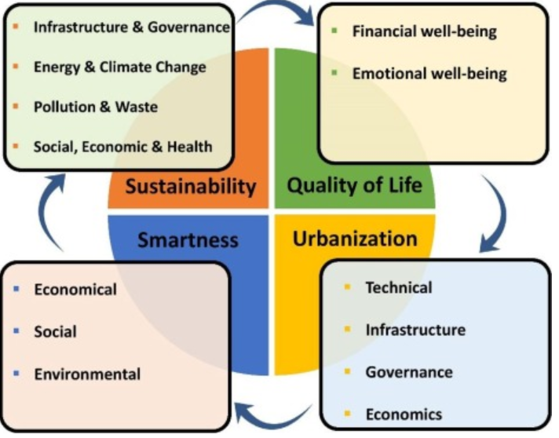
Figure 1: the general characteristics of smart city application using IoT technology [5].

Hence, the IoT technology can be used to implement a smart city that provides and improves many services in IoT-enabled smart cities around the world. Using IoT a smart city can provide various services in many aspects such as health, energy, buildings, transportation, technology, governance, education, public safety and many more. For example, a smart traffic management can be developed using sensor networks where centrally controlled traffic signals and sensors regulate the flow of traffic through the city in response to demand regarding traffic jam, alternate route, other means of transportation, automatic control of traffic lights, etc. to passengers [7].
Further, an important application of IoT is smart energy that allows users to monitor and adjust energy consumption, control remotely the operation for smart appliances like dishwasher and heater with a right level of energy consumption and track billing information in real time. Moreover, smart meters can be installed in offices and homes to collect and report data on electricity, gas and water use. This will reduce costs, carbon emissions and the need for regular check-ups. Thus, smart energy can be utilized to provide economic growth and quality of life to the citizens of a city using IoT technology [8].

Challenges facing IoT in smart cities
At present, IoT is gaining popularity at a fast pace. However, there are some challenges with the implementation of IoT [9]. The common challenges in IoT are listed below.
- Security-is the main issue in IoT. This is because, IoT uses the internet to send and receive data. However, the internet is vulnerable to malicious attacks from hackers. Thus, IoT in cities can be disastrous without a proper security implementation.
- Connectivity- in the future, many IoT devices will be connected to the internet. Hence, the increasing number of IoT devices will create a bottleneck for the current server-client mode connectivity.
- Compatibility and longevity
- Standards.
- Cost operation
- System failures
- Performance issue
- Sustainability and others [6].

Problem formulation
At present, energy is an essential element in the world. It can be used for industries, home appliances, transportation, agriculture and many others. The main source of energy is from natural sources such as coal, oil, natural gas and others. However, these sources of energy are limited. Hence, it is important to find a solution that can be used to manage the energy efficiently and intelligently. The aim of this project is to simulate and model a smart energy solution that can be used in industries using an IoT network. The project is implemented and simulated using a network simulator tool called packet tracer. The project must provide solution to the following problems.
- Why is smart energy needed?
- What are the benefits of smart energy?
- How is it possible to build a smart energy?
- What is smart energy?
- How is it possible to automate and control services?

Related Work

Smart Energy
In physics, energy is the ability to do work. Energy can be changed from one form to another, but it cannot be created, nor destroyed. In addition, energy sources are categorized as renewable and non-renewable. Non-renewable sources are limited e.g. fossil fuel and oil, whereas renewable sources are unlimited such as solar and wind energy [10]. In recent years, new energy terms are being used that are related to energy apart from the common energy forms, such as renewable, sustainable, green, clean and smart energy. These new energy concepts have been introduced to overcome the fear of depletion of non-renewable energy sources [11].
Energy demand in cities is growing due to the increasing economic growth and consumption. Today, 84% of the energy source is from natural resources [12]. Hence, it is essential to manage these limited resources effectively and intelligently. This can help to reduce energy wastage and costs. Moreover, it can minimize the emission of carbon-di-oxide, while maintaining sustainability of the energy resources [13]. The picture below is showing the general characteristics of smart energy.
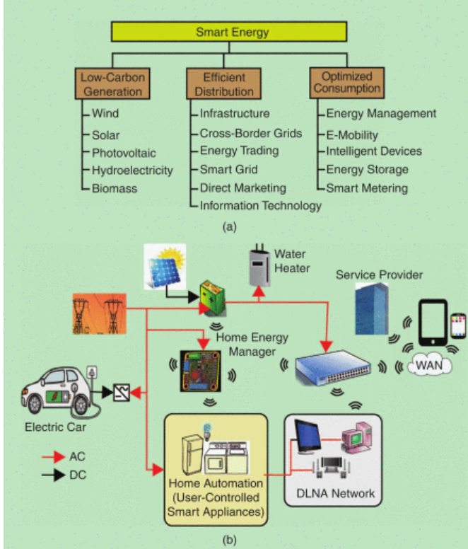
Figure 2: features of smart energy [5].
Over the last few years, the Internet of things (IoT) coupled with sensing devices and others has been used to develop smart energy application. In, [14] the authors researched of developing a smart energy management for home appliances based on cloud infrastructure and IoT. According to the authors, the model contains four parts, and these are: smart objects, hubs, cloud and third party. The smart objects include sensors and actuators such as light and temperature sensors that are connected in a smart grid to communication lines. The hubs can be utilized to interconnect between the smart devices and to forward data to the cloud server. The cloud can be used to store big data and the third-party part is used to develop software applications for the users. In another study, Mani et.al, [13] developed a smart energy management system that controls home appliances such as light and fan wirelessly. The system uses light and temperature sensor to collect data based on humidity, temperature and light intensity of the environment. In addition, it uses Arduino microcontroller, Wi-Fi shield and raspberry Pi3. The Arduino microcontroller is utilized to manage the consumption of the appliances based on the readings from the two sensors, and the raspberry Pi3 is connected to the Arduino through the Wi-Fi shield and is used for processing the amount of energy consumed by the fan and bulb. However, the system can only be applied to manage for controlling the fan and light of home appliances.
In, [15] researchers developed a smart streetlight management system. The utmost aim of the system is to reduce energy wastage and manpower. The system is designed using Light Dependent Resistors (LDR), Arduino nano microcontroller, relays, ESP-12 Wi-Fi module, and DHT11 sensor. The DHT11 sensor is used to measure temperature and humidity of specific area, while the LDR is used to manage the light intensity of the smart LED lamps. The Arduino is used to automatically control the relays, and to process data from the sensors to the database server through the ESP-12 Wi-Fi module. Thus, the system can be used to automatically switch on/off the streetlights with the relays, based on the instructions from the Arduino and the reading from the LDR sensor. The system is built with low cost. Moreover, it can used to reduce CO2 emissions to the air and energy consumption. However, the maintenance can be costly.
Further, the authors in [16] implemented a system that controls the streetlights based on the traffic flow in a specific street. The main function of the system is to reduce energy consumption using IoT, sensors and other electronic equipment’s. The system contains versatile technologies such as Liquid Crystal Display (LCD), LDR, Light Emitting Diodes (LED), power transistors, relays, infrared photoelectric control (IR), microcontroller AT89S52, ZigBee and timer. The system utilizes the LDR sensor to switch on/off the streetlights based on the intensity of light (day or night). In addition, it uses the IR sensor to automatically switch on/off the lights when it detects vehicle or pedestrian movement. Moreover, the system uses the ZigBee wireless communication to transfer the information from the sensors to central base station to create a visual interface for the users. Thus, the system can be used to reduce energy consumption and maintenance cost. However, the system can be used for a short-range coverage because, the Zigbee communication coverage is short.

Proposed system
This project is designed to provide a smart energy solution to be used in industries. It is designed on a network simulation software packet tracer. The model contains various devices such as solar panel, battery, wind energy, motion detector, 6LowPan gateway, routers, smartphone, Pcs, switches, MSU and servers. The node MSU is used to connect various smart devices while the 6LowPan gateway is used to connect the sensor nodes with the users in the internet. The 6LowPan device is used for low-power, low rate and low cost. Moreover, this device is an open standard which is capable working with TCP, UDP and others. In addition, it uses ipv6 address scheme which offers end to end connection with the sensors [17]. The model is designed to automatically control streetlights and lights that are generated from wind energy based on light intensity (day or night). It is also used to control fan and window based on reading from the temperature monitoring sensor. Moreover, it uses solar panel to generate electricity to be used in production line such as motors, coffee maker and others. In addition, it uses motion sensor and camera to monitor for intrusion detection. The diagram below shows, the blueprint of the network layout, which is created using the draw.io from the internet.

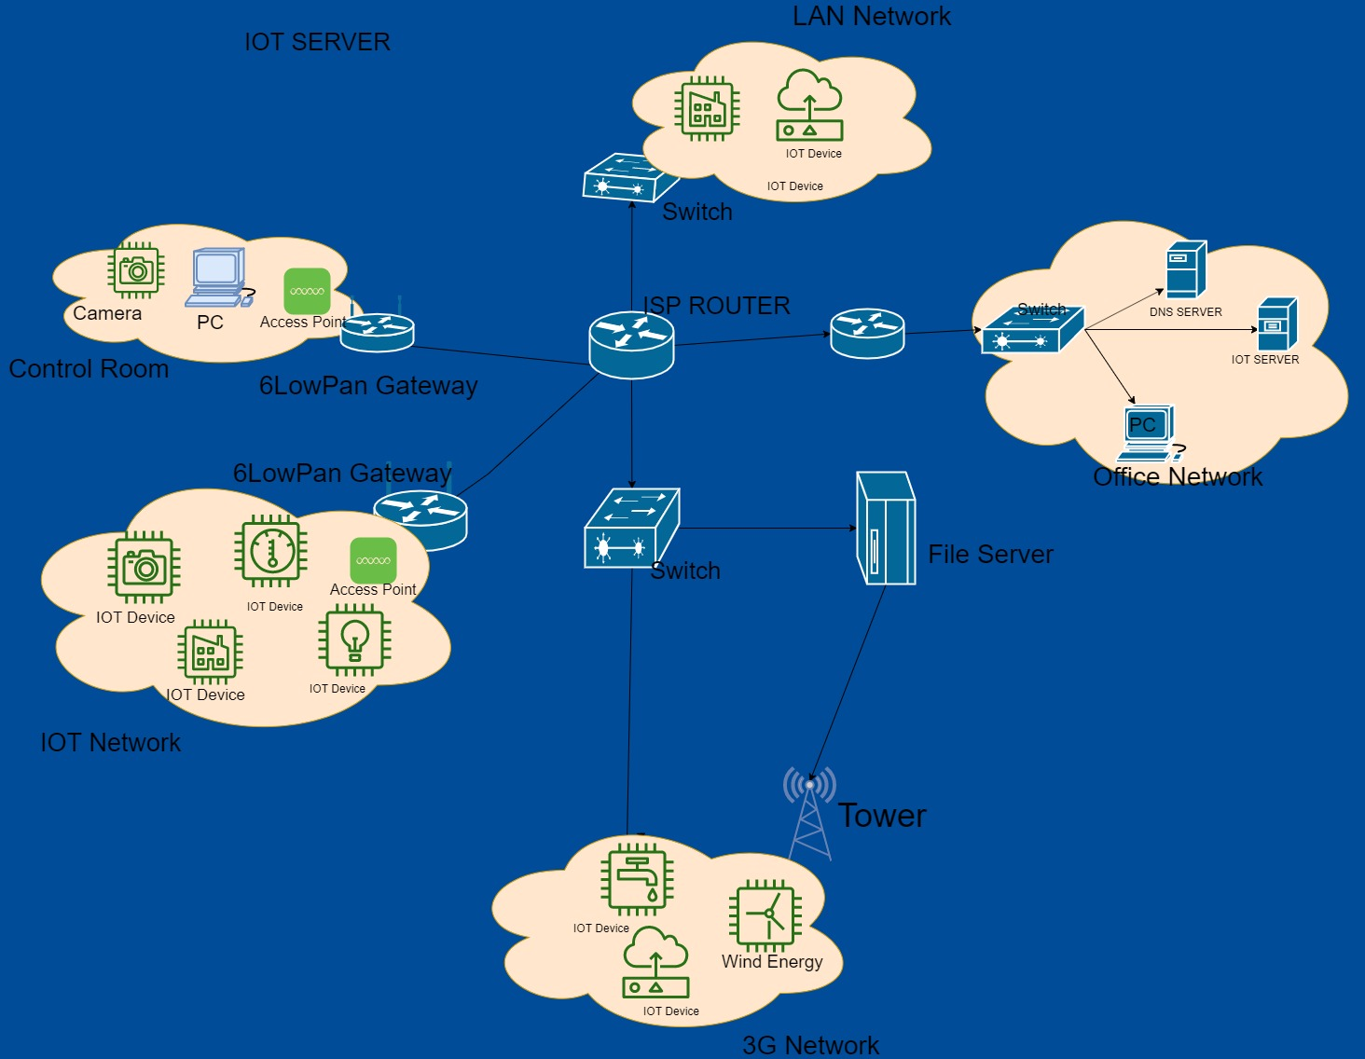
Figure 3: the network layout of the network [18]

Implementation
The complete model of a smart energy system is developed using IoT technology on packet tracer. The system uses OSPF routing protocol to connect each device on the network. It also uses DHCP to automatically assign IP address to devices. The screenshot below shows the proposed system.

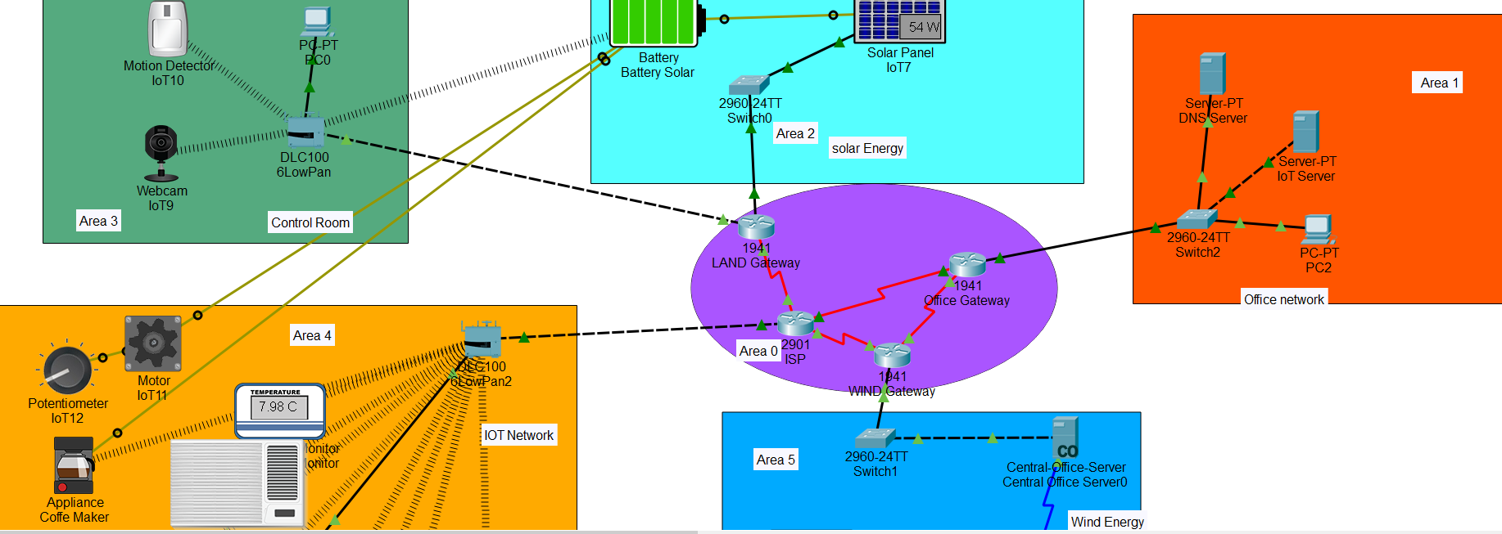
Figure 4: proposed system

The model uses various technologies and devices such as:
- IoT Server – which is used as a management area where all devices on the network are connected through a router to the server, here you are able to monitor the devices and their system settings. The IoT server is used as a registration server where all the sensors and actuators can be monitored remotely. The screenshot below shows the device registration list.

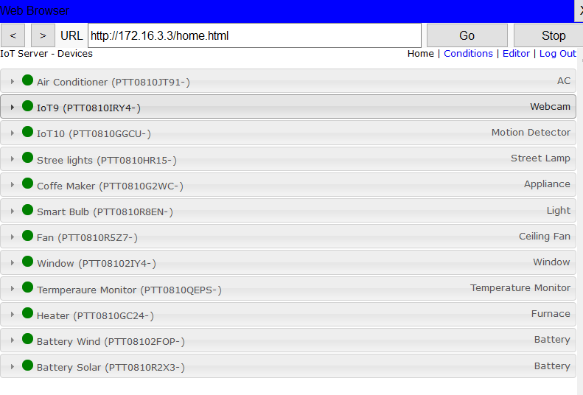
Figure 5: screenshot taken of the registered IoT devices on the server
- Routers: the routers are in place to allow the internet from the ISP to flow through the network effortlessly further allowing all the devices to be constantly connected to the internet which helps with the monitoring and tracking of their system issues. The routers are configured with OSPF routing protocol. The reason is to give fast convergence for the network traffic.
- Switch: The switch acts as a connector to end devices on the network, allowing for multiple devices to be connected to the network at one single time and further transporting the data to the server to be able to be monitored
- Backbone router: this router is the main transport hub for the internet to flow through the network, without this router in place the other routers on the network will not be able to receive internet information causing the network to be a LAN without internet connectivity
- Access Points – are connectivity areas where smart devices are able to connect to the internet network and be allowed to be monitored on the server
- The control room – this area of the network is a security center where a webcam is in place and provides images to the PC which further acts a CCTV monitor. The motion detector sensor and the camera are connected wirelessly to the 6LowPan gateway so that it can controlled remotely from the internet. The motion detector activates the camera when it senses any movement around it.

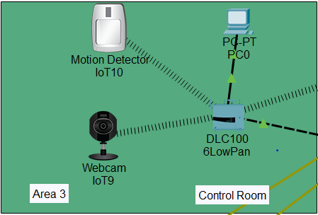
Figure 6: motion sensor and camera connected to the gateway.

- The office area – this part of the network acts as a business where there are servers holding information for the organizations with PC’s available to look into data and information.
- Solar energy – this area of the network has a solar panel in place which charges a battery which in turn allows for another device on the network to run via a renewable energy source. The solar energy is cabled via IoT custom cable to provide energy to motors and coffee maker devices. These two devices are then set to automatically switch on/off at a certain battery level.
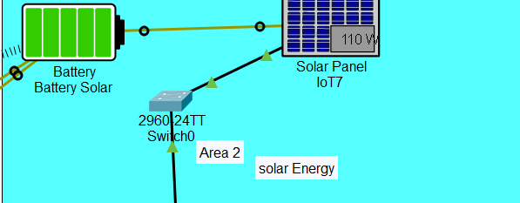
Figure 7: solar energy architecture.
- Wind energy – this area of the network consists of a wind turbine creating energy to charge a battery which again is being used to power another device within the network. The wind energy battery is connected to the streetlight and smart bulb using the custom IoT cable to provide power to these devices. In addition, it is connected to the registration server via the tower network. The smart bulb is programmed to automatically switch on/off at a certain battery level. The screenshot below shows the implementation of the wind energy.
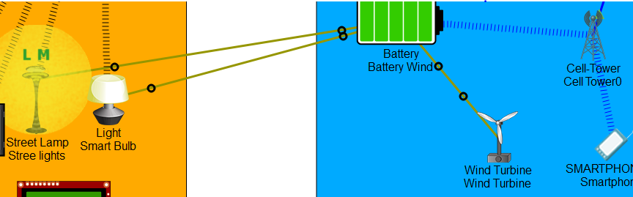
Figure 8: the wind battery providing power to streetlights and bulbs.
- The IoT network – this area of the network can be seen as a smart home or organization building, the devices in this area can be automatically controlled by a smart device or manually controlled and monitored by a human, that allows for things such as a window to be opened when the temperature is at a certain degree, or also be able to turn a fan or air conditioning on if the air is too hot. This IoT network contains various sensor and actuators in which all are connected to the 6LowPan gateway. The MCU is used as a microcontroller in which temperature sensor, window, heater, fan and air conditioner are connected to it. All these devices are set to turn on/off automatically based on certain conditions of the environment.
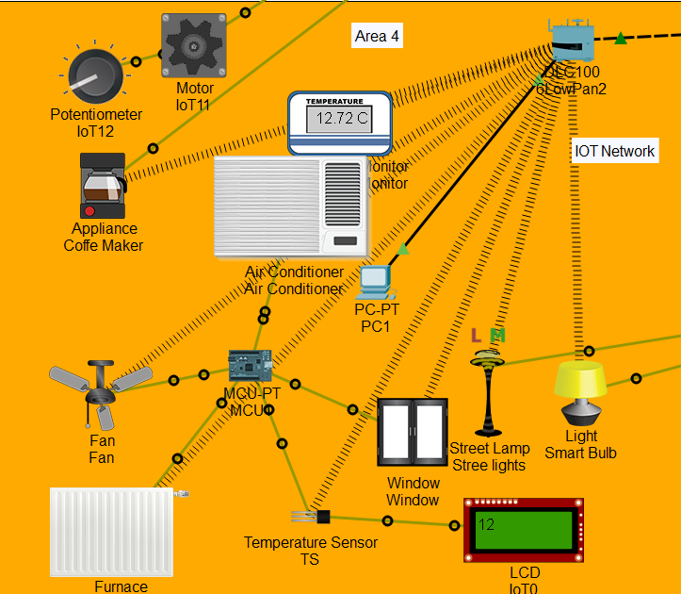
Figure 9: the IoT network of the industry
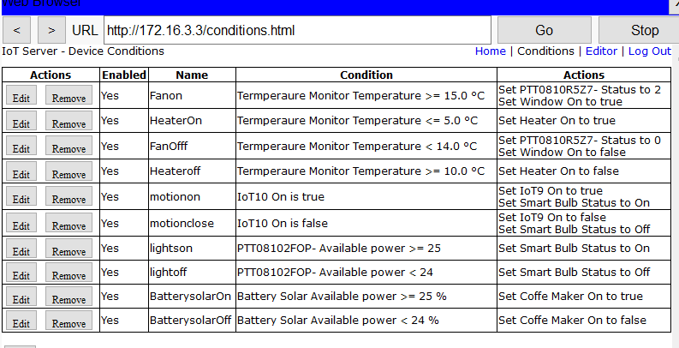
Figure 10: conditions on the IoT server.
- Area 0 – this are of the network is where all routers are interconnected to each other to be able to pass information and data on with each other, all routers have their own IP address relating to their own areas within the network which automatically apply IP addresses to all the devices within the network.

Results and discussions
In the simulation, the window and fan are set to automatically on/off at a certain temperature. Fig 10 below shows when both the window and the fan are on.
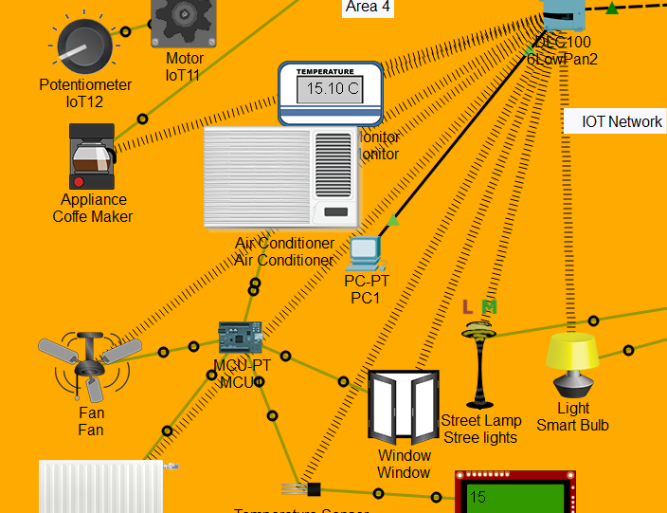

Figure 11: fan and window are on.
The motion sensor is used to detect the movement of an object whereas the camera is used to capture image of the object. To simulate this, the mouse is hovered while pressing the ALT key over the motion sensor. As a result, the camera is automatically activated with red signal. Fig 11 below shows the simulation of camera and motion sensor.

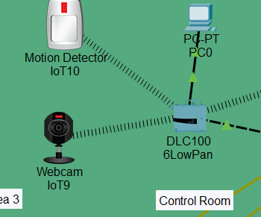
Figure 12: the camera is on when motion detected.

Conclusion
To conclude this report, wireless sensors and actuators allow cities to manage their services and resources by tracking and monitoring the levels of use and further benefiting the communities by providing low cost and safe energy sources. Sensors can automatically reduce waste if they are programmed in the correct manner which doesn’t require a human to fully control any device on the network. End devices can provide the end user reports on the usage levels as well as information on how to reduce their usage and wastage. Overall, sensor and the management are very expensive to maintain as this is affected by many factors such as weather or the use of inexpensive equipment which can be damaged overtime.

References

[1] | A. Zanella, N. Bui, A. Castellani, L. Vangelista and et.al, "Internet of Things for Smart Cities," IEEE Internet of Things Journal, vol. 1, no. 1, pp. 22-32, 2014.
[2] | United Nations, "UN DESA," UN DESA, 16 May 2018. [Online]. Available: https://www.un.org/development/desa/en/news/population/2018-revision-of-world-urbanization-prospects.html. [Accessed 23 November 2019].
[3] | M. Angelidou, A. Psaltoglou, N. Komninos and et.al, "Enhancing sustainable urban," Journal of Science and Technology Policy Management, vol. 9, no. 2, pp. 146-169, 2018.
[4] | E. Nuaimi, H. Neyadi, N. Mohamed and et.al, "Applications of big data to smart cities," Journal of internet Services and Applications, vol. 6, no. 1, p. 25, 2015.
[5] | S. Mohanty, U. Choppali, E. Kougianos and et.al.
[6] | B. Nathali, M. Khan and K. Han, "Towards sustainable smart cities: A review of trends, architectures, components, and open challenges in smart cities," Sustainable Cities and Society, vol. 38, pp. 697-713, 2018.
[7] | K. Su, J. Li and H. Fu, "Smart city and the applications," in IEEE, Ningbo, 2011.
[8] | M. Khan, B. Silva and K. Han, "Internet of Things Based Energy Aware Smart Home Control System," IEEE Access, vol. 4, pp. 7556-7566, 2016.
[9] | A. Banafa, "Three Major Challenges Facing IoT," IEEE, 14 March 2017. [Online]. Available: https://iot.ieee.org/newsletter/march-2017/three-major-challenges-facing-iot. [Accessed 12 December 2019].
[10] | cosmos, "What is energy?," cosmos, 12 September 2016. [Online]. Available: https://cosmosmagazine.com/physics/what-is-energy. [Accessed 26 November 2019].
[11] | B. Silva, M. Khan and K. Han, "Towards sustainable smart cities: A review of trends, architectures, components, and open challenges in smart cities," Sustainable Cities and Society, vol. 38, pp. 697-713, 2018.
[12] | K. Schulte, "Nonrenewable Resources: Definition & Examples," Study.com, 2003. [Online]. Available: https://study.com/academy/lesson/nonrenewable-resources-definition-examples.html. [Accessed 26 November 2019].
[13] | V. Mani, Abhilasha, Gunasekhar and et.al, "IoT based smart energy management system," International Journal of Applied Engineering Research, vol. 12, no. 16, pp. 5455-5462, 2017.
[14] | B. Stojokoska and K. Trivodaliev, "A review of Internet of Things for smart home: Challenges and solutions," Journal of Cleaner Production, vol. 140, no. 3, pp. 1454-1464, 2017.
[15] | P. Dheena, G. Raj, G. Dutt and et.al, "IOT based smart street light management system," in IEEE, Kanyakumari, 2017.
[16] | Vipasha and P. Abrol, "Design of Traffic Flow based Street Light Control System," Center for Development of Advacned Computing, vol. 72, no. 8, pp. 32-37, 2013.
[17] | RadioCrafts, "6LowPan," RadioCrafts, 2003. [Online]. Available: https://radiocrafts.com/technologies/6lowpan/. [Accessed 10 December 2019].
[18] | draw.io, "draw.io," draw.io, [Online]. Available: https://www.draw.io/. [Accessed 3 December 2019].

