

Assignment Title: Component 1- Information Booklet of Long- term Condition Management
Programme: MSc Public Health and Social Care in Practice
Module: Community Care and Management of Longer-term Conditions
Module code: LCHS7003
Student Name: Priyanka Maheshwar Bhattrai
Student ID: 2605617

Table of Contents
1. Introduction 3
1.1 Background 3
2. Definition of HIV 3
3. Burden and Prevalence of HIV 4
3.1 Overall burden 4
3.2 UK-wide context 4
3.3 Regional and demographic differences 4
4. Risk Factors and Aetiology 5
4.1 Transmission 5
4.2 Aetiology 5
5. Physical, Psychological and Social Impacts 5
5.1 Physical implications 5
5.2 Psychological implications 6
5.3 Social implications 6
5.4 Implications for families and informal carers 6
6. Evidence-Based Treatment in the NHS 7
7. UK and International Care Models 9
7.1 UK model: BHIVA Standards of Care 9
7.2 International model: WHO differentiated HIV service delivery 10
7.3 Critical comparison of care models 10
8. National and Local Health and Social Care Policy 11
8.1 National health and social care agendas 11
8.2 Local implementation: Cardiff and Vale 12
9. Person-Centred Care, Self-Management and End-of-Life Care 13
9.1 Person-centred care and supported self-management 13
9.2 End-of-life and palliative care, where appropriate 13
10. Recommendations for Improving HIV Care 13
References 14

LIVING WELL WITH HIV
Long-term management, person-centred care and self-management in the United Kingdom

Introduction

1.1 Background
HIV has become a long-term manageable disease to the majority of those who are able to receive proper treatment. This booklet will look at its clinical and social outcomes, and what the UK services can do to help people lead healthy and meaningful lives. It is aimed at health and social care professionals, and is written in a manner that can be comprehended by people receiving care. The clinical judgment should be based on personal evaluation and the existing recommendations and informed consent (World Health Organization, 2026a; British HIV Association, 2018).
Good management of HIV goes beyond the minimization of viral load. It encompasses the early detection of the disease, access to medication, avoiding other diseases, psychological needs and anti-discrimination. The case is that of antiretroviral treatment with strong evidence but less even on the social support amongst various communities. Whole-person care also necessitates specialist clinics and general practice, mental health teams, and public health services and voluntary organisations (Department of Health and Social Care, 2025; Positive Voices 2022 Study Group, 2026).

2. Definition of HIV
Human immunodeficiency virus (HIV) attacks immune cells especially the CD4 T lymphocytes. The untreated infection gradually compromises the immune defence and may cause acquired immunodeficiency syndrome (AIDS) which is the terminal stage that is accompanied by severe opportunistic disease. HIV and AIDS are not synonymous: antiretroviral therapy (ART) can suppress the virus replication and restore immune functioning but does not eliminate the virus (World Health Organization, 2026a; National Institutes of Health, 2025a).
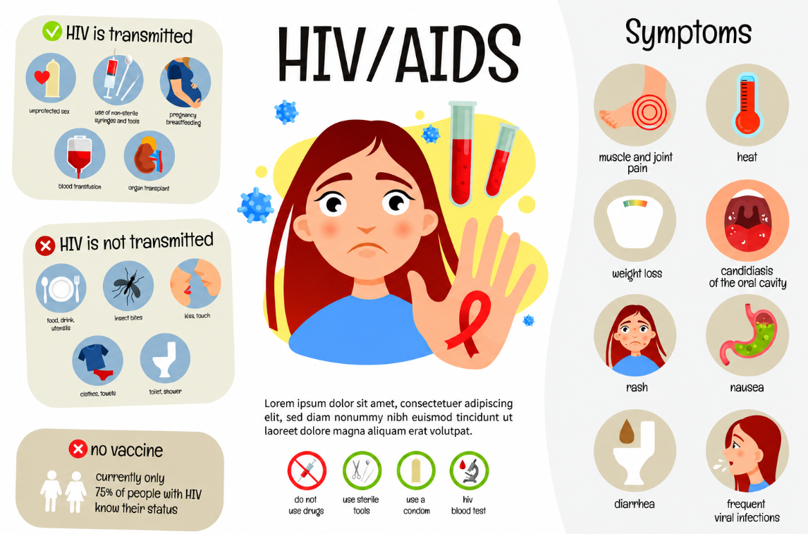
Figure 1: Overview of HIV
(Source: Hope, 2023)

Burden and Prevalence of HIV

3.1 Overall burden
In 2025, approximately 41.0 million people were living with HIV globally with 1.2 million new infections and 570, 000 deaths caused by AIDS. Around 32.1 million were receiving ART. These estimates are used to depict expansion of treatment as well as significant need still; they are not to be confused with UK prevalence figures (UNAIDS, 2026). In 2024, there were an estimated 114,000 adults living with HIV in England, with an estimated 6,000 of them undiagnosed. The estimation is approximated and uncertain and 2,773 new diagnoses achieved that year are not the same as infections acquired during that year (UK Health Security Agency, 2026).

3.2 UK-wide context
UK-wide context: 3,043 new HIV diagnoses were reported across the United Kingdom in 2024, compared with 3,169 in 2023. These represent newly recorded diagnoses, not the number of people living with HIV. The 114,000 prevalence estimate above applies to England, rather than to the whole UK (UK Health Security Agency, 2025c).
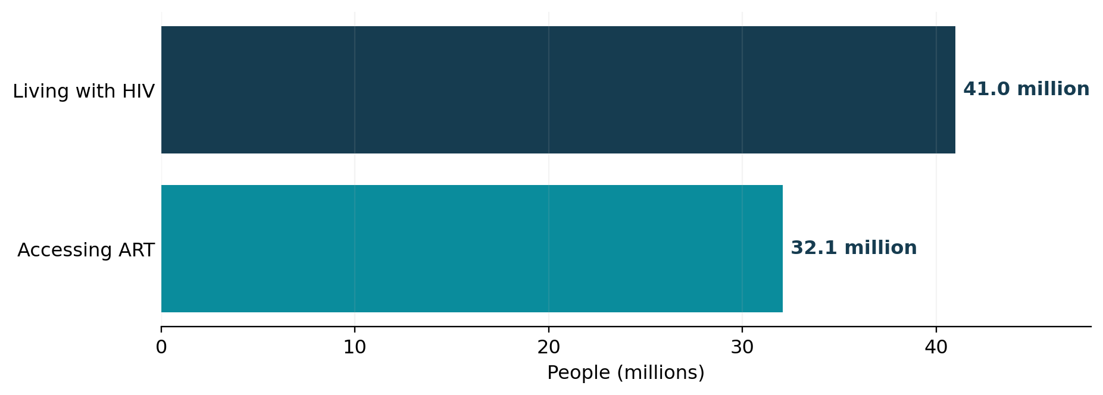
Figure 2. Global HIV burden and treatment access in 2025
Source: UNAIDS (2026).

3.3 Regional and demographic differences
Regional and demographic differences can be covered by the national success. Testing, diagnosis and long-term suppression vary among populations and late diagnosis adds to preventable sickness. Surveillance is, therefore, most informative when it involves a combination of general trends with age, ethnicity, gender, geography and service use and not as a single group of people who live with HIV (UK Health Security Agency, 2025a; UK Health Security Agency, 2025b).
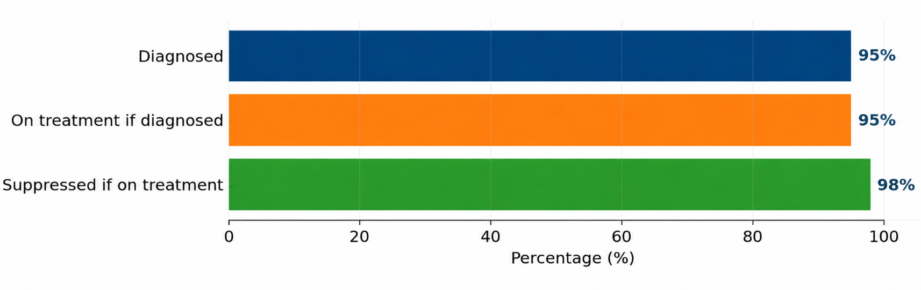
Figure 3: England HIV care cascade, predicted 2024
Source: UK Health Security Agency (2026).

Risk Factors and Aetiology

4.1 Transmission
It is transmitted by certain body fluids, such as blood, semen, vaginal secretions and breast milk and during pregnancy or birth. HIV cannot be spread through casual interaction, sharing of food and hugging. The risk of exposure is influenced by prevention access, condom use, needle sharing, untreated infection and inequalities in general. The framing of HIV as a result of individual behaviour will disregard structural factors, like poverty, insecurity and stigma in immigration which potentially discourages testing and continuity of care (World Health Organization, 2026a; World Health Organization, 2024).

4.2 Aetiology
Blame is not biological susceptibility and exposure. Mothers with untreated infections can pass the infection to infants, but timely antenatal screening and ART specialist can significantly decrease the risk of transmission. The injecting drug users have access to clean needles and access to addiction care. Prevention of sexual exposure may be conducted by condoms, pre-exposure prophylaxis (PrEP) and immediate post-exposure prophylaxis (PEP) in case it is clinically necessary. The strategies of preventing can be effective when the care is culturally sensitive and confidential. Particularly, employees are not to make assumptions with regards to gender identity, ethnicity or relationship status. Equity can be enhanced by having universal information and locally-focused outreach (World Health Organization, 2024; British HIV Association, 2025b).

5. Physical, Psychological and Social Impacts

5.1 Physical implications
The physical outcomes have been enhanced significantly as efficient ART has been made the norm. However, late diagnosis can manifest itself through weight loss, frequent infections, tuberculosis or some types of cancer. In individuals receiving treatment, cardiovascular disease, metabolic illness, kidney issues and ageing-related multimorbidity are growingly affecting wellbeing. Pitavastatin in REPRIEVE decreased major cardiovascular events in people with HIV chosen who are at risk, implying that avoiding non-AIDS disease is important as well as viral control; the results fail to support universal prescribing without assessing individual risk (Grinspoon et al., 2023; British HIV Association, 2025a).

5.2 Psychological implications
The diagnosis itself, the expected examination and evaluation, the required medications and the disclosure doubt can have an impact on mental health. A global meta-analysis approximated the prevalence of depression (31 percent) and anxiety (29 percent) among HIV-positive individuals, although there was a lot of heterogeneity across the studies included, which restricts generalizability to all UK populations (Hu et al., 2025). A survey conducted by Positive Voices in England reported anxiety or depression in 48.1% of their survey compared to 33% in a general-population comparison. Such measures and populations are not exactly comparable, and thus the numbers cannot be put as directly interchangeable prevalence estimates (UK Health Security Agency, 2024a).

5.3 Social implications
Clinical instability is usually outlived by social consequences. Individuals might encounter undesirable exposure, interfered employment, and a strained relationship or stigma in healthcare. The evidence in the UK has connected healthcare discrimination to worse quality-of-life outcomes, and cross-sectional data cannot prove that stigma solely resulted in poorer quality-of-life outcomes (Wiginton et al., 2023). In the case of trans and gender-diverse individuals, further discrimination may intersect with HIV issues, with the emphasis on serving people individually and without judgements based on their behaviour or identity (PV2022 Study Group, 2026).
Special attention should be paid to disclosure as it can have favorable or unfavorable effects. There are those who embrace family involvement in treatment consultations, and there are those who fear being rejected, coerced or invaded privacy. When a clinician is investigating these issues, he/she should discuss confidentiality, provide referral to relationships/legal assistance when necessary, and inform about information-sharing protection. On the same note, limitation of opportunity can be imposed on an HIV positive individual by his/her employer or coworker due to poor understanding of how HIV is transmitted despite the fact that the health of the individual is stable. Dealing with such pressures necessitates beyond education resources: personnel training, ready complaints channels and connections with special charities might be necessary. Services ought to evaluate whether or not their own practices inadvertently support stigma (UK Health Security Agency, 2024a; Wiginton et al., 2023).

5.4 Implications for families and informal carers
Effects are different on relatives and informal carers. Families can offer emotional support, transportation, childcare and practical support with appointments. They can also feel anxious, lonely or hard pressed. However, at the same time, confidentiality is paramount: the patients must choose who information is shared with unless a certain legal or protective requirement. It is important to ask the individual whom they would like to involve instead of directly approaching a partner or a relative (National Institute for Health and Care Excellence, 2021; British HIV Association, 2018).
Area | Examples to explore | Practical service response
Physical | Cardiovascular risk; comorbidities; treatment effects | Joint HIV-GP reviews and preventive screening
Psychological | Anxiety; depression; disclosure concerns | Routine screening and agreed counselling referral
Social/family | Stigma; housing; relationships; caring responsibilities | Confidentiality, welfare links and chosen carer involvement
Table 1. Whole-person implications and illustrative responses
Notably, HIV does not establish all the facets of the wellbeing of an individual. Quality of life can be safeguarded by social support, meaningful employment, stability in housing and stable access to treatment. Mental health, welfare and lifestyle needs were often unmet in the UK Positive Voices analysis although specialist HIV care was available to them. This shows a service gap: high virological results cannot be considered high-quality evidence of high lived experience (Positive Voices 2022 Study Group, 2026; UK Health Security Agency, 2024b).

6. Evidence-Based Treatment in the NHS
ART should be prescribed to all people with HIV, and should be started as soon as they are clinically evaluated. The most common combination of these nowadays includes integrase inhibitor together with nucleoside reverse-transcriptase inhibitors, other combinations are used depending on resistance, drug interactions, other illnesses, pregnancy considerations and patient preferences. START trial showed significant clinical advantages of early treatment as compared to late treatment when the immune worsens (INSIGHT START Study Group, 2015; British HIV Association, 2025a).
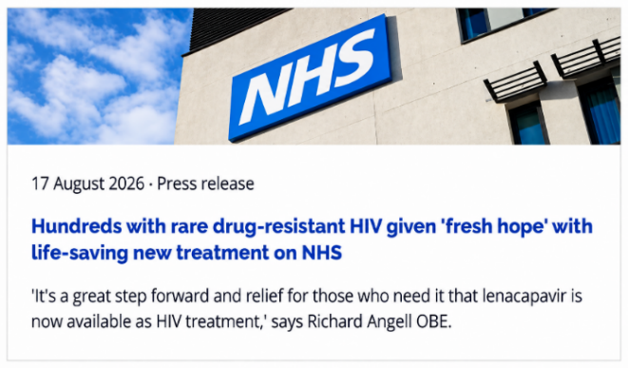
Figure 4: HIV treatments at NHS
(Source: Terrence Higgins Trust, 2026)
The evaluation of treatment success is based mainly on HIV RNA viral load, along with the measurements of CD4 where it is clinically necessary, adverse effects, as well as the overall health results. Adherence, renal and metabolic health, vaccinations, sexual health and drug interactions should be considered in regular reviews. One-on-one care is important than just repeating the instructions: the work schedules, depression, issues with confidentiality and supply of medicine need to be considered as the otherwise effective regimens can be not viable (British HIV Association, 2025a; World Health Organization, 2022).
The long-term viral suppression leads to a significant prevention advantage. Couple studies that compared couples of different HIV status revealed no sexual transmission to be related, in cases where the HIV partner had a suppressed viral load. This underpins Undetectable = Untransmittable (U=U): an individual who has an HIV RNA that is less than 200 copies/mL with effective treatment does not transmit HIV sexually. U=U does not imply that HIV is cured and does not prevent other sexually transmitted diseases (Rodger et al., 2019; National Institutes of Health, 2025b).
Some patients can be treated with long-acting injectable therapy, although clinical eligibility, attendance at and history of resistance should be evaluated thoroughly. The discussion of pregnancy, fertility and infant feeding is a specialization; blanket advice may ignore the goals of the person and current development of evidence. The UK pregnancy guidance acknowledges explicitly where the available safety evidence is insufficient with a call to make individual multidisciplinary decisions (British HIV Association, 2025b; British Association for Sexual Health and HIV and British HIV Association, 2026).
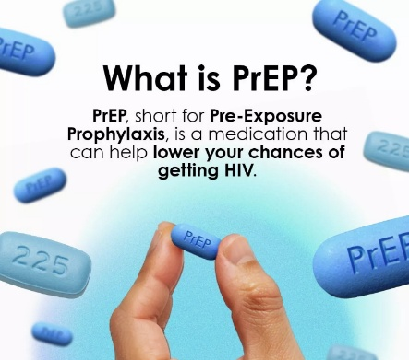
Figure 5: PrEP in HIV treatment
(Source: Pulse clinic, 2026)
Although prevention is applicable following a diagnosis, such as screening other sexually transmitted infections, and communication of the reproductive plans of patients and partners. PrEP benefits those with no HIV infection at risk who might have had their risky behaviour, whereas PEP is an emergency, short-term therapy following a potential exposure; neither should replace the ongoing ART of the person. U=U is used to explain correctly and does not guarantee protection against all infections. Clinicians should also take into consideration access disparities: not all people feel comfortable to visit traditional sexual-health clinics or to pick the prescription up in the neighbourhood. Specialist pathways can be supplemented with remote access, community testing and respectful partner services (British Association for Sexual Health and HIV and British HIV Association, 2026; World Health Organization, 2024).
Testing and linkage are still a part of the delivery of treatment. NICE recommends that local HIV prevalence is used to inform offers of testing whereas the emergency-department opt-out programme by NHS England aims to normalise testing where prevalence is high. These methods can help minimize missed diagnoses, yet the explanation needs to be readily available, real chances to decline, confidentiality and trustful referral following a positive outcome (National Institute for Health and Care Excellence, 2025; NHS England, 2024).

7. UK and International Care Models

7.1 UK model: BHIVA Standards of Care
One beneficial UK model is the British HIV Association (BHIVA) Standards of Care. Its eight standards are the diagnosis, treatment, wider health, psychological needs, reproductive care, life-course concerns and service quality. They provide quantifiable anticipations and specifically encompass care and palliative support incorporated into them. They have the advantage of being relevant to UK commissioning and specialist practice but standards are not necessarily a solution to local shortages of workforce or organisational fragmentation (British HIV Association, 2018).
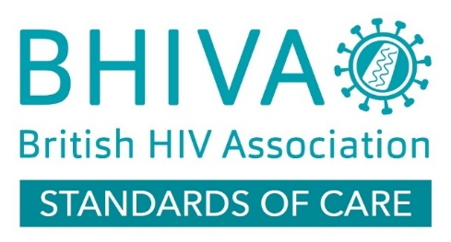
Figure 6: British HIV Association (BHIVA) Standards of Care Model
(Source: British HIV Association, 2018)

7.2 International model: WHO differentiated HIV service delivery
In other parts of the world, the World Health Organization (WHO) promotes person-centred and differentiated HIV service provision. Clinical stability and preferences can be adjusted by changing the frequency of appointment, medicine collection and community support. This flexibility has the potential to decrease the travel and service load, although simplified follow-up should not ignore mental illness, protection, the development of comorbidities or individuals who have difficulty accessing care (World Health Organization, 2023; World Health Organization, 2026b).

7.3 Critical comparison of care models
These are not competitive treatment algorithms but complementary to each other. BHIVA explains what comprehensive care is to be covered; WHO is concerned with the ways of organising the services according to various needs. The integration of quality criteria and flexible delivery may lead to fewer additional appointments and maintenance of routine psychosocial check-up. The indicators of evaluation must focus on retention, the ability to suppress the virus, quality of life and patient-reported experience rather than on the number of appointments (World Health Organization, 2022; British HIV Association, 2018).
Dimension | BHIVA: UK Standards of Care | WHO: differentiated delivery
Primary emphasis | Comprehensive standards and quality assurance | Adapting intensity and location of services
Strength | Specific to UK care expectations | Flexible, less burdensome follow-up
Limitation | Implementation depends on local resources | Reduced contacts can miss unmet needs
Best use together | Define holistic care outcomes | Adapt delivery while monitoring those outcomes
Table 2. Critical comparison of UK and international approaches

8. National and Local Health and Social Care Policy


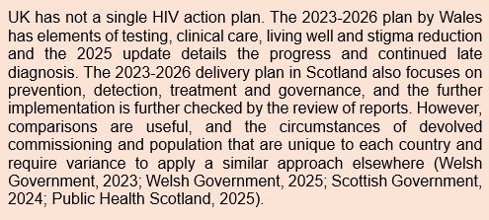
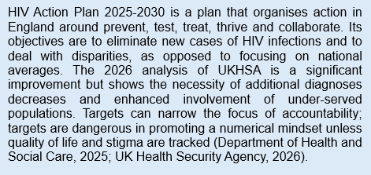
8.1 National health and social care agendas
Figure 7: HIV Action Plan 2025-2030
(Source: Department of Health and Social Care, 2025)
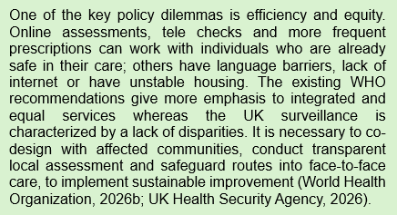

8.2 Local implementation: Cardiff and Vale
Implementation of local health and social care (Cardiff and Vale). In October 2024, Cardiff Council distributed free NHS Wales Test and Post HIV/STI self-sampling kits, distributed through city hubs and libraries, partners with Public Health Wales, Cardiff and Vale University Health Board and Fast Track Cardiff and Vale. This will bring the Welsh HIV Action Plan to the local level and provide an avenue to those residents who are scared off by clinics, or order online or lack an address (Cardiff Council, 2024; Welsh Government, 2023). Nevertheless, HIV-specific uptake, diagnoses or connection to treatment are not reported in the published announcement; simply the provision of kits does not demonstrate improved health outcomes.
Policy implementation is to be critically evaluated. The Cardiff and Vale Texting 4 Testing project demonstrates this shortcoming: 20 GP practices dispatched 143,526 texts, yet 3.36% of the clients were able to use the test link, 347 HIV tests were ordered and no reactive HIV test was noted by this time. Though possible, they do not determine cost-effectiveness or fair access (Lukacs et al., 2023). The English HIV Action Plan 20252030 on the national level lays emphasis on prevention and return to care; however, more than 5 per cent of those who had previously had HIV treatment were not retained in care in the UKHSA 2026 monitoring report. The local authorities, NHS services and commissioners should then monitor the early diagnosis, linkage and retention, social economic inequalities, and reported stigma, but not the tests provided or texts dispatched (Department of Health and Social Care, 2025; UK Health Security Agency, 2026).

9. Person-Centred Care, Self-Management and End-of-Life Care

9.1 Person-centred care and supported self-management
Person-centred HIV care acknowledges the fact that effective long-term management goes beyond viral suppression. Self-management involves adherence to antiretroviral therapy (ART), understanding of viral-load test outcomes, recognizing potential side effects, scheduling appointments and understanding when consultation with a professional is required. The discussions should be influenced by individual preferences of confidentiality, relationships, fertility and employment. Informed choice can be reinforced through clinician clarifying treatment options using simple language, ensuring comprehension and recording the goals together (National Institute for Health and Care Excellence, 2021; National Institutes of Health, 2025a).
The social circumstances may dictate the viability of a treatment plan. Peer-led groups, counselling and welfare advice have the potential to minimize the isolation and enhance confidence, but assistance must be provided at the will of the individual. Late appointments or delays in treatment must prompt a supportive evaluation of access to medication, the cost of transport, unstable housing, mental health and communication issues as opposed to presumptions about motivation. Monitoring must thus include both engagement and patient-reported wellbeing and laboratory outcomes (World Health Organization, 2022; Positive Voices 2022 Study Group, 2026).

9.2 End-of-life and palliative care, where appropriate
End of life care and palliative care should always be provided in case of advanced HIV or other severe illnesses that bring about a significant burden of symptoms. These support areas are pain relieving, family involvement with consent and advance care planning. However, they should not be used to suggest that HIV is always a death sentence: with proper ART, plenty of individuals are able to lead a long and happy life. The response to prognosis and individual priorities, rather than diagnosis, should be considered in care (British HIV Association, 2018; World Health Organization, 2021).

10. Recommendations for Improving HIV Care
Regular checks of psychological health, cardiovascular risk and social needs and virological monitoring should be incorporated into services. Defined referral pathways and patient-reported outcome measures would assist in identifying the unmet needs, and local audits should look into the prompt treatment linkage and retention, especially in underserved population (UK Health Security Agency, 2025b; Positive Voices 2022 Study Group, 2026).
Practical barriers can be minimized through flexible appointments, reliable access to medicine and substitutes of digital consultation. Teaching confidentiality, respectful communication and Undetectable (U=U), and meaningful engagement of people living with HIV in service design would have a positive impact on trust. The observed gaps should be addressed by commissioners who should compare the results of the population groups. The main idea is that long-term viral control ensures a healthy state and prevents sexual transmission of HIV, and the quality of care should prioritise dignity, autonomy and quality of life on a daily basis (Department of Health and Social Care, 2025; World Health Organization, 2026b).

References
British Association for Sexual Health and HIV and British HIV Association (2026) Joint BASHH/BHIVA guidelines for the sexual and reproductive health of people living with HIV 2026. Available at: https://bhiva.org/clinical-guideline/sexual-and-reproductive-health-guidelines/ (Accessed: 13 October 2026).
British HIV Association (2018) British HIV Association Standards of care for people living with HIV 2018. Available at: https://bhiva.org/clinical-standards/standards-of-care/ (Accessed: 12 October 2026).
British HIV Association (2025a) BHIVA guidelines on antiretroviral treatment for adults living with HIV-1 2022 (2025 interim update). Available at: https://bhiva.org/clinical-guideline/hiv-1-treatment-guidelines/ (Accessed: 10 October 2026).
British HIV Association (2025b) BHIVA guidelines on the management of HIV in pregnancy and the postpartum period 2025. Available at: https://bhiva.org/clinical-guideline/pregnancy-guidelines/ (Accessed: 13 October 2026).
Cardiff Council (2024) 'Hubs and libraries support community STI-testing service', Cardiff Newsroom, 16 October. Available at: https://cardiffnewsroom.co.uk/releases/c25/34374.html (Accessed: 17 October 2026).
Department of Health and Social Care (2025) HIV Action Plan for England, 2025 to 2030. Available at: https://www.gov.uk/government/publications/hiv-action-plan-for-england-2025-to-2030/hiv-action-plan-for-england-2025-to-2030 (Accessed: 13 October 2026).
Grinspoon, S.K. et al. (2023) Pitavastatin to prevent cardiovascular disease in HIV infection. New England Journal of Medicine, 389(8), pp. 687–699.
Hope, J.S. (2023) Early signs and symptoms of HIV | st. hope pharmacy, Myofferinghoperx.org. Available at: https://www.myofferinghoperx.org/blog/early-signs-and-symptoms-of-hiv (Accessed: 10 October 2026).
Hu, F.-H. et al. (2025) Prevalence of mental health problems in people living with HIV: a systematic review and meta-analysis. Psychology, Health & Medicine, 30(3), pp. 397–413.
INSIGHT START Study Group (2015) Initiation of antiretroviral therapy in early asymptomatic HIV infection. New England Journal of Medicine, 373(9), pp. 795–807.
Lukacs, Z. et al. (2023) 'Impact and experiences of offering HIV testing across the whole city population through primary care clusters and GP surgeries in the Texting 4 Testing (T4T) project', HIV Medicine, 24(S3), p. 5 (abstract O05). Available at: https://doi.org/10.1111/hiv.13476 (Accessed: 17 October 2026).
National Institute for Health and Care Excellence (2025) HIV testing: increasing uptake among people who may have undiagnosed HIV. NICE guideline NG60 (updated 2025). Available at: https://www.nice.org.uk/guidance/ng60/chapter/recommendations (Accessed: 12 October 2026).
National Institutes of Health (2025a) HIV and AIDS: the basics. Available at: https://hivinfo.nih.gov/understanding-hiv/fact-sheets/hiv-and-aids-basics (Accessed: 12 October 2026).
National Institutes of Health (2025b) Antiretroviral therapy to prevent sexual transmission of HIV (treatment as prevention). Available at: https://clinicalinfo.hiv.gov/en/guidelines/hiv-clinical-guidelines-adult-and-adolescent-arv/arv-therapy-as-prevention (Accessed: 10 October 2026).
NHS England (2024) Blood-borne viruses opt-out testing in emergency departments in areas of high and extremely high HIV prevalence: good practice guidance. Available at: https://www.england.nhs.uk/long-read/blood-borne-viruses-opt-out-testing-in-emergency-departments/ (Accessed: 11 October 2026).
Positive Voices 2022 Study Group (2026) Service needs of people living with HIV in the UK (Positive Voices 2022): a cross-sectional survey. The Lancet HIV, 13(4), pp. e258–e270.
Public Health Scotland (2025) Ending HIV transmission in Scotland by 2030: HIV transmission elimination delivery plan 2023–26 – progress report to March 2025. Available at: https://publichealthscotland.scot/publications/ending-hiv-transmission-in-scotland-by-2030-hiv-transmission-elimination-delivery-plan-2023-26-progress-report-to-march-2025/ (Accessed: 12 October 2026).
Pulse clinic (2026) HIV pre-exposure prophylaxis (PrEP) | pulse clinic Hong Kong | A lifestyle clinic., Pulse-clinic.com.hk. Available at: https://www.pulse-clinic.com.hk/hiv-prep (Accessed: 11 October 2026).
PV2022 Study Group (2026) Wellbeing of trans and gender-diverse people with HIV in the United Kingdom: results from Positive Voices 2022. HIV Medicine (in press).
Rodger, A.J. et al. (2019) Risk of HIV transmission through condomless sex in serodifferent gay couples with the HIV-positive partner taking suppressive antiretroviral therapy: final results of PARTNER. The Lancet, 393(10189), pp. 2428–2438.
Scottish Government (2024) Ending HIV transmission in Scotland by 2030: HIV transmission elimination delivery plan 2023–26. Available at: https://www.gov.scot/publications/ending-hiv-transmission-scotland-2030-hiv-transmission-elimination-delivery-plan-2023-26/ (Accessed: 11 October 2026).
Terrence Higgins Trust (2026) ‘Good news: Hundreds of people living with HIV that is resistant to all other treatments will now receive a life-saving’, LinkedIn. Available at: https://www.linkedin.com/posts/terrence-higgins-trust_good-news-hundreds-of-people-living-with-activity-7495141442315526144-DHut (Accessed: 13 October 2026).
UK Health Security Agency (2024a) Positive Voices 2022: survey report. Available at: https://www.gov.uk/government/publications/hiv-positive-voices-survey/positive-voices-2022-survey-report (Accessed: 12 October 2026).
UK Health Security Agency (2024b) HIV Action Plan monitoring and evaluation framework 2024 report. Available at: https://www.gov.uk/government/publications/hiv-action-plan-monitoring-and-evaluation-framework/hiv-action-plan-monitoring-and-evaluation-framework-2024-report (Accessed: 11 October 2026).
UK Health Security Agency (2025a) HIV testing, PrEP, new HIV diagnoses and care outcomes for people accessing HIV services: 2025 report. Available at: https://www.gov.uk/government/statistics/hiv-annual-data/hiv-testing-prep-new-hiv-diagnoses-and-care-outcomes-for-people-accessing-hiv-services-2025-report (Accessed: 9 October 2026).
UK Health Security Agency (2025b) Understanding HIV testing in England: 2025 report. Available at: https://www.gov.uk/government/publications/understanding-hiv-testing-in-england/understanding-hiv-testing-in-england-2025-report (Accessed: 12 October 2026).
UK Health Security Agency (2025c) HIV diagnoses fall in England. Available at: https://www.gov.uk/government/news/hiv-diagnoses-fall-in-england (Accessed: 19 October 2026).
UK Health Security Agency (2026) HIV Action Plan monitoring and evaluation framework: 2026 report. Available at: https://www.gov.uk/government/publications/hiv-action-plan-monitoring-and-evaluation-framework/hiv-action-plan-monitoring-and-evaluation-framework-2026-report (Accessed: 10 October 2026).
UNAIDS (2026) Global HIV & AIDS statistics – fact sheet. Available at: https://unaids.org/en/resources/fact-sheet (Accessed: 12 October 2026).
Welsh Government (2023) HIV action plan for Wales 2023 to 2026. Available at: https://www.gov.wales/hiv-action-plan-wales-2023-2026 (Accessed: 11 October 2026).
Welsh Government (2025) HIV Action Plan for Wales 2023–26: annual update, 1 December 2025. Available at: https://www.gov.wales/written-statement-hiv-action-plan-wales-2023-26-annual-update (Accessed: 11 October 2026).
Wiginton, J.M. et al. (2023) HIV-related stigma and discrimination in health care and health-related quality of life among people living with HIV in England and Wales: a latent class analysis. Stigma and Health, 8(4), pp. 487–496.
World Health Organization (2021) Consolidated guidelines on HIV prevention, testing, treatment, service delivery and monitoring: recommendations for a public health approach. Available at: https://www.who.int/publications/i/item/9789240031593 (Accessed: 13 October 2026).
World Health Organization (2022) Consolidated guidelines on person-centred HIV strategic information: strengthening routine data for impact. Available at: https://www.who.int/publications-detail-redirect/9789240055315 (Accessed: 12 October 2026).
World Health Organization (2023) Policy brief on integrating and strengthening monitoring of differentiated ART service delivery. Available at: https://www.who.int/publications/i/item/9789240067493 (Accessed: 8 October 2026).
World Health Organization (2024) Consolidated guidelines on differentiated HIV testing services. Available at: https://www.who.int/india/publications/i/item/9789240096394 (Accessed: 10 October 2026).
World Health Organization (2026a) HIV and AIDS – fact sheet. Available at: https://www.who.int/en/news-room/fact-sheets/detail/hiv-aids (Accessed: 12 October 2026).
World Health Organization (2026b) Consolidated HIV guidelines: service delivery. Available at: https://www.who.int/publications/i/item/9789240124233 (Accessed: 9 October 2026).

