
University of Wales Trinity Saint David (UWTSD)

Paper Title:
A comparison between Autodesk Maya 2018 & Blender 2.79 software’s 3D mesh modelling process, with a study experiment focus for beginners.

Course of Study: BA(Hons) Creative Computer Games Design
Academic Year: 6
Author: Ben Russell – P141534
Lecturer: John Carroll
Word Count: 4660

Table of Contents

Table of Contents 2
Chapter 1 - Introduction 3
Chapter 2 - Literature Review 4
Chapter 3 - Methodology 7
Chapter 4 - Results 10
Chapter 5 - Analysis 15
Chapter 6 - Conclusion 18
References 19
Bibliography 20
Appendix 22

Chapter 1 - Introduction
The purpose of this study is to compare two software’s to answer a specific question raised within that field. This studies focus is on comparing software’s Blender 2.79 to Autodesk Maya 2018 regarding their 3D polygonal modelling process towards a beginner audience. The study would focus on conducting a primary experiment in which beginners would create a model within their given software to then answer a questionnaire to gather the data. This data will then be compared and analysed to define an answer. Another aspect of the study would focus on the step by step navigation around the user interface (UI) along with the tools used.
This study will record the gathered data within a production diary, following the studies progress through the course of the assignment. To then be used to display the production process of the study.
Although the conclusion that has been reached does not have a definitive answer, the current research and analysis of the current data may still serve as a guidance for other readers. Future work that could be carried out for this studies development are recommended.

Chapter 2 - Literature Review
With the purpose of this study being the comparison of two software’s based upon which one would be best suited for beginners. This study focuses that through comparing Blender 2.79 and Autodesk Maya 2018 regarding their 3D polygonal modelling process. From this there needs to be an understanding across the subject area.
Within recent years the video games market and application has become increasingly popular and further studied as a form of art within our society, and it’s likely that this application would ever increase with further development in technology and application. At this current moment the video games market as of the year 2016 is worth $101.1bn, with projections the end of 2017 reaching $108.9bn and 2020 to reach $128.6bn (G2 Crowd, 2017) and along with the number of UK-based academic students undertaking degree-level computer games courses has increased from 3,100 in the year 2012/13 to 5,210 in 2015/16 showing a total compound annual growth rate (CAGR) of 18.9% (Twist 2015/see appendix 1).
With the growth in both the market and the number of students studying computer games this study would serve as a bases for beginners to gain an understanding of these software of their strengths and weaknesses for each and then a comparison result to identify which would serve them best in preparing for both the academic degree-level and for the later industry level. Of course there are other 3D modelling software’s available to compare and use, but the focus on these software’s in particular due to the community popularity of these specific programmes and their application for industry work (Lacoma, June 2017). The Autodesk Maya software was 3rd ranking on as best 3D modelling software’s compared to Blender which was 5th ranking (G2 Crowd, 2017) also along with this both software’s have industry implementation to this date, but Maya does have a stronger presence compared to Blender due to Maya being marketed for a more professional working programme compared to Blender which is marketed as more of a starting programme (G2 Crowd, 2017).
The 3D modelling process is the creation of 3D representation of any surface or object by manipulating polygons, edges and vertices in simulated 3D space. 3D modelling can be achieved manually with specialised 3D production software that lets an artist crate and deform polygonal surfaces or by scanning real-world objects into a set of data points that can be used to represent the object digitally (Slick, 2017).
The application for 3D modelling in today’s age has a wide range of industry level fields from engineering to entertainment to game development, it’s most popular and most recognisable form would be in the entertainment field of films and games, with major pictures such as Avatar (2009), Harry Potter (2001-2011) to video games from Call of Duty: Advance Warfare (2014) and Ratchet & Clank (2016).
There are many forms of modelling but it is stated to be down to two primary types of 3D modelling, those being NURBS Surface Modelling and Polygonal Modelling. Both processes may achieve the same end result, but they have different paths of being created and manipulated which would also underline the mathematics behind it (Slick, 2016).
NURBS Modelling (Non-uniform Rational B-Spline) is referred to the mathematical model that represents curves and surfaces which is ideal of flexibility and precision for both analytic and modelled shapes. This form is most commonly used for computer-aided design (CAD), manufacturing (CAM) and engineering (CAE) due to the high demand for the level of mathematics needed to accomplish (Slick, 2016). The other form is Polygon modelling, this form is what the study would focus upon due to the nature of polygon modelling being the most common form in Animation, Film and Games Industries. There are three key components for polygon modelling that are fundamental for this process of modelling:
- Faces; are the key factor in this process due to it defining the characteristics of polygon modelling by creating faceted meshes, meaning the surface of the 3D model is composed of hundreds and thousands of individual faces.

- Edges; is any point on the surfaces of the 3D where two polygonal faces meet, this can be in the form of Quads, Triangles and so on.

- Vertices; where an intersection is met between three or more edges having multiple points called vertex. The vertices are based on the different direction in the 3D space being x, y and z axis, through moving these vertexes to change the shape of the model is a common use within this process.
Therefore for this study the focus of polygonal modelling would be used as its application has higher factors within the given video games study.
Both software’s offer different application dependant on the individual’s needs and wants. For instance to compare the pricing of both software regarding licenses to be used commercially, Blender 2.79 is free, there is no cost to download or publish work created in this programme as it is covered by the GNU General Public License (GPL) which allows freedom within the programme. Compared to Autodesk Maya 2018, there is a free version to work within, so long as the individual is a student of an academic level given the freedom of learning through their studies, but as it states this is only applicable for academic students along with having a time period of usage being 3-4 years dependant on course. Once that period is done they no longer have the student license to utilise, on top of this no work from this license can be published as the license revokes part of the work completed in the software, meaning if the individual wishes to publish work they must pay for the full license. This license as a yearly subscription would cost the user £1,644,000 for the year, this is then the full license properties that come free with Blender (From this point it would appeal to most members due to the nature of the price of both programmes) with the same application, but this then this follows on from another comparison that the application of the programmes within the industry. Autodesk Maya has a larger presence within the industry regarding high profile projects from the Animation, Film and Games aspects in comparison to Blender due to the programme being further tailored Indie foundation and solo individual projects, but have still impacted on higher profile projects.
To reference some work created using Autodesk Maya based from the films and animation industry; Harry Potter and the Deathly Hallows: Part 2 (2011), Transformers: Dark of the Moon (2011) and Rango (2011) with a higher profile case within the video games industry such as; Assassins Creed Syndicate (2015), Fallout 4 (2015), DOOM (2016) and Firewatch (2016) these are just examples of projects.
Blender has been used in many projects both Animation, Film and Games; such as televised commercials in Australia – Bridgestone (2009), Brazil – The Desmrenho (2009) and Russia – Soda (2010) with films of Spider Man 2 (2004), Friday or Another Day “Vendredi ou un autre jour” (2005) and Hardcore Henry (2015). To full application with NASA of the Online Exploration Tool for Mars Rover (2015).The application regarding video games has no real high profile projects with the nature of the software regarding for indie level and solo projects but games published such as; Tank Wars (2009), Lucy and the Time Machine (2010) and More than Duty (2012).
Overall Maya and Blender were chosen for their popularity within the community in regards to their differences in application and their marketing for professional and beginner audiences.

Chapter 3 - Methodology
In order to discover the result based from this studies question, a method for conducting the primary experiment would need to be laid out. This was any future reproducibility can follow this exact method to ensure all data gathered are of the same conditions to ensure it remains in the same parameters.
An initial test would be conducted by an experienced user within the software’s to identify the most optimal method of which the experiment the beginner testers would be based from. This is done identifying the steps of each tool and measurements to ensure uniform, along with the director path to the tool. This will also serve as data to determine which software utilises the tools and easier navigation for the testers. This data will also be backed up from beginner tester’s feedback.
Once the initial test is done and laid out for the next step, testing on the targeted audience. An overview of this method is for testers within their given software being Blender or Maya would follow a tutorial sheet guiding their action to complete a polygon model. The same model will be created within the two software’s, but the process is unique within each. The testers would be made aware that the process is recorded and that they will remain anonymous for the study. Each tester has allocated time to complete the given experiment within, without any aid by the conductor. Once time limit has been reached each tester would fill out a questionnaire to gather the needed data for later analysing.
This process would be the core foundation for the methodology, so that any future work gains an understanding of the set environment.
This section details step by step of what the experiment would encounter, to ensure any repeat of the process is identical for the data to be set within the same parameters;
- Tester would be made aware of which software they are working within and given the overview of the experiment method

- Testers would be given 30 minutes to complete the experiment
  - The tutorial sheet would only be presented once the time has started – Digital Form (see appendix – 2,3)

- Once the time limit has been reached the tester would be told to stop current placement of work – regardless if finished or not

- The conductor would then save the individuals work and recorded data for later use

- The Questionnaire would then be presented for the individual to fill out

- Once filled out the conductor would then save the feedback for later use

This method would be the form in which every tester would undergo. The data gathered from the questionnaires would serve as the results from the experiment to then be later analysed. The structure for the questionnaires would have primary focuses to gather data on;
- If the tester completed the experiment
  - If so how long

- How did they find navigating the user interface (UI)

- How did they find the functionality of each individual tool

- Overall rating on their experience
(see appendix – 4)
The approach used for this study allows the targeted audience to first hand use the software to ensure the data gathered is received from the exact audience the test is tailored for otherwise the data gathered from others would be incorrect and therefore not helpful for the needed study. As the focus is also for navigation around the software regarding the tools and functions, that is why an initial test done by an experienced member within the software to determine the most optimal approach within the study. To later allow the additional feedback from beginner testers to add onto it.
Maya and Blender were the chosen software’s due to over other 3D software’s listed previously due to their popularity within the gaming community as of 2017.Also regarding their application within the industry and accessibility with Maya being the preferred choice at industry level companies therefore would be the optimal choice if pursuing that level. But with Blender being free and accessible for anyone to download, makes it easier for those only looking into the field without any commitments.
There were other forms this study could have conducted, such as relaying the information to the audience for them to then base their feedback upon. Or to display an entire process done by an experienced user. These forms have one primary flaw, being that the testers would base their feedback on preconceived information. Therefore, how would they truly know and experience the software without truly knowing the information given is correct. By ultimately allowing the tester first hand to use the software would allow more personal data to be obtained and therefore better quality of data as its tailored for the same target audience.
The data gathered would fall under the ‘Inter-Rater Reliability’ meaning the decisions based from the testers are compared to each other to see how consistent the tester decisions are. With this study the results collected could pose a low inter-rater reliability due not knowing the number of testers that would be gathered, in order to clearly identify the result based of this study there would be the need for a large testing audience to participate in order compare the quantity of the data to identify the general average. To demonstrate this point the average result based from 100 testers would hold a higher status compared the average result based from 10 testers, whatever the result may be due to the amount of data needed to analyse from the 100 then the 10.
Validity is the form of which the instrument being the software’s is accurate to output the data given form the testing’s. The type of validity that would be utilised for the study would focus on the ‘Content’ meaning how well the software’s cover a range of meaning points that is still being measured. This is done through the testers filling out the questionnaires to gather the data. This would then inform the base of the feedback to later compare with each software to then determine which one is best suited for the studies answer.
With this study focused on 3 main areas that being the 3D modelling process and tailored for beginners all within the gaming industry. It is unlikely the data can be generalised. Generalisation of data is the meaning of taking the data collected form this studies environment and able to utilise within another environment. Ultimately because of these restricted set parameters.

Chapter 4 - Results
The purpose of this study aims to identify, out of the two chosen software’s being, Autodesk Maya 2018 & Blender 2.79. Of which is best suited for beginners focusing on the 3D Modelling aspect. This study also aims to compare the two software’s based on the functionality of the given tools within each software to then relay the findings to the navigation of the UI.
These results show the data gathered following the Methodology process to ensure all data is equal when compared. The first set of results would focus on the specific comparisons regarding the functionality of the tools along with the UI;
As a form for beginners no shortcuts were instructed to focus primarily on the UI form of detailing the locations of the given functions. Therefore, following the tutorial guidance would give the tester the most optimal way conducting the experiment. This being done the results showed that the software Blender required more tools to complete the same polygonal model than Maya, this table shows the tools needed to be used to complete the experiment;
Given Software | Tools
Blender 2.79 | Extrude Region
Blender 2.79 | Extrude Region (Vertex Normals)
Blender 2.79 | Insert Faces
Blender 2.79 | Loop Cut & Slide
Blender 2.79 | Bevel
Autodesk Maya 2018 | Extrude
Autodesk Maya 2018 | Insert Edge Loop
Autodesk Maya 2018 | Bevel

This next section details the tool and its path for users to access within the given software, this is done to determine the navigation the user must undertake to find and use each tool;
Blender 2.79
Tool | Path | Number of Steps
Extrude Region | Tool Bar – () | 2
Extrude Region (Vertex Normals) | Tool Bar – Extrude Dropdown - () | 3
Insert Faces | Tool Bar – () | 2
Loop Cut & Slide | Tool Bar – () | 2
Bevel | 3D View Bar – Mesh – Edges – () | 4

Autodesk Maya 2018
Tool | Path | Number of Steps
Extrude | Workspace Tab – Edit Mesh – () | 3
Insert Edge Loop | Workspace Tab – Mesh Tools – () | 3
Bevel | Workspace Tab – Edit Mesh – () | 3

This next section focuses on the primary aim of this study. To allow the targeted audience being beginners to conduct the experiment, to gather qualitative data. These results detail the amount of time each tester used within the studies experiment, with the second showing how many testers were able to complete the experiment within the allotted time;
Blender 2.79 | Autodesk Maya 2018

Within the ‘Testers Experiment Times’ graph the line represents the average time testers took within that given software, detailing that;
Given Software | Average Time (Minutes)
Blender 2.79 | 26.78
Autodesk Maya 2018 | 22.59

These results detail how the testers found navigating the UI in the given software’s, following the tutorial sheets to identify locations for tools and other functions. Along with how testers felt the tutorial sheet conveyed the details;
Blender 2.79 | Autodesk Maya 2018

These results detail how testers found the use and functionality of the tools within the given software, basing this from if they felt confused by its function or felt that the tool and usage was straight forward;
Blender 2.79 | Autodesk Maya 2018
 | -----------------------------------

These final results detail the score testers gave their an overall rating of their experience within the given software based on how they felt about the navigation, functionality, display, usage and such;
Blender 2.79 | Autodesk Maya 2018

Within the ‘Testers Experiment Rating’ graph the line represents the average rating for that given software, the table below details the given result;
Given Software | Average Rating
Blender 2.79 | 3
Autodesk Maya 2018 | 3.8

All of the data gathered has importance, as it shapes the study’s findings to reach the end result of giving a definitive answer to its question. Although there are some results that pose more importance than others regarding the type of data collected, one of which is if testers were able to complete the given experiment at all, and if so what time did they complete it. These results would form the bases of how the testers navigate through the UI along with how efficient it was within the given software’s. Another of which was their opinion of the overall UI along with how they felt the tutorial sheets conveyed the information. These results have importance impact due to the impact each have on one another and therefore, could have impact on the overall result. But it also gives clear indication as to how the testers felt navigating around the UI. The last important results are based from the overall rating each tester gave on their experience. This shows the overall opinion each tester had for the given software to then be used as an overall result based on the collective of ratings to determine the average outcome. This outcome would determine the final result for the most margin.

Chapter 5 - Analysis
This study aims to identify which out of the two chosen software’s being Blender 2.79 and Autodesk Maya 2018 is better for beginners to start, relating to the 3D modelling process. Firstly a study was conducted focusing on the application of the tool as to the path the user would follow to the function of the tool itself. This is done to identify of which software’s navigation around the UI is more suitable for the audience and the efficiency of it. Another section of the study focuses on conducting experiments with beginners to the software’s to create a polygonal model following a tutorial step by step within the given software. Different testers were used within the software’s to ensure equal little knowledge beforehand. Once finished the testers would answer a questionnaire of which is gathering the needed data to analyse
Following the same structure layout as the results, the first data to be analysed is the focused on the specific comparisons regarding the functionality of the tools along with the UI. Based from at first within Blender the user must use 5 tools In order to complete the same polygonal model than can be completed within Maya at 3 tools. Any operating system that can achieve the same end goal with less tools and functions to use, especially since the target audience is for beginners that have not use any type of 3D software prior would be more efficient and beneficial for the user.
For example the Extrude tool, within Blender the user must use two various functions of the same tool at different stages in order to complete the experiment. Whereas Maya utilises a single tool that operates the two functions automatically dependant on the user’s needs. In regards to the path of the tools although some tools paths were shorter within Blender in turn allowing quicker access to their function. Not all tools were accessible within their primary ‘Tool Bar’ in which the ‘Bevel’ tool was located within another section of the workspace, in which was also reflected within the results based from tester feedback. 67% of users within Blender found complication with this tool, with majority of the feedback detailing it “difficult to find”. In comparison to Maya in which all tools were located within the same workspace and all shared similar path of 3 step to gain access. With 100% of users happy with the tool. The function of the bevel tool was not the issue, but the navigation around the UI felt unnecessary due to the other tool functions within the same tool bar. The navigation around the UI was also resulted from feedback off the testers; with 67% of users within Blender found it difficult to navigate compared to the opposite of Maya in which 67% found it was straight forward. This result has conflicting bases due to the possibility of them being tainted by the tutorial sheets not having enough detail described for the user. But this was identified not to be the case within this study with 67% in Blender and 83% in Maya finding the tutorial sheets to be clear and concise, with the others stating their needed to be more detail or more diagrams to illustrate. This result was expected as each individual has different forms of processing information, but with members still able to complete the given experiment.
Therefore it can be stated that Maya, regarding UI and the efficiency of the tools used was more successful than Blender and therefore, would be better tailored for the target audience of beginners.
The next section of the study’s results focuses on the testers feedback based on their experience within their given software’s. Overall out of the 12 testers that participated only 7 managed to complete the experiment meaning a 37% completion result, this is seen as unsuccessful result with majority of those who did not complete were stuck on particular sections of the experiment due to confusing on the function of the tool. With a higher percent of completed experiments within Blender of 50% not completing compared to 33% in Maya. Each tester’s progress was recorded on time of completion as shown in the results graph, to which details the average completion time within the two software’s showing that;
Given Software | Average Time (Minutes)
Blender 2.79 | 26.78
Autodesk Maya 2018 | 22.59

Detailing that those within Maya completed the experiment 4.19minutes quicker than those within Blender. This results shows that regarding the previous analysis of the UI, that testers within Maya found the UI to be straight forward. Compared to testers in Blender which found it difficult to find some tools. That it’s also resembled here with quickest time of completion in Blender was 19.43minutes compared to Maya which holds 16.12minutes.
Another factor is based upon the tester’s feedback on their overall experience within the given software. This has been gathered through the final question on the questionnaire to rate it out of 5 (1 being the worst, 5 being the best), an average rating has been recorded detailing that;
Given Software | Average Rating
Blender 2.79 | 3
Autodesk Maya 2018 | 3.8

From this result it clearly shows that the users within Maya along with the UI, tool functions and the completion time results had more success than those within Blender. Overall then it can be stated that Maya was more successful than Blender regarding this studies experiments.
A production diary was kept in accordance to this study, detailing all the stages throughout the project. The production diary was effective as it kept evidence of the current placement of work for the project that was later reflected upon to now be analysed of its effectiveness. It also was used as a reference to the studies plan to identify if the study was on track with the expected plan, to which this study had fallen behind with work and could also factor how less people were gathered for the testing. The study overall gave better insight to the application for other new beginners to the field as it sets basic foundation information needed to progress that more experienced users use automatic. For example following the tutorial sheets before conducting true experiments, the basics of information were left out due to naturally knowing their controls. Therefore, needed editing to ensure all relevant information was given for the true targeted testers. One of the biggest problems the study encountered was the lack of sticking to the initial planning, this then led the study to be behind and delayed regarding work. This effected the rest of the project as it hit a wave effect meaning less time was given for data gathering than previously planned therefore fewer results were collected than should have. For future reference would be to ensure all work is completed within the pre-planned structure, to avoid the wave effect.
(see appendix – 5)

Chapter 6 - Conclusion
This study aimed to answer of which software Blender 2.79 or Autodesk Maya 2018 would be best suited for beginners, concluded by recorded data from tester experiments to create a polygon 3D model following a tutorial sheet to then analyse the data for the definitive answer. This study cannot conclude that definitive answer. Although the data gathered thus far states that Maya had succeeded Blender in almost all aspects being the navigation around the UI, to functions of the tools, to the time testers took in completing the experiment with an overall higher testers experience rating too. It cannot be stated as a definitive answer due to the number of testers data gathered being so small. Overall the study collected 12 testers feedback, 6 testers working within each software. Yet the minimum required for any quantitative study as stated by Jakob Nielsen (2012) 20 testers to achieve statistically significant numbers, thus 20 testers in both software’s totalling 40 testers minimum.
Therefore, with far less than the supposed minimum this study cannot give a definitive answer of which software would be best suited for beginners. But as future work from the basic starting point of the 12 testers further experimentation could be conducted to gather further data to determine that definitive answer.

References
- Adams, S. (2005). Comparison of Blender and Maya, read it.. [online] Blenderartists.org. Available at: https://blenderartists.org/forum/showthread.php?48881-Comparison-of-Blender-and-Maya-read-it [Accessed 10 Oct. 2017].

- Foundation, B. (2017). Statistics — blender.org. [online] blender.org. Available at: https://www.blender.org/about/website/statistics/ [Accessed 10 Oct. 2017].

- G2Crowd. (n.d.). Compare Maya vs Blender. [online] Available at: • https://www.g2crowd.com/compare/blender-vs-maya [Accessed 10 Oct. 2017].

- Lacoma, T. (2017). Get your next project started right with the best 3D modeling software. [online] Digitaltrends.com. Available at: https://www.digitaltrends.com/computing/best-3d-modeling-software/ [Accessed 10 Oct. 2017].

- Pluralsight.com. (2014). Where Blender Functionality is Better Than Maya's. [online] Available at: https://www.pluralsight.com/blog/film-games/where-blender-functionality-is-better-than-mayas [Accessed 10 Oct. 2017].

- Slick, J. (2016). 3D Model Components - Vertices, Edges, Polygons & More. [online] Lifewire. Available at: https://www.lifewire.com/3d-model-components-1952 [Accessed 10 Oct. 2017].

- Slick, J. (2017). 3D Modeling Process Defined. [online] Lifewire. Available at: https://www.lifewire.com/what-is-3d-modeling-2164 [Accessed 10 Oct. 2017].

- Twist, J. (2015). The Uk Video Game Sector. 1st ed. United Kingdom: Ukie, pp.14,15.

Bibliography
- 12321, t. (2006). Elephants Dream. [online] YouTube. Available at: https://www.youtube.com/watch?v=bsGEWHNJ3s8 [Accessed 10 Oct. 2017].

- Autodesk.co.uk. (2017). Maya Subscription | Buy Maya 2018 Software | Autodesk. [online] Available at: https://www.autodesk.co.uk/products/maya/subscribe?plc=MAYA&term=1-YEAR&support=ADVANCED&quantity=1 [Accessed 10 Oct. 2017].

- Blenderartists.org. (2009). Tank Wars - Tb1alexc's GE Contest Entry - RELEASED! Check last post.. [online] Available at: https://blenderartists.org/forum/showthread.php?147440-Tank-Wars-Tb1alexc-s-GE-Contest-Entry-RELEASED!-Check-last-post [Accessed 10 Oct. 2017].

- Desk, A. (2017). Autodesk Games Show Reel 2017. [online] YouTube. Available at: https://www.youtube.com/watch?v=UuqfkKRlY8c&t=1s [Accessed 10 Oct. 2017].

- Formica, T. (2006). Brasilian TV Commercial made with Blender - BlenderNation. [online] BlenderNation. Available at: https://www.blendernation.com/2006/09/26/brasilian-tv-commercial-made-with-blender/ [Accessed 10 Oct. 2017].

- Forums.unrealengine.com. (2014). Autodesk Maya VS Blender - Unreal Engine Forums. [online] Available at: https://forums.unrealengine.com/community/general-discussion/88880-autodesk-maya-vs-blender [Accessed 10 Oct. 2017].

- Foundation, B. (n.d.). License — blender.org. [online] blender.org. Available at: https://www.blender.org/about/license/ [Accessed 10 Oct. 2017].

- Guides.library.harvard.edu. (n.d.). Research Guides: The Literature Review: A Research Journey: Overview. [online] Available at: https://guides.library.harvard.edu/literaturereview [Accessed 10 Oct. 2017].

- Idatalabs.com. (2015). Companies using Autodesk Maya. [online] Available at: https://idatalabs.com/tech/products/autodesk-maya [Accessed 10 Oct. 2017].

- NASA. (2015). New Online Tools Bring NASA’s Journey to Mars to a New Generation. [online] Available at: https://www.nasa.gov/press-release/new-online-exploring-tools-bring-nasas-journey-to-mars-to-new-generation/ [Accessed 10 Oct. 2017].

- Roosendaal, T. (2016). Hardcore Henry – using Blender for VFX — blender.org. [online] blender.org. Available at: https://www.blender.org/news/hardcore-henry-using-blender-for-vfx/ [Accessed 10 Oct. 2017].

- Studiorola.com. (2009). Blender in TV Commercials – Studio Rola. [online] Available at: http://www.studiorola.com/news/blender-in-tv-commercials/ [Accessed 10 Oct. 2017].

- Studiorola.com. (2010). Blender in TV Commercials – Studio Rola. [online] Available at: http://www.studiorola.com/news/blender-in-tv-commercials/ [Accessed 10 Oct. 2017].
- TeacherVision. (n.d.). Displaying Data. [online] Available at: https://www.teachervision.com/displaying-data [Accessed 10 Nov. 2017].

- Users.skynet.be. (n.d.). blender. [online] Available at: http://users.skynet.be/mume/vendredi/blender.html [Accessed 10 Oct. 2017].

- Web.archive.org. (2017). blender.org - Testimonials. [online] Available at: https://web.archive.org/web/20070221025521/https:/www.blender.org/features-gallery/testimonials/ [Accessed 10 Oct. 2017].

- Www2.le.ac.uk. (n.d.). Presenting numerical data — University of Leicester. [online] Available at: https://www2.le.ac.uk/offices/ld/resources/numerical-data/numerical-data [Accessed 10 Nov. 2017].

Appendix
1.
Statistics Table
Academic Year | UK | Other EU | Non-EU | Total all domiciles | Studied Computer Games | % of Students | Year-on-year Growth
2010/11 | 559,305 | 27,550 | 48,280 | 635,135 | - | - | -
2011/12 | 587,925 | 29,125 | 50,640 | 667,690 | - | - | -
2012/13 | 595,265 | 29,615 | 51,830 | 676,710 | 3,100 | 0.46% | -
2013/14 | 607,635 | 30,045 | 53,715 | 692,525 | 3,445 | 0.50% | 11.1%
2014/15 | 614,135 | 30,500 | 55,205 | 699,855 | 4,165 | 0.60% | 20.9%
2015/16 | 633,380 | 32,375 | 57,465 | 723,225 | 5,210 | 0.72% | 25.1%
CAGR |  |  |  |  |  |  | 18.9%
(Twist, 2015)

2.
Autodesk Maya 2018 – Tutorial Sheet
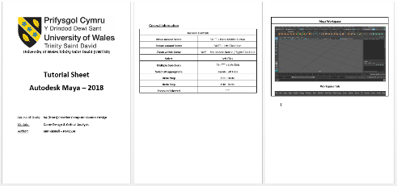
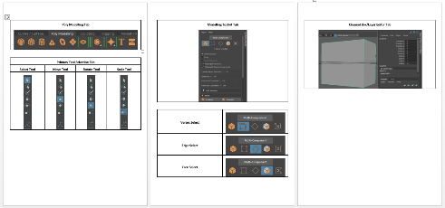

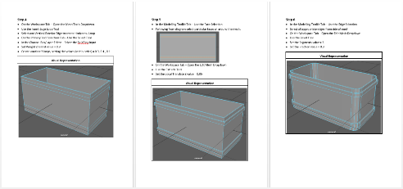
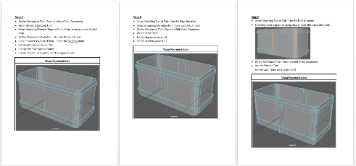

3.
Blender 2.79 – Tutorial Sheet
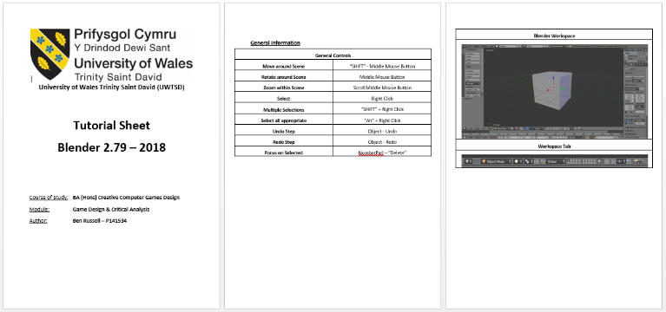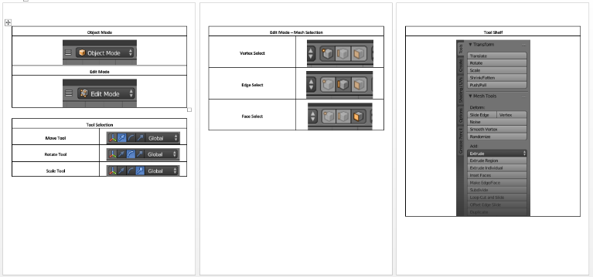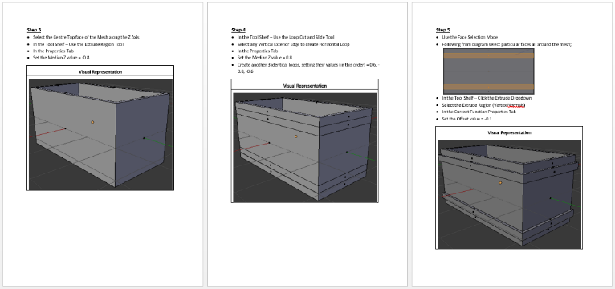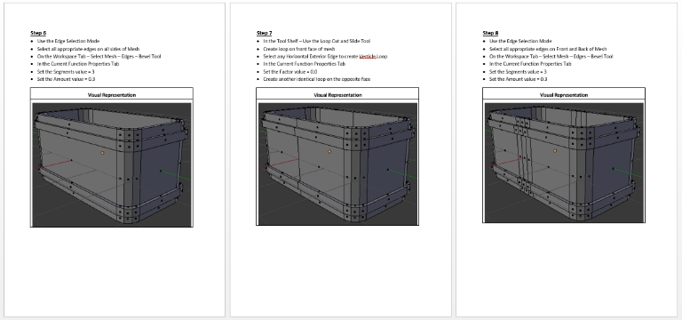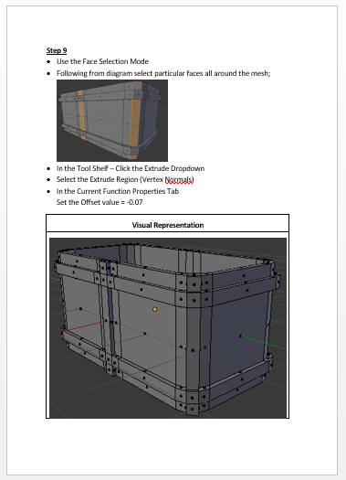

4.
Questionnaire Format Sheet
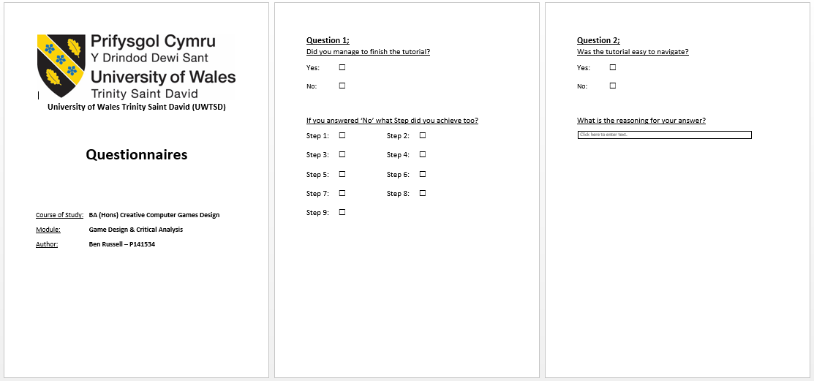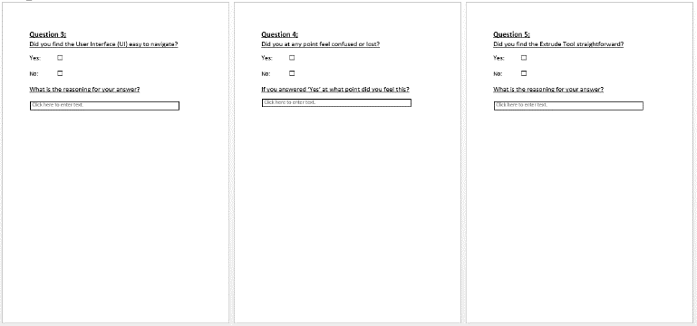

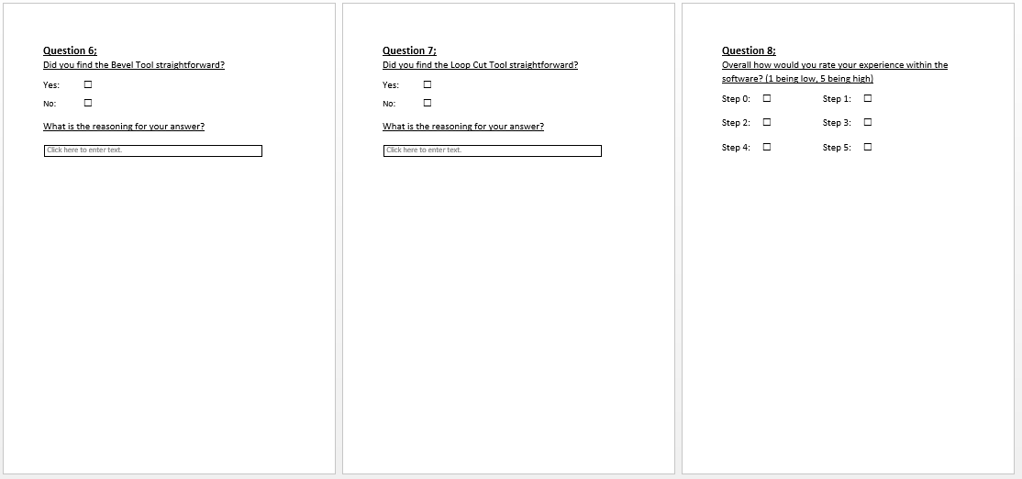

5.
Production Diary


