
Investigation of the Seven Wastes of Lean in Three Business Operations
Name: kush hareshbhai patel
Subject: lean six sigma (acha 7013)
student id: 2508700

Executive Summary
Lean management aims to improve business operations by identifying and eliminating waste within business processes. Waste is any process that uses resources, but it does not add value in the eyes of the customers. The seven wastes of lean are commonly summarized using the TIMWOOD acronym: Transportation, Inventory, Motion, Waiting, Overproduction, Over-processing and Defects.
This report investigates the occurrence of these wastes in three operational environments: warehousing operations for an online retailer, textile manufacturing producing clothes and construction work involved in building an extension on a house. These examples represent different sectors including logistics, manufacturing and construction.
The report identifies where waste occurs in each environment using the TIMWOOD framework and estimates the scale of these inefficiencies. Based on this analysis, improvement strategies are offered to reduce waste and improve operational efficiency. The potential costs and challenges of implementing these improvements are also discussed.
Overall, the findings demonstrate that applying lean principles can help organizations reduce operational waste, improve productivity and deliver better value to customers.

Table of Contents
Executive Summary 1
Table of Contents 2
List of Figures and Tables 3
1. Introduction 4
2. Investigation into Types of Waste (TIMWOOD) 5
2.1 Warehousing Operations for an Online Retailer 5
2.2 Textile Manufacturing Producing Clothes 7
2.3 Building an Extension on a House 8
3. Quantification of Wastes 11
3.1 Warehouse Operations for an Online Retailer 11
3.2 Textile Manufacturing Producing Clothes 12
3.3 Building an Extension on a House 13
4. Evaluation of Improvements 14
4.1 Warehouse Operations Improvements 14
1. Warehouse Layout Optimization 14
2. Use of Automated Picking Technology 14
4.2 Textile Manufacturing Improvements 15
1. Implementation of Lean Production Cells 15
2. Quality Control During Production 15
4.3 Construction Improvements 16
1. Improved Project Planning and Scheduling 16
2. Improved Construction Site Organisation 16
5. Costs of Improvements and Potential Implementation Issues 18
5.1 Warehouse Operations for an Online Retailer 18
5.2 Textile Manufacturing Producing Clothes 18
5.3 Building an Extension on a House 19
6. Conclusion 21
References 22
Appendices 23
Appendix A - Definition of the Seven Wastes (TIMWOOD) 23

List of Figures and Tables
Figure 1 – 7 Wastes 5
Table 1 - TIMWOOD Waste in Warehouse Operations 6
Table 2 - TIMWOOD Waste in Textile Manufacturing 8
Table 3 - TIMWOOD Waste in Construction 9
Table 4 - Quantification of Warehouse Waste 11
Table 5 - Quantification of Textile Manufacturing Waste 12
Table 6 - Quantification of Construction Waste 13
Table 7 - Costs, risks and controls 19

1. Introduction
Lean management is widely used by organizations to improve efficiency by reducing waste within operational processes. The concept originated from the Toyota Production System and has since been applied across many industries including manufacturing, logistics and construction (Ohno, 1988).
Operational waste refers to activities that consume resources but do not create value for customers. Ohno identified seven types of waste, which are commonly summarized using the TIMWOOD acronym: Transportation, Inventory, Motion, Waiting, Overproduction, Over-processing and Defects. Identifying these wastes allows organizations to improve operational performance and reduce unnecessary costs (Womack and Jones, 2003).
This report inspects the seven wastes within three different operational environments:
- Warehouse operations for an online retailer
- Textile manufacturing producing clothes
- Construction work involved in building a house extension
These examples represent different operational contexts where lean principles can be applied. Warehousing operations focus on logistics and inventory management. Textile manufacturing involves the transformation of raw materials into finished garments. Construction projects involve temporary work environments that require coordination between workers and contractors.
The report identifies where waste occurs in each example, estimates the extent of these inefficiencies and evaluates potential improvement strategies based on lean management principles.

2. Investigation into Types of Waste (TIMWOOD)
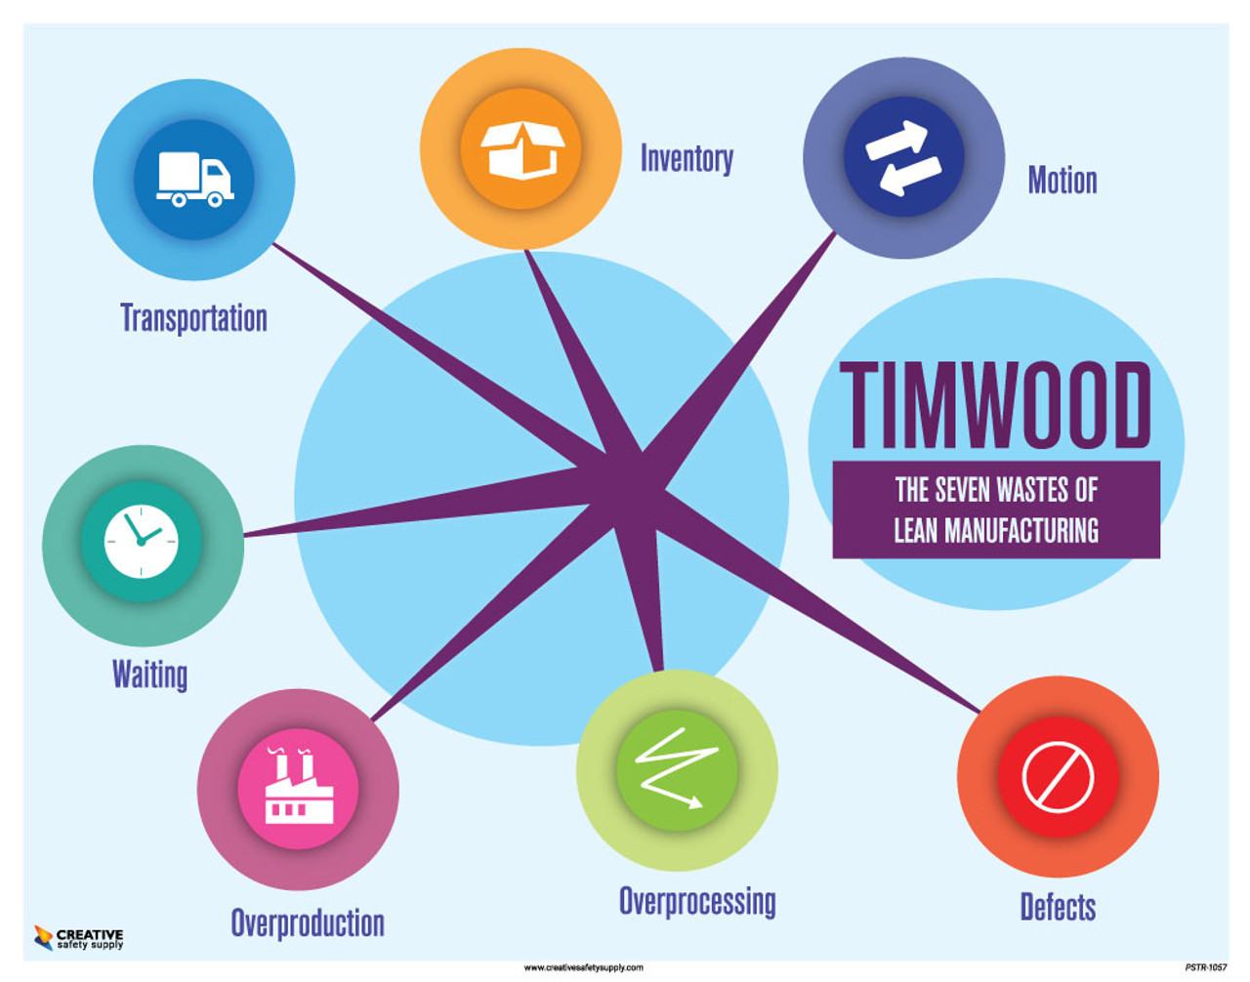
Lean management focuses on identifying waste within operational processes. The TIMWOOD framework provides a structured method for analysing inefficiencies.

Figure 1 – 7 Wastes

Each waste type represents an activity that consumes resources without adding customer value.

2.1 Warehousing Operations for an Online Retailer
Warehouse efficiency is important in online retail businesses as it allows them to have the customer orders taken fast and correctly. The typical warehouse process includes receiving goods, storing products, picking items, packing orders and shipping them to customers.
Despite technological advances, warehouse operations often experience operational waste.
Transportation
- Transportation waste occurs when goods are moved unnecessarily within the warehouse. Poor layout design may require products to be moved multiple times before reaching their final storage location.
Inventory
- Inventory waste occurs when excess products are stored beyond what is required to meet demand. High inventory levels increase storage costs and reduce available warehouse space (Christopher, 2016).
Motion
- Motion waste refers to unnecessary movement by workers. Warehouse employees may walk long distances to locate products, particularly if high-demand items are not stored near packing areas.
Waiting
- Waiting occurs when workers or processes remain idle. This may happen due to system delays, equipment breakdown or inefficient coordination between warehouse activities.
Overproduction
- Overproduction occurs when orders are picked or packed earlier than required. This may result in congestion in staging areas before shipping.
Over-processing
- Over-processing refers to performing tasks that do not add value. For example, products may be checked multiple times during packing.
Defects
- Defects occur when incorrect products are shipped to customers. Returned orders require additional handling and increase operational costs.

Table 1 - TIMWOOD Waste in Warehouse Operations
Waste Type | Example
Transportation | Products moved between storage areas
Inventory | Excess stock stored
Motion | Workers walking long distances
Waiting | Delays due to system processing
Overproduction | Orders packed too early
Over-processing | Multiple product checks
Defects | Incorrect items shipped

2.2 Textile Manufacturing Producing Clothes
Textile manufacturing involves transforming raw materials into finished garments through several production stages.
Due to the complexity of these processes, various types of waste can occur.
Transportation
- Fabric and garments may be moved repeatedly between departments. Poor factory layout can increase transportation waste.
Inventory
- Large quantities of unfinished garments often accumulate between production stages, creating work-in-progress inventory (Bicheno and Holweg, 2016).
Motion
- Workers may spend time searching for tools, materials or instructions if workstations are not properly organized.
Waiting
- Machines and workers may remain idle if materials are not delivered from previous stages on time.
Overproduction
- Producing garments in large batches before demand is confirmed can result in excess inventory.

Over-processing
- Additional finishing processes or decorative stitching may increase production time without adding significant value.
Defects
- Common defects include incorrect stitching, damaged fabric or incorrect sizing.

Table 2 - TIMWOOD Waste in Textile Manufacturing
Waste Type | Example
Transportation | Fabric moved between departments
Inventory | Work-in-progress inventory
Motion | Workers searching for tools
Waiting | Machines idle due to delays
Overproduction | Excess garment production
Over-processing | Extra finishing steps
Defects | Sewing errors

2.3 Building an Extension on a House
Construction projects involve multiple stages and coordination between workers and contractors.
Lean construction aims to reduce inefficiencies in these processes (Koskela, 1992).

Transportation
- Materials such as bricks and cement may be moved multiple times around the construction site.
Inventory
- Excess materials stored on site increase the risk of damage or theft.
Motion
- Workers often walk across the site to collect tools or materials.
Waiting
- Construction workers frequently wait for material deliveries or equipment availability.
Overproduction
- Preparing materials before they are required may lead to unnecessary handling.
Over-processing
- Reworking completed structures due to measurement errors increases labour costs.
Defects
- Construction defects can result in expensive repairs and project delays.

Table 3 - TIMWOOD Waste in Construction
Waste Type | Example
Transportation | Materials moved across site
Inventory | Excess construction materials
Motion | Workers walking for equipment
Waiting | Delays due to missing materials
Overproduction | Materials prepared early
Over-processing | Rework required
Defects | Structural errors

3. Quantification of Wastes
Quantifying waste helps organizations understand how inefficiencies affect productivity and costs. In lean management, measuring waste allows managers to identify the most significant problems and priorities improvements. In the three operational environments analysed in this report, waste can be estimated through time loss, excess inventory, rework levels and reduced productivity.

3.1 Warehouse Operations for an Online Retailer
In warehouse operations, motion waste is a common issue. If a picker works an 8-hour shift and about 25% of that time is spent walking long distances due to inefficient layout, approximately 2 hours of productive time per worker are lost per shift. In a warehouse with 10 pickers, this equals around 20 labour hours lost daily.
Inventory waste can be estimated through excess stock levels. If the warehouse holds about 15% more inventory than required, storage costs increase and working capital is tied up. For example, if total inventory value is £200,000, around £30,000 may be unnecessary stock.
Waiting waste may occur due to system delays or coordination issues. If order processing is delayed by 10 minutes per batch and 12 batches are processed daily, the warehouse loses around 2 hours each day.
Defects can also be measured through order accuracy. If 3% of orders are incorrect and the warehouse processes 1,000 orders daily, around 30 orders require correction or return handling.

Table 4 - Quantification of Warehouse Waste
Waste Type | Measurement | Estimated Impact
Motion waste | Walking during picking | ≈2 hours per worker per shift
Inventory waste | Excess stock | ≈15% extra inventory
Waiting waste | Order processing delays | ≈2 hours per day
Defects | Incorrect orders | ≈3% error rate
These inefficiencies reduce warehouse productivity and increase operational costs.

3.2 Textile Manufacturing Producing Clothes
In textile manufacturing, waste often appears as work-in-progress inventory, waiting time and defects.
Work-in-progress inventory slows production flow. If unfinished garments create a 20% delay between stages, a production cycle that normally takes 5 days may increase to about 6 days.
Waiting waste occurs when machines remain idle due to delays in material supply. If each sewing machine waits 15 minutes per shift and the factory operates 20 machines, this equals around 5 hours of lost machine time per shift.
Defects can also be measured through rework levels. If 5% of garments require correction and the factory produces 2,000 garments per week, about 100 garments need repair each week.
Motion waste may reduce worker productivity. If poor workstation layout reduces efficiency by 10%, a worker expected to produce 50 garments per shift may produce only around 45 garments.

Table 5 - Quantification of Textile Manufacturing Waste
Waste Type | Measurement | Estimated Impact
Work-in-progress inventory | Production delay | ≈20% longer cycle
Waiting waste | Machine idle time | ≈5 hours lost per shift
Defects | Rework percentage | ≈5% defective garments
Motion waste | Productivity loss | ≈10% lower output
These inefficiencies slow production and increase labour requirements.

3.3 Building an Extension on a House
In construction projects, waste often occurs through waiting time, material waste and rework.
Waiting waste occurs when workers cannot continue tasks due to missing materials or equipment. If each worker loses 1-2 hours per day, a team of four workers could lose 4-8 labour hours daily.
Material waste can be measured as a percentage of unused materials. If 8-10% of materials are wasted, a project with a £25,000 materials budget could lose around £2,000-£2,500.
Defects may also lead to rework. If rework increases labour costs by 5% and the labour budget is £40,000, this results in about £2,000 in additional labour costs.
Motion waste reduces efficiency when workers walk to collect tools or materials. If this reduces productive time by about 15%, each worker may lose around 1 hour per day.

Table 6 - Quantification of Construction Waste
Waste Type | Measurement | Estimated Impact
Waiting waste | Worker idle time | ≈1–2 hours per worker per day
Material waste | Unused materials | ≈8–10% of materials
Defects / rework | Extra labour cost | ≈5% increase in labour cost
Motion waste | Productivity loss | ≈15% of working time
These estimates show how waste directly affects both project cost and completion time.

4. Evaluation of Improvements
Lean management focuses on improving operational efficiency by removing activities that do not add value to the final product or service. Based on the analysis conducted in the previous sections, several improvements can be implemented in each of the three operational environments.

4.1 Warehouse Operations Improvements

1. Warehouse Layout Optimization
One major source of waste identified in warehouse operations is excessive worker movement during order picking. This can be improved by redesigning the warehouse layout.
Key improvements include:
- Storing high-demand products closer to packing stations to reduce travel distance.
- Using ABC inventory classification, where frequently ordered products are placed in easily accessible locations.
- Organizing storage areas so that similar products are grouped together.
- Reducing congestion in picking areas by improving aisle layout.
Expected benefits include:
- Reduced order picking time
- Increased worker productivity
- Lower physical strain on employees
Research suggests that improving warehouse layout design can significantly reduce travel distances and increase operational efficiency (Christopher, 2016).

2. Use of Automated Picking Technology
Another improvement involves introducing automated technologies to assist order processing.
Examples include:
- Barcode scanning systems to verify that the correct product is selected.
- Warehouse management systems (WMS) to guide workers through optimal picking routes.
- Automated storage and retrieval systems (ASRS) to reduce manual handling.
Benefits of automation include:
- Reduced human errors in order picking
- Faster order processing
- Improved inventory accuracy
Although automation requires initial investment, it can significantly improve long-term warehouse performance.

4.2 Textile Manufacturing Improvements

1. Implementation of Lean Production Cells
A major issue in textile manufacturing is the accumulation of work-in-progress inventory between production stages.
Lean production cells can address this issue by:
- Allowing workers to perform multiple production tasks in one area.
- Reducing the need to transport garments between different departments.
- Improving communication between workers involved in the production process.
Benefits of this approach include:
- Reduced waiting time between production stages
- Faster production flow
- Lower work-in-progress inventory levels
Lean production cells also support continuous improvement practices within manufacturing environments (Bicheno and Holweg, 2016).

2. Quality Control During Production
Defects are another significant source of waste in textile manufacturing.
Quality can be improved by introducing quality checks during each production stage rather than relying only on final inspection.
Key actions include:
- Encouraging workers to inspect their own work during production.
- Providing training to improve quality awareness among employees.
- Implementing standardised work procedures to reduce production errors.
Benefits include:
- Early detection of defects
- Reduced rework and material waste
- Improved product quality and customer satisfaction

4.3 Construction Improvements

1. Improved Project Planning and Scheduling
Construction projects often experience delays due to poor coordination between tasks.
Project planning can be improved through:
- Using digital project scheduling tools to coordinate construction activities.
- Ensuring materials are delivered at the correct time to avoid waiting.
- Improving communication between contractors and workers.
Benefits include:
- Reduced waiting time for workers
- More efficient use of labour and equipment
- Improved project completion times
Better planning is an important aspect of lean construction practices (Koskela, 1992).

2. Improved Construction Site Organisation
Another important improvement involves better organisation of tools and materials on construction sites.
Key improvements include:
- Storing tools and materials close to the work area.
- Creating designated storage locations for frequently used equipment.
- Keeping construction sites clean and organised to reduce movement waste.

Benefits include:
- Reduced time spent searching for equipment
- Improved worker productivity
- Safer working conditions on construction sites

5. Costs of Improvements and Potential Implementation Issues
Lean improvements can reduce waste, but they also involve costs. Some costs are direct, such as software, equipment or training. Others are indirect, such as time lost during the change. In each case, the aim is to choose improvements that are practical, affordable and likely to give clear results.

5.1 Warehouse Operations for an Online Retailer
Improvement 1: Layout redesign and ABC slotting
This improvement would involve moving fast-selling items closer to packing areas and changing stock locations. It may also require new labels, updated records and small layout changes. The likely cost would be around £8,000 to £15,000.
The main benefit is less walking during picking. This would improve productivity, reduce fatigue and speed up order processing. The main risk is short-term disruption while stock is being moved. This can be reduced by changing one area at a time and giving staff clear instructions.
Improvement 2: Warehouse management system and barcode control
A warehouse management system would improve stock control and picking accuracy. Barcode scanners would help staff confirm the correct items during picking. The likely cost would be around £25,000 to £60,000.
The main benefit is fewer picking mistakes and better stock accuracy. It would also reduce waiting for order information. The main issue is that staff may need time to learn the system, and poor data could create errors. These problems can be managed through training, data checks and a pilot launch.

5.2 Textile Manufacturing Producing Clothes
Improvement 1: Lean production cells and line balancing
This would involve changing the layout so work moves more smoothly between stages. Machines may need to be moved, and staff may need training. The likely cost would be around £12,000 to £25,000.
The main benefit is better flow through production. This would reduce waiting, lower work-in-progress and shorten lead time. The main problem is that output may fall at first while workers adjust. This can be managed by testing the new layout on one line before full use.

Improvement 2: In-process quality control and standard work
This improvement would focus on checking quality during production instead of mainly at the end. It would require training, standard work sheets and simple visual controls. The likely cost would be around £3,000 to £8,000.
The main benefit is that defects would be found earlier, which would reduce rework and improve consistency. The main issue is that checks may be skipped when production is busy. This can be controlled by keeping checks simple and reviewing defect results daily.

5.3 Building an Extension on a House
Improvement 1: Better planning and delivery scheduling
This would involve stronger coordination between trades, suppliers and the site manager. It may include planning tools, more detailed delivery schedules and regular short meetings. The likely cost would be around £2,000 to £6,000.
The main benefit is less waiting on site. Workers would know when materials and other trades are ready, which would reduce delays. The main challenge is that construction is affected by outside factors such as late deliveries and client changes. These can be managed through regular planning and early confirmation of deliveries.
Improvement 2: Site organization and visual management
This would involve clear storage areas, signs, visual boards and daily housekeeping checks. The likely cost would be around £1,000 to £3,000.
The main benefit is less time wasted searching for tools and materials. It would also improve safety and reduce damage to materials. The main issue is that site organisation can quickly decline if no one takes responsibility. This can be managed by assigning ownership for each area and checking standards daily.

Table 7 - Costs, risks and controls
No. | Case | Improvement | Cost | Main problem | Control
1. | Warehouse | New layout and better stock locations | £8k-£15k | Disruption while moving stock | Change the layout in stages and brief staff clearly
1. | Warehouse | WMS and barcode scanning | £25k-£60k | Training needs and data errors | Pilot the system first and check data carefully
2. | Textile | Lean cells and line balance | £12k-£25k | Lower output during change | Start with one line and review progress each day
2. | Textile | In-process quality checks | £3k-£8k | Checks may be missed | Use simple checks and monitor defects daily
3. | Construction | Better planning and delivery control | £2k-£6k | Late deliveries and changes | Confirm deliveries early and hold regular meetings
3. | Construction | Better site organisation | £1k-£3k | Poor housekeeping | Assign responsibility and inspect the site every day

6. Conclusion
This report analysed the seven wastes of lean in three operational environments: warehouse operations for an online retailer, textile manufacturing producing clothes and the construction of a house extension. The TIMWOOD framework was used to identify where waste occurs and how it affects operational efficiency.
The analysis showed that similar types of waste occur across different industries. In warehouse operations, motion waste, excess inventory and order errors reduce efficiency. In textile manufacturing, work-in-progress inventory, waiting time and defects slow production. In construction projects, waiting time, material waste and rework increase both project time and costs.
The quantification of waste demonstrated that even small inefficiencies can significantly affect productivity and resource use when they occur repeatedly. Improvements such as better warehouse layout, lean production cells, improved quality control and better project planning can help reduce these wastes.
Although implementing lean improvements may involve some challenges, applying lean principles can significantly improve operational performance. By continuously identifying and reducing waste, organisations can increase productivity, reduce costs and deliver greater value to customers.

References
Bicheno, J. and Holweg, M. (2016) The Lean Toolbox: A Handbook for Lean Transformation. 5th edn. Buckingham: PICSIE Books.
Christopher, M. (2016) Logistics and Supply Chain Management. 5th edn. Harlow: Pearson Education.
George, M. (2002) Lean Six Sigma: Combining Six Sigma Quality with Lean Speed. New York: McGraw-Hill.
Hines, P., Holweg, M. and Rich, N. (2004) ‘Learning to evolve: A review of contemporary lean thinking’, International Journal of Operations & Production Management, 24(10), pp. 994–1011.
Koskela, L. (1992) Application of the New Production Philosophy to Construction. Stanford: Stanford University.
Liker, J.K. (2004) The Toyota Way: 14 Management Principles from the World’s Greatest Manufacturer. New York: McGraw-Hill.
Ohno, T. (1988) Toyota Production System: Beyond Large-Scale Production. Portland: Productivity Press.
Shingo, S. (1989) A Study of the Toyota Production System from an Industrial Engineering Viewpoint. Portland: Productivity Press.
Slack, N., Brandon-Jones, A. and Burgess, N. (2019) Operations Management. 9th edn. Harlow: Pearson Education.
Stone, K.B. (2012) ‘Four decades of lean: A systematic literature review’, International Journal of Lean Six Sigma, 3(2), pp. 112–132.
Womack, J.P. and Jones, D.T. (2003) Lean Thinking: Banish Waste and Create Wealth in Your Corporation. Revised edn. London: Simon & Schuster.
Womack, J.P., Jones, D.T. and Roos, D. (2007) The Machine That Changed the World. New York: Free Press.

Appendices

Appendix A - Definition of the Seven Wastes (TIMWOOD)
The TIMWOOD acronym is commonly used in lean management to describe the seven types of operational waste. Each type of waste represents activities that consume resources but do not add value to the customer.
Waste Type | Description | Example
Transportation | Unnecessary movement of materials or products | Moving goods between multiple storage areas
Inventory | Excess products or materials that are not immediately needed | Overstocked warehouse inventory
Motion | Unnecessary movement of workers | Workers walking long distances to pick items
Waiting | Idle time when workers or machines cannot continue work | Workers waiting for materials or instructions
Overproduction | Producing more than is required | Manufacturing garments before demand is confirmed
Over-processing | Performing extra work that does not add value | Repeated quality checks or unnecessary finishing
Defects | Errors that require rework or replacement | Incorrect orders or damaged products

