portfolio
Frederic Legris

STUDENT NO: 1715708
MODULE: DSAW4077
REFLECTIVE ESSAY WORD COUNT: 2566

TABLE OF CONTENTS

Part 1 Reflective Essay
Page no
- Introduction 2
- Analytic part 5
- Future developments 6
- How I include together 6
- Financial analysis 6
- Time management 7
- Internal customer service 8
- Project management 8
- References 9

Part 2: Appendices

Appendix 1: Curriculum Vitae 11
Appendix 2: Job Description 16
Appendix 3: Training Need Analysis 23
Appendix 4: Personal Development Plan 24
Appendix 5: Projects Implemented At LUX* Belle Mare 26

- Introduction

After 15 years evolving with LUX* Resorts & Hotels Group (ex Naiade Group) as Assistant Maintenance Manager in 2003 to Maintenance Manager till now, I have gained extensive professional experience in the field of engineering and projects. This experience has been acquired on the job while working on diverse projects alongside different leaders and teams.
When we go in depth in the Honey and Mumford learning’s style and Vark (Honey P. & Mumford. A, 1982), I can see the array of possibilities of these new tools in helping me to understand others by knowing their style of learning. This will allow me to optimize on communication and create a better working environment by adapting myself and changing my way of thinking. In a typical working environment, we all know that everyone thinks he is better than others as what is obvious to one-self is not necessarily the case for others.
Moreover, after the 360-degree survey which was done as part of the LUX* CHE Program, I can say that I had the opportunity to discover my weaknesses and where I actually stand vis-a-vis the management and my colleagues at my workplace. This will help me to build-up on the feedbacks to acquire self-confidence in order to work towards first readjusting them and second on my future objectives.
Since I completed my “BREVET EN ELECTROTECHNIQUE Course” in 1999 after having successfully completed a 3 years course, I had that eagerness to continue learning in order to gain more experience in a short period of time. Given the fact that due to the wideness of the profession, which is the technical field, no companies in Mauritius had that willingness to take on board an unexperienced technician.
My very first step was in the refrigeration sector where I learnt the maximum from the subsections pertaining to that sector; from air-conditioning installation, servicing of cold equipment to industrial compressors installations and servicing. My journey in gaining experience and learning in that industry led me to three different companies from 2000 to 2003 (refer to CV in Appendix 1). I discovered that the Hotel Industry was more appealing to me and that despite having gained a lot of experience, I was aiming at a higher career path.
After having made my mind, I decided to enroll for an intensive night course in Human Resources and Management while working during the day to attain my objective. Once the course completed, combined with my technical background led me to the position of Assistant Maintenance Manager at LUX* Le Morne Hotel (ex Les Pavilions Hotel), a 4 star hotel composing of 150 rooms, 01 swimming pool, 03 restaurants, garden & grounds and a wastewater treatment plant. I was finally there!
This new career path proved to be very fruitful in my personal growth and widen my knowledge in the technical field as it was the boost needed to make full use of my competence. I became more guest oriented and this helped me develop my communication skills and be more at ease in conversing with others.
The very first day at the hotel was very decisive as I had to take over the Maintenance Department alone for two weeks due to an unforeseen situation whereby the Maintenance Manager at that time had to leave without notice. I therefore discovered my ability to adapt to change and my capacity to gain the confidence of the team consisting of approximately 20 individuals with different mindset, technical skills and years of experience in the same hotel.
Nevertheless I was on top of my subject and found myself effectively managing the team, thus attaining more and more goals in that short period during the absence of the Maintenance Manager. Seeing the change after his return, he was thankful. I was given progressively other duties which contributed for my personal growth, as I was gaining in strength accompanied with recognitions.
After 4 years, I was given the opportunity of a new challenge; to take the lead of the maintenance team of LUX* Belle Mare (ex. Beau Rivage Hotel) as Maintenance Manager. LUX* Belle Mare is a 5 star hotel comprising of 174 rooms, 12 villas with their 12 private pools, 01 main pool, the Spa, 04 restaurants, 01 main kitchen, 04 satellite kitchens and 01 waste water treatment plant.
From thereon, my job description changed completely with more responsibilities other than the normal day-to-day operations expected from a Maintenance. Now, I was more and more solicited in projects to create and innovate on different guest experiences where I was the one to implement. Along with my General Manager and the team we created new facilities for the guests to enjoy their stay in line with our vision; we make each moment matter!
Some of the innovative projects in 2017 – 2018 (refer to Photo Gallery in Appendix 2):
1. Gin Bar – A place where you may experience and taste a wide variety of GIN based cocktails 2. The Flute – A cozy place carved in sand-dunes where a selection of champagne are served
3. Herb Garden – A garden where the guests can discover all the aromatic plants of Mauritius while walking around settled in a very typical way with a glimpse of the old Mauritius.
4. Sandy Toes Bar – A beach bar offering a variety of cocktails when the guests are relaxing on the beach.
5. Chef’s Table – A place where your food is cooked right in front of you by the Chef. While doing so, there’s a live exchange between the Chef and his guests. The particularity of this place is that it was an abandoned site which was converted into this lively dining area.
6. Alfresco – An external site located in the middle of the garden with lights hanging from a huge tree where food is served in a very cozy atmosphere.
7. The Pergola – An erected pergola structure next to the beach where you may enjoy a cocktail during the day. Once a week, there’s a huge barbecue diner theme with your feet right in the sand.
8. Wine Cave – An underground unused store which is being converted into a wine cave, where wine tasting will also be made and offering a variety of aged wines from different countries
To be able to participate actively in the above projects, I had to develop my creative skills and make use of SMART objectives in order to go in depth with the General Manager’s ideas. My active participation in the above projects got me more recognition and I am now involved in the Group Projects to assist the Group Maintenance Manager; e.g. Renovations of LUX* properties - LUX* Belle Mare, LUX* Le Morne and LUX* Grand Gaube. The last project in which I have been involved is the new acquisition and renovation of a new hotel in the LUX* Collective portfolio - SALT of Palmar. SALT is the new brand of LUX* and the SALT of Palmar will be the first hotel under this brand, opened on 1st November 2018.

II. Analytic Part
When analyzing my career path and referring to a quote by Atkins and Murphy (Atkins and Murphy, 1994; Boud et Al., 1994), when I look back at my career experiences, actions and feelings with an in-depth analysis of these, I can say that during that journey I have acquired good leadership skills. I have been able to lead different individuals with different backgrounds, technical competencies and handling difficult situations while taking the right decisions at the right time. Trying my best to be a good listener also helps me tremendously in creating confidence among the team in order to get the very best outcome to achieve specific set goals. Emotional management skills also prove to be crucial while dealing with people who day in and day out is committed to giving time, energy and involvement in ensuring that the hotel’s assets and equipment are running smoothly in order to make each moment matter for our guests and our team members.
All those learnings gave me the ability to empower people and build trust within the working environment which came after a lot of time and communication. Being a visual and kinematic kind of person (VARK Study ,Fleming & Mills,(1992), I have been using those abilities to interact with my team members and piers to make them understand and learn what was requested, their needs and where I wanted to go.
Moreover, I am always with the team in operations on site as a support and mentor. Being present and supportive helps to build trust within the team and also facilitates their actions so that work can be executed rapidly, thus saving cost and energy.

My daily work plan includes a one hour walk-around with my General Manager. This is an important part of the day; this is the time when we look at what needs to be uplifted, where we are on current projects and feedback from my General Manager is ongoing. Based on the discussions and feedback from the walk around, I would plan and amend my work targets. Same is proactively done with each department at least once a week to see all maintenance or improvement works.

- Future developments

As per Daudelin’s (1996, 39) definition, capturing all course of events, experiences of the past or current ones in order to serve as a guide for future behaviors so that one can alter or understand same.
Being someone very spontaneous, easy-going and visual, I see the following as my main areas of focus:
- Being more analytic on how to start a new job taking into consideration a complete study of budget by assessing all details that are required for the project and preparing provision for unforeseen issues that may occur.
- Focus on the planning stage so that I can meet my objectives at the proposed dates. Through that good planning, I will empower my supervisors to follow-up the progression of each project at different stages instead of trying to complete everything myself. Before I learnt to empower the team, I was always running out of time on projects and losing focus which impacted on the quality not being as per the required standards and finally not meeting the deadlines set by my General Manager. Finally the projects were all stagnating.
- Focus on ways to fill the gap of having limited exposure to what is currently changing in the tourism sector in different hotels in both at a national and international level.

- How I intend to get there

After building-up my Personal Development Plan pertaining to where I want to go, I have identified some crucial points that I need to work-on in order to fulfill my learning:

- Financial Analysis

With the help of the Financial Controller, I will work on the daily revenue report in order to understand the strategies to adopt to make the budget and to make value added contributions in the company’s success. Since my department is a non-revenue department, it is imperative that I understand the company’s goals so that I can bring my participation to make that happen. My role is very crucial in terms of expenditures concerning HLP (Heat, Light & Power) as the majority of the vital equipment such as chillers, water pumps, swimming pool pumps, external lightning, extraction to the kitchen hood, extraction to rooms and hot water boilers are huge energy consumption areas, which vary from 12-15% of the total hotel’s budget per month.

In order to control and reduce those consumptions, it is of upmost importance that those equipment are in excellent working condition and all preventive works carried-out are practiced as planned. All this also forms part of the Finance department as in case the equipment’s servicing are not regularly practiced, this may incur huge costs on daily consumptions or severe cost due to major repairs. This unplanned cost will eventually affect the bottom-line as it was not a budgeted cost. Thus the maintenance contracts have to be well negotiated so that we spend the least amount of money while ensuring the efficiency of the servicing.

On the same line, the forecast budget should be done in advance and well prepared taking into consideration any unforeseen factors that may occur; this allows us to be prepared for any eventuality.

Financial analysis for me also englobes the management of my stock which is around Mauritian Rupees 3 million. I will need to have a clear picture of what we have in stock, what needs to be purchased and the respective costs. To achieve an efficient stock management, a complete inventory must be done so as to determine what are the dormant items and the costs we are retaining in stock.

- Time Management

The Quality Manager will assist me in developing my skills on excel tools; how to prepare a planning chart so that I may have an overview of the jobs to be done. By doing so, with a simple glance of the sheet duly filled with all required information(e.g.: dates, different task to do, which part of the schedule come first and the one that will follows), I will know at a glance all the sub-sections of the projects, the defined deadlines and follow the work-flow with their sequences. This will enable me to better meet the deadlines.

- Internal Customer Service

I have requested the help of the Resident Manager in coaching me to develop a helicopter view of the hotel’s operations; how each department is inter-linked. For this I will have to step-back and see the things from his point of view; look at the opportunities that he sees from above and then act accordingly on those.

In line with that, I will need to participate once per week to sub-departmental meetings jointly with the Executive Housekeeper and the Room Division Manager for all aspects pertaining to rooms, laundry, back and front of house. With the Food & Beverage part, regrouping all the Restaurant Managers & Kitchen Chefs in order to see what may be done for us to collaborate more and consolidating a better atmosphere resulting in a smooth running of the operations.

- Project Management

This is my next aim: To be fully involved in Projects Management at national and international level for LUX* group. For this to happen, a training in Auto-Cad is imperative so as to be able to be fully literate on all technical drawings whenever required. Moreover, I will need to decide in conjunction with my General Manager to work out a plan where I can be together with the Group Maintenance Manager for a longer period of time on future renovations as I will be out of the hotel’s property.

Secondly I will also like to consider with the Management the possibility of having more cross exposures to other properties in Mauritius and abroad in order to get a wider picture of what is happening in the technical world. As such, I will be able to update myself on new advancements in technologies around the world.

When considering all the learnings’ styles and its applications, I can rightly say that this is an on-going process which applies to the day-to-day work of an individual conjointly with the current pace technologies are changing. This means that we will always have to adapt since the only constant in the world is change!
References

- Flemings & Mills, (1992), Vark study, Available from: Vark-learn.com/the -vark-questionaire/
- Honey P. Mumford A (1982), Honey & Mumford learning style
- Atkins and Murphy (1994), Boud et Al., (1994), Reflection

PART 2: APPENDICES

APPENDIX 1: CURRICULUM VITAE

PERSONAL DETAILS

SURNAME Legris
NAME Louis Franco Federic
ADDRESS 47, Stafford Mayer Street, Plaisance, Rose-Hill
TELEPHONE Mobile: 59191740
Work: 4022154
E-MAIL frederic.legris@luxbellemare.com
LANGUAGES Fluent in English and French

Achievement

Annotation

PROFILE

During 16years in the hotel industry, I have developed good management skills and strong leadership capabilities.
My openness towards new technologies and people surrounding me have widened my field of understanding to behave and tackle any situation that can arise.

EXPERIENCE
April 2007 - Present
Maintenance Manager
Lux* Belle Mare Hotel – 5 Star Resort
www.luxresorts.com
Hotel of 174 Rooms and 12 villas
4 A La carte Restaurants and one Main Buffet Restaurants
1 Main Kitchen and 4 satellite kitchen
16 Pools and one sewage plant

Main Responsibilities:
Ensuring the good running and conditions of all assets of the hotel such as:

- Generators (standby generators in case of power failure)
- Chillers (for air conditioning of rooms, officers, kitchen etc.)

- Kitchen equipment(food preparations)
- Sewage treatment plant(sewage water treated for the upkeep hotel ground via irrigation)
- Swimming pools(ensuring good quality of water for the guest)
- Spa equipment and facilities( hammam ,sauna, Jacuzzi – so that guests can have a good experience during their stay)
- Building and Ground(all the visual aspect of the Hotel)

Note: Those listed points are crucial elements that forms part of the structure of an Hotel and the good running and condition is of the upmost importance

Projects completed:

- Successfully assess renovation of sewage treatment plant in Year 2011 at Lux Belle mare: (reviewed the extraction system, the filtration process of the water, installation of oxygen piping for the aeration tank, renewal of 10 of submersible pumps and their guide rails.)
- Contribute in achieving ISO14001 for Year 2010 at Lux Belle Mare.
- Contribute in the expansion of the hotel property by inaugurating 12 villas with private pool.
- My main role was to ensure that:
-all electrical distribution to each villa was done as per standard
-all sizing of piping for cold water supply and chill water system was as require below closure of duct
-coordination with interior design team and related skills workers was as per design
- Implementing different standards of procedures to reduce energy consumption on Electricity/Gas/Water.
- In order to make optimize use of resources
- Reduce cost
- To have records for financial reviews
- Ensure that supervisors are well monitoring equipments/fittings/materials/lighting in line with energy saving.
- Create a monitoring tool for energy consumption throughout the hotel premises, where each area or department can be accountable in view of reducing energy where possible.
- Work in close collaboration with contractors and suppliers, ensuring that deadlines are met and quality are respected.

In-House projects:

- Reviewing all hot water recirculation system/heat exchanger after the opening of The Villas (Due to a wrong design on hot water recovery from the air conditioning system the villas was running with hot water not to required temperature – individual boiler have been installed )
- Reduce water consumption by the implementation of new water meters in order to detect eventual leakage
- (Result: recovery of 300m3 per day)
- Assist Group Maintenance Manager in different hotels project of the company: Namely: Opening of LUX* Grand Gaube Hotel, Opening of SALT and any other hotel enhancement project for the company.

Assistant Maintenance Manager

August 2003 – April 2007
Les Pavillons Hotel – 4 Star Resort
Hotel of 150 Rooms
3 Restaurant
3 Kitchen
1 pool and one Sewage treatment plant

Main Responsibilities:

- Daily planning of maintenance work
- Implement directives of Maintenance Manager
- Follow-Up of projects during the laundry renovation (ensuring that new electric panels for new equipment have been done as per the norms, all civil work are followed as per architectural drawings and ensuring that deadline fixed is followed and met)
- Scheduling routine maintenance of equipment such as generators, desalination plant, kitchen and laundry equipment(a rostering system was implemented so that all electricians-7 team members in total ,will inspect each day of the week, all crucial points with a log book for each sections)
- Liaise with suppliers to ensure timely delivery of spare parts
- Responsible of hotel decoration for the end of year events

Supervisor

January 2000 to July 2003
Resiglas Co Ltd & Aquatec Ltd

Main Responsibilities:

- Responsible for the supply, installation and repairs of solar water heaters
- Responsible for the maintenance of machines with a team of 4 team members at Aquatec factory(for the manufacturing of plastic water tanks)

Technician

August to December 2000
Cogestimo Ltd

Main Responsibility:

Affected to the general maintenance of the N.P.F Building (national Pension Fund Headquarters in Port –Louis Capital of Mauritius) as Technician in Maintenance department.

Operator/Technician

March to July 2000
Food Canners Ltd

Main Responsibility:

Responsible of the juice packing machine with automated command in terms of operation and maintenance

Refrigeration Technician

December 1999 to February 2000
Modern Refrigeration Services

Main Responsibility:

Installation and repairs of air-conditioners
Involved in the monthly servicing of Cold Room in Shopping Malls

ACADEMIC

Diploma in Human Resources & Management
The Institute of Commercial Management
February 2002 to January 2003

Technical School Management Trust Fund
BT in Electrotechnic (“BREVET EN ELECTROTECHNIQUE”)
Lycée Polytechnique Sir Guy Forget
January 1997 to June 1999

Certificate in Basic Electronic Module
School of Electronics
January 1996 to June 1996

School Certificates
University of Cambridge
January 1995 to November 1995

COURSES & TRAININGS

Impact of Personal stories on Leadership Practice
White & White Associates
May2017

Uplifting your service
Ron Kauffman
May2012

INTERESTS

Helping in events for the Junior Football Team of the Racing Club
Event organizer
Djaying

APPENDIX 2: JOB DESCRIPTION

MAINTENANCE MANAGER

Job Description:  Accountable to :  Responsible for : | MAINTENANCE MANAGER  General Manager  To plan, implement, organise and coordinate the smooth and efficient operation of the Maintenance Department on Hotel upkeep , garden and ground
Key Relationship:  Base of work : | Human Resources Department- Personnel Management  Account Department –purchasing/stock items/inventory  Food and Beverage Department –Maintenance upkeep of all Assets( restaurents,equipments,furnitures)  Kitchen Department – equipment upkeep and buildings  Housekeeping Department and Front Office –upkeep of rooms ,villas and laundry equipments  LUX* BELLE MARE HOTEL  Coastal road Belle Mare Mauritius

Vision, Purpose and Values

Vision
We make each moment matters.

Purpose
Helping People Celebrate Life

Values
- People – consideration for people
- Passion – Serving with Passion
- Integrity – Insistence on Integrity
- Leadership – Responsibility of leadership
- Creativity – Entertaining with creativity

Skills required

A Maintenance Manager should be able to adapt to all technical/mechanical issues and leading a team of different technical background individuals.
Maintenance manager will be expected to deal with all urgencies on the property so as to keep a smooth running of all vital equipments

ORGANIGRAM

General Manager

Resident Manager
Group Maintenance Manager
Maintenance Manager
Assistant Maintenance Manager

Maintenance Supervisor
X 3
Head Gardener x 1
Assistant Head Gardener
x 1
Garden Supervisor x 1
Maintenance Coordinator x 1
Handyperson x 15
Sewage Treatment Plant Operator x 1
Assistant Handyperson x 1
Gardener x 12

GENERIC ACTIVITIES
- Checks the daily attendance book to control punctuality, absenteeism, overtime and casual labour, in order to make sure staff members have recorded their IN and OUT duty time.
- Ensure that supervisors maintain a thorough log of each day’s activities and problems that occur and ensures that the information is passed on to other shifts.
- Daily analysis of consumption of Heat, Light and Power (HLP) :
- Ensure proper process of water management within the hotel property, which consist of :
- Incoming water
- Swimming pools
- Sewage

SOP Compliance & Quality Assurance
- Efficiently implements all SOP(s) and ascertains their professional execution by ensuring that work performed complies with all applicable codes, safety, sanitation rules and regulations.
- Conducts frequent quality spot-checks, within the Maintenance Department, with regards to procedures, equipment’s, facilities and systems.
- Conducts walk through to visually assess the safe and efficient maintenance, and operation of the physical aspect of the hotel, including guest rooms, public spaces, all mechanical, electrical and any other related equipment.
- Overseas assignments and verifies completion of all preventive and corrective maintenance in guest rooms, public spaces, meeting rooms, outlets, back of house spaces and grounds.
- Observes Health & Safety rules and regulations, and ensures that all work is done in accordance with jurisdictional codes, as well as manufacturers’ recommendations.

Team Management
- Efficiently uses the human resources of the Maintenance Department, by preparing the monthly roster for departmental staff, allocating stations and tasks, and employing as well as releasing Maintenance staff, according to Human Resources Policies and Guidelines.
- Provides regular feedback to staff members on their performances; conducts their performance evaluation and completes performance appraisal reports in accordance with Human Resources Policies and Guidelines.
- Keeps track of any overtime and casual labour on a regular basis.
- Conducts selection interviews and orientation, working closely with the Human Resources Department.
- Establishes training and development plans for subordinates, and organises on-the-job training and coaching sessions in order to develop knowledge and competencies.
- Holds regular briefings and meetings with staff members to share information and resolve work issues.

Material Handling & Inventory
- Supervises the appropriate use, care and maintenance of company owned tools and equipment.
- Maintains appropriate supply of materials and equipment’s to carry out the normal day-to-day operating and maintenance requirements of the hotel.
- Conducts stock inventory as per Finance Department guidelines on a monthly basis, and determines the minimum and maximum Maintenance par stock.
- Maintains inventory of tools, test/calibration of equipment’s and spare parts and recommends purchases.
- Calculates quantity of materials, equipment’s, supplies and parts required and orders them in accordance with corporate procedures.
- Utilises and updates the operating, maintenance and procedure logs where applicable.

Health & Safety Management
- Establishes emergency action plan and evacuation procedures according to legal standards, and organises regular briefings and drills.
- Monitors fire alarms, life safety & security and systems as required, and regularly checks fire sprinkler and emergency fire systems.
- Attends emergencies in a maintenance capacity to protect guests and team members and takes appropriate steps to preserve the hotel and its systems during the emergency, and to return the hotel in its normal operating status as quickly as possible.

Projects Co-ordination
- Co-ordinates all renovation, expansion and special projects.
- Establishes timeframes and work schedules, and follows-up to ensure that work is completed in order of urgency or priority.
- Develops, implements and maintains preventive maintenance and energy conservation programs for guest rooms, public areas, back of house, mechanical equipment’s, and building systems according to corporate and hotel standards.
- Directs and/or performs schedule preventive maintenance and updates records pertaining to these programs.
- Directs and monitors design & planning by corporate maintenance and projects.
- Supervises and co-ordinates implementation of on-property capital, construction, renovation, building system, equipment and engineering related preventive maintenance activity and projects.

Budget Preparation & Cost Control
- Prepares annual hotel capital budget, Maintenance Department operating budget, utility budget and manages departmental operations, and capital projects to achieve budgeted goals.
- Complete capital projects within budget, financial objectives for the Maintenance Department and time guidelines.
- Adheres to all corporate required purchasing policies and controls, to include all outside contractor bids, budgets and schedules.
- Monitors cost and expenditures for hotel maintenance operating, utility and capital budget, and estimates cost of installation, manufacturing and repair work.
- Prepares monthly and year-end reports for submission to the Resident Manager.

SPECIFIC MAINTENANCE ACTIVITIES

Maintenance Management
- Manages and supervises installation, repair and servicing of equipment’s and facilities, and maintenance operations of the entire hotel facility in accordance with guest service, preventive maintenance, energy conservation standards and programs.
- Ensures the upkeep of guest and service areas to maintain them in proper working order and appearance.
- Takes appropriate action, as indicated by observation on demand, to ensure that equipment’s and systems are operating normally and within prescribed parameters.
- Monitors water and energy use and develop ways for efficient use and conservation of water and energy, and submits any ideas to Management.

Waste Management
- Ensures that the disposal of solid waste (bins and kitchen waste) is performed according to hotel’s sanitary rules and regulations.
- Ensures that effluents are within legal parameters and the wastewater sewage plant functioning properly.

APPENDIX 3: TRAINING NEED ANALYSIS

STRENGTH | WEAKNESS
Good communicating skills | Time management
Very creative | Self Confidence
Ability to Adapt to change | Financial Reports
Strong Team Spirit | Presentation skills
Determination in Achieving set goals
OPPORTUNITIES | THREATS
Growing company with lots of new projects | Sudden change in personal life
Personal Growth within the company | Advancement of technology in the maintenance sector
Mobile | Change in hospitality trends
Learning Opportunities | Decision making

APPENDIX 4: PERSONAL DEVELOPMENT PLAN

Development Need Identity | Development Objectives | Method | By Whom | By When | Review
Time Management | A) Be fluent in organisation chart/program/schedule | Learn how to implement organisational chart on Excel | QAM | 01st week of Oct | 01st week of Nov
Time Management | B) To be able to prioritize my work and all projects | Design a clear weekly work schedule for all team members |  | 01st week of Oct | 01st week of Nov
Time Management | C) To set and meet deadlines | Create a timer system on my calendar and implement a visual tool to monitor progress on daily basis |  | 01st week of Oct | 01st week of Nov
Internal Customer Service | A) To Create a smooth and efficient working relations with other departments | Weekly meeting with key operational departments |  | 15th of | End of
Internal Customer Service |  | Sharing and improve flow of information |  | October | November
Internal Customer Service |  | Give full and detailed training to the operational team on any new project before handing over to them for usage in guest area
Internal Customer Service |  | To take all operational considerations when making a new design or project. Always have the end result and usage in mind
Project | To be able to participate actively | a)Auto Cad drawing course | External Training | Feb-19 | General Manager
Management | in the rapid growth/expansion of |  | Quality/Training |  | and Finance
Management | the Lux* group in all incoming |  | Manager |  | Controller
Management | future projects and increasing
Management | number of properties | b) Cross Exposure to other | General Manager | May & June | General Manager
Management |  | Lux* properties in Mauritius |  | 2019
Management |  | and other countries
Management |  | c) Shadowing Group | Mr. Steeve Fidele | Next Renovation | General Manager
Management |  | Maintenance Manager |  | to come June 2019
Financial Analysis | To be able to understand how to prepare a budget, taking into consideration future forecast | Weekly meetings with the finance team | Financial controller | Every Monday during financial presentation | 3 months

APPENDIX 5: PROJECTS IMPLEMENTED AT LUX* BELLE MARE

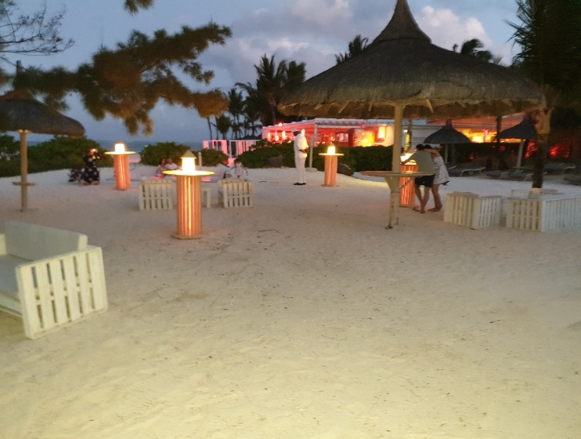
- GIN BAR 2. THE FLUTE
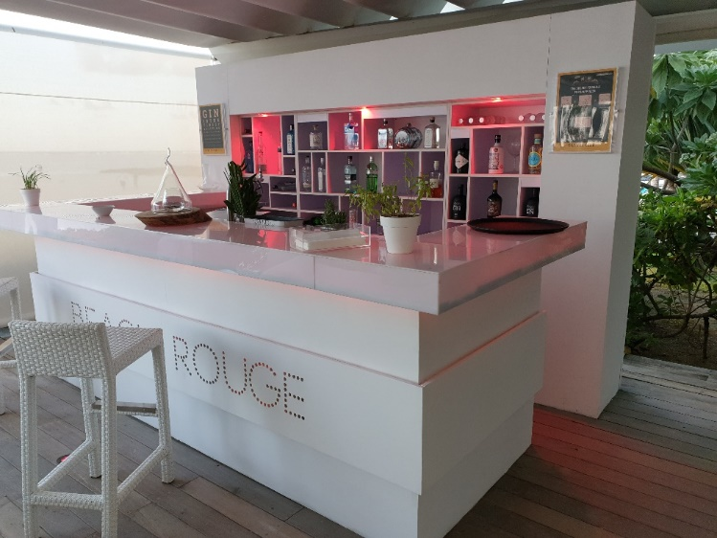

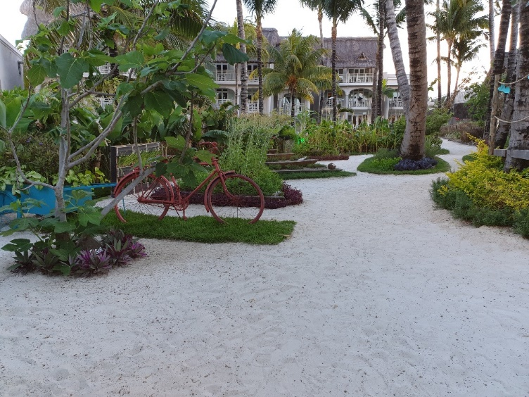
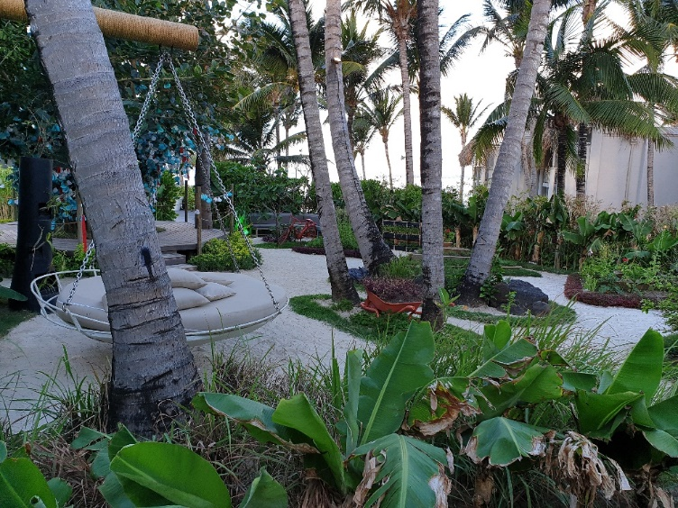
3. HERBS GARGEN

- SANDY TOES BAR 6. ALFRESCO
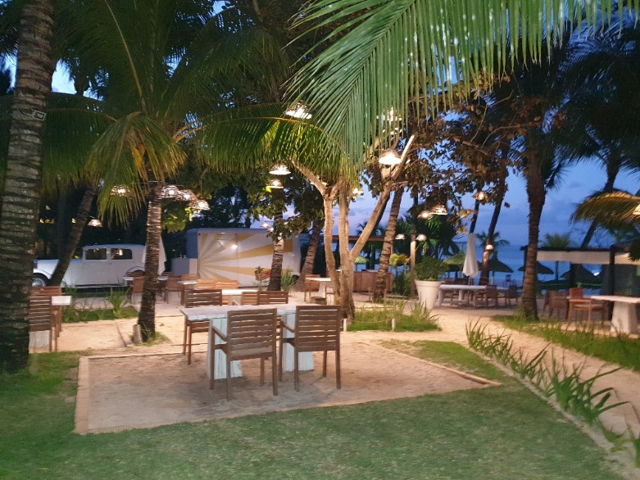
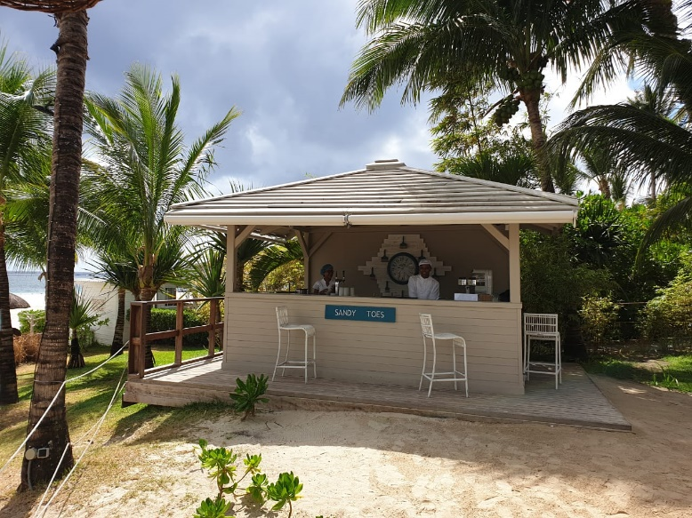

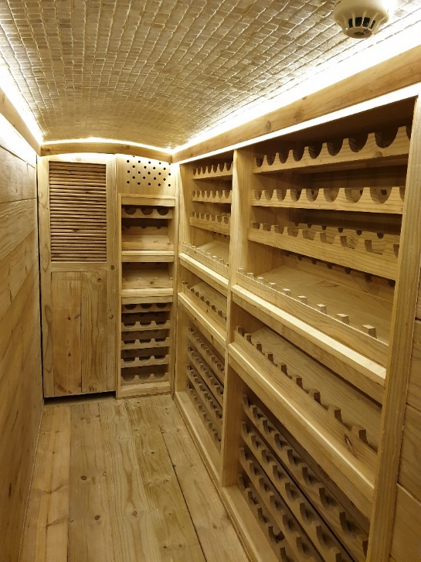
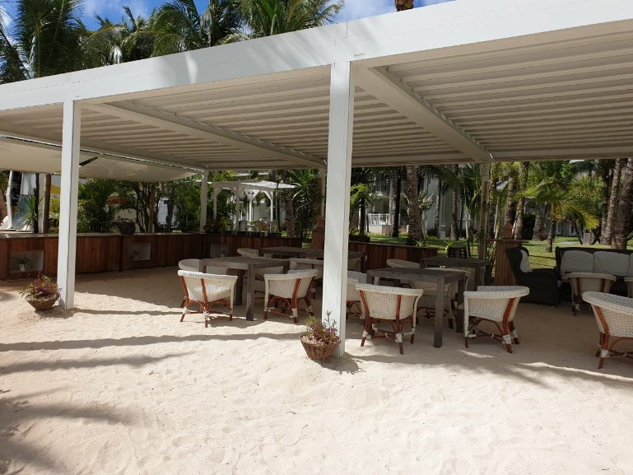
- THE PERGOLA 8. WINE CAVE

