Computer systems fundamentals



Student name: Naeed Khan 2228648

Lecturer: Stallion Jacob

Course: digital skills

Table of Contents
Contents
Table of Contents 2
Introduction 3
Task one 3
Building a pc on budget cost 3
Shopping list 5
Gigabyte H610M H V2 DDR4 mATX Motherboard 10
Intel CPU BX8070110100F Core i3-10100F / 3.6GHz / 6MB LGA1200 4C / 8T 10
Crucial 8GB (1x8GB) 3200MHz CL22 DDR4 Desktop Memory 10
Bliksem SSD 256GB SATA III 6Gb/s internal Solid-State Drive 2.5″ 7mm 10
WD Blue 1TB Desktop 3.5" Internal Hard Drive, 7200 RPM Class, SATA 6 GB/s, 64MB Cache, 2 Year Warranty 10
SHOWKINGS Radeon RX 580 Graphic Cards, 8GB 256Bit 2048SP GDDR5 AMD 10
AOC 24B3HM - 23.8 Inch FHD Monitor, 75Hz, VA, 4ms, Free Sync, Low Blue light, Flicker Free, 10
Hypercube USB to 3.5mm, 10
Desktop Computer Case Switch 10
iONZ KZ10 Series PC 10
Trust Doba 2-in-1 USB Headset with Microphone & HD Webcam 10
BENFEI SATA Cable III 11
ARCTIC P12 - PC Fan, 11
Conclusion on task 1 11
References 12
Task two 13
Introduction on task two 13
CPU SPEED 15
HARD DISK TRANSFER SPEED 16
graphic performance 17
Network internet speeds 17
Conclusion to task 2 18

Introduction
Building a desktop can be challenging as they are so many levels of building. To improve your desktop pc in capability e.g. if you are looking for a gaming pc then you would increase in motherboard, CPU, RAM, and many other parts that are needed in building a pc. You can build pc at budget cost too and that will help you for your use that you need it for. E.g. emailing, internet browsing.

Task one

Building a pc on budget cost

Processor/CPU:
A low-cost processor will be required such as intel i3 this is basic requirement for everyday tasks such as emailing, streaming, browsing.

Motherboard:
The budget motherboard compatible with CPU will be h610, a motherboard is the computer's primary circuit board. As the desktop pc is for basic uses this will be a good motherboard to purchase.

Ram:
8GB DDR4 RAM refers to a type of memory that is used for building a pc, this is also good memory storage for needing a basic pc and not for advanced uses.

Storage:
256GB SSD this indicates the amount of storage space that is available for the pc that is being built and for its purpose this is good amount of storage.

Hard drive:
7200 RPM SATA HDD 1TB or more
The hard drive will store videos, documents, and pictures.

Operating systems:
There are many types of operating systems available, but I think for this pc windows 10 will be more suitable, it built with security and more protection.

Graphics:
Integrated graphics are enough for its non-gaming tasks.

Monitor:
A large screen of 21 to 24inches will be suitable for use, better image quality and with a larger monitor more pixels, comfortable viewing.

Mouse and keyboard:
Easy font sizes and full large keyboard and mouse with easy navigation not too advanced.

Webcam:
A basic webcam that can be used to video call family and friends, easy to use, nothing too complicated.

Input/output port needed:
There are various ports that require USB ports, audio ports, wireless connections, ethernet port, keyboard/mouse if they not wireless, webcam power supply, storage connectors.

Suitable case and power supply:
NZXT H510 compact ATX mid tower case
Here Is details of a budget case that affordable and looks good, clean, and modern design.

Network connectivity:
You would want the use of wired and wireless choice.

Shopping list

CPU

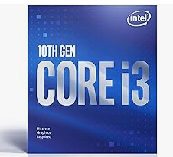 https://www.googleadservices.com/pagead/aclk?sa=L&ai=DChcSEwj_3fGxmtaDAxVAkYMHHTcrAN4YABALGgJlZg&ase=2&gclid=Cj0KCQiAwP6sBhDAARIsAPfK_wb9XfqzxbjeYmalwo_KL8eEH2NM5baXE6IWuZMYCLJ4hblvBPGBKgEaAnU6EALw_wcB&ohost=www.google.com&cid=CAESVuD2XwfBaYWzsThOpIWv0RivmTUNWT0gUv-4WBc9fmw-U_4NUEwsWksdDGtk3n1yNsh4nxVW6lrXCO2utj4fY-4VlvzYmp5jv3kN3WyQQt5vWrY_kGV9&sig=AOD64_1HmRlTgt2DDebkzkf_TGy4JfC5CA&ctype=5&q=&nis=4&ved=2ahUKEwjN0uexmtaDAxWD9bsIHTfgDKAQ9aACKAB6BAgGECg&adurl=

£69.99

MOTHERBOARD
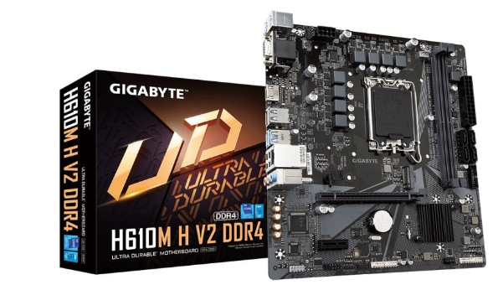 https://www.googleadservices.com/pagead/aclk?sa=L&ai=DChcSEwjH8-jClNaDAxUno4MHHdO3CowYABAOGgJlZg&ase=2&gclid=Cj0KCQiAwP6sBhDAARIsAPfK_waRVN8bKpuDPShccdIDJw-t6ugjDJaxMdksDI1FQ9VaS074Q9cmdNgaAvSKEALw_wcB&ohost=www.google.com&cid=CAESVuD2sE4fl_OkwfDqaPHpCiyvGuspNe2hCF77cr7wSbPdcz_tZsw0GD5AyK1GhxS_Pj8QUE_ndhVBvJAN4CiQlWsI3ICKjSRlP8y5r7ziunW54cNgE6oB&sig=AOD64_3McTtPL_6g6ycfiunJZo4_RGZQVg&ctype=5&q=&nis=4&ved=2ahUKEwjHpuLClNaDAxVvhf0HHYR3DUEQ9aACKAB6BAgEEDI&adurl=

£78.99

RAM

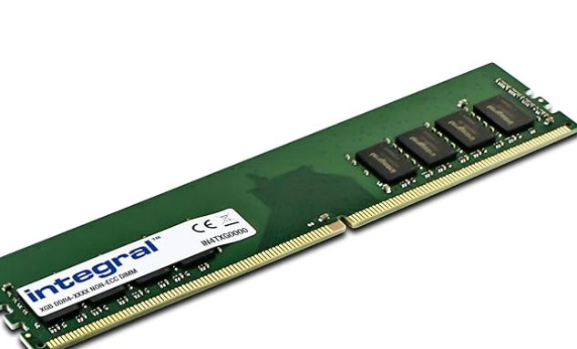 https://www.googleadservices.com/pagead/aclk?sa=L&ai=DChcSEwj-_oG2ldaDAxVNimgJHW_8CowYABAKGgJ3Zg&ase=2&gclid=Cj0KCQiAwP6sBhDAARIsAPfK_wbuWxgV36pU2x1byyLxZOvjfCU3CuXqRZ6NHVCx_H4QAfd2GLzu3TAaAmTrEALw_wcB&ohost=www.google.com&cid=CAESVuD2yg_Rklb3zpE2kPG0MryPauKlH8jnv354NyjaqHeyhAaEimIeA6n0jeDMsC2-R2SATnYb1mFzKlP05veuc3yjquoEoW0tDTDRxrIRELMBJ-aBcma4&sig=AOD64_29uwAFJDy6MLD6FRpwTPksZ5W5QQ&ctype=5&q=&nis=4&ved=2ahUKEwiiqPu1ldaDAxVH_7sIHZIPAyAQ9aACKAB6BAgDEEw&adurl=

£17.99

STORAGE SSD

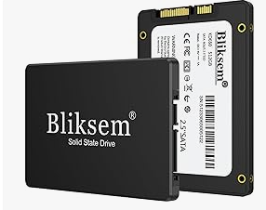 https://www.amazon.co.uk/Internal-Compatible-Desktops-Bliksem-H650%EF%BC%88Black/dp/B09WDGPHVR
£17.99

HARD DRIVE
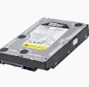 https://www.amazon.co.uk/WD-TB-PC-Hard-Drive/dp/B0088PUEPK
£46.97

GRAPHIC CARDS
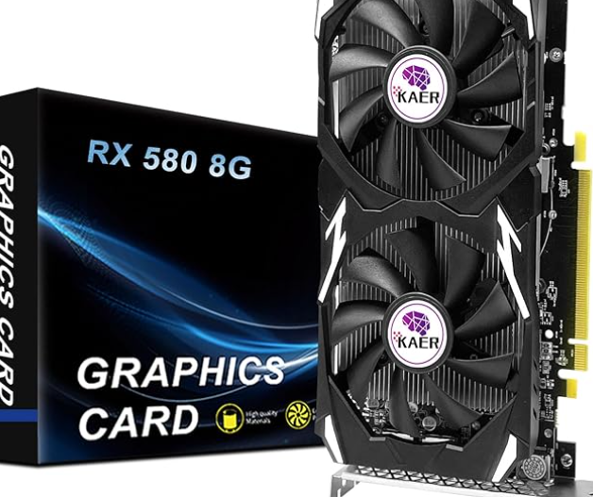 https://www.amazon.co.uk/SHOWKINGS-Radeon-Graphic-HDMI-Output-Express/dp/B0C6PY9BNW
£129.99

SATA CABLE
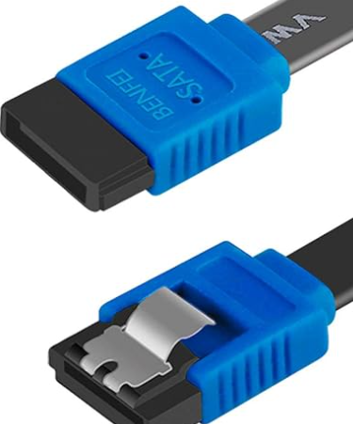 https://www.googleadservices.com/pagead/aclk?sa=L&ai=DChcSEwjgwY-Mx9eDAxX3h1AGHQ_nCPwYABAOGgJkZw&ase=2&gclid=CjwKCAiA44OtBhAOEiwAj4gpOZirFPezL0qwf_lFbnq4AEXduD0CJJaihCaBLxF8d9EXWMiBotLmoBoCem0QAvD_BwE&ohost=www.google.com&cid=CAESVuD2NTQ-U5wP3hTdMwPBK6Zjx0NJJm_gI23lQgHDRmAoXgFDWrzHSpA5BJvI6ME9UPPjQWzEBdmBmpnsNvhaHgeTHZnqIn4gmr2YdC3t0hLMzLBijTrv&sig=AOD64_1yzt2HAUj-fIOSwNGZP9_EzDaEbg&ctype=5&q=&nis=4&ved=2ahUKEwiym4qMx9eDAxXAQkEAHSJDBoQQ9aACKAB6BAgEED0&adurl=

MONITOR
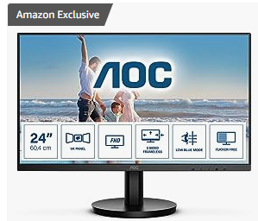
https://www.amazon.co.uk/sspa/click?ie=UTF8&spc=MTo1MzUxMTQ5MzE0MDI1MDEwOjE3MDUwMDY0MjE6c3BfYXRmOjMwMDA1MzU0MTc5MDgzMjo6MDo6&url=%2FAOC-24B3HM-FreeSync-Flickeer-Frameless%2Fdp%2FB0BT4Y3Y4H%2Fref%3Dsr_1_1_sspa%3Fadgrpid%3D134890421181%26dib%3DeyJ2IjoiMSJ9.1WGo-6Ajxh5AtInhPP3_LBhI52u0SVKXlXBIGF7aRx7Fsd988Zp9-97_vnQmBtG3sPrU02MD8VPxnFHxrxWT4Q.Vxc_TbCejFUBQosy2Fpo3BKYJuWrZc9kegbS2Y40WE4%26dib_tag%3Dse%26hvadid%3D605403243559%26hvdev%3Dc%26hvlocphy%3D9046655%26hvnetw%3Dg%26hvqmt%3De%26hvrand%3D1287772484483576128%26hvtargid%3Dkwd-301502006575%26hydadcr%3D24890_1723790%26keywords%3Dmonitor%2B21%2Binches%26qid%3D1705006421%26sr%3D8-1-spons%26sp_csd%3Dd2lkZ2V0TmFtZT1zcF9hdGY%26psc%3D1
|£79.99

INPUT/OUTPUT PORT
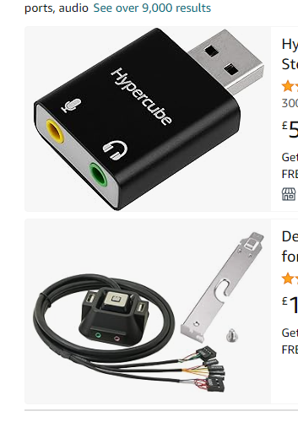 https://www.amazon.co.uk/Hypercube-Headphone-Microphone-converter-Compatible/dp/B0BN6WJF8R/ref=sr_1_fkmr0_1?crid=YX1DU4XK1RJD&dib=eyJ2IjoiMSJ9.xvFAPS1P6zhDkLq_ovqUVD_lXjntpsLhUASMLrs63Cw.lU_hWgkfdKePNGqgWnzdy7SJGL2MnqHrbThGIG8oV2g&dib_tag=se&keywords=There+are+various+ports+required+USB+ports%2C+audio+ports%2C+wireless+connections%2C+ethernet+port%2C+keyboard%2Fmouse+if+they+not+wireless%2C+webcam+power+supply%2C+storage+connecters.&qid=1705006631&sprefix=there+are+various+ports+required+usb+ports+audio+ports+wireless+connections+ethernet+port+keyboard%2Fmouse+if+they+not+wireless+webcam+power+supply+storage+connecters.%2Caps%2C99&sr=8-1-fkmr0
£5.99
https://www.amazon.co.uk/Desktop-Computer-Switch-Reset-Button/dp/B083FN2L3L/ref=sr_1_fkmr0_2?dib=eyJ2IjoiMSJ9.xvFAPS1P6zhDkLq_ovqUVD_lXjntpsLhUASMLrs63Cw.lU_hWgkfdKePNGqgWnzdy7SJGL2MnqHrbThGIG8oV2g&dib_tag=se&keywords=There+are+various+ports+required+USB+ports%2C+audio+ports%2C+wireless+connections%2C+ethernet+port%2C+keyboard%2Fmouse+if+they+not+wireless%2C+webcam+power+supply%2C+storage+connecters.&qid=1705006797&sr=8-2-fkmr0
£11.99
TOWER/ CASE
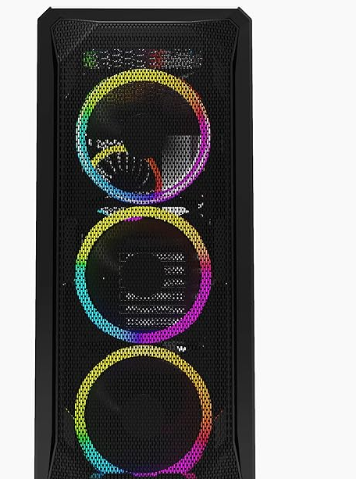 https://www.googleadservices.com/pagead/aclk?sa=L&ai=DChcSEwiW2-jAndaDAxUukoMHHda4BJMYABAOGgJlZg&ase=2&gclid=Cj0KCQiAwP6sBhDAARIsAPfK_wZ3gn1RM_8AZUJAjO0x36j1Z3I7QTlw0jca_zlV30v5jKyk2VYvyXMaAhKgEALw_wcB&ohost=www.google.com&cid=CAESVuD2X1DHdd8VQpfCq1ItUFA1nIeQ9SDa_ANVbLatTHvBJVleVK0nAA1QDAtLkgi9SDCvWdxslcWH8u5wuXPH4myi2nSx2u7bPmAlp-L2dzva8nrzee18&sig=AOD64_3dusAjU6dkiGHAv4L_y0bkSezvNw&ctype=5&q=&nis=4&ved=2ahUKEwj6luDAndaDAxU5gv0HHQ4wDDEQ9aACKAB6BAgEEEg&adurl=
£38.95

KEYBOARD AND MOUSE
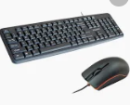
https://www.googleadservices.com/pagead/aclk?sa=L&ai=DChcSEwid-t2VxNeDAxWfilAGHWG6Aa0YABANGgJkZw&ase=2&gclid=CjwKCAiA44OtBhAOEiwAj4gpOQH2O3jUaM8suGPLy8ZsBCmpJNlpIRhtz7luhiXIxqq7gp5_obpm3hoCEjQQAvD_BwE&ohost=www.google.com&cid=CAESVuD2rKmtW1cibq164wiyxu-GyXt9NB86yVULCpv8OxgFoidbK1JzGeDRvSW7tCYh3A53De26x2C2ToaPpHNwWToNvwwzxbRTCQFqkX0n8raT5S749eQF&sig=AOD64_0-pB_GcLAtMOLzhfdA4yCYQmHyIA&ctype=5&q=&nis=4&ved=2ahUKEwjRxdWVxNeDAxVTSkEAHWh1BhwQ9aACKAB6BAgEEEY&adurl=
£8.00
HEADPHONES AND WEBCAM SET
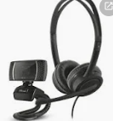
https://www.googleadservices.com/pagead/aclk?sa=L&ai=DChcSEwido7OVxdeDAxWymFAGHfrpB0oYABAMGgJkZw&ase=2&gclid=CjwKCAiA44OtBhAOEiwAj4gpOYNkJtlel6pVahXf-rIHgGBExYSUmIPCO_g1utvOaeUR0rPoGCpWNhoCkSQQAvD_BwE&ohost=www.google.com&cid=CAESVuD26_5lBatZbv6PDGhL08RRv9nx2EPhczDr_B5D0MmsfWETtjEiqN1CeelzWZ6NpBnwaq3dhxEXcTCVRwtia11f69A7BWj1Y77Y4V1ZFiU9gRC3BdXd&sig=AOD64_2Uwc1jb7kNrLo6s2qUBF8Ktauy1A&ctype=5&q=&nis=4&ved=2ahUKEwj_mq6VxdeDAxXcTEEAHQcLCBYQ9aACKAB6BAgEEGU&adurl=
£9.97
FAN
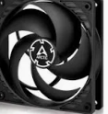
https://www.googleadservices.com/pagead/aclk?sa=L&ai=DChcSEwiw3df_ydeDAxXDmlAGHdhyDOIYABALGgJkZw&ase=2&gclid=CjwKCAiA44OtBhAOEiwAj4gpOYY6upzwjG4WwyMa_P81K1KVIkGvNKP7mV9LUD6pC4j1Rh6prkEXJRoCEQEQAvD_BwE&ohost=www.google.com&cid=CAESVuD2GW6S57w33noQrqGIH5gR1mx74ksYyyTF7YNiQugADMTxn8jgV5j4nxZqx3qoy3i7K3tgrq7Sexe0poYxqBL0kkmct1Ux-zcQOEdBGqRud3UZNlxb&sig=AOD64_1MX1BiZmqSJ5GB9SpRw8qMoUthaA&ctype=5&q=&nis=4&ved=2ahUKEwiypNL_ydeDAxXbQkEAHaWPCLgQ9aACKAB6BAgGEB0&adurl=
Quantity | Product | Price
1 | Gigabyte H610M H V2 DDR4 mATX Motherboard | £78.99
1 | Intel CPU BX8070110100F Core i3-10100F / 3.6GHz / 6MB LGA1200 4C / 8T | £69.99
1 | Crucial 8GB (1x8GB) 3200MHz CL22 DDR4 Desktop Memory | £17.99
1 | Bliksem SSD 256GB SATA III 6Gb/s internal Solid-State Drive 2.5″ 7mm | £17.99
1 | WD Blue 1TB Desktop 3.5" Internal Hard Drive, 7200 RPM Class, SATA 6 GB/s, 64MB Cache, 2 Year Warranty | £46.97
1 | SHOWKINGS Radeon RX 580 Graphic Cards, 8GB 256Bit 2048SP GDDR5 AMD | £129.99
1 | AOC 24B3HM - 23.8 Inch FHD Monitor, 75Hz, VA, 4ms, Free Sync, Low Blue light, Flicker Free, | £79.99
1 | Hypercube USB to 3.5mm, | £5.99
1 | Desktop Computer Case Switch | £11.99
1 | iONZ KZ10 Series PC | £38.95
1 | Infapower Full Size Wired Keyboard and Mouse | £8.00
1 | Trust Doba 2-in-1 USB Headset with Microphone & HD Webcam | £9.97

Quantity | Product | price
1 | BENFEI SATA Cable III | £2.29
1 | ARCTIC P12 - PC Fan, | £8.69
 | Total cost | £526.83

Conclusion on task 1
For an elderly relative wanting a low-cost budget desktop pc, the list of products on the table above are seem best of value, they include all features that are required. Simplifying and keeping cost low will benefit them to be able use a pc that has good speed, storage and can make video calls on there communicating with family and friends. It is important to understand that everyone needs advanced pc if they are not gamers or using it for advanced purpose then purchasing a desktop with extra speed, storage may not be benefit to them.

Some benefits to a low budget pc can be for many people those that are needing to communicate via email us it for internet browsing keep a pc simple for them can help on space as well as you won’t be needing so much equipment.
We need to research each part to help keep costs low and which is the best value for a PC desktop. When looking at RAM you must look at what will be the best amount for memory, using the operating system windows 10 as this has better security features and protection 8gb memory will be enough for building a pc.
Each part that is needed for a pc can be brought at levels of increased storage, memories for building games when comparing and researching the parts listed in the tables seem of best value to build a pc. The motherboard is also known as system board, logic board or the main board. This is the key feature in connection of parts the connect to mother board for a pc to be built. Keeping in mind the requirements needed for a PC, you must look at all equipment such as the hard drive, cables, headphones, keyboard, mouse, and webcam plus many other requirements. Keeping everything to its best capability and budgeting the cost low. You would use easy to use keyboards and mouse, so they are not too advanced for an elderly relative.

References
"Computers For Seniors - Best Buy." https://www.bestbuy.com/site/shop/computers-for-seniors.

"How to Choose the Right RAM for Your Desktop or Laptop PC." 06 May. 2021, https://www.pcmag.com/how-to/how-to-choose-the-right-ram-for-your-desktop-or-laptop-pc-in-2021.

"What is a motherboard: your computer's foundation explained." 09 Oct. 2023, https://www.techradar.com/computing/motherboards/what-is-a-motherboard.

"Amazon.com: Headphones'." https://www.amazon.com/headphones/s?k=headphones%27.

"Internal Hard Drives | Amazon.com." https://www.amazon.com/Hard-Drives-Internal-Desktop-Components/b?node=1254762011.

"Amazon.com: Computer Keyboard & Mouse Combos - Computer Keyboard ...." https://www.amazon.com/Computer-Keyboard-Mouse-Combos/b?node=1194464.

"Amazon Best Sellers: Best SATA Cables." https://www.amazon.com/Best-Sellers-SATA-Cables/zgbs/pc/3015394011.
"How To Build Your Own PC | Parts, Budget, Step-by-Step." https://www.crucial.com/articles/pc-builders/how-to-build-a-computer.

https://www.youtube.com/watch?v=N4pA_JAwJQ0

"The Best Budget PCs in 2024 - Life wire." 18 Sept. 2023, https://www.lifewire.com/best-budget-pcs-832103.

Task two

Introduction on task two

I will be sharing information based on my own personal desktop pc and what size speed, memory hard drive is used and the benefits in using a pc with extra storage and for what I use it.
Key features in a pc are the appearance of the other, speed and storage is particularly important as many times it is used for building games and the storage is important to be able to save it on my pc. There also DVD features if I wanted to burn cd, excellent for using various search engines and using Microsoft 365 for any work I need to send. It has multiple users accessing the pc using their own google account and endless videos pictures etc saved on there.
Good set of headphones on playing online games as well as advanced keyboard and mouse features. webcam with built in microphone to use for teaching and studying. A high-performance graphic card a high core count CPU, with impressive performance RAM.
The p cis dedicate to mainly visual quality so its appearance is looking as one of the key features, the case itself is containing many lighting features.

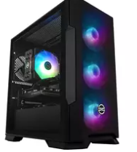a tower that looks good for my gaming pc was a good feature, when thinking of buying o was looking for something that had a lot of lights and more the transparent look. Many gaming cases are designed with best airflow to keep components cool. Many have cable management features. This will allow you to keep your build neat and tidy.

RAM size which is in my computer is 32gb can manage multiple applications and once and when building and playing it increases the storage to be used before the pc is turned off. Smother multi-tasking, faster data access and improved performance. It helps enhance system speed and helps future proof your device as software and workload becomes more demanding.

Graphic card gtx10 50ti is the one that I am using in my current pc this increase the graphics on games. videos, visual images and increases loading speed.
Motherboard I bought one suitable for a gaming pc they were many options available in this field such as ASUS, MSI, or GIGBYTE they key feature to look for in this is the one that is most compatible with the CPU you have bought. The mother board in my gaming pc is an LGA 1150, some of the benefits of this mother board is that it compatible with CPU I have, the sockets provide a range of options including core i3, i5, and i7 CPUs.

CPU intel core i5 5th gen, this has many key features such as improved power efficiency compared to many of the other generations that are available. Graphic performance saw many improvements. One of the benefits to the intel i5 fifth generation is that it is compatible to most motherboard, which is particularly important as mother board is the key feature in building a pc.

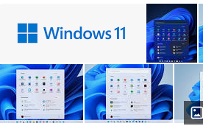
The O/S (operating system) is windows 11 and the benefits of it are that the computer is more secure and it is safer to use as older operating systems are more vulnerable to hackers making it more dangerous for you as you are at risk of potentially getting hacked or receiving a trojan horse from someone trying to harm you with malicious intent.

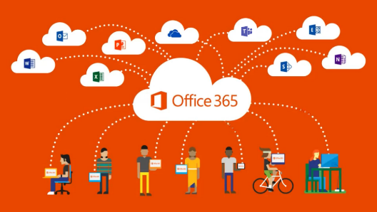
This Photo by Unknown Author is licensed under CC BY-SA
Installed applications are a variety or Microsoft office 365 apps as it is easy to work and fast and responsive Aswell as a virus threat protection service and a few gaming apps that help boost performances or allow clips to be recorded over the computer such as NVidia panel.

Internet connectivity has two 2.4 connections sticks at the back of the computer to have access to connect to internet wirelessly however, there is a possibility to use and ethernet cable is so wished to which is a big positive, because wired connections supply stronger internet output.

CPU SPEED
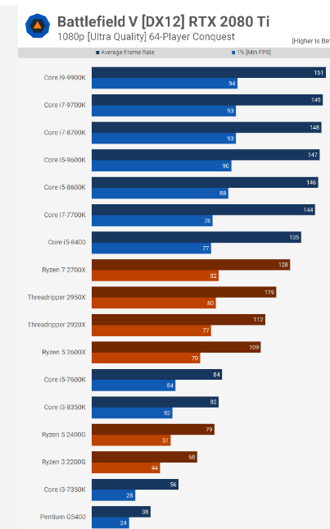

When comparing CPU speeds, it features to look at are clock speeds allows you to know the speed on how fast the CPU can obtain instructions.
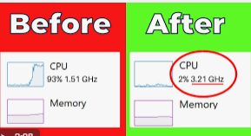

Cores and threads: the modern CPU come with multiple cores, more core and thread can lead to multi-tasking and performance.
Integrated graphics, some CPUS have graphics this can be good for pc that do not have graphic cards.

HARD DISK TRANSFER SPEED

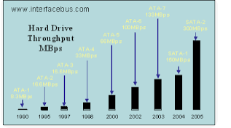

A typical hard disk 7200 rpm hdd will deliver read and write speeds of 80 -160 mb.
The transfer speed of a hard disk is vital to see how fast data can be written or read.

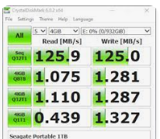
several factors that can influence the transfer of hard disk. Rational speed, data transfer interface, internal data transfer rate. Chace size

graphic performance

graphic performance is a measure of how well graphics are performing, graphic performance benchmarks are tools to assess and compare compatibility of graphics processing unit. theses measure various aspects such as 3D, superposition, fur mark,

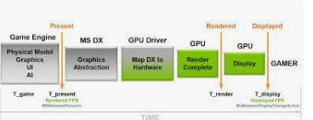

Network internet speeds

They are several tools that measure the aspects of your connection. Speed test by Okla., fast .com, ping test, fast speed test.
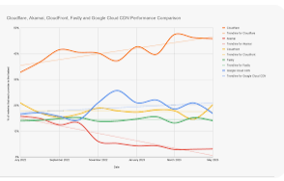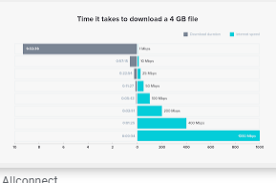
The Ip address of the machine acting as a server and port numbers are used to help with security system protection. Duration of the test, tests threads.

Conclusion to task 2

To be able to share the information on personal pc and to be able to understand the benefits of a budget pc has helped me to gain more knowledge on purpose of each part and importance in speed, storage compatibility , as well understanding the main connection for building is a motherboard they are many different types so it always important to get the one that compatibility with your CPU.

