Ibrahim Balogun
Programming in C

Contents

Exercise 1 2
Exercise 2 4
Exercise 3 9
Exercise 4 11
Appendix 16
Exercise 1 16
Exercise 2 16
Exercise 3 18
Exercise 4 18

Exercise 1

Before I started the task, I made a flow chart in figure 1, that will describe each step of the exercise, the first steps are making sure that the user can adequately enter their data, the data then needs to be stored in the same way and displayed back to the user.
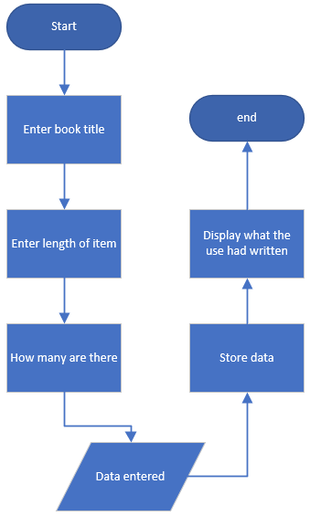
Figure 1

The first stage for development for exercise 1 is to start on where the user will enter their data, I have created a new variable that is called bootTitle, this is where the user will enter the title of the book, I then added getline command this, will allow the code to save what the user answer, as shown in figure 2, there is a screenshot of the tested code, to make sure that the code works, in figure 3.
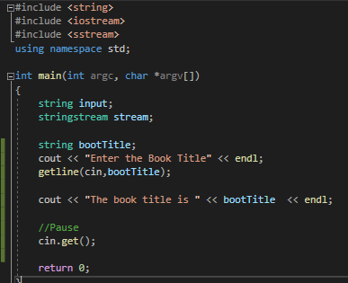 | 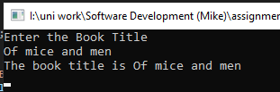
Figure 2 | Figure 3

The next stage is adding the other areas to the code that the user will use to answer the other questions. Adding the code was simple I had to add new variables to the code and give them different names, this way it would be easier to identify the variables and I added an output, so the user will know what data they have entered at the end of the code, as shown in figure 4, there is also a result of the test in figure 5.
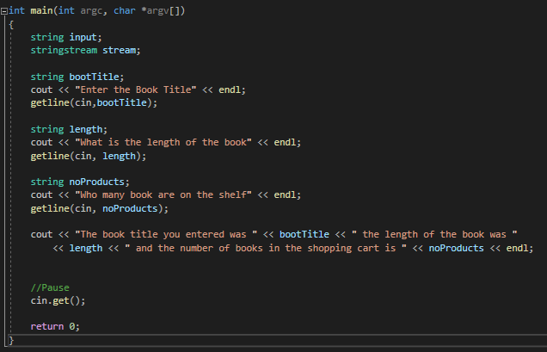
Figure 4

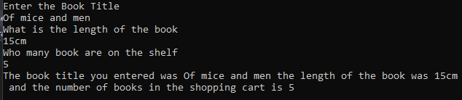
Figure 5

Exercise 2

Exercise 2 brought up a different problem to exercise 1, so I made a flow chart in figure 6, to show me the flow of task I will undergo, the first challenge is calculating the area of a circle by using C++. The area of the circle has needs to be calculated. I will then need to calculate the area of the white box, the reason for this is that they are not part of the blue box and their value combined will need to be taken away from the area of the blue box to give us the total area of the box, on the other hand, if the user types in a value for the white circle and box that is greater than the blue, it will pass up an error. The user will have to start again until the blue box area is higher.
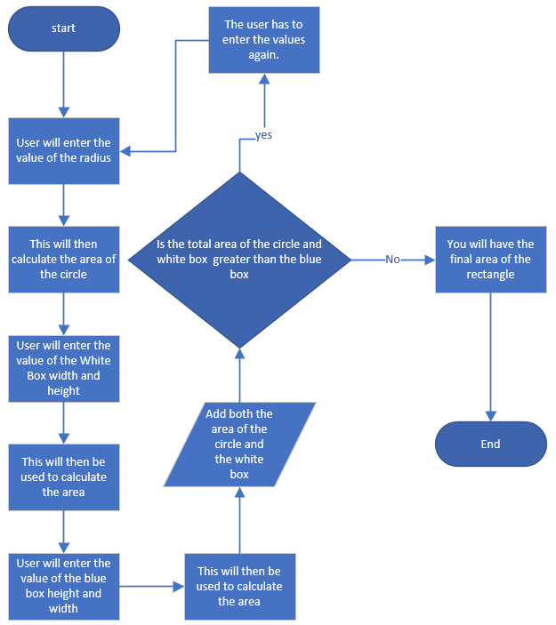
Figure 6

The first task I started with was making sure the user can type in the value of the radius, and it will then need to be calculated into the circumference. The first problem I had was when I was trying to work out the area of the circle, which is πr2. When it came to squaring the radius value, I multiplied the radius value by itself, which should give the of the square value. The C++ doesn’t have a set constant for PI, so I created a new variable and gave it the value of PI to the 11th decimal place, to try and make my answer as accurate as possible as shown in figure 7, figure 8 is the result of the test.
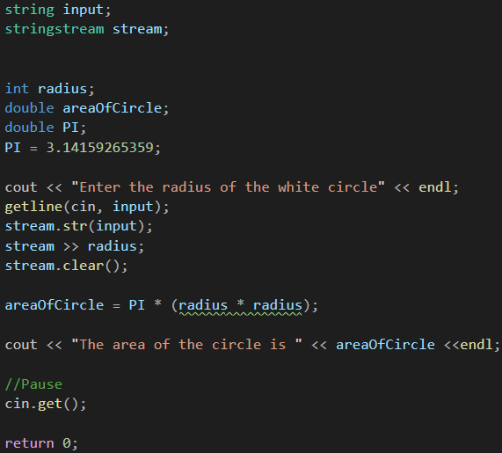
Figure 7

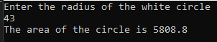
Figure 8

There was a warning prompt telling me there was a problem with code, on line 23 this was the section I use to work out the area of the circle, to mitigate this problem I decided to create a new variable for the squared number, this way the error warning shouldn’t appear as shown in figure 9
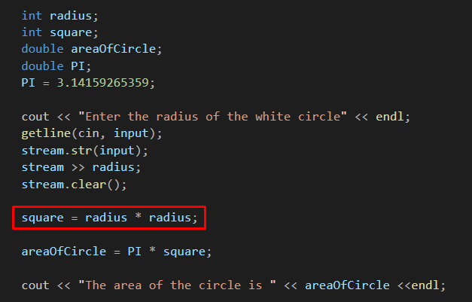
Figure 9

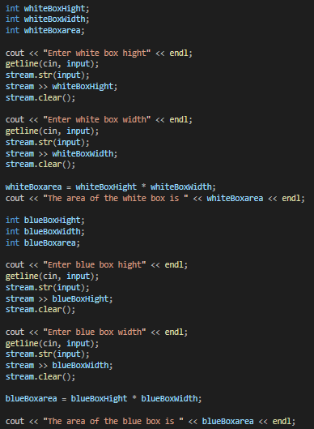
Figure 10
The next stage is working out how to calculate the area for the white box and blue box, I have put these in the category because they require the same code to run but different names, so they don’t get mixed up, in figure 10 I have the code and in figure 11 is the results of the code being run

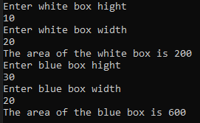
Figure 11

The next step is to calculate the difference between the blue space and the white space; to do this, I created a variable as shown in figure 12; this will make the whole process of add the circle and white box value easier.
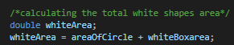
Figure 12

Following that, I had to create an IF statement to make sure that the user has typed in the correct values because if the white space is higher than the blue, the area would be a negative number, which would not make any sense. Figure 13 shows this IF statement, and figure 14 shows the result of the whole code. To make sure that the IF statement works, I entered unreasonable values; figure 15 shows the results of this test.
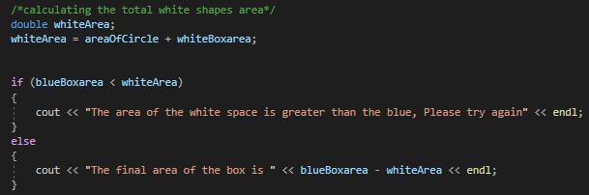
Figure 13

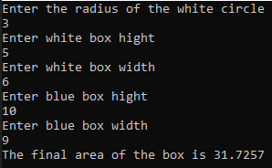 | 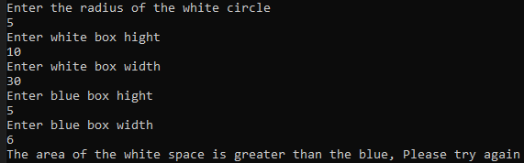
Figure 14 | Figure 15

The final code layout for exercise 2
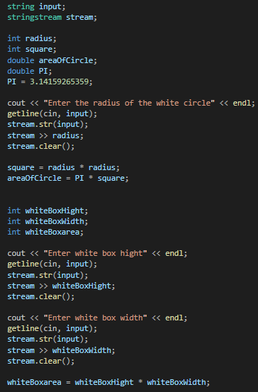
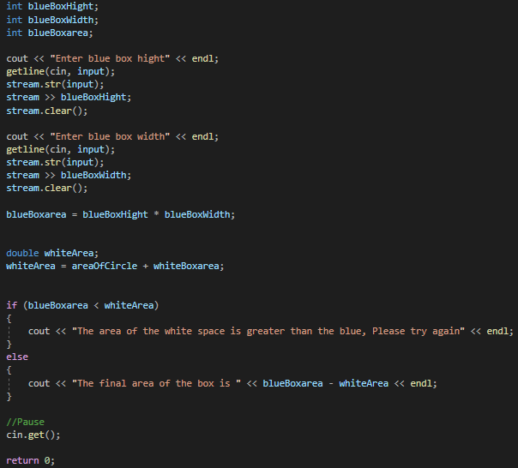

Exercise 3

This task I had to create an array that a user will have to enter values and they need to be converted, to make this task easier I create a flow diagram, in figure 16.
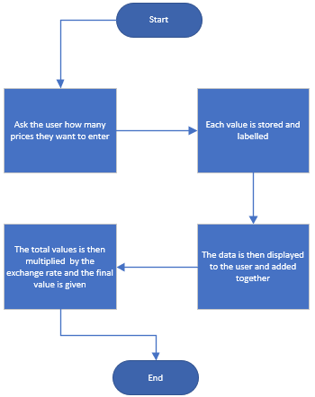
Figure 16

The first step is allowing the user to enter how many prices they want to be converted and storing those value, so we know the size the array. To make sure the user doesn’t enter one thousand prices and use up all the ram, I set a limit to have may values can be entered which was 50 as shown in figure 17
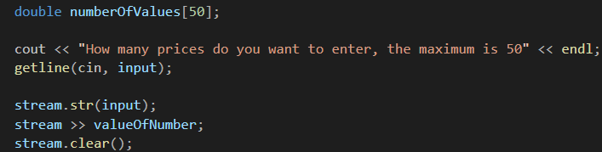
Figure 17

The next stage of this is to create an array that the user will use to enter their set prices, the number of prices is based on how many prices the users wanted to enter. I made the prices a double variable because this allows the user to type in values to the second decimal place, making this exercise represent the real world, this is shown in figure 18.
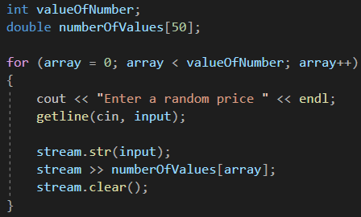
Figure 18

I would now need a way to access all the values entered, and I will also need to add them and display these values to the user. I did this by creating a new variable for the total price entered and another array; this can be seen in figure 19.
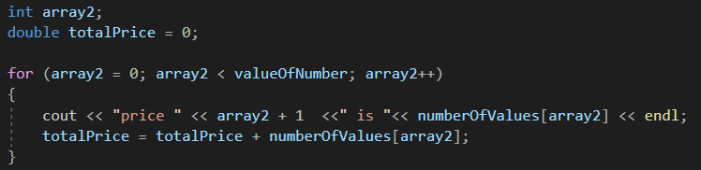
Figure 19

The final stage is converting the total price of the values entered into euro’s, and according to google the exchange rate for the euro to a pound is 1.12, so with this value I made a new variable and gave it a fixed value of 1.12, to represent the euro, and I then multiply the total values entered by the user by the euro as shown in figure 20 and there is a test of the code in figure 21.
Figure 20
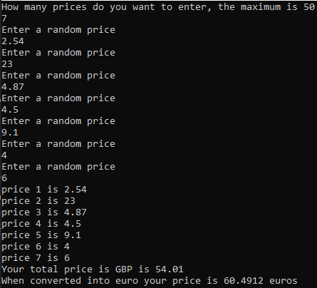
Figure 21

Exercise 4

The first stage is working out the steps that I will need to conduct to make sure that I complete the task; this is shown in figure 22. The first action I take is to make sure that player one can enter the coordinates of the treasure and that the values will be saved. Player two needs to enter their coordinates if the coordinates match there should be a message saying that player two has found treasure if not it will say player two has not found any treasure and the number of treasures that player two finds should be visible.
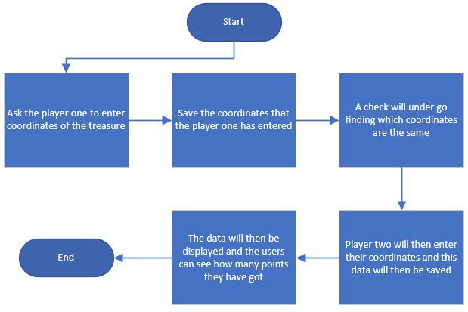
Figure 22

The first step is to display the board where the player will enter their coordinates, in figure 23, a map was created, this was made to make sure the values started from one instead on zero.
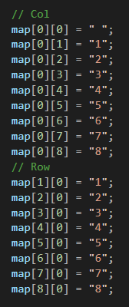
Figure 23

The next step is allowing player one to enter the coordinates this was done by creating a variable for both X and Y values three times because that’s the number of time player one is going to enter the value, the value will then be saved and used in an IF statement.
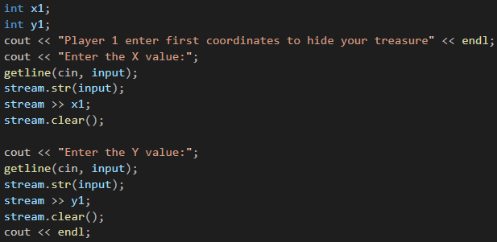
Figure 24

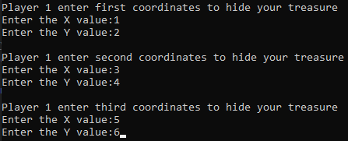
Figure 25

I add this to the code to separate what player one typed in to make sure that player two cannot just scroll up the screen to see what player one entered, making the game reality.
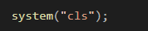
Figure 26

The first thing to show up on the next page are instructions for player two so that they can enter their coordinates a map will then be shown giving the user an idea of where they can place their coordinates.
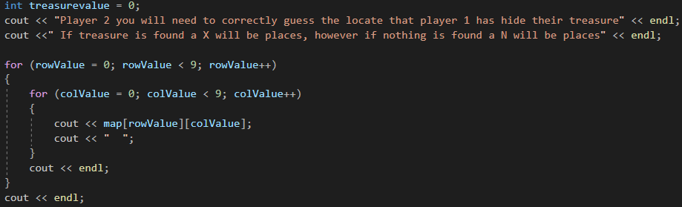
Figure 27

The next step is adding the area where player two will enter their guess, and I also gave the values introduced a variable this way it is more straightforward to keep track, this was done three separate times to simulate the number of time player two will have to guess.
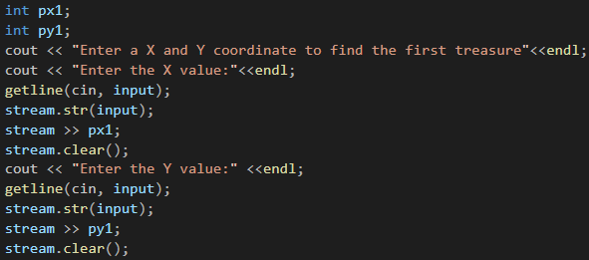
Figure 28

The IF statement in figure 29 shows how the check who be conducted to find out if player one values are the same as player two, by using the variables assigned to each value, I said if players one X and the Y value is the same with player two’s place, an X in the coordinates of player two used and display a message that player two has found treasure, if not place a N and a message saying that the player hasn’t found any treasure, the integer name treasurevalue is a counter so if the statement is positive the counter will be added, figure 30 and 31 shows the result.

Figure 32 and 33 show the treasurevalue variables as player two only finds 1 out of the three treasures on the map, and that is what gets displayed.
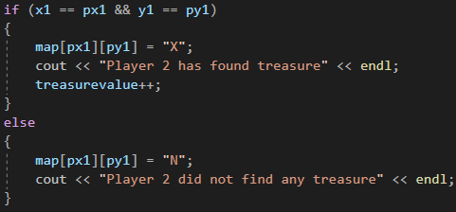
Figure 29

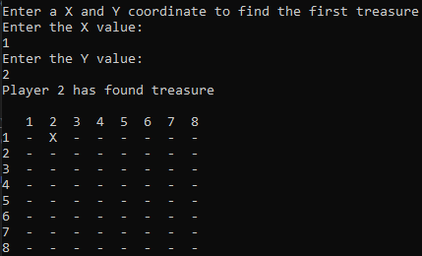
Figure 30

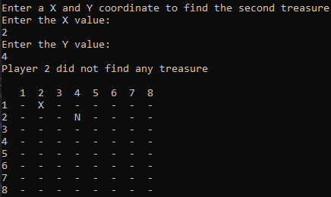
Figure 31

Figure 32

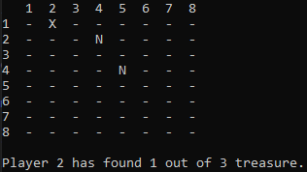
Figure 33

Appendix

Exercise 1
#include <string>
#include <iostream>
#include <sstream>
using namespace std;

int main(int argc, char* argv[])
{
string input;
stringstream stream;

string bootTitle;
cout << "Enter the Book Title" << endl;
getline(cin, bootTitle);

string length;
cout << "What is the length of the book" << endl;
getline(cin, length);

string noProducts;
cout << "Who many book are on the shelf" << endl;
getline(cin, noProducts);

cout << "The book title you entered was " << bootTitle << " the length of the book was "
<< length << " and the number of books in the shopping cart is " << noProducts << endl;

//Pause
cin.get();

return 0;
}

Exercise 2
#include <string>
#include <iostream>
#include <sstream>
using namespace std;

int main(int argc, char* argv[])
{
string input;
stringstream stream;

int radius;
int square;
double areaOfCircle;
double PI;
PI = 3.14159265359;

cout << "Enter the radius of the white circle" << endl;
getline(cin, input);
stream.str(input);
stream >> radius;
stream.clear();

square = radius * radius;
areaOfCircle = PI * square;

int whiteBoxHight;
int whiteBoxWidth;
int whiteBoxarea;

cout << "Enter white box hight" << endl;
getline(cin, input);
stream.str(input);
stream >> whiteBoxHight;
stream.clear();

cout << "Enter white box width" << endl;
getline(cin, input);
stream.str(input);
stream >> whiteBoxWidth;
stream.clear();

whiteBoxarea = whiteBoxHight * whiteBoxWidth;

int blueBoxHight;
int blueBoxWidth;
int blueBoxarea;

cout << "Enter blue box hight" << endl;
getline(cin, input);
stream.str(input);
stream >> blueBoxHight;
stream.clear();

cout << "Enter blue box width" << endl;
getline(cin, input);
stream.str(input);
stream >> blueBoxWidth;
stream.clear();

blueBoxarea = blueBoxHight * blueBoxWidth;

double whiteArea;
whiteArea = areaOfCircle + whiteBoxarea;

if (blueBoxarea < whiteArea)
{
cout << "The area of the white space is greater than the blue, Please try again" << endl;
}
else
{
cout << "The final area of the box is " << blueBoxarea - whiteArea << endl;
}

//Pause
cin.get();

return 0;
}

Exercise 3
#include <string>
#include <iostream>
#include <sstream>
using namespace std;

int main(int argc, char* argv[])
{
string input;
stringstream stream;

int array;
double euro = 1.12;
int valueOfNumber;
double numberOfValues[50];

cout << "How many prices do you want to enter, the maximum is 50" << endl;
getline(cin, input);
stream.str(input);
stream >> valueOfNumber;
stream.clear();

for (array = 0; array < valueOfNumber; array++)
{
cout << "Enter a random price " << endl;
getline(cin, input);
stream.str(input);
stream >> numberOfValues[array];
stream.clear();
}

int array2;
double totalPrice = 0;

for (array2 = 0; array2 < valueOfNumber; array2++)
{
cout << "price " << array2 + 1 <<" is "<< numberOfValues[array2] << endl;
totalPrice = totalPrice + numberOfValues[array2];
}

cout << "Your total price is GBP is " << totalPrice << endl;
cout << "When converted into euro your price is " << totalPrice * euro << " euros" << endl;

//Pause
cin.get();

return 0;
}

Exercise 4

#include <sstream>
#include <iostream>
#include <string>

using namespace std;

int main(int argc, char** argv)
{
string area[9][9];
stringstream stream;
string input;

// the column
area[0][0] = " ";
area[0][1] = "1";
area[0][2] = "2";
area[0][3] = "3";
area[0][4] = "4";
area[0][5] = "5";
area[0][6] = "6";
area[0][7] = "7";
area[0][8] = "8";
// the row
area[1][0] = "1";
area[2][0] = "2";
area[3][0] = "3";
area[4][0] = "4";
area[5][0] = "5";
area[6][0] = "6";
area[7][0] = "7";
area[8][0] = "8";

int rowValue;
int colValue;

for (rowValue = 1; rowValue < 9; rowValue++)
{
for (colValue = 1; colValue < 9; colValue++)
{
area[rowValue][colValue] = "-";
}
}
for (rowValue = 0; rowValue < 9; rowValue++)
{
for (colValue = 0; colValue < 9; colValue++)
{
cout << area[rowValue][colValue];
cout << " ";
}
cout << endl;
}
cout << endl;

int x1;
int y1;
cout << "Player 1 enter first coordinates to hide your treasure" << endl;
cout << "Enter the X value:";
getline(cin, input);
stream.str(input);
stream >> x1;
stream.clear();
cout << "Enter the Y value:";
getline(cin, input);
stream.str(input);
stream >> y1;
stream.clear();
cout << endl;

int x2;
int y2;
cout << "Player 1 enter second coordinates to hide your treasure" << endl;
cout << "Enter the X value:";
getline(cin, input);
stream.str(input);
stream >> x2;
stream.clear();
cout << "Enter the Y value:";
getline(cin, input);
stream.str(input);
stream >> y2;
stream.clear();
cout << endl;

int x3;
int y3;
cout << "Player 1 enter third coordinates to hide your treasure" << endl;
cout << "Enter the X value:";
getline(cin, input);
stream.str(input);
stream >> x3;
stream.clear();
cout << "Enter the Y value:";
getline(cin, input);
stream.str(input);
stream >> y3;
stream.clear();
cout << endl;

system("cls");

int treasurevalue = 0;
cout << "Player 2 you will need to correctly guess the locate that player 1 has hide their treasure" << endl;
cout <<" If treasure is found a X will be places, however if nothing is found a N will be places" << endl;

for (rowValue = 0; rowValue < 9; rowValue++)
{
for (colValue = 0; colValue < 9; colValue++)
{
cout << area[rowValue][colValue];
cout << " ";
}
cout << endl;
}
cout << endl;

int px1;
int py1;
cout << "Enter a X and Y coordinate to find the first treasure"<<endl;
cout << "Enter the X value:"<<endl;
getline(cin, input);
stream.str(input);
stream >> px1;
stream.clear();
cout << "Enter the Y value:" <<endl;
getline(cin, input);
stream.str(input);
stream >> py1;
stream.clear();

if (x1 == px1 && y1 == py1)
{
area[px1][py1] = "X";
cout << "Player 2 has found treasure" << endl;
treasurevalue++;
}
else
{
area[px1][py1] = "N";
cout << "Player 2 did not find any treasure" << endl;
}

cout << endl;
for (rowValue = 0; rowValue < 9; rowValue++)
{
for (colValue = 0; colValue < 9; colValue++)
{
cout << area[rowValue][colValue];
cout << " ";
}
cout << endl;
}
cout << endl;

int px2;
int py2;
cout << "Enter a X and Y coordinate to find the second treasure"<<endl;
cout << "Enter the X value:"<<endl;
getline(cin, input);
stream.str(input);
stream >> px2;
stream.clear();
cout << "Enter the Y value:"<<endl;
getline(cin, input);
stream.str(input);
stream >> py2;
stream.clear();

if (x2 == px2 && y2 == py2)
{
area[px2][py2] = "X";
cout << "Player 2 has found treasure" << endl;
treasurevalue++;
}
else
{
area[px2][py2] = "N";
cout << "Player 2 did not find any treasure" << endl;
}

cout << endl;
for (rowValue = 0; rowValue < 9; rowValue++)
{
for (colValue = 0; colValue < 9; colValue++)
{
cout << area[rowValue][colValue];
cout << " ";
}
cout << endl;
}
cout << endl;

int px3;
int py3;
cout << "Enter a X and Y coordinate to find the third treasure"<<endl;
cout << "Enter the X value:"<<endl;
getline(cin, input);
stream.str(input);
stream >> px3;
stream.clear();
cout << "Enter the Y value:"<<endl;
getline(cin, input);
stream.str(input);
stream >> py3;
stream.clear();

if (x3 == px3 && y3 == py3)
{
area[px3][py3] = "X";
cout << "Player 2 has found treasure" << endl;
treasurevalue++;
}
else
{
area[px3][py3] = "N";
cout << "Player 2 did not find any treasure" << endl;
}

cout << endl;
for (rowValue = 0; rowValue < 9; rowValue++)
{
for (colValue = 0; colValue < 9; colValue++)
{
cout << area[rowValue][colValue];
cout << " ";
}
cout << endl;
}
cout << endl;

cout << "Player 2 has found " << treasurevalue << " out of 3 treasure." << endl;

cin.get(); // Pause
return 0;
}

