Client Letter and Draft BEP
Module No: ACBA5010
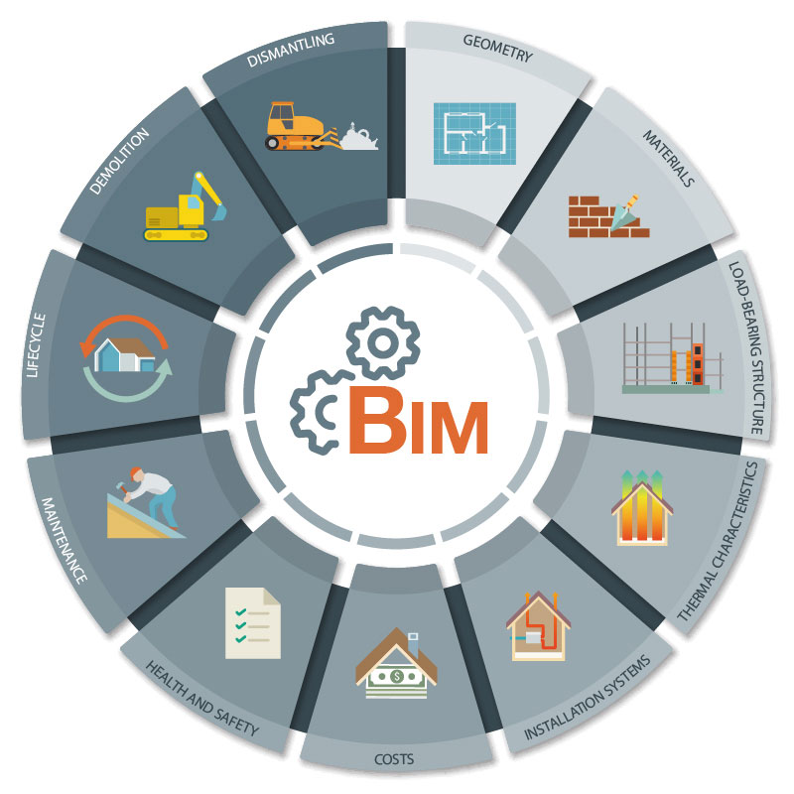
Module: BIM
Written by: Jon Phillip Langstone
Prepared for: Gavin Traylor
Date: March 26th, 2022
University of Wales Trinity Saint David
Client Letter

43 Higher Lane,
Langland,
Swansea,
SA3 4NT
28th March 2022

Dear Mrs Julie Jones,
I am writing to you on behalf of Langstone Design Management Ltd, regarding the proposed project for the ‘state of the art’ infant school in Swansea:
Project number: 5010
Project Title: Ysgol Bae Abertawe
Description: 1 Form entry infant school for 90 Pupils, with 48 PT Nursery provision.
As previously requested, the information provided in this letter will aim to outline the measures that will be taken forward to show the competency of the project team in reaching the BIM maturity requirements for the proposed project named above. Also, to accompany this letter, a draft Building information Execution Plan (BEP) is attached as appendix 1.
Firstly, when using BIM, there must be a clear plan that needs to be agreed upon with all project stakeholders to ensure that maximum benefits and efficiencies will be obtained for the client, the project, and the team.
A quote taken from Kensek helps describe benefits for the client: “BIM can also improve the owner’s bottom line by fostering reductions in life cycle costs and improvements in delivery schedule and operational performance.” (Kensek, 2014). BIM in the UK is condensed into 4 maturity levels by the government construction strategy. This is aimed to enable the government to set targets for the development of BIM in the UK and allow construction professionals to outline what the government mandates are. As outlined previously, in relation to the proposed project, we are required to meet the standards of BIM maturity (Level 2).
Listed below are the BIM Levels in descending order and a brief description for each:
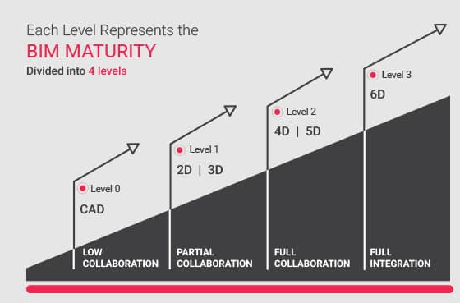
- BIM Level 0 – Where just CAD tools are adopted.
- BIM Level 1 – Where 2D & 3D Information is used to define standards.
- BIM Level 2 – Where BIM applications are used with fully integrated model collaboration.
- BIM Level 3 – Where BIM models are used for project/building lifecycle management (Lester, 2021).
Figure 1 BIM Maturity Explained (United-BIM, 2021)
BIM Maturity (Level 2)
Level 2 can be described as smart projects where BIM models detail every characteristic of a building or infrastructure project. As well as using 3D modelling, it also incorporates improved collaboration where all key stakeholders of the given project have a shared view.
The key elements contained in level 2 cover:
- Creation of a federated model
- Common classification of data
- Collaborative working
- employer’s information requirement
- Information exchange methods
- Individually authored models
In the pre-construction phase, it is a requirement to successfully deploy the use of a BIM Execution Plan (BEP). The BEP is an important and useful document and is essentially the supplier’s response to the questions and requirements set out in the employer's Information Requirements (EIR). The BEP also specifies the delivery plan which will be undertaken by the delivery team as a response to the received tender documentation, which includes who is responsible for providing information, and who will be undertaking different specific responsibilities in the design delivery team (BSI, 2020). It will also include an assessment of the capabilities of the team and the protocols for integrated working. Which would include software and forms of data storage (CIOB, 2014).
As stated, the Draft BIM Execution Plan (BEP) for Ysgol Bae Abertawe can be found in Appendix 1.
Also in the pre-construction phase, it is important to ensure that BIM Level 2 Maturity is under the guidance of the CIC BIM protocol. The BIM Protocol was first commissioned by the Construction Industry Council (CIC) in 2013 and supports BIM working at Level 2 (CIC, 2018). It also identifies models that are required to be produced by the project team and puts in place specific obligations, liabilities, and associated limitations on the use of those models. (Sacks, 2018).
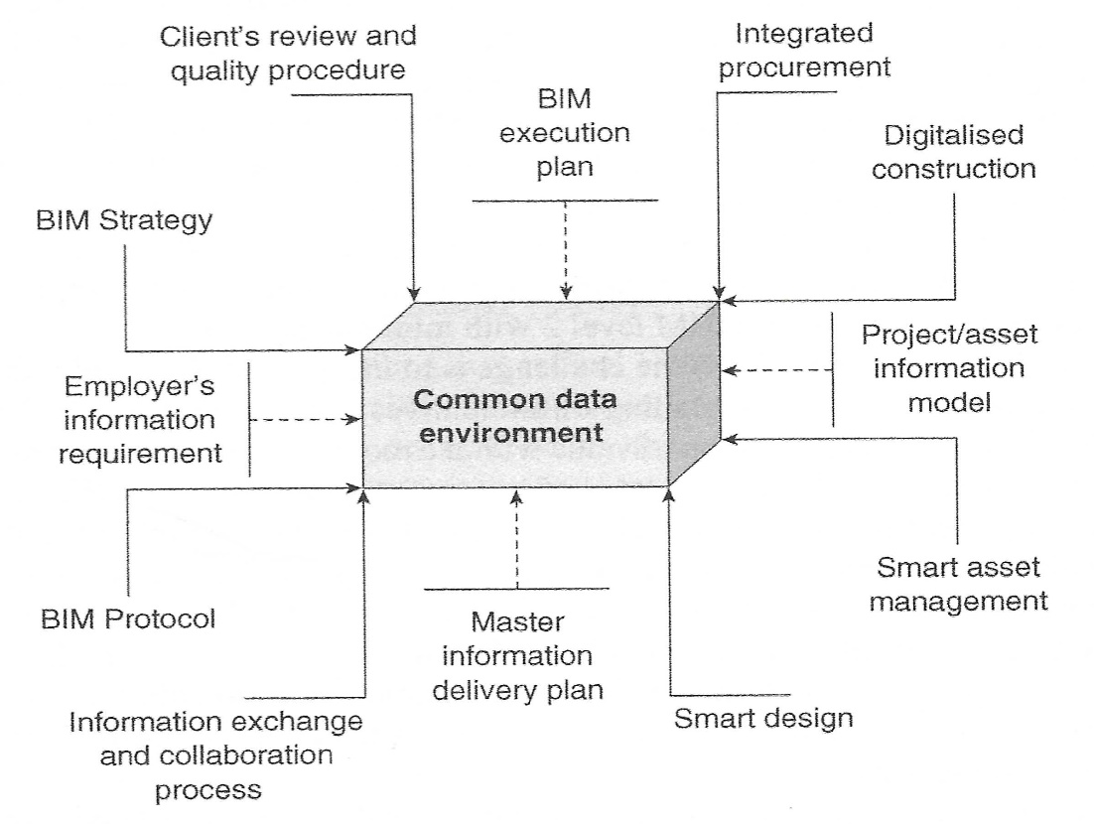
Figure 2 Common Data Environment (Peter Fewings, 2019).
All the key aspects that surround the function of the CDE are illustrated in Fig2. One of the main requirements that the CIC outline for level 2, is the creation of a common data environment (CDE). The CDE is simply a central project server in which information about the project is input and shared, which therefore allows all information to be accessed and edited. Although the data is shared between many users involved in the project, the ownership remains with the creator, and they alone can alter, change, or update the information within (Mordue F. , 2014). The use of a CDE is managed with relevant security checks for all relevant members, as to avoid lost or stolen information, this is in accordance with BS EN ISO 19650 – 5:2020. It is important to note that the appointed information manager in the team, will always ensure that all the agreed protocols are being followed, thus maintaining BIM Level 2 compliance, throughout the project phases. The CDE requirements have been defined in the PAS1192: 2013 (which was superseded), and BS1192 documentation in the past, and more recently, in the ISO 19650.
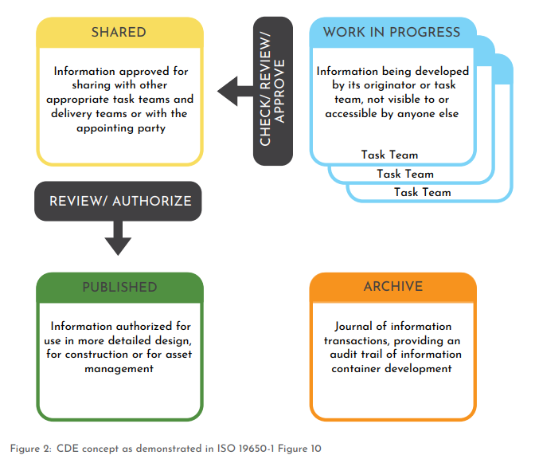
Any person who wishes to contribute information using the CDE must comply with the file naming conventions covered in the relevant standard: BS EN ISO 19650-1 2018. CDE is seen as having more relevance to technology and less about workflows. Fundamentally, workflows are developed first, and solutions are selected to facilitate the workflow (UK BIM Framework, 2020). Fig.3 on the following page is taken from the relevant standard BS EN ISO -1pt12 and illustrates the structure that would be used to convey information being admitted into a CDE.
Figure 3 CDE Structure BS EN ISO 19650-1 pt12
As indicated in Fig3, the work in progress (WIP) is often found within the supply chain systems of the CDE. It is not until the information has been shared after being reviewed and approved, that it goes into the client’s system. A quote taken from Mordue helps to give clarity on how models are used in a CDE: “You may think of the model as a single entity, but it’s an assembly of distinct, interlinked domain models each produced by individual contributors” (Mordue S. P., 2016).

What is BS ISO 19650?
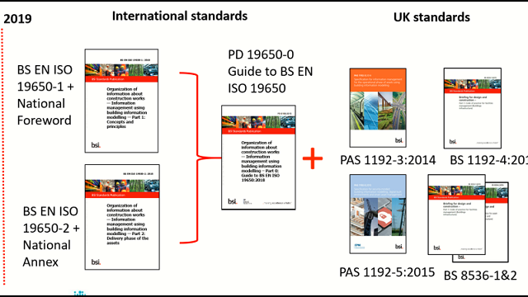
After mentioning this set of standards throughout the letter, it is important to give it some context to what it does. BS ISO 19650 is a collection of international standards for managing information over the whole life cycle of a built asset using BIM (including the British Standards). It has the same principles as the UK BIM framework and is primarily associated with the UK PAS 1192 standards being used to this day (BSI, 2022). Fig4 below conceptualizes the UK BIM Level 2 standards in the context of ISO 19650:
Figure 4 Up to date UK BIM Level 2 standards (SFT, 2020)
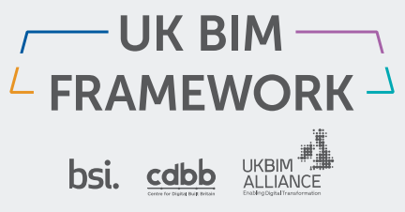
If you require any further information, there is plenty of valuable, and up to date additional information regarding the current UK BIM framework found at the following website: (UKBIMFramework, 2022).

I hope the information I have provided clarifies the steps we can take to ensure that BIM level 2 maturity will be met for the Ysgol Bae Abertawe project. We understand it is a lot to take in, but rest assured, we will help you and your team at every point along the way. For any further information or questions, please feel free to contact me or my team.

Sincerely,

Jonathan Langstone
Lead Consultant
Langstone Design Management Ltd.
Jon@LangstonedesignManagementLtd.co.uk

Appendix 1 Draft Pre-Appointment BIM Execution Plan (BEP)

5010-LDM-XX-ZZ-DB-Z-0000-YSGOLBA-S0-A

Contents
1.0 Introduction
1.1 Project Information 7
1.2 Information Management
1.3 Strategic BIM Goals
1.4 EIR

2.0 Management
2.1 Management Contacts
2.2 Key Milestones
2.3 Model Quality Control

3.0 Planning and Documentation
3.1 Clash Detection Software
3.2 Levels of Detail
3.3 Matrix of responsibility

4.0 Standards, Methods, and Procedures
4.1 File Naming Standard
4.2 Coordinate System

5.0 IT Solutions Used
5.1 Software Solutions
5.2 Exchange Formats
1.0 Introduction
Building information modelling (BIM) is a management process tool to bring about industry change. BIM has and can support collaboration needed for design and construction projects to build for the whole life cycle and bring the UK construction industry into the new digital age. The BIM Execution Plan (BEP) specifies the delivery plan in which will be undertaken by the design team as a response to the received documentation that accompanies the initial tender (which hasn’t been included yet). Essentially the BEP will detail the project deliverables estimated by the contract and the information exchange protocol and requirements. But the crucial component of the BEP the use of clear communication and collaboration and the timeline of that coordination. From the start to the completion of the project, stakeholders are well informed with the collaborative structure, thus ensuring a smooth process going forward. In the case of any misinformation, there is clear understanding of responsible parties, and it can be resolved in a short time. It also covers the aims to define a foundational framework that ensures technologies deployed are successful for this project. It also responds to the following:
- Relevant Specifications and pre contract information
- Employers’ information requirements (EIR) – (not received yet)
- The principles of the BS 19650 series of standards and specifications
All the associated project BIM models should comply with this document going forward. This draft document will be constantly updated with changes due to this early stage of the project.
Document Ownership - This document should be compiled and completed by the (project team as a collaborative submission), reviewed with all key project stakeholders.
Project Title | Ysgol Bae Abertawe | Client: | Swansea Council
Description | Design and construction of 1 Form Entry Infant School for 90 Pupils, with 48 PT nursery on the Swansea Bay Waterfront
Number | 5010
Design Start Date | 5/04/2022
Construction Commencement Date | 10/11/2022
Completion Date | 20/06/2023
Project Location | Swansea, SA1, 51°36'52.1"N 3°56'12.7"W
Project Language | English (UK)
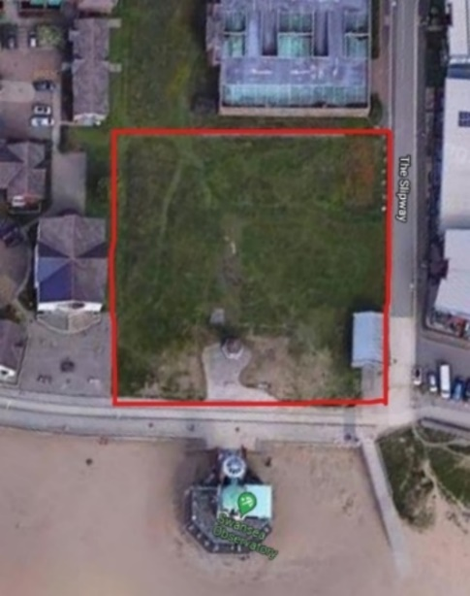
  - Project Information

Figure 5 Proposed Site for the New-Build School: Ysgol Bae Abertawe - 51°36'52.1"N 3°56'12.7"W.
As indicated in the aerial photo from google maps, the red line represents the land area for the proposed school.

1.2 Information Management
Information management success hinges on the delivery of appropriate high-quality information. How that is managed and shared across the project team is vitally important. In its simplest form, Information management is the management and execution of different task that relate to the definition of the information requirements, production, reviewing, editing and delivery. Information management applies to all information involved inside the project (Boutle, 2020). That information may be:
- Geometrical
- Alphanumerical
- General documentation
Every person that is involved in the project design and construction team, is involved in the information management spectrum, and should read the relevant information on how to comply with this plan.

  - Strategic BIM Goals

Strategic goals for the use of BIM during the design and construction phases:
- Standardize the production process and maintain uniformity across projects and regions.
- Create a standardized data structure that allows data to be reused and eliminates redundant and conflicting information.
- Decrease waste by utilizing a virtual building process to simulate design & construction activities.
- Allowing the design and construction models to be used for building operations without adding significant costs or time to the design & construction process.
- Visual communication of site conditions for planning and health/safety/risk assessment.
- Accurate budgeting and cost estimating, ensuring the project is constructed with the least variations / clashes as possible.
- Fully clash detected models that reduce RFI’s requesting data on object location, with an emphasis on clash avoidance.
- Utilize 3D models for reporting, review and decision making.
- Ensuring that there is coordinated, quality design documentation to estimate the build cost.
- Ensure that the constructability and methodology of the design have been assessed before documents are issued for construction (Plannerly.com, n.d.).

  - EIR
At this early stage of the project, there has been no need to acquire the Employers information requirement. Although The EIR will be required soon, as to move on with the planning phases. The BEP is essentially a response to the client's EIR. There is further guidance for the standards procedure for the EIR requirements under BS EN ISO 19650- 1 2018 pt12.

2.0 Management
In this chapter of the BEP, project management key roles and responsibilities will be highlighted in accordance with the relevant contact details provided for the project.
2.1 Management Contacts
Below is the table for the main contact details, for the professionals involved in the product:
Table 1 Contact Details
Position/  Responsibility | Association/  Company | Name | Email Address: | Mobile Number:
Lead Architect | Arci. Consultants | Robert Davies RIBA | Robertdavies@gmail.com | 07883645210
Project Manager | Hixon Construction | Jon Phillip MCIOB | Jp@HixsonConstruction.com | 07952751623
Main Contractor Director | Hixon Construction | John Hixon | JH@hixonconstruction.co.uk | 07395102478
Site manager | Hixon Construction | Jayne Hixon MCIOB | JayneH@HixonConstruction.co.uk | 07666524342
Assistant Site Manager | Hixon Construction | Elliot Taylor | ET@gmib.co.uk | 07777238321
Lead Consultant | Langstone Design Management | Jon Langstone | Jplangstone@gmail.com | 07254552621
Design Consultant | Langstone Design Management | Edward Davies | eddie@langstone.co.uk | 07992365472
Structural Engineer | SDC Engineering | Henry Sheridan | HS@SDC.co.uk | 07523311117
Mechanical Engineer | Mech-Eng Associates | Eric Whitehead CIBSE | EricW@Mech-Eng.com | 07395102665
Electrical Engineer | BJones | Barry Jones | Barryjones@hotmail.com | 07264683821
Health & Safety Consultant | SW health and safety | Sara White | SaraWhite@SWH&S.co.uk | 07388822663
Main Client | Swansea Council | Dr.Julie Jones | JulieJones@swansea-council.co.uk | 07152332111
Client Consultant | BS Surveying | Kate Cooms | KC@BSsurveying.co.uk | 07355355481
Information Manager | Langstone Design Management | Jerry Lewis | JerryLew@LDM.co.uk | 07985222118
Quantity Surveyor | Hixon Construction | Debbie Downer | DB@Hixonconstruction.co.uk | 07253677712
Facilities Manager | Hixon Construction | Frederick Taylor | FT@Hixonconstruction.co.uk | 07274938561
2.2 Key Milestones
Listed in the table 2 are the estimated dates for delivery of major key milestones of the proposed project. Further down the line, a more realistic and thorough range of dates will be compiled, according to project plan. The dates in the table below are purely rough estimates, as to show an example for the later version of the BEP to come.
Table 3 Project Milestones
Start of Project date: | Design stage completion date: | Construction commencement date: | Construction phase completion date: | As built models, Cobie files, documents, & Data sent date: | Built Asset Inspection Date: | Final Handover date:
08/01/2022 | 14/06/2022 | 10/11/2022 | 20/06/2023 | 1/07/2023 | 27/06/2023 | 5/07/2023

2.3 Model Quality Control
Table 4 states the responsibilities of those who oversee quality control of the relevant models found in the CDE.
Table 4 Quality Control responsibilities. Template taken from: (Plannerly.com, n.d.)

Check | Definition | Responsible Party | Software Used | Frequency
Visual | Ensure there are no unintended model components, and the design intent has been followed | Information Manager, Lead Consultant | Revit, Enscape, Revizto, Auto CAD | Daily
Clash Detection | Detect problems in the model where two building components are clashing including soft and hard | Information Manager | Revit, Enscape, Revizto, Auto CAD | Weekly
BIM Standards | Ensure that the BIM Standards have been followed (fonts, dimensions, line styles, levels/layers, etc) | Architect, Design Team, Information manager | Revizto, Revit, Auto CAD | Daily
Overall, Integrity | Ensure that the Project Facility Data set has no undefined, incorrectly defined, or duplicated elements and the reporting process on non-compliant elements and corrective action plans | Design Team, Information Manager | TBC | Weekly

3.0 Planning and Documentation
3.1 Clash Detection

During the design and construction process, the information manager should assess design decisions and clashes to see if they can resolve them internally, and where this cannot be done, separate models may be combined for review by a design team lead.
The chosen clash detection software for use on the project models will be:
Solibri Office –
“Solibri offers workflow support to the construction project. In the office, Solibri is the gatekeeper for quality management. It will combine all the different models into one, to perform highly advanced checks on them, and allow collaboration between all the involved parties effortless”
(Solibri, 2022)
3.2 Levels of Detail
Level of Detail is used to determine both the level of geometry detail (LOD), and level of associated information (LOI) for any given model element at an agreed project work stage. Defining LOD and LOI informs suppliers of the degree of information reliability when using the model. Below is an example of unfinished LOD table.
 | Project Stage / Milestone |  |  | Estimated Start Date |  | Estimated Completion Date |  | Project Stakeholders Involved
 | Design Stage
Design Model |  | Design concept phase  LOD 100-200 | TBC |  | TBC |  | Client, Architect
 |  | Design development phase  LOD 200-300 | TBC |  | TBC |  | Architect, design team
 |  | Construction Documents Phase  LOD 300 Complete | TBC |  | TBC |  | Contractor, Client, PM, Design team
Construction Stage
As-built Model |  | Construction delivery Phase  LOD 400 Complete | TBC |  | TBC |  | PM, Contractor, CM, Architect
 |  | Project close-out phase  LOD 500 Complete | TBC |  | TBC

3.3 Matrix of Responsibility
Considering not having the EIR, the matrix of responsibility cannot apply to this BEP yet. But if an EIR was submitted to the design team, they would assign different responsibilities and use a typical example, as shown below:

4.1 File Naming Standard

4.2 Coordinate system
All models will be coordinated around one control point, determined at the beginning of the project. The composite model must contain a 3D target element that is a visual reference point to assist in aligning the Revit models. The 3D target also contains the reference data found in the site survey from the project.
The figure below represents the project base point for the proposed school project, that shows the northings and eastings already. It also contains exact co-ordinates for the intended site in Swansea Bay.
Swansea, SA1, 51°36'52.1"N 3°56'12.7"W

Project location:

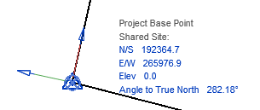

References
Boutle, A. (2020). Information management: its increasing importance as BIM matures. BIM+, https://www.bimplus.co.uk/information-management-its-increasing-importance-b/.
BSI. (2020). The Little book of BIM. British Standards Institution .
BSI. (2022). ISO 19650 Building Information Modelling (BIM). Retrieved from www.bsigroup.com/: https://www.bsigroup.com/en-GB/iso-19650-BIM/
CIC. (2018). BIM Protocol Second edition. London: Construction Industry Council.
CIOB. (2014). code of practice Project management for construction and development. London: Wiley Blackwell.
Kensek, K. M. (2014). Building information Modelling. Routledge.
Lester, A. (2021). Project Management, Planning and Control. Oxford: Matthew Deans.
Mordue, F. (2014). BIM for construction Health and Safety. Newcastle upon Tyne: RIBA publishing.
Mordue, S. P. (2016). Building information for dummies. Chichester: John Wiley & Sons Ltd.
NBS. (2020). https://www.thenbs.com/knowledge. Retrieved from https://www.thenbs.com: https://www.thenbs.com/knowledge
Peter Fewings, C. H. (2019). Construction Project Management An Integrated Approach. Abingdon: Routledge.
Plannerly.com. (n.d.). BEP Assembly. Retrieved from plannerly.com: https://app.plannerly.com/projects/6c5ea95a-52c8-49c3-a0c7-4f2f5a9694dc/plan
Sacks, E. L. (2018). BIM Handbook. Hoboken: John Wiley & Sons Ltd. .
SFT. (2020). New BIM Standards - ISO19650. Retrieved from http://www.scottishfuturestrust.org.uk/: https://bimportal.scottishfuturestrust.org.uk/page/new-international-bim-standards
Solibri. (n.d.). Retrieved from https://www.solibri.com/
Solibri. (2022). Solibri Office. Retrieved from solibri.com: https://www.solibri.com/solibri-office
UK BIM Framework. (2020). Information management according to BS EN ISO 19650. UK BIM Framework.
UKBIMFramework. (2022). THE OVERARCHING APPROACH TO IMPLEMENTING BIM IN THE UK. Retrieved from ukbimframework.org: https://www.ukbimframework.org/
United-BIM. (2021). Maturity Levels Explained. Retrieved from united-bim.com: https://www.united-bim.com/bim-maturity-levels-explained-level-0-1-2-3/

