University Of Wales
Trinity Saint David

MSc Property and Facilities Management
Dissertation
An Evaluation of Whole Home Assessment for Retrofit: The Case of Social Housing

Author’s Declaration

I declare that the work in this dissertation was carried out in accordance with the regulations of UWTSD. The work is original except where indicated by special references in the text and no part of the dissertation has been submitted for any other degree.

Any views expressed in the dissertation are those of the author and in no way represent those of the UWTSD.

The dissertation has not been presented to any other University for examination either in the United Kingdom or overseas.

I hereby give permission for my work, if accepted, to be available for photocopying and inter-library loan, and for the title and summary to be made available to outside organisations.


Signed:

Date: 29/03/2024

Abstract
This dissertation looks at whole home reassessment within social housing in Wales and the aim of the research is at what juncture should a Whole Home Reassessment take place and what are the parameters that trigger a reassessment and what elements do you reassess. This aim was chosen because of the lack of guidance and/or steer on how, when and what to assess after the initial assessment.
There is significant literature into the initial whole home assessment but very little around the next steps on reassessment and more importantly what triggers the reassessment. The data collected shows a very clear disparity between customer community settings in terms of their understanding of retrofit as a whole. Also, there is a general consensus between industry experts around what the next steps should be around data harmonisation and at what point should a whole home reassessment take place, also there is clear consensus between both customer and industry experts around what social markers are fit for reassessment. Within the dissertation there are a set of clear recommendations which outline the next steps to take reassessment forward.

Contents
1.0 Introduction 6
1.1 Introduction 6
1.2 Justification for the Research 7
1.3 Aim 7
1.4 Objectives 7
1.5 Summary 8
2.0 Literature Review 11
2.1 Introduction 11
2.2 Objectives and Focus of Research 11
2.3 How the Literature Review was Conducted 12
2.3.1 Literature around Whole Home Assessment 12
2.3.2 Literature around Decarbonisation, Net Zero & Retrofit 13
2.4 Structure of the Literature Review 13
2.5 Review of Literature 13
2.5.1 Legislation 13
2.5.2 Welsh Quality Housing Standards 2023 (WHQS23) 14
2.5.3 PAS 2035 & PAS 2038 15
2.5.4 Net Zero Technologies 16
2.5.5 Retrofit & Whole Home Assessments 18
2.5.6 Customer Communication and Beyond 20
2.5.7 Research Gaps 22
2.6 Summary 23
3.0 Methodology 24
3.1 Research Approach 24
3.2 Philosophy & Strategy 24
3.3 Selection of Participants 25
3.4 Data Collection Methods 25
3.4.1 Housing Stock Data 26
3.4.2 Limitations 27
3.4.3 Interviews 27
3.4.4 Limitations 28
3.4.5 Questionnaires 28
3.4.6 Limitations 29
3.5 Data Analysis 29
3.6 Summary 30
4.0 Findings 30
4.1 Introduction 30
4.2 Housing Stock Data 31
4.3 Interviews 34
4.4 Questionnaires 42
4.4.1 Customers 42
4.4.2 Industry Experts 53
4.5 Summary 64
5.0 Analysis 65
5.1 Introduction 65
5.2 Housing Stock Data 65
5.3 Interviews 70
5.4 Questionnaires 74
5.5 Summary 89
6.0 Conclusion and Recommendations 90
6.1 Introduction 90
6.2 Recommendations 90
6.3 Conclusion 92
6.4 Critique 93
6.5 Future Research 93
7.0 References 94
8.0 Bibliography 99
9.0 List of Figures 104
10.0 Appendixes 107
10.1 Appendix 1 107
10.2 Appendix 2 108
10.3 Appendix 3 110
10.4 Appendix 4 111
10.5 Appendix 5 112
10.6 Appendix 6 114
10.7 Appendix 7 115
10.8 Appendix 8 117
10.9 Appendix 9 120
10.10 Appendix 10 123
10.11 Appendix 11 127
10.12 Appendix 12 131

Chapter 1

Introduction

Introduction
This research aims to address the pathway to net zero and how that pathway gets assessed and most importantly reassessed within social housing homes in Wales. It’s an extremely ambitious challenge to achieve net zero in socially rented homes in Wales especially as the UK and Wales has some of the oldest housing stock in Europe and it sits within the top 3 of oldest housing stocks in the world. This is mainly down to the industrial revolution where thousands of homes were needed to satisfy the growing demand of the era, the demand for cheap housing focused on the labour needed at the time and still currently housing stocks of the industrial era are still the foundation of the UKs housing stock (Justine, et al., 2020). The housing stock in Wales, both social and private is some of the most thermally ineffective in Europe and the world, with around 32% of homes build before 1900. The average standard assessment procedure (SAP) score for homes in Wales is currently 61 points, this is roughly equivalent to EPC D (Jofeh, 2019). Wales has an estimated 1.36 million homes (Welsh Government, 2020) of which around 1.1 million of these homes have a form of fossil fuel for their heating. Welsh housing stock in Wales both social and private as a whole can be categorised into 14 distinct housing types with over 50% of these falling into just 4 dwelling types, with only 10% of homes-built post 2000 (Jofeh, 2019). Unfortunately, Wales has thermally ineffective homes and older more traditionally build homes, and this leads to higher fuel costs for people within Wales compared to countries within the other parts of Europe, but this issue exists in both in socially rented homes and privately owned. National Energy Action estimates at around 45% (614,000) of households in Wales suffer from some level of fuel poverty (National Energy Action, 2022) and this is only made worse by the ongoing war in Ukraine and other geopolitical issues around the world. The ongoing war in Ukraine and other geopolitical issues around the world have pushed an estimated 20% of additional households in Wales into fuel poverty when they otherwise wouldn’t have been. To ensure that buildings are net zero, a wide range of fabric, heating, energy, and social changes must be included in all short, medium, and long-term retrofit plans. No single organisation or industry can meet the target of net zero and decarbonisation on its own. Building improvements alone won't bring about net zero alone; infrastructure and social changes are also required. The UK government has set the ambitious objective of decarbonising the electrical grid by 2035 (UK Government, 2021). The ongoing energy crisis has brought the UK’s energy security sharply into focus, and because of this it is likely UK government will be announcing that nuclear energy is to be classified as green in the coming months, this would be a big step to securing the UK energy supply. This would allow the electricity grid to be classified as net zero in time and it would help the UK and Wales safeguard our countries energy security by guarantee a consistent home-grown energy supply.

Justification for the Research
The main justification behind the decarbonisation agenda is the UK Governments ambitious target for all of the UK to be net zero by 2050 (legislation, 2019). The Welsh Government also have set a target of 2050 (Welsh Government, 2023), but have introduced more ambitious targets for the social housing sector. Welsh Quality Housing Standards 23 (WHQS23) sets out that all properties will be required to be SAP 75 and EPC C by 2030 with housing providers producing targeted energy pathways and whole home assessments for all their housing stock by 2026.

Aim
What juncture should a Whole Home Reassessment take place and what are the parameters that trigger a reassessment and what elements do you reassess. This aim was chosen because of the lack of guidance and/or steer on how, when and what to assess after the initial assessment.

Objectives
The objectives below have been allocated a Primary or Secondary status; both are linked to each other with the secondary objectives underpinning the primary objectives. They have also been allocated numbers based on collective issues.
Primary 1- Identify what gaps exist within current guidance documents and legislation to support reassessment.
Secondary 1 - Evaluate PAS 2035/2038 and its role in reassessment.
Primary 2 - Assess customers understanding of reassessment.
Secondary 2 - Consider the role of communication in best practice/legislation reassessment.
Primary 3 - Propose a best practice set of recommendations (or decision-making tool) for reassessment.
Secondary 3 - Assess what social markers are fit for reassessment.

Summary
The aim of the dissertation will be met by using data from social housing providers and the wider retrofit community, to help guide the research key questions will be used to help achieve the overall aim the dissertation, these are.

- What role should PAS 2035/PAS 2038 play in the whole home assessment.
- What occupational elements should be looked and how should they be reassessed.
- Should the whole home assessment be reevaluated of new technology is brought into the market.
- What challenges come with retrofit, both technological and human.
- What should the communication strategy be for the initial and reassessment.
- What technology is available to expedite whole home assessments.

The above questions directed the initial research into whole home assessments and helped meet the aims and objectives of the dissertation. Given that whole home assessments for retrofit are new to the social housing sector and new to the wider construction management sector it is important to understand the lack of literature, guidance, and best practice around retrofit assessments.
The structure of the dissertation is set out as follows.

- Chapter 1
Introduction
Justification for the research
Aim and objectives of research and hypotheses.
Summary of chapter

- Chapter 2
Literature Review
Introduction
Objectives and focus of research.
How the literature review was conducted
Structure of literature review
Review of literature (Under subheadings)
Research gaps.
Summary of chapter
- Chapter 3
Research Approach
Philosophy & Strategy
Selection of Participants
Data Collection Methods
Housing Stock Data & limitations
Interviews & limitations
Questionnaires& limitations
Data Analysis
Summary of chapter
- Chapter 4
Housing Stock Data
Interviews
Questionnaires
Customers
Experts
Summary of chapter

- Chapter 5
Housing Stock Data
Interviews
Questionnaires
Summary of chapter
- Chapter 6:
Recommendations
Conclusion
Critique
Future Research

Chapter 2

Literature Review

Introduction
Decarbonisation, net zero and retrofit are all relevant when looking at whole home assessments, the terminology may be different, but the drivers are the same, homes within UK and Wales will need to be more self-sufficient and kinder to the environment in how they are constructed and maintained (Edwards, 2020). Achieving this ambition is linked to not only technological and personal innovation but political desire and ambition to not just do what is right but what is required to ensure subvert the ever-impending catastrophe that is climate change.
Specifically looking at the social housing sector in Wales, Welsh Government have set very ambitious targets for net zero, these plans and subsequent targets are aimed to help the wider privately owned housing sector in Wales (Welsh Government, 2023). Social housing is seen by government as the test and trial sector, significant funding has been provided by Welsh Government over the last few years for programmes like Arbed, Homes As Power Stations (HAPS) and the Optimised Retrofit Programme (ORP), these test and trial programmes have created significant amounts of data which is still being collected by Welsh Government (ORP, 2022). Due to the volume of funding housing associations within Wales are receiving they have started to grow their localised data sets around decarbonisation and retrofit, these data sets are predominantly around the effectiveness of energy efficiency measures and the capital costs to install and maintain these technologies.

Objectives and Focus of Research
Given how fast paced the world of decarbonisation and retrofit is moving within the housing sector in Wales and couple that with the political landscape within the current UK Government, it is challenging to get clear and concise information relating to the UK’s ambition around decarbonisation. The Governments recent change in policy around the ban on internal combustion engines which has now been pushed back until 2035 (UK Government, 2023), this is just one example where a clear lack of a political roadmap for decarbonisation is having a disruptive effect on the efforts to decarbonisation not just on housing stocks but the wider UK infrastructure. Research will be focused on specific requirements for the housing sector in Wales but will also look wider at legislation from both Welsh & UK Government, there is also significant overlap in research within other sectors like customer communication, housing, and social housing rents. These areas will all be researched given that it is likely there will be crossovers which will help towards the outcomes of this research.
The objectives during the research were to understand the gaps of both knowledge and technological ability to undertake a whole home assessment, given that most housing associations in Wales have only now started to undertake the initial whole home assessment it is presumed that there will be significant knowledge gaps in the sector.

How the Literature Review was Conducted
The sector has three separate elements that drive the social housing sector, legislation, best practice/guidance standards and academic reports/literature. Given the depth of guidance documents and legislation that covers this area of study, these will be analysed independently from academic literature, but they all play a key part in the direction of travel when it comes to undertaking whole home assessments. Many of these elements overlap other parts of the housing sector like comms and people/customer management, The literature and other guidance documents were researched using the library, case studies, academic reports and industry guidance and best practice documents.

Literature around Whole Home Assessment
Within the world of whole home assessment/reassessment there are best academic reports, standards and legislation that look at specific parts of the process like the Housing Stock Condition Survey’s: Guidance for Local Authorities, 2008 guidance document (Welsh Government, 2000) but this is not really aimed at reassessment and is based on older ways of working and is much less coherent around retrofit assessment and reassessment. Academic literature around retrofit assessments is limited to guidance and test and trial projects currently, but this is an ever-changing landscape with new data and literature being available almost on a daily basis.

Literature around Decarbonisation, Net Zero & Retrofit
There is a significant volume of literature around decarbonisation, net zero & retrofit, the vast majority of the literature focuses on the technology itself and not necessarily the whole home assessment. The vast majority of information is focused on technologies like heat pumps and photovoltaics and how to get the best outcomes when you couple these with other energy efficiency technologies. The literature itself does not solely focus on social housing or whole home assessments but has a more general view looking at big picture elements within the decarbonisation bubble.

Structure of the Literature Review
The following has been split out into unique areas that this research will look into. Each area has significant relevance either directly or indirectly to whole home assessment with the social housing sector.
- Legislation
- Welsh Quality Housing Standards 2023
- PAS 2035 & PAS 2038
- Net Zero
- Retrofit & Whole Home Assessment
- Customer Communications and Beyond

Review of Literature

Legislation
The UK has an overarching piece of legislation which is the main driver of the net zero agenda, this is the Climate Change Act 2008, 2050 Target Amendment (legislation, 2019). The legislation was amended in 2019 to legislate a long-term, target to reach net-zero greenhouse gas emissions which was in line with the wider economic policy, by 2050. Prior to this amendment, the target was at least 80% reduction from 1990 levels by 2050. Since 2019 housing associations and local authorities in Wales have undertaken numerous test and trial projects and some at considerable scale (Optimised Retrofit Programme) to help inform their net zero ambitions with funded projects like Active Homes in Neath and Hydrogen Heating initiative in Milford Haven and most recently, Homes As Power Stations across the Swansea Bay City Deal Region. Welsh Government have a deadline of 2050 which mirrors the deadline in climate change act and they have also embedded sub deadlines to public sector areas under its remit like the housing sector. Welsh government has set targets with the public sector and local authorities which aims to have net zero technologies and behaviours fully implemented and are normal practices by 2030 as shown from figure 1 which is below.
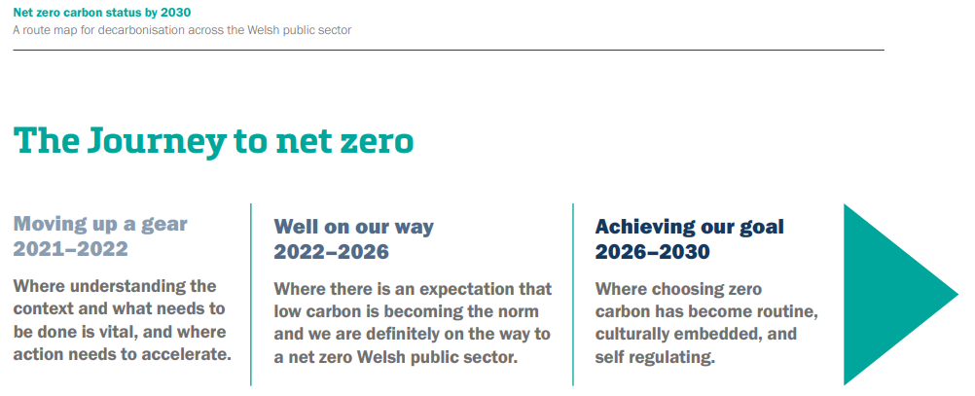

(Taken From Welsh Government, 2021)
Fig. 1

Another significant piece of legislation that within the social hosing sector in Wales is the Rented Homes Wales Act 2022, the main aim of this legislation is one of prevention, to ensure landlords maintain their housing stocks to prevent them from becoming unfit for human habitation and it puts significant pressure on organisations both from a maintenance and housing management perspective. The legislation sets out 29 matters or circumstances in which the landlords have a responsibility to ensure their homes do not fall into an unfit condition and are fit for human habitation (legislation, 2022), a full list of all the 29 matters or circumstances can be seen in Appendix 1.

Welsh Quality Housing Standards 2023 (WHQS23)
Welsh Housing Quality Standard (WHQS) 2008 was the first version of the homes standard set in Wales, its aim was to align homes standards across Wales in the social sector and this was also meant to somewhat mirror England’s “The Decent Homes Standard”, both standards set out what is a pass, a conditional pass or temporary fail for every home within a socially rented property in Wales. As of October 2023, WHQS has been updated to WHQS23, this standard goes live from 1st April 2024. The new standard adds serval different requirements to housing association such as.
- Flooring required on all voids.
- Housing association to now look at biodiversity on all estates.
- Water poverty relieving measures to be installed in all homes.
Additional to the standard requirements above the standard now sets out ambitious targets for decarbonisation, full details are in Appendix 2. Within the newest version of WHQS there is now a new within section 3 of the document that requires social housing providers to undertake whole home surveys and targeted energy pathways for each property individually, this is critical to ensuring housing stocks in Wales achieve an EPC rating of C/ SAP 75 by March 2029 and it empowers the individual housing associations to set an ambitious target to achieve EPC A, SAP 95 for all homes. This last requirement will be set by the individual housing associations and Welsh government collaboratively, but the standard does stress that this must be achieved and must be ambitious. By setting out these targets the Welsh Government hopes this will be the first steps for homes in Wales to achieve a net zero in terms of energy consumption (Welsh Government, 2023). In tandem with this the grid is also being decarbonised which will mean that the homes themselves will not become fully decarbonised until the heating and electrical grids are fully decarbonised, the target for this is 2035 as set out by the Climate Change Committee (Climate Change Committee, 2023).

PAS 2035 & PAS 2038
There are two version of PAS (Publicly Available Specifications), one for domestic properties and one for commercial properties PAS 2038 the commercial specification would not be applicable to the vast majority of social housing stocks as not all have commercial premises which they rent. Both versions are a set of guidelines which sets out criteria on how to achieve the best energy efficiency rating and lays out a path of measures to achieve net zero. Both use the whole homes approach utilising the fabric first approach (elmhurst energy, 2021). In the Welsh social housing context both PAS and WHQS23 are to be used to produce the whole home assessments and targeted energy pathways for properties, currently this combination has only predominantly been used for funded projects like ORP and HAPS. PAS standards were created to deal with the energy efficiency issues with UK homes it also acts as a mechanism to enable the Government to trust that any funding is being spent in the correct manner (elmhurst energy, 2021). Within PAS there are several roles which are required to be fulfilled to ensure the dwelling is having the appropriate energy efficiency measure installed, all these roles can be seen in Appendix 3. The PAS process considers the following key elements building, environment factors, occupants and the overall strategic objective, the process is risk based where the retrofit coordinator would complete a site risk assessment which would determine the energy efficiency measure that would be suitable. Undertaking retrofit in this methodical way will help mitigate any issues connected to retrofit and helps to avoid any unintended consequences, see Appendix 4 for unintentionally consequences matrix which surveyors would uses to help idenify energy efficiency measure which would bring about un unintentional consequences while retrofitting a home. The below outlines the key differences in both PAS standards.
PAS 2035:2019 Retrofitting dwellings for improved energy efficiency – PAS 2035 applies to domestic buildings and aims help achieve their energy efficiency potential, through a whole house approach to retrofit.
PAS 2038:2019 Retrofitting non-domestic buildings for improved energy efficiency – PAS 2038 applies to non-domestic buildings (commercial) that are less than 500 square metres in internal size and have similar construction types to buildings of a more domestic nature.
(elmhurst energy, 2021)
Both PAS 2035 and 2038 play a key role in helping ascertain what measures would be suitable and what the associated risks might be that come with installing energy efficiency measures into a lived-in home, but the process alone is only one small process of the whole home assessment puzzle.

Net Zero Technologies
For social housing providers in Wales the main driver for net zero is the UK Government target of net zero by 2050 (legislation, 2019). This is an extremely ambitious target with lots of technological obstacles that lay in the road. These new and emerging technologies will unearth new obstacles for retrofit assessors and many of these new and emerging technologies will be untested when combined with deep retrofit programmes (Fylan, 2021).
Domestic space heating in Wales and the UK is the biggest challenge in achieving net zero by 2050, currently 82% of Welsh homes use gas to heat their homes and 66% of the gas heated properties are condensing combi boilers of some type (Statistics for Wales & Welsh Government, 2019). Wales has an estimated 1.38 million homes spread across 22 local authority areas (Welsh Government, 2021), this would be an estimated total 1.13 million homes in Wales who currently need a new and environmentally green heating source, finding alternative heat sources which are bespoke to the property, customer, building type and geographical area will be the biggest challenge in getting retrofit right first time (Ehsan, et al., 2023).

Social housing homes in Wales will need to move to becoming ’smart homes’, they will be required to have a high level of autonomy and flexibility that helps balance the grid and also store energy in homes for peak times (Mbungu, 2019). If these homes are to become smart, they will need to also become a prosumer that stores energy and hot water in battery storage, this could be either standalone energy storage battery or a combined unit which would be direct current invertor and battery storage device. In a typical social housing property in Wales the average battery (dependent upon space with the property) size would be around the 3.75KWh with an AC incoming peak capacity of around 5KW from a source like PV or wind generation. Hot water batteries are also an option for social housing, SUNAMP hot water batteries store energy using phase change materials that discharge energy so it can be used to heat or cool water when the demanded is needed (SUNAMP, 2023).

If new and emerging technologies are fitted poorly and are not compatible together under PAS 2035, this could push social housing customers into fuel poverty (Welsh Government, 2021). Fuel poverty is defined by the UK & Welsh Governments as a household that spends 10% or more of their combined earnings on heating. Of the total amount of homes that are in fuel poverty an estimated 25% of them have no access to mains gas (Wright, 2010). Housing providers need to ensure that technologies are suitable when combined with other renewable technologies otherwise customers will face unintentionally consequences like damp and mould which will have health impacts.

Retrofit & Whole Home Assessments
Retrofitting Wales socially rented properties at scale is a huge challenge but can lead to lots of positive outcomes form all stakeholders involved, Joanne Patterson states “whole house deep approach can provide huge financial, comfort, carbon and social benefits but that costs to undertake the retrofit works were still prohibitively high to undertake at scale” (Patterson, 2016). To undertake domestic retrofit in the most unintrusive and cost-effective way, the works will need to be phased and this will need to be bespoke to each individual property and person (Welsh Government, 2023). PAS 2035 (or 2038 where applicable) is the guidance document that is needed to achieve this measured approach and its sets out a clear and proper assessment criteria, design concepts and implementation methods (Edwards, 2020). By undertaking a phased approach there is flexibility for the pathway to change and stops a potential lock-in of the path, this is needed as new technology is constantly being released onto the market. This form of delivery will allow for collaboration with other social housing providers on elements like procurement and contractor management which would help achieve economies of scale (Green, 2020). Generally, the cost of building refurbishment/retrofit is generally considered less than the cost of demolition and new construction (Highfield, 2000).

Initial Whole Home Assessments that are undertaken while on site within social housing can be challenging due to several factors these include property access, social factors, and geography of the housing providers property stock. Ensuring the information that is collected is viable and accurate is one of the biggest challenges the sector faces (Welsh Government, 2022) and the influence of how people live and what effects that has on retrofit is the least understood aspect of the retrofit process (Van Den Brom, et al., 2019). After the initial assessment the Targeted Energy Pathway data is collated and compiled ready to form the net zero pathway, but as Zeifman states “Specific retrofit opportunities are identified via on-site home energy assessments that can be inconvenient to homeowners, expensive, and of variable accuracy” (Zeifman, 2020).

Currently Initial Whole Home Assessments are being carried out is differing ways across the sector with no one organisation undertaking them in the same manner, lots of housing associations and local authorities are either up skilling their internal workforce and asset management systems or opting to outsource the Whole Home Assessment entirely to an accredited third party, both options come with their own risk in terms of compliance with WHQS23. ateb housing group took the route of upgrading their assessment system to incorporate Whole Home Assessments and energy modelling of their homes, see Appendix 5 for details of the asset management system.
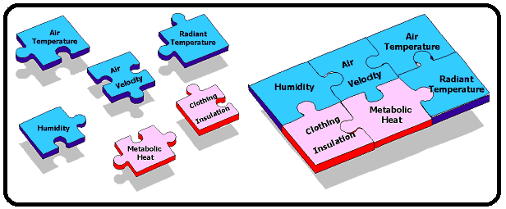
SAP (Standard Assessment Procedure) and RdSAP (Reduced data Standard Assessment Procedure) are energy assessment tools that are focused on energy consumption and efficiency within a building or property. The assessment aims to identify opportunities for reducing energy usage, optimizing processes, and improving overall sustainability, SAP is used as part of the initial Whole Home Assessment and the Target Energy Pathway under WHQS 23. Both SAP & RdSAP data collection must be undertaken by a domestic energy assessor (DEA) which currently in the UK we have a shortage of suitable skilled people to undertake these tasks. There are questions also around if SAP & RdSAP is the most suitable metric to ascertain if a property/building is net zero, the disadvantages may include the expenses and efforts required to retrofit or upgrade systems to comply with energy-efficient technologies. It also does not consider a thermal comfort strategy, thermal comfort is made up of six basic factors, four of which are environmental factors and two are personal factors (hsqeconsultancy, 2023) . Each one of the factors are independent from each other but all should be considered when assessing thermal comfort for a building/property or a person (Health and Safety Executive, 2023).
Above in figure 2 is an illustration of the six basic factors that make up thermal comfort.
(Taken From hsqeconsultancy, 2023)
Fig. 2

Given the difficulty in ensuring accurate net zero pathways, it is important to the sector that we have experienced, qualified and skilled surveyors to undertake the initial surveys, unfortunately the sector currently has a skill shortage of suitable surveyors to undertake these surveys and that is having a negative impact on the UK’s economic growth (Rogers, 2018).

Customer Communication and Beyond
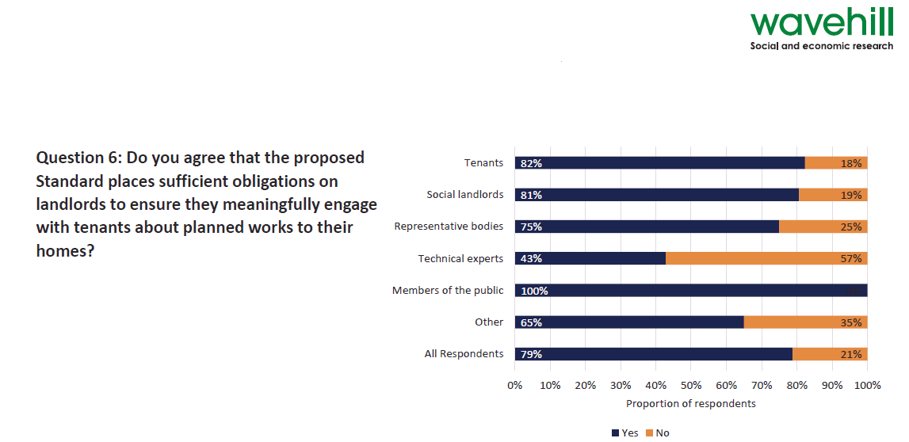
Clear communication while undertaking retrofit is essential and with the social housing sector it becomes more vitally important due to the variety of customers that could potentially be within a housing associations stock portfolio. Given the potential differing dynamic within each property, customers need to be at the heart of decision making from project inception to completion, a recent study undertaken by Wavehill (social & economic research body) on behalf of the Welsh Government on the updated version of WHQS23 found that the new WHQS23 is a significant demand on social housing providers and this is hoped that they will meaningfully engage with their customers around retrofit upgrades works to their homes (Wavehill, 2022). Below in figure 3 is an extract depicting the outcome of the Wavehill survey conducted on behalf of the Welsh Government.
(Taken Wavehill, 2022)
Fig. 3

Looking holistically at retrofit at scale and the assessment process, two-way communication will be key in achieving the best outcomes for both client and customer, this will be the most effective strategy with buy in and commitment from both parties’ being key (Campbell & Finch, 2004). Looking at the Wavehill study the drive for communication in there within the sector, but this ambition needs to be matched with actions and the financial support to allow two-way communication to be the backbone of whole home assessments. Currently only some housing associations are undertaking whole home assessments and retrofit measures, so when it comes to customer communication the sector is trying to ascertain the best on the ground approach when it comes to specific customer profiles, see Appendix 6 for some case studies around retrofit and customer communications.
Welsh housing associations & local authorities are at the start of their retrofit journeys which begin with undertaking initial whole home assessments on mass, it will be important that standardised customer engagement benchmarking is established. Given that all the social housing landlords meet regularly this is achievable to form a standardised model to help clearly identify trends with customer engagement, this process is already in place within the facilities management sector (this sector falls within the Welsh Governments remit), “The benchmarks identify trends between key variables of criticality, efficiency and service provision, including general variables regarding the performance of the FM team” (Tucker & Pitt, 2009). There is clear evidence that when the meaningful customer engagement is placed at the core of decisions on retrofit, procurement and the environment, the outcomes are advantageous for all stakeholders and a recent study looking at energy customer engagement during retrofit works helped decrease energy consumption and this is illustrated in figure 4 below, “It was found that education, social norms, and self-awareness are all key components when it comes to initiating environmentally responsible behaviours. The three approaches complemented each other” (V & Jansson-Boyd, 2017).
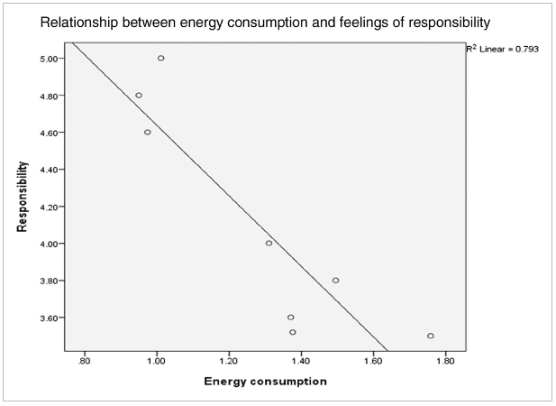

(Taken From V & Jansson-Boyd, 2017)
Fig. 4
An unengaged customer could reduce the effectiveness of a retrofit project and customers should receive training to understand firstly why the measure are needed, then training on how to operate the technologies in their home. “holistic retrofit that benefits the tenant, and tenant engagement are critical if decarbonisation is to be perceived positively and be as effective as possible” (Green, 2020). Customers must be a key stakeholder within the retrofit process, this is to better understand the retrofit action required, this is critical to ensuring the goal of net zero and decarbonisation is achieved (Ben & Steemers, 2018). Engagement with customers’ and all key stakeholders needs to be flexible and adaptable, the flexibility to tailor communication to the end user is critical to ensure housing providers are carrying out good initial assessments and then reassessments (Professor Fionn Stevenson 2023, personal communication, 28 March 2023).

Research Gaps
Holistically looking at academic literature, legislation and best practice guidance documents, the literature is extremely relevant around general net zero principles and technologies and retrofit, but when it comes to the reassessment of homes to ensure there are on the retrofit pathway is very little in terms of tangible research. There is guidance and literature around the initial retrofit assessments, but the research doesn’t focus in on reassessment or what role the customer plays within that journey. All the current research around reassessment within homes and customer influence seems to be light touch without ever diving into the more integrate details of the subject. Reassessment is not mentioned in WHQS23,PAS2035, or any other housing related document, and both UK and Welsh Governments have not legislated for it in any of the legislation on the statute books, so housing associations & local authorities have no requirement to undertake it in the first place “Considering this ambition and the scale of the challenge, there remains a surprising paucity of documented post occupancy evaluation studies of deep retrofit projects” (Colclough, et al., 2022). This is in contrast to the previous stock condition surveys in which required housing associations & local authorities to undertake housing stock condition surveys every five years or at change of tenancy under the Housing Stock Condition Survey’s: Guidance for Local Authorities, 2008. Drilling down into the academic literature we have a clear understanding that the missing piece of the puzzle is the role of the customer in the whole process, the customer is the least understood element of retrofit (Van Den Brom, et al., 2019). The customer needs to feel that their views and considerations are taken into account and that they are then taken on the journey, what’s also vitally important that customers feedback at the end point, this could be once the whole home assessment has taken place or once a retrofit measure has been installed (Darby, 2019). The two very contrasting points of view evidence an almost disconnect between all key stakeholders and political agenda/policy.

Summary
Focusing in on reassessments of whole home surveys there is very little in terms of legislation, guidance/best practice, or academic literature and certainly no mention of what frequency or what triggers a reassessment. It is widely accepted that the customer should be a key part of the journey of net zero with their views and thoughts at the forefront of decision making ensuring there is a feedback loop on all measures and assessments undertaken in their homes. The majority of literature is focused on the front end of the retrofit problem with very little concern as to the future surveying requirements of future social housing homes in Wales. Currently the technology aspect is well understood in terms of the full measures that could be required within homes, also there is a good understanding and framework for the implementation of these technologies under PAS 2035 and PAS 2038. The overarching legislation across the UK and Wales is robust enough in principle to help social housing providers with achieving net zero but there are questions what around what is actually achievable based on both financial and labour constraints in Wales and the UK.

Chapter 3

Methodology

Research Approach
This research will be looking at potentially a wide range of data sets from property data metrics to property experts and customer opinions. Because of this a variety of data collection methods will be required, stock condition data will be gathered using excel and asset management systems, and then a mix of interviews and questionnaires will be used to attain the relevant information. By undertaking these methods in this way this will help achieve the aims and objectives of the research.

Philosophy & Strategy
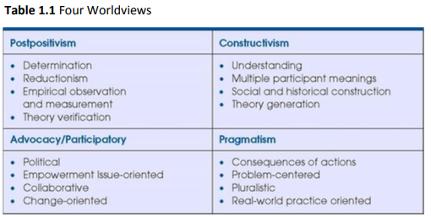
Creswell states that there are 4 philosophical worldviews which influence research which are illustrated in figure 5 below.
(Taken From Creswell, 2009)
Fig. 5
This research will base it data collection and analyses on pragmatic approach based on real world problem solving and this will be based on grounded theory using mixed methods approach utilising both quantitative and qualitive research to help formulate new approaches to the issues (Creswell, 2009). Adopting both quantitative and qualitive research methods will allow for follow on questions which could deep dive in on interesting trends and outcomes and will also allow for analysing numerical data based on Likert scale (O'Dwyer & Bernauer, 2016). By using grounded theory approach, it will allow for the development of theories which offers explanations around the main concerns when analysing the data and formulating hypothesis (Tarozzi, 2020). A clear gap exists in the academic literature, and this demonstrates a need for new and creative ways of thinking about retrofit based not only on sound building pathology techniques but on human factors and how they both interlink.

Selection of Participants
This research will focus on two groups of participants within the social housing sector, these will be unbiased and balanced experts who currently either work within the sector or are directly affiliated either as consultants or contractors, customers within the social housing sector will also form part of this research, the questionnaires will aim to target as many customers as possible from varying geographical areas. Industry experts will take part in a detailed retrofit interview and both industry experts and customers will take part in wider retrofit topics within the questionnaire. Experts and customers will be sampled from Wales current 38 housing associations and 22 local authorities which cover all major geographical locations in Wales as classified by Ed Green, which are Rural, Suburban & Urban (Green, 2020).

Data Collection Methods
Random sampling method will be used for this research, this will allow for accurate results but only relying on a fraction of the population (Quinlan, 2023), by undertaking random sampling it will mitigate the risk of any real or perceived biases during the process (Novosel, 2023). Figure 6 below sets out each sampling method for each data gathering tool. The sample size and the connected aims and objectives that are related to the specific section of data are also in the table .
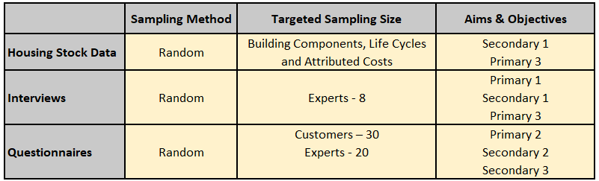

Fig. 6
The interviews will be undertaken first with the questionnaires being sent out shortly after then the data will be analysed to check if any follow up interviews and questionnaires will be needed. if follow if questions are needed and they will follow the same. It is not expected that follow up questions will be required unless specific trends arise from the interviews.

Housing Stock Data
Housing stock data is pivotal to ensuring medium and long term retrofit plans are successful both for customer and client, so it is vital that (Initial & reassessment) whole home assessments are accurate and are carried out in the correct way, so having strong asset management data is critical to making good informed decisions (María Carmen Carnero, 2017) to avoid unintended consequences under PAS 2035. The research will sample stock data and will be quantitative data including, specific building component data, component replacement costs, etc., and it will be from various housing associations and local authorities that are willing to share this information, this will ensure that the information being stored is relevant to the assessment and idenify if there are any data gaps. PAS2035 outlines what data sets are required to manage retrofit coordination out effectively. Property stock data collected randomly from housing providers and organisations via their annual WHQS submissions which are made available via the Welsh Government, or via direct request to social housing providers and the data will then be compared like for like if we are able to. This research will be looking at the main capital component information and their replacement cycles, as this information would be most relevant in terms of reassessment. Interpreting the usefulness of this data will require skills not only from asset managers but data analysts also, these key people will help organisations make the best financial decisions (Kirkham, et al., 2002). Analysing this data will be key, as having “big data” that doesn’t add value to the assessment is worthless (Aziz, 2017).

Limitations
Some of the data might not be comparable as there is no set standard for data collection and storage within the social housing sector, the vast majority of housing associations & local authorities base their storage structure off WHQS, but these data sets will vary depending on the housing provider and their stock portfolios. Each organisation will have different asset management systems and different way of collecting data.
- In-house Retrofit Assessors (Surveyors)
- Building Maintenance Contractors – collect information post upgrading of capital replacements (Kitchen, Bathrooms, Boilers, etc).
- Consultants – Third Party Retrofit Surveyors/Property Surveyors

So, information might be incomplete in some instances depending on the collection method also there might be several elements of cloned data due to property access issues.

Interviews
For this research Interviews will provide great holistic flow of information from a diverse pool of people and will help understand how reassessment should be handled in the future. It will also help understand the root cause of current problems within the initial assessment and the expert’s knowledge gap. The aim is that interviews will be semi structured but this is totally dependent upon the interviewee and what time they can give up to take part in the interview; this approach will hopefully allow flexibility and each person that being interviews will have differing experiences with this type of data gathering, Brinkmann states “semi structured interviews can make better use of the knowledge-producing potentials of dialogues by allowing much more leeway for following up on whatever angles are deemed important by the interviewee.” (Brinkmann, 2022). The interviews will consist of 8 questions with further questions if needed, these extra questions will allow further explanation for some of the more pressing questions (Rowley, 2012), if required. Each interviewee will be offered to undertake the interview in person at there place of work on online via zoom, MS teams of another digital platform and if the interviewee will allow, it will be recorded, the recording will prove the validity of the data collected and then deleted once the information has been recorded. If the interviewee declines for the interview to be recorded this will be noted on the interview form. Please see Appendix 7 for the full list of interview questions.

Limitations
The information collated from experts may be biased and geographically isolated in terms of their views on retrofit and whole home assessments, this might exist because of urban and rural differences and access to services and technology. Given that a wide range of experts from differing backgrounds will be interviewed, it is expected that they will have differing agendas based on their experience and organisations strategic direction. Below are some of the key areas that organisations are focusing on at the present time, so there may be links to the below in their answers.
- Housing Disrepair Claims for Non-Completed Repairs Works
- Damp and Mould
- Training and Qualifications
The above must be taken into consideration when analysing the data as for some organisations this is a strategic direction set by them. Some experts that work in the sector may be biased because of their organisations strategic mandate, long standing ways of working with their current employer and their affiliations with external partners and bodies like CIOB, RICS, etc.

Questionnaires
Two questionnaires will be sent out which will have similarities from one another, but one will be for customers and one for the industry experts, but both questionnaires will look at the larger issues like decarbonisation, whole home assessment & reassessment. The questionnaire will need to achieve three things, firstly ascertain what the baseline of knowledge currently exists for retrofit and reassessment amongst both customer and industry experts, second understand what communication baseline best and what legislation/guidance or best practice is is there to support communication being at the heart of retrofit and whole home assessments. Finally understand what markers, both social and building oriented are able to be reassessed and how this can be developed into a decision-making tool. For both customer and expert questionnaires, a variety of checklists and ranking questions will be used predominantly with the Likert scale, the Likert scale is extremely good in the cross-cultural research where different groups of people are being surveyed (Weijters, et al., 2016). Customer and Expert questionnaires will be provided via Microsoft forms, it is an online tool which can be access remotely via the cloud. Using this tool will allow a customer to complete this in person if needed. Please see Appendices 8 & 9 for the customer and industry expert questionnaires in which people will be completing.

Limitations
The process of collecting data via questionnaires is time consuming given the volume of customers that this research intends on gathering data from with participates potentially taking longer periods of time to complete, this could be due to several factors like age, hearing, and ability to communicate etc. If the question sets are complicated or there are abnormally long data sets and questions to interpret it could require a vast amount of time to analyse and complete the questionnaire. Participants could possibly be less engaged than other methods of data sampling and collection and poorly chosen distribution methods could lead to lower-than-normal response rates in certain customer groups.

Data Analysis
After the data is collected from the participants it will be collated organised and stored automatically using Microsoft Forms, then the information must be broken down granularly to understand the data sets (Creswell, 2009), this can be a very arduous task depending on the data sets. When critiquing the data sets, its vital that we ensure that the research objectives are considered and cross referenced, data must be in an easily understandable format that can be translated into easy-to-understand tables, graphs, and data sets in which you can clearly identify trends and anomalies.
Within the customer data sets there are results which can already be predicted around the customer element of reassessment, it is expected that customer knowledge of reassessment to be low as an overall average and customer expectation of communication and an overwhelming need to feel involved in the process to be high in terms of retrofit. This is extremely predictable given the current energy, geopolitical and cost of living crisis that the UK is currently going through.

Summary
Both qualitative and quantitative data sets have been collected under the framework of grounded theory with a pragmatic approach based on real world issues, both questionnaires and interviews were tailored to differing audiences. By undertaking this method of data gathering, it was easier to investigate and address the aims and objectives of the research. All the data sets will be summarised within the next chapter of this dissertation.

Chapter 4

Findings

Introduction
As this research will be using a pragmatic approach based on real world problem solving coupled with grounded theory using mixed methods approach utilising both quantitative and qualitive data sets, this chapter will be split into 3 sections.
- Housing Stock Data -This data was collected through anonymised requests from asset managers and other staffing members within social housing providers throughout Wales, 5 data sets were collected. This raw data can be found in Appendix 10.
- Interviews – 8 interviews were conducted with housing association experts that currently work within the sector within Wales. They were asked a total of 8 questions in which some have follow on sub questions. This raw data can be found in Appendix 11.
- Questionnaires
  - Customer (Sub Section) - 35 customer questionnaires were completed via an online Microsoft Form; this method automatically collects and summarizes the data, and this raw data can be found in Appendix 12.
  - Industry Experts (Sub Section) - 22 expert questionnaires were completed via an online Microsoft Form; this method automatically collects and
summarizes the data, and this raw data can be found in Appendix 12.

Housing Stock Data
Within this chapter of the research 5 data sets will be discussed separately and within chapter 5 they will be analysed to look at trends and observations between them. The full data sets are within Appendix 10.
The 5 data sets that have been collected have a variety of differing components within them, within this we will look at 3 key areas of difference.
- Total Component Count
- Average Life Cycle in Years
- Total/Average Component Cost

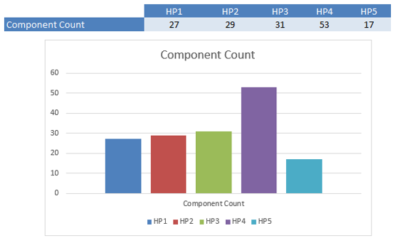
Total Component Count
Fig. 7
Looking at the 5 data sets provider by the different housing providers there is a clear difference between what constitutes a component that needs to be monitored and have a replacement programme. Currently there is no set structure that housing providers need to follow, they only need to comply with WHQS in terms of ages of specific components like Kitchens, Bathrooms, Boilers, Electrical Systems and etc. as per the raw data in Appendix 10 all housing providers do have these major components.

Average Life Cycle in Years

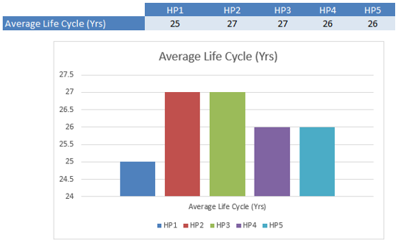

Fig. 8

Looking at the average life cycles there does seem to be certain level of cohesiveness, this would be because of WHQS and their recommended life cycle replacement dates. The size of an organisation in terms of stock numbers (i.e. an organisation with a large stock portfolio) and their financial position will have an impact on this element of operations.

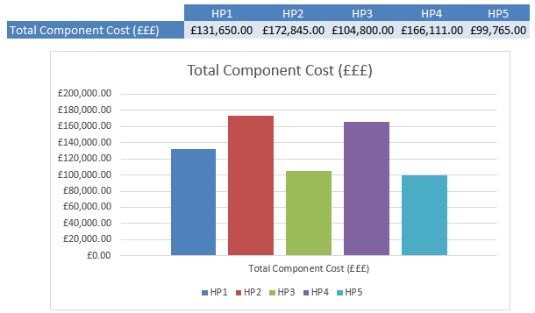
Total/Average Component Cost

Fig. 9
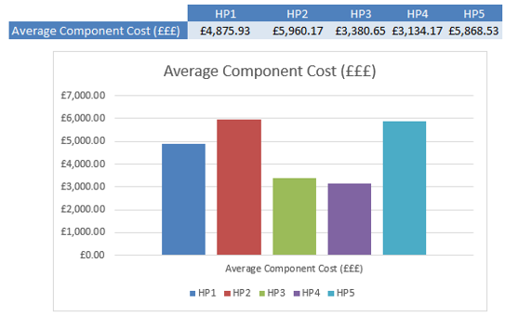
Total component costs per component are high across the 5 data sets, housing providers will have components like a Kitchen but will have X amount of volume of this component with their housing stocks, so if housing provider 1 has 100 kitchens at £2,900.00 their total capital replacement programme for kitchens would be £290,000.00. The above figures are the costs per component per unit not for their total stock volume. This data was provided by all of the housing providers, but data can be estimated and extrapolated based on estimated property figures.

Fig. 10

Average component costs across the 5 data sets are varied with some organisations having very low average costs per component type.

Interviews
Within this chapter of the research the interview answers from the 8 industry experts will be briefly summarised. Within chapter 5 these answers will be critiqued to discuss trends and observations between them. The full data sets are within Appendix 12.

Question 1
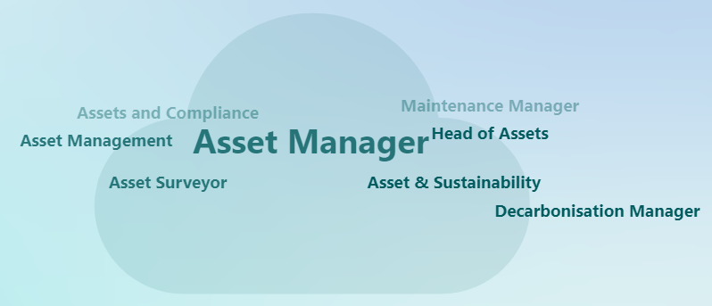
What is your job title?
Fig. 11
Over the 8 interviews we had the majority of titles included the word “Asset” as illustrated above. The full list of titles is below.
- Asset Manager
- Director of Asset Management
- Head of Assets & Compliance
- Asset Manager
- Decarbonisation Manager
- Senior Asset Surveyor
- Asset & Sustainability Manager
- Area Maintenance Manager
All the people who took part in the interviews are leading large teams within the social housing sector that are undertaking retrofit and whole home assessments.
Question 2
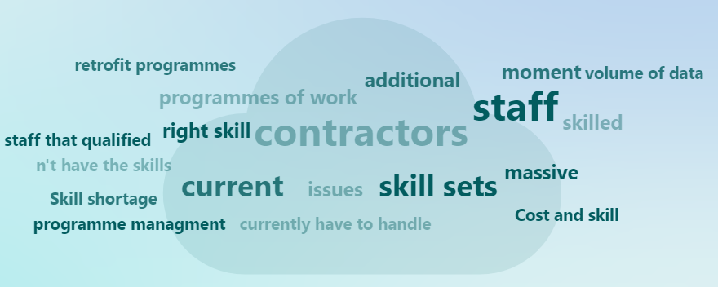
What are the main issues for you and your organisation in delivering retrofit at scale?
Fig. 12

Interview 1, Asset Manager - “having the right skill sets, both internally with our staff and externally with our contractors, we can’t recruit surveyors or tradespeople at the moment”.
Interview 3, Head of Assets & Compliance - “Skill shortage is huge at the moment, both with our own staff and contractors”.
Interview 6, Senior Asset Surveyor - “For us and my team the main issue is having the right skill set to deliver the retrofit programmes for in house and with our contractors”.

Across the 8 interviews contractors, skills and data were all the common themes and these are illustrated above, with 5 interviews talking about the right skill sets in both contractors and internal staff.

Question 3
What is your view on the role of PAS 2035/2038 in the context of social housing retrofit planning?
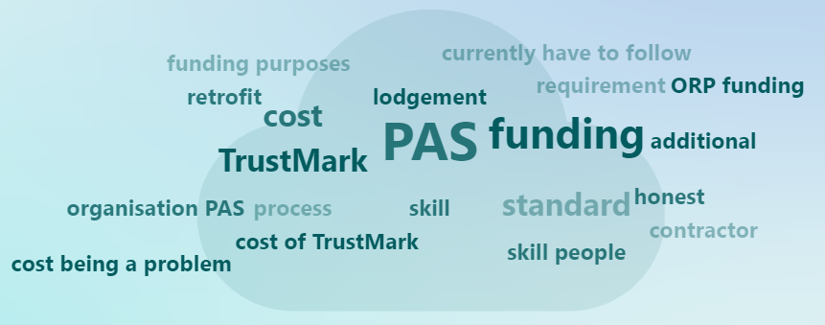
Fig. 13

Interview 3, Head of Assets & Compliance - “there shouldn't be fees evetime you undertake the correct procedure”.
Interview 5, Decarbonisation Manager - “the only downside is the added cost of TrustMark which if I'm honest did catch us by surprise”.
Interview 7, Asset & Sustainability Manager - “It’s a very onerous process to follow PAS and then the lodgement is costly”.

Across the 8 interviews cost of the PAS process specifically the TrustMark lodgement was the key takeaway from the answer to this question. Other common themes are around the overall process of PAS, and these are illustrated above.

Question 4
Does WHQS 23 go too far or not far enough in providing best practice and industry targets?
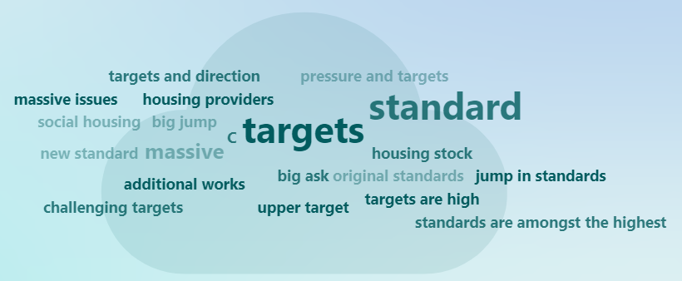
Fig. 14

Interview 4, Asset Manager - “Yes these standards are amongst the highest in the UK, it’s a big jump from the original standards”.
Interview 6, Senior Asset Surveyor - “So I think it’s a big jump in standards but it’s good for tenants, I think we will straggle to be able to budget for all the additional works that are required. The targets are a big ask but could be doable with the right support from gov”.
Interview 8, Area Maintenance Manager - “I don’t see how you could push it anymore without causing massive issues for housing providers”.

Across the 8 interviews the overwhelming consensus was that the standards are already very high. All responses were concerned around the how their organisation will achieve the new standard. This is illustrated above.

Question 5
What asset stock data should be harmonised between social housing providers if not why?
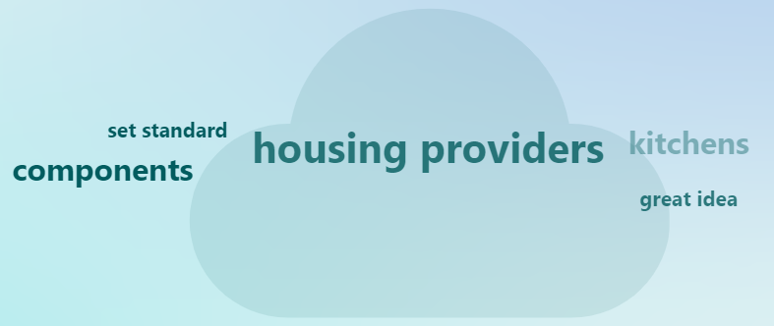
Fig. 15

Interview 4, Asset Manager – “All of our stock components could be and yes we would welcome it”.
Interview 6, Senior Asset Surveyor - “100% the basics as in kitchens, bathroom etc”.
Interview 8, Area Maintenance Manager - “Basic stuff like boilers bathrooms and kitchens you could … yea definitely”.

Across the 8 interviews the answers were very short and overall, very positive towards the idea of component stock data harmonisation and this is illustrated above.

Question 6
What is your view on Whole Home Assessments?

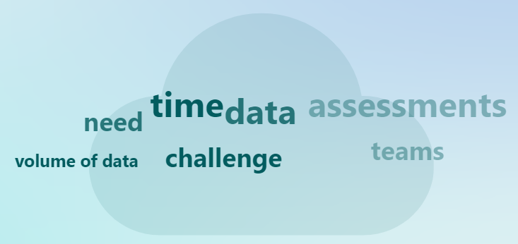
Fig. 16

Interview 1, Asset Manager - “The idea behind them is great and they gather lots of data which we do need for our retrofit plans, but it comes down to resources”.
Interview 2, Director of Asset Management - “Very onerous but yes i see the reasons for undertaking such a detailed assessment but this does add significant time, money and effort onto every housing provider”.
Interview 3, Head of Assets & Compliance - “volume of data we are now collecting is staggering and it forced us to reevaluate our asset managment systems”.

All responses centred around the same issues of data, time, and resources, and this is illustrated above.

Question 7
How could the initial Whole Home Assessment be improved?

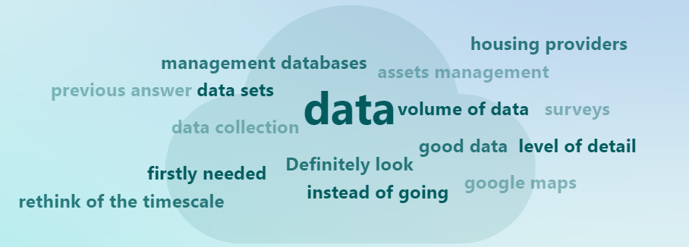

Fig. 17

Interview 1, Asset Manager - “The ability to use cloned data could help fill gaps that helps decrease the volume of data that surveyors need to collect”.
Interview 2, Director of Asset Management – “It could focus more on missing data sets”.
Interview 7, Asset & Sustainability Manager - “Definitely look at what data sets are firstly needed”.

All responses centred around the same issues of data expect for one, views were heavily data centric, and this is illustrated above.

Question 8
How do you think retrofit reassessment should be undertaken if undertaken at all?

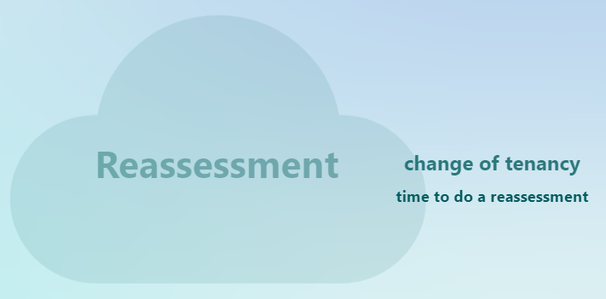

Fig. 18

Interview 2, Director of Asset Management – “Currently we don't undertake reassessment purely because of resources and cost issues and it is not mandated”.
Interview 5, Decarbonisation Manager - “We currently don't do reassessments but if we could look to do them at change of tenancy”.
Interview 8, Area Maintenance Manager - “I wasn’t aware that this was even a thing”.

Across the 8 interviews the general consensus was the same with all interviewees answer very similar. One interviewee didn’t even know about reassessment, and this is illustrated above.

Questionnaires
Within this chapter of the research both customer and expert questionnaires will be discussed separately and formally layout the findings of each individual. Within chapter 5 both questionnaires will be analysed together to discuss trends and observations between them both. The full data sets are within Appendix 12.

Customers
Question 1
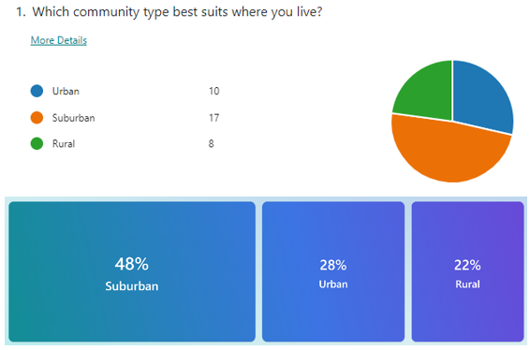
b
Fig. 19

The majority of customers who took part in the questionnaire were from a suburban community, 17 out of a total of 3, with urban having 10 customers and rural having 8 customers take part.

Question 2

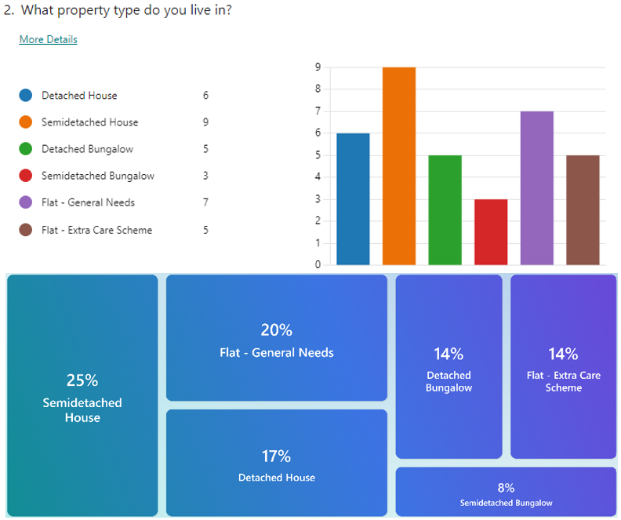

Fig. 20

The spread of household types that took part was mixed with detached homes, semidetached house and flats making up the majority of replies. Bungalows had a lower response percentage making up just 22% of responses.

Question 3
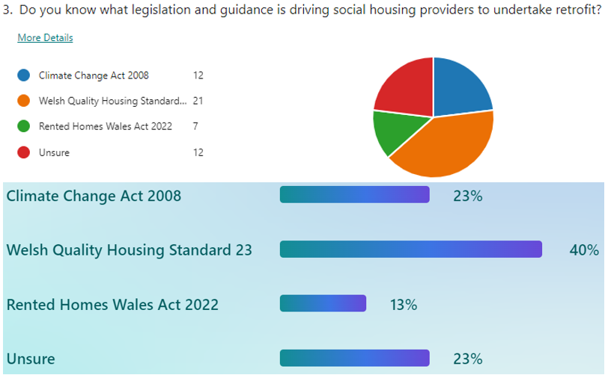
Fig. 21

As this was a question where multiple choices could be selected so there is a higher number of responses per option. The majority of customers who took part in the questionnaire did have a good overall knowledge of the main drivers behind the push for retrofit works as the Climate Change Act 2008 and WQHS 23 was selected 33 times which is a combined percentage of 63%. Only 36% of the responses didn’t have a good knowledge as there was 12 selections for Unsure and 7 for Rented Homes Wales Act 2022, which doesn’t actually play a major role in the overall direction of net zero.

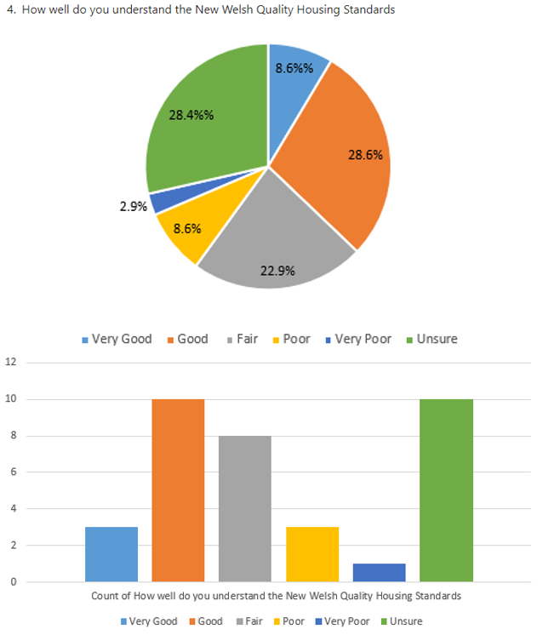
Question 4

Fig. 22

This question used the Likert scale to ascertain customer knowledge and background of guidance behind WHQS 23 and the whole home assessments. Generally, the outcomes where mixed with 28.4% unsure, 37.2% between very good to good and the remaining split between fair, poor and very poor. No exceptional responses were submitted.

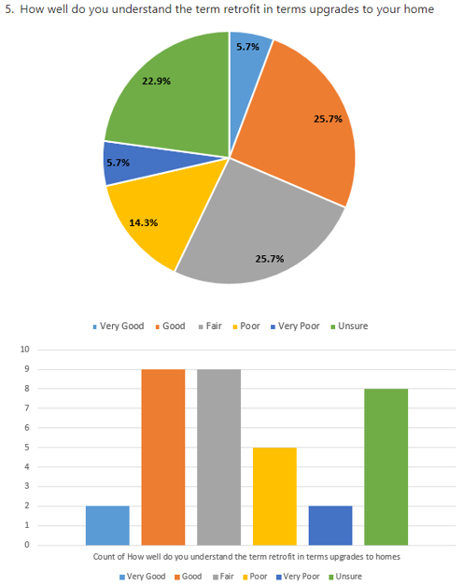
Question 5

Fig. 23

This question used the Likert scale to ascertain customer knowledge for the general term of retrofit. The overall answers to this questions matched question 4 answers, overall, a mixed response with just over 50% responding god to fair in their understanding. No exceptional responses were submitted.

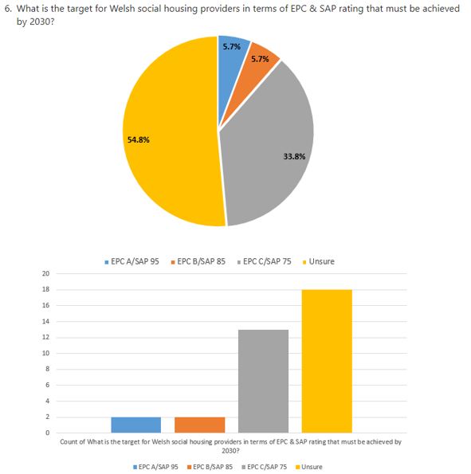
Question 6
Fig. 24

This question used the Likert scale to ascertain if customers know what targets social housing providers have to meet before 2030. Customers seemed to lack knowledge around the specific target of EPC/SAP C/75, the majority of customers 54.8% were unsure of the target within WHQS.

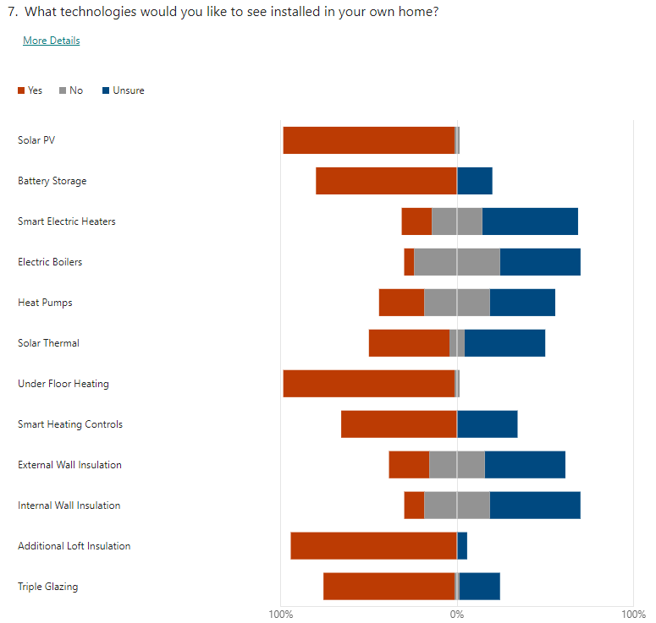
Question 7

Fig. 25
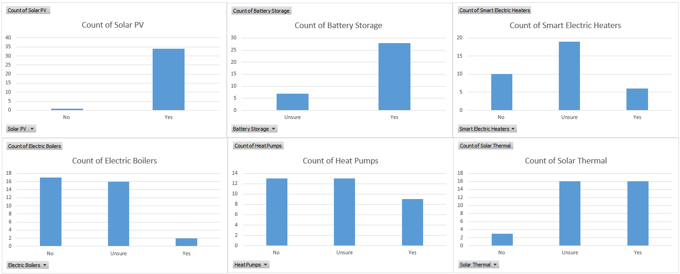
This question used the Likert scale to understand what types of retrofit measures customers would like to see installed in their own homes. It’s quite clear that customers favoured solar PV, underfloor heating, and additional loft Insulation. These customer views do not correspond with current guidance from WHQ23 and PAS 2035. Fabric measures are currently promoted, especially within WHQS.
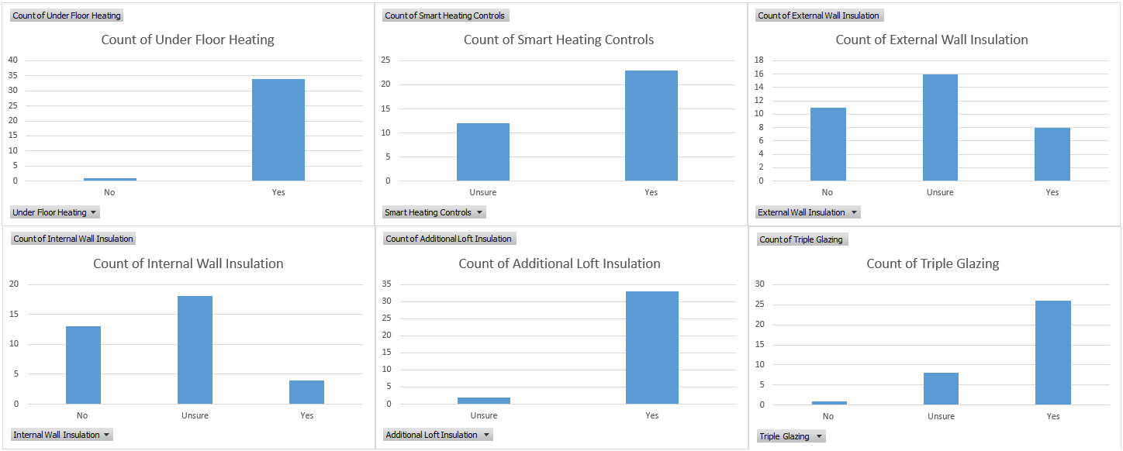
Fig. 26
Fig. 27
Lots of customers were unsure with heating and fabric technologies, but all customers recognized that retrofit measures would be needed and recommended at least one that they would like to have installed in their home.
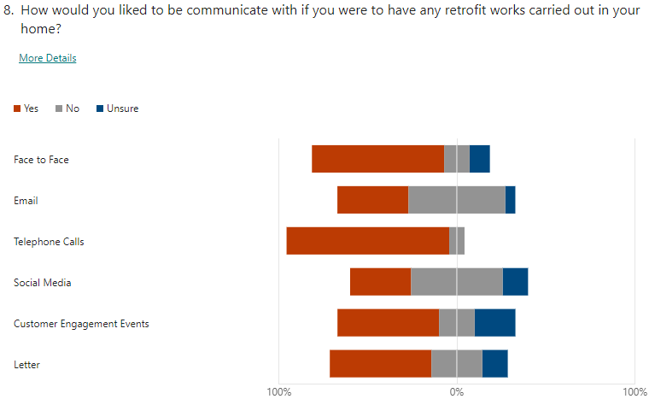
Question 8
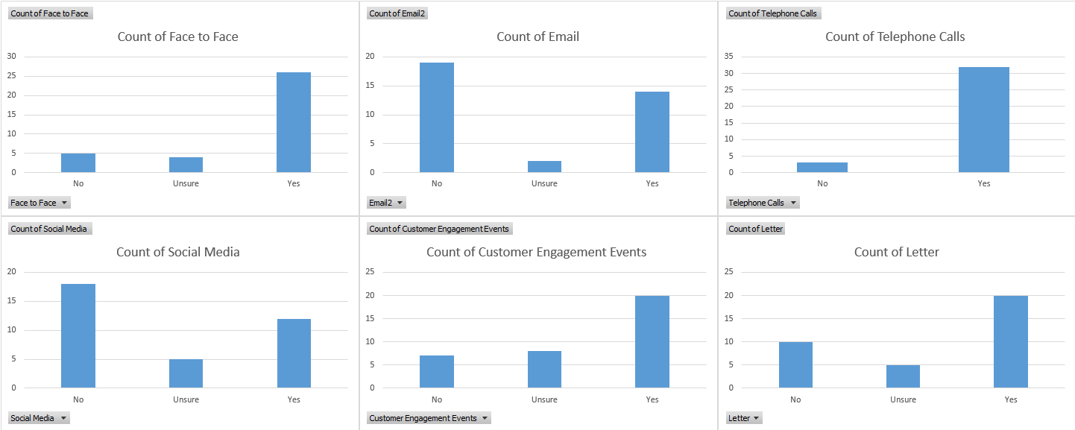
Fig. 28
Fig. 29
This question used the Likert scale to understand what communication methods customers would prefer if they were to have of retrofit measures installed in their homes. Very mixed repose with a wide variety of methods preferred or not, only a small amount was usure of certain methods.

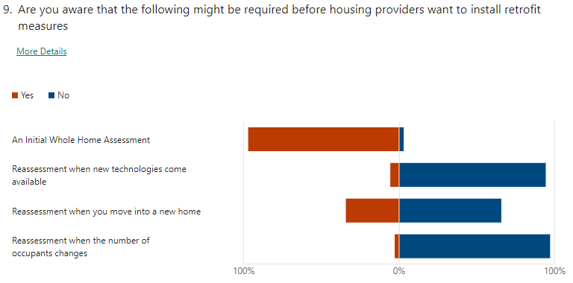
Question 9
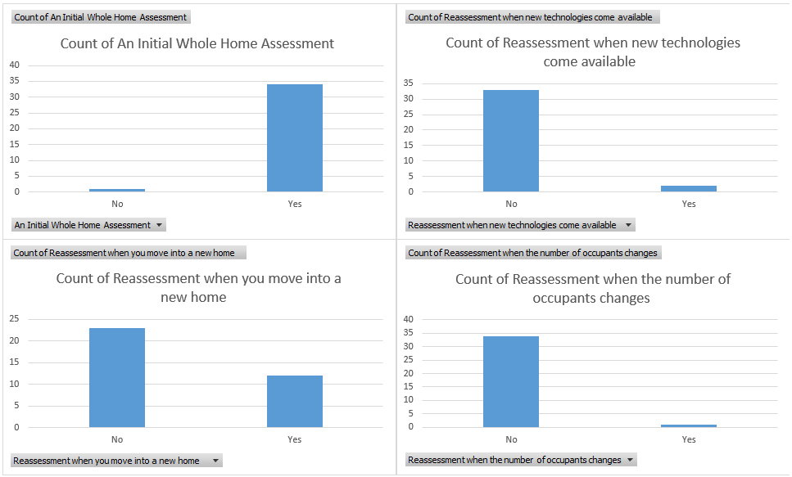
Fig. 30
Fig. 31
This question used the Likert scale to understand what customer expectations and knowledge around initial home assessment and reassessment was. The majority of customers knew about an initial assessment but did not know about any further future assessments that might need to be undertaken.

Question 10
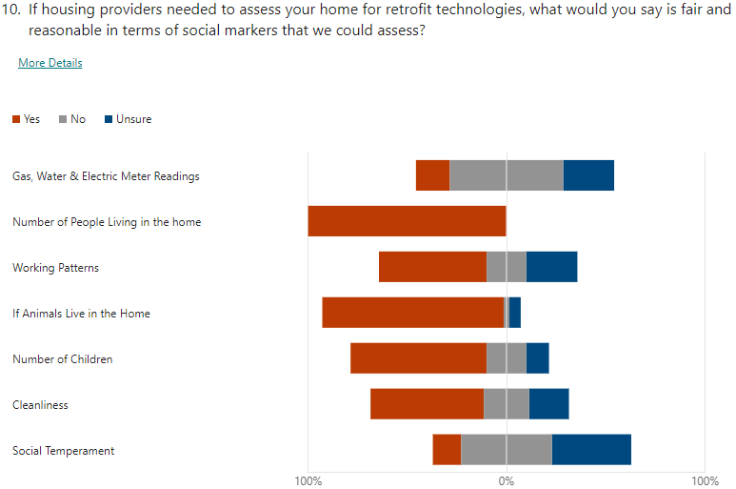

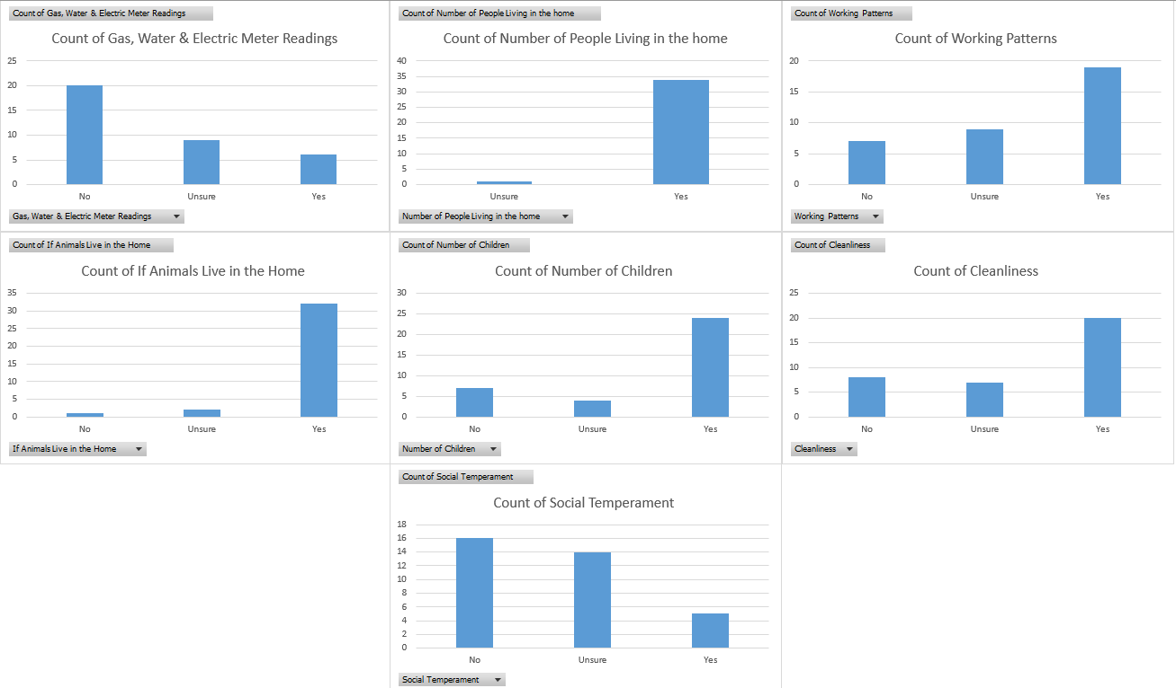
Fig. 32
Fig. 33
This question used the Likert scale to understand what customers deemed reasonable in terms of social factors that could be reassessed. Overall, a mixed response with some customers in favour of certain factors and not in favour of others.

Industry Experts
Question 1
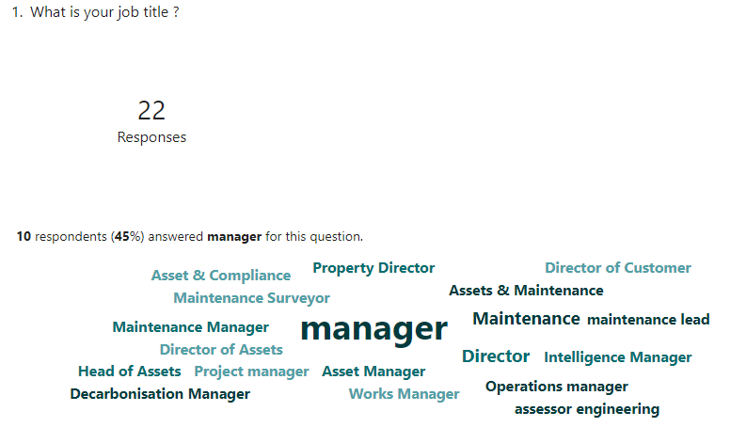
Fig. 34

The majority of industry experts who took part in in the questionnaire were managers, 10 out of the 22 responses which equates to 45%. The overwhelming majority were from the social housing sector.

Question 2
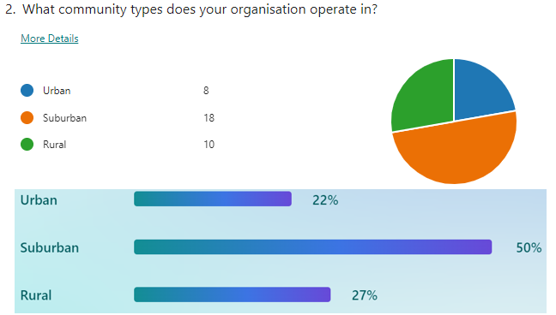
Fig. 35

The majority of industry experts who took part in the questionnaires have their organisations operate in suburban communities, which is 50% of the overall responses. This question was able to have multiple answers as many organisations operate across multiple geographical areas; this is why a total of 36 answers have been provided across the 22 responses.

Question 3
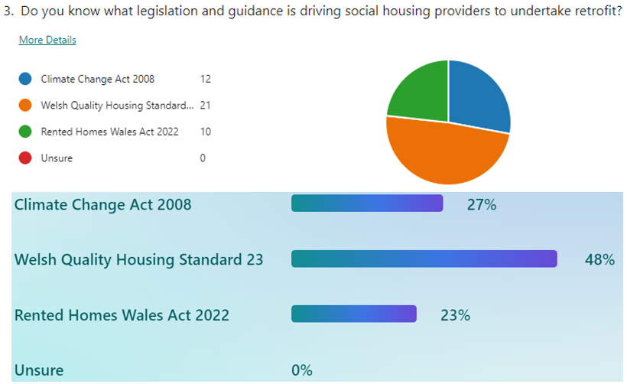
Fig. 36

As this was a question where multiple choices could be selected so there is a higher number of responses per option. The majority of experts who took part in the questionnaire did have a good overall knowledge of the main drivers behind the push for retrofit works as the Climate Change Act 2008 and WHQS 23 was selected 33 times which is a combined percentage of 75%. Only 23% of the responses didn’t have a good understanding as there was 10 for Rented Homes Wales Act 2022, which doesn’t actually play a major role in the overall direction of net zero. No responses selected Unsure which is positive as its shows good education within the sector.

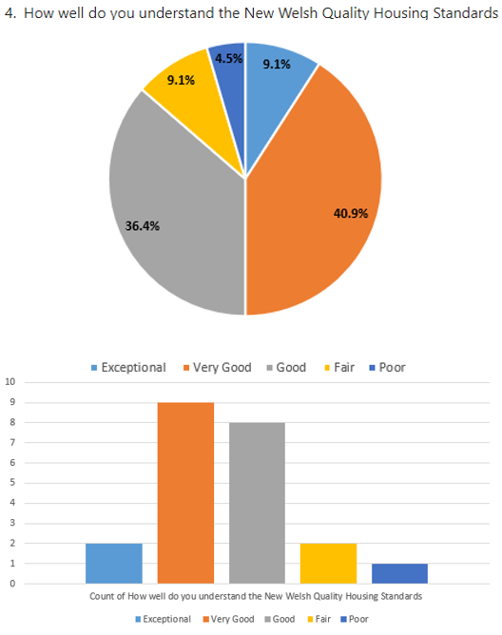
Question 4

Fig. 37
This question used the Likert scale to ascertain industry experts’ knowledge and background of the guidance behind WHQS 23 and the whole home assessments. Generally, the outcomes really good with the overwhelming majority having exceptional, very good and good understanding when it comes to WHQS. No very poor or unsure responses were submitted.

Question 5
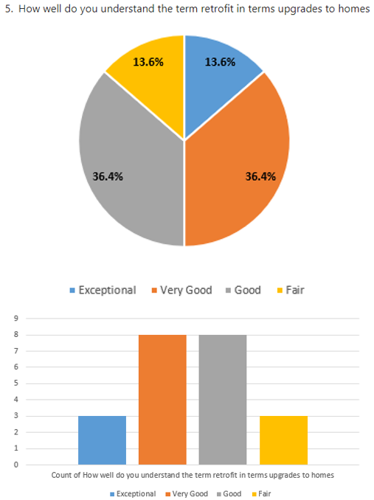

Fig. 38
This question used the Likert scale to ascertain industry experts’ knowledge for the general term of retrofit. The overall answers to this questions matched question 4 answers, the overwhelming majority having exceptional, very good and good understanding when it comes to the term retrofit and its meaning in homes. No poor, very poor or unsure responses were submitted.

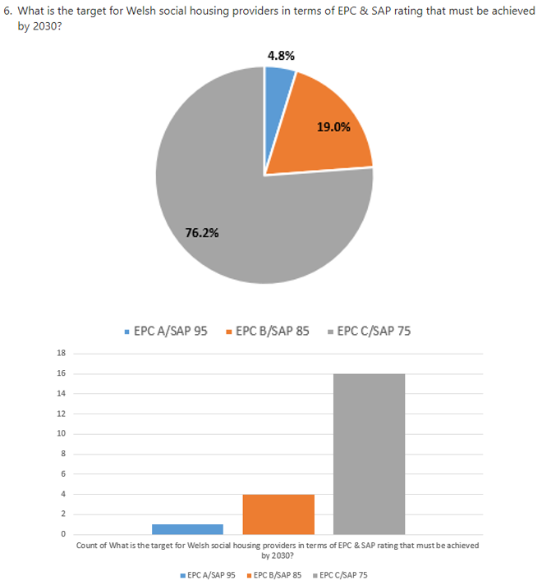
Question 6
Fig. 39

This question used the Likert scale to ascertain if industry experts know what targets social housing providers have to meet before 2030. The experts have excellent knowledge around the specific target of EPC/SAP C/75, with the majority of them submitting the correct target of EPC C/ SAP 75 76.2%. No unsure responses were submitted.

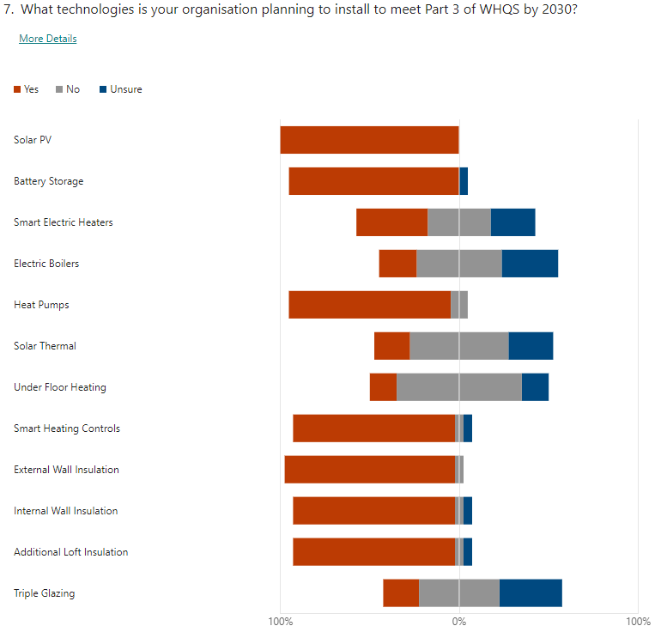
Question 7
Fig. 40

This question used the Likert scale to understand what types of retrofit measures social housing providers are planning to install in their homes. Housing providers are looking at a fabric first options coupled with energy generation and heat pumps, these rea the common themes. Housing providers plans do correspond with current guidance from WHQ23 and PAS 2035, which is fabric first approach.
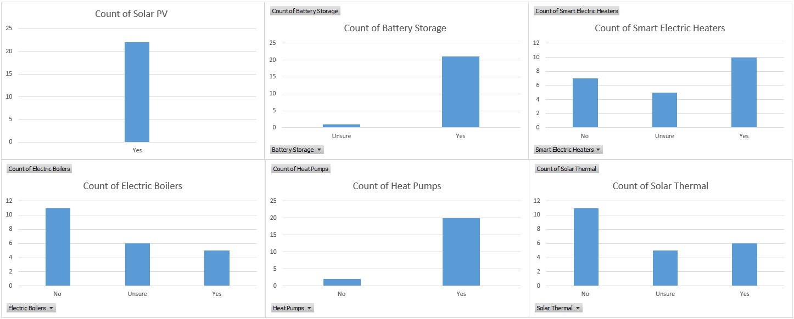

Fig. 41
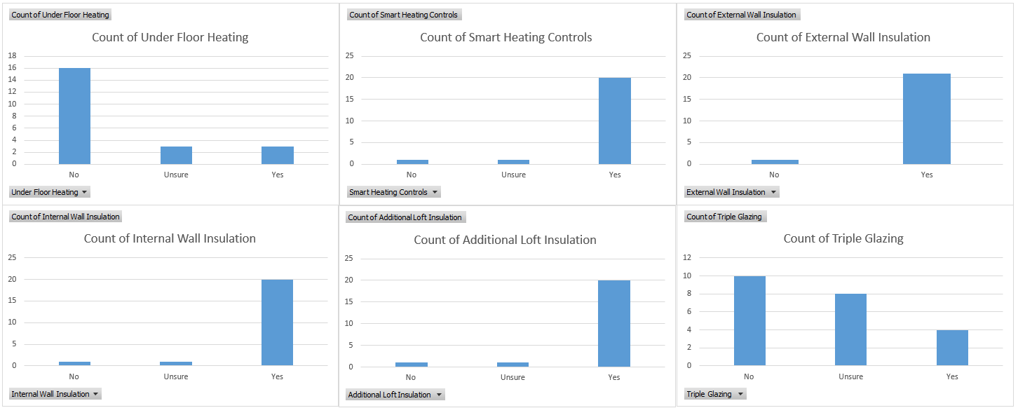
Fig. 42
Social housing providers have a clear understanding of what is needed especially when it comes to a fabric first approach, it is also clear that certain technologies like electric boilers, solar thermal and under floor heating will not be installed on mass if even at all.

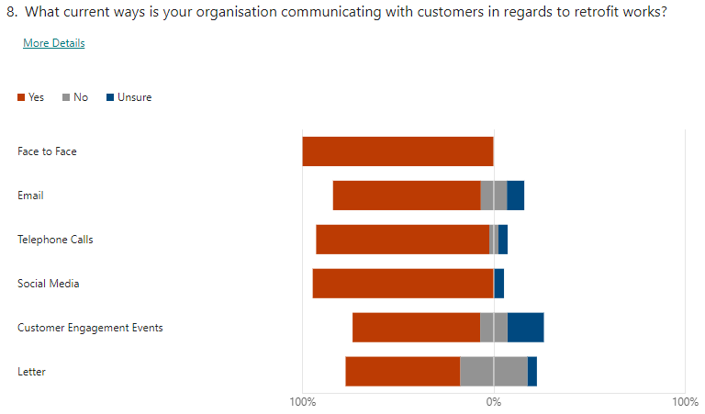
Question 8
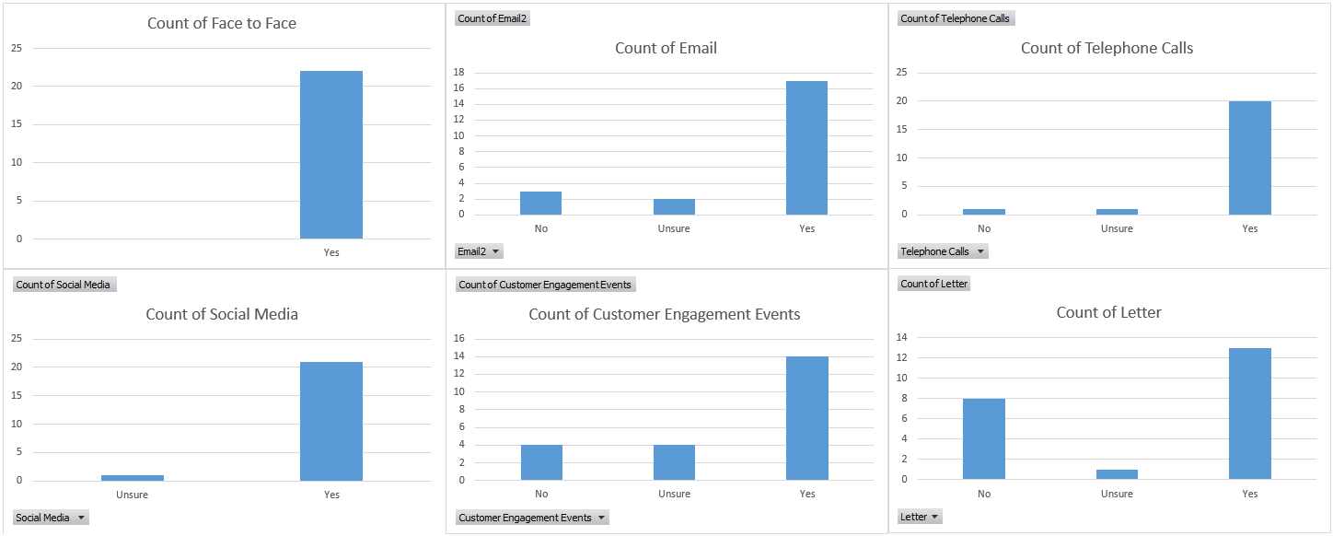
Fig. 43
Fig. 44
This question used the Likert scale to understand what communication methods social housing providers are currently undertaking when they are installing retrofit measures in their homes. Very mixed response with a wide variety of methods being currently used.

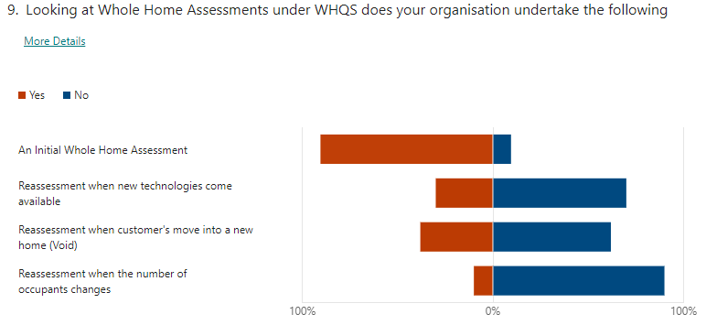
Question 9
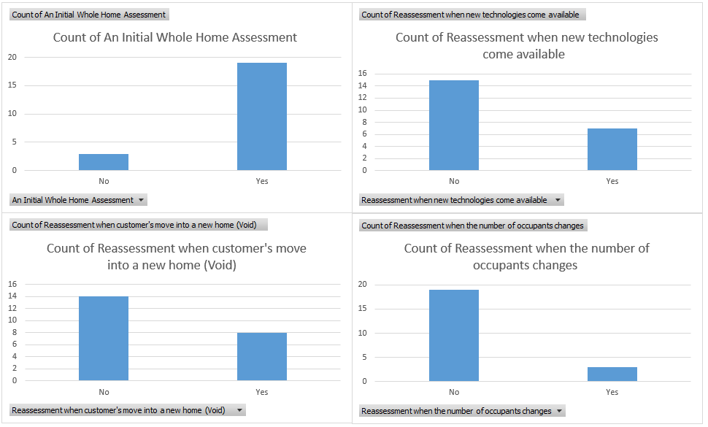
Fig. 45
Fig. 46
This question used the Likert scale to understand what social housing providers current arrangements around initial home assessment and reassessment was. The majority undertook initial assessment, but future assessments practices were sporadic and not uniform, with the majority not undertaking any reassessment at all.
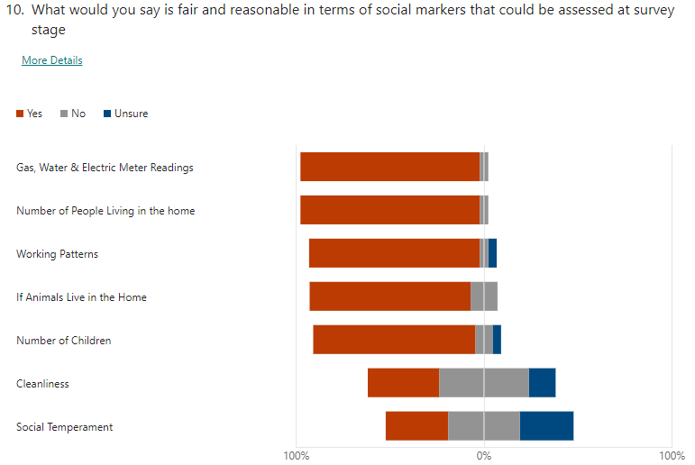
Question 10
Fig. 47

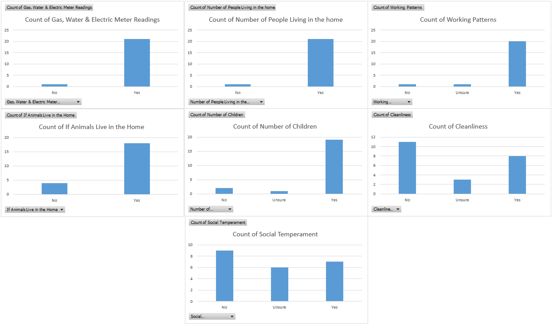

Fig. 48

This question used the Likert scale to understand what social housing providers found to be reasonable in terms of social factors that could be reassessed. The majority found all factors to be suitable for reassessment.

Summary
The Housing Stock Data that was collected was vast and detailed, but the data sets are very specific to the housing providers that they originated from, this does make it difficult to look for trends and themes within the data sets. Housing providers that have shared these data sets are clearly prioritising their own policies as these data sets have very little in common from the components themselves to life cycles and actual replacement costs.
The Interviews gathered a lot of data that was very subjective and passionate, but there are clear themes which all 8 interviewees have brought up, data is one of the key themes and how they would like that data to be used, especially the volume of data and how its handled and what could be cloned in regard to data gaps.
The questionnaires both customer and industry experts had a total of 57 responses which has generated very interesting data comparisons especially between questions 7, 8, 9 & 10. Customers have a very clear view on what technologies they would like to have installed in their homes and the industry experts also have a view on this, but they do differ. Question 10 around what social markers could be reassessed has also drawn some very interesting responses where customers and industry experts have very contrasting views on what they deem acceptable.
The results will now be analysed in chapter 5 of this research with a view to deep dive into trends with a view to try and compare each data set against the aims and objectives.

Chapter 5

Analysis

Introduction
This chapter will analyse the results from chapter 4, firstly looking back to the aims and objectives of the research we need to define at what juncture should whole home reassessment take place and what are the parameters that trigger a reassessment. The data obtained will be analysed to help set out recommendations to meet the aims and objectives of this research. This chapter will be split into 3 sections which are as follows.
- Housing Stock Data
- Interviews
- Questionnaires – Both customer and Industry Expert data will be analysed together.

Housing Stock Data
Housing Provider 1

Housing provider 1 has a total of 27 components that cover its housing stock, the average life cycle is 26 years, and its average cost of component replacement is £131K.
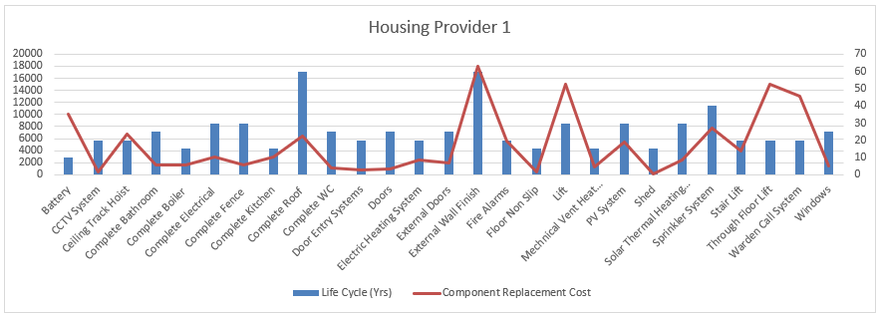
Fig. 49
Housing provider 1 as illustrated above has a very typical set of components which align with WHQS23, but they also have specific components like ceiling track hoist and stair lift. Costs of component replacement are also in line with WHQ23, External Wall Finish (EWI) which has a cost of £18K which is inline with current cost market costs. The housing provider would not share the volume of each component that they have in their stock so we cannot look deeper into the overall total capital cost of their component replacements but only into the unit cost of the component.

Housing Provider 2

Housing provider 2 has a total of 29 components that cover its housing stock, the average life cycle is 27 years, and its average cost of component replacement is £172K.
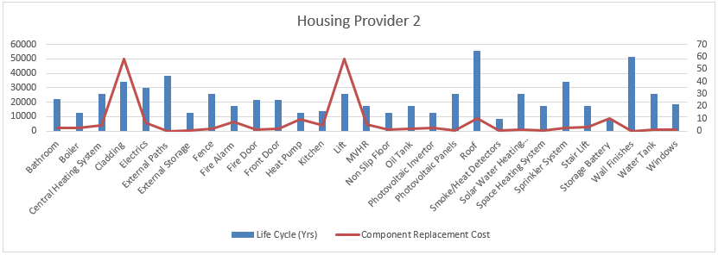
Fig. 50

Housing provider 2 as illustrated above has a very typical set of components which align with WHQS23, but unliked housing provider 1 they do not seem to have specific components, but their components seem very generic. Costs of component replacement are generally in line with WHQS23, but there are some abnormal costs like Cladding which has a cost of £50K which is higher than expected, this could be because of a specific extra care scheme requirement within their respective housing stock. The housing provider would not share the volume of each component that they have in their stock so we cannot look deeper into the overall total capital cost of their component replacements but only into the unit cost of the component.

Housing Provider 3

Housing provider 3 has a total of 31 components that cover its housing stock, the average life cycle is 27 years, and its average cost of component replacement is £104K.
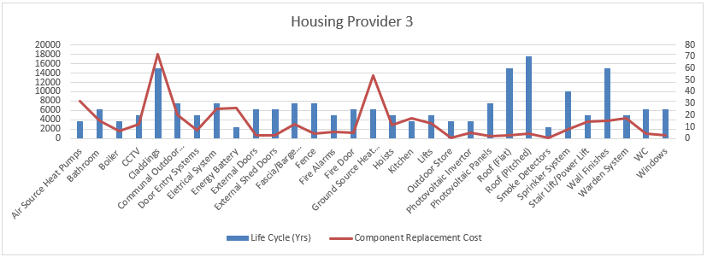
Fig. 51

Housing provider 3 as illustrated above has a very typical set of components which align with WHQS23, they do have both generic housing components and some stock specific components like CCTV & Communal Outdoor Areas. Costs of component replacement are in line with WHQS23, unlike the other data sets from the other housing providers, housing providers 3 has the most a typical costs and almost perfects reflect current market expectations within the sector. The housing provider would not share the volume of each component that they have in their stock so we cannot look deeper into the overall total capital cost of their component replacements but only into the unit cost of the component.

Housing Provider 4

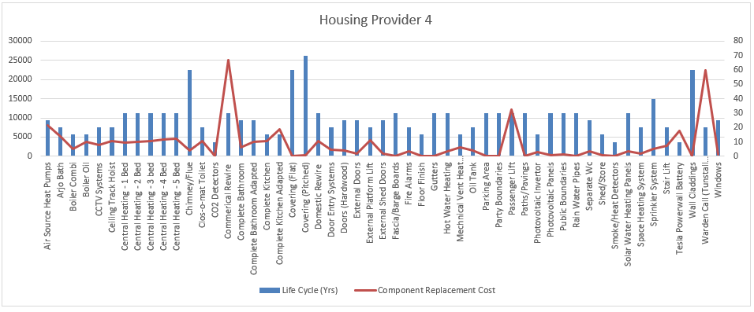
Housing provider 4 has a total of 53 components that cover its housing stock, the average life cycle is 26 years, and its average cost of component replacement is £166K.
Fig. 52
Housing provider 4 as illustrated above has an unusually high volume of components but these do align with WHQS23 and in some areas exceed WHQS23. They do have both generic housing components and some stock specific components, but all components are more methodical in there listing, this housing providers for example splits heating systems into property types (1 bed, 2 bed, 3 bed, etc). Costs of component replacement are in line with WHQS23 and are very typical, but the difference would like the better costing structure for specific items like heating systems. Housing providers 4 has a very large number of components, this would be very typical from a larger housing provider which delivers a variety of different services across Wales. The housing provider would not share the volume of each component that they have in their stock so we cannot look deeper into the overall total capital cost of their component replacements but only into the unit cost of the component.

Housing Provider 5

Housing provider 5 has a total of 17 components that cover its housing stock, the average life cycle is 26 years, and its average cost of component replacement is £99K.

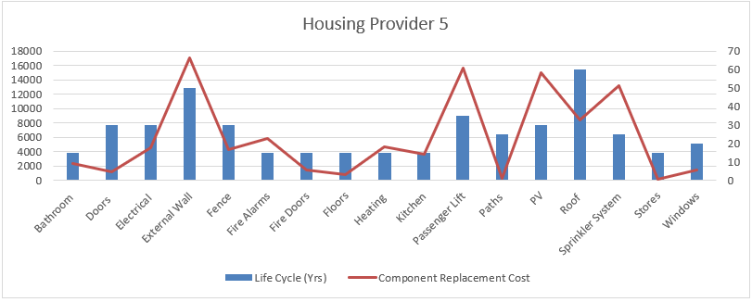
Fig. 53

Housing provider 5 as illustrated above has an unusually low volume of components and they partly align with WHQS23 and in some areas fall short of WHQS23. They do have both generic housing components and some stock specific components. Costs of component replacement are partly in line with WHQS23, but some costs do look specific to this housing provider, Paths, Floors & Fence. Housing providers 5 has a very small number of components, this would be very typical from a small housing provider which delivers limited services across a small geographical area. The housing provider would not share the volume of each component that they have in their stock so we cannot look deeper into the overall total capital cost of their component replacements but only into the unit cost of the component.

Across all 5 housing providers the data provide is non comparable but follows a similar thread which is WHQS23, individual data sets like Kitchen/Complete Kitchen can be mapped across and compared to a certain extent but it’s clear that there are very different interpretations of what each component is meant to represent. Also housing stock numbers and services provided clearly affect the volume and type of data collected by a housing provider, component costs are somewhat comparable, but these have geographical variances and again costs also reflect stock numbers and services provided with larger housing providers being able to compress costs by offering larger volumes to tender or leverage when negotiating costs.

Interviews
Question 1
What is your job title?
Across the 8 interviews we had strategic senior managers and operational managers give their views. The interviews targeted the right target audience, so the opinions of the interviewees are very topical and accurate. The full list of job titles of the interviewees is below.
- Asset Manager
- Director of Asset Management
- Head of Assets & Compliance
- Asset Manager
- Decarbonisation Manager
- Senior Asset Surveyor
- Asset & Sustainability Manager
- Area Maintenance Manager

Question 2
What are the main issues for you and your organisation in delivering retrofit at scale?
Out of the 8 interviews, skill shortage/qualifications were directly mentioned in 6 of the responses so 75% of interviewees are concerned with what skills sets are needed and how they attain qualifications and experience to deliver retrofit at scale. Other key topics that were brought up were financial elements around retrofit and the data volume that the retrofit process creates.
Overall, the responses were fairly similar, with all responses either directly mentioning skill shortage/qualifications or indirectly by mentioning “won’t be unlikely to take on all this additional works so we will need to look at new frameworks to deliver” Interview 7.

Question 3
What is your view on the role of PAS 2035/2038 in the context of social housing retrofit planning?
Out of the 8 interviews, costs of the PAS process were directly mentioned in 5 of the responses so 62% of interviewees are concerned with the cost of the PAS 2035 process and their ability to absorb this cost within their budgets. Other key topics that were brought up were the very onerous process that PAS lodgement is and the additional time and resources that the overall process is needed to complete.
Overall, the responses were fairly similar with all responses either directly mentioning the additional costs or indirectly by mentioning “the requirement to lodge with Trustmark which add to the costs isn't sustainable” Interview 2.

Question 4
Does WHQS 23 go too far or not far enough in providing best practice and industry targets?
Out of the 8 interviews, all agreed that the WHQS 23 was more than sufficient in terms of setting a high standard of living within social housing homes, that’s 100% of responses. Other key topics that were brought up were additional costs that the new standard brings and it possibly being unaffordable.
Overall, the responses were fairly similar with some responses either directly mentioning the additional cost of the new standard of WHQS23 or indirectly by mentioning “I don’t see how you could push it anymore without causing massive issues for housing providers” Interview 8.

Question 5
What asset stock data should be harmonised between social housing providers if not why?
Out of the 8 interviews, all agreed that harmonising data would be a positive, that’s 100% of responses. There was mixed reposed tho on what could be harmonised and weather that could actually be achievable, it was mentioned that basic components could be mapped across but there was some scepticism around how it could be achieved.
Overall, the responses were fairly similar with all agreeing it was a positive “All of our stock components could be and yes we would welcome it” Interview 4.

Question 6
What is your view on Whole Home Assessments?
Out of the 8 interviews, resource / time to complete the initial whole home assessment was directly mentioned in 7 of the responses so 87% of interviewees are concerned with the timescales to achieve an initial whole home assessment and the level of resources that might be needed. Other key topics that were brought up was the volume of data that these initial whole home assessments were creating and how best to deal with this data,
Overall, the responses were fairly similar with responses mentioning the resources and time needed to undertake the initial assessment “Very onerous but yes i see the reasons for undertaking such a detailed assessment but this does add significant time, money and effort onto every housing provider” Interview 3.

Question 7
How could the initial Whole Home Assessment be improved?
Out of the 8 interviews, data cloning or optimising was directly mentioned in 6 of the responses so 75% of interviewees would like to see a different approach when it comes to what data should be collected and what housing providers can do with their existing data sets to make the process more streamlined. Interviewee 6 was concerned with timeframes to deliver and interview 8 didn’t have a view as it wasn’t his area of expertise.
Overall, the responses were fairly similar with all responses either directly mentioning skill shortage/qualifications or indirectly by mentioning “The ability to use cloned data could help fill gaps that helps decrease the volume of data that surveyors need to collect” Interview 1.

Question 8
How do you think retrofit reassessment should be undertaken if undertaken at all?
Out of the 8 interviews, reassessment at void/change of tenancy was directly mentioned in 7 of the responses so 87% of interviewees think it was best if the reassessment was undertaken at void/change of tenancy. Other key topics that were brought up were that a lot of housing providers don’t currently undertake reassessment and that it would be costly in both resources and budget.
Overall, the responses were fairly similar with most responses directly mentioning reassessment at void/change of tenancy “We currently don't do reassessments but if we could look to do them at change of tenancy” Interview 5.

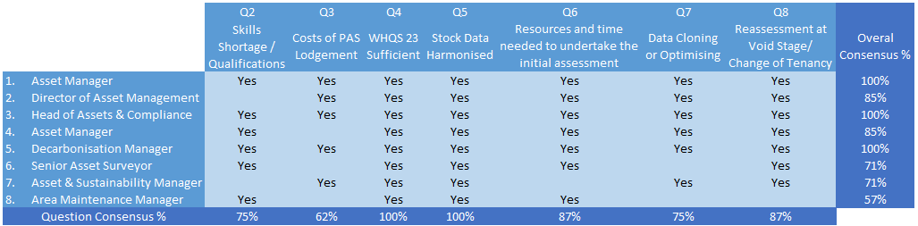
The main themes of the interviews have been summarised in the table below. Question 1 answers have been left out of the overall summary below as this question was just asking for their job title within the sector.
Fig. 54

Overall, across the 8 interviews there have been several key themes which have the overall consensus of the group, and these have been identified below.
  - The current WHQS is sufficient and does not need to be strengthened further. 100%
  - Main headline data sets should be harmonized but how to implement this was still up for further discussion. 100%
  - Reassessment should happen at void/change of tenancy. 87%
  - Data that is currently being collected in the initial whole home assessments needs to be streamlined with either existing data or cloned data. 75%
  - Industry skill shortage will hinder the progress to decarbonisation of the housing stock in Wales. 75%
  - PAS 2035 cost and lodgement process needs a rethink and possibly a different approach. 62%

Questionnaires
Both questions 1 & 2 in the customer and expert questionnaires are different from each other, the remaining 8 questions are the same but aim at their respective target audience. This first part will briefly analyse questions 1 & 2 of the customer and expert questionnaire.

Question 1 & 2 – Customer
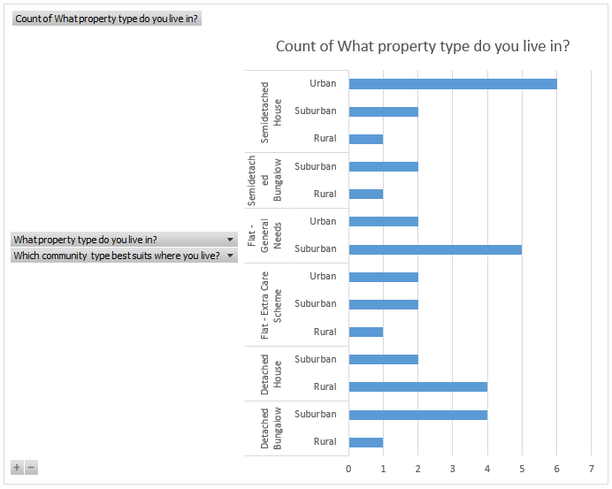
Looking at responses to both questions 1 & 2, suburban setting has had the greatest response, with urban and closely behind is rural. Looking at the property types, this is an overall mixed response, but semidetached houses did get the greatest number of returns. In terms of data correlation, it is a fair representation of how social housing is managed. An example of this is usually customers in bungalows are older and are not usually supported by the housing provider, so in terms of number of response it is around the expected percentage. Below is a table with the combined data from questions 1 & 2, overall, there is nothing in terms of results that could be analysed but it’s a very typical and wide-reaching data sample to work from.

Fig. 55

Question 1 & 2 – Expert
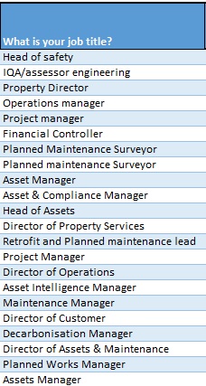
Question 1 looks at the expert’s job titles only; the responses are from experts that are all in relevant fields of work within the social housing sector. All job titles are in the table to the right.

Question 2 looks at what community types their organisations work and operate in, and the table below outlines this. there is a good mix or organisational areas with some organisation operating across multiple community types and some operating within a singular type. The responses are a good representation of the current housing providers within Wales and does offer good representation when compared with the customer demographic. Fig. 56
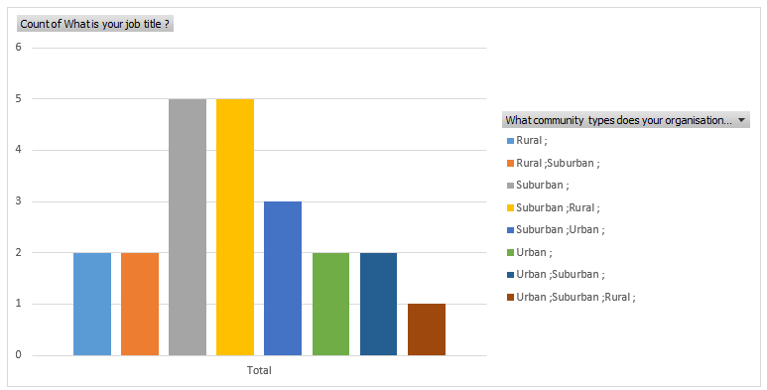
Fig. 57

Question 3
Below looks at the customer and experts’ knowledge around what is driving the need for retrofit in Wales. The below table of customer data looks at the correlations between this and what community type they are from. Answers were mixed, they either were unsure or did not know the right answers the majority did have a good overall knowledge tho and when looking at the community types that they are from this did not make a huge difference, if anything there was more confusion from the urban and suburban areas with more sporadic answers.

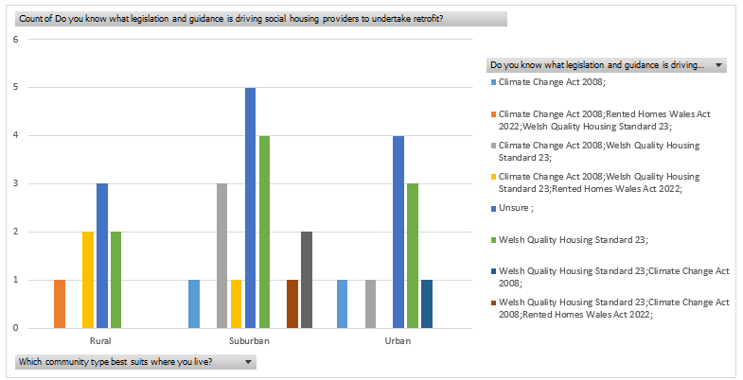

Fig. 58

The next table looks at experts’ overall knowledge, responses with a correct percentage score was 75%. 23% of experts didn’t have a good, with nobody responding with unsure.

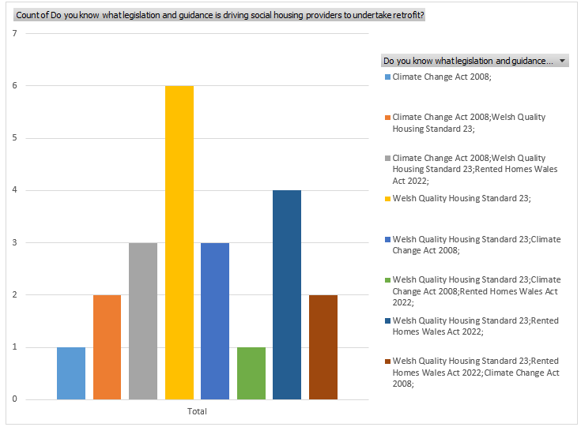

Fig. 59

Overall experts showed a reasonably good level of understanding, but this is expected as these are the experts that will be leading the pathway to net zero. When looking at the customer responses it is clear that, targeted and concise education around decarbonisation is lacking and greater confusion exists with the urban and suburban communities. When looking at education and understanding around decarbonisation the golden thread of training will be key to ensure successful projects from start to finish.

Question 4
Below looks at the customer and experts’ knowledge around WHQS 23. The below table of customer data looks at the correlations between this and what community type they are from. Answers were mixed but overall customers felt like they understood the new version of WHQS well but across all the community types 39% of response were very poor, poor, or unsure. Customer from a rural setting seem to have the best understanding with all responses from rural customer either very good, good, fair, or unsure. Linking this fact to the responses from question 3, rural customers seem to have a better understanding in broader terms around decarbonisation.
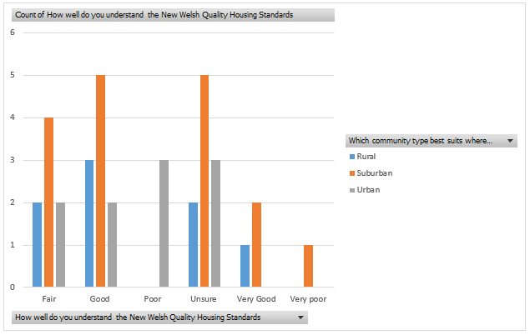

Fig. 60

The next table looks at experts’ overall knowledge in regard to WHQS23 against what community type’s their organisation delivers services in. As expected, knowledge of WHQS is very good with one exception with one response voting poor and their organisation services urban and suburban areas. This overall type of response was fully expected given as these people work in the sector.

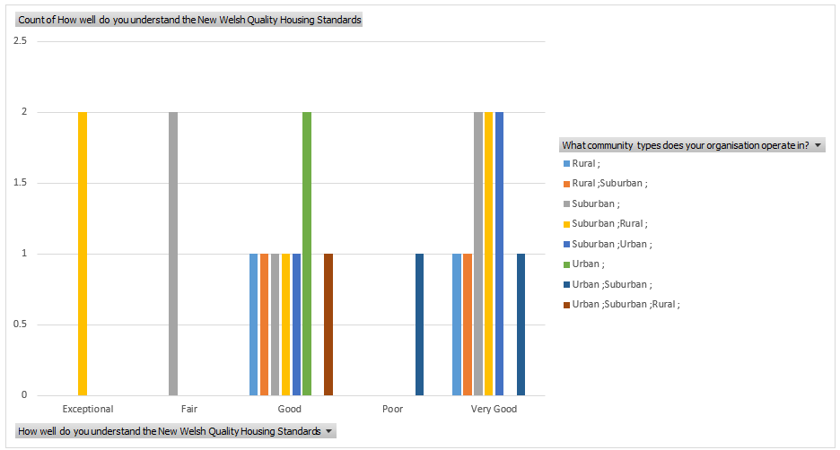
Fig. 61

There are some very clear patterns within customer knowledge and understanding, customers in urban and suburban areas seem overall less sure and more confused around both general decarbonisation and WHQS23.

Question 5
Below looks at how customers and experts understand the term retrofit in the context of the homes they live in and own as an organisation. The below table of customer data looks at the correlations between this and what community type they are from. Answers overall were very mixed with all customers voting across the spectrum available, no one community setting stands out, but it is clear that customers have an uneven understanding of what the term retrofit means to them and their homes.

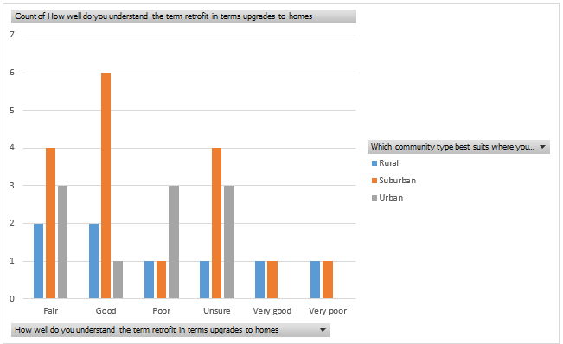

Fig. 62

The next table looks at experts’ understanding of the term retrofit against what community type’s their organisation delivers services in. As expected, the industry expects have a good understanding of the term retrofit, this overall type of response was fully expected given as these people work in the sector. There is nothing that stands out when mapped across the communities their organisations work in.

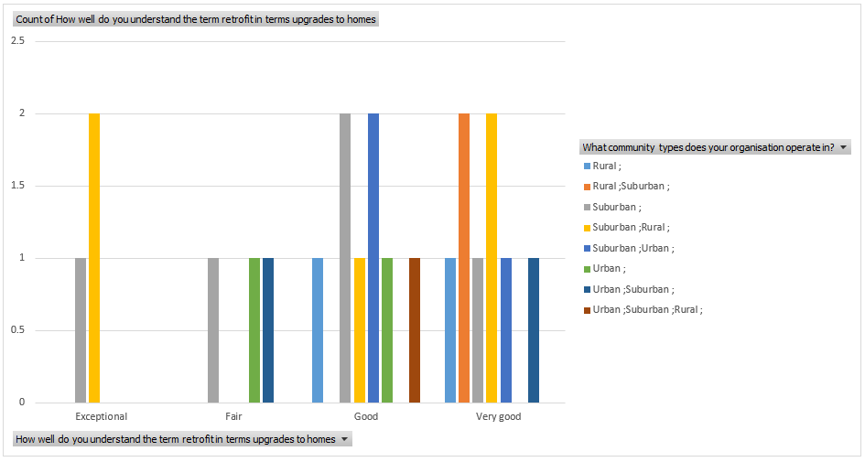
Fig. 63

Again, the outcomes of this question mirror the previous questions with very clear patterns within customer knowledge and understanding, customers in urban and suburban areas seem overall less sure and more confused around the whole subject.

Question 6
Below looks at the customer and experts understanding of what targets have been set for retrofit by Welsh Government. The below table of customer data looks at the correlations between this and what community type they are from. This result was partially expected as this is a technical target that does require people to have a working knowledge of building pathology. Only 13 customers had the correct answer of EPC C / SAP 75, again customers from suburban and urban settings were the most unsure overall.

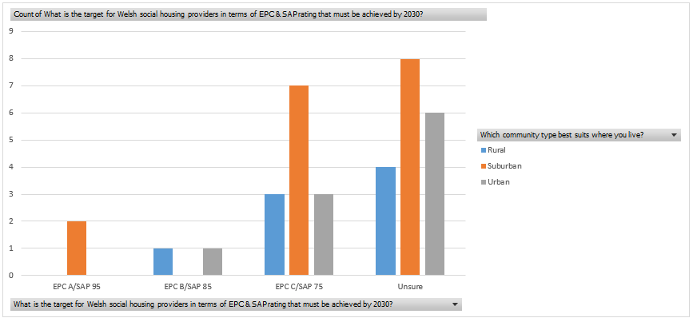

Fig. 64

The next table looks at experts’ understanding of what targets have been set for retrofit by Welsh Government. Now this result was a little unexpected, experts that operate in urban and suburban areas did flag up as providing the wrong answer, 5 in total were wrong and there all from either urban and suburban separately or combined.

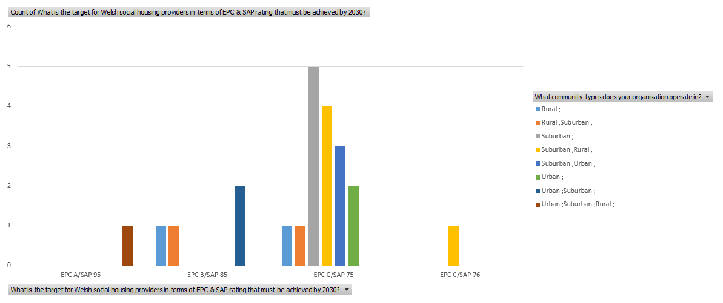

Fig. 65

It’s now clear that understanding around the whole decarbonisation agenda is weakest in urban and suburban areas, but customers and industry experts in a rural setting have better understanding.

Question 7
This section will directly compare the customers’ expectations around what type of technology they would like to see installed in their homes against what the housing providers intend to install on their retrofit journey. The table below compares this data.
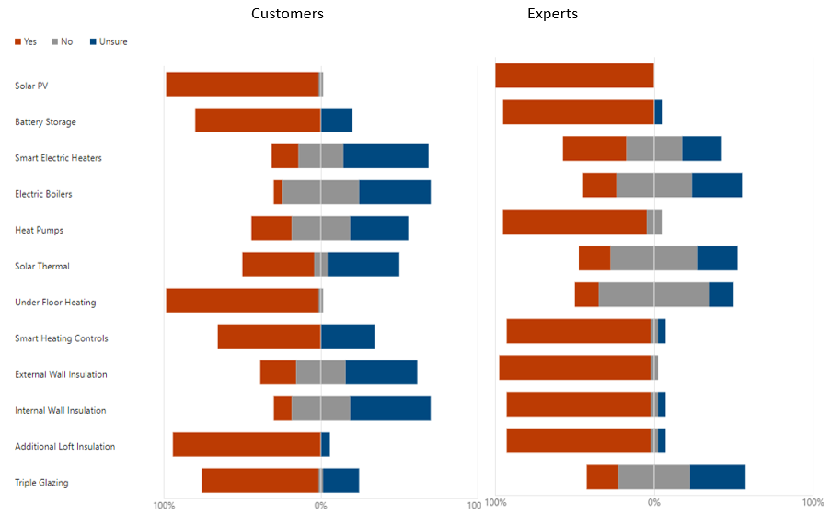

Fig. 66
From the above comparison it’s clear that customer expectations and what organisations will actually be installing are not aligned. Measures like PV, Battery Storage & Additional Loft Insulation are aligned but other elements like Under Floor Heating are not. It’s clear from the above data that housing providers will be undertaking a fabric first approach by installing insulation, EWI, IWI etc, which follows what is mandated in WHQS23. It’s clear that this lack of cohesion is linked back to customers having the correct knowledge base.

Question 8
This section will directly compare the customers’ expectations around what communication methods would customers like and what is currently being used by organisations. The table below compares this data.

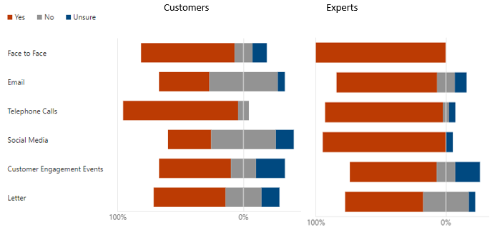
Fig. 67

From the above comparison it’s clear that customers expect a variety of communication types, overall social housing providers do provide a wide range of communication types to meet customer expectations.

The below table looks at customer expectations around communication types in comparison to what community types they are from.
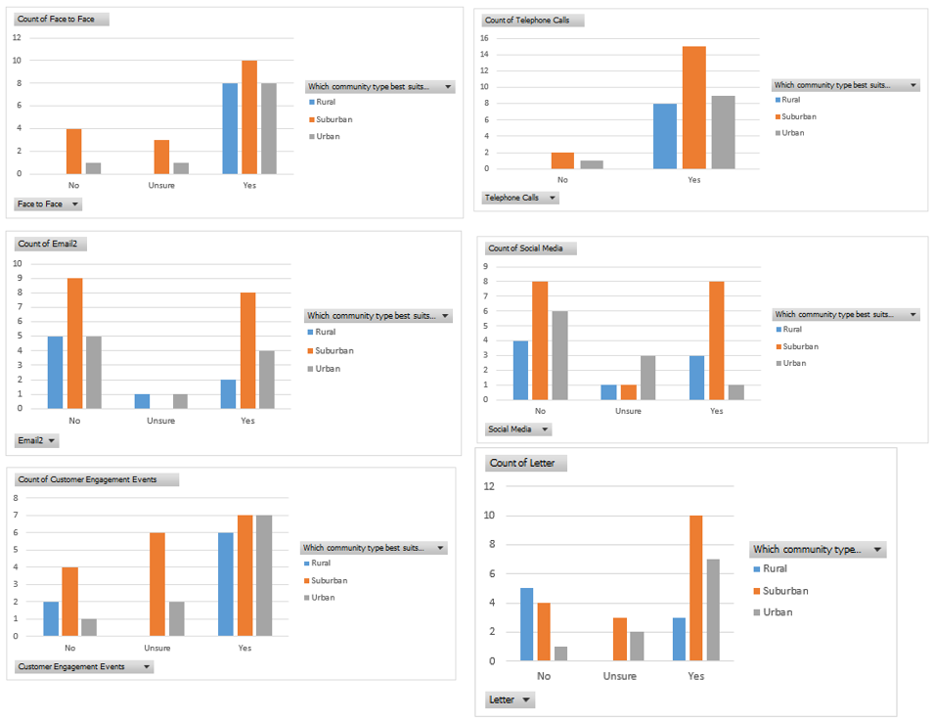
Fig. 68

Looking at the data above there is no trends that are evident but if additional data was collected around elements like customer age, we could have looked at any correlation between age and communication type.

Question 9
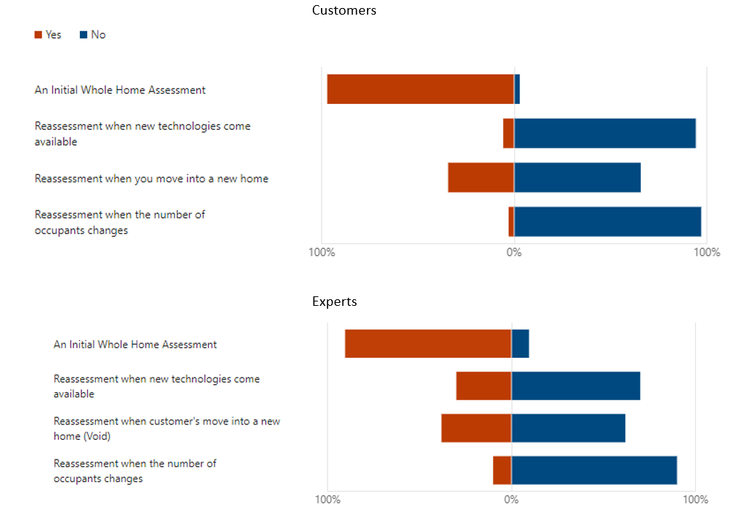
This section will directly compare customers’ and experts current understanding and processes around Initial whole home assessment and reassessment The table below compares this data.

Fig. 69

Both customers and housing providers are fully aware and undertake the initial assessment but when it comes to anything beyond that both customers and experts either don’t know of reassessment currently or they don’t do any reassessments. Looking at the data above about undertaking reassessment at void stage does seem to be the leading choice. This would make sense as the property is empty, but you will struggle then to attain any customer data.

Question 10
This section will directly compare customers’ and experts’ views on what can be reassessed in terms of social factors. The table below compares this data.
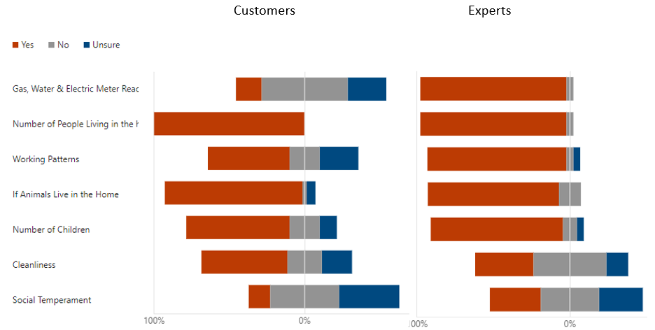

Fig. 70

The data above shows that experts are deeming more social markers that could be assessed than customers. It’s clear from the above that customers are protective of data like meter readings and social temperament. The data shows that there must be very little communication from social housing providers to customers around what they would reassess.

Summary
From the data collected between all three data sets there are clear threads and themes that have been identified,
Housing Stock Data
- Some commonalities between components
- Non comparable data
- Geographical and service delivery difference which influence costs.

Interviews
- The current WHQS is sufficient and does not need to be strengthened further.
- Main headline data sets should be harmonized but how to implement his was still up for further discussion.
- Reassessment should happen at void/change of tenancy.
- Data that is currently being collected in the initial whole home assessments needs to be streamlined with either existing data or cloned data.
- Industry skill shortage will hinder the progress to decarbonisation of the housing stock in Wales.
- PAS 2035 cost and lodgement process needs a rethink and possibly a different approach.

Questionnaires
- Knowledge and understanding of retrofit as a whole process is lacking between both customer and some experts.
- Social markers for reassessment need proper and meaningful discussion between the housing provider and their customer base, but overall customers are receptive to a variety of social markers being reassessed.
- Rural customers have a better knowledge and understanding of retrofit than urban and suburban customers.

Chapter 6

Conclusion and Recommendations

Introduction
The aim of the dissertation was to ascertain at what juncture should a Whole Home Reassessment take place and what are the parameters that trigger a reassessment and what elements do you reassess. This aim was chosen because of the lack of guidance and/or steer on how, when and what to assess after the initial assessment.
Given the lack of literature and data around whole home reassessment for retrofit, data was collected from secondary sources within the social housing sector from both customers and industry experts, also current asset management data was collected from a small number of social housing providers in Wales.
The objectives of the dissertation were as follows.
Secondary 1 - Evaluate PAS 2035/2038 and its role in reassessment.
Primary 2 - Assess customers understanding of reassessment.
Secondary 2 - Consider the role of communication in best practice/legislation reassessment.
Primary 3 - Propose a best practice set of recommendations (or decision-making tool) for reassessment.
Secondary 3 - Assess what social markers are fit for reassessment.
Based on the research undertaken within this dissertation the following recommendations have been made.

Recommendations
The recommendations that are set out below follow a similar format to the overall objectives from chapter one of this research.
- Currently very little in terms of guidance, legislation and academic literature exists around reassessment, it is recommended that this be strengthened particularly within best practice guidance. There is little need for legislation to be amended as the simplest way this could be achieved is an amendment to WHQS23. Through the research it was identified that the standard in its current iteration is strong enough, but it is recommended that reassessment is added to provide customer and housing providers clarity on the requirement to undertaken them in the first instance.
- It is recommended that PAS 2035 and the lodgement process be reworked so that the overall lodgement process is simplified to a similar process like building control notifications. Organisations need a streamline process to help with workload and cost control. When it comes to the lodgement cost Welsh government need to seriously consider the implications of this additional cost as housing providers will seriously look to avoid any additional costs and if that means avoiding PAS 2035 and funding opportunities then unfortunately some will avoid this process.
- Knowledge around retrofit, decarbonisation and reassessment is unfortunately a postcode lottery with more rural customers having a better baseline knowledge and understanding of the requirements and targets. Both urban and suburban customers struggled compared to customers from a more rural setting, because of this it is recommended that whole home assessment be made part of their tenancy sign up which would be added to their occupancy contracts when they accept a social housing home. Housing providers should lay on courses for all customers when they start their tenancy, these could be delivered in person, online or at the customers’ homes if needed. Within this small course housing providers would outline the organisations plans and what part the customer plays in the process.
- When it comes to the legislation and best practice around communications since the start of this research Welsh government and certain housing providers have been working on a website where organisations can share knowledge and experience from retrofit projects (TrustMark, 2024), it is recommended that all housing providers and contractors have access to this site and that that it is mandated within best practice , this will help promote good communication and knowledge throughout the sector.
- When looking at a best practice set of recommendations around reassessment it is recommended that reassessment to be added as an amended to WHQS23 and that reassessment should be done under the following conditions.
    - At void stage when the property becomes vacant
    - At a mutual exchange of a property
    - Every 5 years unless one of the above is met first.
Firstly, by undertaking reassessment when the property is being vacated the housing provider is able to get extremely accurate building pathology data. Secondly to capture the properties that are not being vacated a timeframe of 5 years is sufficient as this falls in line with the previous stock condition timeframe, this will not add any additional resource issues to the housing providers and still meet reassessment requirements.
- It is recommended that the following social markers be reassessed.
    - Gas, Water & Electric Meter Readings
    - Number of People Living in the home
    - Working Patterns
    - If Animals Live in the Home
    - Number of Children
    - Cleanliness
The only social marker that is not recommended is Social Temperament, this is because there were significant negative responses to this element within the questionnaires from both customer and experts. So, to ensure customer buy in it is not recommended to undertake an assessment of the customers Social Temperament.

Conclusion
This research has demonstrated that there is a significant gap in academic literature, legislation & industry best practice guidance around whole home reassessment, it also shows how little the sector is currently focussing on reassessment as all social housing providers are currently trying to integrate WHQS23 into their operating practices and there is little time or resources to deal with the next phase of retrofit which is reassessment. There is also a clear breakdown of knowledge and communication between housing provider and customer base, the improvement in this link will be fundamental to the success in achieving the targets set out in WHSQ23 by Welsh government.
Overall, the research sets out clear recommendations to help put reassessment firmly on the agenda of social housing providers in Wales.

Critique
The topic chosen was very narrow in terms of focus but did form part of the wider issues of retrofit of homes in the UK, also given that the main underpinning document is new (WHQS23) it was challenging as the topic is so new to the industry and the fact that WHQS23 only mandates the initial whole home assessment. Because this area of research is so new and the complete lack of industry best practice or guidance it was difficult to get a true sense of the issues as the housing sector in Wales is dealing with a constant set of moving objectives.

Future Research
Future research could focus on how to mandate collaboration between social housing providers to provide more of a joined-up approach to not only data but to customer knowledge and learning and development. It’s clear that more joined up working between organisations would bring better outcomes in terms of customer experience and organisational benefits, this could bring about more organisational mergers or a completely new look and approach on how Wales deals with social housing.

References
Aziz, Z. R. Z. &. A. M., 2017. Leveraging BIM and Big Data to deliver well maintained highways. Facilities, 35(13), pp. 818-832.
Ben, H. & Steemers, K., 2018. Household archetypes and behavioural patterns in UK domestic energy use. Energy efficiency, 11(3), pp. 761-771.
Brinkmann, S., 2022. Qualitative interviewing : conversational knowledge through research interviews. 2nd ed. London: Oxford University Press .
BSI, 2023. Retrofit Academy. [Online]
Available at: https://memberships.retrofitacademy.org/wp-content/uploads/2021/02/PAS-2035-and-PAS-2030-2020.pdf
[Accessed 12 January 2024].
Campbell, L. & Finch, E., 2004. Customer satisfaction and organisational justice. Facilities, Volume 22, pp. 178-189.
Climate Change Committee, 2023. TheCCC.org.uk. [Online]
Available at: https://www.theccc.org.uk/2023/03/09/a-reliable-secure-and-decarbonised-power-system-by-2035-is-possible-but-not-at-this-pace-of-delivery/#:~:text=Decarbonised%20electricity%20by%202035%20will,electric%20vehicles%20and%20heat%20pumps.
[Accessed 12 January 2024].
Colclough, S. et al., 2022. Post occupancy evaluation of 12 retrofit nZEB dwellings: The impact of occupants and high in-use interior temperatures on the predictive accuracy of the nZEB energy standard. Energy and Buildings , Volume 254, p. 111563.
Creswell, J. W., 2009. Research Design: Qualitative, Quantitative, and Mixed Methods Approaches. 3rd ed. London : Sage Publications Ltd.
Crisp, S., 2023. Proposal Lifespan Software. s.l.:Porperty Tectonics.
Darby, S. J., 2019. Communicating innovations: examples from smart technology retrofits. IOP conference series. Earth and environmental science, 329(1), p. 12020.
Edwards, J., 2020. New Standards in Retrofit. Property Journal, pp. 20-21.
Ehsan, A. et al., 2023. Development of an optimization model for decision-making in building retrofit projects using RETROSIM. Advances in building energy research, 17(3), pp. 324-322.
elmhurst energy, 2021. elmhurst energy. [Online]
Available at: https://www.elmhurstenergy.co.uk/blog/2022/07/04/what-is-pas-2035/
[Accessed 10 January 2024].
elmhurst energy, 2021. elmhurst energy. [Online]
Available at: https://www.elmhurstenergy.co.uk/blog/2022/07/04/what-is-pas-2035/
[Accessed 12 January 2024].
Fylan, F. a. G. D., 2021. Barriers to domestic retrofit quality: Are failures in retrofit standards a failure of retrofit standards?. Indoor and Built Environment, p. 1420326.
Green, E., 2020. Decarbonising the Welsh housing stock: from practice to policy. Buildings & Cities, 1(1), pp. 277-292.
Health and Safety Executive, 2023. Health and Safety Executive. [Online]
Available at: https://www.hse.gov.uk/temperature/thermal/
[Accessed 21 January 2024].
Highfield, D., 2000. Refurbishment and Upgrading of buildings. 1st ed. London: Taylor & Francis Group.
hsqeconsultancy, 2023. hsqeconsultancy. [Online]
Available at: https://hsqeconsultancy.co.uk/the-six-basic-factors/
[Accessed 21 January 2024].
Jofeh, C., 2019. Better Homes, Better Wales, Better World - Decarbonising existing homes in Wales, Cardiff: Decarbonisation of Homes in Wales Advisory Group.
Justine, P., Simon, N., Helen, G. & Matthew, C., 2020. The Housing Stock of The United Kingdom, Watford: BRE Trust.
Kirkham, R. J., Boussabaine, A. H. & Awwad, B. H., 2002. Probability distributions of facilities management costs for whole life cycle costing in acute care NHS hospital buildings. Construction management and economics, 20(3), pp. 251-261.
legislation, 2019. legislation.gov.uk. [Online]
Available at: https://www.legislation.gov.uk/ukdsi/2019/9780111187654
[Accessed 1 December 2023].
legislation, 2019. legislation.gov.uk. [Online]
Available at: https://www.legislation.gov.uk/ukdsi/2019/9780111187654
[Accessed 12 January 2024].
legislation, 2022. legislation.gov.uk. [Online]
Available at: https://www.legislation.gov.uk/wsi/2022/244/contents/made
[Accessed 12 January 2024].
María Carmen Carnero, V. G.-P., 2017. Optimum decision making in asset management. Hershey: IGI Global.
Mbungu, N. T., 2019. Smart Energy Coordination of Autonomous residential Home. IET Smart Grid , 2(3), pp. 336-346.
National Energy Action, 2022. National Energy Action. [Online]
Available at: https://www.nea.org.uk/fuel-poverty-map/fuel-poverty-in-wales/#:~:text=How%20many%20people%20in%20Wales,cap%20increase%20of%20April%202022.
[Accessed 3 December 2023].
Novosel, L. M., 2023. Understanding the Evidence: Sampling and Probability (Random) Sampling Designs. Urologic nursing, 43(4), pp. 1294-196.
O'Dwyer, L. M. & Bernauer, J. A., 2016. Quantitative Research for the Qualitative Researcher. 1st ed. London: SAGE.
ORP, 2022. gve.wales. [Online]
Available at: https://www.gov.wales/optimised-retrofit-programme-3-guidance-2022-2025-html
[Accessed 28 January 2024].
Patterson, J. L., 2016. Evaluation of a Regional Retrofit Programme to Upgrade Existing Housing Stock to Reduce Carbon Emissions, Fuel Poverty and Support the Local Supply Chain. Sustainability , 6(12), pp. 1261-1261.
Quinlan, C., 2023. Populations, samples, and sampling methods. Dublin : The Business & Management Collection.
Rogers, K., 2018. Careering on course. Building Surveying Journal, Volume 11, pp. 9-9.
Rowley, J., 2012. Conducting research interviews. Management Research Review, 35(3), pp. 260-271.
Statistics for Wales & Welsh Government, 2019. Welsh Housing Conditions Survey 2017-18: Energy Efficiency of Dwellings, s.l.: Welsh goverment.
SUNAMP, 2023. SUNAMP. [Online]
Available at: https://sunamp.com/en-gb/case-studies/smart-mini-district-heating-network-tackling-fuel-poverty-for-older-people/
[Accessed 21 January 2024].
Tarozzi, M., 2020. What is grounded theory?. 1st ed. London: Bloomsbury Academic.
TrustMark , 2023. TrustMark. [Online]
Available at: https://cms.trustmark.org.uk/media/ja0hyidk/pas2035-roles-and-qualifications-v13.pdf
[Accessed 12 January 2024].
TrustMark, 2024. Carbon Hwb. [Online]
Available at: https://zerocarbonhwb.cymru/
[Accessed 1 March 2024].
Tucker, M. & Pitt, M., 2009. National standards of customer satisfaction in facilities management. Facilities, Volume 27, pp. 497-514.
UK Government, 2021. gov.co.uk. [Online]
Available at: https://www.gov.uk/government/news/plans-unveiled-to-decarbonise-uk-power-system-by-2035
[Accessed 3 December 2023].
UK Government, 2023. Gov.UK. [Online]
Available at: https://www.gov.uk/government/speeches/pm-speech-on-net-zero-20-september-2023
[Accessed 12 January 2024].
Van Den Brom, P., Meijer, A. & Visscher, H., 2019. Actual energy saving effects of thermal renovations in dwellings—longitudinal data analysis including building and occupant characteristics. Energy and Buildings , Volume 182, pp. 251-263.
V, C. & Jansson-Boyd, R. A. V. R. R. C. C. J.-B., 2017. Complementing retrofit with engagement: exploring energy consumption with social housing tenants. International journal of Energy Research, 41(8), pp. 1150-1163.
Wales & West Housing , 2023. wwha. [Online]
Available at: https://www.wwha.co.uk/en/news/waleswesthousingleadsthewayininstallingenergy-savingtechnologyforresidentslivingincardiffapartments/
[Accessed 20 January 2024].
Wavehill, 2022. Welsh Housing Quality Standard 2023 - Summary of consultation responses, Cardiff: Wavehill.
Weijters, B., Baumgartner, H. & Geuens, M., 2016. The calibrated sigma method: An efficient remedy for between-group differences in response category use on Likert scales. nternational journal of research in marketing, 33(4), pp. 944-960.
Welsh Government , 2021. Net zero carbon status by 2030 - A route map for decarbonisation across the Welsh public sector, Cardiff: Crown .
Welsh Government, 2000. Gov.Wales. [Online]
Available at: https://www.gov.wales/sites/default/files/publications/2019-06/housing-stock-condition-surveys-guidance-for-local-authorities.pdf
[Accessed 12 January 2024].
Welsh Government, 2020. Gov.wales. [Online]
Available at: https://gov.wales/household-estimates-mid-2019
[Accessed 12 December 2023].
Welsh Government, 2021. Gov.wales. [Online]
Available at: https://www.gov.wales/household-estimates-mid-2020-html
[Accessed 21 January 2024].
Welsh Government, 2021. Tackling fuel poverty 2022 to 2035. [Online]
Available at: https://www.gov.wales/tackling-fuel-poverty-2021-2035-html
[Accessed 27 November 2021].
Welsh Government, 2022. Fitness of homes for human habitation: guidance for landlords, Cardiff: Welsh Government.
Welsh Government, 2022. Sector Risk Overview - Challenges, Risks and Regulatory Expectations, Cardiff: Welsh Government.
Welsh Government, 2023. gov.wales. [Online]
Available at: https://www.gov.wales/sites/default/files/publications/2023-10/welsh-housing-quality-standard-2023.pdf
[Accessed 12 January 2024].
Welsh Government, 2023. gov.wales. [Online]
Available at: https://www.gov.wales/net-zero-wales
[Accessed 3 December 2023].
Wright, F., 2010. Old and Cold: Older People and Policies Failing to Address Fuel Poverty. Social policy & administration, 38(5), pp. 488-503.
Zeifman, M., 2020. Residential retrofits at scale: opportunity identification, saving estimation, and personalized messaging based on communicating thermostat data. Energy efficiency, 12(3), pp. 393-405.

Bibliography

Aziz, Z. R. Z. &. A. M., 2017. Leveraging BIM and Big Data to deliver well maintained highways. Facilities, 35(13), pp. 818-832.
Ben, H. & Steemers, K., 2018. Household archetypes and behavioural patterns in UK domestic energy use. Energy efficiency, 11(3), pp. 761-771.
Brinkmann, S., 2022. Qualitative interviewing : conversational knowledge through research interviews. 2nd ed. London: Oxford University Press .
BSI, 2023. Retrofit Academy. [Online]
Available at: https://memberships.retrofitacademy.org/wp-content/uploads/2021/02/PAS-2035-and-PAS-2030-2020.pdf
[Accessed 12 January 2024].
Campbell, L. & Finch, E., 2004. Customer satisfaction and organisational justice. Facilities, Volume 22, pp. 178-189.
Climate Change Committee, 2023. TheCCC.org.uk. [Online]
Available at: https://www.theccc.org.uk/2023/03/09/a-reliable-secure-and-decarbonised-power-system-by-2035-is-possible-but-not-at-this-pace-of-delivery/#:~:text=Decarbonised%20electricity%20by%202035%20will,electric%20vehicles%20and%20heat%20pumps.
[Accessed 12 January 2024].
Colclough, S. et al., 2022. Post occupancy evaluation of 12 retrofit nZEB dwellings: The impact of occupants and high in-use interior temperatures on the predictive accuracy of the nZEB energy standard. Energy and Buildings , Volume 254, p. 111563.
Creswell, J. W., 2009. Research Design: Qualitative, Quantitative, and Mixed Methods Approaches. 3rd ed. London : Sage Publications Ltd.
Crisp, S., 2023. Proposal Lifespan Software. s.l.:Porperty Tectonics.
Darby, S. J., 2019. Communicating innovations: examples from smart technology retrofits. IOP conference series. Earth and environmental science, 329(1), p. 12020.
Edwards, J., 2020. New Standards in Retrofit. Property Journal, pp. 20-21.
Ehsan, A. et al., 2023. Development of an optimization model for decision-making in building retrofit projects using RETROSIM. Advances in building energy research, 17(3), pp. 324-322.
elmhurst energy, 2021. elmhurst energy. [Online]
Available at: https://www.elmhurstenergy.co.uk/blog/2022/07/04/what-is-pas-2035/
[Accessed 10 January 2024].
elmhurst energy, 2021. elmhurst energy. [Online]
Available at: https://www.elmhurstenergy.co.uk/blog/2022/07/04/what-is-pas-2035/
[Accessed 12 January 2024].
Fylan, F. a. G. D., 2021. Barriers to domestic retrofit quality: Are failures in retrofit standards a failure of retrofit standards?. Indoor and Built Environment, p. 1420326.
Green, E., 2020. Decarbonising the Welsh housing stock: from practice to policy. Buildings & Cities, 1(1), pp. 277-292.
Health and Safety Executive, 2023. Health and Safety Executive. [Online]
Available at: https://www.hse.gov.uk/temperature/thermal/
[Accessed 21 January 2024].
Highfield, D., 2000. Refurbishment and Upgrading of buildings. 1st ed. London: Taylor & Francis Group.
hsqeconsultancy, 2023. hsqeconsultancy. [Online]
Available at: https://hsqeconsultancy.co.uk/the-six-basic-factors/
[Accessed 21 January 2024].
Jankovic, L., 2012. Designing zero carbon buildings : using dynamic simulation methods. 2nd ed. London : Routledge.
Jofeh, C., 2019. Better Homes, Better Wales, Better World - Decarbonising existing homes in Wales, Cardiff: Decarbonisation of Homes in Wales Advisory Group.
Jones, P., Li, X., Perisoglou, E. & Patterson, J., 2017. Five energy retrofit houses in South Wales. Energy and buildings,, Volume 154, pp. 335-342.
Justine, P., Simon, N., Helen, G. & Matthew, C., 2020. The Housing Stock of The United Kingdom, Watford: BRE Trust.
Kirkham, R. J., Boussabaine, A. H. & Awwad, B. H., 2002. Probability distributions of facilities management costs for whole life cycle costing in acute care NHS hospital buildings. Construction management and economics, 20(3), pp. 251-261.
legislation, 2019. legislation.gov.uk. [Online]
Available at: https://www.legislation.gov.uk/ukdsi/2019/9780111187654
[Accessed 1 December 2023].
legislation, 2019. legislation.gov.uk. [Online]
Available at: https://www.legislation.gov.uk/ukdsi/2019/9780111187654
[Accessed 12 January 2024].
legislation, 2022. legislation.gov.uk. [Online]
Available at: https://www.legislation.gov.uk/wsi/2022/244/contents/made
[Accessed 12 January 2024].
María Carmen Carnero, V. G.-P., 2017. Optimum decision making in asset management. Hershey: IGI Global.
Mbungu, N. T., 2019. Smart Energy Coordination of Autonomous residential Home. IET Smart Grid , 2(3), pp. 336-346.
National Energy Action, 2022. National Energy Action. [Online]
Available at: https://www.nea.org.uk/fuel-poverty-map/fuel-poverty-in-wales/#:~:text=How%20many%20people%20in%20Wales,cap%20increase%20of%20April%202022.
[Accessed 3 December 2023].
Novosel, L. M., 2023. Understanding the Evidence: Sampling and Probability (Random) Sampling Designs. Urologic nursing, 43(4), pp. 1294-196.
O'Dwyer, L. M. & Bernauer, J. A., 2016. Quantitative Research for the Qualitative Researcher. 1st ed. London: SAGE.
ORP, 2022. gve.wales. [Online]
Available at: https://www.gov.wales/optimised-retrofit-programme-3-guidance-2022-2025-html
[Accessed 28 January 2024].
Patterson, J. L., 2016. Evaluation of a Regional Retrofit Programme to Upgrade Existing Housing Stock to Reduce Carbon Emissions, Fuel Poverty and Support the Local Supply Chain. Sustainability , 6(12), pp. 1261-1261.
Quinlan, C., 2023. Populations, samples, and sampling methods. Dublin : The Business & Management Collection.
Rogers, K., 2018. Careering on course. Building Surveying Journal, Volume 11, pp. 9-9.
Rowley, J., 2012. Conducting research interviews. Management Research Review, 35(3), pp. 260-271.
Statistics for Wales & Welsh Government, 2019. Welsh Housing Conditions Survey 2017-18: Energy Efficiency of Dwellings, s.l.: Welsh goverment.
SUNAMP, 2023. SUNAMP. [Online]
Available at: https://sunamp.com/en-gb/case-studies/smart-mini-district-heating-network-tackling-fuel-poverty-for-older-people/
[Accessed 21 January 2024].
Tarozzi, M., 2020. What is grounded theory?. 1st ed. London: Bloomsbury Academic.
TrustMark , 2023. TrustMark. [Online]
Available at: https://cms.trustmark.org.uk/media/ja0hyidk/pas2035-roles-and-qualifications-v13.pdf
[Accessed 12 January 2024].
TrustMark, 2024. Carbon Hwb. [Online]
Available at: https://zerocarbonhwb.cymru/
[Accessed 1 March 2024].
Tucker, M. & Pitt, M., 2009. National standards of customer satisfaction in facilities management. Facilities, Volume 27, pp. 497-514.
UK Government, 2021. gov.co.uk. [Online]
Available at: https://www.gov.uk/government/news/plans-unveiled-to-decarbonise-uk-power-system-by-2035
[Accessed 3 December 2023].
UK Government, 2023. Gov.UK. [Online]
Available at: https://www.gov.uk/government/speeches/pm-speech-on-net-zero-20-september-2023
[Accessed 12 January 2024].
Van Den Brom, P., Meijer, A. & Visscher, H., 2019. Actual energy saving effects of thermal renovations in dwellings—longitudinal data analysis including building and occupant characteristics. Energy and Buildings , Volume 182, pp. 251-263.
V, C. & Jansson-Boyd, R. A. V. R. R. C. C. J.-B., 2017. Complementing retrofit with engagement: exploring energy consumption with social housing tenants. International journal of Energy Research, 41(8), pp. 1150-1163.
Wales & West Housing , 2023. wwha. [Online]
Available at: https://www.wwha.co.uk/en/news/waleswesthousingleadsthewayininstallingenergy-savingtechnologyforresidentslivingincardiffapartments/
[Accessed 20 January 2024].
Wavehill, 2022. Welsh Housing Quality Standard 2023 - Summary of consultation responses, Cardiff: Wavehill.
Weijters, B., Baumgartner, H. & Geuens, M., 2016. The calibrated sigma method: An efficient remedy for between-group differences in response category use on Likert scales. nternational journal of research in marketing, 33(4), pp. 944-960.
Welsh Government , 2021. Net zero carbon status by 2030 - A route map for decarbonisation across the Welsh public sector, Cardiff: Crown .
Welsh Government, 2000. Gov.Wales. [Online]
Available at: https://www.gov.wales/sites/default/files/publications/2019-06/housing-stock-condition-surveys-guidance-for-local-authorities.pdf
[Accessed 12 January 2024].
Welsh Government, 2020. Gov.wales. [Online]
Available at: https://gov.wales/household-estimates-mid-2019
[Accessed 12 December 2023].
Welsh Government, 2021. Gov.wales. [Online]
Available at: https://www.gov.wales/household-estimates-mid-2020-html
[Accessed 21 January 2024].
Welsh Government, 2021. Tackling fuel poverty 2022 to 2035. [Online]
Available at: https://www.gov.wales/tackling-fuel-poverty-2021-2035-html
[Accessed 27 November 2021].
Welsh Government, 2022. Fitness of homes for human habitation: guidance for landlords, Cardiff: Welsh Government.
Welsh Government, 2022. Sector Risk Overview - Challenges, Risks and Regulatory Expectations, Cardiff: Welsh Government.
Welsh Government, 2023. gov.wales. [Online]
Available at: https://www.gov.wales/sites/default/files/publications/2023-10/welsh-housing-quality-standard-2023.pdf
[Accessed 12 January 2024].
Welsh Government, 2023. gov.wales. [Online]
Available at: https://www.gov.wales/net-zero-wales
[Accessed 3 December 2023].
Wright, F., 2004. Old and Cold: Older People and Policies Failing to Address Fuel Poverty. Social policy & administration, 38(5), pp. 488-503.
Wright, F., 2010. Old and Cold: Older People and Policies Failing to Address Fuel Poverty. Social policy & administration, 38(5), pp. 488-503.
Yang, L., Yan, H. & Lam, J. C., 2014. Thermal comfort and building energy consumption implications – A review. Applied Energy , Volume 115, pp. 164-173.
Zeifman, M., 2020. Residential retrofits at scale: opportunity identification, saving estimation, and personalized messaging based on communicating thermostat data. Energy efficiency, 12(3), pp. 393-405.

List of Figures
Figure 1 - Welsh Journey to Net Zero Pg. 14
Figure 2 - Thermal comfort Six Basic Factors Pg. 19
Figure 3 - Wavehill Study Pg. 20
Figure 4 - Energy Consumption Chart Pg. 21
Figure 5 - Philosophical Worldviews Table Pg. 24
Figure 6 - Data Collection Overview Table Pg. 25
Figure 7 - Housing Component Count Table Pg. 31
Figure 8 - Housing Life Cyle Table Pg. 32
Figure 9 - Housing Component Cost Table 1 Pg. 33
Figure 10 - Housing Component Cost Table 2 Pg. 34
Figure 11 - Interviews – Q1 Visual Pg. 35
Figure 12 - Interviews – Q2 Visual Pg. 35
Figure 13 - Interviews – Q3 Visual Pg. 36
Figure 14 - Interviews – Q4 Visual Pg. 37
Figure 15 - Interviews – Q5 Visual Pg. 38
Figure 16 - Interviews – Q6 Visual Pg. 39
Figure 17 - Interviews – Q7 Visual Pg. 40
Figure 18 - Interviews – Q8 Visual Pg. 41
Figure 19 - Customer Questionnaire – Q1 Visual Pg. 42
Figure 20 - Customer Questionnaire – Q2 Visual Pg. 43
Figure 21 - Customer Questionnaire – Q3 Visual Pg. 44
Figure 22 - Customer Questionnaire – Q4 Visual Pg. 45
Figure 23 - Customer Questionnaire – Q5 Visual Pg. 46
Figure 24 - Customer Questionnaire – Q6 Visual Pg. 47
Figure 25 - Customer Questionnaire – Q7 Visual 1 Pg. 48
Figure 26 - Customer Questionnaire – Q7 Visual 2 Pg. 49
Figure 27 - Customer Questionnaire – Q7 Visual 3 Pg. 49
Figure 28 - Customer Questionnaire – Q8 Visual 1 Pg. 50
Figure 29 - Customer Questionnaire – Q8 Visual 2 Pg. 50
Figure 30 - Customer Questionnaire – Q9 Visual 1 Pg. 51
Figure 31 - Customer Questionnaire – Q9 Visual 2 Pg. 51
Figure 32 - Customer Questionnaire – Q10 Visual 1 Pg. 52
Figure 33 - Customer Questionnaire – Q10 Visual 2 Pg. 53
Figure 34 - Expert Questionnaire – Q1 Visual Pg. 53
Figure 35 - Customer Questionnaire – Q2 Visual Pg. 54
Figure 36 - Customer Questionnaire – Q3 Visual Pg. 55
Figure 37 - Customer Questionnaire – Q4 Visual Pg. 56
Figure 38 - Customer Questionnaire – Q5 Visual Pg. 57
Figure 39 - Customer Questionnaire – Q6 Visual Pg. 58
Figure 40 - Customer Questionnaire – Q7 Visual 1 Pg. 59
Figure 41 - Customer Questionnaire – Q7 Visual 2 Pg. 60
Figure 42 - Customer Questionnaire – Q7 Visual 3 Pg. 60
Figure 43 - Customer Questionnaire – Q8 Visual 1 Pg. 61
Figure 44 - Customer Questionnaire – Q8 Visual 2 Pg. 61
Figure 45 - Customer Questionnaire – Q9 Visual 1 Pg. 62
Figure 46 - Customer Questionnaire – Q9 Visual 2 Pg. 62
Figure 47 - Customer Questionnaire – Q10 Visual 1 Pg. 63
Figure 48 - Customer Questionnaire – Q10 Visual 2 Pg. 63
Figure 49 - Housing Provider 1 – Asset Data Pg. 65
Figure 50 - Housing Provider 2 – Asset Data Pg. 66
Figure 51 - Housing Provider 3 – Asset Data Pg. 67
Figure 52 - Housing Provider 4 – Asset Data Pg. 68
Figure 53 - Housing Provider 5 – Asset Data Pg. 69
Figure 54 - Interview Trend Data Table Pg. 73
Figure 55 - Customer Questionnaire – Q1&2 Pg. 74
Figure 56 - Expert Questionnaire – Q1&2 (1) Pg. 75
Figure 57 - Expert Questionnaire – Q1&2 (2) Pg. 75
Figure 58 - Questionnaire – Q3 Table 1 Pg. 76
Figure 59 - Questionnaire – Q3 Table 2 Pg. 77
Figure 60 - Questionnaire – Q4 Table 1 Pg. 78
Figure 61 - Questionnaire – Q4 Table 2 Pg. 79
Figure 62 - Questionnaire – Q5 Table 1 Pg. 80
Figure 63 - Questionnaire – Q5 Table 2 Pg. 81
Figure 64 - Questionnaire – Q6 Table 1 Pg. 82
Figure 65 - Questionnaire – Q6 Table 2 Pg. 83
Figure 66 - Questionnaire – Q7 Table 2 Pg. 84
Figure 67 - Questionnaire – Q8 Table 1 Pg. 85
Figure 68 - Questionnaire – Q8 Table 2 Pg. 86
Figure 69 - Questionnaire – Q9 Table 1 Pg. 87
Figure 70 - Questionnaire – Q10 Table 1 Pg. 88

Appendixes

Appendix 1
Below sets out the full list of 29 matters or circumstances with the Rented Homes Wales Act 2022
- Damp and mould growth
- Cold
- Heat
- Asbestos and Manufactured Mineral Fibres
- Biocides
- Carbon monoxide and fuel combustion products
(nitrogen dioxide, sulphur dioxide and smoke)
- Lead
- Radiation
- Uncombusted fuel gas
- Volatile organic compounds (VOCs)
- Crowding and space
- Entry by intruders
- Lighting
- Noise
- Domestic hygiene, pests and refuse
- Food safety
- Personal hygiene, sanitation and drainage
- Water supply
- Falls associate with baths etc
- Falling on surfaces
- Falling on stairs etc
- Falling between levels
- Electrical hazards
- Fire
- Flames, hot surfaces etc
- Collision and entrapment
- Explosions
- Position and operability of amenities etc
- Structural collapse and falling elements.

(Welsh Government, 2022)

Appendix 2
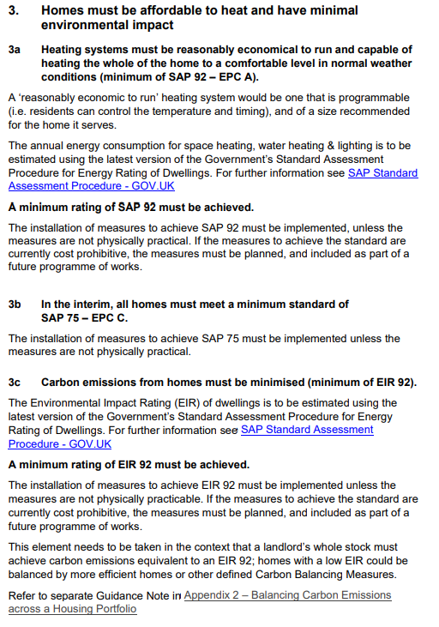
Below is an extract from WHQS 2023 Part 3 around decarbonisation, this sections set outs ambitious targets from Welsh housing associations.

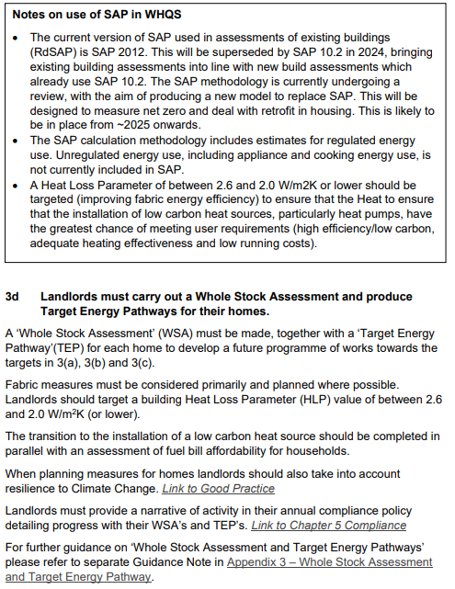

Appendix 3
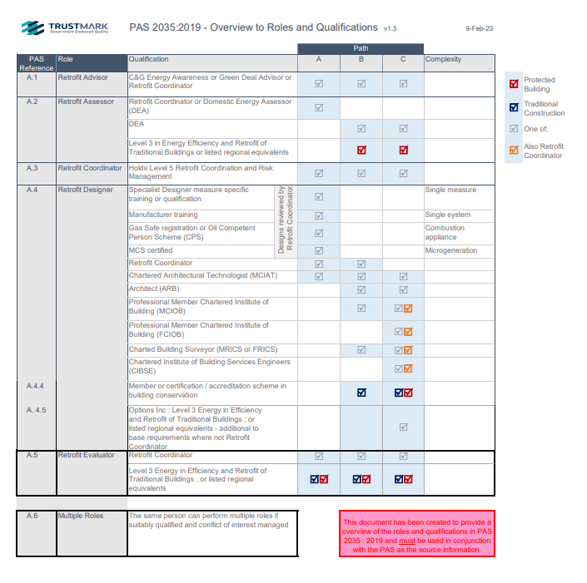
Below is a document from the TrustMark website which outlines the role with PAS 2035.

(TrustMark , 2023)

Appendix 4
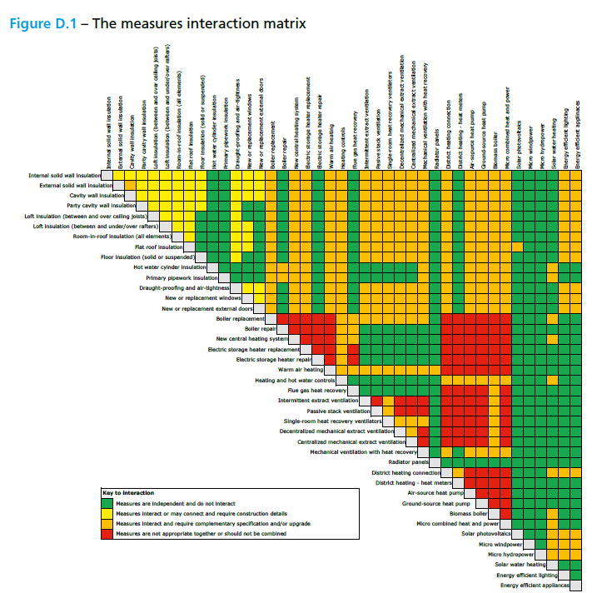
Below is an extract from the PAS 2035 specification document which outlines measures that would cause unintended consequences when installed in tandem.

(BSI, 2023)

Appendix 5
Below are extracts from a System Upgrade Proposal from Salma Crisp BSc MCIOB of Property
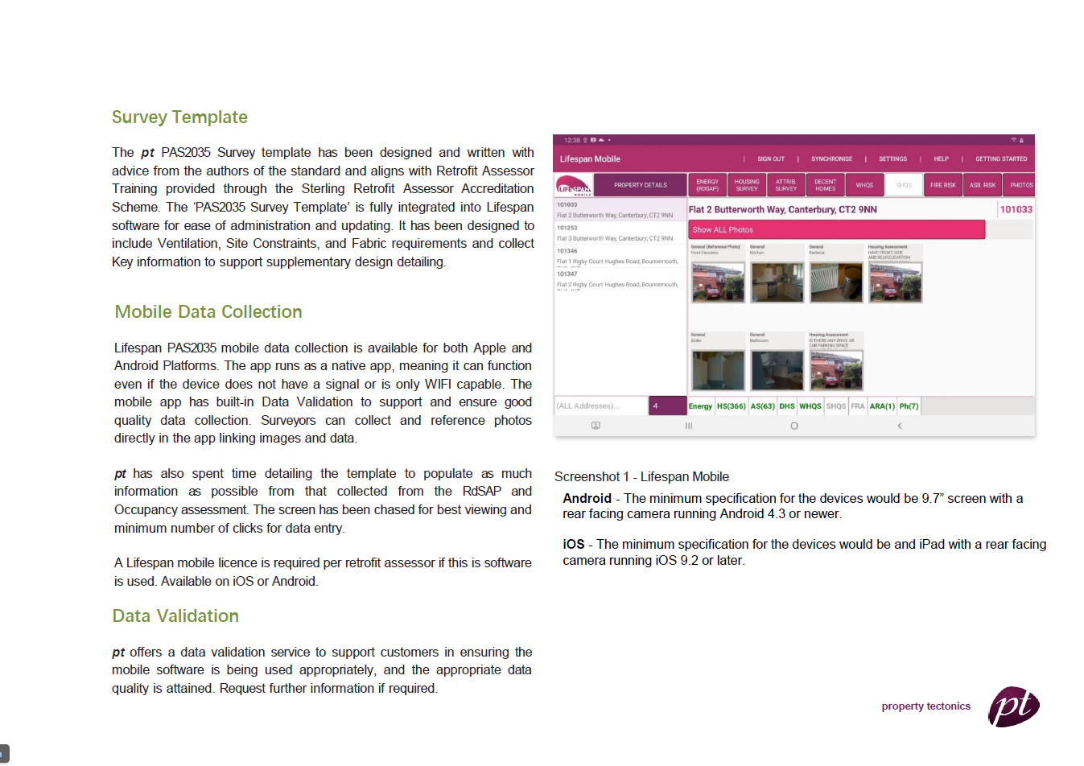

Tectonics dated 11/8/23.
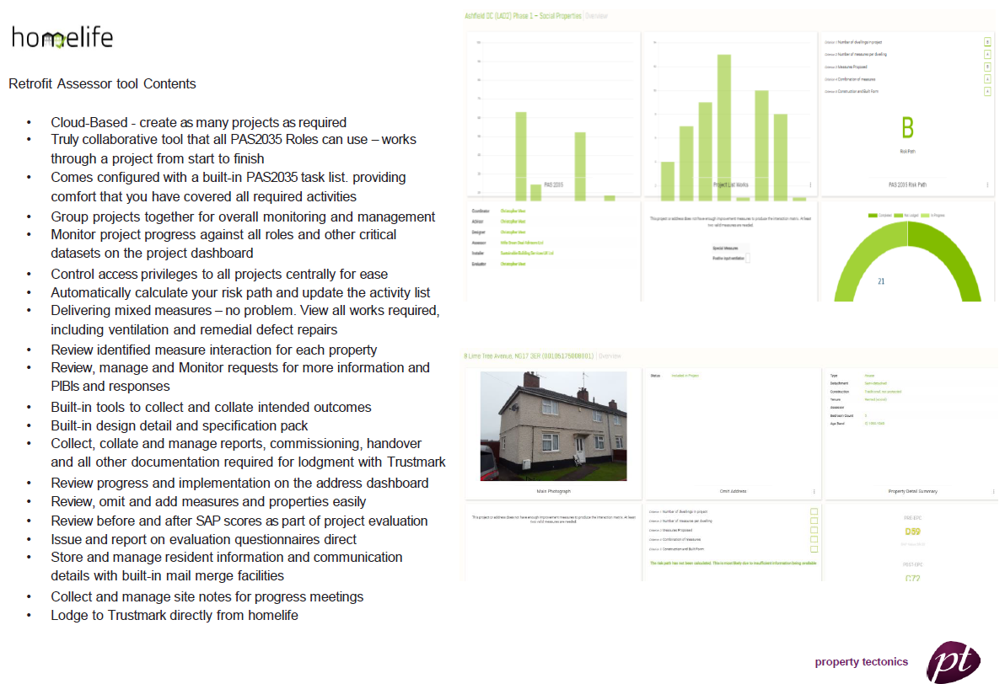
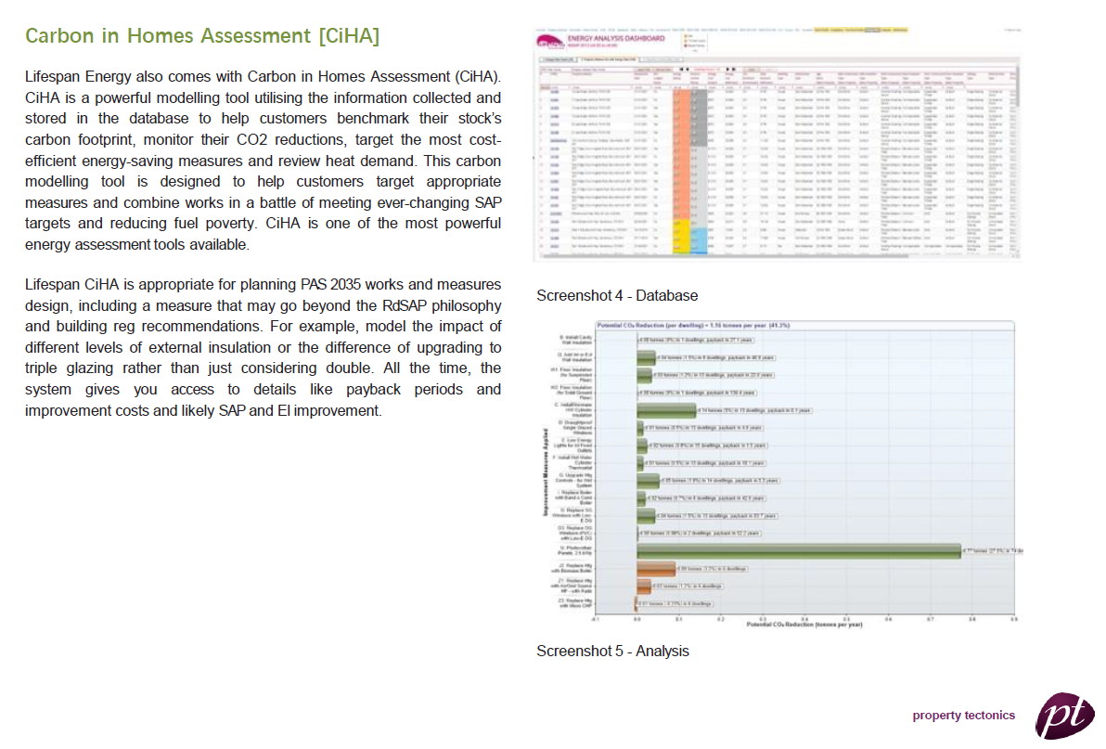

(Crisp, 2023)

Appendix 6
Publication of Wales & West Housing tenanted retrofit programme, customer views on what measures should be installed in their homes were considered and they also took part in the procurement of the main contractor.
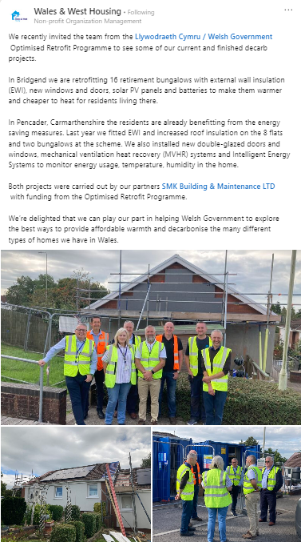

https://youtu.be/QNNxPfUXV8Q

(Wales & West Housing , 2023)

Appendix 7
Below are the interview questions that will be used.
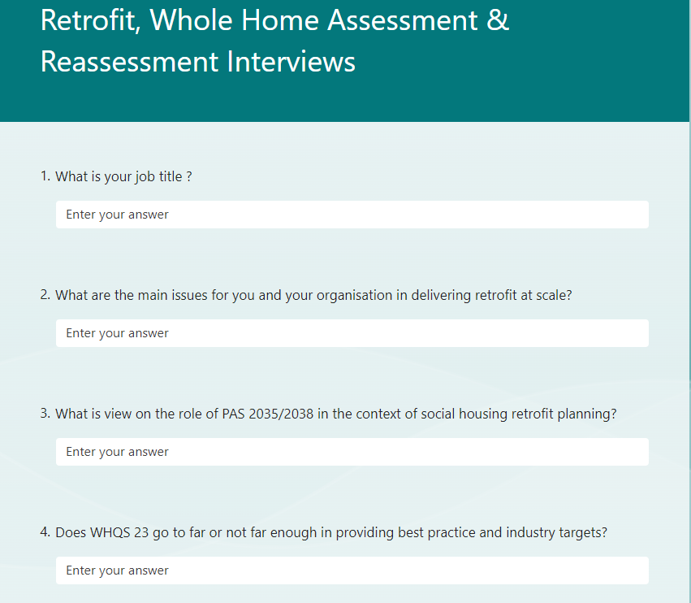

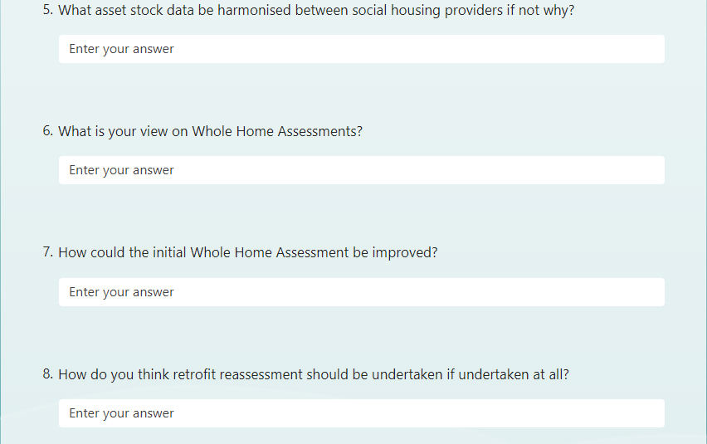

Appendix 8
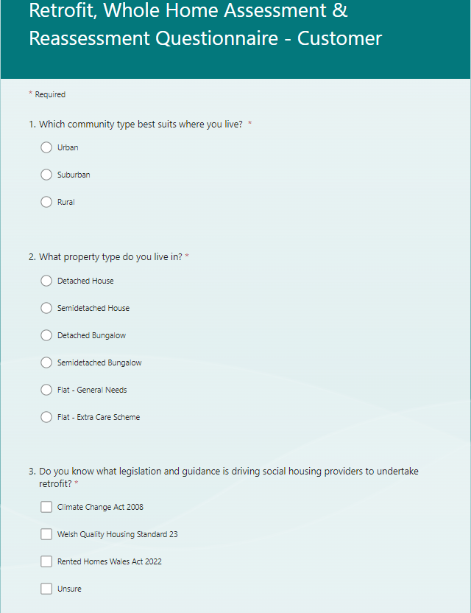
Below is the questionnaire for Customers.
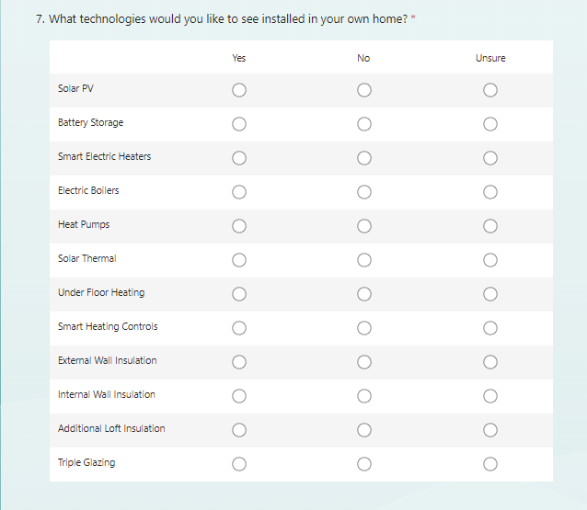
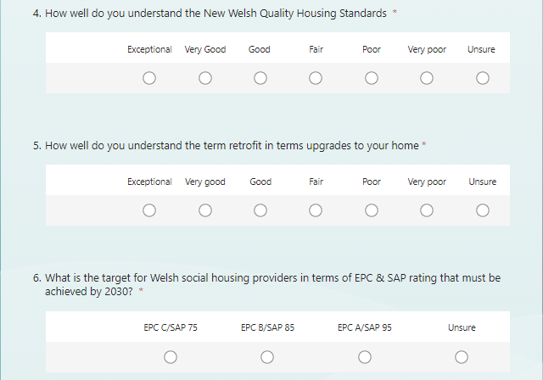
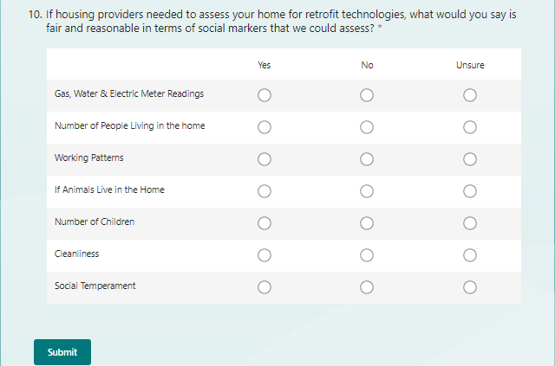
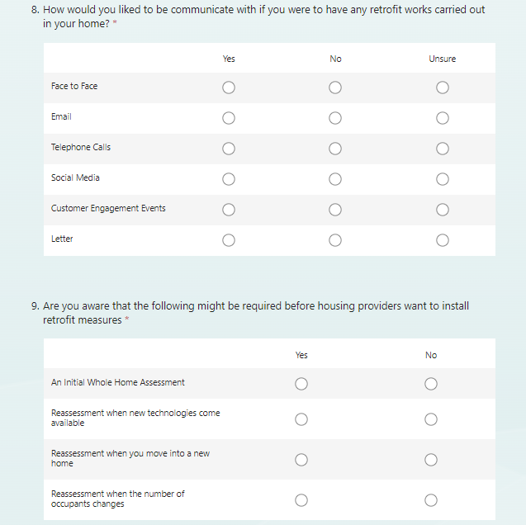

Appendix 9
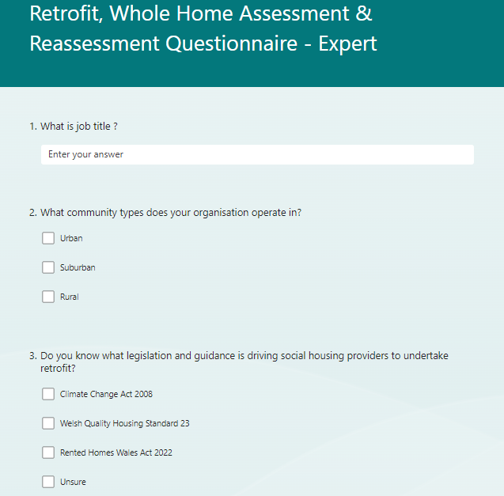
Below is the questionnaire for the Industry experts.

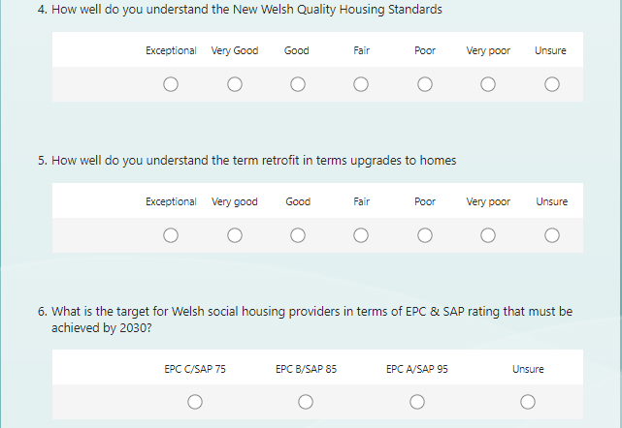

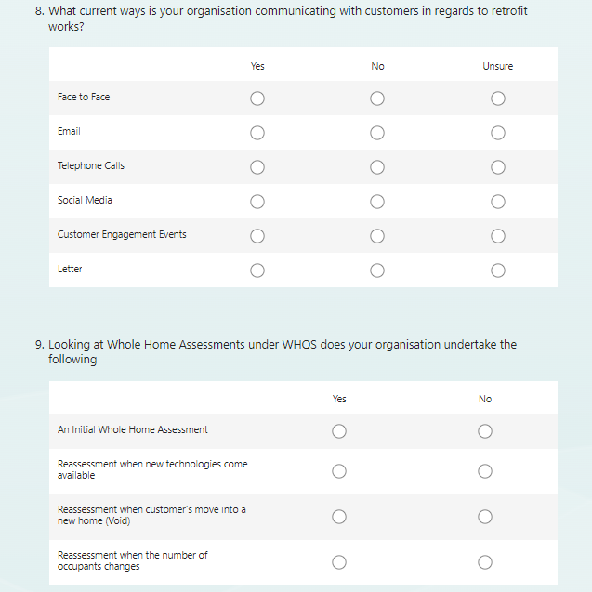
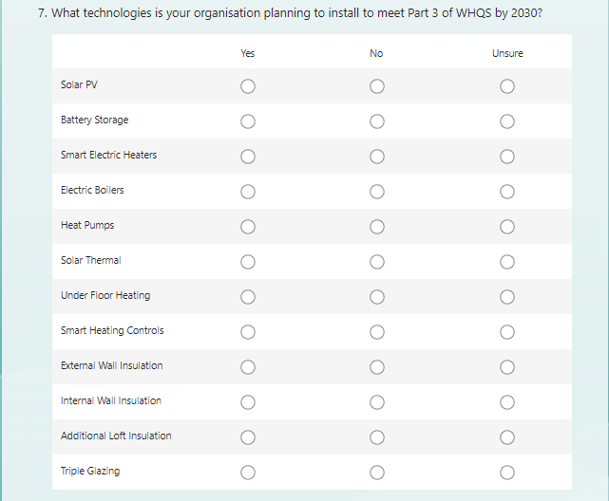
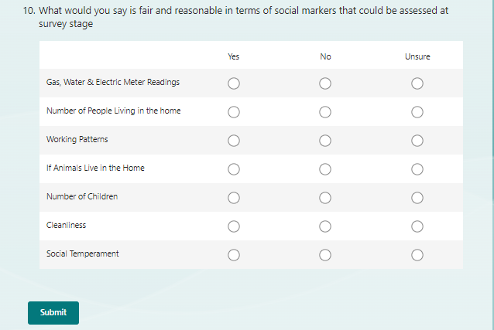

Appendix 10
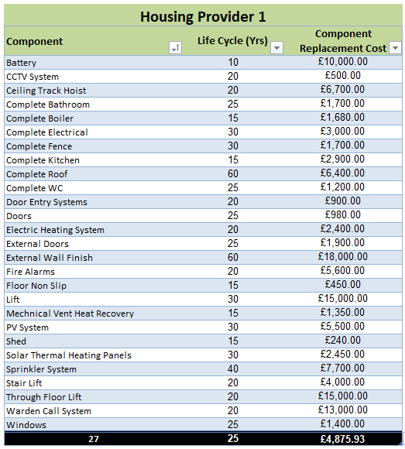
Below is the raw data for the housing stock data.

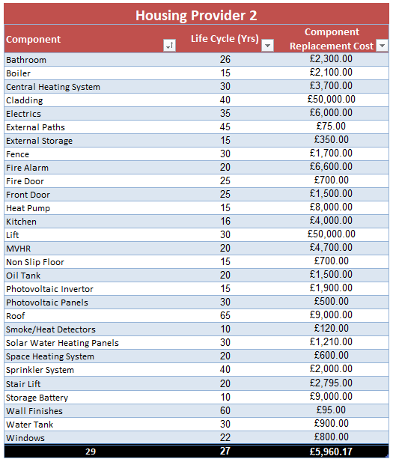

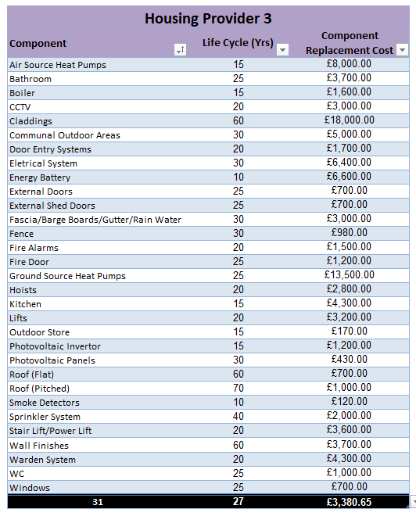

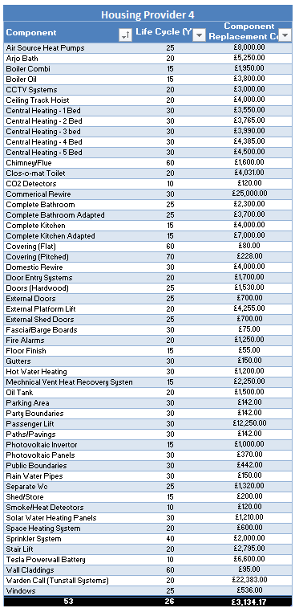

Appendix 11
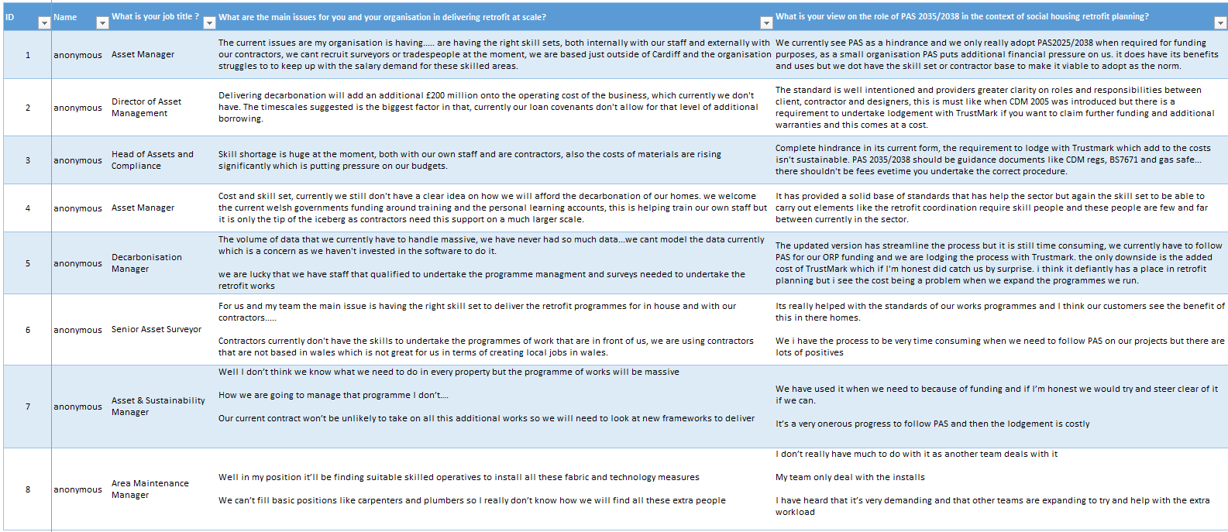
Below is the raw data for the interviews.
NOTE – All interviewees declined to for their interviews to be recorded for professional reasons .
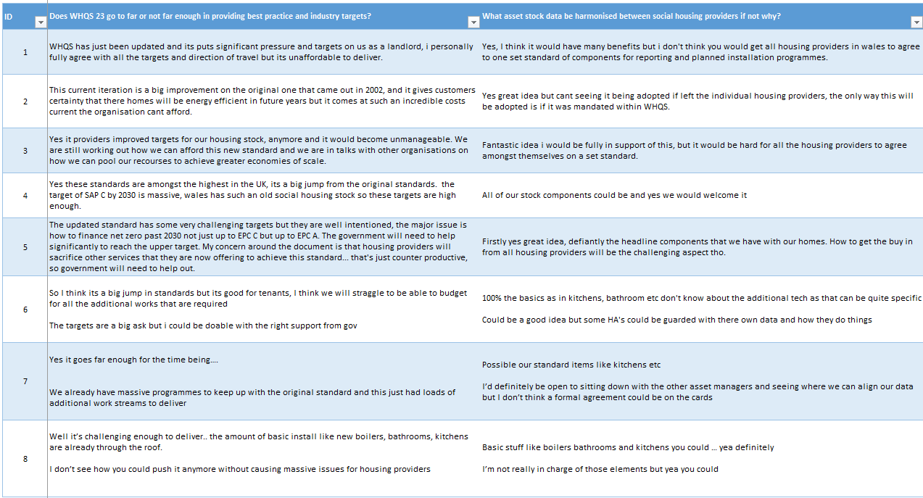
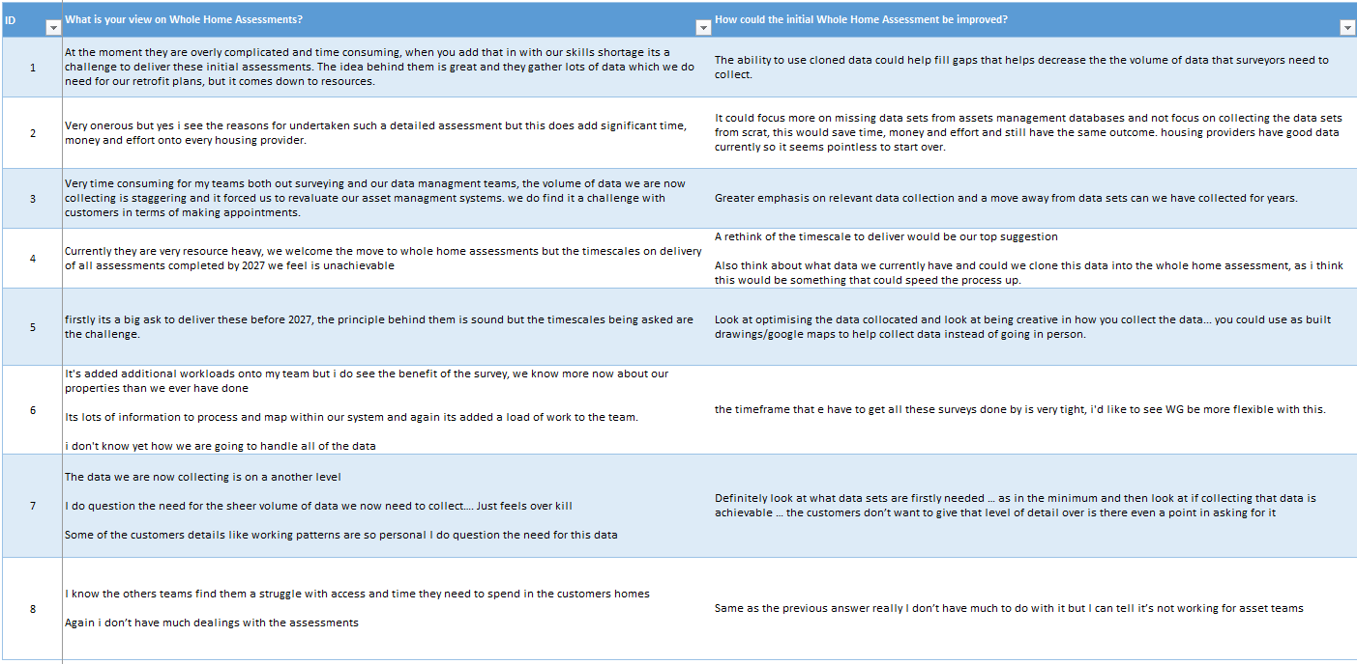

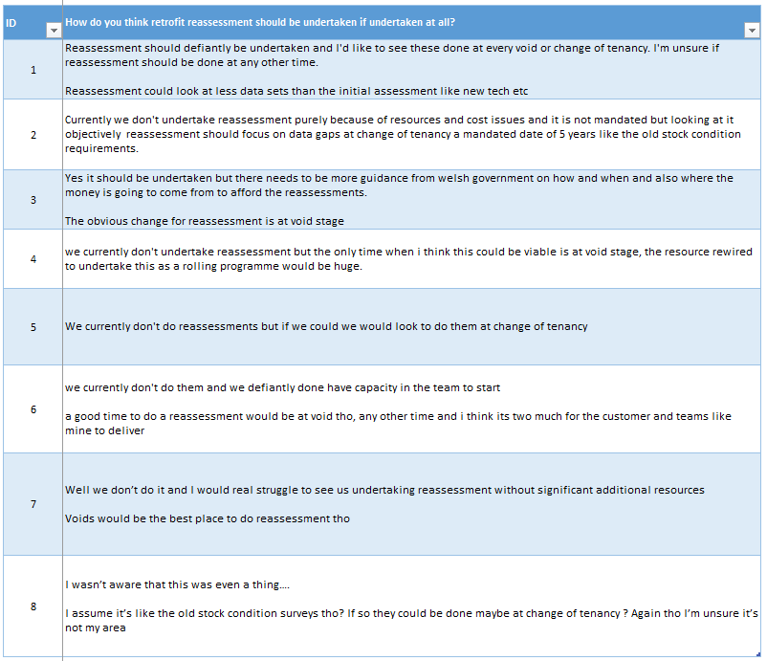

Appendix 12
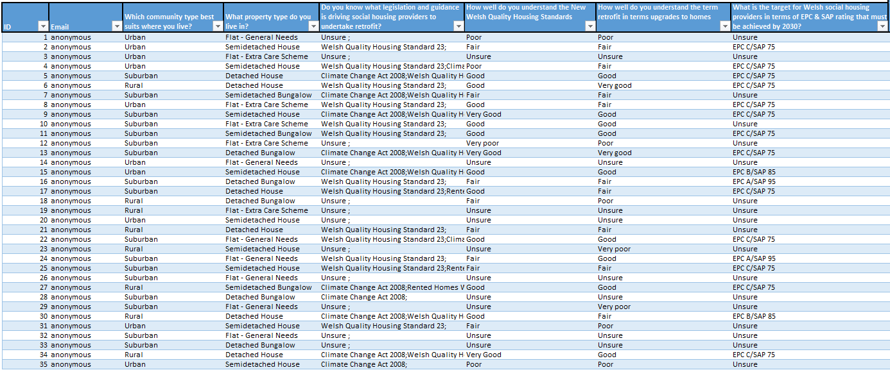
Below is the raw data from the customer questionnaire.

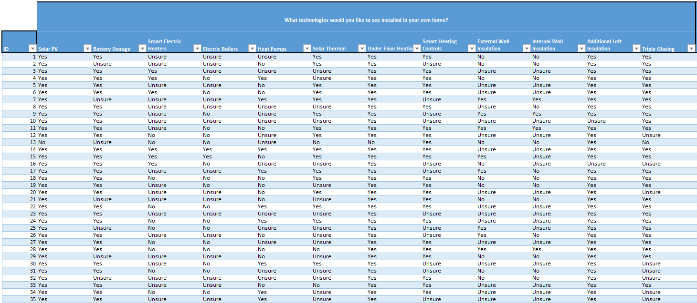

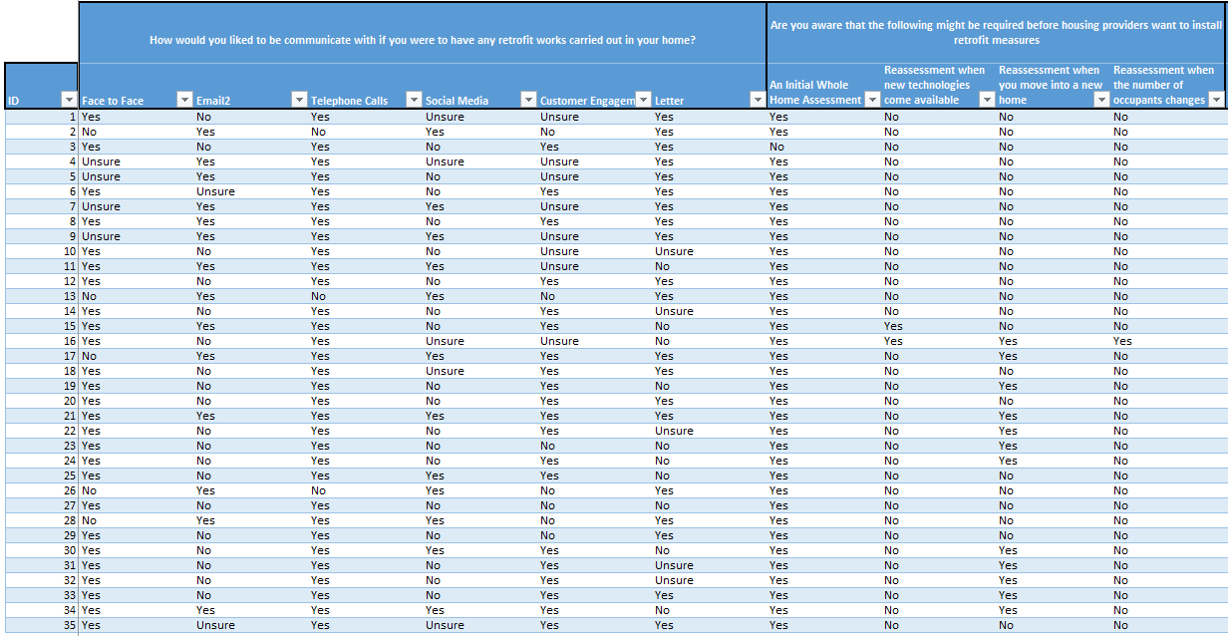
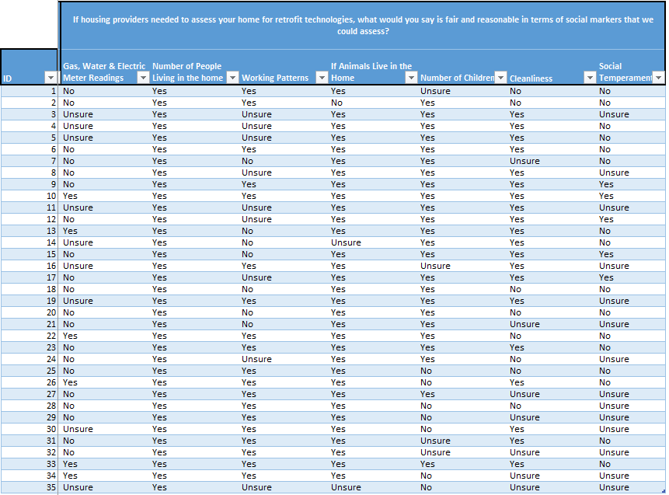

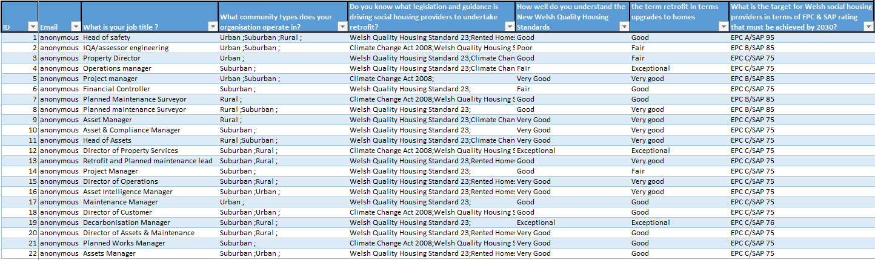
Below is the raw data from the expert questionnaire.



