University of Wales Trinity Saint Davids
Wales Institute of Science and art


Materials Testing and Sustainability of Composites for Motorsport & Automotive Industries
Automotive Materials & Sustainability
ACHA6012

Cody Surridge
2304028
26.04.2026
Table of Contents
1 Introduction 2
2 Literature Review 3
2.1 Material Properties 3
2.2 Carbon Fibre 3
2.3 Kevlar 3
2.4 Flax 3
3 Sustainability Analysis 5
4 Experimental Testing 6
4.1 Methodology 6
4.2 Aluminium 6
5 Recommendations 12
6 Conclusion 13
References 14

Figure 1-Aluminium Stress Strain Curve 6
Figure 2- Non-Woven Carbon Fibre with Bio Resin Stress Strain Curve 7
Figure 3- Woven Carbon Fibre with Bio Resin Stress Strain Curve 8
Figure 4- Woven Carbon Fibre with Epoxy Resin Stress Strain Curve 8
Figure 5- Non-Woven Flax with Bio Resin Stress Strain Curve 9
Figure 6- Woven Flax with Bio Resin Stress Strain Curve 9
Figure 7- Kevlar with Bio Resin Stress Strain Curve 10
Figure 8- Material Testing Sample Fractures 11

Introduction
Understanding material properties and their applications within the automotive, motorsport and motorcycle industries is essential for advancing the integrating sustainable design and manufacturing processes into industry. This report will examine a range of composite materials focusing on identification of their properties, structures, manufacturing methods and their typical applications
The materials investigated in this study were provided through laboratory sessions and include aluminium, woven and non-woven bio-resin carbon fibre, woven epoxy carbon fibre, woven and non-woven bio-resin flax, woven bio-resin Kevlar. Through analysis of these materials, both the mechanical properties and the environmental impact will be evaluated, while considering factors such as the resource extraction process, recyclability and end-of-life disposal. Additionally, discussion of how these materials are integrated into current future legislations and industry processes allows for further analysis of the viability in modern engineering applications.
Experimental tensile testing was conducted to enable the comparison of the mechanical properties of the materials enabling comparison between the materials. The resultant data will then be analysed and compared against manufacturer specification and published literature to ensure the validity of the data by assessing accuracy and reliability.
Finally, based on both the experimental findings and sustainability analysis recommendations regarding the most suitable application of how these materials could be used in automotive and motorsport industry will be identified. This highlights opportunities of future research and development aimed to enhance sustainability of composite materials.

Literature Review

Material Properties
Composite materials are widely used in the motorsport and automotive industries due to their high strength-to-weight ratios and excellent performance characteristics and excellent performance characteristics. This is evident in materials such as carbon fibre which is “stronger and stiffer than steel and aluminium per unit of weight, it weighs approximately one-quarter as much as steel and 70% as much as aluminium” (Hossain , et al., 2025).
However, despite their mechanical advantages, composite materials present significant sustainability concerns. This is highlighted by ( Rajak , et al., 2019) who has stated “though composite materials succeeded in increasing the durability of the material, currently a strong concern regarding the accumulation of plastic waste in the environment”. This is consequence of composites commonly being comprised of a mixture of fibres and epoxy resin which is a thermosetting plastic meaning that it is difficult to breakdown and recycle resulting in significant waste once the component has reached its end of life. This has been attempted to be mitigated using bio resin which “is a thermoplastic made from plant-based materials instead of petroleum products” (GreenPaper Products, 2026). This aims to reduce the carbon footprint of the resin by using fully renewable materials, lowering greenhouse emissions and reliance of fossil fuels
Therefore, understanding the application of composites materials within these industries is essential for identifying the required material properties while also considering their environmental impact.

Carbon Fibre
Woven epoxy-resin carbon fibre composites are manufactured by “the fibres being embedded within a polymer matrix, typically an epoxy resin, which serves several critical functions: it binds the fibres, transfers and distributes loads between them, and provides protection from the environment” (Davidson, et al., 2026). Through the woven structure of the fibres enhances the load distribution throughout the composite, resulting in improved tensile strength and stiffness.
Furthermore, this structure influence This directly affects how both impact loads are handled by the material and the consequences of a consistently applied load on the composite structure.

Kevlar
“Kevlar fibres are known as materials with very good impact strength. Kevlar fibres absorb a large amount of strain energy on impact and, as a result, are used for the manufacturing of ballistic protection panels and military protective equipment (bullet-proof vests, helmets, tactical gloves)” (Ursache, et al., 2024). This demonstrates the Kevlar’s excellent energy absorption and impact resistance making it highly suitable in applications where protection against higher loads is required. Additionally, Kevlar possesses high tensile strength, meaning that relatively large loads are needed to be constantly applied to cause permanent deformation and fracture within Kevlar’s structure.

Flax
Natural fibres such as flax aim to improve the sustainability of composite materials used in the automotive and motorsport industries. This has been achieved by the composite material being comprised of sustainable fibres. However, “Thermoplastic composites reinforced with natural fibre, in general, show poor strength performance when compared to thermoset composites. Therefore, to acquire benefits of design flexibility and recycling possibilities, these natural fibre composites are hybridized with small amounts of synthetic fibres to make them more desirable for technical applications” ( Raja, et al., 2023). This presents issues within the flax composites as this will result in the tensile resistance in the composite being reduced due to the lack of synthetic fibres within the composites.

Sustainability Analysis

Understanding the environmental impact of composites through the material life cycle is essential for improving sustainability in the automotive and motorsport industry. This will be achieved by considering factors such as resource extraction, manufacturing processes, the material’s recyclability and how the materials are disposed with. Moreover, awareness of how legislation and policies from both governments and motorsport bodies dictate the use of composites to reduce the carbon footprint and improve sustainability.
Carbon fibre is a composite used primarily in the motorsport industry due to its lightweight properties while remaining resistant to high impact collisions. This results in the vehicle being overall lighter resulting in less work needing to be done by the engine resulting in lower fuel consumption. This agrees with Koumoulos who states that a societal impact of using carbon fibre is enhanced fuel efficiency, hence saving energy ( Koumoulos, et al., 2019), consequently reducing the greenhouse gas emissions.
Within industry carbon fibre is not commonly recycled due to the common use of thermosetting resin within the composites structure. “Their resistance to heat and chemical degradation is attributed to the covalent bonds formed during cross-linking.” (Plastics Europe, 2026). This had led to a large ignorance in the effort to sustainably recycle carbon fibre despite the theoretical advantages stated by McLaren that there is “a 90% reduction in life cycle emissions compared to standard carbon fibre, the equivalent of 27 tonnes of carbon emissions for each tonne of material used.” (McLaren, 2023). Additionally, McLaren have introduced natural fibres into previously pure carbon fibre components in an aim to increase the recyclability of components once they have reached their end of life. This has first occurred with Daniel Ricciardo’s seat which features hybrid sandwich construction of flax and carbon fibre (McLaren, 2021) meaning that any stored energy between the fibres can be used to break the thermoset bonds increasing sustainability.
Composites comprised of naturally occurring fibres such as flax aim to provide a sustainable alternative to traditional composites such as carbon fibre. Through the use of renewable materials, the carbon footprint of the COMPOSITE will be reduced however there is still CO2 emissions associated with the manufacturing process. Despite this, Maiti states that although the composite manufacturing process adds carbon emissions in the production of natural fibre-based composite; it is still 50% lower than glass fibre-based composites (Maiti, et al., 2022)showing that despite having emission through the manufacturing process natural fibres remain more sustainable than the alternatives.

Experimental Testing

Methodology

Firstly, the provided material samples were measured using vernier callipers due to the smaller dimension that are being assessed, particularly the thickness of each sample. The measurements recorded include the gauge length of each sample, measured between the two enlarged ends and the width of the gauge section allowing for calculation of the cross-sectional area. Finally, the thickness of each sample was measured.
Next, once the universal testing machine (UTM) has reset the grip positioning, the samples were secured within the UTM. This was achieved by positioning the enlarged ends of each sample within the machine grips, ensuring that only a small proportion of the sample extended outside of the grips. The grips were then tightened sufficiently to prevent sample movement during tensile loading while avoiding excessive clamping force that could cause deformation or damage before testing commenced.
Continuing, an extensometer was attached to the sample that is being tested to accurately recorded the change in length of the gauge section allowing for strain calculations to occur. Before the material factures, the extensometer was removed for its preservation of the components to be used again for other samples.
The sample then continues undergoing going until failure where the materials will undergo necking until the sample fractures. This results in the need for health and safety to be considered. The first is safety goggles must worn in the instance that fragments are expelled from the sample. Additionally, only one person should interact with the UTM at the same time.

Aluminium
The first material that was tested was aluminium; this sample is used as a baseline for comparison between the different composites.
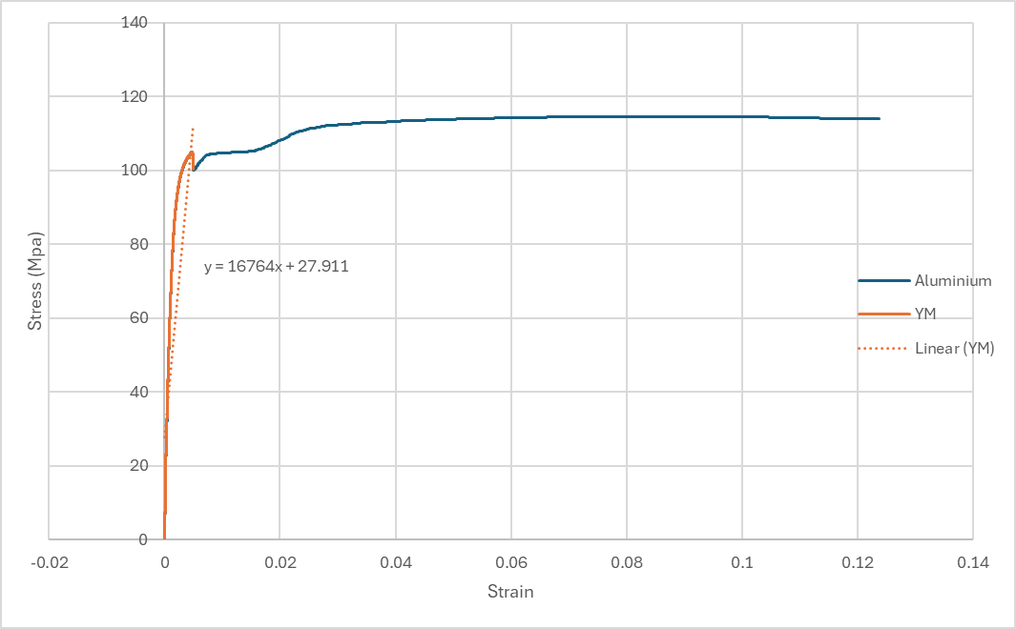
Figure 1-Aluminium Stress Strain Curve
The plot above is showing the aluminium stress strain curve during tensile loading. The figure shows that the maximum range of the elastic region is around 104MPa resulting in a high quantity of force for permanent deformation to occur. The maximum load before fracturing is around 115Mpa resulting in a small difference the load required to deform past the elastic region and start the fracturing process. Additionally, as the material undergoes necking there is a small increase in the applied stress meaning that there no resistance caused by the deformation.
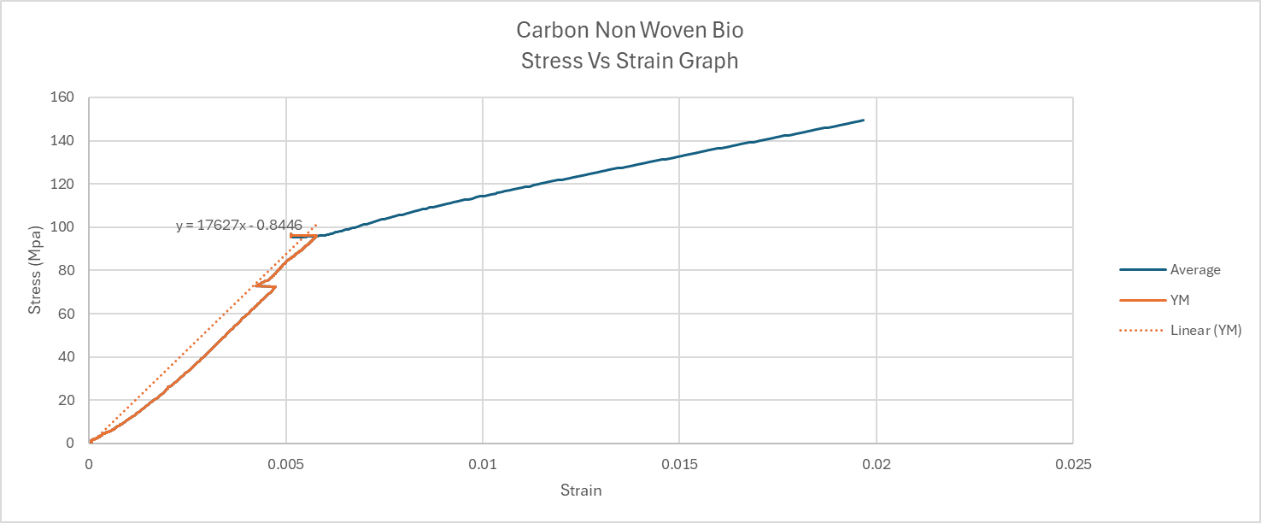
Figure 2- Non-Woven Carbon Fibre with Bio Resin Stress Strain Curve

The next material that was tested was non-woven carbon fibre with bio epoxy resin. This carbon fibre has a significantly shorter elastic region when compared to aluminium. This is shown through the elastic region having a maximum stress of around 96MPa while little deformation occurred as shown through the small strain ratio. This has resulted in a calculated Young’s Modulus of 17.627 GPa compared to the manufacturer value of 25MPa (Easy Composites, 2024). This is in comparison to aluminium which reaches a peak elastic region of around 104Mpa while having similar strains at the peaks. However, they differ with their total change in length shown by the strain of the aluminium having a value of 0.125 whereas the non-woven carbon fibre with bio epoxy resin has a significantly lower strain of 0.018 showing that the carbon fibre is more brittle when compared to aluminium and experiences sudden fracture.
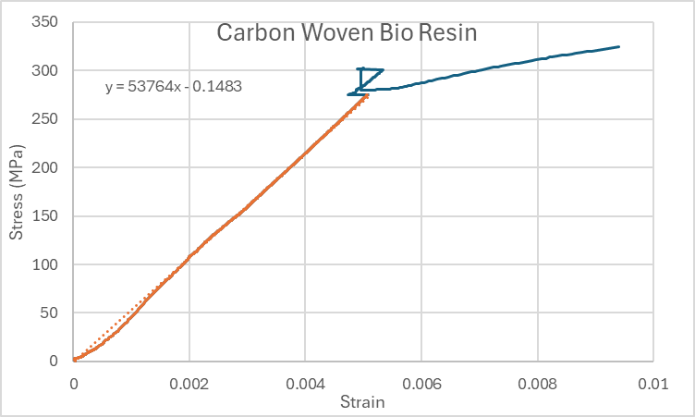
Figure 3- Woven Carbon Fibre with Bio Resin Stress Strain Curve
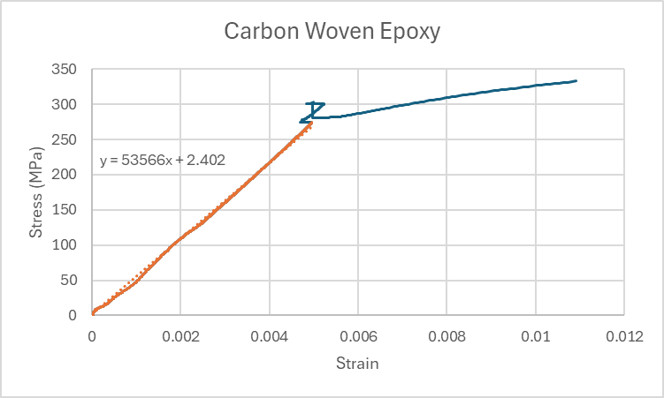
Figure 4- Woven Carbon Fibre with Epoxy Resin Stress Strain Curve
Figures _ and _ show the strain curves for both the woven carbon fibre samples with both the bio and epoxy resin. The plots show similar elastic regions between the two resin types. This is shown through the Young’s Modulus of the different samples having similar values of 53.566GPa for the Epoxy resin and 53.764 GPa showing that between resins the effect on the applied stress in minimal presenting the possible usage of sustainable resin within composites. Differences occur between the two resins with their maximum stresses having a slight deviation with the bio resin having a maximum stress of 324Mpa whereas the epoxy resin has a value of 333MPa once again showing how both samples have near identical tensile properties.
Comparative to aluminium both woven carbon fibre samples have a higher maximum stress value for the elastic region with the carbon fibres have a value of around 275MPa whereas has value of around 105MPa. This is in comparison to the total deformation as shown by the strain value where both carbon fibres only reach a ratio of 0.011 and aluminium has a larger value of 0.12 showing aluminium has an extension around 10 times greater than the woven carbon fibre samples being a more brittle material compared to the aluminium sample while withstanding a larger applied load.
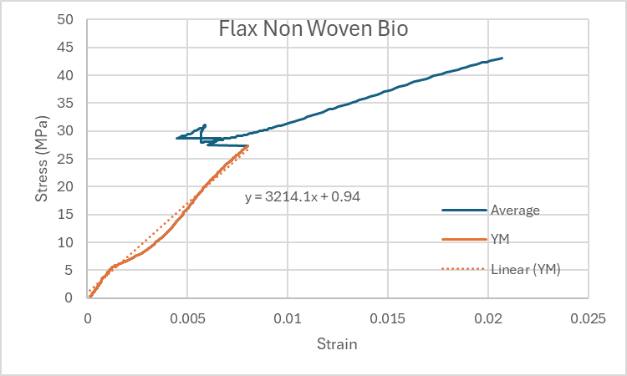
Figure 5- Non-Woven Flax with Bio Resin Stress Strain Curve
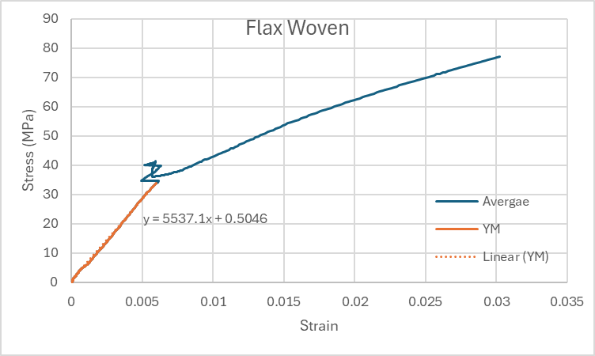
Figure 6- Woven Flax with Bio Resin Stress Strain Curve

Woven and non-woven flax with bio resin were the next materials that had undergone tensile testing. Comparing the elastic regions of the two flax materials the non-woven flax can withstand around 27MPa whereas, the flax is slightly stronger than non-woven with a maximum stress of around 32MPa. Despite this, the strain ratio during elastic region is greater for the non-woven flax having at the peak of 0.0075 whereas the woven has a peak around 0.0055. As previously mentioned, aluminium has a peak stress in the elastic region of around 105MPa this is greater than the both the flax samples. Through the necking range the strain is smaller for both flax sample than the aluminium with the flax samples having a maximum 0.02 for the non-woven sample and 0.03 for the woven sample whereas the aluminium has had a maximum value of 0.12 showing that aluminium is a better material once a large load has applied and the overall weakness of flax. Finally comparing the Young’s modulus, the non-woven flax has values of 3.2GPa, compared to 5Gpa (Easy Composites, 2026)found by the manufacturer. Whereas woven has a value of 5.5GPa.
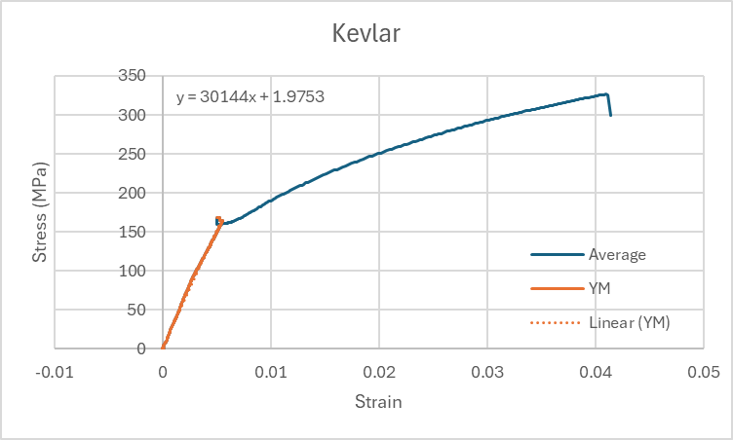
Figure 7- Kevlar with Bio Resin Stress Strain Curve
The final material that was tested was Kevlar. This material has a larger stress tolerance for the elastic region than aluminium reaching a maximum value of around 160MPa while having a similar strain value to aluminium. Comparing the necking region the final strain of the Kevlar reaches a value of 0.04 compared to aluminium’s strain of 0.012 showing the aluminium sample will stretch around 3 times more than the Kevlar. Finally, Kevlar has a young’s modulus of 30GPa compared to aluminium’s 16.7GPa resulting in Kevlar having a stronger elastic region.
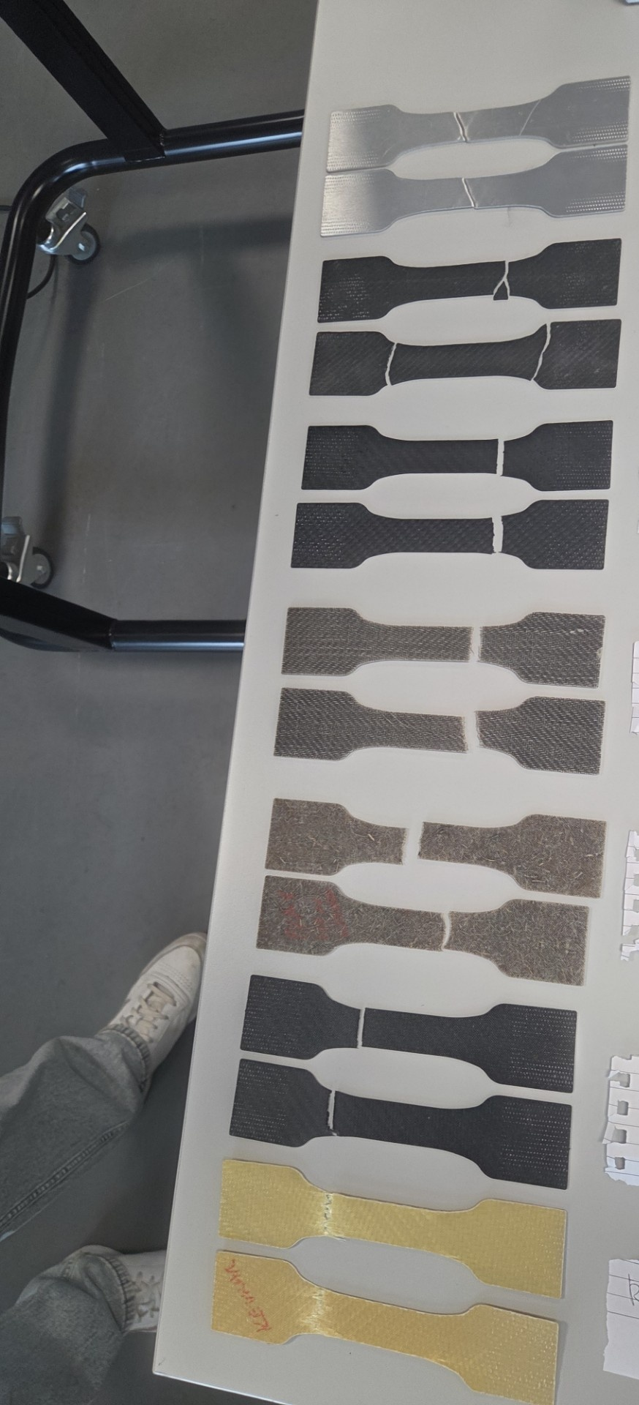
Materials Tested
-Aluminium

-Carbon Non-Woven Bio Resin

-Carbon Woven Bio Resin

-Flax Woven Bio Resin

-Flax Non-Woven Bio Resin

-Carbon Woven Epoxy Resin

-Kevlar

Figure 8- Material Testing Sample Fractures

Recommendations
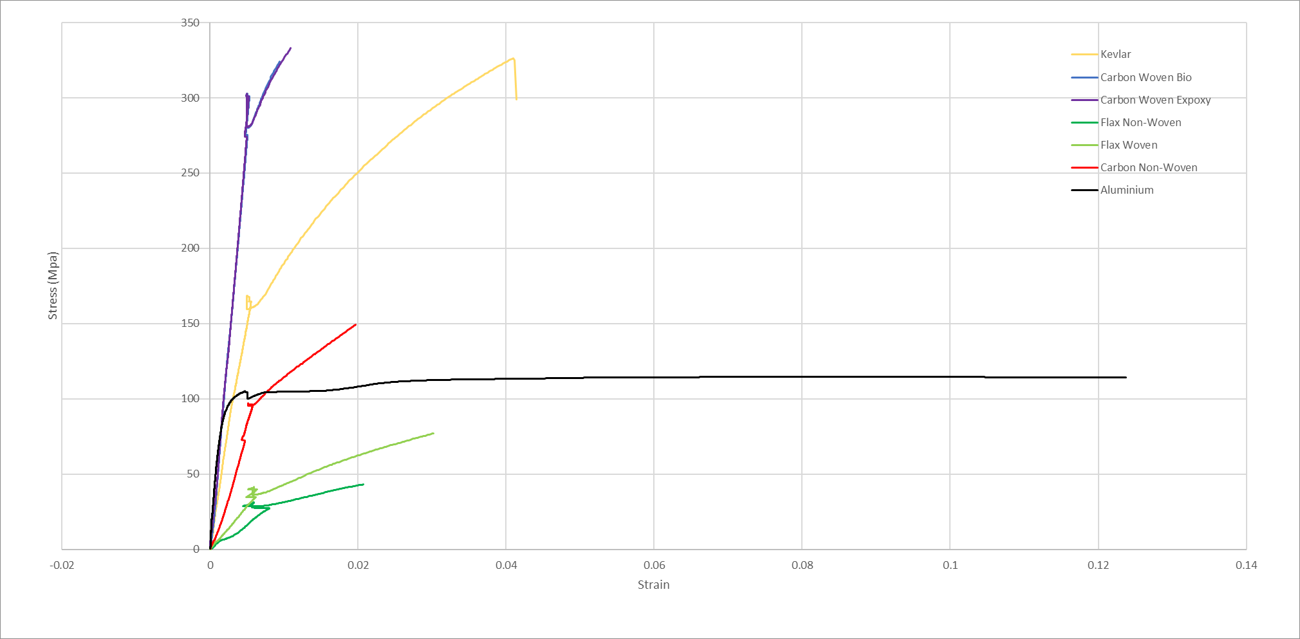
The plot above is showing a comparison between the sampled materials. The plot shows that every material tested is significantly more brittle than the aluminium sample due to each material having a lower strain ration resulting in a lower allowance for deformation to occur during the necking process. Additionally, the figure_ shows that when a load has been applied both flax samples have significantly worse tensile properties making them unideal for high duty impact loading and situation that require significant stretching showing metals advantage over the natural fibres.
In contrast the plot demonstrates that the carbon fibre samples particularly the woven samples as well the Kevlar have improved tensile results compared to aluminium when high forces are applied. This makes both woven carbon samples as well as the Kevlar better suited to impact collisions than consistently applied loads due to having a smaller strain value and therefore being brittle resulting in a lack of deformation the necking process occurring.
In conclusion the use flax by itself is not recommended when undergoing tensile forces due the low stress needed to take the materials past its elastic region as well as the materials being unwilling to be stretched beyond the original length. Moreover, while carbon fibre and Kevlar have a higher resistance to stretching beyond their original length due to the low strain value present, they have a high resistance to large, applied resulting in good impact resistance. Finally, Kevlar maintains of aluminium ability to deform while maintaining high load resistance.

Conclusion
To conclude understanding how composites are used in the automotive and motorsport industry is crucial for future development of sustainability within these industries. This involved understanding the components use and identification of if the material is suitable for the required purpose or if a sustainable replacement could be found. For example, this could involve changing the type of resin that is used with composites from the epoxy resin comprised from oils to the renewable bio resin. As well as integrating sustainable composites into key components that that may not require the same amount of tensile strength as other components such as Riccardo’s seat containing flax fibres improving both the renewability and recyclability of the seat.
Additionally, tensile testing has led to understanding material properties and their suitability for key components around an aluminium baseline. Through testing the samples comprised of both woven and non-woven flax had terrible tensile properties resulting in a low resistance to stress and deformation making them suitable for combing with other fibres to improve recyclability and improve component renewability. Moreover, both woven carbon fibre and Kevlar were found to have a higher resistance to loading than the aluminium baseline. This provides a replacement material that is more idealised for use for components that experience high impacts as shown through use in Kevlar vests. The negatives of such occur through the materials ability to deform and stretch beyond their original length with carbon fibre in particular being a brittle material.

References
Koumoulos, E. P. et al., 2019. Research and Development in Carbon Fibers and. Journal of Composites Science, 3(3), p. 86.
Raja, D. K., Pagar , D. D., Menezes , P. L. & Linul, E., 2023. Fiber-Reinforced Polymer Composites: Manufacturing, Properties, and Applications. Polymers, 11(10), p. 1667.
Rajak , D. K., D. Pagar, D., L. Menezes , P. & Linul , E., 2019. Fiber-Reinforced Polymer Composites. Scholarly Journal, 11(10), p. 1667.
Davidson, M. et al., 2026. Carbon Fiber-Reinforced Polymer Matrix Composites: Processing, Properties, and Applications. Scholorly Journal, 14(3), p. 29.
GreenPaper Products, 2026. What is bioresin?. [Online]
Available at: https://greenpaperproducts.com/faq/eco-friendly-materials/what-is-bioresin?srsltid=AfmBOoojmQGvpctsf-0c-WnxcW90LkT-qzWjtCsKsebSaQD8ia9HK_xr
[Accessed 28 April 2026].
Hossain , N. et al., 2025. Advances of composite materials in automobile applications. Journal of Engineering Research, 13(2), pp. 1001-1023.
Maiti, S. et al., 2022. Sustainable Fiber-Reinforced Composites: A Review. Advance Sustainable Systems, 6(11).
McLaren, 2021. THE NEXT STEP IN McLAREN'S USE OF SUSTAINABLE COMPOSITES IN F1. [Online]
Available at: https://www.mclaren.com/racing/sustainability/sustainable-natural-fibre-composites/
[Accessed 7 May 2026].
McLaren, 2023. McLAREN RACING PIONEERS USE OF SUSTAINABLE MATERIALS WITH INNOVATIVE RECYCLED CARBON FIBRE TRIAL. [Online]
Available at: https://www.mclaren.com/racing/formula-1/2023/mclaren-racing-pioneers-use-of-sustainable-materials-with-innovative-recycled-carbon-fibre-trial/
[Accessed 7 May 2026].
Plastics Europe, 2026. Thermosets. [Online]
Available at: https://plasticseurope.org/plastics-explained/a-large-family/thermosets/#:~:text=The%20initial%20material%20for%20thermosets,bonds%20formed%20during%20cross%2Dlinking.
[Accessed 7 May 2026].
Ursache, S., Cerbu , C. & Hadăr, A., 2024. Characteristics of Carbon and Kevlar Fibres, Their Composites and Structural Applications in Civil Engineering—A Review. Ploymers, 16(1), p. 127.

