International Hotel Management (BA)

Contemporary Themes in the Hotel and Hospitality Sector.
BMIH6001

Assignment Two
Conference Presentation

CONTEMPORARY THEMES: PERSONALISED GUEST EXPERIENCES

ESAB ALI 2110102

ESAB ALI PRESENTATION WITH SPEAKER NOTES:

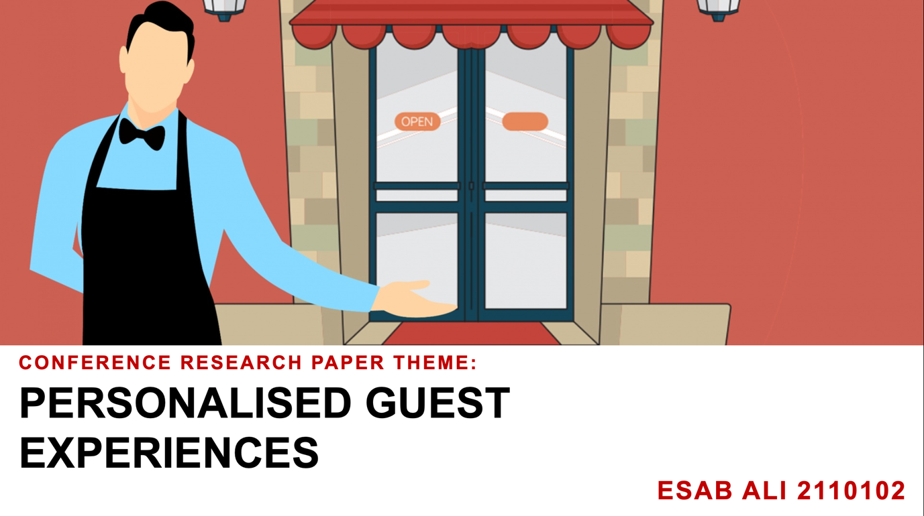

Speaker Notes:
Welcome to my presentation on the theme of personalised guest experiences in the hotel industry.
This contemporary approach addresses modern travellers' desire for unique, tailored stays, driving significant changes in industry practices.



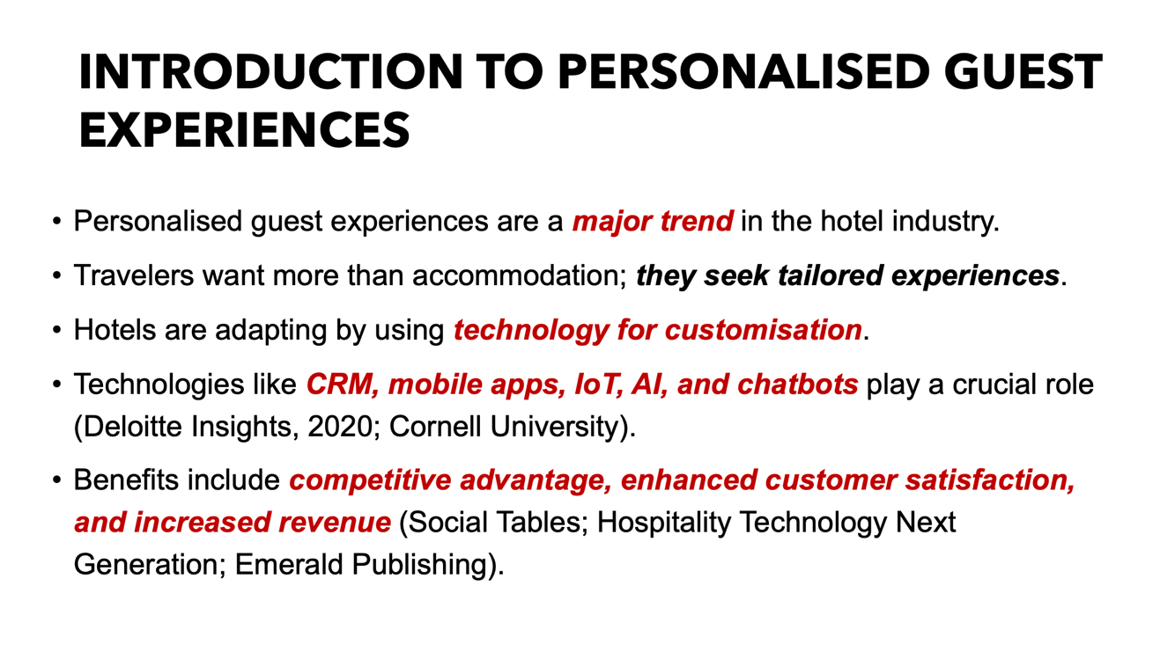
Speaker Notes:
- Welcome! Today's presentation is about the growing importance of personalised guest experiences in the hotel industry. Modern travelers desire more than just a place to stay; they seek unique, tailored experiences.
- To meet these demands, hotels are leveraging various technologies such as CRM systems to manage guest data, mobile apps for convenient services, IoT devices for customised room settings, AI, and machine learning for personalised recommendations, and chatbots for round-the-clock support.
- These personalised experiences help hotels stand out in a competitive market, boost customer satisfaction, and create additional revenue opportunities.



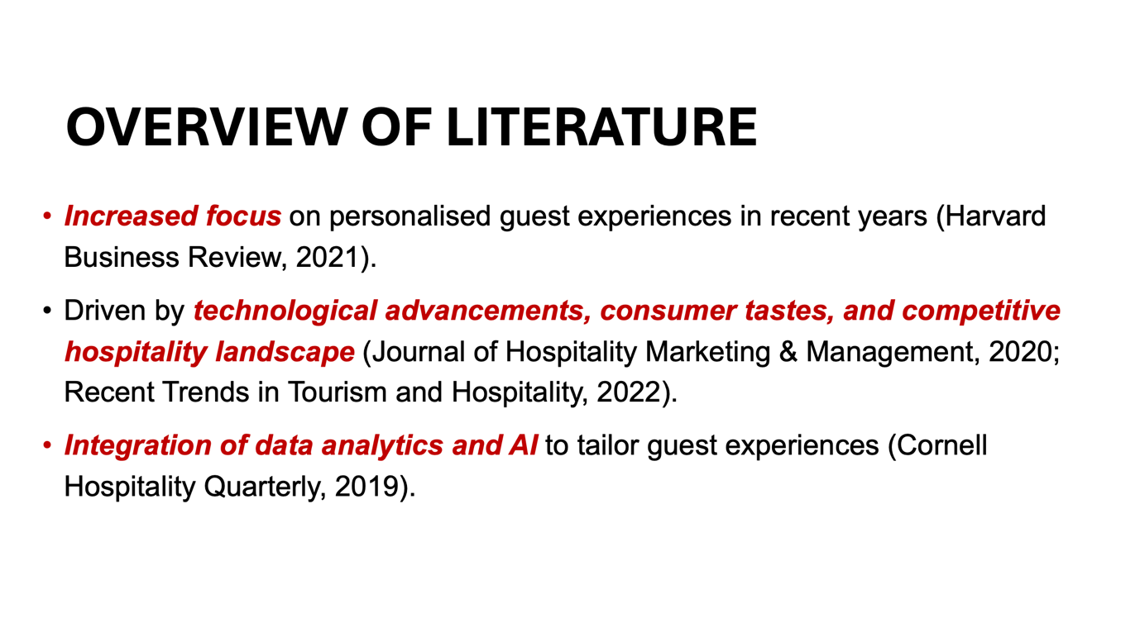

Speaker Notes:
- Recent studies highlight the growing focus on personalised guest experiences in the hotel industry.
- This trend is driven by technological advancements, evolving consumer tastes, and the competitive nature of hospitality.
- One key area is the integration of data analytics and artificial intelligence (AI), which helps hotels tailor experiences to each guest's unique preferences.

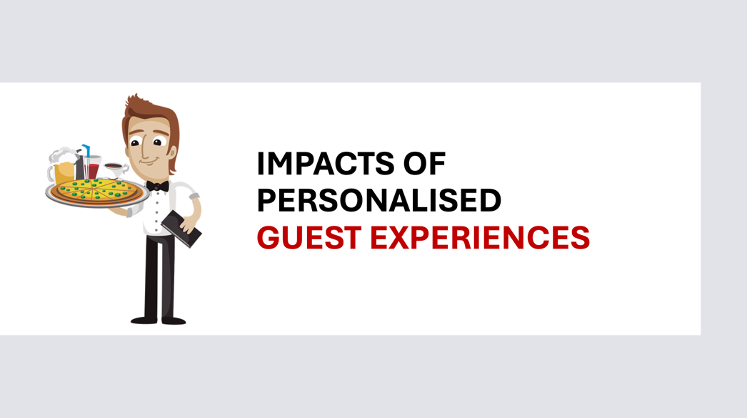

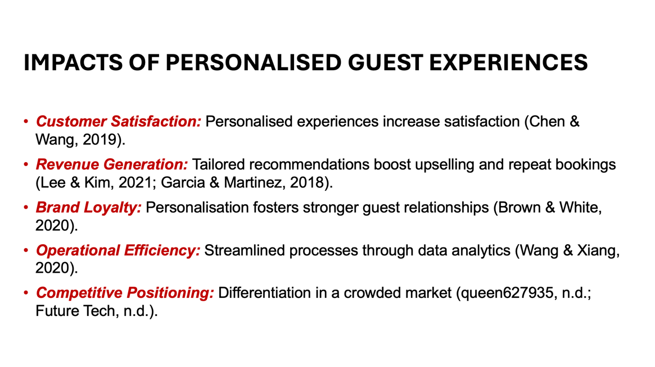

Speaker Notes:
Personalised guest experiences positively impact several areas:
1. Customer Satisfaction: Guests feel valued when their preferences are met, leading to positive reviews and repeat bookings.
2. Revenue Generation: Hotels can upsell and encourage repeat visits by offering personalised recommendations.
3. Brand Loyalty: Guests are more likely to return and recommend hotels that provide personalised experiences.
4. Operational Efficiency: Data analytics streamline processes like check-in and housekeeping, improving resource allocation.
5. Competitive Positioning: Hotels offering personalised experiences stand out in the market, attracting and retaining more customers.
Research supports these benefits, demonstrating how personalised guest experiences enhance satisfaction, revenue, loyalty, efficiency, and competitive advantage in the hospitality industry.

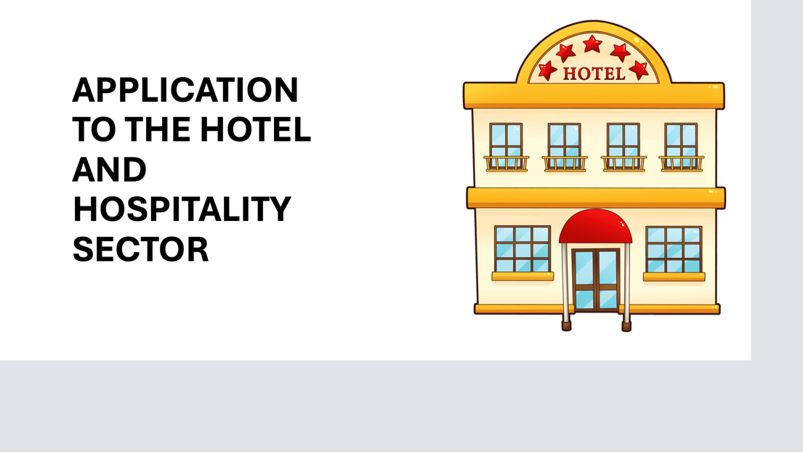

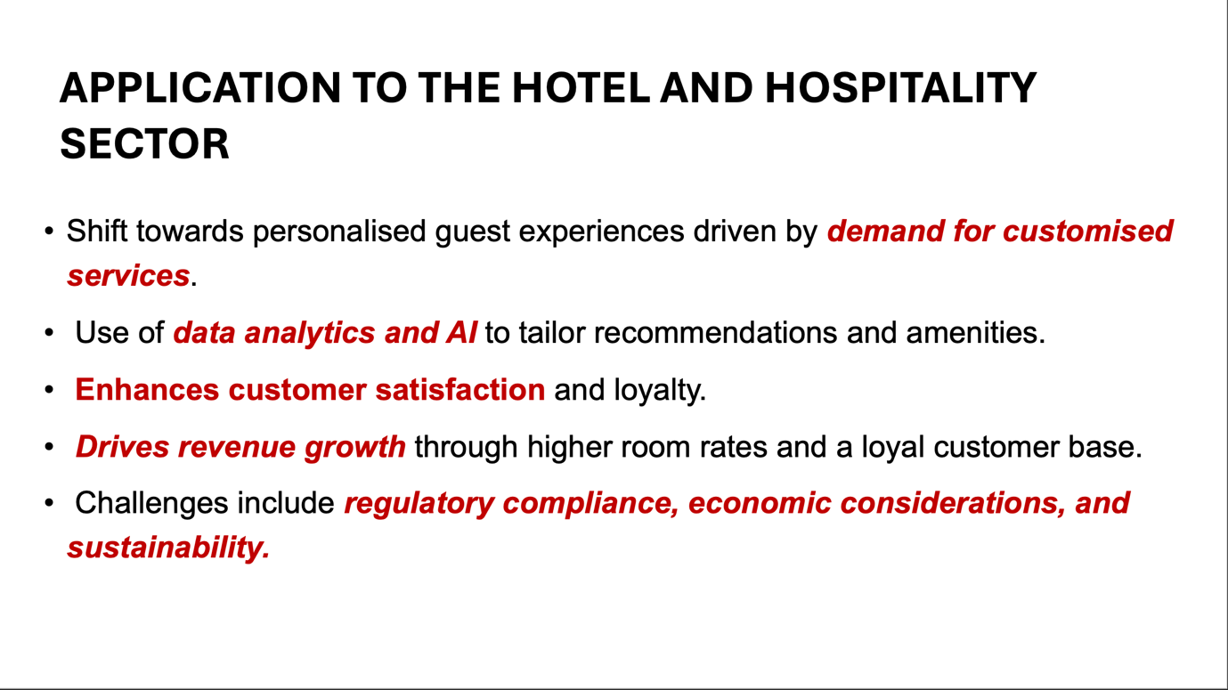

Speaker Notes:
Personalised guest experiences are becoming a core strategy in the hotel industry, responding to the growing demand for customised services. Hotels use technology, like data analytics and AI, to gather extensive guest data, enabling them to offer highly personalised recommendations and amenities. This approach not only boosts customer satisfaction and loyalty but also supports revenue growth by justifying higher room rates and attracting loyal guests. However, implementing these personalised experiences requires navigating challenges such as regulatory compliance, economic factors, and sustainability issues.

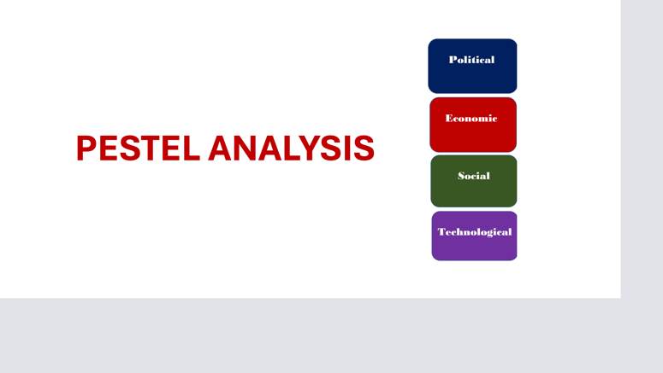

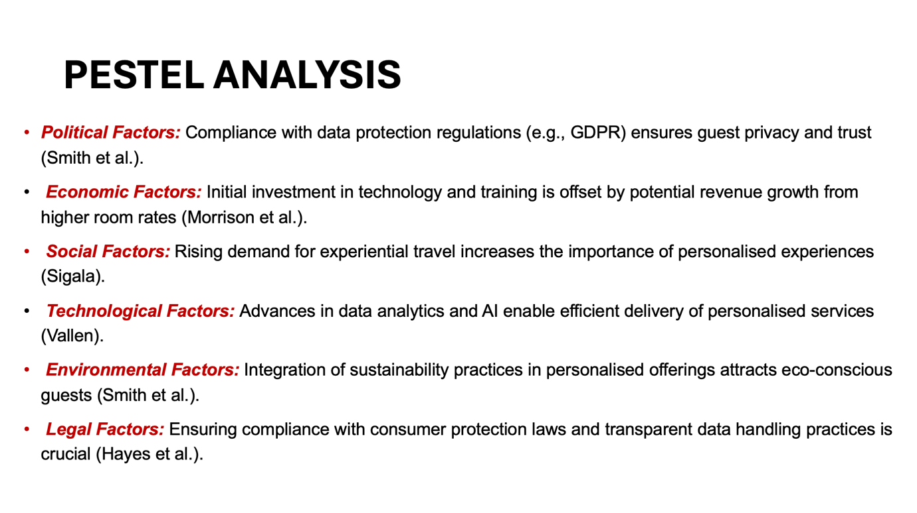

Speaker Notes:
A PESTEL analysis helps us understand the multifaceted impacts of personalised guest experiences in the hotel industry:
Political: Compliance with data protection laws like GDPR is essential for maintaining guest privacy and trust.
Economic: Although costly, investments in technology and training are justified by the potential for increased revenue through higher room rates and loyalty.
Social: There is a growing consumer preference for experiential travel, making personalised services increasingly important.
Technological: Advances in AI and data analytics enable hotels to offer efficient and highly personalised services.
Environmental: Sustainable practices are becoming a key factor in guest preferences, and integrating these into personalised offerings can attract eco-conscious travelers.
Legal: Compliance with data privacy laws and transparent communication about data handling are critical for maintaining legal and ethical standards.

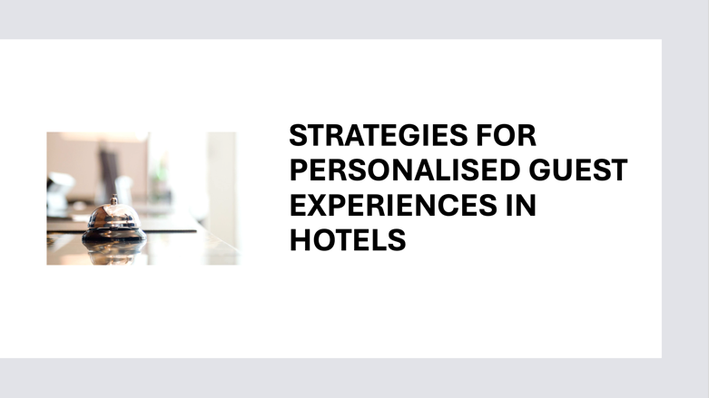

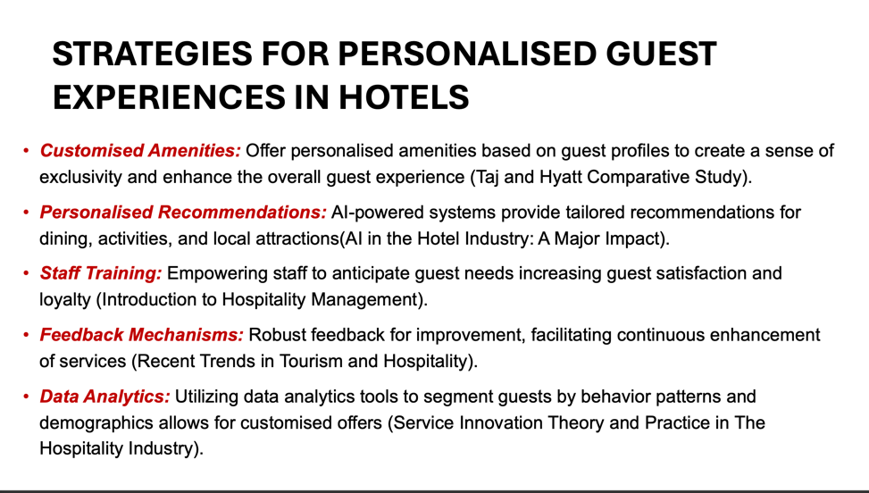

Speaker Notes:
To meet the growing demand for personalised guest experiences, hotels have adopted various strategies:
1. Customised Amenities: Luxury hotels like Taj and Hyatt offer personalised amenities based on guest profiles, creating a unique and luxurious experience.
2. Personalised Recommendations: AI-powered systems provide guests with tailored suggestions for dining, activities, and attractions, making their stay more enjoyable.
3. Staff Training: Training staff to anticipate and meet guest needs leads to exceptional service, boosting satisfaction and loyalty.
4. Feedback Mechanisms: Implementing strong feedback systems helps hotels understand guest preferences and identify areas for improvement, ensuring continuous service enhancement.
5. Data Analytics: Using data analytics to segment guests allows hotels to create targeted marketing campaigns and customised offers, enhancing the personalised experience.

In conclusion, personalised guest experiences are essential for hotel success, driving customer satisfaction, loyalty, and revenue growth. By embracing evolving trends and leveraging technology, hotels can navigate the complexities of the hospitality industry and deliver exceptional personalised services.



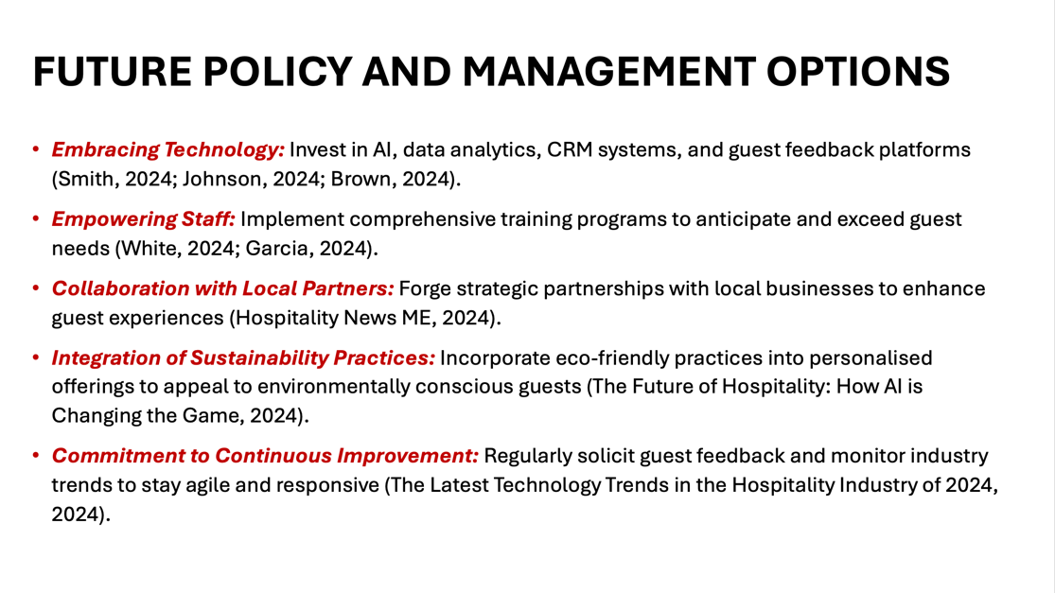

Speaker Notes:
To remain competitive and enhance personalised guest experiences, hotels should focus on:
1. Embracing Technology: Investing in AI, data analytics, CRM systems, and guest feedback platforms can provide valuable insights and enable tailored recommendations and amenities.
2. Empowering Staff: Comprehensive training programs can help staff anticipate guest needs and deliver exceptional service, fostering loyalty and positive word-of-mouth.
3. Collaboration with Local Partners: Partnering with local businesses can offer guests unique experiences, showcasing the destination and supporting the community.
4. Integration of Sustainability Practices: Eco-friendly initiatives appeal to environmentally conscious guests and align with their values.
5. Commitment to Continuous Improvement: Regular feedback and trend monitoring ensure hotels remain agile and responsive to guest preferences.



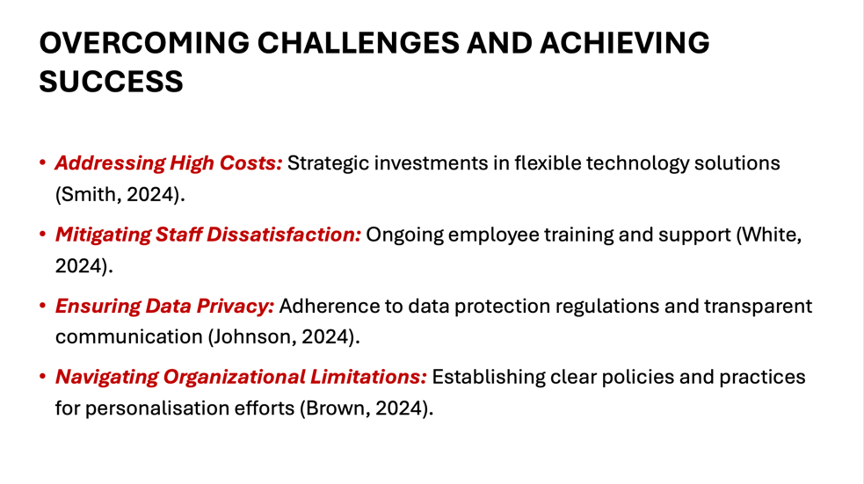

Speaker Notes:
To successfully implement personalised guest experiences, hotels must overcome several challenges:
1. High Costs: Make strategic investments in flexible technology solutions that offer long-term benefits.
2. Staff Dissatisfaction: Provide ongoing training and support to ensure staff are equipped and motivated to deliver personalised services.
3. Data Privacy: Ensure compliance with data protection regulations and maintain transparent communication with guests regarding data usage.
4. Organisational Limitations: Establish clear policies and practices to support personalisation efforts across all levels of the organisation.

By addressing these challenges, hotels can improve customer satisfaction, encourage loyalty, and gain a competitive edge in the hospitality sector. Embracing technology, empowering staff, fostering local partnerships, prioritising sustainability, and committing to continuous improvement are key strategies for delivering unparalleled personalised guest experiences.



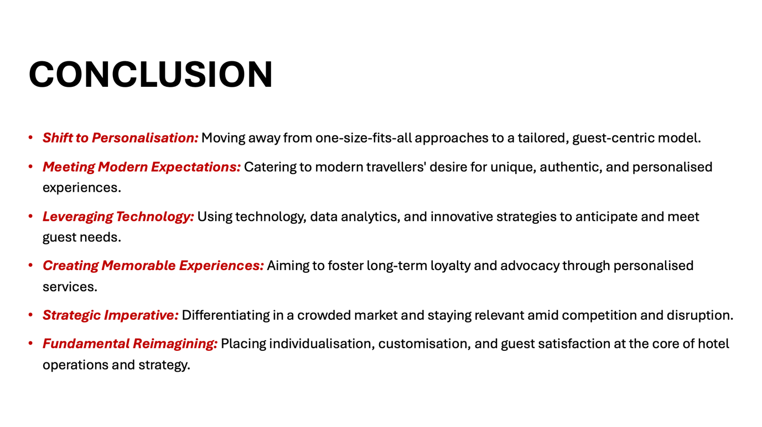

Speaker Notes:
In conclusion, the contemporary theme of personalised guest experiences marks a significant shift in the hotel and hospitality industry. Moving away from one-size-fits-all approaches, hotels now focus on tailored, guest-centric models to meet modern travellers' desire for unique, authentic, and personalised experiences. Leveraging technology and data analytics, hotels anticipate and fulfill individual guest needs, creating memorable experiences that foster loyalty and advocacy. This approach is a strategic imperative in a crowded and competitive market, fundamentally reimagining guest experiences by placing individualisation, customisation, and satisfaction at the core of operations and strategy.

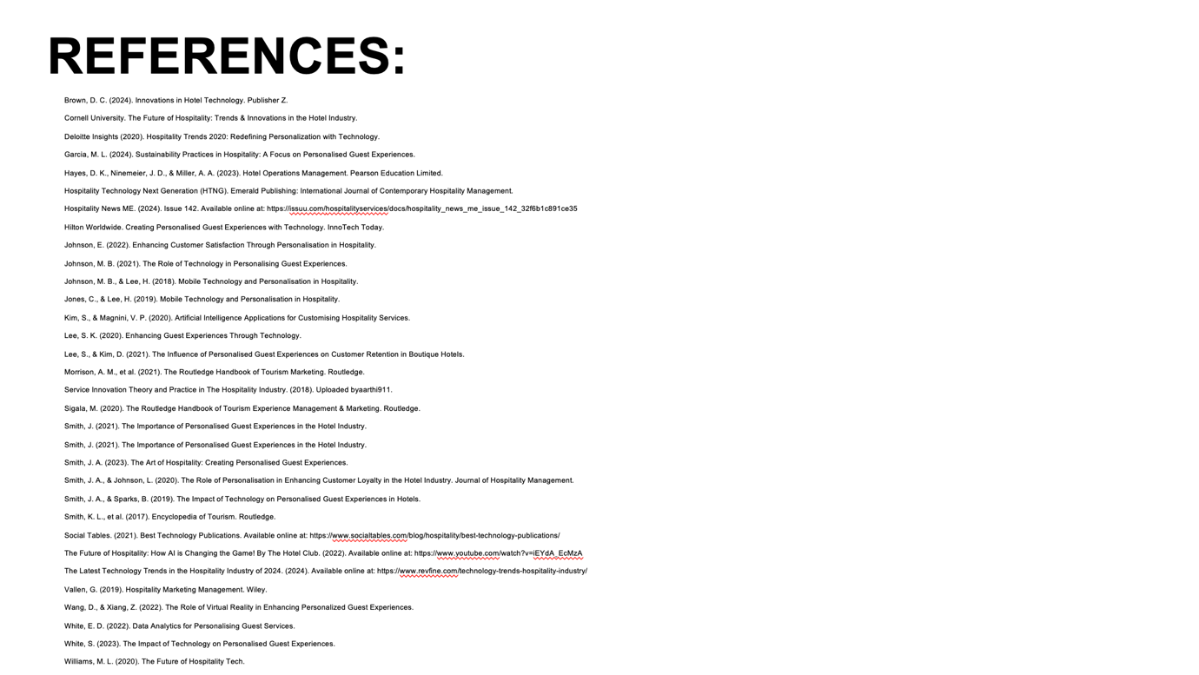



Speaker notes:
Thank you so much for listening.

