Operating Systems (ACCA4022)
  - Daniel Jones

Contents
1. Introduction 3
2. Key functions of general Operating Systems 4
Process Management 4
Device Management 6
Protection and Security 7
3. Use of Windows OS CLI commands 10
4. Use of Linux OS CLI commands 18
5. Use of Windows OS scripts 28
6. Use of Linux OS scripts 32
7. Conclusion 34
8. References 35
9. Appendices 38
Appendix A. Tutorial Activity - What are the types of OS used today? 38
Appendix B. Lecture Activity Questions 39
Appendix C. Evidence of engagement with online course 40

1. Introduction
An operating system is a collection of software that manages and controls the computer’s hardware, resource allocation and file storage [1] [2]. This report, focused mainly on the Windows and Linux operating systems, will explore and demonstrate the core functions of both these systems as well as examine the use of the command-line interface (CLI) and document the use of scripting languages such as Batch and PowerShell. Everything within this report will be presented via screenshots and descriptions to properly show and explain the functionality in use.

2. Key functions of general Operating Systems
The purpose of this section will be to present the key functions of an operating system. Listed below are the core functions found with corresponding screenshots demonstrating how a user may see, monitor or manage said functions.

Process Management
Process Management is a key function that allows the operating system to manage active programs called processes. The core purpose of this function involves the creation, scheduling and termination of processes and allows an operating system to run multiple processes simultaneously via multitasking and CPU allocation [3].
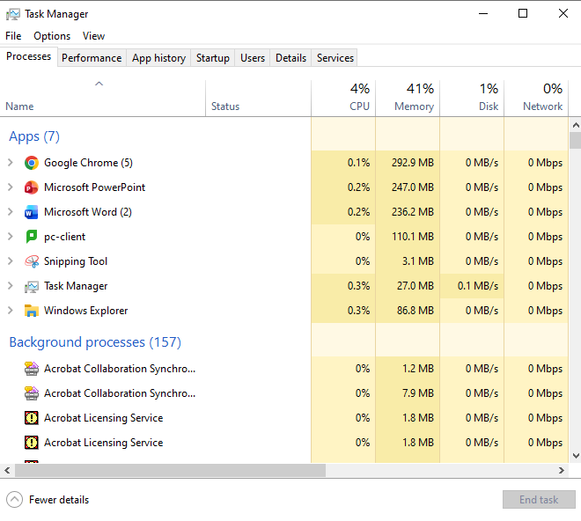
One way this can be monitored and managed by the user is through the Task manager program providing the user with a centralized interface to manage various applications, services and processes as shown below [4].
Figure 1: Task Manager

Task manager provides the user with a high-level overview of apps as well as background processes providing the user with details on status but also the process usage such as CPU, memory, disk and network usage as shown in the screenshot above. Users are also able to use the task manager tool to terminate processes using the end task button.
A similar tool to task manager is the resource monitor which gives a more advanced overview of current working processes and even network activities as shown in the screenshot below.
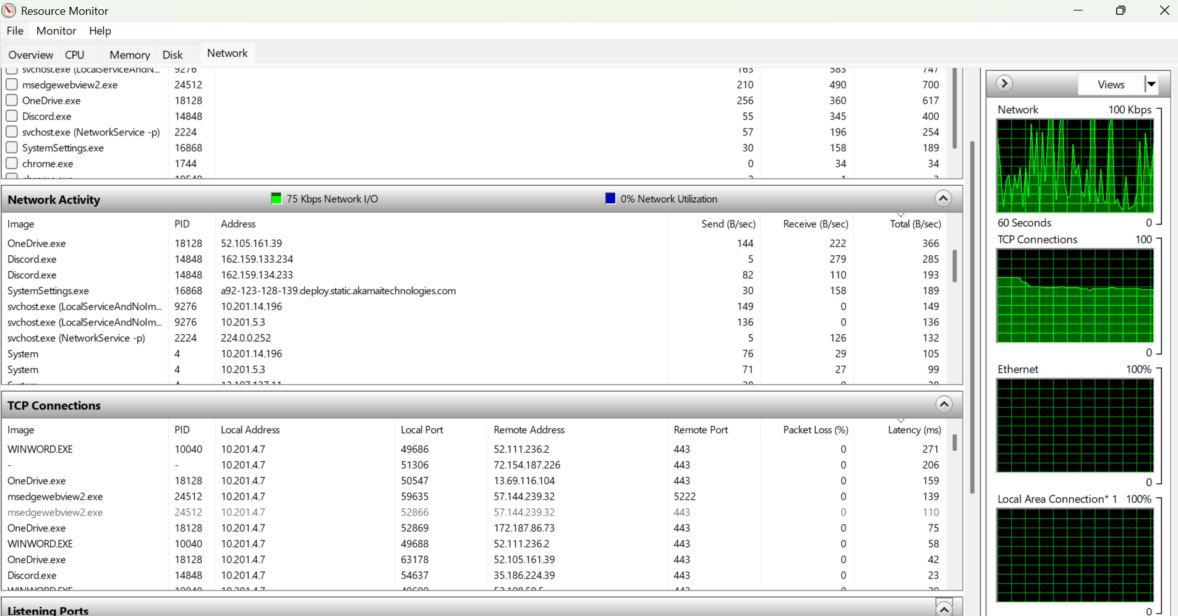
Figure 2: Resource Monitor

Device Management
Another key aspect of the operating system is its ability to manage the communication of hardware through the use of device drivers which acts as a translator between the operating system and the hardware devices [5].
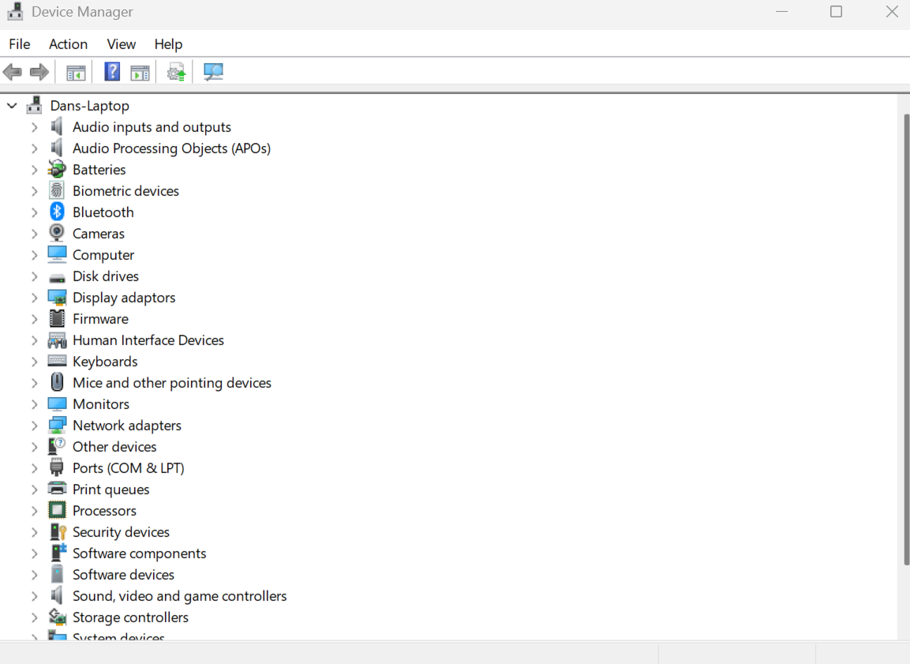
A user would be able to access and manage the drivers and hardware connected to a device with an operating system such as windows by using the Device manager which provides detailed information on each device such as the type of device, the device status, the manufacturer and information about the driver for each device [6]. Below is a screenshot of the device manager that is used on a windows operating system.
Figure 3: Device Manager
Figure 3: Device Manager

Protection and Security
System security is an important aspect of computing and so operating systems have built in tools and systems to help safeguard devices from malicious users and viruses. The operating system protects system resources and user data ensuring that only users with proper authorization can access such content [7].
Below is a screenshot of windows security which is a tool built into the windows operating system that helps manage the security of the system. It is a comprehensive security solution that offers features such as Microsoft Defender Antivirus, Windows Firewall and Smart App Control that all work in tangent to protect a user’s device from viruses, malware and other threats [8].
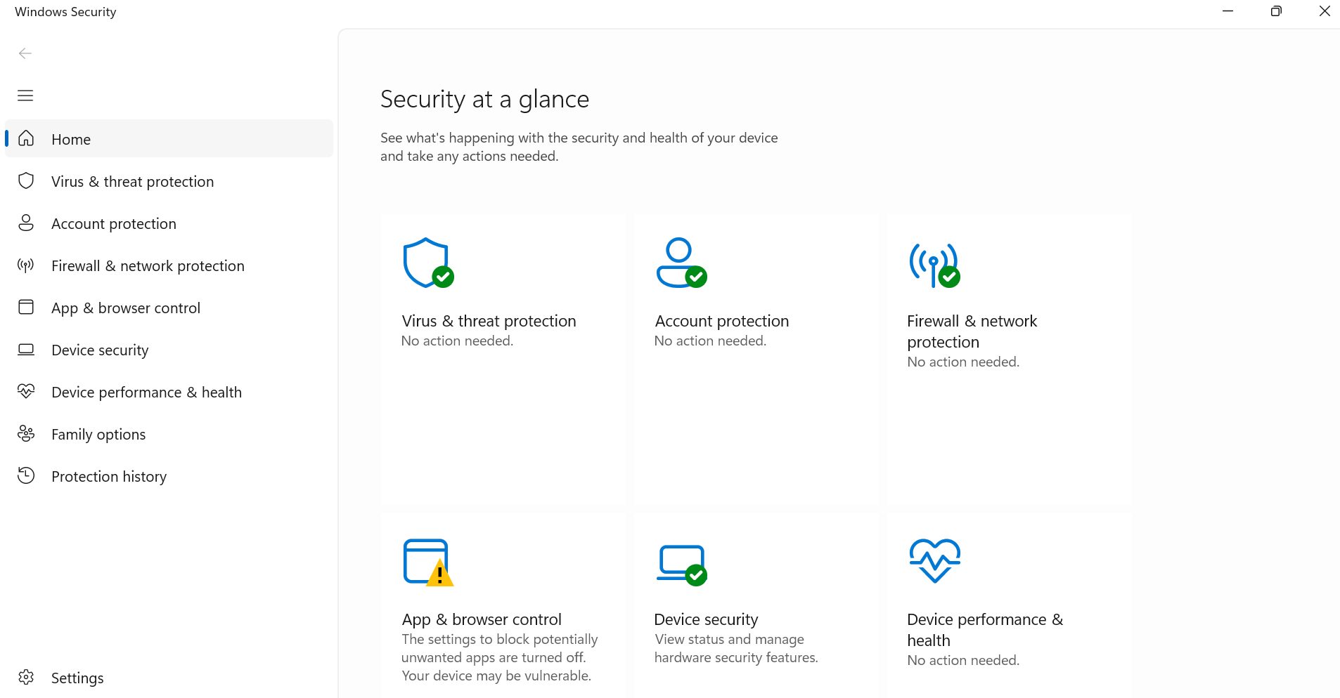
Figure 4: Windows Security

Performance & System Monitoring
Another core function of an operating system is its ability to track system efficiency and look for any potential bottlenecks. This functionality ensures that everything within the operating system runs smoothly and maintains the reliability of the system [5].
The event viewer is a tool built into the windows operating system which allows the user to view and manage event logs that contain information of systems, security and even application events which can help the user to diagnose any potential issues, work out system performance and ensure security is correctly set [9]. The screenshots below present the use of the event viewer and how it assisted with diagnosing a critical error in the past.
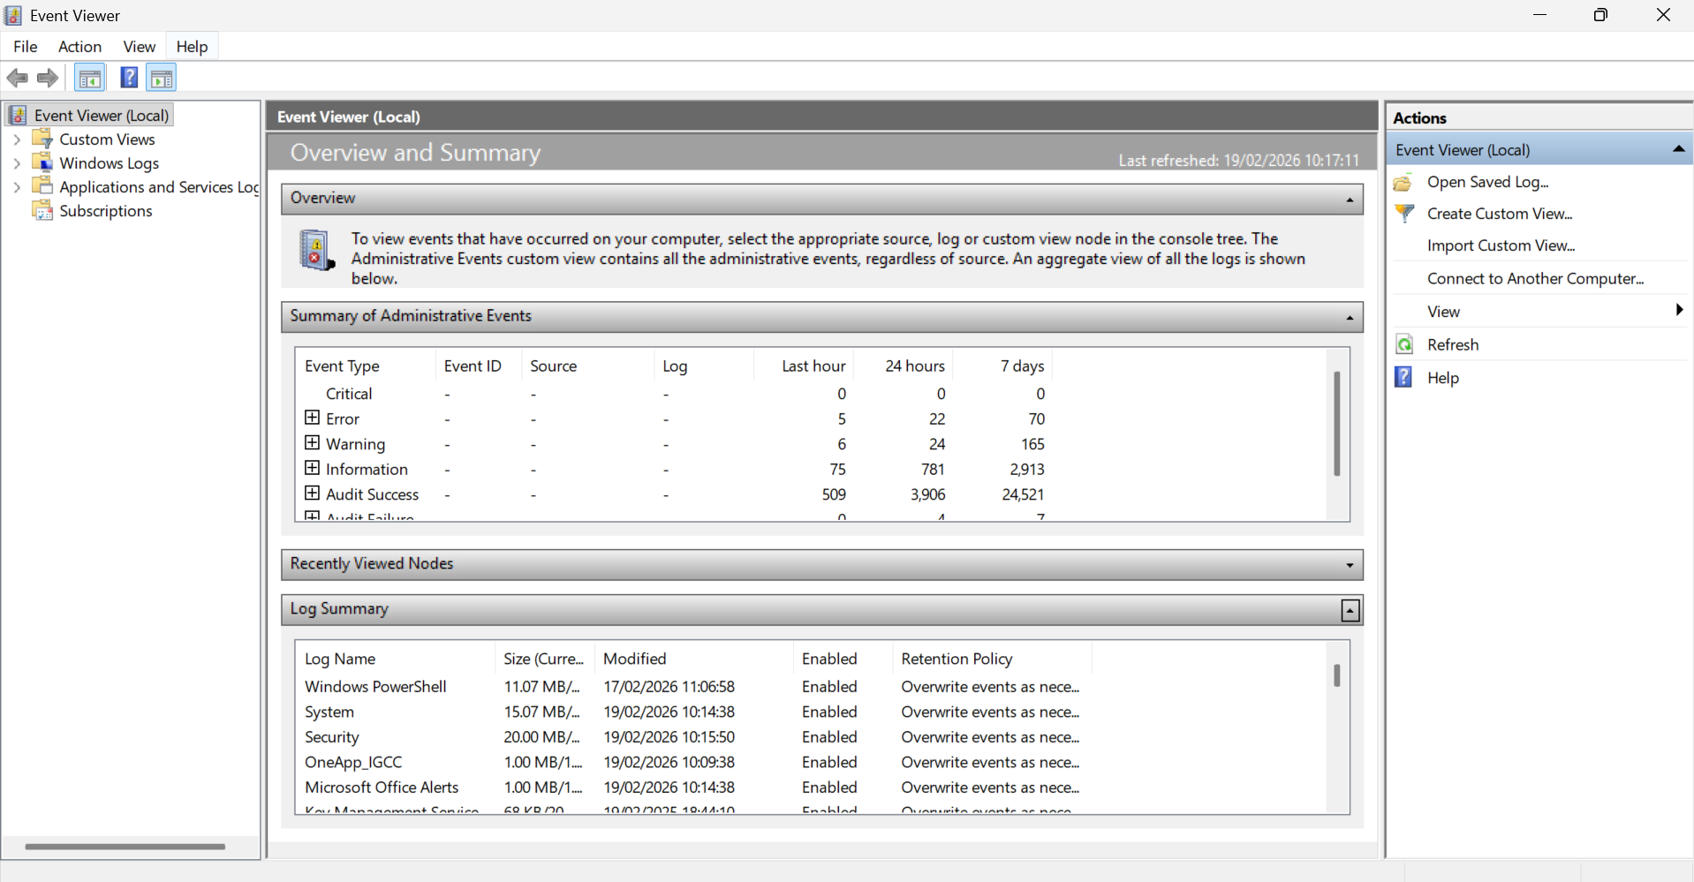
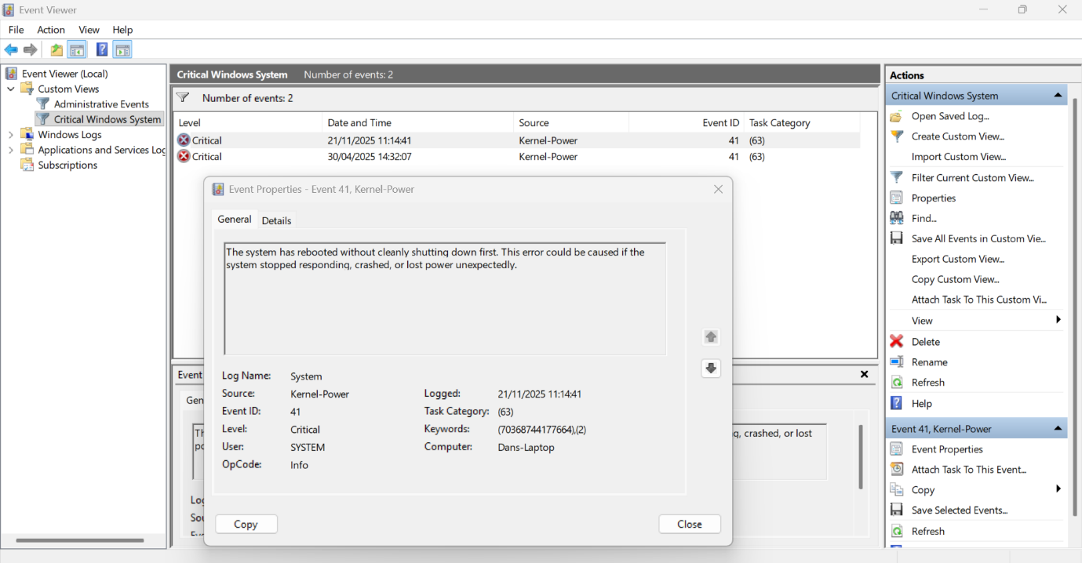
Figure 5: Event Viewer
Figure 6: Event Viewer - Error
Figure 6: Event Viewer - Error

Another similar tool that can be used to monitor key information such as performance is the computer management console that provides centralized location for managing a wide range of system components and services [10]. Below is an example of its use related to performance monitoring.
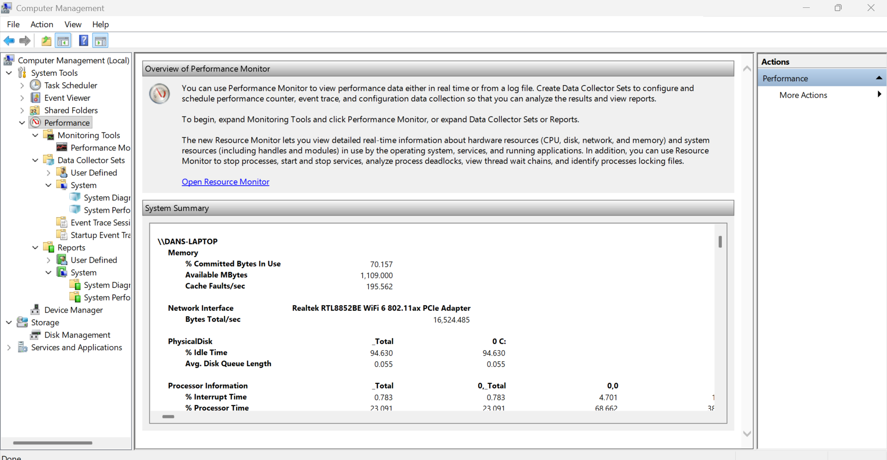
Figure 7: Computer Management - Performance Monitor
The Reliability Monitor is an additional tool that allows for quick and easy view of how stable the system has been. Below is screenshot demonstrating how it presents this data to the user.
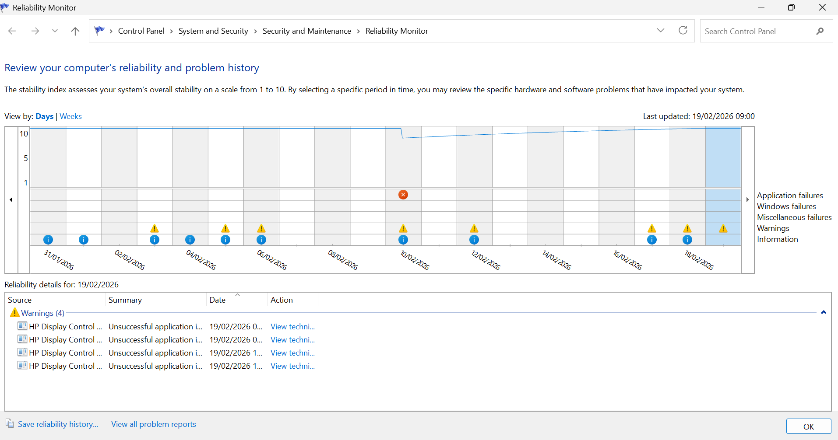
Figure 8: Reliability Monitor

3. Use of Windows OS CLI commands
The windows operating system offers two powerful tools that allow administrators to execute commands, manage system processes and automate administrative tasks. These essential command-line interfaces are called Command Prompt (CMD) and PowerShell [11]. This section will present the use of commands within these tools that allow system administrators to manage and execute various tasks within the windows operating system. Screenshots will be printed below accompanied with descriptions to help present examples of different commands available within windows and their capabilities.
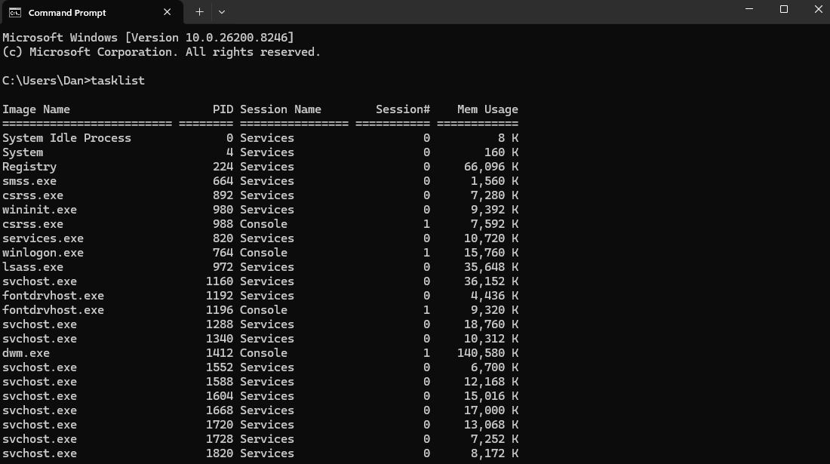
Figure 9: Command Prompt - tasklist
The first command displayed above is the tasklist command. The purpose of this command is that it displays a list of processes on either the local computer or on a remote computer allowing an admin to have a quick and simple view of any and all processes currently in use on a device [12].

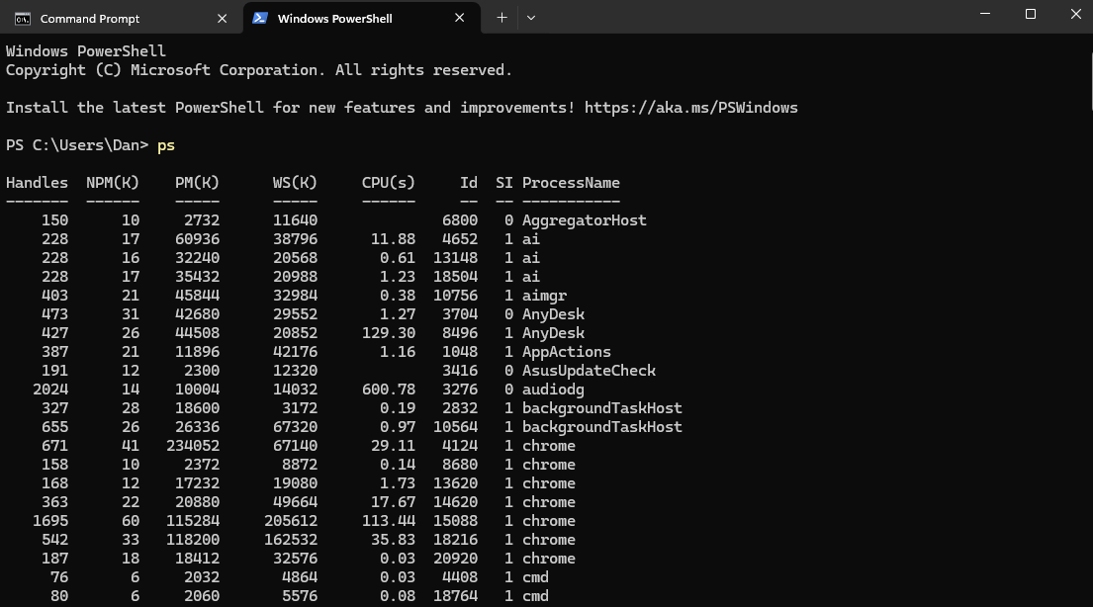
Figure 10: PowerShell - ps
Similar to the previous command tasklist a user can use the ps command through PowerShell for a more in-depth list of active processes on a device providing more details on usage compared to tasklist in cmd.
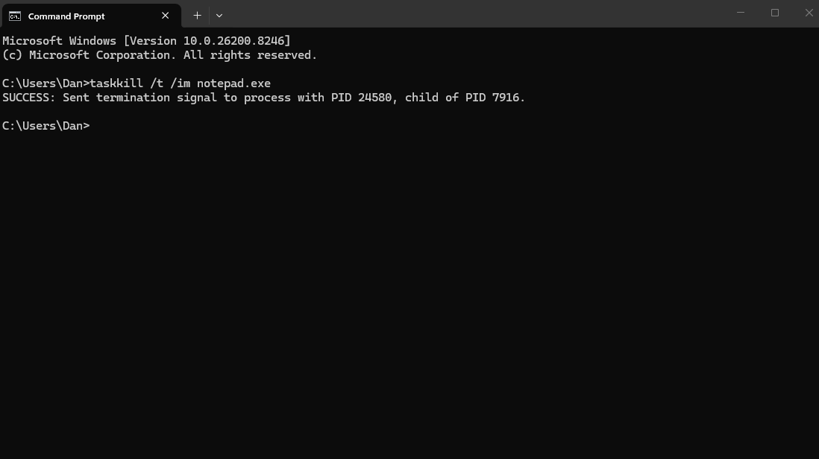
Figure 11: Command Prompt - taskkill
The command used above is called Taskkill. It is a powerful command that allows the admin to end one or more tasks/processes directly using command prompt. As shown above the taskkill command was declared followed by /t which tells the system the user would like to terminate the main process and any child processes followed by /im notepad.exe which specifies that the process that is being targeted for termination has the notepad.exe image name [12].

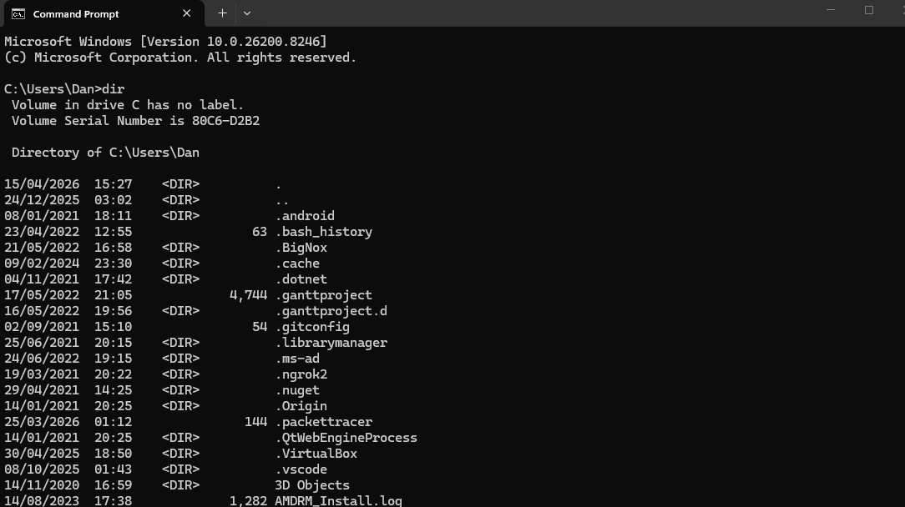
Figure 12: Command Prompt - dir
This next command is used to present a list of directory files and subdirectories. The dir command is useful as it allows the user to navigate through all the directories on a device as well find out when said directories were last modified [12].

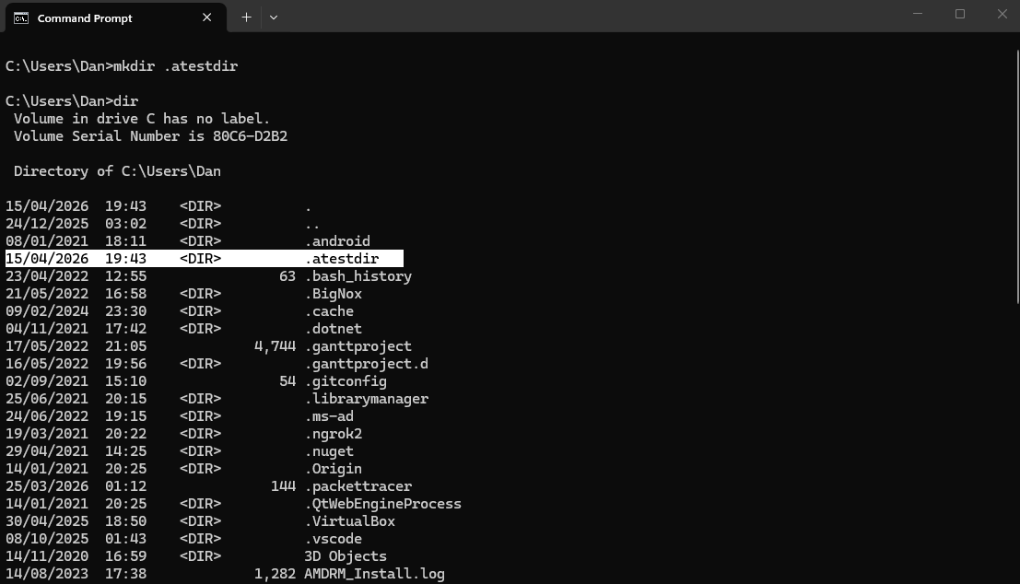
Figure 13: Command Prompt - mkdir
Much like the previous command this command also involves system directories/files [12]. The mkdir command allows the user to create new directories or subdirectories within the system in specified paths by using typing mkdir followed by the name of the directory which in this case was “.atestdir” in the example above.
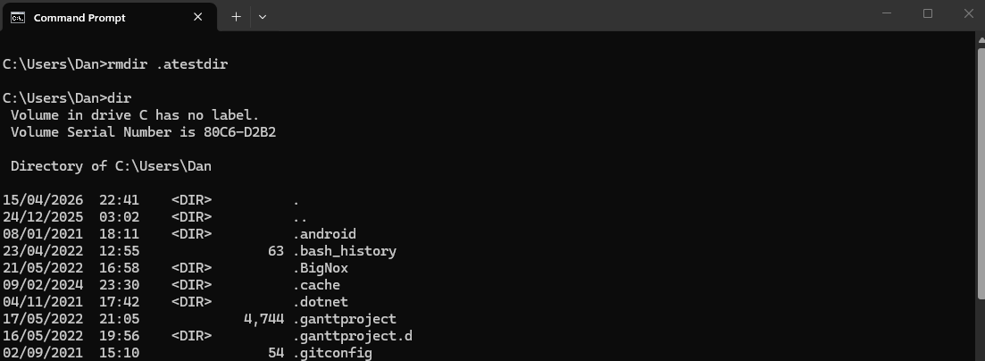
Figure 14: Command Prompt - rmdir
In addition to being able to create directories users will also be able to remove directories through the rmdir command as shown above.

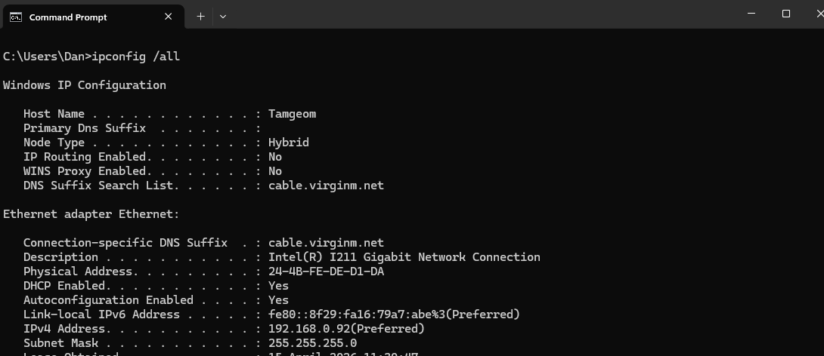
Figure 15: Command Prompt - ipconfig
The ipconfig command is a very useful function that display all current TCP/IP network configuration values on the host device providing the user with private ipv4 and ipv6 addresses as well as the subnet mask and default gateway of any and all adapters [12].

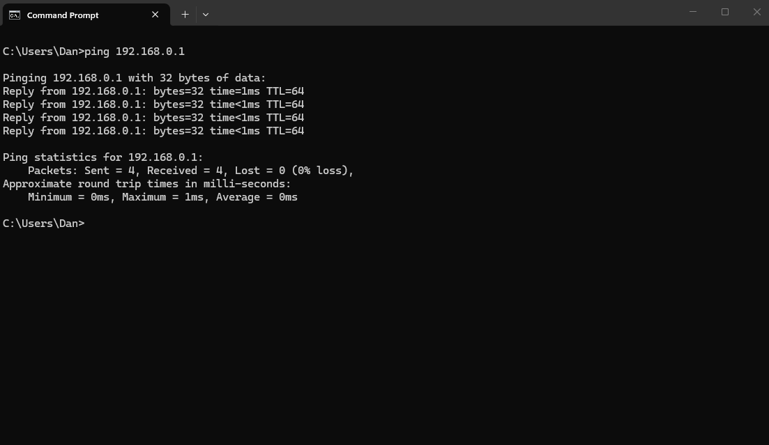
Figure 16: Command Prompt - ping
Ping is another useful command in relation to networking as it allows a user to verify the connectivity of another tcp/ip computer on a network using an ip address. When executed it sends out signal and waits for a reply from the recipient which is shown above and finally statistics are shown that tracks the response time as well as the number of successful packets received [12].

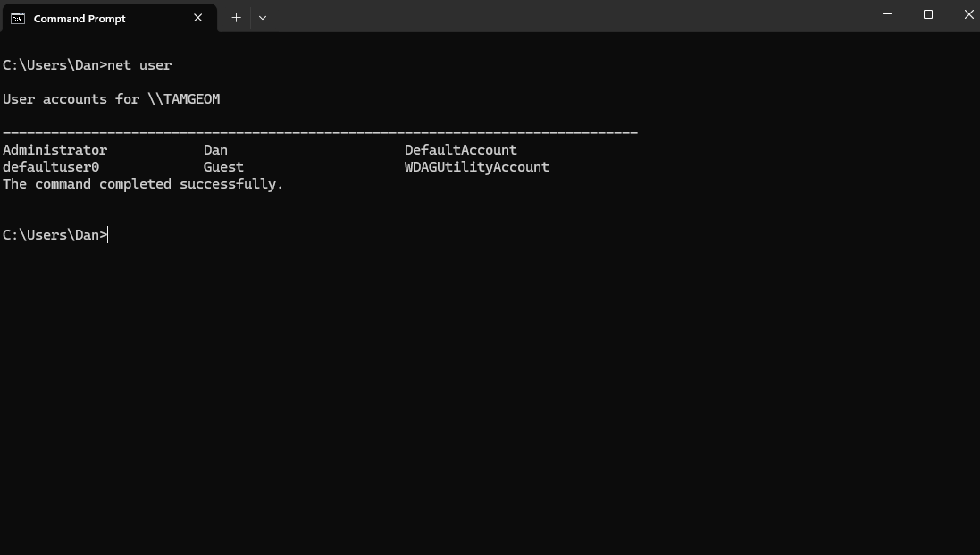
Figure 17: Command Prompt - net user
The next command used is the net user command which allows the user to add, modify and even delete user accounts as well as display information regarding user account within the computer or the domain [12].

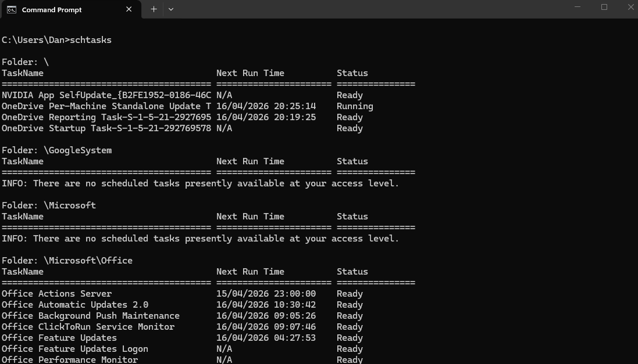
Figure 18: Command Prompt - schtasks
Schtasks is a powerful command that allows an administrator to schedule commands and programs to run periodically or even set for specific times as well view and manage existing scheduled tasks [12].

4. Use of Linux OS CLI commands
This section of the report will cover the various command line interface (CLI) commands found within the Linux operating system. Similar to the previous section, this section will present a number of commands used by the Linux operating system with screenshots and descriptions explaining what these commands are and how they could be useful. All of the commands present below were done through a Ubuntu terminal.
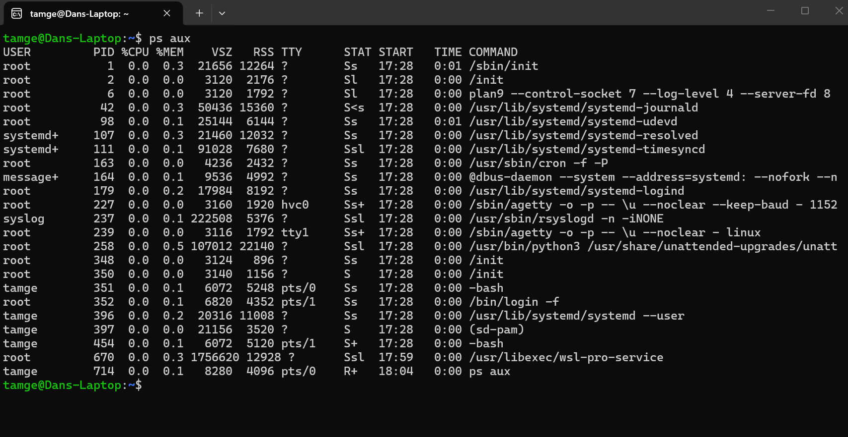
Figure 19: Ubuntu – ps
The first command presented above is the ps function which is the same command presented previously above through PowerShell. This command provides the user with a list of any and all processes currently being run through the system. This is a useful function that grants an overview of the processes and can help assist with identifying any issues with a system such as a specific process using to many resources [13].

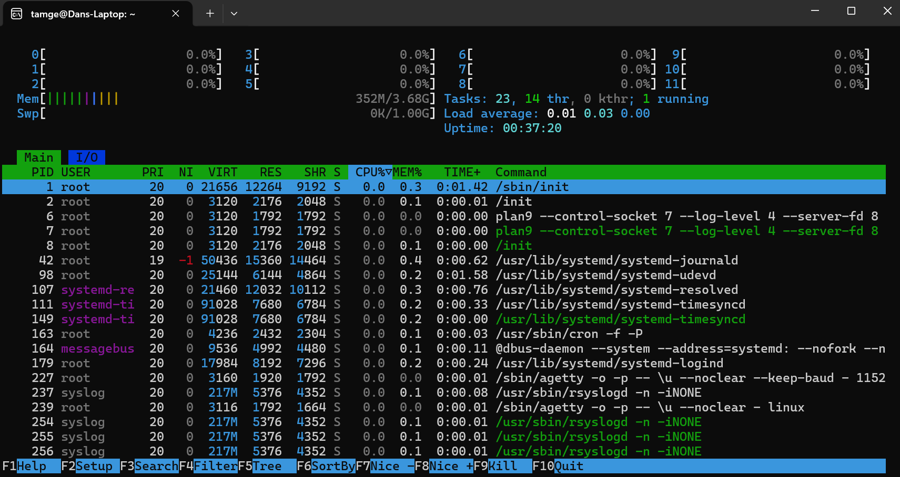
Figure 20: Ubuntu – htop
The screenshot above shows the result of a htop command which acts as a more interactive version of the ps command allowing the user to view processes in a more user-friendly interface. Additionally, htop allows for a more interactive interface providing the user with the ability to search and manage running processes as well supported mouse interactions rather just keyboard interactions like most console commands [14].

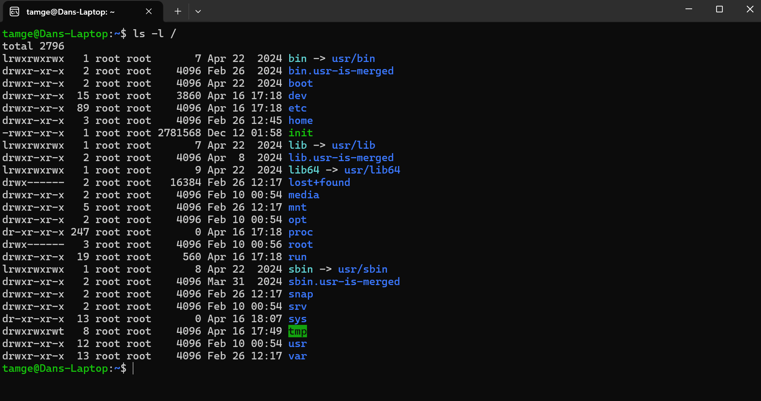
Figure 21: Ubuntu – ls
The next command is the ls command which provides the user with a list of any and all files and or directories under a specific directory [15]. As shown in the screenshot above it also presents the user with file/directory details such as modification dates and times which certainly be useful for file management of a system.

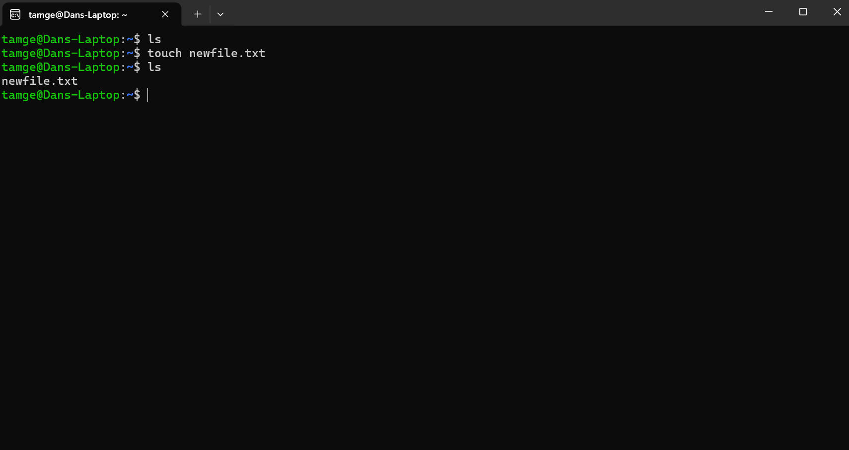
Figure 22: Ubuntu – touch
Following on from the ls command, the touch command is also a useful tool in relation to file management as this allows for empty files such as a .txt file to be created [16]. The file is created in whichever directory you are currently in, which in the case of the screenshot above would be the root directory.

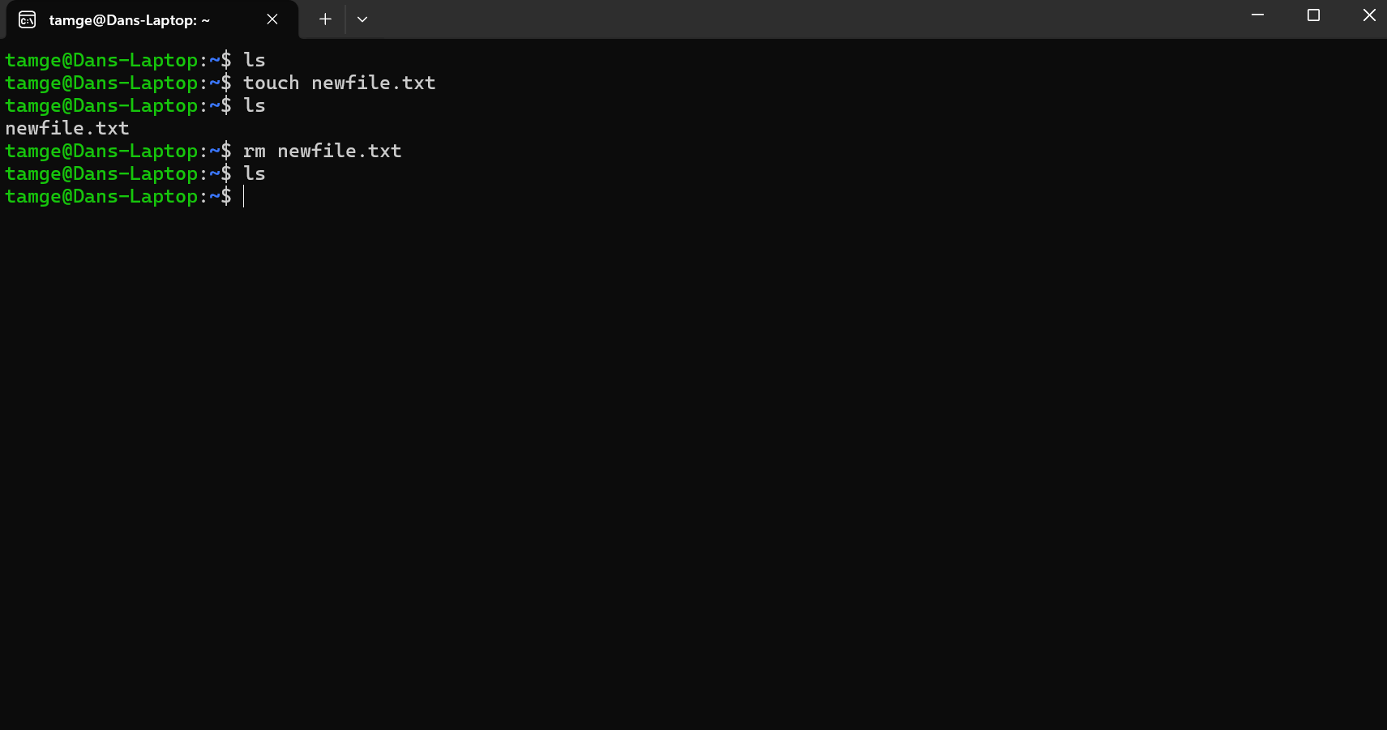
Figure 23: Ubuntu – rm
To remove a file or directory in Linux the command rm would be used followed by the file/directory name a user wanted to delete. The command seems to be the quickest way to delete files/directories and can certainly help users to clean up any bloated folders on a system [17].

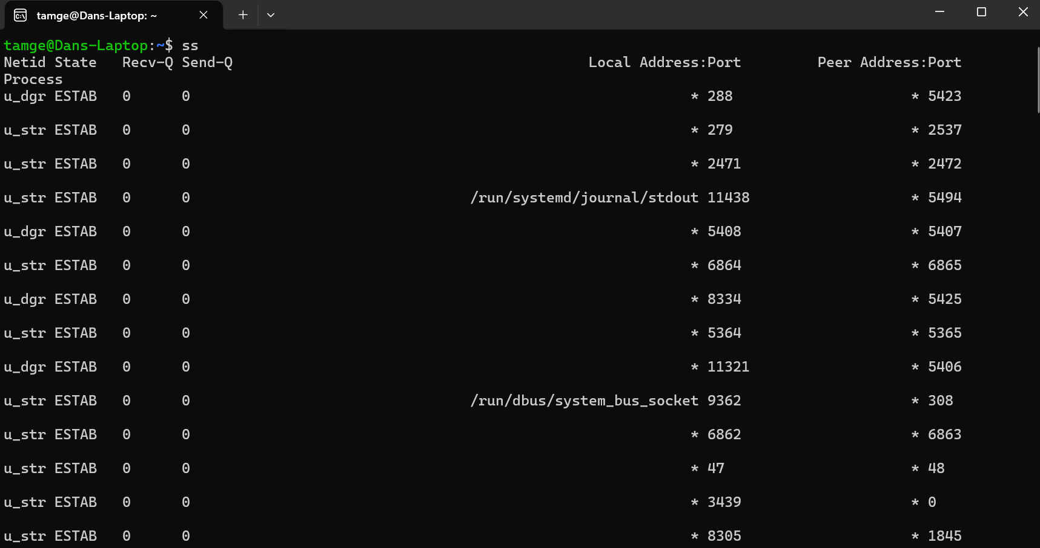
Figure 24: Ubuntu – ss
The ss command works in a similar way to the netstat command where it presents the user with a list of socket information. It’s a powerful tool for networking that can present the user with a multitude of statistics for things such as PACKET, TCP, UDP, DCCP, RAW, and Unix domain sockets [18].

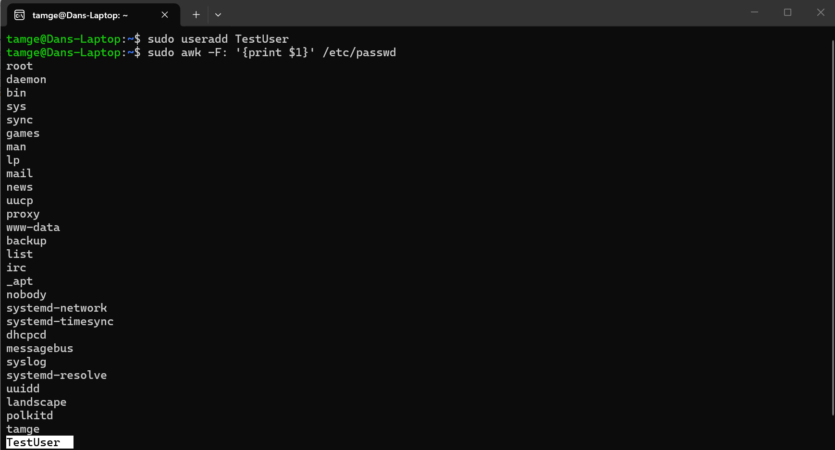
Figure 25: Ubuntu - useradd
This next command is great for user management on a system as it allows an administrative user to add users to a system via the useradd command shown in the above screenshot [19].

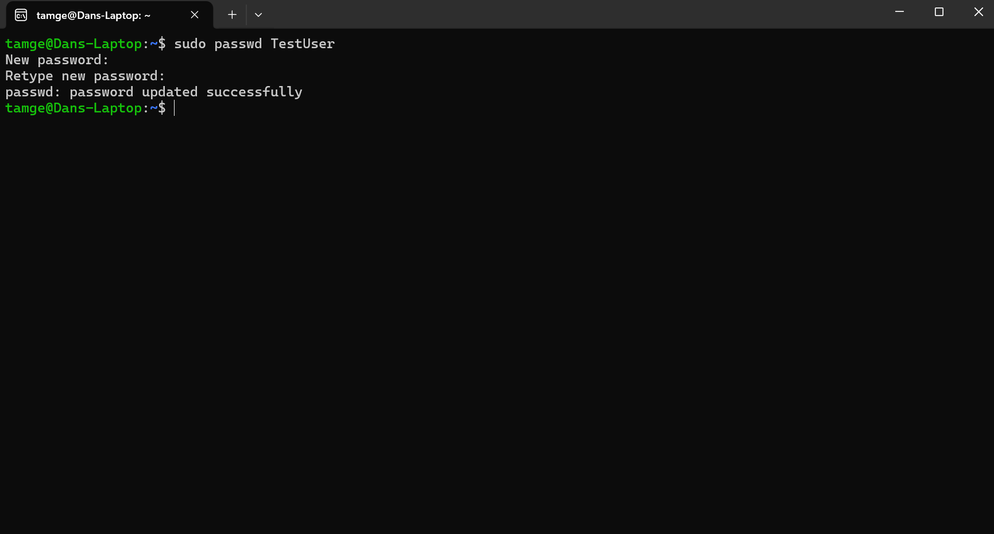
Figure 26: Ubuntu – passwd
Not only can administrators add users via the Ubuntu terminal, but they can also set them a password via the passwd command [19].

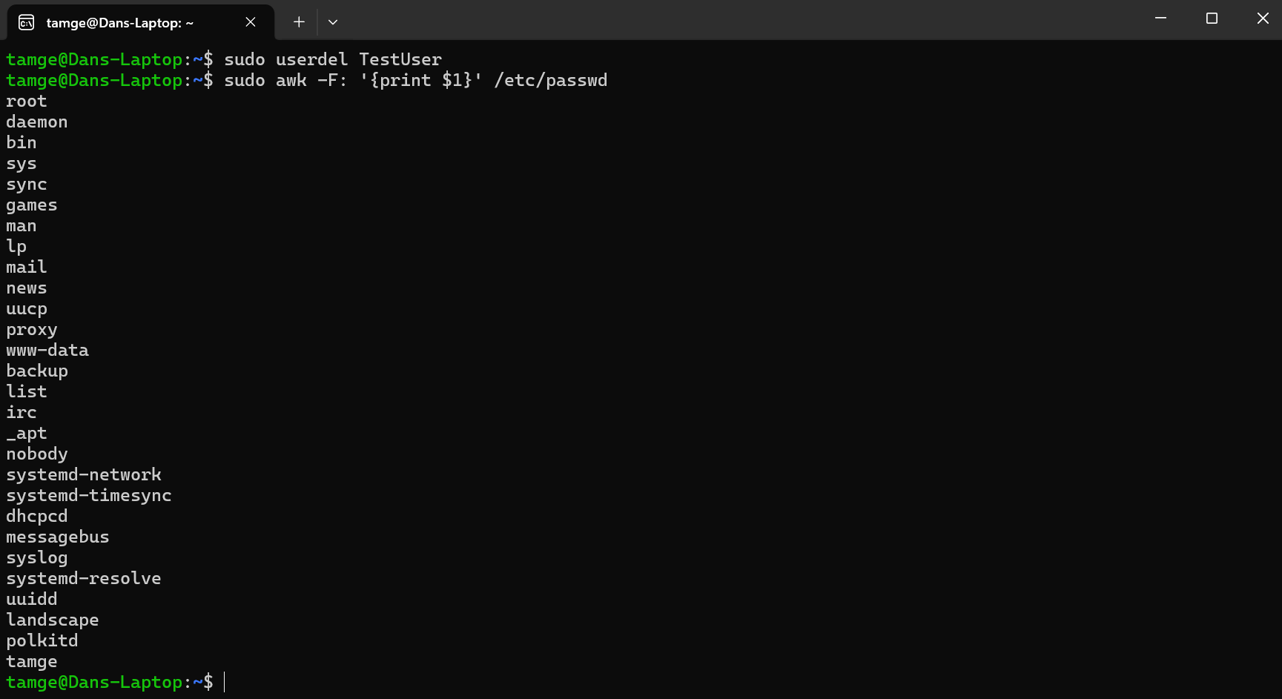
Figure 27: Ubuntu – userdel
Additionally, administrators can remove users on the system via the terminal using the userdel command [19].

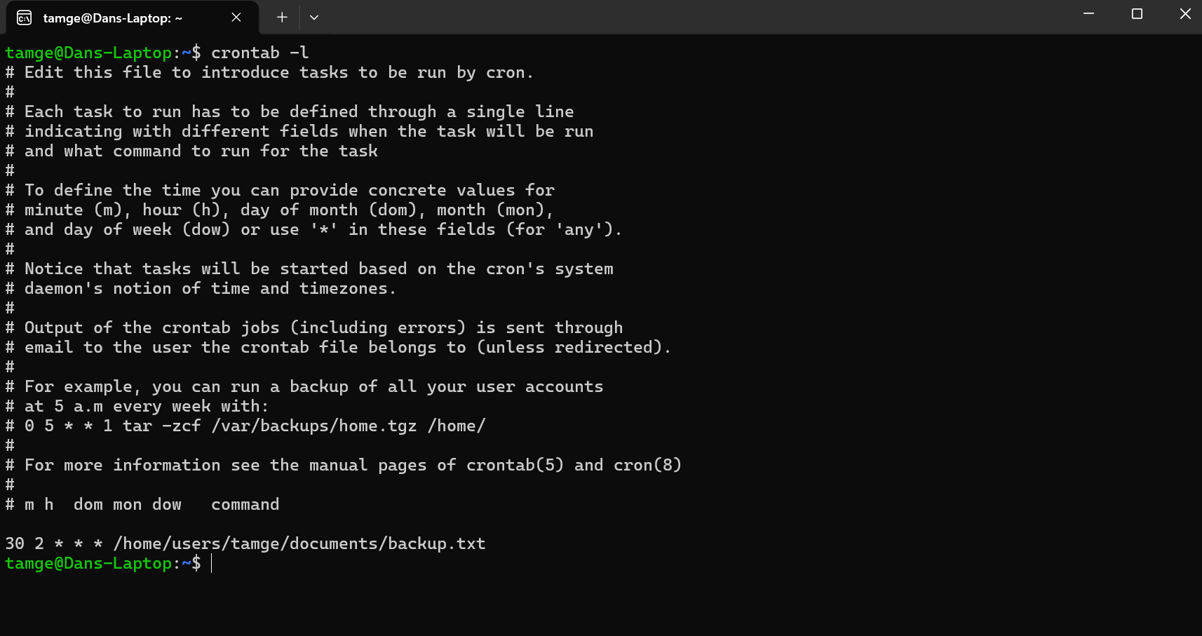
Figure 28: Ubuntu – crontab
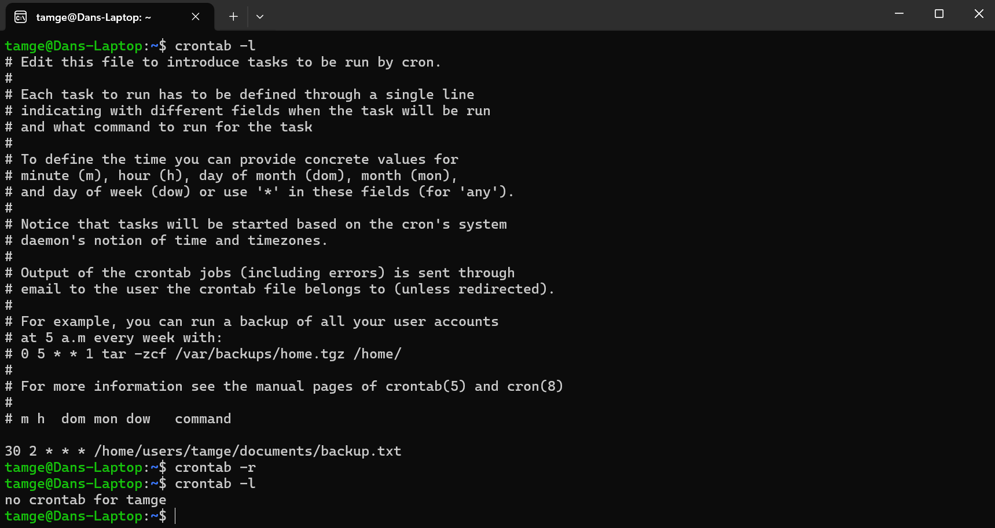
Figure 29: Ubuntu – crontab -r
On the Linux operating system task scheduling can be performed through the use of the crontab command. crontab is a powerful tool that can be used to view, add, edit and even remove tasks scheduled within a file called the cron list. The tasks within the cron list can be customized to run in intervals of minutes, hours, days and even months making it a very powerful tool for systems administrators [20].

5. Use of Windows OS scripts
This section aims to present some of the fundamental concepts of Windows Batch programming within a single number guessing batch script. The program includes a number of features that work together to form a working number guessing game where a user would get three attempts to guess the correct answer which in this case is 7.
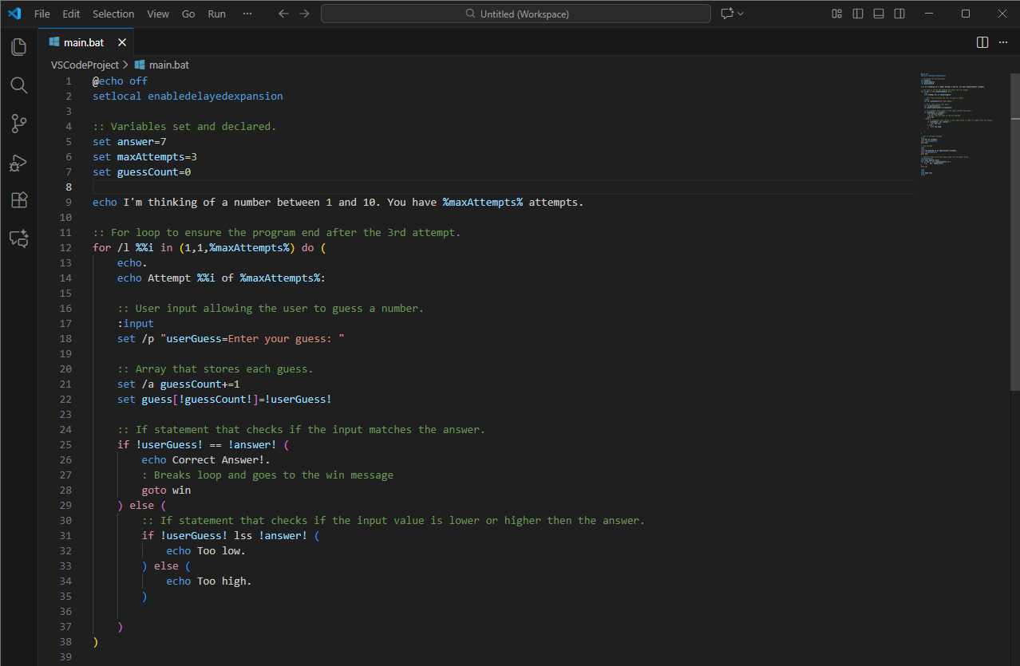
Figure 30: Visual Studio Code - batch program
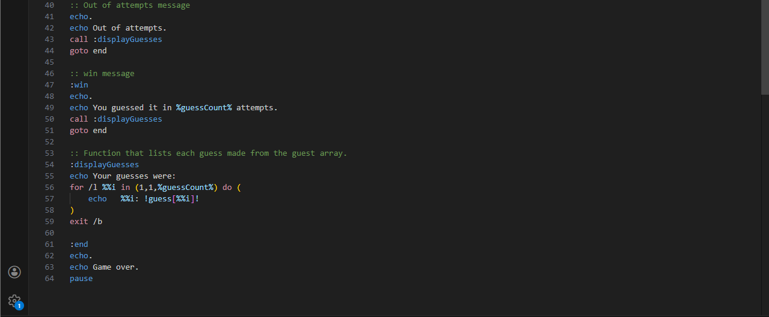
Figure 31: Visual Studio Code - batch program 2

The script first begins with an @echo off command which ensure that no commands are printed and instead only the outputs are printed making for a clean output window [21]. The next command used was setlocal enabledelayedexpansion which allows variables needing to be set within a loop to be set using exclamation marks instead [22].
The next part of the script was to set the variables that would be used throughout such as the maxAttempts variable that determines how many times the user would be able to submit a number.
Once the initial variables have been set and the user message has been printed using the echo function the next step was to set a for /l loop function which allows a program to loop a number of times equal to a range of numbers [23]. In the case of this program the range was 1 to maxAttempts variable which was 3 and so the program would loop 3 times unless finished early with a goto function which when executed jumps the code to the target line [12].
Inside of the for loop the function set /p is used to capture the user input [12] which is essential for the number game to work properly. Once a guess has been made it is added into an array using the function set guess[!guessCount!]=!userGuess! so that they can be printed as a list later in the program once the loop has finished.
Finally for the program to work properly an if command had to be implemented so that conditions such as if the user guessed correctly were checked [24].

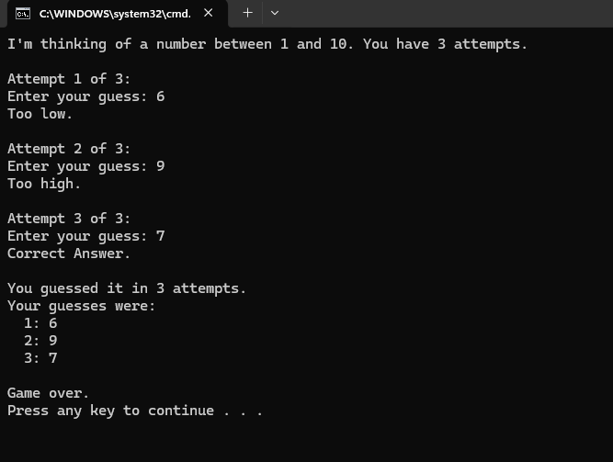
Figure 32: Visual Studio Code - batch program output
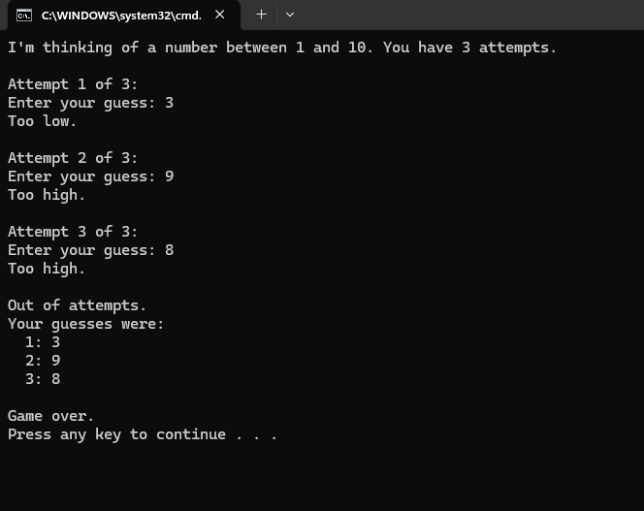
Figure 33: Visual Studio Code - batch program output 2

6. Use of Linux OS scripts
Similar to the previous section this section aims to present some of the fundamental concepts of Linux bash programming within a single number guessing bash script. The program created originally in batch for the previous section was converted into bash to present how the different scripts covers the same core functionality in its own way.
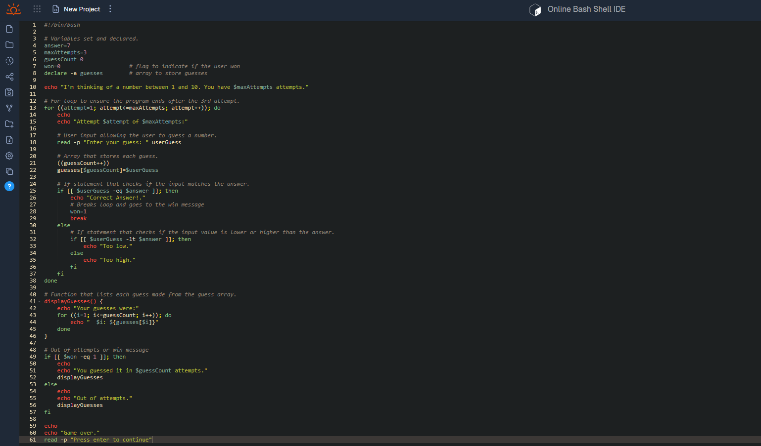
Figure 34: jdoodle.com - bash program
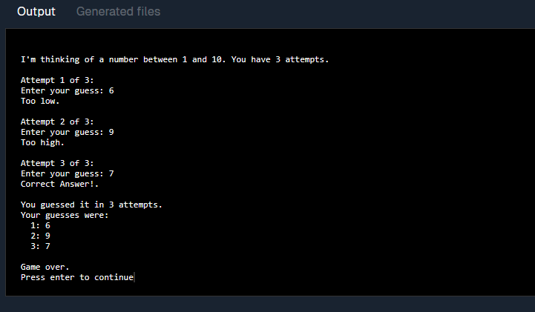
Figure 35: jdoodle.com - bash program output
The script begins with the #!/bin/bash command, which tells the system to use the Bash interpreter when executing the following script. This is essential for ensuring the system runs the following commands correctly within the intended environment [25].
To capture the user input in bash and allow the user to submit their guesses the read -p command was used. Using read -p followed by a string of text to form a message will display a prompt to the user similar to how set /p command works in batch [26]. Once a value is inputted by the user it becomes saved with in the userGuess variable where it will be used later in the program.
Much like the previous script done in batch the bash alternative also uses a for loop that loops until the maxAttempts have been made. It works through the use of a counter variable named attempt that increments with every loop until it reaches or exceeds the target number which in this case is the maxAttempts variable [27].
When the attempts have been made by the user the user input is stored in userGuess which is then stored into a numerically indexed array using the line guesses[$guessCount] = $userGuess similar to how it was written in the batch script program presented in the previous section. The use of an array is perfect for this script as it allows the program to store multiple values in a singular variable which leads to an easier management of data [28].
To ensure the loop does not continue when the user puts in the correct value the use of the break function is implemented inside of the loop to break the loop early as the goto function is not supported within bash script [29]. Additionally, the variable won is set to 1 which denotes that the user has answered correctly.
After the loop, a simple if statement is made to check if the variable won is equal to 1 and depending on the outcome either the win or “Out of attempts” message will be displayed, followed by a function that uses the guesses array to display the previous guesses made by the user.
The structure of this program should hopefully demonstrate the similarity between the batch script and bash script but also present the differences between the two and how both can be used to solve the same problem.

7. Conclusion
The purpose of this report was to record, examine and present several fundamental functions and tools provided to users by general-purpose operating systems such as Windows and Linux. The report covers the general command-line interface (CLI) commands in both Windows and Linux as well as presents the application of both of their scripting languages in use and how they differentiate from each other.
In conclusion, both windows and Linux seem to offer a wide range of uses to a user with their robust CLI commands, front-end applications and scripting environment that seem to greatly support users such as system administration to work efficiently. While the choice between the two operating systems could be looked at in more detail it seems that both systems offer the same core functionality making them both great tools for management and administrative tasks.

8. References

[1] | IBM, “What is an operating system?,” [Online]. Available: https://www.ibm.com/think/topics/operating-systems. [Accessed 12 February 2026].
[2] | BBC, “Functions of operating systems,” [Online]. Available: https://www.bbc.co.uk/bitesize/guides/zkkkw6f/revision/6. [Accessed 12 February 2026].
[3] | geeksforgeeks, “Introduction of Process Management,” 27 February 2026. [Online]. Available: https://www.geeksforgeeks.org/operating-systems/introduction-of-process-management/. [Accessed 12 April 2026].
[4] | geeksforgeeks, “What is Task Manager?,” 23 July 2025. [Online]. Available: https://www.geeksforgeeks.org/techtips/what-is-task-manager/. [Accessed 12 April 2026].
[5] | M. Gareth, “The Function of an Operating System in a Computer Managing Resources,” 09 October 2025. [Online]. Available: https://pcmonster.co.uk/the-function-of-an-operating-system-in-a-computer-managing-resources/#User_Interaction_and_System_Security_Features. [Accessed 12 April 2026].
[6] | Microsoft, “Using Device Manager,” 04 23 2025. [Online]. Available: https://learn.microsoft.com/en-us/windows-hardware/drivers/install/using-device-manager. [Accessed 12 April 2026].
[7] | geeksforgeeks, “Functions of Operating System,” 16 October 2025. [Online]. Available: https://www.geeksforgeeks.org/operating-systems/functions-of-operating-system/. [Accessed 14 April 2026].
[8] | Microsoft, “Stay Protected With the Windows Security App,” [Online]. Available: https://support.microsoft.com/en-us/windows/stay-protected-with-the-windows-security-app-2ae0363d-0ada-c064-8b56-6a39afb6a963. [Accessed 14 April 2026].
[9] | ManageEngine, “What is Windows Event Viewer?,” 07 October 2024. [Online]. Available: https://www.manageengine.com/products/eventlog/kb/windows-event-viewer.html. [Accessed 14 April 2026].
[10] | Microsoft, “System Configuration Tools in Windows,” [Online]. Available: https://support.microsoft.com/en-us/windows/system-configuration-tools-in-windows-f8a49657-b038-43b8-82d3-28bea0c5666b. [Accessed 14 April 2026].
[11] | T. Reese, “PowerShell vs CMD: Key Differences, Use Cases, and Benefits,” 25 August 2025. [Online]. Available: https://netwrix.com/en/resources/blog/powershell-vs-cmd/. [Accessed 15 April 2026].
[12] | Microsoft, “Windows Commands,” [Online]. Available: https://learn.microsoft.com/en-us/windows-server/administration/windows-commands/windows-commands. [Accessed 15 April 2026].
[13] | IONOS, “How to use the Linux ps command to get an overview of running processes,” 11 August 2023. [Online]. Available: https://www.ionos.co.uk/digitalguide/server/configuration/linux-ps-command/. [Accessed 17 April 2026].
[14] | geeksforgeeks, “htop Command in Linux,” 3 April 2026. [Online]. Available: https://www.geeksforgeeks.org/linux-unix/htop-command-in-linux-with-examples/. [Accessed 17 April 2026].
[15] | M. Heller, “9 Ways to Use the Ls Command in Linux,” 11 April 2023. [Online]. Available: https://www.linode.com/docs/guides/ls-command-in-linux/. [Accessed 17 April 2026].
[16] | Paul Hill, “How to Use the Touch Command in Linux,” 29 May 2024. [Online]. Available: https://www.serveracademy.com/blog/how-to-use-the-touch-command-in-linux. [Accessed 17 April 2026].
[17] | IONOS, “How to use the Linux rm command to delete directories and files,” 11 August 2023. [Online]. Available: https://www.ionos.co.uk/digitalguide/server/configuration/linux-rm-command/. [Accessed 17 April 2026].
[18] | Linux, “An Introduction to the ss Command,” 22 January 2019. [Online]. Available: https://www.linux.com/topic/networking/introduction-ss-command/. [Accessed 17 April 2026].
[19] | Dejan Panovski, “How to Create Users in Linux (useradd Command),” 10 March 2026. [Online]. Available: https://linuxize.com/post/how-to-create-users-in-linux-using-the-useradd-command/. [Accessed 17 April 2026].
[20] | Computer Hope, “Linux crontab command,” 6 January 2025. [Online]. Available: https://www.computerhope.com/unix/ucrontab.htm. [Accessed 17 April 2026].
[21] | geeksforgeeks, “Batch Script - Echo Command,” 24 April 2023. [Online]. Available: https://www.geeksforgeeks.org/linux-unix/batch-script-echo-command/. [Accessed 17 April 2026].
[22] | “EnableDelayedExpansion,” [Online]. Available: https://ss64.com/nt/delayedexpansion.html. [Accessed 17 April 2026].
[23] | tutorialspoint, “Batch Script - Looping through Ranges,” [Online]. Available: https://www.tutorialspoint.com/batch_script/batch_script_looping_through_ranges.htm. [Accessed 18 April 2026].
[24] | tutorialspoint, “Batch Script - If Statement,” [Online]. Available: https://www.tutorialspoint.com/batch_script/batch_script_if_statement.htm. [Accessed 18 April 2026].
[25] | geeksforgeeks, “Shell Scripting – Understanding Shebang (#!/bin/bash),” 23 Febuary 2026. [Online]. Available: https://www.geeksforgeeks.org/linux-unix/shell-scripting-define-bin-bash/. [Accessed 18 April 2026].
[26] | D. Panovski, “Bash read Command,” 12 March 2026. [Online]. Available: https://linuxize.com/post/bash-read/. [Accessed 18 April 2026].
[27] | Dejan Panovski, “Bash For Loop: Syntax and Examples,” 2 March 2026. [Online]. Available: https://linuxize.com/post/bash-for-loop/. [Accessed 18 April 2026].
[28] | w3schools, “Bash Arrays,” [Online]. Available: https://www.w3schools.com/bash/bash_arrays.php. [Accessed 18 April 2026].
[29] | baeldung, “Flow Control in Bash Without Goto,” 18 March 2024. [Online]. Available: https://www.baeldung.com/linux/flow-control-without-goto. [Accessed 18 April 2026].
[30] | theknowledgeacademy, “Types of Operating Systems(OS): An Overview,” 25 February 2026. [Online]. Available: https://www.theknowledgeacademy.com/blog/types-of-operating-systems/. [Accessed 17 April 2026].
[31] | geeksforgeeks, “Types of Operating Systems,” 14 April 2026. [Online]. Available: https://www.geeksforgeeks.org/operating-systems/types-of-operating-systems/. [Accessed 17 April 2026].
[32] | A. Mahamuni, “Batch Processing Operating System,” 14 October 2023. [Online]. Available: https://www.scaler.com/topics/batch-processing-operating-systems/. [Accessed 17 April 2026].
[33] | Microsoft, “What is an operating system?,” 29 January 2026. [Online]. Available: https://www.microsoft.com/en-us/windows/learning-center/what-is-an-operating-system. [Accessed 18 April 2026].
[34] | Michael Fedar, “What is an operating system?,” 20 March 2026. [Online]. Available: https://www.phoenix.edu/articles/it/what-are-the-top-operating-systems.html. [Accessed 18 April 2026].
[35] | M. Rua, “Most used operating systems today,” 22 November 2024. [Online]. Available: https://roilab.es/en/blog/most-used-operating-systems/#windows-dominates-the-personal-computer-market. [Accessed 18 April 2026].
[36] | CasbayMY, “Top 5 Most Popular OS,” [Online]. Available: https://www.casbay.com.my/blog/tips-sharing/top-5-most-popular-os. [Accessed 18 April 2026].

9. Appendices

Appendix A. Tutorial Activity - What are the types of OS used today?
Over time, various operating systems have been developed to meet a variety of needs. They have evolved for specific roles to address specific needs such as handling a task one at a time to managing multiple tasks simultaneously. There seems to be around 7 primary operating system types used today categorised based on functions [30] [31].
Batch operating system: This system is used to convert large groups of similar jobs into batches automatically. Jobs were collected, queued and executed one after another sequentially. This operating system is useful as it minimized the need for user interaction with the computer to perform repetitive tasks as well as allows multiple users to work on the same system without too much disruption [30] [31] [32].
Multi-Programming system: In this system multiple programs run simultaneously in memory using the resources of the system much more efficiently as well as improving the overall performance of the system [30] [31].
Multi-Processing system: The use of this operating system is to provide faster processing with higher reliability. It does this using multiple CPUs rather than one singular CPU like other operating systems use. Due to the need of extra processers it does make the architecture much more complex as well as increases the cost of the system as a whole [30] [31].
Multi-Tasking Operating System: Also known as a time-sharing operating system is used to allocate specific time limits to each task which allows the system to switch and prioritise different tasks giving it an advantage over other types of operating systems as it can prioritise different tasks simultaneously. Due to the popularity of this system, it was made standard in modern operating systems as it can allow users to switch between applications [30].
Distributed Operating System: Connecting multiple independent computers through a shared network it allows multiple machines with their own CPU and memory to work in unison as a single unit allowing for an easily scalable system [31].
Network Operating System: As the name suggests this operating system is commonly used for networking such as server management. Designed to manage data, users, security, applications and other essential network functions [30] [31].
Real-Time Operating System: This last operating system helps serve real-time systems used when timing is essential and strict. It is apparently one of the best operating systems in use today as it can maximise the efficiency of devices and systems to ensure any time restraints are met [30] [31].

Appendix B. Lecture Activity Questions
What is an Operating System and what does it do?
An Operating System is a software that allows a computer to manage a number of things such as applications, hardware devices, files and even security while typically acting as a interface between a user and the computer [1] [33].
What are the 5 most commonly used operating systems today?
It seems that the most commonly used operating systems today are Microsoft Windows, MacOS, AndroidOS, Linux and IOS [34] [35] [36]

Appendix C. Evidence of engagement with online course

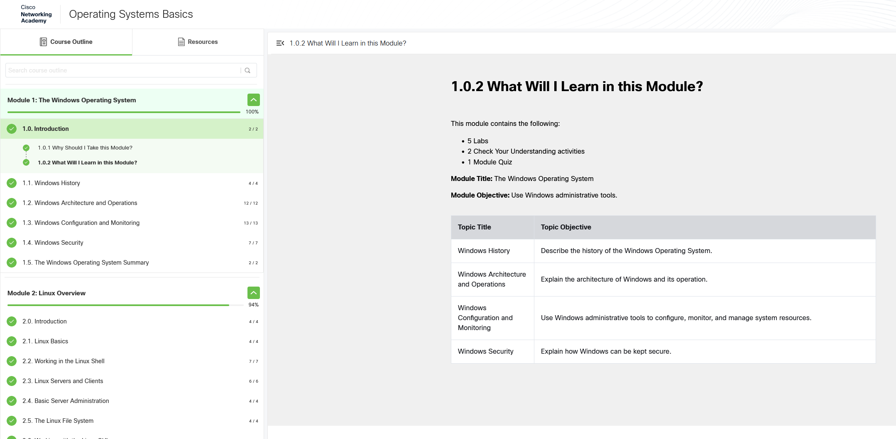
Figure 36: Online Course Evidence 1

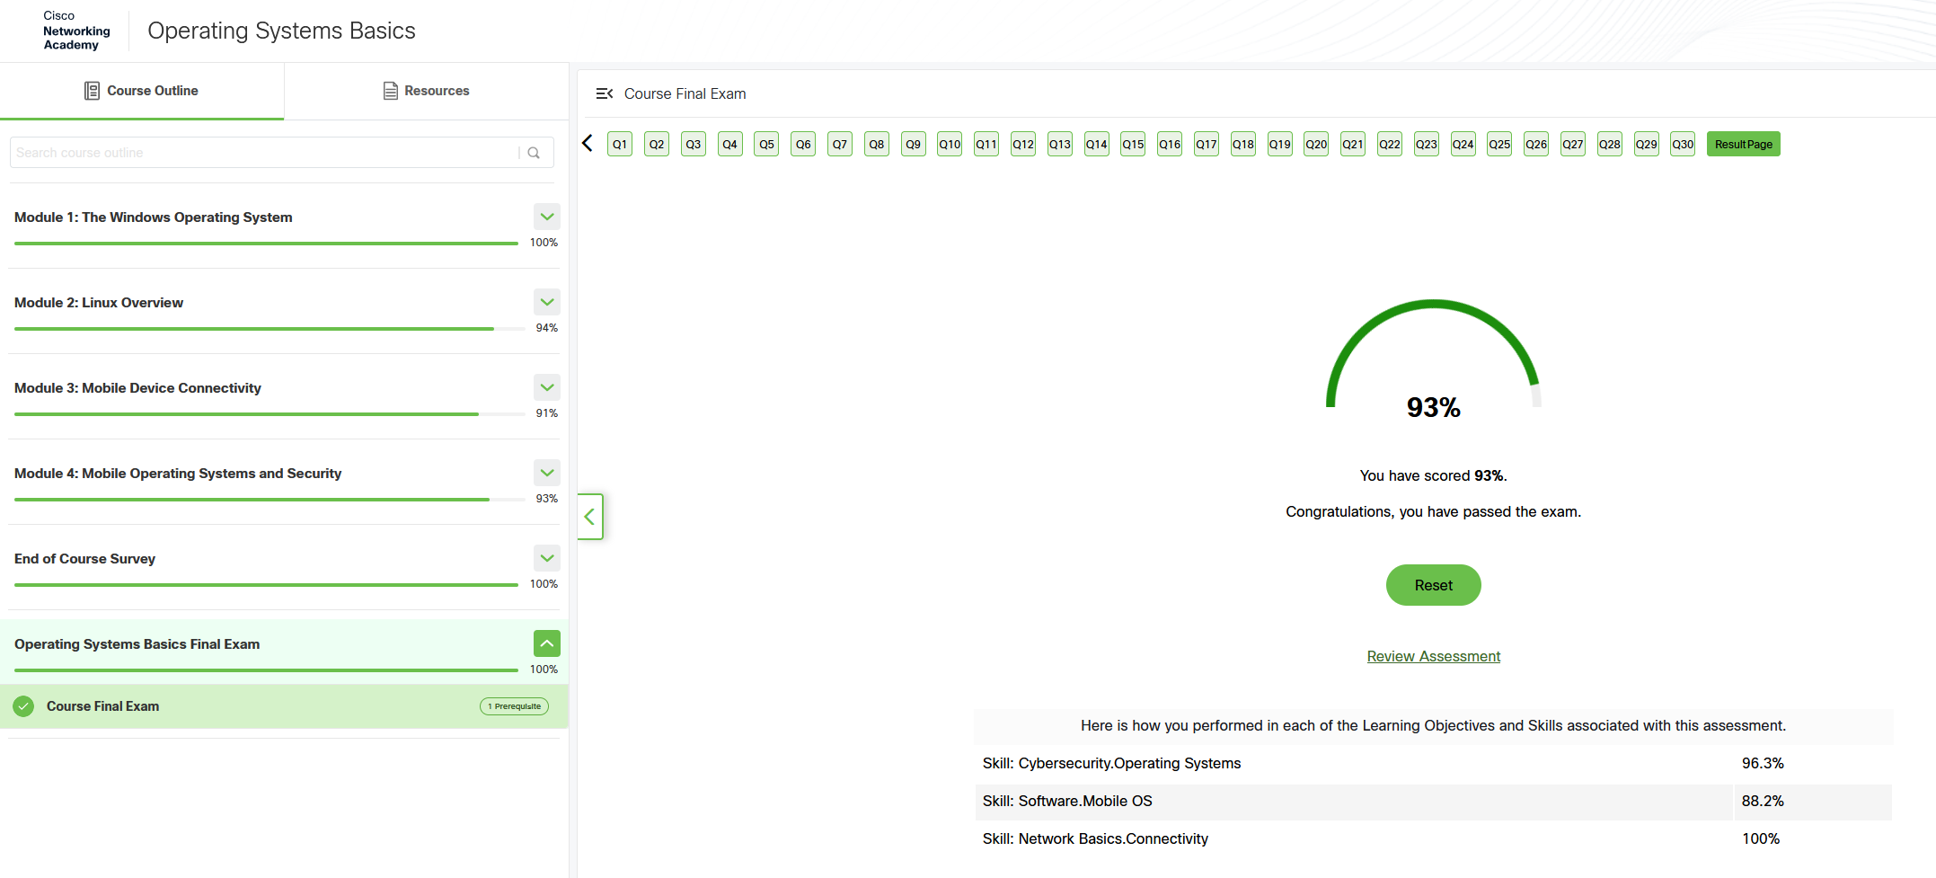
Figure 37: Online Course Evidence 2

