UNIVERSITY OF WALES TRINITY SAINT DAVID
EMERGENT LEADERSHIP SKILLS IN THE WORKPLACE
BMSW6101
STACEY WALLER
1911557
LECTURE
SUJEEWA HERATH

List of Table and Diagrams
Effective Leadership Styles……………………………………………………………5-6
Agile leader five components………………………………………………………… 8-9
Leadership ethics in practices………………………………………………………….10
Ethical leadership style questionnaire…………………………………………………12
Conceptualizing leadership Questionnaire……………………………………………13
Leadership style Questionnaire………………………………………………………...13
Task and Relationship Questionnaire…………………………………………………14
Table of Content
Cover Page………………………………………………………………………...…………1
Table of Content………………………………………………………………...……………2
Introduction…………………………………………………………………...………………3
Leadership………………………………………………………………...………………….4
Management……………………………………………………………...………………….4
Difference between Leadership and Management ………………………………………4
Effective Leadership Style…………………………………………………………………5-6
Effective Leadership Skills…………………………………………………………………6-7
Challenges to Leadership in uncertain times such as in COVID-19 errand
other emergencies………………………………………………………………………….7-8
The Agile Leader…………………………………………………………………………….8-9
Ethical Leadership & Practices of Ethics….………………………………………………9-10
Reflection Report…………………………………………………………………………...11-14
Conclusion……………………………………………………………………………………15
Reference list…………………………………………………………………………………16-17
INTRODUCTION
This report on emergent leadership, management and the styles, skills, and the effectiveness in organizations, challenges in leadership in uncertain, times such as dealing with COVID-19 and other emergency the effectiveness of ethical leadership concerning the NHS and the leadership within that organization.
The report will focus on the difference between leadership and management and how they are essential for the workplace in the 21st century.
The report will compare the different leadership styles in a table autocratic, democratic, laissez-faire, transactional and transformational to see how they compare with each other.
This report will show a reflective report on my learning experience on leadership and management skills for the workplace. Leadership styles, skills, management and finish with a conclusion for both parts of the report and reference list.

LEADERSHIP
According to (Khan, 2015) Leadership is an individual relationship where one individual coordinates, organizes and regulates others in the execution of a typical errand. (Khan, 2015). This is times thought about the old-style approach (Khan, 2015). Leadership is one of the world's most established distractions, filling in as both a hotly debated issue and a significant driver of development for millennia (Bass, 1990). There is progressively a requirement for more leadership at all levels of the association and to satisfy that need, managers need to turn into better in leaders (Toor, Ofori, 2008).

MANAGEMENT
Management is a genuinely new peculiarity (Kotterman, 2006). According to (Armstrong, 2012). Management is people oriented, “about overseeing individuals” ‘The word the executives is gotten from the Italian action word maneggiare which means to deal with a horse (Morris, 2022). Management is to carried request and consistency to the considerable number of work environment processes. Since that time, the obligations of working environment the board and its related cycles have been explored, refined, and worked on fundamentally in the previous hundred years (Kotterman, 2006).

DIFFERENCE BETWEEN LEADERSHIP AND MANAGEMENT
They are differences when it comes to leadership and management, yet they can get confused by individual who use the term in organisations overlapping leadership with management vice versa. While leaders are as magnetic and often respected and held in high regard, manages regularly are considered the association's slave drivers with a whip in one hand and a bullhorn for shouting out orders in the other hand (Kotterman, 2006). "Leadership" is different from “management” simply realize it instinctively yet have not had the option to obviously grasp this distinction. These are two completely various capabilities considering their hidden ways of thinking, capabilities, and results. Additionally, Leaders and management are not similar individuals (Toor, Ofori, 2008). Leaders are more defiant in nature while management like to adjust to the authoritative standards, rules, and ordered progression (Toor, Ofori, 2008). The board is productivity in moving up in progress; authority decides if the stepping stool is resting up against the right wall (Toor, Ofori, 2008).
EFFECTIVE LEADERSHIP STYLES
That all leaders need to have a balance when it comes to effective leadership democratic, transformational leadership would be best suited for most situation. Autocratic, democratic, laissez-faire, transformational and transactional leadership styles and comparing each one against each other to see which is the most effective from organizations situations. Leaders who dismissal culture, especially during intercultural associations, will antagonistically influence the viability of their initiative. Alternately, leaders who are socially cognisant and act in agreement therewith are going to be progressively practical.
Below is a table of Effective Leadership Styles.
Autocratic | Democratic | Laissez-Faire | Transactional | Transformational
Has adverse results. | Directs as opposed to coordinates. | The absence of leadership from above can bring about disappointment that prods devotees to act and make positive results. | Contracts trade of remunerations for exertion, guarantees prizes for good execution, perceives achievements | Gives vision and feeling of mission, imparts pride, gains regard and trust.
Results can now and then be positive. | Directs as opposed to coordinates. | Bunch individuals can feel aimless | Watches and looks for deviations from rules and norms, makes a remedial move. | Conveys exclusive requirements, uses images to concentrate endeavours, communicates significant purposes  in straightforward ways.
They do not support correspondence among individuals; all things being equal, they would rather that correspondence be coordinated to them. | Friendliness and common commendation. | Truly little is achieved. Since individuals are aimless and at a loss to know what to do, they will quite often sit idle | Mediates if norms are not met | Advances insight, discernment, and cautious critical thinking.
Correspondence is top down. | More grounded specialist inspiration and innovation | Individuals who are self-starters, who succeed at individualized errands and do not need continuous criticism, may incline toward working under laissez-faire. |  | Offers individual consideration, treats every worker exclusively, mentors, exhorts.
University of Wales Trinity Saint David, (2022).

EFFECTIVE LEADERSHIP SKILLS
Leaders are integral to authoritative accomplishment (Araujo-Cabrera, Suarez-Acosta and Aguiar Quintana, 2016) (Muchiri et al., 2011) (Murschetz, 2005). after, they must be compelling. Nonetheless, an absence of conviction wins about what is vital for one to be an effective leader (Rosete and Ciarrochi, 2005). This present circumstance is worsened in that there is 'neither an acknowledged way to deal with nor meaning of leadership effectiveness (Mesterova et al, 2015). As needs be, effective leadership is appeared as a general judgment predicated upon both depiction and assessed attributes (Oyinlade, 2006). Effective leadership skill leaders, understanding what will motivate their team members to get the best results from their team members. Effective leadership skills Leaders’ abilities allude to gotten capabilities that leaders can show in execution of any situation. “Can assume responsibility, pass their vision on to their group, get their colleagues right into it and guarantee that they accomplish their concurred objectives” (Armstrong, 2012). For a leader to lead people they need to have certain leadership skills. The three main skills requirements for a leader to have effective leadership skills are as follows. ADMINISTRATIVE within this skill set leaders are excellent in overseeing individuals, overseeing assets, and showing specialized capability (University Wales Trinity Saint David, 2022). INTERPERSONAL skills focus on leaders being socially discerning, showing the ability to understand anyone on a deeper level, overseeing relational conflict. (University Wales Trinity Saint David, 2022). It shows up then that effective leaders are the people who stand for interpersonal aptitudes that allow them to shape strong associations with a variety of people through which they enhance the last possibility as per assumptions which, thus, prompts objective achievement (Solomon and Steyn, 2017). CONCEPTUAL skills that leaders should posse for effective leadership in having the ability to create visions for people.
CHALLENGES TO LEADERSHIP IN UNCERTAIN TIMES SUCH AS IN COVID-19 ERA AND OTHER EMERGENCIES
Conveyance of each part of care by all clinical and non-clinical divisions in the UK's NHS is being reconsidered and in a general sense revamped in the assumption for an up-and-coming flood of patients with Coronavirus 19.1. Modelling of the flare-up expects a disease casualty proportion of 0.9% and a clinic confirmation pace of 4.4%, with 30% of those conceded requiring critical care or extracorporeal membrane oxygenation (Willan et al, 2020). The challenges in leadership in COVID-19 times were keeping the public, key workers safe. Especially the NHS staff when the NHS was under immerse pressure from Covid-19 sick individuals and the already clinical vulnerable individuals already occupying hospital beds all over the UK. Clinical beds and basic consideration limit require significant development, and this is now being empowered by dropping elective work, reusing working medical theatres, and appointing use of private facilities. Expanded help for release of existing patients to the local area is likewise in progress. Whenever the situation allows, arrangements are being moved to phone or video calls to keep away from pointless visits (Willan et al, 2020). To ease these challenges and to help the clinical exercises, clinics ought to consider getting groups of profoundly prepared experts, like project managers, from outside the NHS to work close by current directors and managers. They would have the aptitude to convey operations answers for clinics answering the epidemic, empowering more productive medical services conveyance (Willan, et al, (2020).
THE AGILE LEADER
There are five credits that are most unmistakable in depicting how associations make the progress to be an agile and client driven association in this computerized age (Hayward, 2018).
Below is Agile leader five components.
Agility
Collaborating
Devolved decision making

Purpose and direction
Authenticity

The components of the connected leadership connected leaders lead with a profound feeling of direction and clearness to be confident in the future. Connected leaders are legitimate, open, driven by values that rouse certainty and responsibility from others. Connected leaders are straightforward in their relationship with partners fabricate trust and a positive culture. Connected leaders third component is that leaders have confidence in one another and effectively decay navigation as near the client as could really be expected. Connected leaders energize teaming up across the association with individuals cooperating as groups to accomplish shared results and break down silos. At last Connected pioneers are agile empowering others to adjust to changing conditions through trial-and-error learning and steady improvement. Through these associations they are making a dexterous business ready to adjust effectively to changing conditions. (Hayward, 2018). The agile leaders enable and disruptive to be compelling forerunners in a computerized world, we should be both an empowering influence and a disruptor (Hayward, 2018).
ENABLER
Learning dexterity
Clearness of bearing
Sympathy and trust
Engaging
Cooperating
DISRUPTOR
Nicely unequivocal
Carefully proficient
Scrutinizing the state of affairs
Making better approaches for thinking
Near client patterns
(Hayward, 2018).
ETHICAL LEADERSHIP
Having ethical leaders in organisations is excellent for the business and great for the sake of the people from the leadership of that person. Ethical leaders will always make the right decision and put others first.
Since COVID-19 New Zealand has had success in the cases of COVID-19 to near-zero with the efforts of Jacinda Arden, Prime Minister of New Zealand. Arden shows she is excellent in leading by being ethical in her approach to COVID-19 issues. Arden shows courageous, compassion in her leadership style (Moore, 2020).
The six main factors of ethical leadership that a leader should have. Respect will come from others when they see the worth from the leader. Trustworthiness is when individuals can totally trust the leader in the things that the do and speak (University Wales Trinity Saint David, 2022). Citizenship may or must play a part of where the leader originates from in that the leader exposed to harsher times in the country from where they originate from which to the country, they resign to for the leadership to be effective in the leadership what is being executed (University Wales Trinity Saint David, 2022). Caring leaders are beneficial for the employees and for the leader and for the sake of the organisation is wanting what is best for all concerned (University Wales Trinity Saint David, 2022). Fairness in ethical leadership will see good leaders in not taking sides, to see the fairness what would resolve with good leadership (University Wales Trinity Saint David, 2022). Responsibility ethical leadership in the leader taking full responsibility for the action the leader has suggested to their employees (University Wales Trinity Saint David, 2022).

Practice of Ethics
Ethical leaders in practices must show from their actions respect to serve others to show justice in the actions. The goals of leaders to be able to influence their follows to seek out worthy goals to maintain goals agreeable by all the team members. Honesty of the leader will create trust among the leaders’ followers being dishonesty will create resentment and distrust among the leaders’ followers. Power of leaders is to affect others by the power they obtain leaders can use the power in a positive or negative way, power leaders’ practices be fair, caring, vigilant and aware of their leadership

Below is a diagram of leadership ethics in practices.

REFECTIVE REPORT
Reflecting on my journey on BA Leadership and Management skills for the workplace Level 6 and learning about leadership and management and how it has benefits for myself, organization in hiring individuals with theses styles, skill sets, finding out about my own leadership, management, style, skills being more autocratic, task-orientation and relationship-orientation based on questionnaire I took. With the results being a surprising to me. Having a balance in leadership styles democratic, autocratic, laissez-faire, transactional, and transformational is important to my growth of understanding leadership and how to progress in my own business, organizations, and with my own team members so on reflection I am trying to turn my autocratic into democratic and transformational will help me succeed in my chosen field of career. Looking back on my journey leaders can be made as opposed to being born a leader, reflecting on my own leadership, how I can be charismatic which is what a good leader needs to be. Leaders and my own style looking back when I needed to lead my team to be successful in the execution of the project I was understanding, charismatic, open-minded, as a craving to pay attention to more than one side of an issue, to focus entirely on elective perspectives, and to perceive that even the firmest convictions might be addressed (Densten and Gray, 2001). Within my own leadership attribute, I see I have leadership responsibility. Responsibility as the craving to effectively look for truth and apply data acquired to issue circumstances (Densten and Gray, 2001). Wholeheartedness as the mentality by which people can conquer fears and vulnerabilities to roll out significant improvement and to assess themselves, associations, and society (Densten and Gray, 2001). Taking a critical reflection of myself for myself, on my own can be frustrating, difficult I continue to press on looking for ways for me to progress my own unique leadership having an excellent ethical approach in my leadership will have a great achievement. Based on my ethical leadership style questionnaire my leadership style is more duty ethics implying I keep a bunch of moral guidelines and do what is anticipated of me while confronting a moral problem. I centre it around satisfying my moral commitments and carrying out my responsibility (Ethical leadership style questionnaire, 2022). Reflecting on my ethical leadership compared to Jacinda Arden, New Zealand Prime Minister and her having compassion I can see I have compassion and courageous in my ethical approach. Compassion in my approach being able to understand how people feel. My ethical leadership shows I also possess utilitarian ethics it implies that I attempt to do what is best for the great of people in general while confronting a moral quandary. I centre around what will bring about satisfaction for the biggest number of people (Ethical leadership style questionnaire, 2022). My leadership style in ethical is low on justice implying that I centre around treating others decently while confronting a moral issue. I attempt to ensure the advantages and weights of choices are shared even-handedly between everybody concerned.
Below my Ethical leadership style questionnaire.
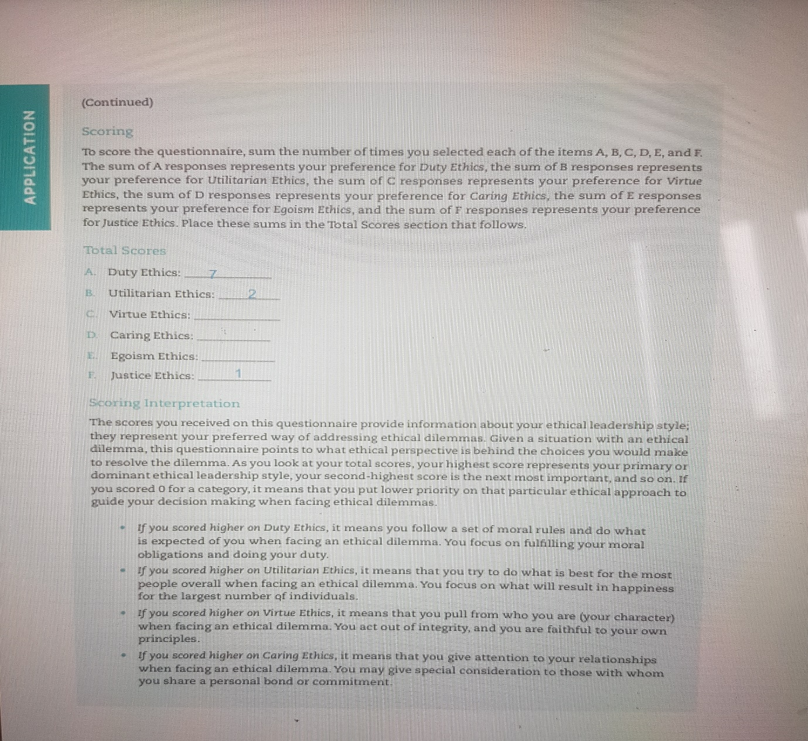University of Wales Trinity Saint David, (2022).
Reflecting on the questionnaire’s I have took over the last ten weeks of my academic studies on leadership and management my own leadership styles, skills my leadership style based on conceptualizing leadership questionnaire I scored high in the ability skills emphasis mid scoring for the trait, process emphasis while behaviour was third and relationship scoring the lowest score. Reflecting on my experience, comparing to my ethical leadership where I have compassioned my score for relationship emphasis could do with becoming higher on par with ability, skills emphasis making my ability to lead effective in all situations that may arise in organizations or my own business.
Below is my conceptualizing leadership questionnaire
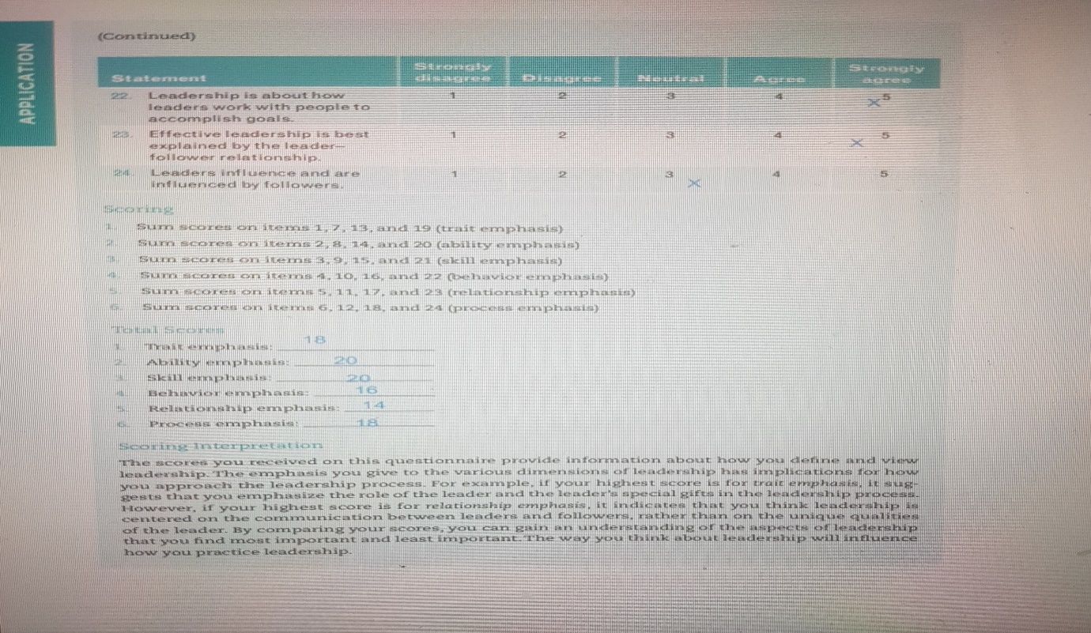University of Wales Trinity Saint David, (2022).
Reflecting on my leadership style on the three main styles my score is high on authoritarian democratic in the middle of my style and laissez-faire scored the lowest reflecting my autocratic styles I need to be more democratic in my approach to my leadership style to be more effective.
Below is my leadership style questionnaire
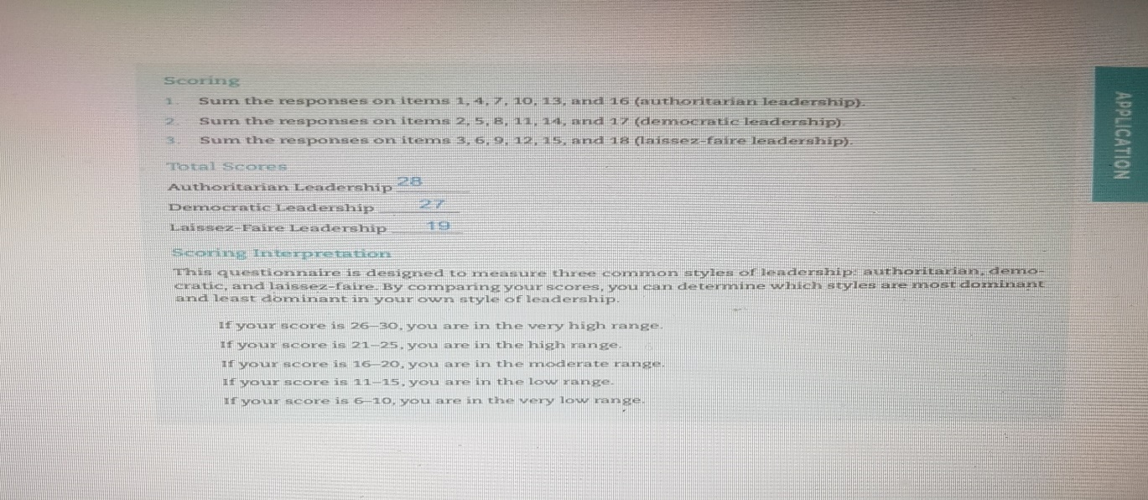 University of Wales Trinity Saint David, (2022).
Reflecting on my own leadership styles task, relationship scoring high in the task score and scoring moderate in relationship, throughout this academic experience and all the different
questionnaires and research I have done it is a continuous learning factor for effectiveness for my leadership styles. When it comes to task I will generally focus on objective achievement and to some degree less thoughtfulness regarding individuals related matters (University of Wales Trinity Saint David, 2022).
Below is task and relationship questionnaire.
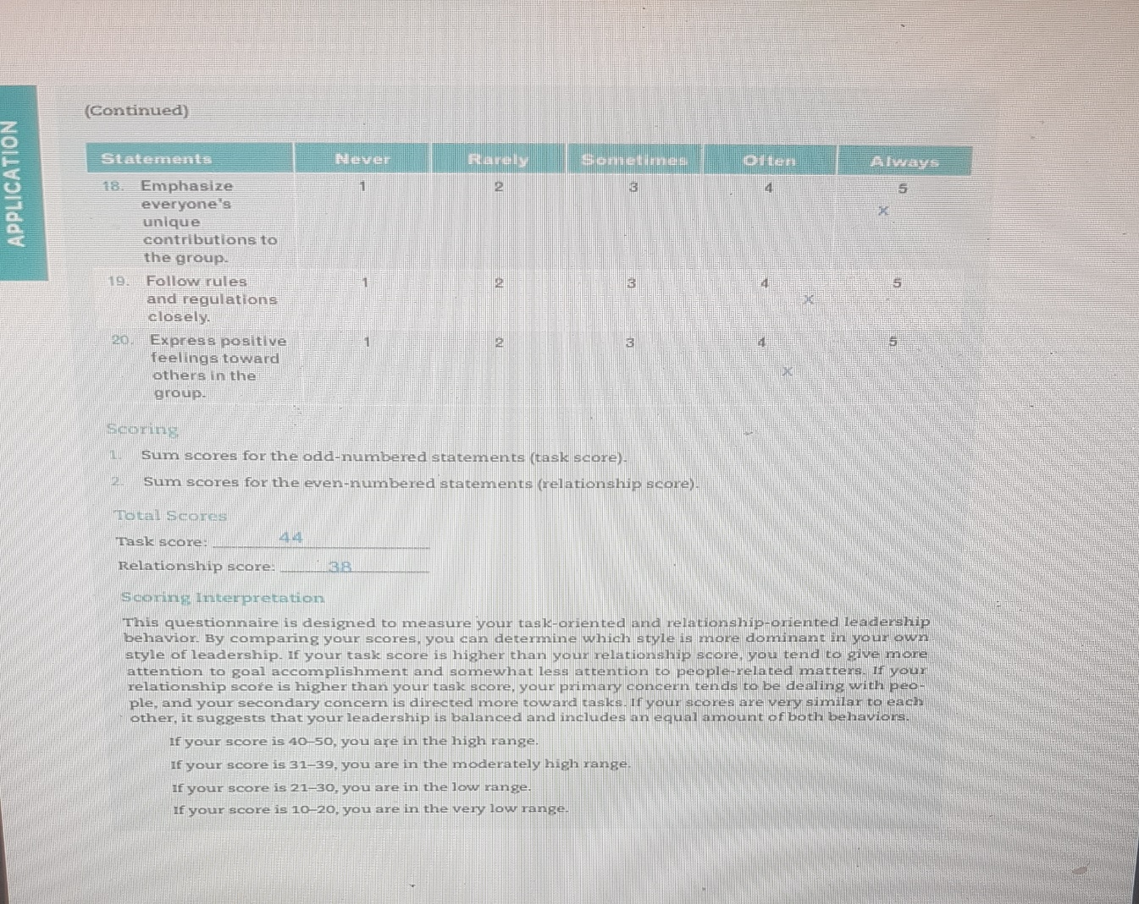University of Wales Trinity Saint David, (2022),

CONCLUSION
TASK 1
Leadership style, skills and all the unique style one can possess is having that overall balance for effectiveness of the leadership the is no best one style fit all or one style fits all situations. So, for leaders to be effective and how to accomplish change they would require a bit of all leadership styles, skills, to be able to communicate with all cultures. Having cultural awareness skills also would be beneficial to followers and the leader himself. Leaders need to be agile in the leadership style in the forever evolving change of the world.
CONSLUSION
TASK 2
Reflecting on my academic learning on my own leadership styles and how they compare to other leaders and more famous leaders, the saying leaders are born leaders can be made I am that person. Trying to get my leadership style at the most effective for me and my business. To possess the best quality of the different leadership styles, skills to be agile in my business and leadership style to keep up with change and to change at a fast speed for success.

References
1 Adair, J. (2013). Develop your Leadership Skills: Kogan Page vol 11 page 73
2 Allafchi, N. (2017). Effect of Democratic leadership Style on Management of Communication with Customers in Melli Banks of Hamedan. International Journal of Culture and Social Studies (IntJCSS), 3(2), 168-179.
3 BASS, B. (1990). From Transactional to Transformational Leadership:. Learning to Share the Vision, 19-31.
4 Densten, I. L. (2001). Leadership Development and Reflection: What is the connection? . The International Journal of Educational Management , 19-124.
5 Hayward, S. (2018). The Agile Leader How To Create An Agile Business in dIgital age. London: Kogan Page.
6 Huston, T. (2016). Research: We Are Way Harder on Female Leaders Who Make Bad Calls. New York: Havard Business Publisher.
7 Insigths, I. B. (2020, July 02). Are Ethical Leaders Good For Business? Retrieved June 23, 2022, from Forbes.com: https://www.forbes.com/sites/imperialinsights/2020/07/02/are-ethical-leaders-good-for-business/#908f60e696a1
8 Khan, M. (2015). The Styles of Leadership: A Critical Review. Public Policy and Administration Research, 5(3), 87-92.
9 Mesterova, J. P. (2015). Relationships Between Self-Efficacy, Transformational Leadership and Leader Effectiveness. Journal of Advanced Management Science, 109-122.
10 Moore, J. T. (2020). Disparities in Incidence of COVID-19 Among Underrepresented Racial/Ethnic Groups in Counties identified as hotspots During June 5-18 2020 22 States, February-June 2020. Morbidity and Mortality Weekly Report, 1122-1126.
11 Oyinlade, A. (2006). A Method of Assessing Leadership Effectiveness . Introducing the Essential Behavioral Leadership Qualities Approach, 25-40.
12 Solomon, A. &. (2017). Leadership style and leadership effectiveness: Does cultural intelligence moderate the relationship? Retrieved 06 23, 2022, from https://doi.org/10-4102/ac.v17i1.453
13 Toor, S. O. (2008). Leadership versus Management How They Are Different, and Why. Leadership and Management in Engineering, 61-71.
14 Trofino, J. (1995). Transformational Leadership in Health Care. Transformational leadership in health care, 26(8), 42-47.
15 Willan, J. K. (2020). CHALLENGES FOR NHS HOSPITALS DURING COVID-19 EPIDEMIC . Healthcare worker need comprehensive support as every aspect of care is reorganised, 1-2.
16 University of Wales Trinity Saint David, (2022, July 26). Ethical leadership style questionnaire. Retrieved from moodle: https://moodle.uwtsd.ac.uk/course/view.php?id=8065
17 University of Wales Trinity Saint David, (2022, July 26). Leadership style Questionnaire. Retrieved from oodle: https://moodle.uwtsd.ac.uk/course/view.php?id=8065
18 University of Wales Trinity Saint David, (2022, July 26). Task and Relationships. Retrieved from Moodle: https://moodle.uwtsd.ac.uk/course/view.php?id=8065

