

Module: Research and Development Methods

Module Code: M5X00737

Module Tutor: Gareth Jones

Project Proposal

Upgrade Waste Water/Liquid Chamber System and Monitoring System

Supervisors: Mr. Gareth Jones/Dr. Gary Jones

Joseph Landeg – 1708387

20/02/2018

Declaration
The work of this report completed under the supervision of Mr. Gareth Jones and Dr. Gary Jones. I Joseph Landeg, declare that this report is the product of my own work and is not being submitted for any other degree etc.

Signed: Joseph Landeg

Acknowledgment
Firstly, I would like to thank my supervisors for the project Mr. Gareth Jones and Dr. Gary Jones for the supervision and guidance throughout the project.
I would also like to thank colleagues at The Royal Mint such as Ricky McDonnell, Section Engineer and Mike Waite, Engineering Manager for their continued support and time and resources allocated to complete the project that has been assigned.

Abstract
The overall aim of the project to upgrade a waste solution chamber control and monitoring system is to ensure that a control system is designed to efficiently control the levels of solution that is pumped from localised sumps used for plating medals, coins and cleaning to the holding chambers. This upgrade is to ensure that the levels can be controlled automatically by a PLC, level probes and also monitored accurately via user interface.
An investigative approach will be applied, ensuring that the current system is understood to ensure the most efficient upgrade and design of the new control system.

Contents
Chapter 1 – Report Introduction 6
1.1 Project Background 6
1.2 Previous work related to problem 7
1.3 Aims and Objectives 8

Chapter 2 – Background Research 11
2.1 – Chamber 1 and Chamber 2 Current System 12
2.2 – Research into Ultrasonic level probes 14
2.3 – Programmable Logic Controllers and Human Machine Interface 16

Chapter 3 - Methodology 17
3.1 – Research Method 17
3.2 - Evaluation Criteria and Testing 18
3.3 – Research Onion 19

Conclusion 21
References 22
Appendix A – Gantt chart 23
Appendix B – P&ID 26
B1 – Current P&ID 26
Appendix C – Hardware Data Sheets 27
C1 Siemens THE PROBE ultrasonic level sensor. 27
C2 Allen Bradley PanelView 1000e Series HMI 29
C3 Allen Bradley SLC 500 PLC General Specifications 30
Appendix D – Management of Change 31
D1 – Management of Change Procedure 31

Table of Figures
Figure 1 - Chamber 1 6
Figure 2- Chamber 1&2 Tank Specification 13
Figure 3 Ultrasonic Level Probe [6] 14
Figure 4 Research Onion [2] 19

Chapter 1 – Report Introduction

1.1 Project Background
Throughout The Royal Mint and its coin treatment industry, many weak acids, detergents and strong acids are used widely to clean, plate or treat the blank coin to ensure that it meets the required specification for pressing into a specific coin that is used/collected not only throughout the UK but also throughout many countries of the world. Therefore, by using wide variety of liquids it is vital that the environment does not get affected and the liquids are transported and stored in suitable chambers to contain them before disposing of them.
Due to the use of strong acids and a number of different types, it is important that the process of controlling waste liquids and the monitoring interfaces operate accurately to ensure that no liquid spills or overfills the chambers that they are stored in.
Over the years there have been many spills and overflowing vessel chambers due to the lack of communication between the chamber levels and the user interface that monitors the condition and levels of the storage chambers.
The main problem with the chamber waste solution system is that the levels being communicated to the user when monitoring is inaccurate. The control of the solutions is not efficient and does not operate, this may be due to changes over the years and an aged system.
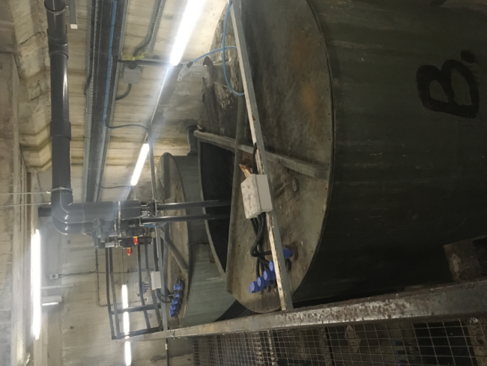

Figure 1 - Chamber 1

1.2 Previous work related to problem

The current process that is used within The Royal Mint for the control and disposal of waste liquids is that the various process such as Medals Plating, where blank medals are dipped into various solutions from cleaning detergents to a highly diluted cyanide solution tank which is dropped on a regular basis to the localised sumps, which when full pumps into what is known as Chamber 1 where there used to be 4 tanks for various solutions to be separated and then once full, chamber 1 should pump to chamber 2 where there used to be 2 separate tanks to store the solutions. However, as time has gone on, the Chamber system has physically changed without the PLC or HMI program being designed for the new specification, resulting in the chambers not giving a true representation of the liquid levels, causing a number of concerns.
Chamber 1 where there was 4 separate tanks for the different type of liquid being used such as:
- Acids
- Detergents
- Strong Acid
- Photography
However, due to the liquids used being highly diluted, there is no need to keep them separate, so work was carried out to utilize the 4 tanks and create 2 storage tanks where the liquids are mixed.
The same process has been applied to Chamber 2 where previously there were 2 tanks and now has been connected to utilize them to create 1 tank. The work that has been carried out is the reason that issues have continued with the chamber processes as the user interface does not correspond to the actual activity of the chamber system.

1.3 Aims and Objectives

The main aim of the project is “To design and upgrade the waste solution Chamber system to enable the control and monitoring of solution levels to be true to that of the human interface monitor and the physical process”. A gantt chart has been produced to indicate each task (See Appendix A).
Project Sub-aims:
- Critically evaluate the current process of the control, monitoring and physical system on Chamber 1 and Chamber 2 waste liquid tanks.

- Select suitable hardware and software to complete the upgrade of the chamber system.

- Design a control system that efficiently controls the level of waste solution in the chamber tanks and pumping system.

- Critically evaluate the designed control system to incorporate an efficient monitoring system for the chamber levels.

- Comply with relevant health and safety procedures within The Royal Mint to ensure a correct procedure of upgrading the chamber system is complete.

Project Objectives:
- Critically evaluate the current process of the control, monitoring and physical system on Chamber 1 and Chamber 2 waste liquid tanks.

- Critically analyse current P&ID for the chamber 1 and chamber 2 process (See Appendix B1).

- Critically evaluate flow diagrams for the current system, familiarise aspects of the system that have changed over the years that do not correspond to documentation (See Appendix B2).

- Compare through investigation the physical chamber system to that of the monitoring system, clearly state differences.

- Select suitable hardware and software to complete the upgrade of the chamber system.

- Research the variety of ultrasonic level probes that are available to use for the required solutions.

- Research and select different PLCs that can be used in a control system, evaluate reason for chosen PLC.

- Research a number of user interface options (HMI), ensuring compatibility with selected PLC.

- Liaise with laboratory team to indicate the Ph level of the chamber system solution in order to select the correct hardware.

- Design a control system that efficiently controls the level of waste solution in the chamber tanks.

- Design a PLC program that meets the required specification for the control of solution levels.

- Design a PLC program that meets the specification to control the pumping from Chamber 1 to chamber 2 whilst continually monitoring levels in tanks at both chambers.

- Design a program that efficiently pumps waste from Chamber 2 to the water treatment plant when chamber tanks are at a high level.

- Critically evaluate the designed control system to incorporate an efficient monitoring system for the chamber levels.

- Design a user interface at Chamber 1 and Chamber 2 that can be monitored before entering the chambers.

- Modify current monitoring network to install a localised monitoring system near engineering workshop to enable monitor of chambers without having to go to the chambers.

- Install an alarm system that alarms at localised monitoring panel when probe reaches a critically high level.

- Install level probes to indicate at monitor system when level is low, high, high-high, etc.

- Comply with relevant health and safety procedures within The Royal Mint to ensure a correct procedure of upgrading the chamber system is complete.

- Critically evaluate process of Management of Change [1] within the Royal Mint to ensure correct procedures are carried out (See Appendix D1 for management of change document).

- Liaise with drawing office to upgrade P&ID when design and installation is complete.

- Liaise with health and safety officer to commission completed chamber system.

Chapter 2 – Background Research

The upgrade of the waste solution chamber system has been put in place to overcome problems of over spills and inaccurate level readings when storing solution before it gets to the water treatment plant.
Throughout this project, the current process for the chambers will be researched along with the hardware and software that will be selected in order to achieve an efficient and working upgrade to the chamber system. Similar problems will be researched.
What are the options that are open to the problem?
Option 1: Contact an outside contractor to install a completely new chamber control and monitoring system.
Option 2: Leave chamber system as it is, manually pumping away solution when level has been manually observed.
Option 3: Upgrade and design new control and monitoring system internally.
Option 3 has been chosen, the reason for this is that leaving the chamber as it is will never solve the problem and is highly inaccurate and inefficient. The first option would not be sufficient due to the cost of the project if an outside contractor was to completely install a new system as well as their labour would be too high. Therefore, by continuing with option 3 it means that the only cost to The Royal Mint is purchasing a new ultrasonic probe and potentially new hardware and software if existing PLC is not utilized.

2.1 – Chamber 1 and Chamber 2 Current System

From conducting research into the Chamber system at The Royal Mint, enough information was obtained to produce a basic block diagram of the process starting with localised sumps and ending up in the Water treatment plant.
Plating Room

Casting Room

Blank Preparation

Chamber 1

Chamber 2

Water Treatment Plant

Block diagram showing the steps that the waste solutions flow through. The Plating room uses solutions such as demineralised water, diluted acid and cyanide which dumps its waste to localised sumps pumped into chamber 1. Casting and blank preparation both mainly use demineralised water and some cleaning agents which gets pumped also into chamber 1, which when full pumps over to chamber 2 before getting treated at the water treatment plant.

Upon researching the chambers there were a number of specification details that had to be clarified to ensure the upgrade of the system can incorporate everything to ensure all parts of the system are compatible and that the project is in fact achievable. The specification details of each tank are as follows:

2.1m
2.2m

Figure 2- Chamber 1&2 Tank Specification

Each tank has a 7500 litre capacity. There are also specification details on each of the pumps that are used in chamber 1 and chamber 2, as follows:
Chamber 1 pump specification:
- Capacity – 10m3/hr @ 16.5m head
- Pump Details: HG32-16E 020 142+Y3
- Shaft sealing by single mechanical seal TC/TC/PTFE
- Pump complete with IE1 1.5kw, 2900rpm, electric motor to a protection of IP55

Chamber 2 pump specification:
- Capacity – 10m3/hr @ 46m head
- Pump Details: RS 32-20C 075 142+Y3
- Shaft sealing by single mechanical seal TC/TC/PTFE
- Pump complete with IE1 5.5kw, 2900rpm, electric motor to a protection of IP55.

2.2 – Research into Ultrasonic level probes

For the chamber system, a non-contact ultrasonic level probe is required. A non-contact ultrasonic level probe works by “sending” an ultrasonic beam to the liquid surface, which then receives an echo back which translates the analogue signal into a digital representation of the distance between the probe and the liquid solution [1].
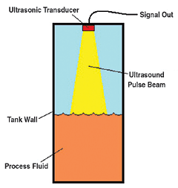

Figure 3 Ultrasonic Level Probe [6]

The ultrasonic level probe requires the correct “IP” rating for the environment it will be used in, it is also important to choose a level probe that is able to operate in the ranges that is required. The requirements for the level probe are:

Requirements | Non-Contact ultrasonic level sensor
Operating Range | Capable of over 2m
Input | 24VDC
Output | 4 – 20mA

Table 1 Ultrasonic level sensor requirement

There are a number of ultrasonic level probes available to use for the monitoring of the chamber levels, as the table below shows:
Brand/Model | Siemens | Vegason 61 | UCL-510
Range | 0.25m – 5m | Up to 5m | Up to 1.25m
Process Temp | -40 to 60°C | -40 to 80° | -7 to 60°C
Input | 18 – 30VDC | 14 – 36VDC | 24VDC
Output | One relay, 4 – 20mA | 4 – 20mA | 4 - 20mA
IP Rating | IP65 | IP66 | Not stated
Error in measurement/  Accuracy | 0.25% of measuring range | ± 10mm | ± 3mm
Cost | £783.90 | £1,066 | $748.00

Table 2 – Ultrasonic level probe comparison

The ultrasonic level probe that will be used for the application is the “Siemens THE PROBE”. The reason for this is because it meets the specification for all of the requirements (See Appendix C1 for data sheet) such as the operating range is suitable for the application it is being used in as well along with the process temperature the probe will operate at. The accuracy of this level probe is also suitable for the application.
The Siemens ultrasonic level probe is set at a cost of £783.90.

2.3 – Programmable Logic Controllers and Human Machine Interface

There are many PLCs which are an option to use for this system such as:
- Siemens
- Allen Bradley
- Omron
- Mitsubishi

Below is a table of the PLC hardware and the required software:
PLC | Siemens S7 | Allen Bradley SLC 500 | Omron | Mitsubishi
Software | TIA Portal | RsLogix 500 | CX-Programmer | GX Developer FX
HMI | Simatic HMI series | PanelView 1000 Series | Omron NB Series | GOT 2000/1000 series

Table 3 Hardware/Software required for each PLC option
Within The Royal Mint, there are only two main PLCs that are used throughout the company; these are Siemens and Allen Bradley. The most widely used PLC throughout the company is the Allen Bradley SLC 500, for this reason for this upgrade the SLC 500 will be utilized and used.
Due to using the SLC 500 the corresponding HMI to use is the Allen Bradley PanelView 1000 Series, this will also be utilized as the software is already available for both the PLC and the HMI.

Chapter 3 - Methodology

3.1 – Research Method

The research methodology that is intended to be used throughout this project of upgrading the waste solution chamber control and monitoring system is investigative as throughout this project the waste solution chamber system at The Royal Mint will be investigated thoroughly to ensure that a complete understanding of the process currently in place is achieved in order to design an upgraded system to be as efficient as possible eliminating the regular occurrences of overspills from the chambers and ensuring a true monitoring system that can be monitored in a number of places, locally and at the chamber entrance.
Not only will the chamber system be investigated but also a number of ultrasonic level probes, PLCs and user interface hardware and software will be investigated to ensure the hardware/software being used can actually carry out its job. The investigative method will be used because it is the only method that will ensure sufficient understanding will be obtained from the current process in order to complete the design and upgrade. The advantage of this method are that it will enable correct selection and erection of hardware to be used with the solutions that are currently being put through the waste chamber system.
The hardware that is required will need to have a certain “IP” rating to ensure that it can operate in the conditions it is being used, therefore the ultrasonic probe will require an IP rating of IP68 as the chamber always has the potential to overflow if components fail or breakdown which would submerse the probe.
The software that will be used is RsLogix 500, this is due to utilizing the hardware/software that is already available and widely used in The Royal Mint. The PLC hardware will be Allen Bradley SLC 500 which requires RsLogix 500 software to control it using ladder logic.

3.2 - Evaluation Criteria and Testing

How will these be tested?
The testing of the upgraded system will take place after the final installation and design of the control and monitoring system. The following testing procedures will be carried out:
- Commissioning document produced and completed to ensure that the upgraded system not only operates safely, but that it meets the required specification and operates to how it was initially set out to.

- Operational test carried out, with scenarios created to enable the levels of the chamber 1 to be at a critically high level to ensure that the alarm will sound and that the user interface clearly indicates that the level is high.

- Localised sumps dropped to fill chamber 1 to ensure that when level probe indicates a high level, the pumps operate to pump to chamber 2, and that the user interface indicates that chamber one is at a high level and in fact is pumping.

- Operational test at chamber 2 that clearly indicates that the user interface shows levels rising due to solution pumping from chamber 1.

- The user interface will alarm if critical level is reached, this can be created through isolating pumps to ensure alarm sounds.

- Once pumps switched back on, the system can be tested by ensuring the user interface at chamber 2 shows the level is high and the pumps operate to remove the solution and pump to the water treatment plant.

- Test sheets will be produced and the test operation will be trialled numerous times.

3.3 – Research Onion

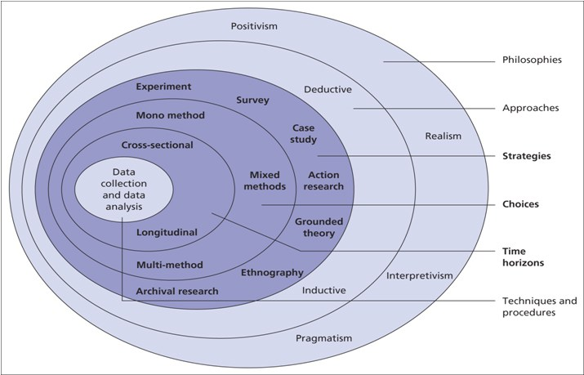
To clearly indicate the research method that will be applied throughout the project, the research onion [1] will be followed.
Figure 4 Research Onion [2]

Starting with the first layer, the method that will be followed is positivism, I have chosen this method as positivism implies that the only facts are gained through observation which means that the research findings can be observed and that the findings are true [3].
A deductive approach will be applied due to the top that this project is based upon a positivism philosophy where the outcome will be true which means that from this project a confirmation can be gained once the upgrade has been completed

The strategy that will be used throughout the project will be action research as in order to upgrade the chamber system, the current system will need to have a thorough action research to completely understand the system to upgrade. It also is the strategy applicable to this project due to action research requires identifying a problem, planning, taking action and evaluating a specific topic [4] which directly applies to this project.
The research choices that will be included throughout the project is multi-method due to the research produced on this project will include meetings with a number of people to gain more understanding of different procedures such as management of change and then also meetings to understand flow diagrams etc.
Cross-sectional research will be applied throughout the project due to the research information carried out is available at any time and the project will not involve studies over a period of time.
Finally, the data collection methods that will be used are sampling and observations, this is because the chambers current control system will need to be observed along with the monitoring system to ensure that when the upgrade is being carried out, they correspond to each other. Also, sampling will be required as the hardware used such as the level probes will need to be able to operate in the solution which is being put into the chambers so a sample of the solution will be taken to gain a Ph level in order to select required hardware.

Conclusion

The plan that has been developed for this specific project will be followed closely and as accurately as possible, ensuring that tasks are met by deadlines and that the project is completed by the end deadline.

References

[1] | M. Grant, Management of Change Procedure Flowchart, 2 ed., 2015.
[2] | “Level Sensor - Introduction to Liquid Level Measurement,” [Online]. Available: https://www.omega.co.uk/prodinfo/level-measurement.html. [Accessed 18 April 2018].
[3] | M.Saunders et al, Research Methods for Business Students, Fifth ed., Essex: Pearson, 2009.
[4] | Unknown, “Positivism Research Philosophy,” [Online]. Available: https://research-methodology.net/research-philosophy/positivism/. [Accessed 18 April 2018].
[5] | R. Sagor, “Guiding School Improvement with Action Research,” [Online]. Available: http://www.ascd.org/publications/books/100047/chapters/What-Is-Action-Research%C2%A2.aspx. [Accessed 18 April 2018].
[6] | W. Smith, “Research Onion – Made easy to understand and follow,” 14 July 2017. [Online]. Available: https://www.allassignmenthelp.co.uk/blog/research-onion-made-easy-to-understand-and-follow/. [Accessed 18 04 2018].
[7] | C. Dodds, “Ultrasonic Level Sensors - Vega Vegason,” [Online]. Available: https://www.heatingandprocess.com/ultrasonic-level-measurement/. [Accessed 18 April 2018].

Appendix A – Gantt chart

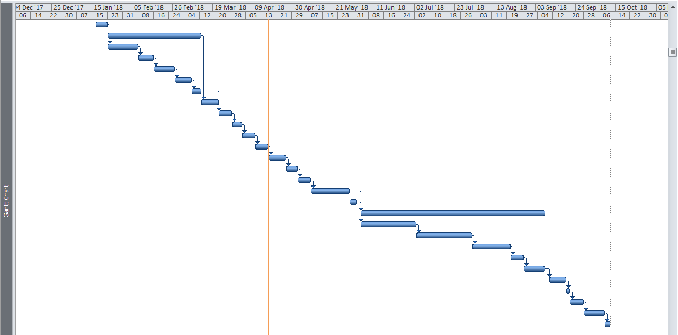

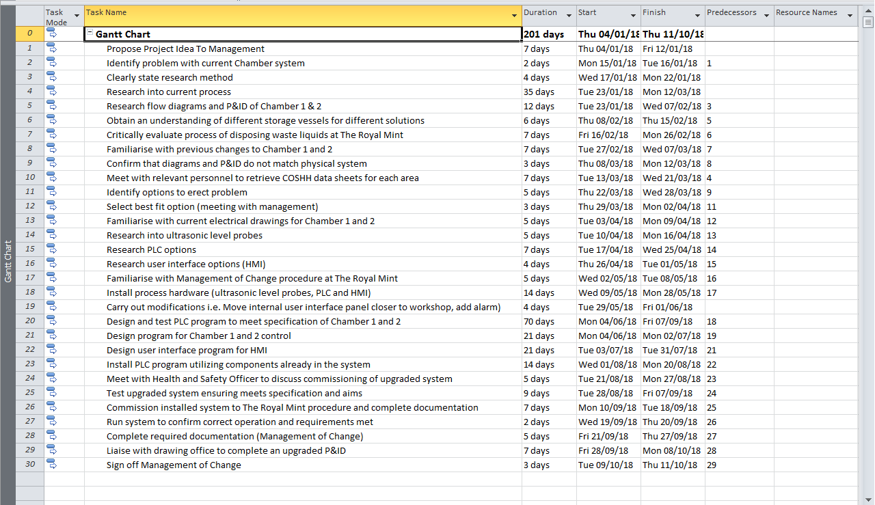

Appendix B – P&ID

B1 – Current P&ID

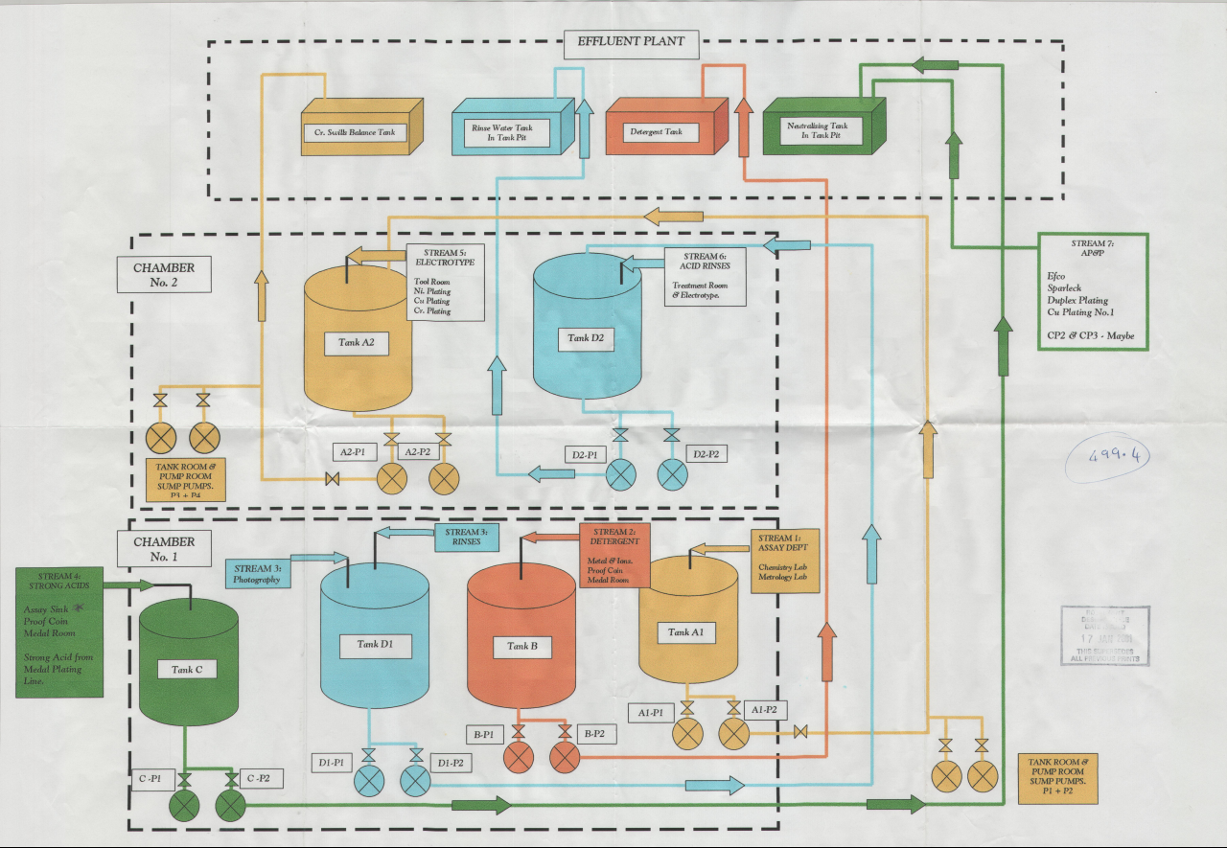

Appendix C – Hardware Data Sheets

C1 Siemens THE PROBE ultrasonic level sensor.
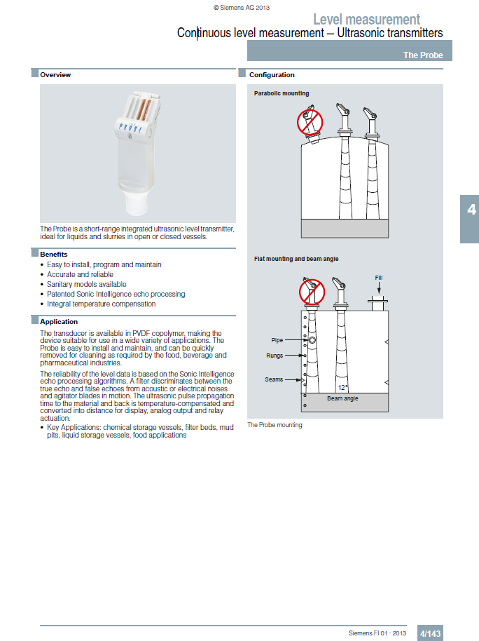
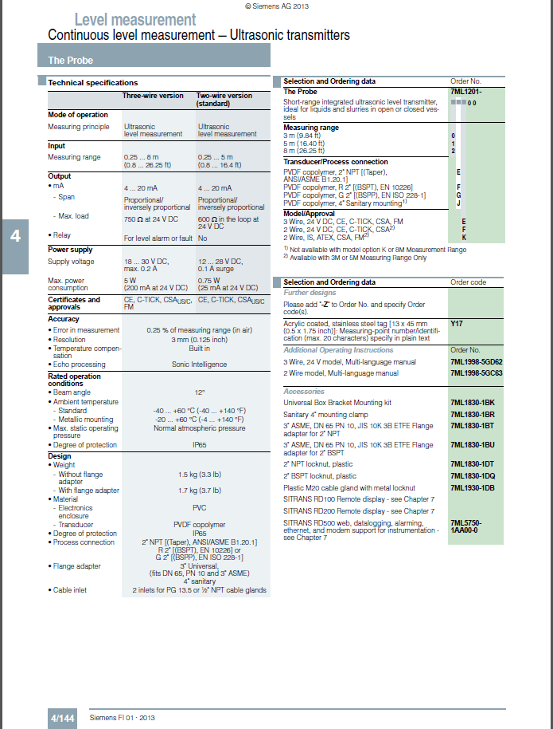

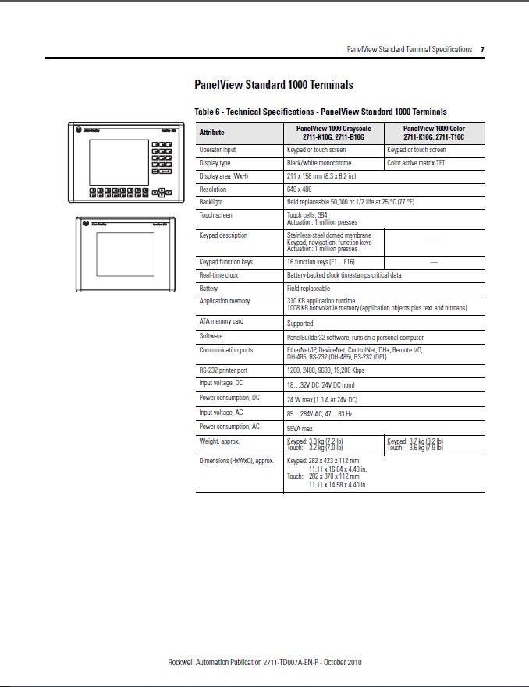
C2 Allen Bradley PanelView 1000e Series HMI

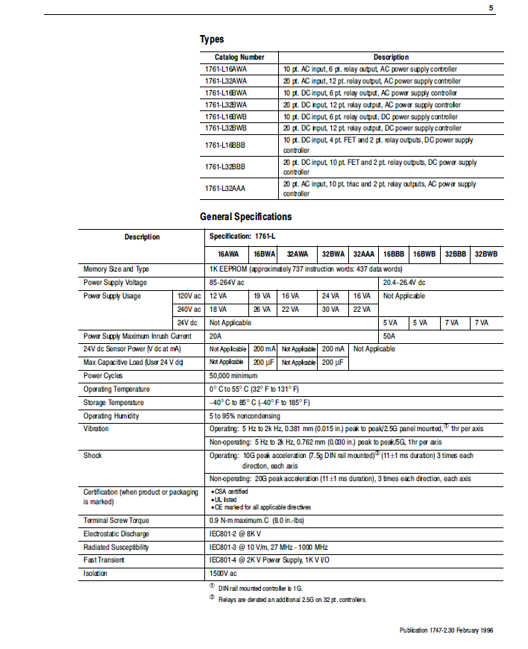
C3 Allen Bradley SLC 500 PLC General Specifications

Appendix D – Management of Change

D1 – Management of Change Procedure
Physical Change Questionnaire Form 28.4.5
Process Change Questionnaire Form 28.4.2
Procedural Change Questionnaire Form 28.4.3
Material Change Questionnaire Form 28.4.4
Personnel Change Questionnaire Form 28.4.6
All Questionnaires must consider any SHE Impact
Prepare project / implementation plan.
Complex changes will require detailed documentation and drawings.
Simple changes may require only an action plan.
All plans must list change instigator, approvers and actionees
Monitor Progress
Guidance Document SMP 28.3
Review completion of change. Complete Change Closure Checklist Form 28.4.7
Implement change in line with project / action plan
Change Instigator communicate change to all stakeholders
Log Change on Change register.
Submit plan to Consultation team for review and approval.
Not approved
Approved
Identify Stakeholders in requested change and form consultation team.

Complete Change Category Questionnaire or combination if multiple changes are involved.
Complete Change Request Form.
Change described, scoped and categorised.
Change Instigator Identified
(Form 28.4.1 link)
SHE Change identified.
Change falls within guidance criteria

Medal System Control Document
28.4.9

