

How do players relate to characters in fantasy and cyberpunk game worlds?

Independent Project Dissertation
Ashanti Mighten
Student No. 2304545
Submitted in partial fulfilment of the requirements for the degree of BA in Computer Games Design, University of Wales Trinity Saint David.

Certificate of Authenticity

This dissertation is a product of my own work and is not the result of anything done in collaboration.

I declare that the work in this dissertation has not been and is not being submitted for any other degree.

I agree that this dissertation may be available for reference or photocopy at the discretion of the University of Wales Trinity Saint David.

Signed: A Mighten
Date: 30/04/2026

Table of Contents
LIST OF FIGURES 3
ABSTRACT 4
INTRODUCTION 5
How do players relate to character in fantasy and cyberpunk game worlds? 5
CHAPTER 1 6
1.0 Literature Review and Theoretical Framework 6
1.1 Relatability as a Concept 6
1.2 Relatability despite Gameplay 7
1.3 Player Relation through Grief 8
1.4 Relatability through Escapism 8
1.5 Relatability through Scepticism 9
1.6 Common Themes despite Genre 9
1.7 Relation through Visual Design 10
1.8 The Power of Ludonarrative Dissonance 11
CHAPTER 2 13
2.0 Methodology of Analysis 13
CHAPTER 3 – Case Studies 14
3.0 Cyberpunk 2077: Johnny Silverhand Character Background 14
3.1 Proof of Character via Narrative 14
3.2 Transhumanism within the Cyberpunk Genre 16
3.3 Player Relationship with Johnny Silverhand 16
3.4 Johnny Silverhand Visual Design 17
3.5 God of War Ragnarok: Kratos Character Background 19
3.6 Premise of GOWR 19
3.7 Enmeshment and Parent-Child Dynamics 20
3.8 Kratos Visual Design 23
CHAPTER 4 25
4.0 Evaluation of Case Studies 25
4.1 Player Expectations within Genres 25
CHAPTER 5 27
5.0 Further Analysis - Relatability through The Human Condition 27
5.1 Relatability beyond Worldbuilding 27
CHAPTER 6 29
6.0 Conclusion 29
REFERENCES 30
BIBLIOGRAPHY 35
APPENDIX A: Questionnaires 36
APPENDIX B: Abbreviations 36
APPENDIX C: Story Elements – Cyberpunk 2077 37
APPENDIX D: Story Elements – God of War Ragnarok 38

LIST OF FIGURES
Figure 1. Depiction of visual storytelling through player customisation 11
Figure 2. Johnny Silverhand 3D Model Design 16
Figure 3. Kratos and Atreus acting as one 18
Figure 4. God of War 2018, Kratos removing his bandages in front of Atreus 19
Figure 5. God of War Ragnarok Kratos Design 21

ABSTRACT
This dissertation discusses how fantasy and cyberpunk genres may tackle immersion, emotional investment, audience relatability and identification, through characters from fantasy and cyberpunk genres, taking consideration of the fantastical settings presented in both games. This will be explored by delving into two games of the respective genres—Cyberpunk 2077 [1] and God of War Ragnarok (GOWR) [2]. With the vast differences between today’s society and a fantastical world of mythical legends, beasts and Gods, audiences relate less to the setting, and more toward the emotional, ideological and psychological themes presented by the characters.
Through two character-focused case studies, this dissertation analyses Johnny Silverhand from Cyberpunk 2077 and Kratos from God of War Ragnarok. Further insight will be gathered on how audiences are able to see themselves in these two characters because of their narrative and visual designs through published questionnaires. In an online questionnaire (see Appendix A), participants completed a survey covering the topic of relatability, and how their preference between cyberpunk and fantasy genres shapes their engagement with characters from the respective genres.

INTRODUCTION

How do players relate to character in fantasy and cyberpunk game worlds?
This dissertation is structured into six chapters.
Following the introduction, Chapter 1 reviews pre-existing literature on character relatability, player identification and genres within video games.
Chapter 2 outlines the methodology used to analyse visual, narrative and player identification within the two case studies conducted in this dissertation.
Chapters 3 includes character analysis studies on Johnny Silverhand from Cyberpunk 2077, and Kratos from GOWR, examining how each character allows for audience relatability through visual design, narrative design and genre conventions.
Chapter 4 evaluates the findings of each case study, and touches on a comparative analysis of fantasy and cyberpunk as distinct, but effective tools for character connection.
Chapter 5 discusses the central research question on a broader scale, and finally, Chapter 6 concludes the dissertation by summarising the thesis, addressing the limitations and considering further research and informed character design practices.

CHAPTER 1

1.0 Literature Review and Theoretical Framework
Character relatability has become an important aspect of player engagement in narrative-focused video games. In an era of emphasised social communication and connection, gaming has explored these topics with abstract and artistic methods in recent years. One of the ways gaming has explored the concept of a ‘society’, is by pushing it to the extreme.
Cyberpunk 2077 is a commentary piece on how humanity’s innate desire to improve and advance, may eventually end in its slow, neon-lit downfall. For example, the games portrayal of cybernetic enhancements as status symbols highlights how technological advances can reinforce social hierarchies, and pictures human augmentation as both a tool of physical empowerment, and a marker of socio-economic divides [3]. Cybernetic enhancements serve as a stark, visual marker, distinguishing the elite from the working class. This further pushes the class divide within the universe of Cyberpunk 2077 and causes despondency and potential uproar between the classes. Audiences are familiar with and relate to the concept of technological advancements in modern society, with hastening developments within the realm of Artificial Intelligence(AI) and wavering trust in corporations and governments becoming rife. But how would one define the idea of relation as a concept?

1.1 Relatability as a Concept
There have been numerous studies conducted on the concept itself. Murray Smith’s theory [4] emphasises the crucial role of emotional engagement in the audience’s experience. Smith argues that audiences do not passively consume narratives, the audience instead actively interprets and emotionally engages with them. Audiences form attachments to characters and experience their emotional journeys alongside them.

Whilst this theory was intended for film, it is only emphasised further within video games—as not only are audiences watching a narrative unfold, but they are also truly, actively taking part in the story that is presented. The player-avatar relationship (PARs) is integral to narrative-driven video games—when audiences feel connected to the playable character and see them as a personal extension of the self, instead of viewing them as a tool, it fosters a parasocial relationship between the player and the avatar. [5] Audiences face the consequences of a ‘Game Over’ and/or ‘Respawn’ screen when they make mistakes, and so they experience the emotional toil placed on the main character via the parasocial relationship.
For example, Cyberpunk 2077 is a first-person, choice-driven experience where players assume the role of the customisable character “V”; if a choice made is “incorrect”, the player, and in lieu, V, will face a consequence. In Cyberpunk 2077’s mission “Search and Destroy”, the player can choose to ignore the game’s deuteragonist, Johnny Silverhand’s wishes to rush to escape a fire in an apartment complex and instead choose to save an ally from the building. If the player chooses not to save them, the character will ‘die’ and no further contact with said character will ensue. However, if the player chooses to save them, the character will live and potentially appear in later sections of the story. This, in connection to PARs, helps players feel responsible, or emotionally attached to characters.

1.2 Relatability despite Gameplay
Not only decision-driven games can trigger empathy, identification and foster attachments to characters, but also third-person, action-adventure hack-and-slash games, such as God of War Ragnarok. The game’s storyline primarily centres around themes of grief, change, forgiveness, and the struggle between leaving things for fate and deciding them for oneself, all pictured through complex familial dynamics. A narrative device that GOWR uses commonly in its script is lexical cues, where specific words, or linguistic features such as tone, provide hints about the context of the character’s feelings or thoughts on past, present or future matters. As soon as the player enters the universe of GOWR for the first time, a loss of life occurs. Atreus (see Appendix D) goes through the loss of one of his wolves, whom the boy refers to multiple times during the opening act. His excitement and anxieties to return to the wolf are both made evident to the player. An emotional scene is set; in the dead of Fimbulwinter (see Appendix D), Atreus runs back home to his wolf, Fenrir, from an outing with his father. Fenrir is elderly and sick, and Atreus attempts to prompt the wolf to eat, but he refuses. The audience can gather that Fenrir held onto life until Atreus returned home, as Atreus settles with the wolf in his lap, and gives him his blessing to move on to the afterlife

1.3 Player Relation through Grief
Despite how little the audience truly knows about this interaction, it is no less gripping and emotive, as it sets a sombre tone for the game. Unknowingly, the boy casts a spell to transfer Fenrir’s soul into one of his weapons, but despite this fantastical moment, the sense of grief and loss is not lost on the player. As stated by Julia M. Wilson and Emily Moyer-Guse, contemplating tragic narratives, such as those that portray death or loss, has been shown to reduce the symptoms of anxiety, depressive moods and improve overall health, but limited work has been presented on how tragic narratives may affect individuals when the content is personally relevant, such as grieving or bereaved individuals [6]. By considering players’ own potential experiences with grief, it lays the groundwork for effective resonance within the audience to the narrative. Players resonate with characters by simulating the character’s perspective (identification), and/or by projecting their own perspective onto the character’s mind (egocentric projection). Thus, players relate not because the world is realistic, but because grief is recognisable, and allows for catharsis.

1.4 Relatability through Escapism
Upon speculating escapist worlds, despite their fantastical nature, lay core themes in which audiences can relate, or escape to; genres such as fantasy, gothic literature and romance often act as an outlet for the yearning of a greater meaning than one’s own. Gothic novels such as Mary Shelley’s Frankenstein [7], Anne Rice’s Interview with The Vampire [8] and the works of Edgar Allen Poe [9] are all set in extreme worlds where magical beings and people exist, much alike fantasy and cyberpunk, they all share an underlying theme; the exploration of the human condition [10].
The human condition refers to the essential, shared experiences of human existence, birth, mortality, growth and emotion. In the modern society, a world where large corporations and governments that control our society are widely regarded as harmful, untrustworthy and/or detrimental to humanity, fantasy provides an antidote to cynicism, despondency, and exercises ones inner, childlike sense of wonder. It allows audiences to live a life they will most likely never experience.

1.5 Relatability through Scepticism
On the opposing side, the cyberpunk genre often does not shy away from delving into and indulging these thoughts of despondency and instead opts to exaggerate and further the sense of corruption rife in modern day society. Defined by the high-tech, high crime rate dystopia, emphasis on corporate dominance and blurred boundaries between humanity and machines, cyberpunk has evolved and become even more relevant today in addressing real-world issues through a fictional lens. Philip K. Dick is considered a major precursor to the cyberpunk genre, especially due to his piece ‘Do Androids Dream of Electric Sheep?’ from 1968 [11], which inspired Blade Runner 1982[12], and as stated by Mike Pondsmith(a consultant for Cyberpunk 2077’s lore during the games continued development), was a significant influence on his work in creating the Cyberpunk tabletop role-playing game (in which directly inspired the Cyberpunk 2077 video game).

1.6 Common Themes despite Genre
Loneliness is also a common theme between cyberpunk and fantasy. The urge to escape is often stemming from a sense of loneliness or isolation, as it is typically to temporarily relieve anxiety, stress, or overwhelming realities when indulged in for long periods of time. As mentioned previously, GOWR’s core narrative revolves around grief, a typically isolating experience. GOWR’s portrayal of a grieving father, husband and warrior is visceral within Kratos; during the opening scene of the game, Kratos acts relatively indifferent to Atreus’ loss, due to his own jaded perspective and understanding of mortality. He permits Atreus to grieve alone.

Isolation is also at the core of Cyberpunk 2077’s narrative, the main storyline is to find a cure for a fatal neural degradation caused by the Relic (see Appendix C). Unfortunately, a cure is not truly found in any of the multiple endings of Cyberpunk 2077, and instead the player is forced to lose contact with a portion, if not all, of the characters they meet during their time in Night City (see Appendix C) one way or another. Feelings of isolation are common in modern-day society, 1 in 3 adults in the United States report feeling lonely, as touched upon by the CDC [13], so it is a graspable concept for audiences to reckon with, resonate with and find cathartic comfort in the shared experience of loneliness within a video game. This also opens the opportunity for egocentric projection amongst audiences, which is only amplified by the media of gaming itself.

1.7 Relation through Visual Design
Whilst narrative design plays an integral part of relation, it is widely argued that visual design is equally as important as the narrative. The act of character designing is to not only design for oneself, but to rather fulfil a series of requirements for both a product (or character) and the audience. For example, the silhouette of a character and which shape(s) their visual design centres around can give the audience a vague idea of the character’s emotional state and personality. Rounded silhouettes and circles often equate to innocence or kindness, whilst jagged, spiked silhouettes and triangular shapes can communicate a potentially aggressive or rebellious personality. As mentioned in ‘The Magic of Character Design in Storytelling’ by Parfait’s Palette [14], a character’s silhouette can change and develop overtime, and it can signify the extent of their narrative development through their visual design. Character designers must consider how a story’s events will affect the character, and how they will potentially weave these changes into the character’s design.
An example of this in Cyberpunk 2077 is ‘The Tower’ ending; the main character successfully removes the Relic, but V can no longer use cyberware (see Appendix C), making them an insignificant, ordinary citizen in Night City. V has their head shaved from the surgeries needed to remove the Relic and are now without their cyberware. Often players will assimilate into the universe and alter the appearance of their V throughout the main chapters of the story to visually display the impact of the main game events, tying back into the concept of PARs.
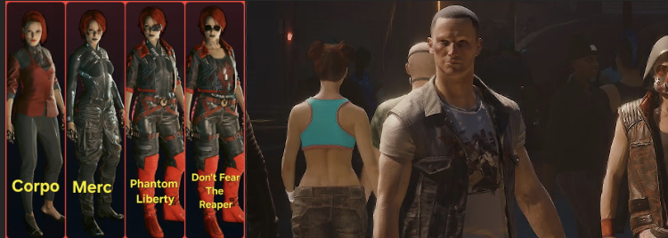
Figure 1. Depiction of visual storytelling through player customisation
[15]

1.8 The Power of Ludonarrative Dissonance
Through focusing on a game’s narrative, players often encounter ludonarrative dissonance, and this is seen explicitly within GOWR. Ludonarrative dissonance is the disconnection between gameplay and narrative themes, it can, in some cases, hinder player immersion. Within GOWR, Kratos has been shown to have grown from his violent, turbulent past portrayed in God of War 1-3(see Appendix D), especially after becoming a father to Atreus and yet the main gameplay systems revolve around combat—it opposes the endorsement of peace that the main storyline of GOWR presents. However, GOWR as a narrative-driven game broadens the definition of violence. The intention of keeping violence in GOWR was not only a beneficial decision to the gameplay, but it also allows the narrative to frame conflict as a burden, a necessary evil, rather than a permanent solution or a source of satisfaction.
Kratos acknowledges and carries the guilt of his previous acts of violence in the earlier instalments of the game, but in GOWR, the player can witness his journey to no longer letting himself be defined by his past actions, and to instead become anew. After Atreus departs on his own quest, Kratos discovers a new prophecy about his destiny, and he is destined to become a God of Hope, rather than a God of War. His evolution is defined by a shift from reactive rage and vengeance to a controlled use of violence framed as necessary rather than gratifying. Gaming itself can contribute to the identity development of their players, particularly within neurodivergent individuals and people who identify as LGBTQ+ [16].
This may be because gaming offers a place for users to assimilate into different roles and can lead to a deeper understanding of why some people act as they do.
Using Kratos as another example of this, audiences often misjudge his relationship and overall attitude with Atreus. Kratos is dubbed as too harsh, too distant and too overprotective over his son, however his strictness with Atreus is a deliberate attempt to dissuade his son from making the mistakes that Kratos himself has learnt from. He grapples throughout the story with this concept and eventually allows Atreus to embark on his own expedition, as Kratos learns that Atreus’ mistakes are only his own to make.

CHAPTER 2

2.0 Methodology of Analysis
This dissertation employs a character analysis case study approach to examine the construction of Kratos and Johnny Silverhand. This will be done by deconstructing the narrative arcs these characters present, as well as covering visual design, genre conventions and questionnaire responses. These characters were selected specifically to provide an exploration of genre and ideological contrast; Kratos represents a high fantasy archetype, whilst shifting from a vessel of perpetual war to a complex commentary on fatherhood and forgiveness of oneself, whilst the science-fiction Silverhand embodies an anti-establishment ‘rocker boy’ terrorist turned human through narrative. The two franchises, Cyberpunk 2077 and GOWR, are both PlayStation [17] exclusive games that have both sold over 15 million copies, and are both considered top-tier AAA [18] gaming experiences. The goal is to not aggregate data, but to outlay a qualitative interrogation of the creative decisions behind their designs, and how their distinct aesthetics and philosophies influence both relatability and the player’s sense of agency.

CHAPTER 3 – Case Studies

3.0 Cyberpunk 2077: Johnny Silverhand Character Background
Born as Robert John Linder, Johnny Silverhand served in the Second Central American War as a U.S. Marine from 2003-2010. His hatred toward corporations formed when he witnessed the military utilise experimental drugs and primitive, first-version cybernetics onto their soldiers. After he discovered the conflict was a front for corporate interests and testing, and losing his arm in combat, he deserted the war. Despite his hatred toward the corporate testing, he himself acquired his signature silver cybernetic arm, and later adopted the name ‘Silverhand’ as he formed his band, ‘Samurai’ to spread anti-corporation and nihilistic messages through his music. The visual of his ‘silver arm’ is iconic, not only within Cyberpunk’s lore, but also amongst players of the game. It is a defining, eye-catching feature that no other character within the storyline of Cyberpunk 2077 shares, as technology has advanced past Johnny’s time. His acts of rebellion reached an apex in the bombing of Arasaka (see Appendix C) Tower in Night City on August 20, 2023 (also referred to as ‘the Night City Holocaust’). This attack ultimately led to his physical death and his digital rebirth; Arasaka created a prototype of their digitalised version of eternal life in the form of ‘Soulkiller’, which contained a copy of Johnny’s psyche and self on an engram, later into the form of an insertable biochip. His psyche was held in a digital prison, known as ‘Mikoshi’ (see Appendix C) within Arasaka for over 50 years (2023-2077).

3.1 Proof of Character via Narrative
Throughout Cyberpunk 2077, Johnny is considered narcissistic, and an unreliable narrator, as his flashbacks often reframe events to centralise himself as the main hero. For example, he portrays himself as the leader of the attack on Arasaka Tower in 2023, whilst the operation was sponsored by Militech (the direct corporate rival to Arasaka), and led by Morgan Blackhand (see Appendix C), and Johnny was instead a member of the distraction team. Silverhand also recalls himself as the sole nemesis and supposed downfall of Arasaka, whilst other characters and lore within the game suggest while he was indeed a notable figure in the uprising against corporations, he was never identified as central nor integral.
His narcissistic tendencies are also emphasised within his interpersonal relationships through characters such as his bandmates, and his former lover, Alt Cunningham (see Appendix C). Johnny’s flashback to Alt’s death works to both justify his actions, and to pass the blame away from himself, and unto Arasaka. This moment highlights an extreme trauma for Johnny, and the player themselves can gather an understanding of Silverhand’s vehement hatred toward Arasaka. For in his mind, it was Arasaka that murdered Alt. Despite the grandeur and specificity of this encounter, misremembering and suppressing intensely traumatic events are a common phenomenon, as the brain can work to push these memories out of conscious awareness to protect itself from emotional pain [19].
Alt is revealed to have assimilated herself into Cyberspace (see Appendix C) as an AI, that V manages to encounter through her connection to Silverhand. Alt confirms that his memories are inaccurate, and that V was witness to a warped account that Johnny had locked away in his subconsciousness for the 50 years he spent in Mikoshi. In a flashback, the player becomes witness to the dysfunction between Johnny and Alt whilst they were alive; the game pictures a tumultuous relationship, in which Johnny mistreats Alt, and she ends their relationship. Johnny chooses to turn his pain from this into something destructive and attempts to manipulate Alt into believing that Johnny ‘never cared about her’. This deflection serves as a protective barrier, both to shield one’s fragile ego, and to avoid acknowledging one’s own fallibility [20]. It also displays Johnny’s multi-faceted and nuanced nature as a character; despite caring so intensely for Alt, he refuses to acknowledge it when she is the one to end their relationship. This portrayal further pushes his egotistical, self-centred personality and desperate need for assertion and control, to view for the player and gives an accurate portrayal of a dysfunctional relationship.

3.2 Transhumanism within the Cyberpunk Genre
Transhumanism is a popular concept within the cyberpunk genre, and Johnny exists as an example of such within the game itself. Transhumanism is the idea that humans should and will integrate themselves with technology to evolve or enhance their pre-existing capabilities; we see this with devices such as VR (Virtual Reality) [21] headsets, Apple Vision Pro [22] headsets, Meta Glasses [23], etc. This shift in society is beginning to slowly integrate into the current reality, altering the picture of what it means to be human. Elon Musk reportedly states that ‘he wants to achieve a symbiosis with artificial intelligence’ [24], and with the development of the Neuralink [25], the concepts raised within Cyberpunk 2077 are no longer limited to fiction, causing media within this genre to resonate deeper with audiences.

3.3 Player Relationship with Johnny Silverhand
Johnny Silverhand loses his bodily autonomy via Soulkiller (see Appendix C), and is limited to acting as a digitalised hallucination to the main character, V. He acts as a passenger within the game, and through the player’s choices, he is forced to view a different perspective from his own. The player watches this unfold when Johnny is first introduced, through to the end state of his character. Silverhand’s first introduction is his attempt to take over the player’s body for himself, effectively ending V’s life, whilst in one ending of the game, Johnny chooses to save V’s life over his own, highlighting his shift from egocentricity to selflessness.
His growth is palpable, and due to Cyberpunk 2077’s choice-central gameplay, the player feels more connected with his character, as his narrative and relationship to V directly changes depending on which choices the player makes. The player can choose to honour Johnny’s memory, through meeting his previous bandmates from Samurai and indulging in activities Johnny suggests. Existing studies indicate that players often develop real emotional attachments to non-playable characters (NPCs) [26], this may suggest that Johnny’s development as a deuteragonist effectively and engagingly enhances player experience, relation and interest with the narrative itself.

Overall, Johnny is a complex deuteragonist who is forced to see through another viewpoint, with equal narcissistic tendencies, and ultimately the capacity for good. He is not only a nihilistic narcissist, but an advocate for the uprising against predatory corporations, and betterment of life quality in the lower class.

3.4 Johnny Silverhand Visual Design
As mentioned previously, his visual design is both iconic and memorable. Silverhand wears aviator sunglasses, that were originally developed in the 1930s to protect US military pilots from high-altitude solar glare. They have evolved from a piece of functional, wartime equipment to a lasting symbol of revolutionary idealism, rebellion, and authority, thus, are common amongst both rock stars icons and activists [27]. His clothing merges both his rock star persona and his veteran status, combining a kitsch jacket and sunglasses with a tactical vest and combat boots. Scuffs and mud on boots, crooked grins and jewellery or lack thereof can all communicate a character’s personality with a single glance, and Johnny is no deviation from this. His colour palette is dark, grungy and deep, utilising shades of maroon, black and brown. Through his grounded, realistic clothing, it serves to balance the fantastical world of Cyberpunk 2077, and clothing audiences would see today. The visual focus and outlier of his design is intended to be his silver arm, as it is the lightest value in his colour scheme. Character designers often use hue, saturation and value to communicate the important sections within a design [28], to help guide the audiences’ eye toward them.
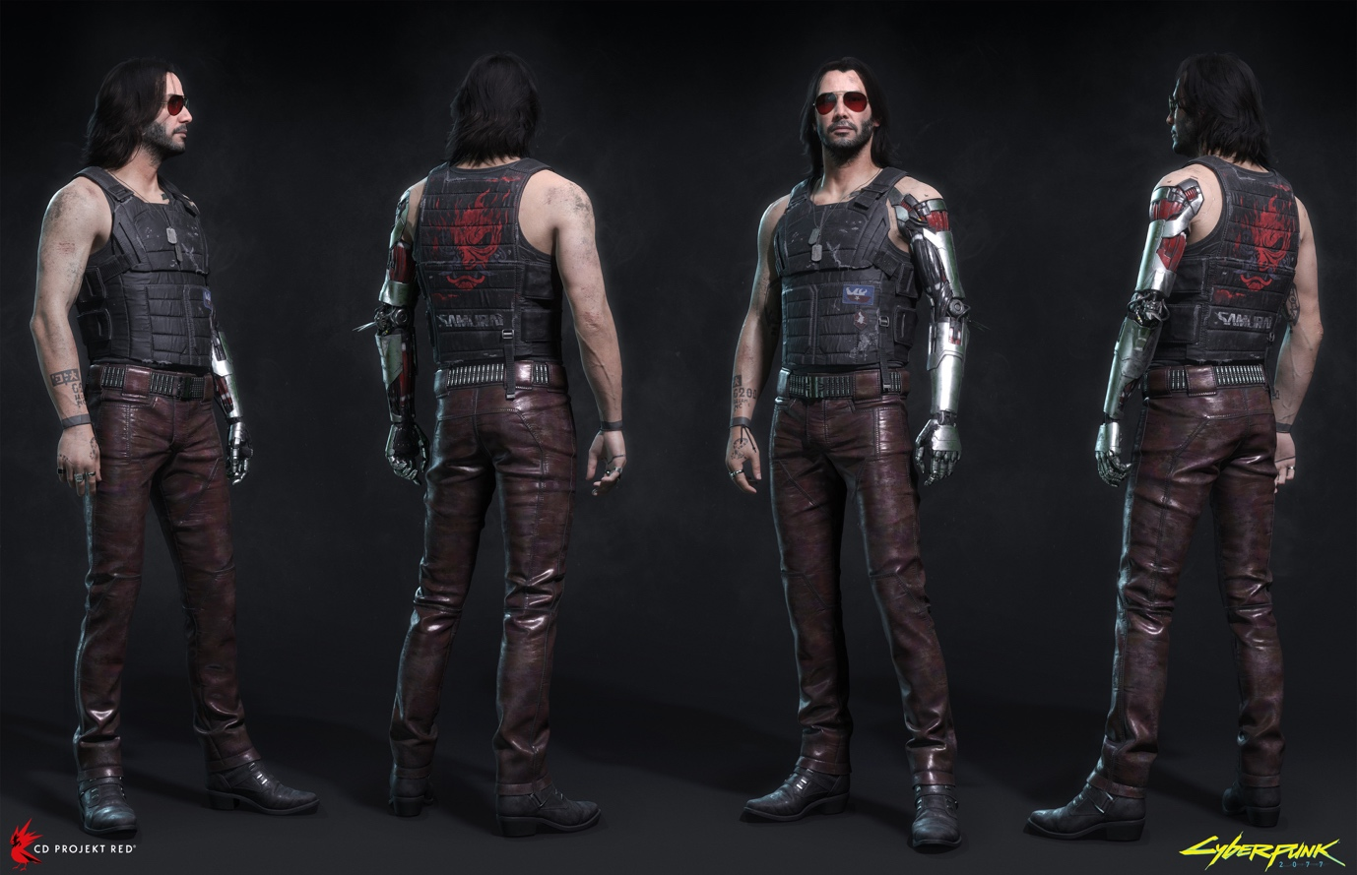
Figure 2. Johnny Silverhand 3D Model Design
[29]
In the questionnaire presented on this topic (see Appendix A), a common theme amongst answers was Johnny’s inherent antagonistic look. Those who had not played Cyberpunk 2077 used descriptives such as ‘rock star’, ‘angry’ and ‘rebellious’, when faced with Johnny’s visual design.
To conclude, Johnny Silverhand’s visual design serves to clearly and effectively enhance, promote and communicate his narrative design and personality.

3.5 God of War Ragnarok: Kratos Character Background
Kratos is defined by two distinct eras that bypass different time periods and mythologies, due to a collective creative decision to reinvent and redefine the franchise. The original trilogy (see Appendix D) focused on Greek mythology, which has been described as ‘exhausted’ in recent years, and Santa Monica Studios [30] took a creative liberty to delve into a deeper storyline, of redemption, fatherhood, and the journey to the forgiveness of oneself.
In 2018, the reinvented God of War (GOW) [31] released. Kratos had travelled to the Norse land of Midgard, one of the Nine Realms (see Appendix D). He remarried, and had his son, Atreus. GOW begins after Kratos’ wife’s death, where her dying wish was for her ashes to be scattered from the highest peak in the Nine Realms, in Jotunheim. This leads Kratos and Atreus to embark on the journey to Jotunheim.
Kratos discovers during the conclusion of his journey, that his wife was a giant (see Appendix D), and in lieu, their son. He discovers that Atreus’ giant name is Loki (the God of Mischief within Norse Mythology), and he also saw a prophecy foretelling his own death during the upcoming apocalypse of Fimbulwinter. GOW ends with the beginning of this apocalypse, and GOWR opens with a scene of grief and loss, as mentioned previously in Chapter 2.

3.6 Premise of GOWR
GOWR revolves around Kratos and Atreus’ relationship, as well as Kratos’ hope for the avoidance of Ragnarok, and Atreus’ urge to understand his purpose as Loki. Despite the intensely mystical and otherworldly themes within GOWR, the interplay between Atreus and Kratos as father and son is a relatable concept to audiences. Kratos, jaded by years of perpetuating violence, of refusal to contain his rage, of desperate revenge, intends for his son to avoid falling down the same path of suffering that he himself had. The duology (GOW and GOWR) began with Kratos exclusively calling Atreus ‘boy’ throughout, both belittling him to his age, and viewing their relationship as a general to a soldier, rather than a father to a son.

During the events of GOWR, Kratos then begins to call Atreus by his name, fostering the start of their relationship as father and son. Their relationship is complex, defined by trust, mutual respect, and navigating independence—they shift from strained, guarded communication, to vulnerability through openly discussing their fears, with Kratos even choosing to lend his trust to Atreus, and letting him grow beyond himself at the conclusion of GOWR.

3.7 Enmeshment and Parent-Child Dynamics
Rather than Kratos pushing forward the narrative of the game, this responsibility falls upon Atreus in GOWR. Whilst his father bears the desire to fight against the Gods no longer, Atreus is restless; he sees the impeding Ragnarok and pushes to take action against the Gods that reside in Asgard (see Appendix D), and Kratos is pushed to become a parent who learns to let his child take initiative, and to no longer dictate him, but to support him to become his own person [32]. Enmeshment is a concept developed by Salvador Minuchin in the 1970s [33]; it describes the phenomenon where parental figures use their child to fulfil an inner desire instead of seeking it out for themselves.
This messaging from parent to child causes the child to believe that it is not okay to be independent, and in adulthood, the child may be stricken with guilt for wanting and needing to lead their own life. Players witness this within Atreus’ innate need to prove himself to his father, that he is worth Kratos’ time and attention, and that he is afraid of what Kratos thinks.
Ultimately for the child, it is safer to diffuse a part of themselves (i.e. Atreus’ independence), rather than to oppose the person on whom their life depends [34]. In the case of God of War 2018, Atreus’ safety relies entirely on Kratos, and so their identities merge for the goal of both surviving and fulfilling Atreus’ late mother’s wishes. Atreus acts with his father through appeasement toward a shared goal, through shared grief, a concept not defined by the universe in which it ensues, but through its grounded, realistic nature that audiences can relate to. This also hints toward the concept of the human condition once more, as mentioned in Chapter 1.
The player bear witness to their enmeshment even within the gameplay itself; during combat in God of War 2018, they function as a single unit with synchronised attacks, rather than the two separate figures audiences see in God of War Ragnarok.
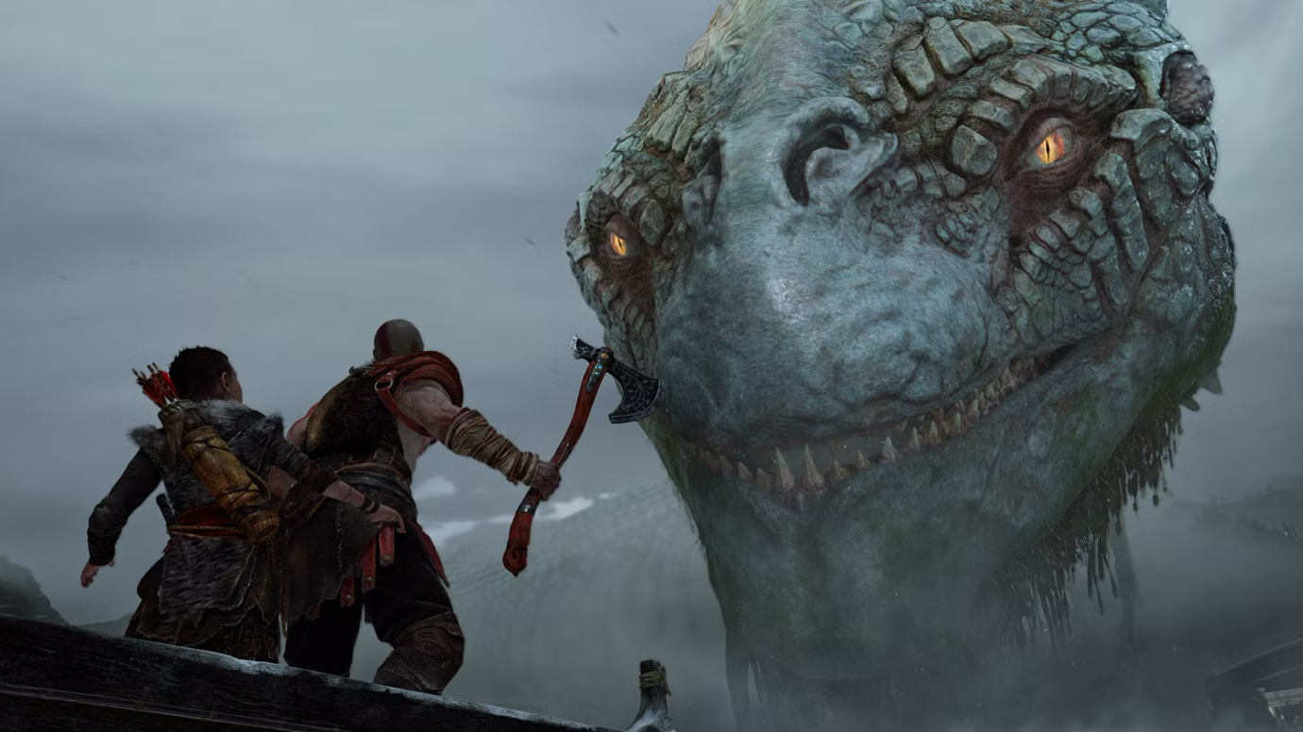
Figure 3. Kratos and Atreus acting as one
[35]
Within GOWR, this enmeshment evolves and becomes more contentious as Atreus grows into a teenager who desires independence. Kratos’ deep fear of losing Atreus, just as he had lost his wife, results with him struggling to allow Atreus to make his own choices and mistakes. As described previously, Kratos’ journey of becoming the God of War in Greece had been isolating—he had never needed to learn to rely on anything other than himself and his weaponry, he does not know how to be supportive of another [36].
Kratos’ journey to the self-forgiveness begins with Atreus. He teaches his son to refuse to wallow in self-pity, and to instead ‘be better’. This breaks the perpetuating, generational cycle of violence and rage. Kratos himself begins to slowly let go of his shame, which is symbolised by the removal of the bandages on his arms in front of Atreus in GOW. The act of becoming vulnerable with a loved one through inner strength, is a realistic struggle that audiences can resonate with.
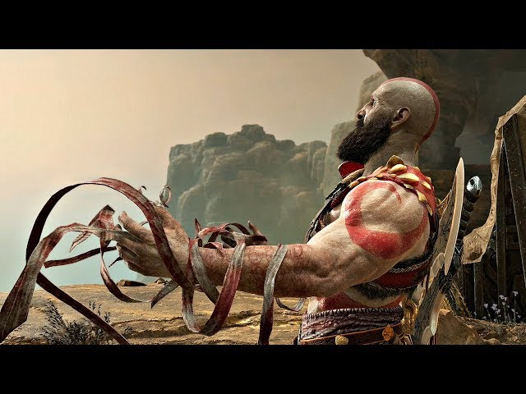
Figure 4. God of War 2018, Kratos removing his bandages in front of Atreus
[37]
Throughout GOWR, they both navigate the universal challenges of a distant parent learning to connect, the struggle to overcome past mistakes and to forgive oneself, and the difficult transition of guiding a child toward independence. During GOWR’s DLC (see Appendix B) Valhalla, Kratos is forced to confront the image of his younger self as an embodiment of his own pain, destruction and arrogance. Rather than rejecting this part of who he is, he decides to accept that version of himself, not as a vengeful monster, but as a man who lives, and chooses the better path despite his origins and past decisions.

3.8 Kratos Visual Design
Kratos’ visual design is large, stalking, and displays visual signs of both age and an extensive, exhausting past weighing heavy on his shoulders. Through his slow, heavy combat style, it reinforces the character’s psychology through gameplay mechanics. His design serves to communicate his strength, through scars and his large, muscular stature.
Kratos’ design reflects the emotional burden through the heavy armour on his shoulders, and the dark animal fur that drapes over his shoulders and down to his back. The fur also serves as a narrative device, communicating the drop in temperature from the beginning of Fimbulwinter to the player.
He is often portrayed with a wide stance, promoting his confidence and stability in his strength [38]. Posture is an often overlooked section of character design, typically overshadowed by narrative and visual design, however it is just as integral in communicating the character’s emotional state and personality, and allows for a more grounded, realistic character. Kratos’ lack of hair is also a feature that ties into his lore and gameplay. In his past, as a Spartan general and fighter, his lack of hair avoids giving enemies a tactical advantage, such as grabbing hair during battle. It would also cause visual clutter to the player, if Kratos had been designed with longer hair.
Kratos’ colour palette includes white, red and dark grey, with golden accents to hint toward the influence of Norse mythology. A bright, saturated blue is also a minor accent colour to his design through his weapon, the Leviathan axe, both representing the cold environment, and the mystical magic at play.
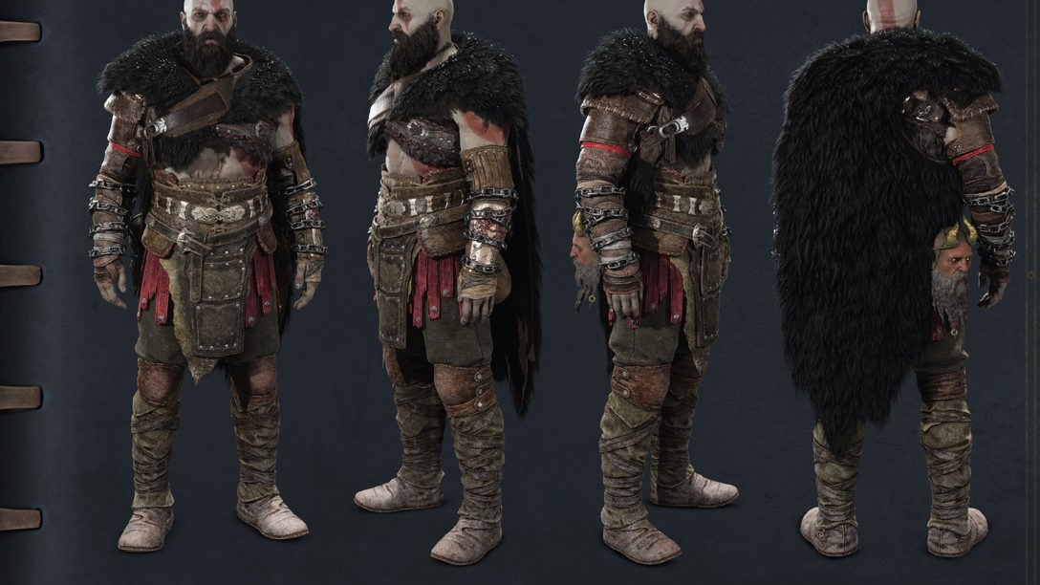
Figure 5. God of War Ragnarok Kratos Design
[39]

CHAPTER 4

4.0 Evaluation of Case Studies
Within Silverhand and Kratos, there are two distinct themes unfolding between them. Kratos’ narrative delves into internal struggle and interpersonal relationships (i.e. fatherhood), whilst Johnny’s narrative tells a tale of external rebellion.
Both characters, however, paint stories of redemption, a capacity to change, and an opportunity to stray the path from vengeance and suffering, to no longer perpetuating acts of violence. The immersive quality of gaming is driven by various narrative immersion techniques, including visual storytelling, sound design, and interactive elements. Together, these components work in tandem to engage players on a deeper emotional level than many other traditional storytelling mediums [40].

4.1 Player Expectations within Genres
Escapism releases a neurochemical dopamine, a neurotransmitter that governs reward, pleasure and motivation. This reaction can occur through both passive daydreaming, and active engagement with gaming, reading, or addictions, effectively turning aversive states into dopamine-driven moments of relief from everyday life [41].
The fantasy genre allows players to escape into a word alien from our own, to absorb storytelling and vast lore, and to create their own experiences that they otherwise would have never endeavoured in. Appositionally, the cyberpunk genre does not shy away from confronting the political and technological state of the world, and instead, it amplifies it to a futuristic, dystopian degree. Cyberpunk offers cautionary storytelling of ‘what could be’ to its audience, whilst maintaining the façade of gritty, flashy aesthetics, through its densely littered, neon-lit streets.
The cyberpunk genre also offers a critique on the systems in place players see perpetuating today and appeals particularly to those seeking political and social resonance, and in some cases, justification of scepticism and nihilism.
Both genres serve to offer audiences power fantasies, where fantasy revolves around dragons, Gods, magic and elves, cyberpunk revolves around cybernetic enhancements, transhumanism and the idealised version of rebellion.

CHAPTER 5

5.0 Further Analysis - Relatability through The Human Condition
Though Silverhand is a digital ghost in a dystopian society, his relatability ultimately stems from regret. His visual design is a constant reminder of his unfinished business with Arasaka, which makes his anger feel earned and justified rather than simply stylistic to the audience.
Kratos, a previous Spartan general and current God of War, evolves from a vengeful God to a grieving father. By anchoring his Godly abilities with the burden of parenthood and grief, the fantastical and mystical environment depicted in GOWR becomes secondary to his newfound motivation; to protect his son, and to support Atreus’ own journey.
Silverhand and Kratos push the narrative that the more fantastical the world, the more intimate and relatable the character’s internal conflict should be to allow for audience resonance and PARs. Relatability is a concept not limited to setting—it instead is created by a connection between the audience and a character’s narrative and visual designs, through realistic character development and exploration of the human condition.

5.1 Relatability beyond Worldbuilding
Outside of the respective genres mentioned throughout the presented thesis, the concept of relatability perpetuates outside of egotistical projection. It can also be seen in how a character is portrayed, and the pre-established notions that one may hold of a concept. For example, vampires have been historically portrayed as ghostly pale, with dark, sleek hair, long black capes and fangs. Despite the concept of a vampire pre-existing this date, Bram Stoker wrote a Gothic horror novel in 1897 dubbed ‘Dracula’ [42]. A movie was then created directly inspired from the book in 1931[43], which depicted the textbook vision of a vampire from Stoker’s writings.
Much like Johnny Silverhand’s ‘rocker-boy’ appearance, and Kratos’ large, stalking structure and posture, these design elements aid in communicating the nature of such a character.
A questionnaire (see Appendix A) was released on this concept, and most responses fit alongside this notion. One responder noted that they ‘expect and hope to see blood when consuming vampire media’. Character tropes such as this facilitate quick and guaranteed audience connection and understanding, cultural familiarity and narrative efficiency.
Playing along to pre-existing character tropes also proves to satisfy audiences’ expectations—as mentioned by the responder, audiences expect to witness blood when consuming media containing vampires [44]. However, this also raises the question of if prioritising recognisability and utilising familiar concepts over innovation can stunt creative character design and instead limit the creative processes taking place over aiding them.
A study was conducted on the exploration of stereotyping within the context of animation and animated media. This study was conducted through 4 individual 30-45 minute interviews with experienced character designers and people working in the animation field. One responder brings up the idea of utilising these tropes as ‘building blocks’ instead of absolutes within a character design visually and narratively [45]. Taking parts from pre-existing tropes can prove effective, as another responder states, ‘tropes are classics for a reason’.
This will also facilitate audience relatability and ease of recognition; Johnny Silverhand and Kratos both consist of these ‘building block tropes’, such as grief or distrust of one’s government, yet still build upon them and stand out as unique due to their respective fictional worlds.

CHAPTER 6

6.0 Conclusion
Players can relate to characters by both bypassing, and indulging, within the fantasy of the world their game offers. Themes such as father and son dynamics, seen in GOWR, and rebellion and social commentary, seen in Cyberpunk 2077, are not only limited to these worlds, but are shared experiences amongst audiences. Through egocentric projection and having agency within the game’s outcome, the player can develop an emotional attachment to NPCs. Therefore, character relatability does not require realism in its world but instead requires strong emotional character arcs with explorations of the human condition, and ideological depths, that connect and resonate within the audience. A character’s visual design can not only appease pre-existing expectations and aesthetics but can also facilitate further resonance amongst audiences. Visual and narrative character designs are both emphasised by one another.
Through the analysis of Kratos and Johnny Silverhand, this dissertation has demonstrated that player relatability is grounded in universal emotional struggles, shared ideologies and visual design, allowing audiences to form meaningful connections with characters, regardless of their fantastical or dystopian settings.
This study is limited to two characters, within two genres, from Western AAA gaming experiences. It may not serve to fully represent the diversity of player experiences or character design practices across the entire industry. This study can both be pushed further and extended through more player reception studies, such as interviews. Broader genre comparisons, such as horror, realism, skill-based gaming, etc, may also pose unique concerns and strengths with relatability. Differing cultural contexts may also inform further exploration on how character relatability is constructed within interactive media.
This dissertation has also informed a prospective character design booklet, where the findings proposed within this study will be incorporated into live practice. It will apply the theoretical and analytical perspective developed throughout this dissertation. This art book will stand as the bridge between analysis and creative practice, as well as demonstrating how research can directly influence character design methodologies.

REFERENCES
[1] “Cyberpunk 2077,” CD Projekt Red, Warsaw, Poland, 2020. https://www.cyberpunk.net/us/en/ Accessed: Mar. 20, 2026.
[2] “God of War Ragnarok,” Santa Monica Studio, Los Angeles, CA: Sony Interactive Entertainment, 2022. Accessed: Mar. 20, 2026.
[3] “A Cyberpunk 2077 perspective on the prediction and understanding of future technology,” Miguel Bordallo López, Constantino Álvarez Casado, University of Oulu, Finland, 2025. https://www.sciencedirect.com/science/article/pii/S1875952125000321 Accessed: April. 30, 2026.
[4] “Engaging Characters: Fiction, Emotion and the Cinema,” Murray Smith, 1995. Accessed: Mar. 20, 2026.
[5] “Player-Avatar Identification, Relationships and Interaction Pt. 1 | Dr. Jaime Banks,” Medienpsychologie Würzburg, 2023. https://youtu.be/glKvWiz8Xgg?si=CeZ5MsyidOmIdQaA Accessed: April 30, 2026.
[6]” Sad Stories as Grief Support: Understanding the Processing and Well-Being Outcomes of Biographic Resonance with Meaningful Entertainment,” Julia M. Wilson and Emily Moyer-Gusé, 2025. https://www.tandfonline.com/doi/full/10.1080/15213269.2025.2548509 Accessed: Mar. 20, 2026.
[7] “Frankenstein,” Mary Shelley, London, 1818. Accessed: Mar. 20, 2026.
[8]” Interview with The Vampire,” Anne Rice, California, 1976. Accessed: Mar. 20, 2026.
[9]” The Works of Edgar Allen Poe,” P. F Collier & Son, 1903. Accessed: Mar. 20, 2026.
[10]” The Human Condition,” Hannah Arendt, The University of Chicago Press, 1958. Accessed: Mar. 20, 2026.
[11]” Do Androids Dream of Electric Sheep?” Philip K. Dick, Doubleday, United States of America, 1968. Accessed: Mar. 20, 2026.
[12]” Blade Runner” Ridley Scott and Michael Deeley, Burbank California, 1982. Accessed Mar. 20, 2026.
[13] “Health Effects of Social Isolation and Loneliness,” CDC, 2024. https://www.cdc.gov/social-connectedness/risk-factors/index.html Accessed Mar. 20, 2026.
[14] “The Magic of Character Design in Storytelling,” Parfait’s Palette, 2025. https://parfaitspalette.medium.com/the-magic-of-character-design-in-storytelling-3460d8f5d36f Accessed Mar. 20, 2026.
[15] “How much does everyone else change their V from start-end?” Cyberpunkgame subreddit, 2025. https://www.reddit.com/r/cyberpunkgame/comments/1htuusl/how_much_does_everyone_else_change_their_v_from/ Accessed April. 20, 2026.
[16] “Why gaming can be good for your mental health,” BBC Bitesize, 2024. https://www.bbc.co.uk/bitesize/articles/zngxkhv Accessed Mar. 20, 2026.
[17] “PlayStation,” Sony Interactive Entertainment, 2026. https://www.playstation.com/en-gb/ Accessed Mar. 21, 2026.
[18] “AAA,” Harish Alagappa, 2021. https://gameopedia.com/blogs/aaa-games-a-comprehensive-guide Accessed Mar. 21, 2026.
[19]” How does Trauma affect Memory,” Wellman Psychology, 2025. https://wellmanpsychology.com/mindbodyblog/2025/2/27/how-does-trauma-affect-memory Accessed Mar. 21, 2026.
[20] “The Truth About Blame-Shifting: Is the Responsibility Never Yours?” Dr Linda Berman, 2025. https://waysofthinking.co.uk/2025/02/18/the-truth-about-blame-shifting-is-the-responsibility-never-yours-by-dr-linda-berman/ Accessed Mar. 21, 2026.
[21] “VR Headset,” Meta, 2026. https://www.meta.com/gb/quest/?srsltid=AfmBOopRftW6Upsiujd_yIPJ5miAanJ_npj_TPCw1AHOctiZ4A2hAT3j Accessed Mar. 21, 2026.
[22]” Apple Vision Pro,” Apple, 2024. https://www.apple.com/uk/apple-vision-pro/ Accessed Mar. 21, 2026.
[23] “Meta Glasses,” Meta, 2025. https://www.meta.com/gb/ai-glasses/?srsltid=AfmBOooLoDoExNkvX8bUO8Lajakgu1GanPm46KEhwsql2FtDasYu0nJQ Accessed Mar. 21, 2026.
[24] “Elon Musk reveals brain-hacking plans,” BBC, 2019. https://www.bbc.co.uk/news/technology-49004004 Accessed Mar. 22, 2026.
[25] “Elon Musk’s startup eyes human testing for brain-computer interface,” Kelly Servick, 2019. https://www.science.org/content/article/elon-musk-s-startup-eyes-human-testing-brain-computer-interface Accessed Mar. 22, 2026.
[26] “It’s a terrible choice to make but also a necessary one: Exploring player experiences with moral decision making mechanics in video games,” Sophie Wright, Alena Denisova, University of London, University of York, 2024. https://www.sciencedirect.com/science/article/pii/S0747563224002929 Accessed Mar 22. 2026.
[27] “How War Turned Aviator Sunglasses into a Style Icon,” Fuse Lenses, 2025. https://youtu.be/hR2p9UhcYTI?si=L4AfxmzKjiZmEkn1 Accessed Mar. 22, 2026.
[28] “The Ultimate Guide to Character Design Fundamentals,” Studio Liddell, Central Manchester, 2024. https://studioliddell.com/news/the-ultimate-guide-to-character-design-fundamentals Accessed Mar. 22, 2026.
[29] “Cyberpunk 2077 – Johnny Silverhand,” Marcin Blaszczak, 2020. https://mblaszczak.artstation.com/projects/J9nVXn Accessed April. 4, 2026.
[30] “Santa Monica Studios,” Santa Monica, California, 1999. https://en.wikipedia.org/wiki/Santa_Monica_Studio Accessed Mar. 23, 2026.
[31] “God of War,” Santa Monica Studio, Los Angeles, CA: Sony Interactive Entertainment, 2018. Accessed: Mar. 20, 2026.
[32] “God of War: Ragnarok totally flips the father-son power dynamic,” Willa Rowe, 2022. https://www.inverse.com/gaming/god-war-ragnarok-preview-kratos-atreus Accessed Mar. 23, 2026.
[33] “Enmeshment Theory,” Salvador Minuchin, 1970. Accessed Mar. 23, 2026.
[34] “When A Parent Needs Too Much: How Enmeshment Hurts a Child,” Dr Margaret, 2025. https://drmargaretrutherford.com/when-a-parent-needs-too-much-what-is-enmeshment-and-how-does-it-hurt-a-child/#:~:text=What%20you%20might%20hear%20from,one%20could%20do%20it%20better Accessed Mar. 23, 2026.
[35] “God of War review,” Chris Plante, 2018. https://www.polygon.com/2018/4/12/17226486/god-of-war-review-ps4-2018/ Accessed April. 5, 2026.
[36] “Fatherhood and Trust in God of War,” Patrick Dickerson, 2022. https://gatecrashers.fan/2022/01/03/fatherhood-and-trust-in-god-of-war/ Accessed Mar. 23, 2026.
[37] “God of War 4 – Kratos Removes His Bandages Infront of Atreus Scene (God of War 2018) PS4 Pro,” Zanar Aesthetics, 2018. https://www.youtube.com/watch?v=MJh0_euxBiQ Accessed April. 5, 2026.
[38]” Character Development Through Posture,” Pamela Fernuik, 2016. https://thewritepractice.com/posture-character-development/ Accessed Mar. 23, 2026.
[39] “From Concept Art to Cosplay: Creating Kratos and Atreus’ new looks for God of War Ragnarok,” PlayStation Blog, 2022. https://blog.playstation.com/2022/10/20/from-concept-art-to-cosplay-creating-kratos-and-atreus-new-looks-for-god-of-war-ragnarok/ Accessed April. 5, 2026.
[40] “Why Video Game Narratives Are Revolutionising Cultural Storytelling,” Jaber Khater, 2025. https://medium.com/@jaberkhater/why-video-game-narratives-are-revolutionizing-cultural-storytelling-26e3953a0a83 Accessed Mar. 23, 2026.
[41] “Dopamine release in the nucleus accumbens by hypothalamic stimulation—escape behaviour,” P V Rada, G P Mark, B G Hoebel, Princeton University, 1998. https://pubmed.ncbi.nlm.nih.gov/9519267/ Accessed Mar. 23, 2026.
[42] “Dracula,” Bram Stoker, Ireland, 1897. Accessed April. 17, 2026.
[43] “Dracula,” Tod Browning, Universal Pictures, New York, 1931. Accessed April. 17, 2026.
[44] “Vampires and the Consumption of Blood,” Kevin Masters, https://people.southwestern.edu/~bednarb/su_netWorks/projects/masters/vampires.html Accessed April 17, 2026.
[45] “How Do Character Artists Work with Or Against Stereotypes and Tropes When Designing, And What Are the Psychological Consequences of Stereotypes on Youth Wellbeing?” Shikha Iyer, 2024. https://nhsjs.com/2024/how-do-character-artists-work-with-or-against-stereotypes-and-tropes-when-designing-and-what-are-the-psychological-consequences-of-stereotypes-on-youth-wellbeing/ Accessed April. 17, 2026.

BIBLIOGRAPHY
“The Art of Character: Creating Memorable Characters for Fiction, Film and TV,” by D. Corbett, 2013.
“Screen, Culture, Psyche: A Post-Jungian Approach to Working with the Audience,” by I. John, 2006.
“Adult Children of Emotionally Immature Parents,” by G. Lindsay, 2015.
“Understanding Media Psychology,” G. S. Stever, C. David, E. M. Mary, 2025.
“Creating Character Arcs: The Masterful Author’s Guide to Uniting Story Structure, Plot and Character Development,” by K.M. Weiland, 2016.

APPENDIX A: Questionnaires
Genre Relatability between Cyberpunk and Fantasy Genres, and Character Design Inference Questionnaire - https://forms.gle/mp6V8YPtq8buQwAQ8
Word and Aesthetic Associations tied to Character Species’ Questionnaire - https://forms.gle/4HczNYJ5CKJBK7Zo9

APPENDIX B: Abbreviations
GOW – God of War 2018.
GOWR – God of War Ragnarok.
AI – Artificial Intelligence.
NPCs – Non-Playable Characters.
DLC – Downloadable Content.
PARs – Player-Avatar Relationships.

APPENDIX C: Story Elements – Cyberpunk 2077
V – The main perspective and character of Cyberpunk 2077. This is who the player assumes the role of within the universe.
Relic - A biochip slotted into the neural port of V's neck containing the engram of Johnny Silverhand.
Engrams – The digitalised consciousness of a human being.
Soulkiller – An advanced AI program within the Cyberpunk 2077 universe that digitalises a person’s consciousness into an engram whilst killing their physical body.
Night City – The fictional city that Cyberpunk 2077 takes place within.
Cyberware – Cybernetic implants that players can install, exchange and upgrade onto V’s body.
Samurai – A fictional rock band featured throughout the Cyberpunk series’, whose music was a method of rebellion against corporations for the lower class.
Arasaka – A fictional world-wide megacorporation dealing in corporate security, banking and manufacturing on a world-wide scale.
Militech – One of the largest manufacturers of weapons and military vehicles within the world of Cyberpunk 2077. Also, Arasaka’s corporate rival.
The Net/Cyberspace – The telecommunications network within the Cyberpunk universe.
Mikoshi – A secure Arasaka prison in Cyberpunk 2077 designed to store digitalised human consciousnesses, or ‘engrams’, created by the Soulkiller program.
Morgan Blackhand – A high-level solo operative and a top Militech mercenary, famous for his black-chrome arm.
Alt Cunningham - Alt Cunningham, a fictional character within the Cyberpunk 2077 universe, was once a talented netrunner during 2013, and Arasaka kidnapped her for her skill during that time. However, Johnny, alongside a team, raided Arasaka Tower to save her, ultimately leading to her accidental death.

APPENDIX D: Story Elements – God of War Ragnarok
Atreus - The Norse God of Mischief, Loki, and Kratos’ son.
Fimbulwinter/Ragnarok - An aspect of Norse mythology, where a three-year long winter signals the beginning of the end of the world, also known as Ragnarok, referred to in the title of the game.
God of War 1-3/Original God of War Trilogy – In the original God of War trilogy, set in Greece, Kratos was once a Spartan general who almost faced defeat, but ultimately pledged his soul to Ares (the God of War in Greek mythology) in exchange for victory. However, Ares deceived Kratos into murdering his wife and daughter, to transform him into the ultimate warrior with no mortal ties or bounds. Their ashes bound into his skin (this design aspect was carried on into GOWR), and thus, came his title “The Ghost of Sparta.” After multiple ages of serving the Greek Godhood, Kratos sought out his own revenge. Eventually, he killed Ares and took his place as the new God of War, systematically destroying the Greek pantheon and defying fate itself. His vengeful rampage left Greece in ruins, for every God he had murdered had inadvertently unleashed a plague amongst humanity. The final instalment of the original trilogy ends with Kratos giving humans the power to live without the aid of the Gods, and his fate was then left undecided until Santa Monica Studios soft-rebooted the franchise in 2018, signifying the switch from Greek mythology to Norse, and beginning the duology of God of War and God of War Ragnarok.
The Nine Realms – The realms of Norse mythology. Midgard, Alfheim, Asgard, Vanaheim, Niflheim, Muspelheim, Helheim, Svartalfheim and Jotunheim. All lands are connected by the world tree, Yggdrasil.
Giants – A near-extinct race of magical beings within Norse mythology.
The Gods in Asgard – Odin, the All-Father and ruler of Asgard, and his son, the God of Thunder, Thor. Odin thrives on foresight and predictability, whilst Kratos is considered an uncontrollable variant, due to his history defying fate itself. Kratos actively threatens Odin’s order, and in lieu, his control in Asgard. Thor’s sons, Modi and Magni, and his brother, Baldur, were all killed by Kratos, making his vendetta visceral and deeply personal. This gives Odin and Thor shared interest in opposing Kratos.

