
Softbank’s Acquisition Deal of ARM Holdings -a Change Management Research Based on an International Strategic Management Perspective

Name: Ren Zheng
Student Number: 1811691
Module Title: Strategic Change and Organizations (LCDB7005)
Module Lecturer: Dr. Gladius Kulothungan

UNIVERSITY OF WALES TRINITY SAINT DAVID

Softbank’s Acquisition Deal of ARM Holdings
-a Change Management Research Based on an International Strategic Management Perspective

Abstract
With the continuous development of the global economy, the international operation of companies in various countries has entered a new stage, gradually developing from passive compliance to active transformation. Softbank Group has continuously adjusted its industrial layout by virtue of its CEO Sun Zhengyi and its management team's sinister and developmental investment vision and distinctive international strategy, making Softbank Group gradually become a very powerful multinational group in the international market. In July 2016, Japan’s SoftBank Group Corp announced the acquisition of ARM Holdings PLC ARM.L for a total of approximately £24.3 billion at a premium of 43%, which is an important international strategic change for Softbank. This paper first introduces the two companies and acquisition events, then uses the PEST model and SWOT model to analyze the Softbank Group theoretically, and summarizes the strategic imperative behind the acquisition from the perspective of internationalization strategy, finally clarifies the impact of acquisitions from the perspective of the two companies’ strategy , structure, culture, and technical aspects.

List of contents
Abstract i
List of contents ii
List of figures iii
1Introduction 1
2Softbank and ARM Holdings 3
2.1Softbank 3
2.2ARM holdings 3
3Strategic imperative behind the acquisition from the view of Softbank 5
3.1Theoretical analysis 5
3.1.1PEST analysis 5
3.1.2SWOT analysis 10
3.2Strategic imperative behind the acquisition 15
3.2.1Acquisition needs 15
3.2.2Acquisition opportunities 16
3.2.3Acquisition ability 16
3.2.4Entrepreneurship 17
3.2.5Culture 17
4Change impacts of the acquisition 19
4.1Change impacts from the viewpoints of Softbank 19
4.1.1Strategy 19
4.1.2Organizational structure 19
4.1.3Culture 21
4.2Change impacts from the viewpoints of ARM 24
4.2.1Strategy 24
4.2.2Organizational structure 25
4.2.3Technology 25
5Conclusion 27
References 28

List of figures
Figure 1 Softbank Development Path 2
Figure 2 Softbank's important strategic initiatives 3
Figure 3 AMR's important strategic initiatives 4
Figure 4 PEST analysis 5
Figure 5 SWOT analysis 15
Figure 6 Organizational structure of Softbank 21
Figure 7 Cultural onion 22
Figure 8 Cultural onion of Softbank 24

1Introduction
On July 18, 2016, Japanese telecom giant Softbank announced its acquisition of British chip design manufacturer ARM Holdings PLC ARM.L for 24.3 billion pounds ($32 billion) in cash which would be the largest acquisition transaction conducted by Softbank since the acquisition of US telecom operator Sprint(Softbank ; Jin, 2007b). According to the news of the financial website MarketWatch on July 21, Softbank CEO Sun Zhengyi said at an event held in Tokyo on the same day: "In 20 years, the annual shipment of ARM architecture chips will reach 1 trillion, and ARM can collect all real-time data immediately."(MarketWatch)
Looking back at the development of Softbank, under the leadership of Sun Zhengyi, Softbank has never stopped its international development. In the 1990s, Softbank set up the Softbank branch in the United States, set up Yahoo Japan, acquired the US magazine publishing company, and cooperated with Australia in the satellite broadcasting business, investing in Alibaba. After 2000, it accelerated the international business. The process not only participated in the fixed communication business, mobile communication business, but also established the Natural Energy Association in the gradual development, launched the mobile advertising business, and even the power supply and the business development of intelligent robots, thus making its international geographical change more extensive, and the business field broader, which provides a solid foundation for its international development. Among the softening internationalization strategies, the most important international cooperative enterprises are China Alibaba, USA Ya-hoo and US Sprint(Ruoyan, 2012; Jie, 2009; Jin, 2007a; Zhengui, 2016; Kotaro Masuda, 2014; Jin, 2007b).
Today, Softbank has become a full-service integrated company that provides almost all mainstream information services, covering basic communication services such as mobile phones, landline phones, and broadband access, as well as e-commerce, broadcast media, book magazines, e-libraries, and digital content (see Figure 2)(Softbank, ; Jin, 2007b).
In summary, Softbank has invested in a variety of businesses through acquisitions, such as acquisitions of ARM, and realized its international strategy of diversification. This not only enabled it to accumulate international experience, but also successfully realized the withdrawal of capital providing favorable conditions for Softbank to further internationalize its process and integrate its own resources. This paper explores the change management of Softbank's acquisition of ARM Holdings from the perspective of corporate internationalization strategy management.
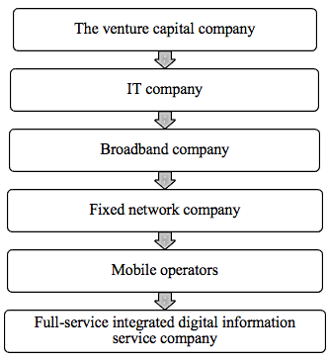
Figure 1 Softbank Development Path

2Softbank and ARM Holdings

2.1Softbank
Founded in Japan in 1981 by Sun Zhengyi and listed in Japan in 1994, Softbank is a comprehensive venture capital firm focused on investments in the IT industry, including networking and telecommunications. Softbank has invested in more than 600 companies worldwide and has a majority stake in more than 300 major IT companies worldwide(Softbank ; Jin, 2007b).
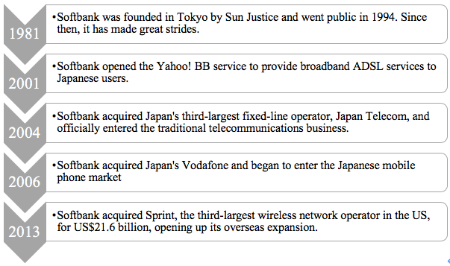
Figure 2 Softbank's important strategic initiatives

2.2ARM holdings
In 1978, ARM's predecessor, the Acorn RISC Machine, was founded in Cambridge, England. After more than 20 years of development, ARM has grown rapidly with the rise of the mobile consumer electronics market. From the beginning of mobile smart terminals to the present, ARM has been in the leading position in the entire chip market. As of 2015, more than 1,384 mobile chip manufacturers worldwide, including Qualcomm, Samsung, and MediaTek, have adopted the ARM architecture, and More than 85% of smartphones and tablet chips worldwide use ARM-based processors. More than 70% of smart TVs are also using ARM processors(ARM ; Gengyi, 2016).
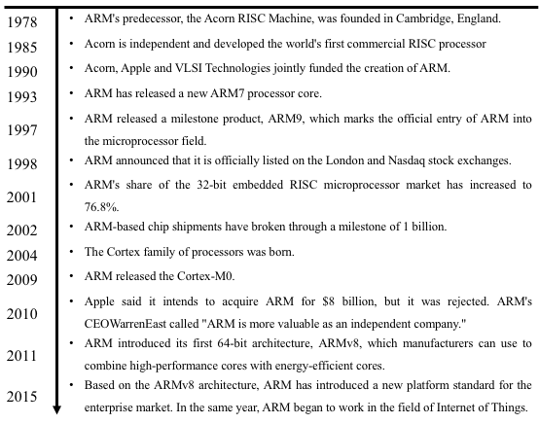
Figure 3 AMR's important strategic initiatives

3Strategic imperative behind the acquisition from the view of Softbank

3.1Theoretical analysis

3.1.1PEST analysis
In many cases, the success of business operations is closely related to the macro environment in which it operates, and its external macro environment is difficult to be controlled and changed by enterprises. Enterprises can only adapt and seek development opportunities in dynamic changes(Gupta, 2013). This paper uses the PEST model (Figure 4) to analyze the macro environment of enterprise development.
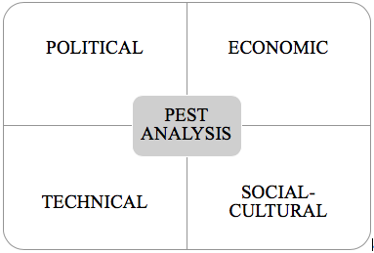
Figure 4 PEST analysis

3.1.1.1Political environment
National policies and regulations will affect the development trend of enterprises. From the perspective of Japan's domestic policies, constant revision and improvement from the initial prototype of the "Public Telecommunications Law" to the "Electrical Business Law" promulgated in 1985, to the "NTT Law" and "KDD Law" introduced later reflects Japan’s policy changes or emphasis on telecommunications industry, reflecting the development of the Japanese telecommunications industry(Jin, 2007b).
In the first round of telecom industry reform in Japan, Japan enacted the "Electrical Business Law" for the first time. The law greatly promoted the development of Japan's domestic telecommunications industry through the encouragement and protection measures for new telecommunications companies, and enriched telecommunications. The number and vitality of the market. The number of telecom operators and service companies has increased to a large extent(Ketterer, Bernhofen and Milner, 2015; Jianxin and Qinghua, 2006).
In the second round of reform, the Japanese government revised the "Telecom Business Law", mainly revised the enterprise access requirements, and industry integration began gradually. The "NTT Law" was revised to varying degrees in 1992 and 2001, including adjustments to limit the proportion of NTT Group's foreign shareholding: From the initial restrictions on foreign capital, only the proportion of shares held up to 1/5 is allowed to increase to 1/3(Jianxin and Qinghua, 2006).
At this point, the telecommunications market has basically achieved the full liberalization of the enterprise. As the level of development of the Japanese economy has improved, the formulation of the government's legal system has become more and more in line with international standards, thus making the internationalization of Japanese companies more rapid and stable(Jun, 2003).

3.1.1.2Economic environment
Since the 1990s, the economic development trends of countries around the world have changed a lot. The United States is still the hegemon of the world and has taken the lead in the international arena. However, the financial crisis that has affected many countries from Wall Street in 2008 has also had a great negative impact on the US economy of the imperialist powers, hitting people's economic confidence and causing greater losses to the global economy. Meanwhile, The resulting debt crisis in Iceland, Greece and other countries, financial and other industries have been seriously affected. Moreover, the physical and virtual economy of each country has also suffered a lot. At the same time, developing countries represented by emerging economies such as China are rapidly emerging. The international status of the “BRIC countries” has risen rapidly and has undergone major changes to the international landscape(Jirui, 2000; Tsukamoto, 2011; Bartlett, Doz and Hedlund, 2013; O'Neill, 2015).
Because of the subprime mortgage crisis in the United States, Japan’s economic development has slowed down, and its status and competitiveness in the international are also somewhat declining(Ruiping, 2006; Siyu, 2015; Ketterer, Bernhofen and Milner, 2015). Especially after Japan’s natural disaster such as a major earthquake, the economy has once again suffered heavy losses. Under the stimulus of Abenomics, the situation in Japan is still in an unfavorable situation such as rising prices and falling Nikkei, and its domestic economy has entered a period of adjustment and oscillation(Jun, 2003; Yongsheng, 2011).

3.1.1.3Social-cultural environment
In the economic development of today's society, the traditional telecommunications industry in various countries has been quite stable. The market for fixed-line, mobile phones and the Internet is close to saturation, and the period of rapid increase in corporate profits is coming to an end(Schwab and Sala-i-Martín, 2016; 'World communication network). With the new vitality brought about by the information revolution, the mobile Internet, Internet of Things and other service industries have been in the new round of industrial cycle. In December 2009, Japan has confirmed that the new economic growth strategy should be oriented to the IT industry. After the improvement and revision of the national policy system, Japan has reached a more optimized development environment for information industry technology, and ultimately achieves the goal of improving people's quality of life and enhancing international competitiveness. The resulting domestic industrial restructuring, economic development, and changing consumer attitudes have brought new opportunities and markets to the telecommunications industry and the Internet industry.
To a certain extent, the economic policies implemented by the Abe government have played a greater role in stimulating Japan’s economic development, especially in disposable income. Increasing disposable income can increase consumption power, increase consumption levels, boost demand, increase employment rate, thereby further increasing income and promoting better development of the Japanese economy(Feng and Xiaolan, 2014). With the development of the economy, the per capita disposable income of the citizens has increased, the consumption structure has been adjusted, and young people who have grown up with Japanese domestic Internet companies have become new consumers. They have potential targets for large and medium-sized domestic enterprises. In order to speed up the construction of a system of convenient services, it is necessary to increase the speed of developing the Internet and related new-type economies, promote the people's increasing consumer demand, and promote the improvement and change of the national lifestyle and related service industries.

3.1.1.4Technical environment
The continuous advancement of global IT technology has brought new opportunities to the development of the communications industry and the Internet. The time between advanced technology and practical applications has become less and less, thanks to the rapid development of new telecom services such as 3G and LTE (a wireless communication standard). In recent years, Japan’s mobile phone business is in a period of rapid development in the new phase(Jingwei, 2009; Shuhong and Ming, 2001; Dongyang, 2002; Jie, 2009).
Japan rebuilt 3G network facilities on a large scale in the post-disaster infrastructure reconstruction in 2011. After vigorously restoring 3G services, it launched LTE services as a new business, and invested heavily in research and development and promotion of this new technology. Driven by 3G and LTE services, Japanese mobile phone users will continue to maintain rapid growth and provide a more solid foundation for overseas expansion. Nowadays, a new round of information technology industry revolution is changing the world, the most prominent being cloud computing and the Internet of Things. Enterprises from all over the world are looking for new development opportunities in some important future industry sectors(Jin, 2007a). Among them, the emerging Internet application intelligent search technology and community network have become more and more popular among the public, and have become an important form of community to expand the Internet economy market. The rapid development of these Internet technologies guarantees the continuous improvement of the Internet economy and is the cornerstone of the rapid development of the Internet economy(Jianqing, 2002).
Therefore, Internet technology service enterprises need to take control of the new business model of this era, form an opportunity for themselves to have more competitive advantages under the premise of solid information technology, and play their own strength in the process of internationalization(Ota Takushiro, 2012; Akdemir, Baúçι and Togan, 2005; Gerpott and Jakopin, 2007).

3.1.2SWOT analysis
This section will analyze the strength and weakness, opportunity and challenge in the development of Softbank's international operations from multiple perspectives.

3.1.2.1Strength
①Leading position of communication operators
Softbank has strong overseas market development strength due to advanced domestic technology and various product preferential policies. The domestic market share of the company's products continues to expand(Hang, 2014; Jin, 2007b). According to the 2006 report, after the acquisition of Vodafone's Japanese business, Softbank became a three-way communications company with NTT and KDDI, the traditional Japanese communications leader. The bright business performance also gave Softbank the ability to continuously expand international capital cooperation, and gradually developed into a world-renowned telecom operator(World communication network).
②Successful marketing and customer service
In developed markets, quality and service determine whether a company can succeed. In order to improve the quality of product service, the company strengthens communication with customers, continuously improves the service system, improves the standardization of service processes, provides diversified services for customers, provides personalized services for customers in different regions, and continuously improves the professional level of customers to create greater economic benefits(Jie, 2009; Shuhong and Ming, 2001).
③Product diversification
Softbank's product services include business software, servers, natural energy, channel sales, professional services and terminals. Softbank is developing towards internationalization, accelerating innovation, constantly improving the production and manufacturing systems of enterprises, and controlling the operating costs of enterprises within a reasonable range to create greater economic benefits for enterprises. Softbank regards consumers as the core, improves customer service quality through multiple channels, builds its own brand, provides customers with a better experience, and creates a good Internet application experience(Jin, 2007b; Kotler, 2000).
④Brand internationalization
The main advantage of the company's international operation lies in its growing influence in the international communications equipment market. Through Heavy Reading's full investigation of multiple service providers around the world, including brand influence, features, product quality, etc., I understand that Softbank enjoys a high reputation in terms of product price, quality, sales service and brand awareness(heavy reading).

3.1.2.2Weakness
① Lack of technical talent
As the market share of overseas business of the company continues to expand and international operations enter a new stage of development, Softbank needs a large number of professional and technical personnel to cope with the rapid development of Internet telecom and other industries(Imai et al., 2015; Ruiping, 2006). At present, the internationalization of Softbank is mostly achieved through acquisitions, investment, etc. The drawbacks of direct acquisitions have led Softbank to lack the talents in the professional and technical fields, and these talents can only be satisfied through the competition for talents(Jin, 2007b; Yongjie, 2016).
②Management structure is not standardized
Although Softbank has obvious management advantages compared to other companies, there are many problems in the internationalization process of the company, especially the imbalance of market, technology and management. There is no major center that is the advantage of as well as its disadvantages Softbank. The ministries are not optimal at the same time in the development of the company. The period of dispute between the parties may lead Softbank to miss better development opportunities(Honjo, 2015; Taozhe, 2004; Jin, 2007b).

3.1.2.3Opportunity and threat
①Huge demand in the world communication market
The rising demand of the world communication market, especially the recovery of the international market, can create a good development opportunity for the world's communication companies to expand their international market share(Imai et al., 2015). The large scale of the world market and the relevant development policies formulated by the government have further promoted the international communications industry to seize emerging markets and created good development opportunities for the industry's trending investment(Akdemir, Baúçι and Togan, 2005).
②International market entry barriers are low
The communication equipment manufacturing industry can expand product sales by continuously expanding the backward market share of the communications industry, and the demand of most overseas communication network companies far exceeds the development space of the Japanese domestic market, and the operating efficiency is low(Schwab and Sala-i-Martín, 2016). Therefore, if local dominant enterprises can actively participate in the international market competition, it will not only help to enhance the influence of enterprises, but also expand the international market share of enterprises(Kotler, 2000).
③To achieve global resource optimization configuration
In the process of internationalization, Softbank also needs to improve the efficiency of human resource utilization on a global scale. In order to introduce foreign advanced technology and absorb successful management experience from abroad, Softbank can strengthen cooperation with other enterprises, which will not only expand the scale of market development, but also help to enhance the core competitiveness of enterprises(Rui, 2012; Jin, 2007b).
④ Industry competition is increasingly fierce
Although Softbank has occupied a large market competitiveness due to its cost-effective product service, other multinational competitors have also set new strategic goals and promoted their technological innovation to expand the market(Jiang, 2002). If the price advantage in emerging markets is not obvious, and in the case of a vicious price war and other factors affecting the market order, such as the adjusted price to obtain a higher transaction amount, the development of Softbank itself will be greatly affected(Jin, 2007b).
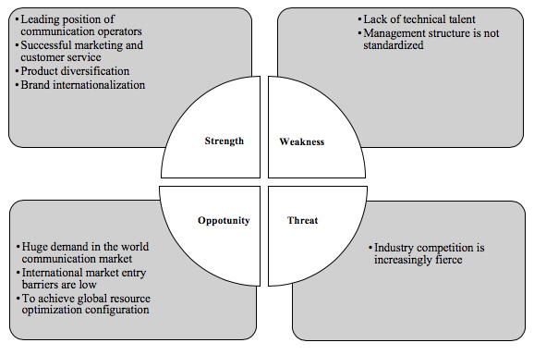
Figure 5 SWOT analysis

3.2Strategic imperative behind the acquisition
Qiuzhi, X. and Jiqing (2008)believe that the necessity or urgency of acquisitions will enable business managers to analyze acquisitions, provide support for acquisition development, and take the initiative to seize acquisition opportunities. Therefore, the necessity of acquisitions is the basis for promoting the development of acquisition, and also determines the economic strength, development opportunities, and acquisition strategies of acquisition. Entrepreneurs' understanding of the development of the target international market, legal policies, political culture, etc. will also affect the acquisition process. At the same time, the learning attitude, enthusiasm and subjective initiative of the company's management personnel determine its understanding of the international market. All of the above conditions are conducive to ensuring the normal development of acquisition, and can also improve the risk prevention capability of enterprises(Qiuzhi, X. and Jiqing, 2008). Therefore, This paper analyzes the motives of acquisitions of Softbank from the following points combining SWOT analysis above.

3.2.1Acquisition needs
Under the conditions of the monopoly of the traditional domestic communication equipment market and the imperfect government's foreign policy, if Softbank wants to take a bigger advantage in the market competition, and compete with domestic industry giants, it is necessary to change the traditional business model, improve its own specialization and gradually develop towards internationalization(Rui, 2012). Due to strong market insight, in the 1990s , Sun Zhengyi invested in Internet-related companies in the United States, where the communications industry developed more rapidly. In 1996, through its holding company in the United States, the company increased its stake in Yahoo, and became the company's largest shareholder(Jin, 2007b). These initiatives provide a key strategic development and acquisition demand base for Softbank's acquisition of ARM.

3.2.2Acquisition opportunities
Sun Zhengyi, the president of Softbank, has a keen eye for observation and familiarity with the international market due to his early years of studying abroad and starting a business. The contacts and work teams established during the US study period enable them to pay close attention to and understand the dynamics of the world market, and provide a solid information foundation and team strength for future Softbank acquisition and international initiatives (Ketterer, Bernhofen and Milner, 2015; Yang, 2009). The joint operation of multiple work teams at home and abroad not only creates and seizes opportunities in overseas markets, but also creates a good development opportunity for Softbank to open markets in Europe and the United States, and provides a rare opportunity for Softbank to acquire ARM.

3.2.3Acquisition ability
Softbank's strong economic strength and unique investment vision have provided support for the company to expand its international market. Since the 1990s, the company has started the process of acquisitions and internationalization. At the same time, Softbank's strong strength in sales, technology and services has laid the foundation for its ability to learn from foreign advanced companies, take acquisitions and other international business initiatives(Hang, 2014; Jin, 2007b).

3.2.4Entrepreneurship
Sun Zhengyi is an adventurous and visionary entrepreneur. With its entrepreneurial spirit, Softbank has a stronger determination to explore the international market than other companies, so that it can better grasp the opportunities for acquisition development(Xiaohe, 2001). In the initial stage of entrepreneurship, Sun Zhengyi told the company's employees,“I would earn 10 billion yuan in five years and 50 billion yuan in ten years. One day, my career will be several trillion yen. “ Internationalization is an important strategy in the process of Sun Zhengyi's goal for many years, and acquisition is an important part of it(Jun, 2002; Fei, 2000).

3.2.5Culture
Sun Yin, the president of Softbank, is known as the “rebel” and is a well-known “hereic character” in the communications industry(Yan, 2007). Under the leadership of Sun Zhengyi, Softbank has not become a patriarchal enterprise, but has formed a corporate culture that adheres to “strengthism”, which makes employees who often have bold challenges and outstanding achievements in the company. For example, in Softbank, employees will be promoted regardless of age,as long as they work hard and make continuous achievements; employees can directly submit to the president, if they have good suggestions.
Although the internal competition of Softbank is very fierce, everyone works together to form an equal and interactive "destiny community" in order to achieve the goals of the company(Jili, 2015). For this reason, Softbank can rise at an alarming rate and become an important member of the international market with fast decision-making, fast action and strict confidentiality, in the process of acquisitions and internationalization(Jin, 2007b).

4Change impacts of the acquisition

4.1Change impacts from the viewpoints of Softbank

4.1.1Strategy
The main strategic change for Softbank's acquisition of ARM is to enter the Internet of Things and artificial intelligence. Sun Zhengyi stressed that enterprises hope to grasp the good development opportunities of the Internet of Things, and ARM is an important part of the company's strategic assets, and also the core of the company's development strategy(Yongjie, 2016). According to ARM's financial report, in the last quarter of 2015, ARM licensed multiple chip manufacturers, including mobile computing, smart cars and other fields.
According to the IDC report, by 2020, the global IoT market will continue to expand and expand to 8.9 trillion US dollars, and access to the Internet will reach 30 billion. There are even reports that the number of access devices for the Internet of Things will reach 100 billion by 2025(IDC). Massive IoT connections require more cost-effective chips, and this is the advantage of ARM architecture. As the influence of mobile clients continues to expand, ARM is gradually developing due to its low cost and absolute ecosystem advantages, becoming a global chip giant(Gengyi, 2016). Softbank hopes that ARM will fully realize its advantages in the field of Internet of Things to improve Softbank’s International Competitiveness(Yongjie, 2016; Zhengui, 2016).

4.1.2Organizational structure
Softbank achieves rapid growth through professional, unique and leading market scent and business investment and services. Softbank mainly operates professional and diversified communication services, and has rapidly grown on the basis of telecommunications and the Internet. Its business involves its domestic telecommunications services, mobile communications services in the United States, Yahoo business, distribution services, hardware and software design services for mobile devices, fund services and other services. Softbank has invested in and provided services to customers in countries and regions around the world through the Internet. It has grown into a large group of companies covering China, Japan, the United States, India, and the Netherlands(Jin, 2007b).
The main organizational change of Softbank's acquisition of ARM is the addition of ARM, a major subsidiary specializing in chip development. Plus a wholly-owned Softbank and Sprint company providing mobile communication services, Japan's Yahoo!, a search service provider, and Brightstar, a leader in the global wireless industry's leading publisher, service and innovation company, Softbank has established a group structure that includes several major businesses involving multiple business areas in order to achieve better international management effect (as shown in Figure 2-1 below)(Jin, 2007a; Zhengui, 2016).
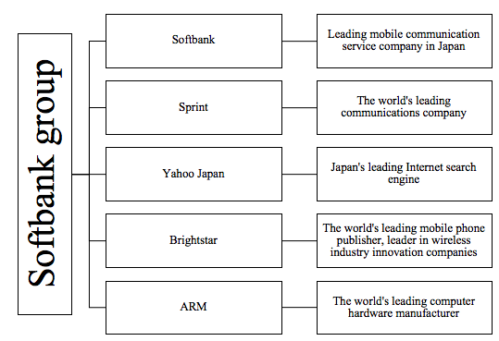
Figure 6 Organizational structure of Softbank

4.1.3Culture
Acquisitions will bring about cultural integration. However, because Softbank's corporate culture is stronger than ARM, the impact of acquisitions on Softbank culture may be minimal. This article describes the corporate culture of the Softbank Group through Hofstede and Bond (1984)'s “onion skin theory”.
Hofstede's “onion skin theory” compares culture to onion, so the levels of culture is like the layers of onion: symbols, heroes, rituals and values. Among them, symbols represent the outermost surface layer which can be a word, a pose, a chart, or an object of their specific meanings. Only people who share this culture can recognize them. The middle layers are heroes and rituals respectively. Heroes represent the ones of people's worship in a culture, and thus more or less symbolize the character of most people in the culture. They can be living or dead, real or fictional characters. Rituals are a group activities, the unique expression of people and nature in every culture, such as social Etiquettes, religious ceremonies, business and political gatherings. Symbols, heroes, and rituals are all attributed to the term "practice," which can be observed by the outside world. However, their cultural significance is intangible, and it is all manifested by the people in this cultural circle. Values, representing the deepest expression, are the basic beliefs and value orientations that people follow. They are the feelings of pointing to the positive side or the negative side with arrows, such as kindness and evil, beauty and ugliness, conforming to the laws of nature and violating the laws of nature. Values are the core of culture(Hofstede, 1980; Baskerville, 2003; Hofstede and Bond, 1984; Hofstede, 2003).
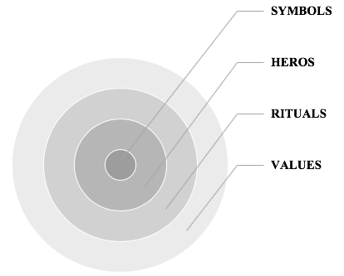
Figure 7 Cultural onion

(2) Softbank’s culture onion rings
The cultural onion rings of Softbank Group are from outside to inside:
- Symbols: bold challenge, hard work, rumored channel, fast decision, fast action, strict confidentiality
Softbank companies often have bold-challenging employees who have achieved outstanding results. As long as employees work hard and continue to make achievements, regardless of age, they will be promoted. If there are good suggestions, employees can ask the president directly. Softbank has become an important player in the international market due to its fast-deciding, fast-moving and confidential campaign style in the process of acquisitions and internationalization(Xiaohe, 2001).
- Hero: Sun Zhengyi ("rebels", "heretics", adventurous, visionary)
Sun Yin, the president of Softbank, is known as the “rebel” and is a well-known “heretic character” in the communications industry. Sun Zhengyi said to the company's employees: earning 10 billion yuan in five years and 50 billion yuan in ten years, one day, my career will be several trillion yen. Internationalization is a stage that Sun Zhengyi must undergo in order to achieve its goals for many years. He is an adventurous and visionary entrepreneur.(Fei, 2000; Jili, 2015)
- Retails: Working together, "the community of destiny"
Although the competition within Softbank is fierce, everyone can work together to form an equal and interactive "destiny community" in order to achieve the goals of the company(Jili, 2015). For this reason, Softbank can rise and develop at an alarming rate.
- Values: "Strengthism", pioneering and enterprising
The entrepreneurial spirit led by Sun Zhengyi makes the company have stronger determination to explore the international market than other companies and can grasp the opportunities of international development. Under the leadership of Sun Zhengyi, Softbank has not become a patriarchal enterprise, but has consistently adhered to "strengthism" within the company. The entrepreneurial spirit led by Sun Zhengyi makes the company have stronger determination to explore the international market than other companies, and can better grasp the opportunities of international development(Jili, 2015; Yang, 2009; Ketterer, Bernhofen and Milner, 2015).
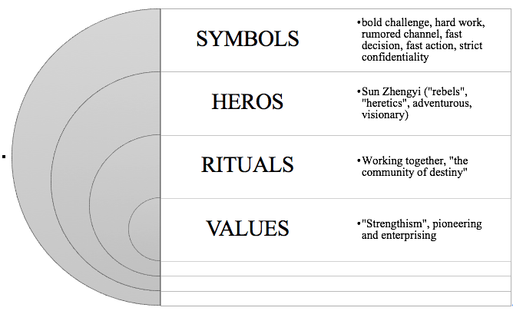

Figure 8 Cultural onion of Softbank

4.2Change impacts from the viewpoints of ARM

4.2.1Strategy
Lan Fergusont, vice president of ARM Global Marketing and Strategic Alliance, revealed that in the future, ARM's regional strategic center will not be tilted to Japan due to Softbank's acquisition, and its headquarters is still in the UK. After the merger, ARM will receive sufficient working capital, and the management will focus on innovation investment and launch a longer-term technology development plan. At the same time, ARM will increase investment in software to build a richer IoT ecosystem(Yanhu, 2016).

4.2.2Organizational structure
After the merger, ARM's board of directors re-combined, from the original five to six, three of which are from Softbank, including Sun Zhengyi, the other three are ARM CEO Simon Higas, CFO and CTO . It can be judged that the original management team of ARM can still grasp the future development direction of the company. Meanwhile, ARM's existing workforce will grow rapidly, and this is the driving force and source of technological innovation. Lan Ferguson said that in the future, ARM will deploy engineers and human resources teams closer to the end market, such as Greater China and the United States, and plans to double the UK team(ARM ; Yanhu, 2016; Kotler, 2000; Jin, 2007b).

4.2.3Technology
Ian Ferguson said that after the merger, the process of ARM's construction of the IoT underlying ecosystem will be accelerated. In the cloud infrastructure of the Internet of Things, ARM is the leader of the IoT terminal ecosystem, and Softbank has already had a strong investment and results. Therefore, the cooperation between the two parties has realized the "end to cloud" system integration, which can accelerate the rapid spread and realization of Internet of Things technology. Ian Ferguson revealed that ARM has begun to think about new acquisition opportunities and provide new value to its IoT platform, with its acquisition target being an innovative company with IoT data analytics solutions(Zhengui, 2016; Yanhu, 2016; Akdemir, Baúçι and Togan, 2005).

5Conclusion
Softbank has achieved such outstanding results in acquisitions and international development. In addition to its incomparable political, economic, social and technological environment in domestic and foreign markets, it is also related to its own unique international strategy. From the acquisition of ARM by Softbank, we can see Softbank's overseas development strategy. In the case of limited domestic development, Softbank set a model for wireless network operators, expanding market share through overseas acquisitions, as well as looking for new development space. In my opinion, Sun Zhengyi, the president of Softbank, is using its forward-thinking thinking in the communications industry to open the prelude to global resource integration in the LTE era for operators.

References
Akdemir, E., Baúçι, E. and Togan, S. (2005) 'EU Integration and the Telecommunications Sector: The Case of Turkey', Impact of Liberalization of Trade in Services: Banking, Telecommunications and Maritime Transport in Egypt, Morocco, Tunisia and Turkey, pp. 123.
ARM, https://www.arm.com.
Bartlett, C. A., Doz, Y. and Hedlund, G. (2013) Managing the Global Firm (RLE International Business). Routledge.
Baskerville, R. F. (2003) 'Hofstede never studied culture', Accounting, organizations and society, 28(1), pp. 1-14.
Dongyang, L. (2002) International Direct Investment and Economic Development. Economic Science Press.
Fei, Z. (2000) 'Sun Justice - Japanese Business Wizards', International Markets, (3), pp. 30.
Feng, S. and Zhang Xiaolan (2014) 'Can Abe Economics Save the Japanese Economy?' Northeast Asia Forum, (1), pp. 75-84.
Gengyi, C. (2016) 'Softbank Betting ARM', China Informatization, (8), pp. 18-21.
Gerpott, T. J. and Jakopin, N. M. (2007) 'Firm and target country characteristics as factors explaining wealth creation from international expansion moves of mobile network operators', Telecommunications Policy, 31(2), pp. 72-92.
Gupta, A. (2013) 'Environment & PEST analysis: an approach to the external business environment', International Journal of Modern Social Sciences, 2(1), pp. 34-43.
Hang, Z. (2014) The Empire of Mobile: The Apocalypse of the Rise and Fall of Japan's Mobile Internet. Zhejiang University Press.
HEAVY READING, http://www.heavyreading.com.
Hofstede, G. (1980) 'Culture and organizations', International Studies of Management & Organization, 10(4), pp. 15-41.
Hofstede, G. (2003) 'What is culture? A reply to Baskerville', Accounting, Organizations and Society, 28(7-8), pp. 811-813.
Hofstede, G. and Bond, M. H. (1984) 'Hofstede's culture dimensions: An independent validation using Rokeach's value survey', Journal of cross-cultural psychology, 15(4), pp. 417-433.
Honjo, Y. (2015) 'Why are entrepreneurship levels so low in Japan?', Japan and the World Economy, 36, pp. 88-101.
IDC, https://www.idc.com.
Imai, H., Chen, W.-l., Fukutomi, E., Okumiya, K., Wada, T., Sakamoto, R., Fujisawa, M., Ishimoto, Y., Kimura, Y. and Chang, C.-M. (2015) 'Depression and subjective economy among elderly people in Asian communities: Japan, Taiwan, and Korea', Archives of gerontology and geriatrics, 60(2), pp. 322-327.
Jiang, H. (2002) Analysis of the new development of multinational corporations and their economic effects. Heilongjiang People's Publishing House.
Jianqing, G. (2002) 'Reform of Japan's Telecom Service Industry and Implications for China', Audit and Economic Research, 17(1), pp. 50-52.
Jianxin, C. and Qinghua, Z. (2006) 'Comparative analysis of changes in US and Japanese telecom industry policies—from regulatory industries to freely competitive industries', Journal of Intelligence, 25(2), pp. 115-117.
Jie, D. (2009) 'The main way of internationalization of overseas M&A telecom operators', Consumer Guide, (4), pp. 25.
Jili, L. (2015) 'Sun Zhengyi', Business Review, 21st Century, (12), pp. 3.
Jin, Z. (2007a) 'Overseas Operators' Road to Internationalization and Transformation' Series (3) - From Non-Telecom Enterprises to Full-Service Operators - The Transformation of Japan's Softbank Corporation, Communication World, (08A), pp. 26-27.
Jin, Z. (2007b) 'Transformation and Development of Softbank Corporation of Japan', Information Network, (4), pp. 62-63.
Jingwei, Z. (2009) 'From the x-Japan model, see Japan's next-generation network development strategy', Communication World, (39), pp. I0015-I0015.
Jirui, G. (2000) 'The Rise, Features and Prospects of the US Internet Industry', World Economic and Political Forum, (3), pp. 6-9.
Jun, L. (2003) 'Analysis of Japanese Economic Trends and Causes (1992-2002)', Asia-Pacific Economics, (5), pp. 23-27.
Jun, T. (2002) 'The Invincible Borrower - Remembering Sun Justice and His Soft Silver Empire', Science and Technology Venture Monthly, (12), pp. 29-31.
Ketterer, T. D., Bernhofen, D. M. and Milner, C. (2015) 'The impact of trade preferences on multilateral tariff cuts: Evidence for Japan', Journal of the Japanese and International Economies, 38, pp. 31-51.
Kotler, P. (2000) 'Marketing management: The millennium edition', Marketing management, 23(6), pp. 188-193.
Market Watch, https://www.marketwatch.com.
O'Neill, D. W. (2015) 'The proximity of nations to a socially sustainable steady-state economy', Journal of Cleaner Production, 108, pp. 1213-1231.
Ota Takushiro (2012) 'The creator of the communication industry - the spirit of studying abroad', the cultivating business, 53(1), pp. 143-157.
Direct Investment and Going Global Strategy: Theoretical Basis and Empirical Analysis', Journal of Fudan University (Social Science Edition), 2008(1), pp. 23-31.
Rui, Z. (2012) 'Japanese companies overseas mergers and acquisitions surges', China Economic Herald.
Ruiping, J. (2006) 'The Japanese Economy and Sino-Japanese Economic Relations after Koizumi', Contemporary Asia-Pacific, 10, pp. 19-25.
Ruoyan, F. (2012) 'M&A Sprint Sun Zhengyi Plays the First Card of Overseas Gambles', IT Times Weekly, (21), pp. 50-51.
Schwab, K. and Sala-i-Martín, X. 'The global competitiveness report 2013–2014: Full data edition'. World Economic Forum.
Shuhong, K. and Ming, L. (2001) International Investment Science. University of International Business and Economics Press.
Siyu, P. (2015) 'My opinion on the current economic situation in Japan after the earthquake and its impact on China's economy', Business Story, (024), pp. 24-25.
Softbank, https://www.softbank.jp/en/.
Taozhe, B. (2004) 'Enli ghtenment brought by the development of Japanese telecommunications industry to China', Liaoning Economics, (3), pp. 96-96.
Tsukamoto, T. (2011) 'Devolution, new regionalism and economic revitalization in Japan: Emerging urban political economy and politics of scale in Osaka–Kansai', Cities, 28(4), pp. 281-289.
'World communication network'.
Xiaohe, D. (2001) 'Softbank Empire and Crash Fighting', Capital Markets, (2), pp. 28-29.
Yan, J. (2007) 'Sun Justice: The "hereic" hero in the digital age, inside and outside the classroom: high school edition, (3), pp. 30-31.
Yang, G. (2009) 'The founder of the network technology empire - Sun Zhengyi', Science Grand View Garden, (17), pp. 74-75.
Yanhu, Y. (2016) 'ARM's "change" and "unchanged" - Interview with Mr. Ian Ferguson, Vice President of Global Marketing and Strategic Alliances ARM, Electronic Technology Applications, 42(12), pp. 1-2.
Yongjie, S. (2016) 'Softbank Premium Mergers and Acquisitions ARM: Both sides are good and good, and variables', Communication World, (20), pp. 9-9.
Yongsheng, Z. (2011) 'The economic situation in Japan after the earthquake and China-Japan economic and trade exchanges', People's Forum, (A12), pp. 78-81.
Zhengui, M. (2016) 'Whales ARM: Softbank gambling future Internet of Things', Shanghai Informatization, (2016 09), pp. 44-47.

