Student Name: Osazee Iyamu
Student ID:2438257
Module Code:LCHS4003
Module Title: Introduction to health and social care
Lecturer Name: Muhammad Aliyu

Contents
Task 1: Poster 3
Task 2: Essay 5
References 7

Task 1: Poster
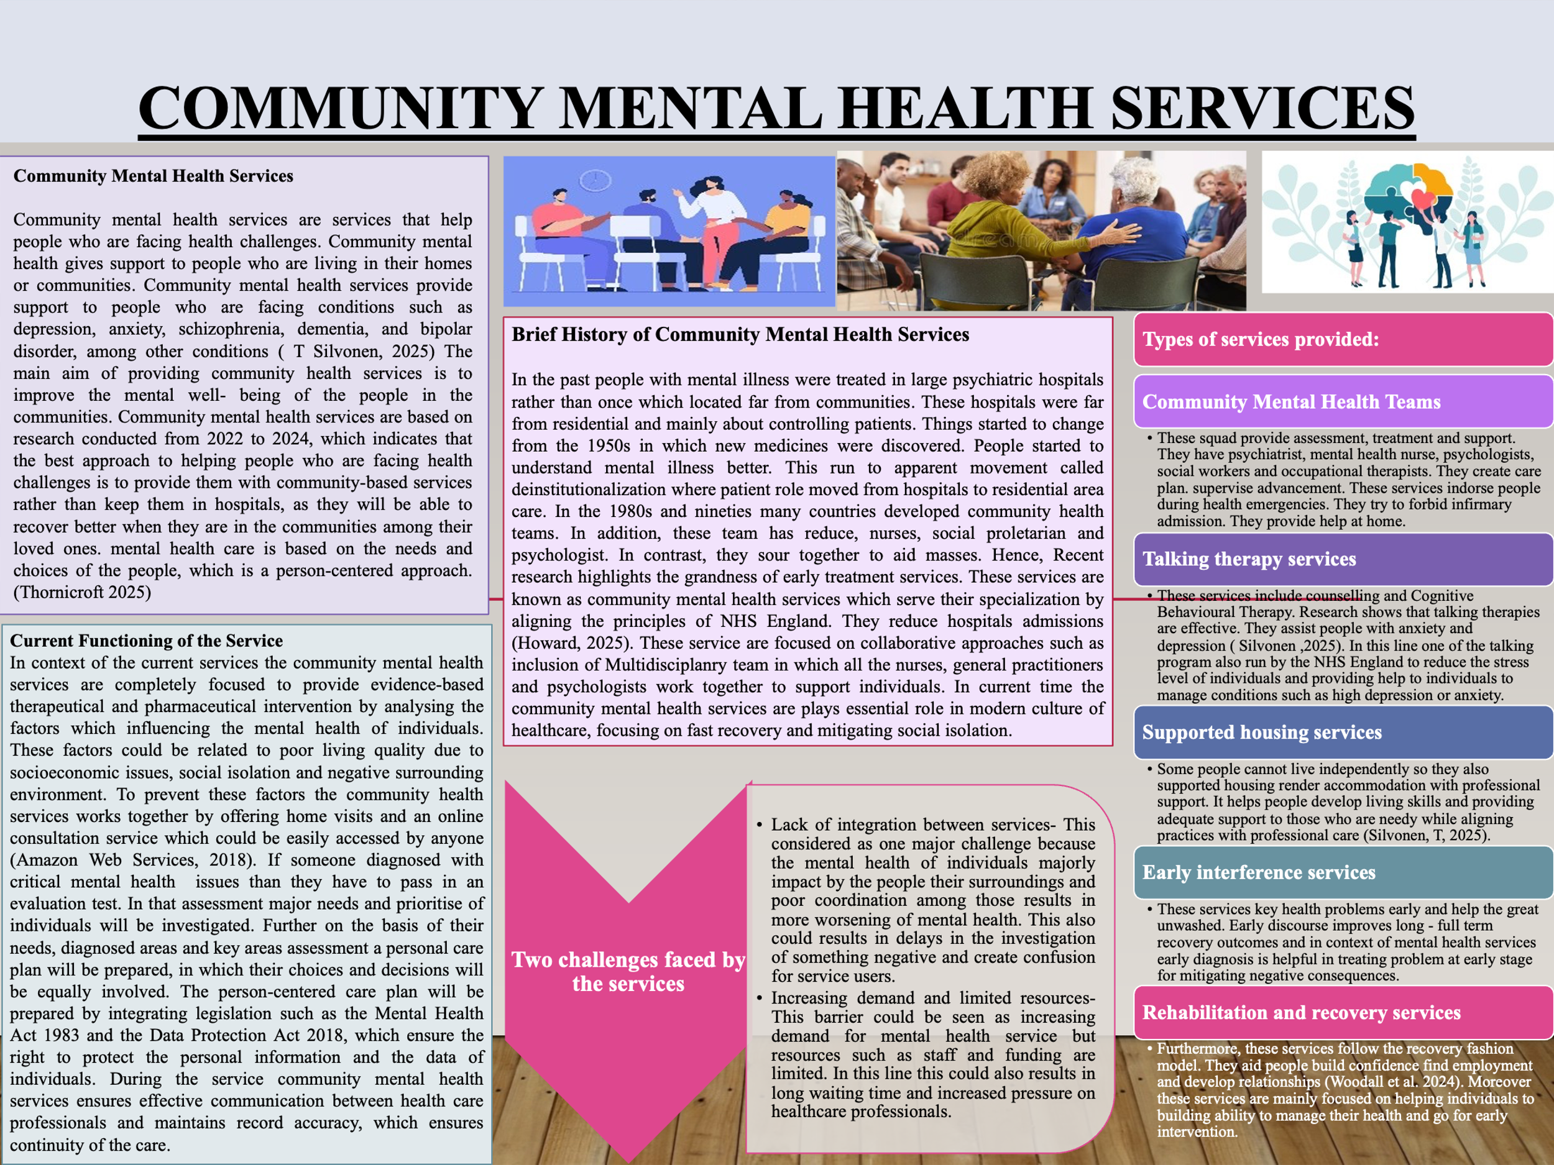
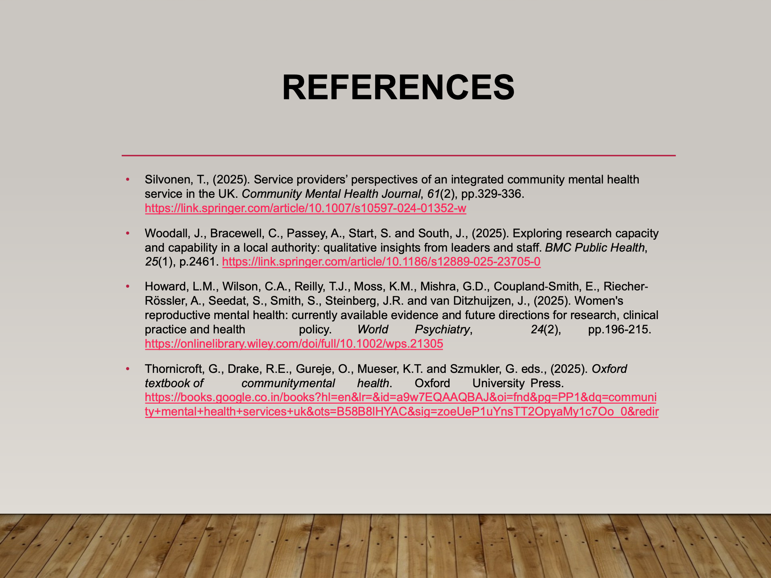

Task 2: Essay
Introduction
The key aim of this essay is to discuss the role of Ambulance services, which are an important part of healthcare systems. They provide emergency medical help to those who are seriously ill or injured. Ambulance services respond to emergencies such as accidents, heart attacks, breathing problems, and other medical conditions. Their main aim is to save lives, provide immediate care and safely transport affected individuals to hospitals. Ambulance helps are believing a vital link between the community and hospitals. They ensure patients receive quick medical attention before reaching the hospital. Modern ambulance services not only provide transport but also offer life - saving treatment on the way (2025).
Origin and historical development of ambulance services
The idea of ambulance services started many years ago, and in the context of the UK, the development of ambulance services in the UK can be traced to the late 18th century and in the initial phase of the 19th century. In these times, the ambulance services are mainly used during the war for soldiers who have suffered serious injuries. In the initial phase, the ambulance system was totally focused on transporting patients rather than providing treatment, so it could be assumed that this was a way of transportation from home to hospital. The development in the ambulance services took place in the late 20th century when the necessary major equipment was introduced in the vehicle, and motor vehicles were replaced with horse-drawn ambulances and basic medical necessities. Over the period, the ambulance was developed under the guidance of NHS England and became a public service for everyone and could be easily accessed by anyone. Over time, the role of ambulance staff developed, and paramedics became trained professionals capable of providing life-saving treatment before reaching the hospital. Basically, the development of the ambulance occurred due to the need for faster emergency response and equal access to healthcare staff for all individuals.
Services by Ambulance Services
Today, ambulance services are highly organized and work 24 hours a day. They respond to emergency calls from the public. When someone calls an emergency number, the rail call animal trainer who sends an ambulance if needed.
Modern ambulance services include:
Emergency response ambulances- These respond to life such as a hand brake. They are providing oxygen, defibrillators, medicines and monitoring equipment. Paramedics provide prompt treatment such as CPR or wound care (Meadley 2025).
Patient transport military service- These ambulances transport patients who are not in emergency brake situations but need medical transport to hospitals or clinics.
Air ambulance services- In serious situations or remote surface areas, helicopters are used to transport patients quickly. Research shows air ambulances improve survival chances in critical psychic trauma cases. Paramedic role paramedic are trained healthcare professionals. They assess patients, give emergency treatment and make decisions about the level of care needed. Their role has expanded in recent years to include advanced life support and clinical decision–making. The consumption of technology in modern ambulance services uses GPS tracking, digital patient track record and communication systems (Meadley, 2025). These technologies help ameliorate response time and coordination with the infirmary.
Importance of ambulance services in improving the quality of life
Ambulance services are very important because they directly affect survival and recovery outcomes. Their importance includes Saving lives. Quick response during emergencies can prevent death. Early medical care increases survival chances, especially in heart attacks and accidents. Providing continuous fear, ambulance staff provide discourse before reaching the hospital. This early intervention improves recovery outcomes. Reducing health complications, fast medical care prevents the condition from becoming worse. For example, quick treatment of stroke patients can reduce long - term disability (Asiri 2025). Week people Ambulance services support elderly people disabled somebody and people with chronic illnesses. This amends their safety and assurance in the healthcare system. Provide reassurance to the residential district. Knowing emergency help is available provides a sense of safety to the public. This improves overall residential area wellbeing (Pilbery, 2025). Challenges faced by ambulance services today are High demand. Recent studies show ambulance services face increasing demand due to an ageing population and an increase in health conditions. Therefore, this can cause wait (Pilbery, 2025). Staff pressure paramedics often work long hours in a stressful environment. Staff shortages can affect the quality of service and process. To improve service, research suggests more than funding, better workforce support and improved emergency planning.
Conclusion
Ambulance helps have developed from a basic transfer system of rules into advanced emergency healthcare providers. They now play a critical role in saving lives, providing other treatment and supporting community health. Although they face challenges such as high demand and staff shortage, ambulance services remain essential for improving the quality of life. With continued investment, training and technology evolution, ambulance services will proceed to play a vital role in the modern healthcare system.

References
Asiri, B.K.Y., Al-Sada, A.H.H., Alzain, M.I., Asiri, M.M.M., Al-barqi, A.A.A., Omar, O.M., Falqy, I.A.A., Alshehri, S.H.B., Alsayed, M.A. and Assiri, M.E.A., (2025). The Role of Paramedics in Early Recognition and Management Of Pediatric Emergencies. The Review of Diabetic Studies, pp.45-59. https://diabeticstudies.org/index.php/RDS/article/view/536
Howard, L.M., Wilson, C.A., Reilly, T.J., Moss, K.M., Mishra, G.D., Coupland‐Smith, E., Riecher‐ Rössler, A., Seedat, S., Smith, S., Steinberg, J.R. and van Ditzhuijzen, J., (2025). Women's reproductive mental health: currently available evidence and future directions for research, clinical practice and health policy. World Psychiatry, 24(2), pp.196-215. https://onlinelibrary.wiley.com/doi/full/10.1002/wps.21305
Meadley, B., (2025). History of Ambulance Services, Paramedics, and Research in Paramedicine. Research‐ focused Careers for Paramedics, pp.27-47. https://onlinelibrary.wiley.com/doi/abs/10.1002/9781394241279.
O'Hara, R., Sampson, F.C., Long, J., Coster, J. and Pilbery, R., (2025). What influences ambulance clinician decisions to pre-alert emergency departments: a qualitative exploration of pre-alert practice in UK ambulance services and emergency departments. Emergency Medicine Journal, 42(1), pp.21-27. https://emj.bmj.com/content/42/1/21.abstract
Pilbery, R., Sampson, F.C., Herbert, E., Goodacre, S., Bell, F., Spaight, R., Rosser, A., Webster, P., Millins, M., Pountney, A. and Coster, J., (2025). What factors predict ambulance prealerts to the emergency department? Retrospective observational study from three UK ambulance services. BMJ open, 15(3), p.e097122. https://pmc.ncbi.nlm.nih.gov/articles/PMC11891521/
Rezaei, J., Azouji, R., Azouji, M. and Ghorbani, H., (2025). Application of the Analytical Hierarchy Process in the management of private ambulance care systems in three selected European countries: a strategic decision-making framework. Frontiers in Public Health, 13, p.1526586. https://www.frontiersin.org/journals/public-health/articles/10.3389/fpubh.2025.1526586/full
Senkamalavalli, R., Prasad, S.N.S.E., Shobana, M., Sri, C.B., Sandiri, R., Karthik, J. and Murugan, S., (2025). Video conferencing algorithms for enhanced access to mental healthcare services in cloud- powered telepsychiatry. International Journal of Electrical and Computer Engineering, 15(1), pp.1142- 1151. https://d1wqtxts1xzle7.cloudfront.net/12
Silvonen, T., (2025). Service providers’ perspectives of an integrated community mental health service in the UK. Community Mental Health Journal, 61(2), pp.329-336. https://link.springer.com/article/10.1007/s10597-024-01352-w
Stoddart, H., (2025). Shifting First Aid: A Socio‐Historical Analysis of Tracing the Changing Relations Between First Aiders and the UK Ambulance Service From 1941 to 2020. Sociology Compass, 19(8), p.e70105. https://compass.onlinelibrary.wiley.com/doi/abs/10.1111/soc4.70105
Thornicroft, G., Drake, R.E., Gureje, O., Mueser, K.T. and Szmukler, G. eds., (2025). Oxford textbook of community mental health. Oxford University Press. https://books.google.co.in/books?hl=en&lr=&id=a9w7EQAAQBAJ&oi=fnd&pg=PP1&dq=communi ty+mental+health+services+uk&ots=B58B8lHYAC&sig=zoeUeP1uYnsTT2OpyaMy1c7Oo_0&redir
Woodall, J., Bracewell, C., Passey, A., Start, S. and South, J., (2025). Exploring research capacity and capability in a local authority: qualitative insights from leaders and staff. BMC Public Health, 25(1), p.2461. https://link.springer.com/article/10.1186/s12889-025-23705-0

