Webfolio
A webfolio is an evidence-based website, used to present stories about yourself or stories about your learning. They can contain any number of pages which can be added to, edited or deleted at any time. Pages may also contain links to websites and other assets within your ePortfolio.
A help movie is also available on this topic to highlight the options within the webfolio creation process. You may also find reviewing the webfolio editor help section useful.
Creating a webfolio
Click create new then more and choose webfolio from the menu

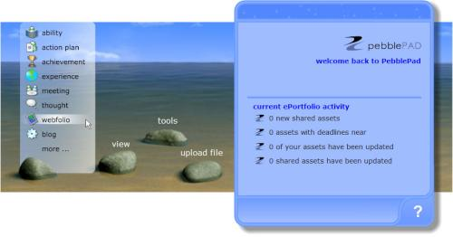

In the pad that opens there are areas to add a title, select a tag and add a description for your webfolio

The tags drop down box contains your most popular tags. More tags can be added by selecting all tags from the list or at the final stage of the creation process.

Click either the number 2 button or the next arrow on the navigation bar to move to the next section.

This section is where you can pick a template for the style of your webfolio.

Click the drop down box and select a template. Once you have chosen a template you can click the coloured boxes below the small preview area to select a different template within the same theme. You can also create your own template by scrolling down to create new template. (See templates help for more information.)

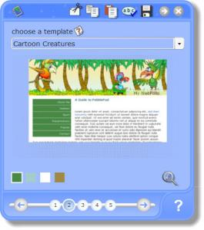

Once you are happy with the template you can view it, by clicking on the magnifying glass at the bottom right of the pad.

Click the number 3 button or the next arrow on the navigation bar to move to the next section.

This section allows you to define where you want to place the navigation baron the pages of your webfolio. You can place the navigation bar on the side or at the top of the webfolio. You can also place the sidebar left of the webfolio or to the right.

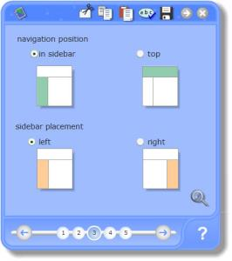

You can preview your selection by clicking the magnifying glass at the bottom right of the pad.

Click the number 4 button or the next arrow on the navigation bar to move to the next section.

This section is where you can add pages, and other items to your webfolio

- To add a page, click in the box which says [Enter Page Title Here] and type in a title for your page
- Click the downward chevrons to add the new page to the webfolio
- Repeat this process for as many pages as you wish to add
- You can re-position the pages, by clicking on the page title in the list and using the up and down arrows, on the left of the box
- You can edit the content of a page by clicking on the edit page icon at the bottom of the pad
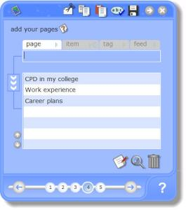

You can also double click on the page title for quick access to the webfolio editor for you to add or edit your page content

Items
You can embed items as separate pages within the webfolio, these include:
- webfolio -You can place an existing webfolio within the webfolio you are creating. When a viewer clicks on the webfolio the pages of the embedded webfolio will appear as subheadings in the webfolio navigation menu
- blog-You can embed a blog as a page in a webfolio this will include all the postings to the blog
- profile- You can add a profile to your webfolio. This will include all the evidence attached to the profile. Once added, the profile can be updated and evidenced from within the webfolio
- Flickr photo sets - If you have accessed your Flickr account through PebblePad you will see your Flickr photo sets. You can add one of these by selecting a set and then clicking the icon on the bottom right of the pad
- CV- You can add a CV previously created within PebblePad

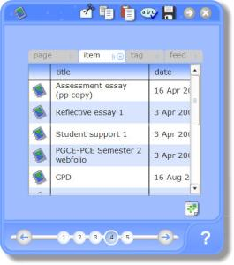

Tag
Adding a tag as a webfolio page simply adds all assets with the chosen tag to a page as a date ordered list. If a tag contains only images the page will be displayed as a gallery.

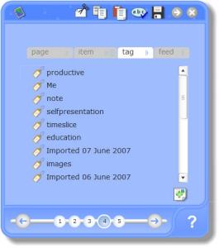

Feed
You can place an external RSS (Really Simple Syndication) feed within your webfolio. These can be obtained from websites if they have a RSS feed. The page will be updated from the website automatically, when you open up your webfolio.

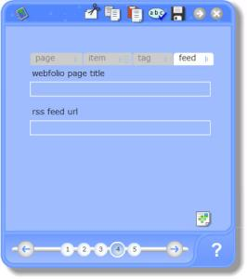

You can preview your webfolio by clicking on the magnifying glass on the bottom of the pad.

Click either the number 5 button or the next arrow on the navigation bar to move to the last section. You can choose to do a number of things with the webfolio asset you have just created:
- view it;
- send it to:
  - person
  - web
  - gateway
  - blog
  - word
  - printer
- add a review;
- add/edit a link/evidence;
- tag it

You can also simply click the tick button to save and close your asset.

