Module Code: BMSW5105
Module Title: Workplace Culture and its Impact on Organisational Efficiency
Task 1

Student Name:Cosmin Daniel Jaleru
Student Number: 237157

Contents
1. Introduction 1
2. Discussing Organisational Culture, Ethos and Values of Google 2
2.1. Four Types of Organsational Culture 2
2.2. Organisational Culture of Google 3
2.3. Cultural Web 3
2.4. Ethos 5
2.5. Values 6
3. Evaluating Effectiveness of Google’s Cultural Practice for Promoting Long-Run Sustainability 7
3.1. PESTEL Analysis 7
3.2. Porter’s Five Forces Analysis 9
3.3. Chances of Google’s Sustainability 10
4. Recommendation 12
5. Conclusion 13
Reference 14

Table of Figure
Figure 1: Organisational Culture 2
Figure 2: Cultural Web 4
Figure 3: PESTEL Analysis 8
Figure 4: Porter’s Five Forces Analysis 10

Introduction
This report focuses on Google, a globally renowned company. The objective of this paper is to illustrate the organisational culture inside Google's workplace. This study will assess to what extent the cultural practices of Google contribute to sustainability within the workplace. Additionally, it seeks to provide some improvement recommendations for cultural enhancement in the future.
Google is a prominent organisation that facilitates the process of discovering information on the Internet. It established its operations in 1998 and has experienced substantial growth in subsequent years. In addition, it performs a wide range of functions outside of its primary search capabilities. Particularly, it offers innovative products such as Google Maps for location identification and YouTube for video consumption. Moreover, it has an operating system for Android devices. Furthermore, Google is used on a daily basis by individuals for the purposes of acquiring knowledge, establishing social connections, and engaging in recreational activities. Thus, it can be considered as a transformative instrument that facilitates effortless navigation of the internet.
For the completion of the report, the paper has been divided into separate sections, each encompassing various stages of study. In the initial phase, Google's organisational culture, values, and ethos have been identified. Moreover, in order to justify Google's sustainability, an analysis of its cultural practices has been conducted through the use of PESTEL and Porter's five forces analysis model. In the final stage, recommendations have been provided.

Discussing Organisational Culture, Ethos and Values of Google

2.1. Four Types of Organsational Culture
Organisational culture can be described as a collective set of personality qualities that govern the behaviours and interactions of individuals inside a certain workplace (Martínez-Caro, et al., 2020). This phenomenon is rooted in individuals' beliefs, thoughts, and behaviours.
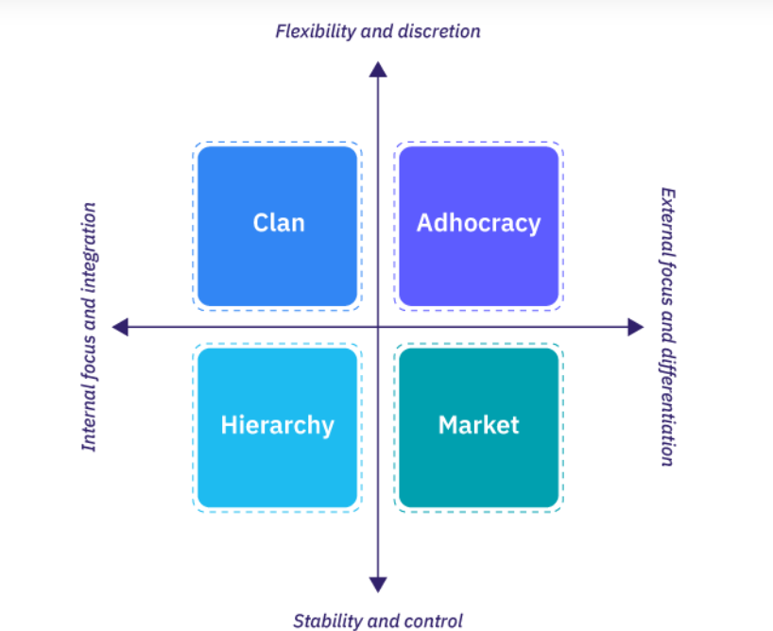
Figure 1 : Organisational Culture
Source: (Gardner, 2023)
Clan Culture: A clan culture might be compared to a large social unit inside a workplace setting (Carvalho, et al., 2018). Employees provide mutual assistance and maintain shared principles. They place confidence in one another and work together harmoniously to accomplish objectives. Moreover, the experienced personnel from the workplace fulfil the role of mentors. Indeed, the focus is on establishing healthy relationships and developing a working culture that prioritises employees.
Hierarchy Culture: In hierarchical cultures, there exists an explicit emphasis on obedience to norms and the establishment of organised roles. The organisational structure can be compared to a pyramid, wherein each employee is assigned specific responsibilities and is obligated to comply with rigid protocols (Krauss and Vanhove, 2022). Additionally, the cultural orientation of this society places a high emphasis on the principles of stability and consistency. Consequently, it has characteristics that are associated with tradition and bureaucracy, fostering a work environment that is well-regulated and well-organised.
Market Culture: In market culture, attaining ambitious goals, competing, and producing results are all essential. The environment of this culture is characterised by intense competition and a strong emphasis on achieving outcomes. The focus is on prioritising achievement and financial gain. Moreover, within this particular cultural context, the dynamic between people and the organisation is characterised by a contractual nature. In addition, this culture exhibits a profound concern for attaining exceptional outcomes.
Adhocracy Culture: The adhocracy culture is characterised by a dynamic and flexible work environment that prioritises creativity and innovation (Hamzah, et al., 2023). It also reduced the emphasis on conventional organisational structures. Moreover, this phenomenon promotes a tendency to engage in risk-taking behaviours and cultivates the ability to make autonomous decisions. However, this culture is commonly embraced by dynamic organisations that undergo rapid change and place significant emphasis on experimentation with novel concepts and the ability to adapt.

2.2. Organisational Culture of Google
The organisational culture of Google is predominantly characterised by a fusion of "Clan" and "Adhocracy" cultures.
First, Google follows clan organisational culture by placing a significant emphasis on cultivating a sense of familial and cooperative environment. In this context, individuals collaborate, demonstrate mutual reliance, and maintain shared principles. The workers involved exhibit a high level of trust and place a strong emphasis on collaborative efforts, fostering an environment reminiscent of an intimate familial unit.
On the other hand, Google possesses an adhocracy organisational culture as it fosters an environment that promotes invention and creativity, which are the exemplifications of the characteristics of an adhocracy Culture. Moreover, the distinctive office spaces and casual atmosphere at Google serve to reinforce the organisation's ethos of innovation and flexibility.

2.3. Cultural Web
The cultural web is a conceptual framework including six interrelated components that collectively provide insights into the essence of an organisation's culture (Driskill, 2018).
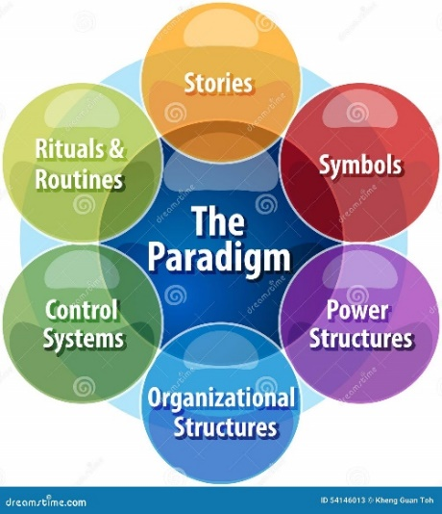
Figure 2: Cultural Web
Source: (Toh, 2018)
Stories: In 1998, Larry Page and Sergey Brin, the founders of Google, launched their entrepreneurial venture while pursuing their doctoral degrees at Stanford University (Levy, 2021). This modest beginning highlights the importance of fostering innovation. Moreover, Google's long-standing practice of featuring distinctive homepage of doodles and historical occasions exemplifies a dedication to fostering user engagement through creative means.
Symbols: The vibrant Google logo symbolises a dedication to innovation and user-friendliness while also reflecting a sense of inventiveness. Moreover, Google's global offices, characterised by their unconventional designs and innovative work environments. It places a strong emphasis on developing enjoyment. It also promotes the welfare of their employees. The goal statement of the organisation stresses the phrase "Don't be evil."
Rituals and Routines: Google's organisational culture is characterised by the use of practices such as the "20% time" policy, which serves to enhance creativity and promote innovation. On the other hand, the "Googlegeist" poll is designed to gather feedback from employees with a focus on promoting ongoing enhancement. These routines illustrate Google's core principles of innovation, transparency, and the promotion of employee welfare. Moreover, the TGIF meetings facilitate an environment of open discourse and visibility.
Power Structures: The organisational structure of Google is characterised by a notable flatness, which fosters a culture of open communication and empowers employees. This configuration facilitates collaborative efforts and promotes inclusivity, prioritising a cultural environment. In the environment, thoughts and choices are openly exchanged. Moreover, Google adopts a matrix management framework, which underscores its dedication to moral leadership and inventiveness. Consequently, employees are accountable to many supervisors as required (Moore and Tambini, 2018).
Control Systems: The control systems employed by Google are characterised by their reliance on data, with a particular emphasis on analytical thinking and the monitoring of performance. The prioritisation of data is given importance for making well-informed and objective conclusions. Moreover, the implementation of strict quality control measures guarantees the dependability of the product. Thus, it matches a corporate ethos centred on achieving high standards of performance and customer contentment. The culture of responsibility and ethics is underscored by adherence to ethical and legal norms.
Organisational Structures: Alphabet Inc., the parent company of Google, employs a corporate structure that prioritises diversification and adaptability. This is achieved through the management of various companies, including Google and Calico. Moreover, Google X projects highlight a culture that is oriented towards exploration and experimentation. Particularly, the primary focus of the organisational structure lies in core product domains, including search, ads, loud, and YouTube. These facilitate a concentrated approach and encourage specialisation.

2.4. Ethos
User Privacy and Data Security: Google places a high level of emphasis on the protection of user privacy and the security of data. Efforts are made to diligently secure sensitive information and enable users to exercise authority over their data. The company adheres to rigorous standards in order to prevent unauthorised access to user data.
Accountability: Google is committed to taking responsibility for its actions. Google owns up to its actions and accepts responsibility for the choices it makes. The organisation strives to uphold ethical principles and maintain transparency in its operations. It believes in a strong commitment to being accountable for its actions and making decisions that benefit all parties involved.
Unbiased and Fair Practices: Google has devoted itself to delivering fair and impartial services. The organisation seeks to prevent any form of manipulation or discrimination in the provision of services and the appearance of search results. They stick to the principle of impartiality. The objective is to establish a sense of trust within the user's mind.
Environmental Responsibility: Google demonstrates a commitment to environmental protection. The organisation shows a strong commitment to mitigating their environmental footprint by actively employing clean energy sources to sustain their operational activities. Engaging in such behaviour reflects their devotion to environmental stewardship and the preservation of our planet.

2.5. Values
Respect: Google fosters a respectful and harmonious work atmosphere that values people from different backgrounds and ideologies. The employees treat each other with great courtesy. Moreover, the organisation promotes a culture of open and transparent communication where every individual's voice is appreciated and actively promoted with respect.
Diversity and Inclusion: Google actively welcomes individuals from all kinds of backgrounds, cultures, and races. This is part of its diversity and inclusion initiatives. Moreover, the organisation ensures equitable opportunities for all its employees and users. However, it has pledged financial resources to promote racial justice. Indeed, all are encouraged to express their unique ideologies.
Gender Equality: Google provides equitable treatment to all of its employees, irrespective of their gender. Google provides training programmes aimed at increasing awareness of gender prejudice and equipping employers with strategies to effectively address it. In addition, it proactively strives to enhance women's presence in technology-related positions through initiatives such as hiring and training programmes.
Responsibility: Google employees are frequently suggested to accept accountability and the consequences of their activities on society and the ecosystem. Google promotes accountability in the organisation by assuring adherence to ethical standards. It advocates for mental wellness, minimises their environmentally conscious influence, and promotes charity.

Evaluating Effectiveness of Google’s Cultural Practice for Promoting Long-Run Sustainability
In order to assess Google’s prospects for long-term sustainability, its organisational culture has been analysed using PESTEL and Porter’s five forces analysis model.

3.1. PESTEL Analysis
The PESTEL analysis is a strategic framework commonly employed in business fields to comprehensively comprehend the external macro-environmental elements that possess the potential to exert influence on an organisation (Shtal, et al., 2018).
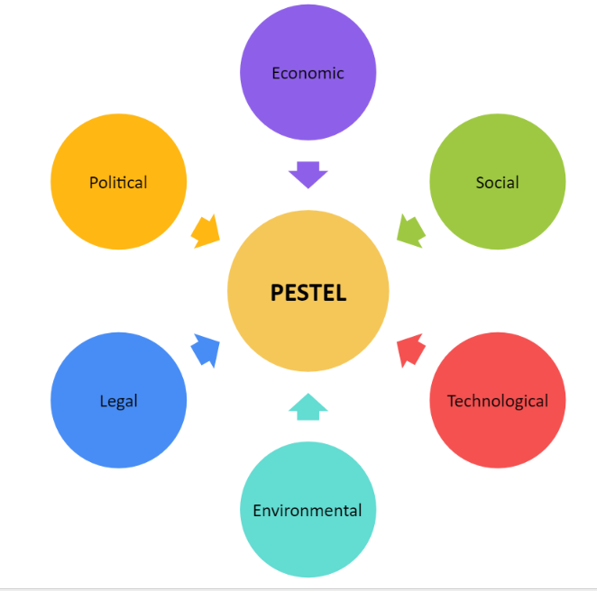
Figure 3: PESTEL Analysis
Source: edramax.com
Political: In the USA, organisations are obligated to adhere to its rules and regulations. These regulations have the potential to influence the operational procedures and financial outcomes of businesses. Political forces and actions may have an influence on the organisational culture of Google. These acts can cause alterations in the behavioural patterns of Google and the work dynamics of its personnel.
Economic: The impact of economic fluctuations in the United States can influence the financial resources available to Google for investment purposes. Additionally, the influence of labour expenses and wage legislation in the United States significantly affects Google's operational strategies and expenditures.
Social: In the U.S., individuals possess the freedom to make choices. Social factors have a significant impact on this phenomenon. Google must adapt to these developments and provide services that accord with user preferences. Indeed, Google must also prioritise diversity in its American workforce. It is important to ensure equitable treatment for all individuals, in accordance with societal expectations.
Technological: Technology undergoes massive transformations in the United States. This necessitates that Google must consistently adjust and be aware of emerging advances in order to maintain its competitiveness. Moreover, Google extensively depends on AI. Therefore, the advancement of artificial intelligence has a significant impact on the usability of Google's services.
Environmental: There is an increasing level of environmental consciousness among individuals residing in the United States. Google is required to adhere to environmental regulations. These regulations have the potential to influence carbon dioxide emissions and energy consumption. In fact, Google considers both the cost and accessibility factors when evaluating the utilisation of clean energy. This has an impact on their dedication to the promotion and use of renewable energy sources.
Legal: Various aspects of Google's operations are impacted by legal regulations. Thus, they must take care to abide by them. In order to mitigate any legal complications and maintain market equity, obedience to the following guidelines is crucial. Google occasionally engages in legal disputes regarding the ownership of specific concepts or innovations. These conflicts have the potential to impact Google's commercial practices.

3.2. Porter’s Five Forces Analysis
Porter's Five Forces Analysis is a theoretical framework developed by Michael E. Porter that aims to evaluate the competitive dynamics of an industry (Bruijl, 2018).
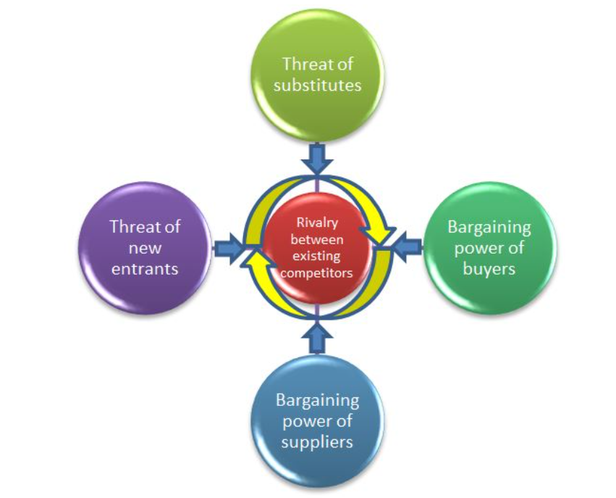
Figure 4: Porter’s Five Forces Analysis
Source: (ABDO, 2019)
Existing Rivalry: The technology sector is characterised by intense competition. Google encounters rivalry from other prominent technology companies. These organisations include Apple, Amazon, and Yahoo. These companies consistently engage in innovation and broaden their range of products. This phenomenon causes a highly competitive environment for Google.
Threat of New Entrants: The level of threat posed by potential new entrants to Google is less. The well-established reputation and dominant market position of Google present significant obstacles for any new company to enter the industry. However, in order to reproduce the extensive range of services offered by Google and its global user base, it would be challenging to new entrance. Reproducing Google's services needs significant investments and specialised knowledge (Jun, 2018).
Bargaining Power of Buyers: The level of buyer bargaining power for Google is moderately less. In addition, Google offers an extensive variety of services and items. Indeed, it is a widely used platform that individuals depend on for a multitude of everyday tasks. Moving to alternate platforms might pose a significant challenge for users. This grants Google authority in determining prices and making product selections.
Bargaining Power of Suppliers: Google has a comparatively lower risk from the suppliers. Its extensive network of suppliers and dominant market position provide it with a competitive advantage in negotiations. Moreover, Google's dominant market position and internal innovation capabilities weaken the negotiating strength of external suppliers.
Threat of Substitutes: The level of substitutability for Google is surprisingly minimal. Google provides a broad range of goods and services. These include search engines, advertising platforms, the AoS, and cloud services. It presents a significant challenge for alternatives to effectively replicate the range of products and services provided by Google.

3.3. Chances of Google’s Sustainability
Based on the organisational culture, PESTEL, and Porter's five forces analysis, it is evident that Google has the ability to remain competitive in subsequent times. The analysis provides numerous causes.
Enduring Organisational Culture: It is noticeable that Google possesses an enduring organisational culture. The prevailing cultural environment has facilitated Google's ability to maintain a leading position in technological breakthroughs. Google places a strong emphasis on promoting innovation and cultivating adaptability. In a dynamic market environment, the capacity to innovate and adjust is crucial for achieving sustained success over an extended period. Moreover, Google's dedication to adopting emerging technologies positions it favourably for the future.
Market Dominance: Google's substantial market dominance within the technology industry gives it a notable competitive edge. Google's services are widely used by users across the world. These sectors encompass search, advertising, and cloud services. Google maintains a significant base of loyal customers. In addition, the high level of trust and significant market dominance enjoyed by Google present formidable obstacles for potential competitors seeking to supplant the company.
Environmental Activities: Google's dedication to environmental responsibility coincides with the increasing environmental awareness among consumers. Moreover, the commitment to renewable energy and environmental activities can build the company's reputation and correspond with changing public expectations.
Abundant Resources: the vast global presence and abundant resources of Google provide significant obstacles for any competitors attempting to imitate its magnitude and user population. Furthermore, the significant capital commitments and specialised knowledge necessary to rivals serve as obstacles preventing new competitors from entering the market.
Promoting Diversity: Google's concentration on diversity and inclusion within its American workforce is in accordance with societal norms and labour regulations. Ensuring fair and just treatment for workers is crucial for achieving sustained success in a society characterised by diversity.
Overall, the discovered cultural practices, along with a PESTEL and Porter's five forces analysis, indicate a faster rate of technical innovation growth. Therefore, Google must engage in ongoing innovation to maintain its position in the market.

Recommendation
Continuous Innovation: Google should try to uphold its powerful commitment to innovation and creativity. The organisational culture should foster an environment that motivates people to embrace risk-taking and engage in the exploration of innovative ideas. The prevalent culture of creativity inside an organisation has the potential to encourage the creation of novel products and services. Hence, it will potentially enhance both sales and the share of the market.
Mitigating Legal Complications: To mitigate legal issues and uphold market equity, it is required for Google to support a firm commitment to complying with ethical and legal requirements. By using this measure, the possibility of encountering legal complications that may disrupt business operations will be lessened. Moreover, any damage that may happen to the company's reputation will be lowered. Thus, it will enhance organisational efficiency.
Prioritising Training: It is suggested for Google to allocate its resources towards training and educational programmes to enhance the expertise and understanding of its workforce. Moreover, proficiently trained employees have the potential to enhance productivity, optimise decision-making, and generate work of superior quality.
Collecting User's Feedback: Google should continue the process of collecting user feedback through the administration of surveys and the subsequent analysis of the gathered data. The organisation should consider this valuable information to implement ongoing enhancements to the quality and functionality of products and services. Moreover, improving customer satisfaction has the potential to result in improved usage and devotion. Therefore, it will exert a favourable influence on financial success.
Availability of Unique Workplace: It is recommended for Google to maintain the availability of adaptable and unique workplace spaces to develop a culture that is innovative and flexible. Moreover, these settings foster inventiveness and a more energetic work ambiance. Consequently, it influences the advancement of products and the generation of new ideas.

Conclusion
In conclusion, Google is a large organisation characterised by a sociable and innovative organisational culture. The employees collaborate in a manner comparable to a familial unit, fostering an environment that promotes the generation of novel concepts. This enables them to maintain a competitive edge in the realm of technology. Additionally, it places importance on the principles of security, fairness, and responsibility for the environment. Moreover, it welcomes a diverse range of individuals into its firm and treats them with respect.
However, Google may encounter competitive pressure from rival firms; nonetheless, it maintains an influential market position. Newly established companies face significant challenges in competing with Google due to its substantial size and established reputation.
In order to maintain its market position, Google needs to stay committed to innovation, adhere to regulatory guidelines, and attentively consider customer feedback. This will facilitate their further growth and contribute to the satisfaction of individuals. In general, Google's organisational culture, core values, and strategic approaches contribute to its sustained success. Moreover, it requires the continuation of its current practices to maintain its competitive position.

Reference
Bruijl, D.G.H.T., 2018. The relevance of Porter's five forces in today's innovative and changing business environment. Available at SSRN 3192207.
Carvalho, C.R.S.P., Castro, M.A.R., Silva, L.P. and Carvalho, L.O.P., 2018. The relationship between organizational culture, organizational commitment and job satisfaction. Revista Brasileira de Estrategia, 11(2), p.201.
Driskill, G., 2018. Organizational culture in action: A cultural analysis workbook. Routledge.
Gardner, R. 2023. 12 types of Organizational Culture You Should know, AIHR. Available at: https://www.aihr.com/blog/types-of-organizational-culture/ (Accessed: 06 November 2023).
Hamzah, M.I., Othman, A.K., Fikry, A. and Abdullah, M.Z., 2023. The interaction effects of adhocracy culture, work experience on information acquisition and job performance of bank salespeople. Journal of Financial Services Marketing, 28(3), pp.544-557.
Jun, S.P., Yoo, H.S. and Choi, S., 2018. Ten years of research change using Google Trends: From the perspective of big data utilizations and applications. Technological forecasting and social change, 130, pp.69-87.
Krauss, J. and Vanhove, A.J., 2022. Organizational culture perceptions and change frequency: the moderating effect of members' hierarchical level in the organization. Leadership & Organization Development Journal, 43(2), pp.302-314.
Levy, S., 2021. In the plex: How Google thinks, works, and shapes our lives. Simon & Schuster.
Martínez-Caro, E., Cegarra-Navarro, J.G. and Alfonso-Ruiz, F.J., 2020. Digital technologies and firm performance: The role of digital organisational culture. Technological Forecasting and Social Change, 154, p.119962.
Moore, M. and Tambini, D. eds., 2018. Digital dominance: the power of Google, Amazon, Facebook, and Apple. Oxford University Press.
Shtal, T.V., Buriak, M.M., Amirbekuly, Y., Ukubassova, G.S., Kaskin, T.T. and Toiboldinova, Z.G., 2018. Methods of analysis of the external environment of business activities. Revista Espacios, 39(12).
Toh, K.G. 2018. Cultural web business diagram illustration stock illustration - illustration of Organizational, guidelines: 54146013, Dreamstime. Available at: https://www.dreamstime.com/stock-illustration-cultural-web-business-diagram-illustration-strategy-concept-infographic-paradigm-image54146013 (Accessed: 08 November 2023).
Useful management tools: Porter’s 5 forces model. 2019. ABDO. Available at: https://www.abdo.org.uk/dashboard/business-hub/leadership/useful-management-tools-porters-5-forces-model/ (Accessed: 06 November 2023).
What is a Pestel analysis with examples (no date) What is A PESTEL Analysis with Examples | EdrawMax Online. Available at: https://www.edrawmax.com/pestel-analysis/ (Accessed: 06 November 2023).

