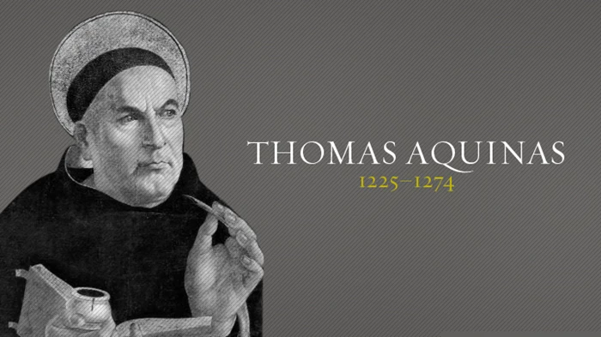

Thomas Aquinas’ Summa Contra Gentiles

Claire Mann 1602593
HPHI5019
Medicine and Miracles: Health, Illness and Cure.
4th June 2021

Thomas Aquinas or ‘Thomas of Aquino’ (1225-1274) was an Italian Dominican friar, Catholic priest, philosopher and theologian of the Roman Catholic church. He was ranked amongst the most influential thinkers of medieval Scholasticism and the father of the Thomistic school of theology. He was a prolific writer and in 1259 produced the massive Summa contra Gentiles also named Liber de veritate catholicae fidei contra errores infidelium ‘Book on the truth of the Catholic faith against the errors of the unbelievers’ a treatise devoted to defending the claims of orthodox Christianity against a wide variety of objections presented by Jews, Muslims, pagans and heretics. It consists of four books and for this assessment we will look at Chapter 101 of the Summa contra Gentiles, entitled Of Miracles.
‘Things that are done occasionally by divine power outside of the usual established order of events are commonly called miracles (wonders).’ The presuppositions behind any thinking about miracles in the Middle Ages are to be found mainly in the works of Augustine of Hippo, for him it was clear ‘there were three levels of wonder: wonder provoked by the acts of God visible daily and discerned by wise men as signs of God’s goodness: wonder provoked in the ignorant, who did not understand the workings in nature and therefore could be amazed by what to the wise man was not unusual ; and wonder provoked by genuine miracles, unusual manifestations of the power of God, not contra naturam but praeter or supra naturam.’
‘An event is wonderful relatively to one man and not to another. The absolutely wonderful is that which has a cause absolutely hidden.’ The proof from causality begins by noting that the senses reveal to us an order of efficient causes. But nothing can be the cause of itself, for if it were then “it would be prior to itself, which is impossible”’. He goes on to suggest that ‘now the cause absolutely hidden to every man is God.’ Aquinas argues that there are always efficient causes and that nothing can cause itself, which raises the question, if everything has a cause, then what caused God?
According to Peter Lombard, following Augustine, God has implanted the seminal causes in things - a horse will give birth to a horse, an apple tree bears apples,’ these sort of marvels of nature are documented within the Topographia Hibernica, the miracle by which St Kevin caused a willow tree to bear apples is distinguished as a miracle because it was caused by the prayers of St Kevin to God. Gerald of Wales argued that anything within the course of nature, however marvellous it may seem, cannot be deemed a miracle, he uses the salmons leap to explain this: ‘ Salmon are moved by wonderful leaps which would be miraculous if this were not the nature of the fish. But this kind of fish makes such leaps because it is its nature to do so. The distinction between the marvellous in nature and the miracles of the saints was not in this period very clearly expounded or applied.
The final paragraph of the extract discusses the ranks and orders of miracles, ‘Miracles of the highest rank are those in which something is done by God that nature can never do’ these types of miracles were considered supra meaning above and beyond natural occurrence. ‘Miracles of the second rank are those in which God does something that nature can do, but not in that sequence or connexion. Thus it is a work of nature that an animal should live, see and walk: but that it should live after death, see after blindness, walk after lameness, these things nature is powerless to effect, but God sometimes brings them around miraculously.’ This rank of miracle was deemed contra meaning it was against natural occurrence. The third rank of miracle is praetor, meaning apart from nature, Aquinas describes this type of miracle as ‘something done by god, which is usually done by the operation of nature, but is done in this case without the working of natural principles, as when one is cured by divine power of a fever, in itself naturally curable, or when it rains without any workings of the elements.’ Examples of these ranks of miracles are in commonly known biblical stories; the transfiguration and resurrection were supra naturam; the Virgin conception and the parting of the Red Sea were contra naturam; and turning water into wine was praeter naturam.

Bibliography

Primary Sources
Aquina, T. Summa Contra Gentiles. Course Handbook.

Books
Bartlett, R. (2008). The Natural and the Supernatural in the Middle Ages (The Wiles Lectures). Cambridge University Press.
Feser, E. (2009). Aquinas: A Beginner’s Guide. Oneworld Publications.
Ward, B. (1987). Miracles and the Medieval Mind: Theory, Record, and Event, 1000–1215 (The Middle Ages Series) (Revised Edition). University of Pennsylvania Press.
Journal Article
Webster, Harriett R. “The Resuscitation of the Twice-Hanged Man: Miracles and the Body in Medieval.” Body Matters: Exploring the Materiality of the Human Body, L. Steel and L. Attala (eds.) (University of Wales Press: Cardiff, 2019) (2019): n. pag. Print.

Websites
Thomas Aquinas. (2008, August 8). Christian History | Learn the History of Christianity & the Church. https://www.christianitytoday.com/history/people/theologians/thomas-aquinas.html

Podcasts
BBC Podcasts. (2018, August 11). St Thomas Aquinas (In Our Time). YouTube. https://www.youtube.com/watch?v=GEv1P29qIKU

Feser, E. (2009). Aquinas: A Beginner’s Guide. Oneworld Publications. p.4.
Aquina, T. Summa Contra Gentiles. Course Handbook.
Ward, B. (1987). Miracles and the Medieval Mind: Theory, Record, and Event, 1000–1215 (The Middle Ages Series) (Revised Edition). University of Pennsylvania Press. p.4.
Aquina, T. Summa Contra Gentiles. Course Handbook.
Feser, E. (2009). Aquinas: A Beginner’s Guide. Oneworld Publications. p.81.
Aquina, T. Summa Contra Gentiles. Course Handbook.
Bartlett, R. (2008). The Natural and the Supernatural in the Middle Ages (The Wiles Lectures). Cambridge University Press. p.6.
Bartlett, R. (2008). The Natural and the Supernatural in the Middle Ages (The Wiles Lectures). Cambridge University Press. p.8.
Ward, B. (1987). Miracles and the Medieval Mind: Theory, Record, and Event, 1000–1215 (The Middle Ages Series) (Revised Edition). University of Pennsylvania Press. p.8
Ward, B. (1987). Miracles and the Medieval Mind: Theory, Record, and Event, 1000–1215 (The Middle Ages Series) (Revised Edition). University of Pennsylvania Press. p.8.
Aquina, T. Summa Contra Gentiles. Course Handbook.
Aquina, T. Summa Contra Gentiles. Course Handbook.
Aquina, T. Summa Contra Gentiles. Course Handbook.
Webster, Harriett R. “The Resuscitation of the Twice-Hanged Man: Miracles and the Body in Medieval.” Body Matters: Exploring the Materiality of the Human Body, L. Steel and L. Attala (eds.) (University of Wales Press: Cardiff, 2019) (2019): n. pag. Print. (Course Handbook)

