Title: Individual project report

Student Name: Elena Butescu
Student Number: 2132844
Module code: LCBB4005_BIRM
Lecturer’s name: Dr Essa Bah
Executive Summary
PESTLE Analysis is an effective framework through which it becomes easier in analyzing the impact of external factors on business activities. Porter's Five Force Model has helped in determining the impact of five external factors on the business. Porter's Diamond strategy helps in determining the various strategies with the help of which the business can expand its activities. Value Networks and Cultural Web play an effective role in determining the value chain of the business and the influence of culture on the organisational efficiency respectively.
Table of Contents
Introduction 4
Overview of the business and the sector in which the business operates 5
Main Discussion 6
PESTLE Framework 6
Porter’s Five Forces 7
Porter’s Diamond 8
Value Network 9
Cultural Web 10
Conclusion and Recommendations 12
References 13

Introduction
Unilever PLC is the organisation which has been analysed in the report. The report will mainly provide an effective evaluation of the key environmental factors which create an impact on the business. Different types of business theories and models will be used to analyze the international environment (Unilever, 2023). An entire overview of Unilever PLC will be provided. The positive and negative impact of all the environmental factors on the business will be effectively discussed. Some of the important business models which will be discussed are PESTLE Analysis, Porter's Five Forces, Porter's Diamond, Value Network, and Cultural Web.
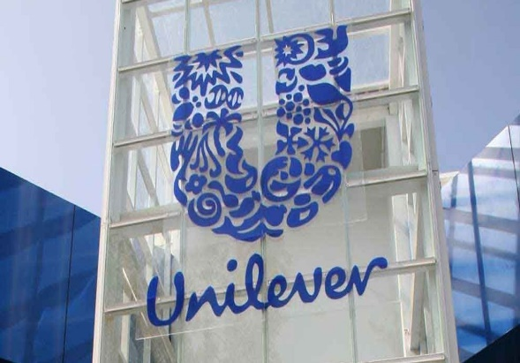
Figure 1:Unilever PLC
Source: (Unilever, 2023)

Overview of the business and the sector in which the business operates
An effective idea about the business is discussed as follows. The business which has been selected is Unilever PLC (Unilever, 2023). This business has its headquarters located in London, England. It is a multinational Consumer goods company offering a large range of products such as water bottle, baby care products, personal care products, and beverages. This public limited company has been operating in the industry for more than 93 years. It has been determined that the average revenue earned by Unilever PLC for the year 2022 was £ 60.075 billion. However, it has been identified that the net income and the total equity of the organisation are £ 8 billion and £ 21 billion respectively. An effective overview of the industry and the sector in which Unilever PLC operates is discussed as follows. The industry is the consumer retail industry. The contribution of this industry towards the GDP of the UK is approximately 3%. The rate of growth of the consumer retail industry of the UK is very high. This industry has been able to generate 10% of the entire employment opportunity in the UK (Unilever, 2023).

Main Discussion

PESTLE Framework
PESTLE Analysis is considered to be an effective tool or a Framework which is used by the market for monitoring and analyzing the macro environment factors which create an impact on the activities of a business. PESTLE Analysis is an effective framework through which it becomes easier in analyzing the impact of external factors on business activities. The positive and negative impact of all the environmental factors on the business will be effectively discussed.
1. Political Factor: Brexit has created a lot of political instability (Baugh, et al., 2022). The negative impact of political factors is identified from the fact that there has been a decrease in the demand for the products and services of Unilever PLC from consumers belonging to European Union countries. On the other hand, the Government of the UK has provided a lot of support to the growth and development of business. This has created a positive influence which is evident from the increase in the profit level of the business.
2. Economic Factor: The covid 19 pandemic created a certain adverse impact on the business activities of Unilever PLC (Birru, et al., 2022). There has been a decrease in the volume of profit and sales of the organisation due to the pandemic. On the other hand, an increase in the inflation rate and employment rate have contributed to the business development and growth in the long run.
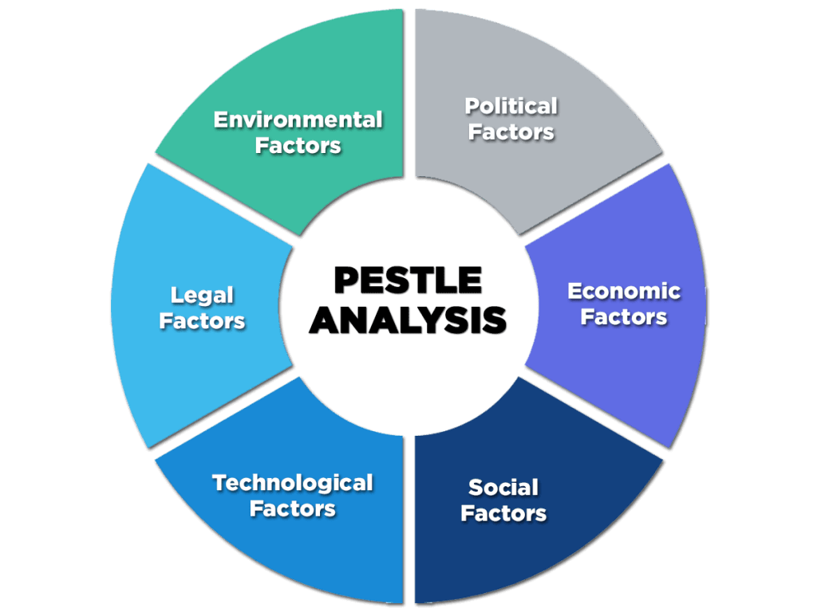
Figure 2:PESTLE Framework
Source: (Eierle, et al., 2022)
3. Social Factor: Social factors which create an influence on the operations of Unilever PLC are customer lifestyle, consumer preferences, demographics, the behavior of the consumer, and taste of the consumers. Manufacturing products based on the needs and preference of the consumers have created a positive impact on the business in the form of a high customer retention rate (Fernando, 2022). On the other hand, fluctuation in consumer references becomes difficult for the organisation to provide satisfaction to them.
4. Technological Factor: Unilever PLC is mainly engaged in using the latest technology of Artificial Intelligence, IoT, Machine Learning, Blockchain mechanisms, and Data Analytics (González, 2022). This has contributed to the growth and development of the organisation. The negative impact of the technological factor is evident from the fact that a huge amount of money is spent by Unilever PLC to adopt the latest technology.
5. Legal Factor: Certain legal factors are taken into consideration by the organisation. The organization ensures to comply with Human Rights Act, Equality and Diversity Act, Employees Laws, Consumer Protection Act, Health and Safety Act, etc. This has created a positive influence on Unilever PLC and is evident from the fact that the reputation of the business has increased. On the other hand, non-compliance can create a negative impact on the business.
6. Environmental Factor: There are certain environmentally sustainable practices which are undertaken by Unilever PLC such as waste management programs, implementing the principle of recycling, measures to reduce carbon emissions, and steps to overcome the emission of greenhouse gases (Kokku, 2022). This has created a positive impact on the business.

Porter’s Five Forces
Porter's Five Force Model has helped in determining the impact of five external factors on the business. Porter's Five Force Model is an effective Framework that helps in determining the competitive environment in which Unilever PLC operates. Hence the competitive environment can be effectively evaluated.
1. The power of bargaining of the buyer: The power of bargaining of the buyers in the consumer retail industry is low. This is because the buyers get only a limited organisation in the UK that is offering the best quality products at a low price (Madsen and Grønseth, 2022). This creates a positive impact on the organisation since the organisation has been able to retain its consumers for a long period.
2. The power of bargaining of the supplier: The power of bargaining of the suppliers in the consumer retail industry is low. There are certain circumstances in which it is determined that the presence of a large number of suppliers of Unilever PLC helps in achieving the low bargaining power of the supplier. This provides an advantage to the organisation to maintain long-term relationships with its suppliers (Martinez-Contreras, et al., 2022).
3. The threat associated with the substitute products: The threat associated with the substitute products in the consumer retail industry is moderate. The moderate presence of substitute products provides an opportunity for Unilever PLC to maintain its share in the consumer goods retail industry of the UK. This helps the organisation to ensure that it caters to the requirement of the consumers easily and within a very short period. This prevents the consumers to switch from one product to another product.
4. The threat associated with the new entrants: The threat which is associated with the new entrants in the consumer goods industry is moderate (Mohd Said, et al., 2022). It is very much difficult for a new organisation to enter the consumer goods industry since it requires a lot of investment. However, it is determined that there are certain big organisations that have been operating in the consumer and retail goods industry for a long period. This factor helps Unilever PLC to conduct its activities effectively.
5. The level of competitive rivalry: The level of competitive rivalry prevailing in the market is high. A few of the competitors of Unilever PLC comprises of Tesco PLC, Morrison's, etc. A high level of competition creates a negative impact on the business activities of Unilever PLC (Park and Park, 2022).

Porter’s Diamond
Porter's Diamond is considered to be an effective model which is designed to evaluate the effects of the domestic market on the competitive advantage of nations or firms in the international market. The effective application of Porter's Diamond in Unilever PLC can be analyzed as follows.
1. Factor Condition: The factor conditions are considered to be the basic production factors that are required to be analyzed in a country (Pranadita, et al., 2022). This comprises infrastructure, labor, land and capital. These are certain essential factors that help in providing a competitive advantage to the organisation. Some of the most essential factors and conditions which are taken into consideration by Unilever PLC are infrastructure, human resources, and natural resources.
2. Demand Condition: It is evident that demand conditions refer to the creation of domestic demand for products and services. There are a large number of schemes and discounts which are offered by Unilever PLC to consumers to enhance the demand for their products and services (Triguero-Sánchez, et al., 2022). This not only helps in increasing product demand but also acts as a positive impact on the organisation.
3. Related and Supporting Industries: Related and supporting industries are considered to be the businesses that are supplying inputs or are engaged in purchasing outputs of the business. Unilever PLC has been able to develop an effective relationship with the related and supporting industries to fulfill the needs of the business and to provide a maximum level of satisfaction to the consumers. This provides the major source of competitive advantage to the organisation (Vivek, et al., 2023).
4. Firm structure, strategy, and rivalry: The various ways through which the level of competition prevailing in the organisation can be determined are through the strategy and structure of the organisation. The structure of Unilever PLC is a functional organisational structure. The entire activity of the organisation is divided into various functions. The major strategy used by the business to establish control in the market is to provide the best products to consumers at an affordable price.

Value Network
A value network is defined as a set of connections between individuals and organisations to interact with each other to provide benefit to the entire group. With the help of a value network, it becomes easier for all the members of the organisation to sell and buy products as well as get engaged in sharing information (Wijethilake, et al., 2023). An effective idea about the value network of Unilever PLC can be provided as follows.
1. Supplier: A supplier is considered to be the most effective component of the value network. Unilever PLC focuses on maintaining a good relationship with the suppliers to ensure that good quality raw materials are provided by them which can be purchased by the business. There are a large number of suppliers of Unilever PLC. This act is a major benefit for the organisation since the bargaining power associated with this supplier becomes moderate.
2. Retail platform: This is the major platform through which the products are made available to consumers. Unilever PLC has a well-designed warehouse in which all the raw materials are effectively stored (Baugh, et al., 2022). This is considered to be an effective way through which the organisation can maintain and manage its inventory. Necessary shipment of the goods prevailing in the warehouse is provided to the consumers as per the requirement of the customer order. A maximum level of efficiency in the retail platform contributes towards the growth of Unilever PLC.
3. Customer: Customers are considered to be the vital element of the value chain network. All the activities in the value chain are conducted effectively and efficiently to ensure that the maximum level of satisfaction is provided to the consumers. It is determined that timely research and market analysis is conducted to ensure that the needs and preferences of the customers are identified on time. This helps in providing maximum satisfaction to the consumers (Martinez-Contreras, et al., 2022).

Cultural Web
The cultural web is considered to be an effective model which helps in determining the various essential dimensions of organisational culture. It is defined as an effective Framework through which the inputs of culture on the efficiency of the organisation can be easily determined (Mohd Said, et al., 2022). The application of the Cultural Web Model in Unilever PLC can the analyzed as follows.
1. Structure: This is considered to be the entire structure of Unilever PLC comprising the managerial levels and the control in the organisation. The organisational structure prevailing in the organisation is functional organisational structure. A maximum level of efficiency exists in the functional organisational structure. This helps in providing a maximum level of power to the function head.
2. Power structure: Power structure mainly indicates the position of every employee working in the organisation to influence the activities of the business. Unilever PLC has provided a maximum level of responsible job opportunities to the top-level management to ensure that effective power is exercised (Park and Park, 2022). This helps in achieving the organisational goals easily and within a very short period.
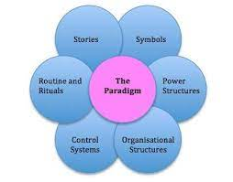
Figure 3:Cultural Web
Source: (Praharsi, et al., 2022)
3. Symbols: The symbols act as the uniqueness of an organisation in comparison to its competitors in the market. The major uniqueness prevailing in Unilever PLC is the implementation of the principle of integrity and honesty in its organisational culture. This makes the organisational unique.
4. Stories: There are a large number of past stories and experiences that play a major role in promoting change in the activities of the organisation as well as in the activities of the employees. Unilever PLC focuses on promoting maximum changes in its organisation activity to promote the easy achievement of the organisational goals.
5. Control: Maximum level of control is exercised by Unilever PLC on its employees to ensure that an effective form of participation takes place in the organisation. This comprises involving the employees in the activities of the organisation so that they contribute towards improvement in employee productivity and organisational productivity.
Rituals: Certain regular rituals and practices are undertaken by Unilever PLC to create and effective existence in the competitive market (Triguero-Sánchez, et al., 2022).

Conclusion and Recommendations
It can be easily concluded that the different Business models and theories have played a vital role in evaluating the internal business environment in which Unilever PLC operates. PESTLE Analysis is an effective framework through which it becomes easier in analyzing the impact of external factors on business activities. Porter's Five Force Model has helped in determining the impact of five external factors on the business. Porter's Diamond strategy helps in determining the various strategies with the help of which the business can expand its activities. Value Networks and Cultural Web play an effective role in determining the value chain of the business and the influence of culture on the organisational efficiency respectively. Certain recommendations have you provided to Unilever PLC to improve its business activities.

References
Baugh, C.W., Dorner, S.C., Levine, D.M., Handley, N.R. and Mooney, K.H., (2022). Acute home-based care for patients with cancer to avoid, substitute, and follow emergency department visits: a conceptual framework using Porter’s Five Forces. Emergency Cancer Care, 1(1), pp.1-10.
Birru, A.C., Sudarmiatin, S. and Hermawan, A., (2022). Competitive strategies in the lodging service sector: Five porter analyses and case study SWOT analysis. Journal of Business and Management Review, 3(1), pp.001-017.
Eierle, B., Hartlieb, S., Hay, D.C., Niemi, L. and Ojala, H., (2022). External factors and the pricing of audit services: A systematic review of the archival literature using a PESTLE analysis. Auditing: A Journal of Practice & Theory, 41(3), pp.95-119.
Fernando, I.N., (2022). Linking Tea, Tourism, and Community Using Porter's Diamond Model. In Routledge Handbook of Tea Tourism (pp. 214-223). Routledge.
González, L.E.C., (2022). The Michael Porter Diamond approach. Level of international competitiveness of the Mennonite cheesemaking industry in Cuauhtémoc, Chihuahua, Mexico. Journal of Business, Universidad del Pacífico (Lima, Peru), 14(1), pp.79-86.
Kokku, R., (2022). Bharat's Solar Energy: An Analysis Using Porter's Diamond Model with a Brief on Ancient Past for Environmentally Sustainable Competitive Advantage. Journal of Energy Research and Reviews, pp.24-32.
Madsen, D.Ø. and Grønseth, B.O., (2022). Five Forces Model. In Encyclopedia of Tourism Management and Marketing (pp. 250-252). Edward Elgar Publishing.
Martinez-Contreras, R.M., Hernandez-Mora, N.C., Vargas-Leguizamon, Y.R. and Borja-Barrera, S.M., (2022). Pestel Analysis and Porter's Five Forces: An Integrated Model of Strategic Sectors. In Handbook of Research on Organizational Sustainability in Turbulent Economies (pp. 292-314). IGI Global.
Mohd Said, N.S., Yusof, R., Omar Ali, S.R., Mat, K.A. and Mansor, F.A., (2022). Employees’ performance and organisational culture in the utility sector. Jurnal Intelek, 17(1), pp.246-256.
Park, H.R. and Park, H.S., (2022). A Study on the Industrial Competitiveness Analysis of Domestic Autonomous Operation Technology Industry Based on the Porter's Diamond Model. Journal of Navigation and Port Research, 46(3), pp.203-208.
Praharsi, Y., Hardiyanti, F., Puspitasari, D., Akseptori, R. and Maharani, A.,(2022). An Integrated Framework of Balance Scorecard-PESTLE-Smart and Green Port for Boosting the Port Performance.
Pranadita, N., Rahayu, A. and Wibowo, L.A., (2022), July. The Effect of Work Creation Law on the Five Forces of Competition Related to the Formulation of Competitive Strategies According to Michael E. Porter. In 6th Global Conference on Business, Management, and Entrepreneurship (GCBME 2021) (pp. 491-496). Atlantis Press.
Triguero-Sánchez, R., Peña-Vinces, J. and Ferreira, J.J.M., (2022). The effect of collectivism-based organisational culture on employee commitment in public organizations. Socio-Economic Planning Sciences, 83, p.101335.
Unilever (2023). Unilever global company website | Unilever Global. [online] Unilever global company website. Available at: https://www.unilever.com/ [Accessed 2023].
Vivek, R., Brahmi, M., Nanthagopan, Y. and Aldieri, L., (2023). A Systematic Review Using a Factor in Pestle Framework: COVID-19 Pandemic and Expansion of Economic Environments. Frugal Innovation and Social Transitions in the Digital Era, pp.26-40.
Wijethilake, C., Upadhaya, B. and Lama, T., (2023). The role of organisational culture in organisational change towards sustainability: evidence from the garment manufacturing industry. Production Planning & Control, 34(3), pp.275-294.

