BA Leadership and Management Skills for the Workplace
Understanding and Engaging in the Customer Experience BMSW5103
Task 1
Student Name: Radu Alexandru Nitu
Student ID: 2109427

Executive Summary
The report has focused on customer relationship management at H&M. A detailed discussion of the ethical and sustainable policies followed by H&M has been discussed in this report. These policies were used by the company to make its impression better in front of its customers.
Customer relationship management is required in every organisation for conserving good relationships with customers. Therefore, by implementing CRM strategies, H&M has grown its business profitability over the years which was reflected in this report. Economic theory can be established by the company for the betterment of its financial situation. The concept of game theory was provided here for providing the necessity of CRM in a company. The report has gone through relationship marketing theory to enhance customer retention within the organisation. The effect of healthy customer relationship management on a company was discussed here. Some recommendations were also provided to increase the sales of the company’s business and provide the best customer experience.

Table of Contents
Introduction 3
a) Ethical and sustainability policies of the company 3
a) Ethical 3
b) Sustainability 5
b) Critical literature review on quality theories 6
Literature review 6
Critical discussion 10
C) Conclusions and recommendations 11
Recommendations 11
Conclusion 12
Reference list 13

Introduction
Customer engagement improves customer experience through an organisation's positive efforts and customer interactions. An organisation can engage with its consumers through different channels like websites, company blogs and social media (Khorsheed, Othman and Sadq, 2020). Many organisations are seeking different paths like- sustainable and ethical marketing to enhance CRM. In this regard, a company will be taken in this report and it will be based on its improving customer relationship management. The main objective of this report is to discuss the sustainability and ethical policies of the organisation. Along with that, the improvement of CRM within the company will also be described. After that, the report will focus on some theories, like- economic theory, game theory and relationship marketing theory. The effect of healthy CRM policies within the organisation will also be explained. Lastly, the report will end with some recommendations based on the developing points in conclusions and findings of the report.

a) Ethical and sustainability policies of the company

a) Ethical
Investigate the customer experience of companies based on the following policies:
H&M, a clothing and fashion company in Sweden has become one of the renowned global brands. Therefore, this company has upgraded many ethical and sustainable practices in the formulation of the policies for growing better relationships with their customers.
a) Ethical: The importance of ethics in the development of better customer relationships can never be ignored. H&M follows many ethical policies for this purpose which are,
Document of Ethics: H&M has published its booklet on ethics for their employees where some obligatory policies have been mentioned to be followed in customer dealing. There are some codes of conduct mentioned in the booklets that help the employees to follow while dealing with the customers directly.
Zero tolerance of corruption: The company follows a strict attitude to handling corruption. They have implemented all rules and regulations to be followed by their partners and employees. These rules include no bribes or gifts to the employees of H&M and the employees are also asked not to take any personal benefit from the business partners (H&M Group, 2021). Here the company has implemented the Right theory of ethics to follow the correct way to deal with corruption.
Maintenance of Integrity: H&M has made it mandatory to maintain integrity and dignity while communicating with customers. All the employees of H&M have to undergo proper training to build these qualities among them. The employees are always directed to behave with the customers appropriately so that the brand image should be maintained.
Trust building with the customers: Total number of H&M stores across the world is more than 4465 (Statista, 2019). which are accessed by millions of customers. Therefore, the company must build a trustworthy relationship with its customers. Ethics policies help their employees in dealing with the customers in the right way and that leads to greater success achievements for the company.
Staying away from false advertisements: H&M is a global brand and they need to stay away from the false practices for advertising their products. The promotion and advertisements of H&M strictly follow the transparency theory. They do not use exaggerating tricks to attract customers. Therefore, they have gained tremendous trust from their global customers.
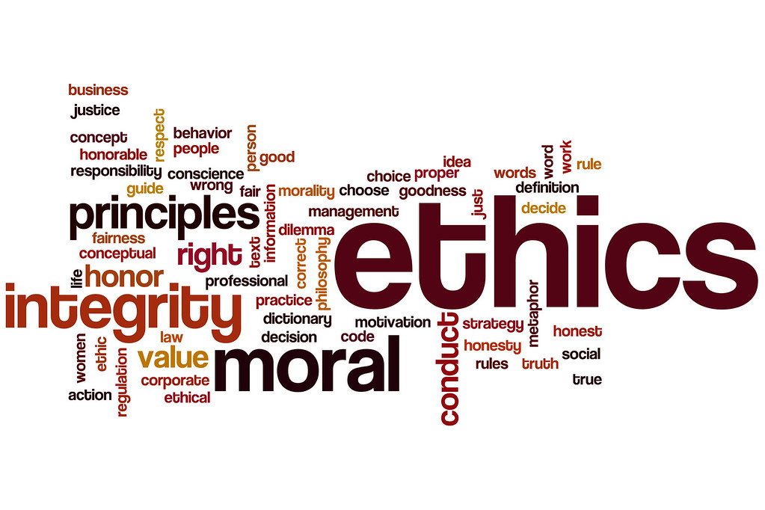
Figure 1: Ethical Policies.
(Source: Flickr, 2022)

b) Sustainability
Sustainability is a social objective that encompasses the importance of fulfilling the desire of the present generation without impacting the requirements of future generations and the planet (Santander, 2022). H&M is a global brand that believes in following sustainable policies for a better future and these policies include:
Sanitation and Water policy: H&M has decided to launch an awareness campaign on the conservation of water, clean drinking water, sanitation and hygiene programs. The company has stores in many parts of the world including those countries that suffer from the problem of water distress. As a global company, it has taken this initiative as a part of its sustainable policies.
Environment education: The company has focused on educating its employees and customers about the importance of the recycle and reuse initiative to save the environment's cleanliness. These initiatives have taken place under H&M’s corporate social responsibility (CSR) theory.
Sustainable Fashion: H&M has started popularising Sustainable fashion as a major promotion. According to the sustainability policy of the company, these fashions will reduce the harmful wastes from the environment. This policy ensures to make the customers aware of the materials used in the production of the clothes they have bought from H&M.
Enhancement of livelihood: This is another sustainability policy of H&M where they have started focusing on the empowerment of women and youths. Youths are the future flag bearers of sustainable practices. Therefore, the company has started providing training about the importance of a sustainable environment. H&M has taken this initiative following the social theory of Sustainability.
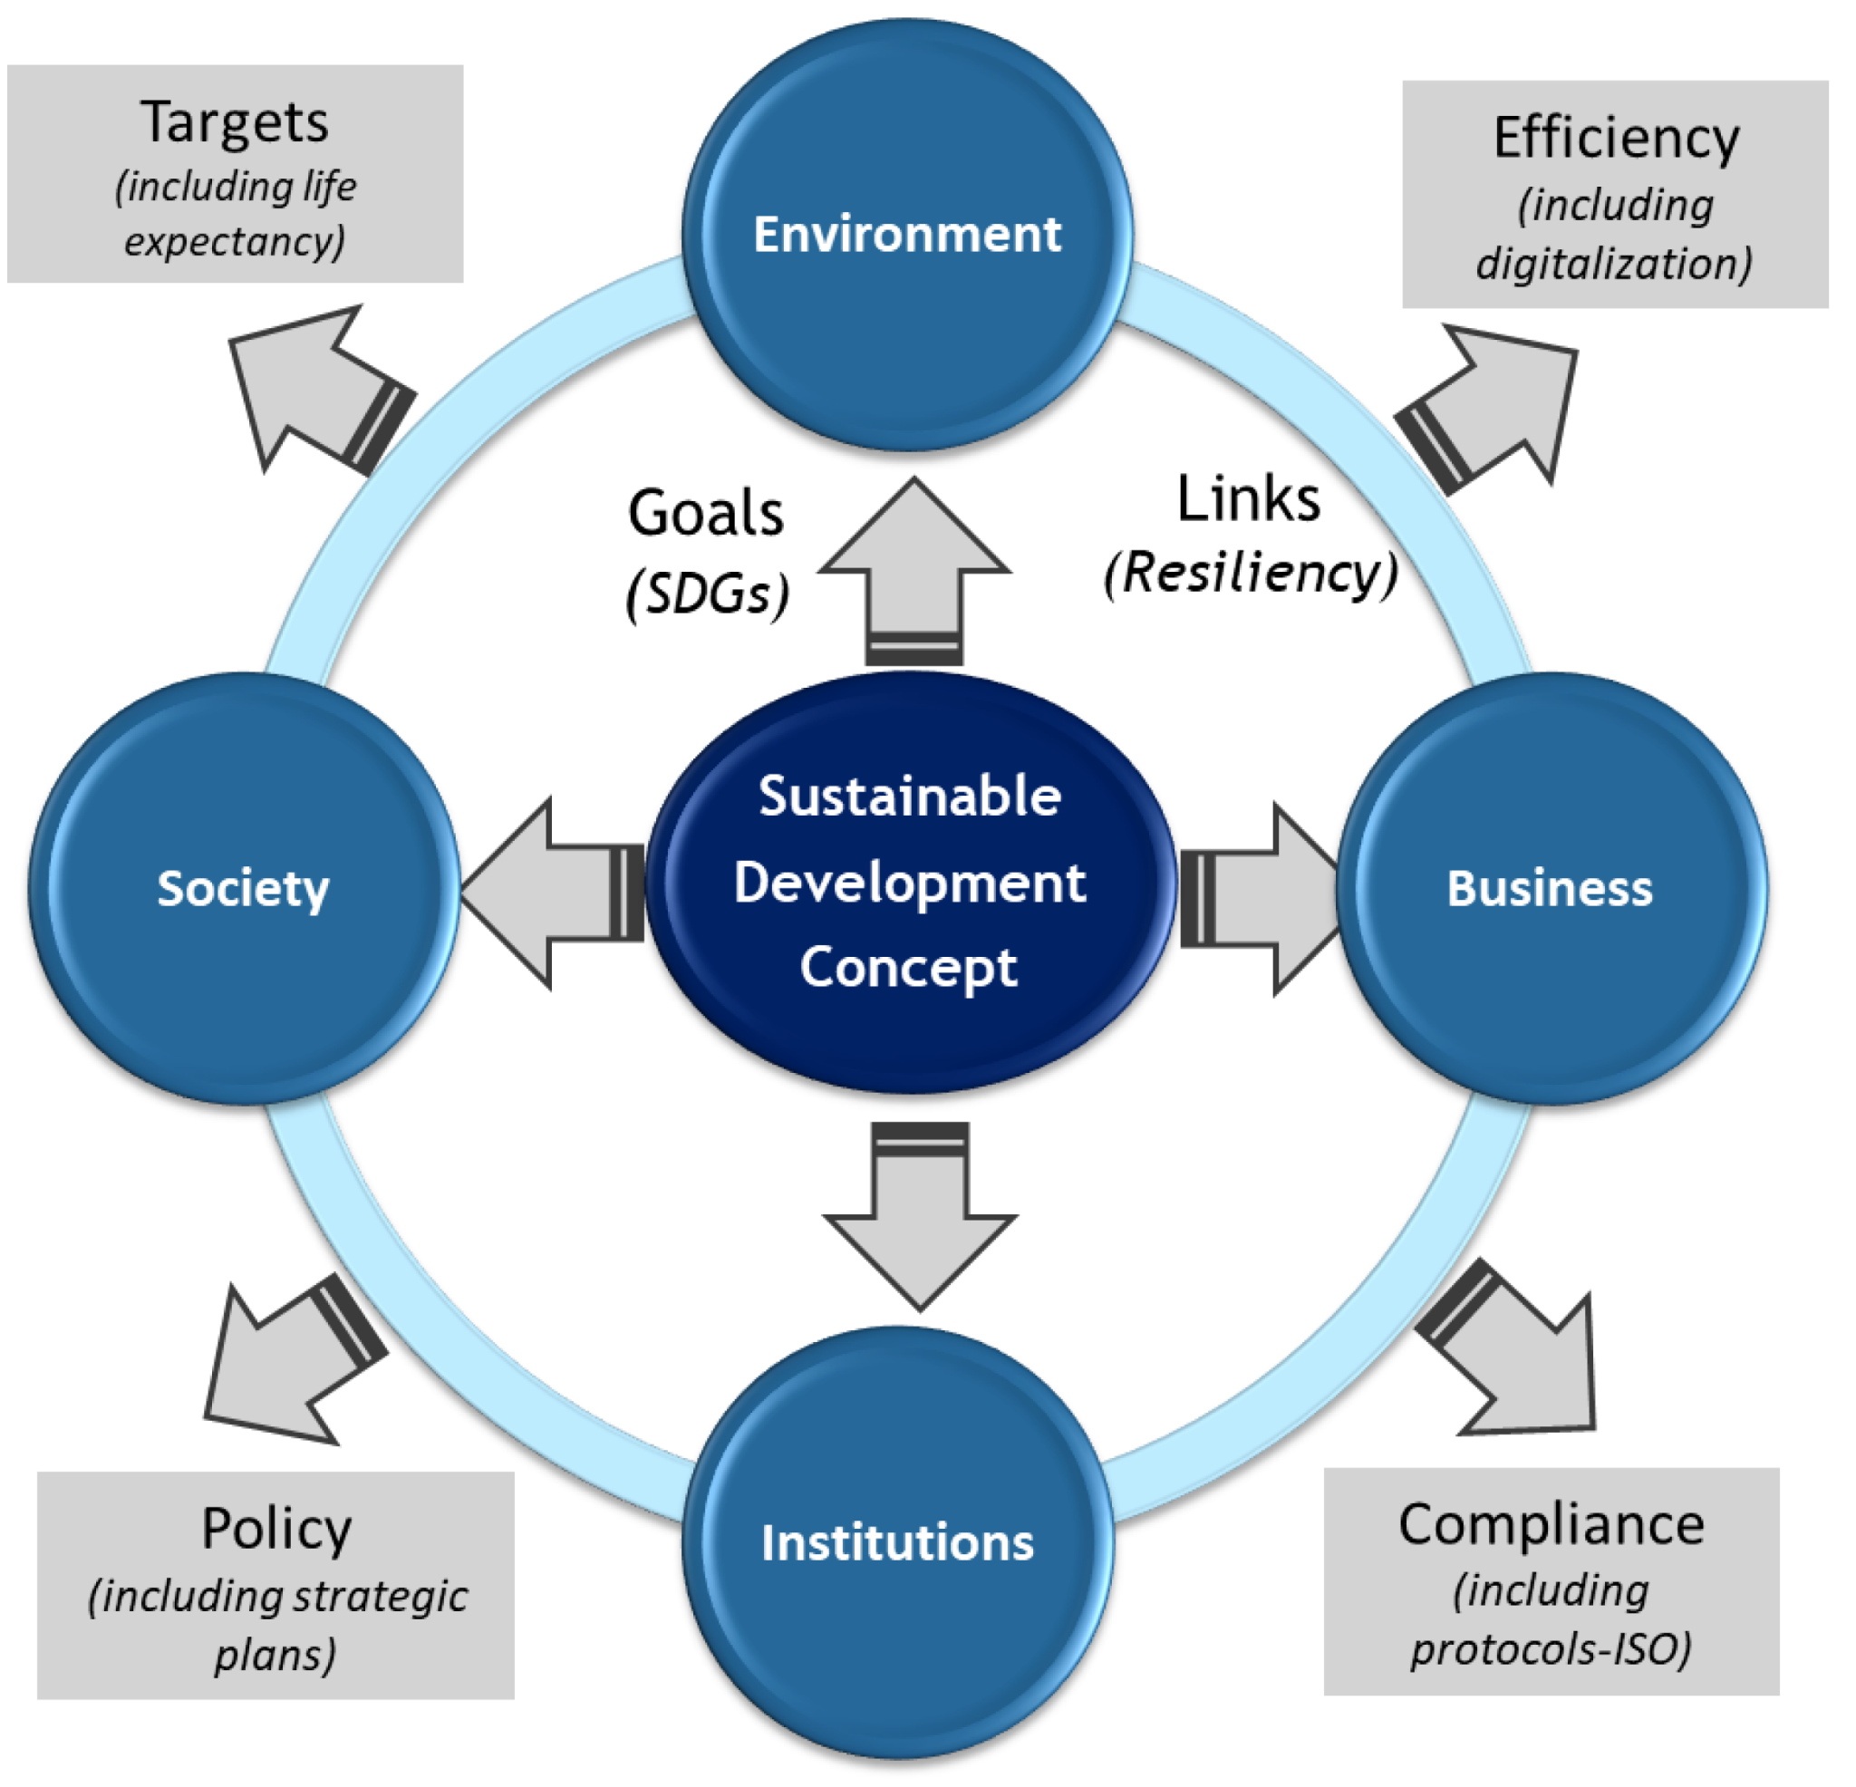
Figure 2: Sustainability Policies
(Source: Dimitriou and Karagkouni, 2022)

‌

b) Critical literature review on quality theories

Literature review
Improvement of customer relationship management in the company
CRM is a useful strategy that is beneficial to foster relationships with customers. As opined by Setiawati et al., (2019), customer relationship management is keen to interact with potential stakeholders and consumers for improving business relationships. CRM strategies are facilitated by all organisations for staying connected to the customers. It helps in streamlining the procedures and growing profitability. CRM strategy is acquired by H&M which has brought profitability for both the consumers and the company. Throughout the years, the company has improved relationship management in order to reach customers on a global level. According to Khan et al., (2022), Relationship management has adopted the idea of finding out useful data regarding the customers. In this way, H&M has found out the names of the potential customers who have interacted mostly and purchased products regularly. For instance, 51.53% of customers prefer to use mobile applications to know about the recent products and offers given by the company.
Hence, it is evident that the management has concentrated on focusing on advertisements that can target more audiences. As stated by Dewnarain, Ramkissoon and Mavondo, (2019), relationship management has measured the identity of the potential consumers and they are contacted through social media via chat process. The company has 40.4 million followers on Facebook and it often gives updates on the Facebook page. Instagram is used by the company for making people aware of recent fashionable products. Many videos are uploaded on both Facebook and Instagram for reaching more customers. The customers collect points by shopping from the online application of H&M. The customers can qualify for free delivery once they earn 300 points. The company also takes care of the feedback of the customers and takes necessary steps to fulfill their requirements. It helps to enhance customer loyalty.
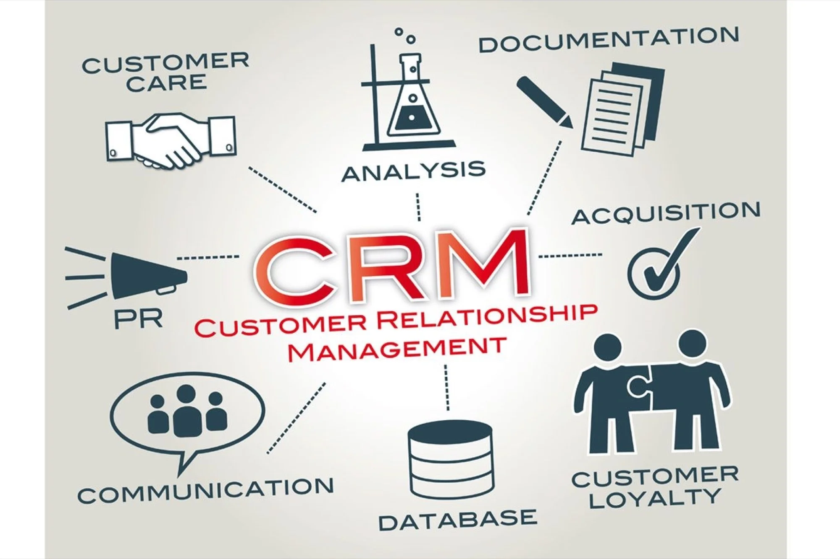
Figure 3: Customer Relationship Management
(Source: Parekh, 2022)
Economic theory: Economic theory proceeds concretely by building an economic model that simplifies the real world. According to Debnath, (2022), there are some major components of the economy such as capital, investment and wages. H&M can utilise economic theory for understanding the sales growth that can be derived from its customers. The main motive of the economic theory is an attempt to describe the financial activities inside the organisations. It also explains how the economy of the organisations works. It is involved with analysing, describing and defining multiple economic aspects and variables which impact economies. The function of economies is understood by economic theory. As opined by Hidalgo, (2021), economic theory is beneficial for predicting future economic functions as well. This is evident that by implementing economic theory, H&M can understand economic phenomena. Therefore, by using economic theory the organisation can influence the customers as it will help to understand the economic situation. H&M can utilise economic theory for building up monetary policies. According to economic theory, customer relationships can be boosted by economic theory. Understanding CRM economics can be beneficial for attaining more customers worldwide. CRM combines economic practices and customers. The main goal of economic theory is to assist in customer retention and drive sales growth.
Game theory: Game theory is focused on the grounded development theory which helps to investigate the additional differences between the results of social as well as commercial relationships. According to Debnath, (2022), CRM processes help an organisation to provide a competitive advantage in the contemporary industry along with enhancing the recognition of inter-organisational and inter-management relationships. Simultaneously it offers the scope to generate measures for the construction of a CRM framework. As opined by Debnath, (2022), the customer relationship management process empirically validates the relationships with several companies and its members who are involved in the management. H&M may use the game theory to provide a competitive advantage in the business environment by understanding the significance of inter-organisational relationships. It will create a great opportunity for the company to build a proper framework for customer relationship management.
According to the game theory CRM plays a crucial factor for enhancing the organisational performance of any company as it boosts the efficiency of its service quality and innovativeness. As stated by NI Business Info, (2019), innovation in production is essential for every organisation to develop its earning as well as profitability. Therefore H&M will follow the game theory to boost its organisational performance by bringing improvement in the innovation and service provision segment. It is evident that customer relationship management can create a connection between the employees’ behaviour and internal branding that is beneficial to deliver the promise of the brand. In this way, H&M can create its brand image properly all across the globe by implementing the processes of CRM. The CRM activities need to include the motivation segment to encourage the employees that can be occurred with proper communication with employees. The motivation will bring more innovation in the production of H&M which may assist it to gather more consumers all across the globe.
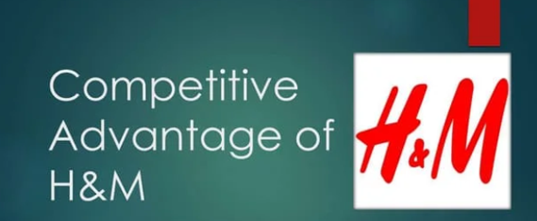
Figure 4: CRM of H&M
(Source: Andy Woojin Kim, 2019)
Relationship marketing theory: Relationship marketing theory is based on a strategy to improve and increase customer retention within an organisation. This theory looks to use traditional marketing tools in order to create long-term value for consumers. H&M may use relationship marketing theory to begin relationships with its customers through an increase in sales. According to the Management study guide, (2022), sales do not always determine the growth of the business but the profit from this relationship can be measured by the organisation’s success. H&M can use relationship marketing in order to develop continuous relationships with its consumers. It is believed in this theory that the consumer is the centre focus of the business instead of the business’s offerings and products. In this regard, H&M may utilise relationship marketing to enhance CRM which will be beneficial for the growth of the business. Long-term relationships can be maintained through relationship marketing which may prove a beneficial step for H&M. Furthermore, the company can boost its sales, pre-sales and after-sales activities. According to the Management study guide, (2022), understanding the expectations of customers may also be improved through this theory. After this understanding process. H&M can show full commitment to deliver within customer expectations. Total quality management is committed through relationship marketing and this commitment towards providing quality services may be influential for the company. Moreover, relationship marketing theory enlightens marketing campaigns which H&M can use to tailor an employer's specific needs within an organisation. Problem-solving capacity of the customers may be addressed through relationship marketing which H&M can utilise to provide solutions to customer issues.
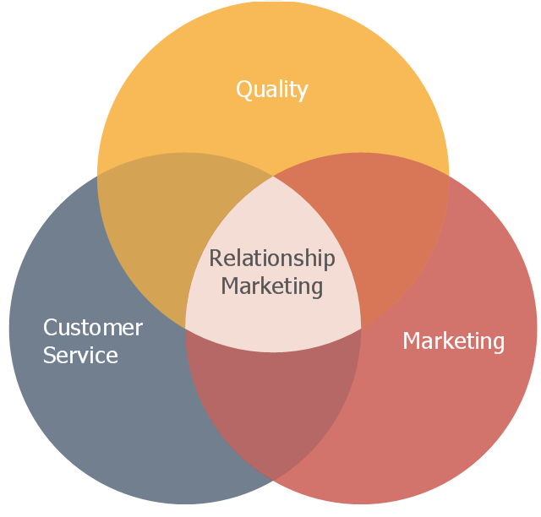
Figure 5: Relationship Marketing
(Source: ConceptDraw, 2023)

Critical discussion
Impact of healthy CRM on the company
The activities of customer relationship management (CRM) assist organisations to manage its interactions with its potential and current customers. Therefore, it helps businesses to create good relationships with its customers that resulted in creating both customer loyalty and retention. Both the factors of customer loyalty and retention leave a great impact on the revenue of any company (Kulpa, 2023). Customer relationship management helps companies to anticipate its customers' needs. Additionally, effective use of CRM can also offer strategic advantages to businesses. It is beneficial for businesses to be more effective in automating and organising certain business aspects (Kuligowski, 2021). CRM assists in enhancing marketing campaigns and sales processes. A healthy customer relationship management can offer various benefits to the renowned international clothing company, H&M. It can improve the quality of its customer service which will be beneficial for the apparel company to build loyalty among its customers. An effective CRM can improve the productivity of H&M which will bring more revenues to the company.

C) Conclusions and recommendations

Recommendations
CRM is used to improve the relationship between the company and the customers. There are various techniques and tools which can be used by an organisation to make its customers feel better. In this process, customers can stay loyal to the business and it will last a strong lasting relationship with the company. CRM software keeps a track record of all interactions between customers and organisations. Some recommendations will be provided to H&M to improve its CRM system.
- Tracking customer behaviour: H&M should track consumer behaviour through the sales cycle and in this way, the company will be able to know their needs or wants. Moreover, the company should need to be familiar with what customers are searching for (Georgiev, 2021). H&M can provide the required services or products customers want. Salesforce is one of the software that H&M should use in order to monitor customer purchasing behaviour and in that way, the company can provide better customer experience. Data should be up-to-date as it will be beneficial for the employees of the company to put accurate information on the system.
- Integrating CRM with various social media platforms: Another process that H&M should follow by integrating its social media platforms with CRM. In this process, the company will be able to know more inside details of the market and it will also be beneficial to reduce duplicate emails. Additionally, more people will be interested in the company’s business and its offerings. A CRM with social media integration can be useful to manage teams and improve customer relationships through effective communication practices (Tawfik, 2022). Connecting social media platforms with CRM should enable H&M to respond to and monitor customer feedback, comments and questions. Additionally, H&M should use its social media marketing to offer incentives, share crucial content and build rapport as well as trust among the consumers.

Conclusion
Therefore, in conclusion it can be stated that leadership management is a crucial factor in every workplace to understand the customers' experiences and their engagement. The report encountered the discussion of sustainability and ethical policies of organisations. The customer experience has been also investigated in the task related to the policies. The procedures of improving CRM in a company was also mentioned here. The report has given a brief description of economic theory, game theory and relationship marketing theory. The discussion of economic theory was mentioned here that was based on the concept to boost the economic improvement of a company. Game theory has been discussed in the report highlighting the significance of CRM in a company. The report provided a brief concept of the relationship marketing theory. The effects of efficient CRM on any organisation was also discussed in the report. Some suggestive things have been recommended here that will be beneficial to improve the system of customer relationship management of a company.

Reference list
Andy Woojin Kim., (2019). [Business Information System] H&M’s SCM, CRM & ERP Strategies. [online] Available at: https://www.slideshare.net/WoojinKim6/business-information-system-hms-scm-crm-erp-strategies.
ConceptDraw., (2023). Venn diagram - Relationship marketing | Block diagram - Six markets model | Marketing Diagrams | Diagram Of Relationship Marketing. [online] Available at: https://www.conceptdraw.com/examples/diagram-of-relationship-marketing [Accessed 7 Jul. 2023].
Debnath, R., (2022). (PDF) Customer relationship management theories, Theories playing vital role in the new era of research. [online] Available at: https://www.researchgate.net/publication/311909734_Customer_relationship_management_theories_Theories_playing_vital_role_in_the_new_era_of_research.
Dewnarain, S., Ramkissoon, H. and Mavondo, F., (2019). Social customer relationship management: An integrated conceptual framework. Journal of Hospitality Marketing & Management, 28(2), pp.172-188. Available at: https://www.academia.edu/download/57575462/Social_customer_relationship_management_An_integrated_conceptual_framework.pdf
Dimitriou, D. and Karagkouni, A., (2022). Assortment of Airports’ Sustainability Strategy: A Comprehensiveness Analysis Framework. Sustainability, 14(7), p.4217. doi:https://doi.org/10.3390/su14074217.
Flickr., (2022). Flickr. [online] Available at: https://www.flickr.com/photos/107190374@N04/27242519066.
Georgiev, A., (2021). 7 foolproof CRM tips to increase customer retention. [online] Enterprise League. Available at: https://enterpriseleague.com/blog/crm-tips/ [Accessed 7 Jul. 2023].
H&M Group., (2021). Code of Ethics. [online] H&M Group. Available at: https://hmgroup.com/sustainability/standards-and-policies/code-of-ethics/.
Hidalgo, C.A., (2021). Economic complexity theory and applications. Nature Reviews Physics, 3(2), pp.92-113. Available at: https://www.researchgate.net/profile/Cesar-Hidalgo-2/publication/348762363_Economic_complexity_theory_and_applications/links/61a74b226864311d938f7e11/Economic-complexity-theory-and-applications.pdf
Khan, R.U., Salamzadeh, Y., Iqbal, Q. and Yang, S., (2022). The impact of customer relationship management and company reputation on customer loyalty: The mediating role of customer satisfaction. Journal of Relationship Marketing, 21(1), pp.1-26. Available at: https://www.researchgate.net/profile/Rizwan-Khan-9/publication/347112774_The_Impact_of_Customer_Relationship_Management_and_Company_Reputation_on_Customer_Loyalty_The_Mediating_Role_of_Customer_Satisfaction/links/60405aeca6fdcc9c780f7af8/The-Impact-of-Customer-Relationship-Management-and-Company-Reputation-on-Customer-Loyalty-The-Mediating-Role-of-Customer-Satisfaction.pdf
Khorsheed, R.K., Othman, B. and Sadq, Z.M., (2020). The impacts of using social media websites for efficient marketing. Journal of Xi'an University of Architecture & Technology, 12(3), pp.2221-2235. Available at: https://www.researchgate.net/profile/Zana-Sadq/publication/339850097_The_Impacts_of_Using_Social_Media_Websites_for_Efficient_Marketing/links/5e692748a6fdcc759502ef30/The-Impacts-of-Using-Social-Media-Websites-for-Efficient-Marketing.pdf
Kuligowski, K., (2021). The 11 Biggest Benefits of Using a CRM System - businessnewsdaily.com. [online] Business News Daily. Available at: https://www.businessnewsdaily.com/15963-benefits-of-crm.html.
Kulpa, J., (2023). Council Post: Why Is Customer Relationship Management So Important? [online] Forbes. Available at: https://www.forbes.com/sites/forbesagencycouncil/2017/10/24/why-is-customer-relationship-management-so-important/?sh=4e3fdc017dac [Accessed 7 Jul. 2023].
Management study guide., (2022). Relationship Marketing – Background and Theory. [online] Available at: https://www.managementstudyguide.com/relationship-marketing-background-and-theory.htm
NI Business Info., (2019). Advantages of innovation. [online] nibusinessinfo.co.uk. Available at: https://www.nibusinessinfo.co.uk/content/advantages-innovation.
Parekh, L., (2022). Here’s Why Companies are Preferring CRM over Traditional Marketing Tools. [online] Entrepreneur. Available at: https://www.entrepreneur.com/en-in/marketing/heres-why-companies-are-preferring-crm-over-traditional/311963.
Santander U., (2022). What is sustainability? Definition, types and examples. [online] www.becas-santander.com. Available at: https://www.becas-santander.com/en/blog/what-is-sustainability.
Setiawati, A.P., Susetyorini Susetyorini, U.E., Rusdiyanto, R., Astanto, D., Ulum, B., Khadijah, S.N., Trimarjono, A., Syafii, M., Mubarroq, A., Kristiningsih, K. and Pratiwi, R.D., (2019). The Role Of Customer Service Through Customer Relationship Management (CRM) To Increase Customer Loyalty And Good lmage. International Journal of Scientific and Technology Research, 8(10), pp.2004-2007. Available at: https://erepository.uwks.ac.id/8672/1/8.%20The%20Role%20Of%20Customer%20Service%20Through%20Customer%20Relationship%20Management%20(CRM)%20To%20Increase%20Customer%20Loyalty%20And%20Good%20Image.pdf
Statista., (2019). Number of stores worldwide of the H&M Group by country 2022. [online] Available at: https://www.statista.com/statistics/268522/number-of-stores-worldwide-of-the-hundm-group-by-country/#:~:text=Number%20of%20H%26M%20Group%20stores%20as%20of%202022%2C%20by%20selected%20country&text=The%20total%20number%20of%20H%26M [Accessed 7 Jul. 2023].
Tawfik, D., (2022). Social CRM: Why your CRM needs social media integrations. [online] monday.com Blog. Available at: https://monday.com/blog/crm-and-sales/crm-with-social-media-integration/.

