ECAD5010 Assignment Appendices:
- Ethics form
- Blank Consent form
- Information sheet 1
- Information sheet 2
- Traffic light smiley faces
- Blank observation activity
- Completed observation activity
- Blank observation sheet
- Completed Observation sheet
- Teacher Blank interview sheet
- Student Blank interview sheet
- Completed staff interview sheet
- Completed student interview sheet
- Blank student questionnaire
- Blank staff questionnaire
- Student questionnaire results
- 16F
- 16G
- 16H
- 16I
- 16J

- 16A
- 16B
- 16C
- 16D
- 16E
- Staff questionnaire results
- 17G
- 17H
- 17I
- 17J
- 17K

- 17A
- 17B
- 17C
- 17D
- 17E
- 17F

(Appendix 1)
UWTSD - APPLICATION FOR ETHICAL APPROVAL
In order for research to result in benefit and minimise risk of harm, it must be conducted ethically. A researcher may not be covered by the University’s insurance if ethical approval has not been obtained prior to commencement.
The University follows the OECD Frascati manual definition of research activity: “creative work undertaken on a systematic basis in order to increase the stock of knowledge, including knowledge of man, culture and society, and the use of this stock of knowledge to devise new applications”. As such this covers activities undertaken by members of staff, postgraduate research students, and both taught postgraduate and undergraduate students working on dissertations/projects. The individual undertaking the research activity is known as the “principal researcher”. Ethical approval is not required for routine audits, performance reviews, quality assurance studies, testing within normal educational requirements, and literary or artistic criticism.
Please read the notes for guidance before completing ALL sections of the form. This form must be completed and approved prior to undertaking any research activity. Please see Checklist for details of process for different categories of application. Delete the Guidance Notes at the end of the form BEFORE submitting your application
SECTION A: About You (Principal Researcher)
Full Name: |  | Harriet Doek
Tick all boxes which apply: |  | Member of staff: | ☐ | Honorary research fellow: | ☐
Undergraduate Student | ☒ | Taught Postgraduate Student | ☐ | Postgraduate Research Student | ☐

Faculty/School/Centre: | Initial Teacher Education, Yr Athrofa
Campus: | Carmarthen
E-mail address: | 1800795@student.uwtsd.ac.uk
Contact Telephone Number: | 07476821215
For students:
Student Number: | 1800795
Programme of Study: | BA Primary Education with QTS
Director of Studies/Supervisor: | Dr. Sioned V. Hughes

SECTION B: Approval for Research Activity
Has the research activity received approval in principle?  (please check the Guidance Notes as to the appropriate approval process for different levels of research by different categories of individual) |  | YES | ☒ | NO | ☐
 |  |  |  | Date
If Yes, please indicate source of approval (and date where known): Approval in principle must be obtained from the relevant source prior to seeking ethical approval | Research Degrees Committee |  | ☐
 | Faculty Research Committee |  | ☐
 | Other (write in) ECAD5010 Module Lead |  | ☒ | 27.02.20

SECTION C: Internal and External Ethical Guidance Materials
Please list the core ethical guidance documents that have been referred to during the completion of this form (including any discipline-specific codes of research ethics, and also any specific ethical guidance relating to the proposed methodology). Please tick to confirm that your research proposal adheres to these codes and guidelines.
UWTSD Research Ethics & Integrity Code of Practice | ☒
UWTSD Research Data Management Policy | ☒
British Educational Research Association [BERA] (2018) Ethical Guidelines for Educational Research, fourth edition, London. https://www.bera.ac.uk/researchers-resources/publications/ethicalguidelines-for-educational-research-2018 | ☒
 | ☐

SECTION D: External Collaborative Research Activity
Does the research activity involve collaborators outside of the University? |  | YES | ☐ | NO | ☒
If Yes, please provide the name of the external organisation and name and contact details for the main contact person and confirmation this person has consented to their personal data being shared.as part of this collaboration.
Institution
Contact person name
Contact person e-mail address
Has this individual consented to sharing their details on this form? |  | YES | ☐ | NO |  |  | ☐
Are you in receipt of a KESS scholarship? |  | YES | ☐ | NO |  |  | ☐
Is your research externally funded |  | YES | ☐ | NO |  |  | ☐
Are you specifically employed to undertake this research in either a paid or voluntary capacity? | Voluntary | YES | ☐ | NO |  | ☐
 | Employed | YES | ☐ | NO |  | ☐
Is the research being undertaken within an existing UWTSD Athrofa Professional Learning Partnership (APLP) | If YES then the permission question below does not need to be answered. | YES | ☒ | NO |  |  | ☐
Permission to undertake the research has been provided by the partner organisation | (If YES attach copy)  If NO the application cannot continue | YES | ☐ | NO |  |  | ☐

Where research activity is carried out in collaboration with an external organisation
Does this organisation have its own ethics approval system? | YES | ☐ | NO | ☒
If Yes, please attach a copy of any final approval (or interim approval) from the organisation

SECTION E: Details of Research Activity
Indicative title: | What are children’s/teachers’ perceptions and preferences between verbal and visual ‘Assessment for Learning’ Strategies when communicating learning?
Proposed start date: | 02.03.20 | Proposed end date: | 01.04.20
Introduction to the Research (maximum 300 words)
Ensure that you write for a Non-Specialist Audience when outlining your response to the three points below:
- Purpose of Research Activity
- Proposed Research Question
- Aims of Research Activity
- Objectives of Research Activity
Demonstrate, briefly, how Existing Research has informed the proposed activity and explain
- What the research activity will add to the body of knowledge
- How it addresses an area of importance.
Purpose of Research Activity
- To explore and investigate how students prefer to communicate learning.
- To explore and investigate the perceptions and preferences between verbal and visual ‘Assessment for Learning Strategies’.
- To trail different research strategies
Research Question
What are children’s/teachers’ perceptions and preferences between verbal and visual ‘Assessment for Learning’ Strategies when communicating learning?
Aims of Research Activity
- To uncover the perceptions and preferences students/teachers have with visual and verbal ‘Assessment for Learning’ strategies.
- To critically evaluate the different research tools
- To further develop my personal knowledge and understanding of AFL and how it can/needs to be adapted to suit the children and the teacher.
- To improve my professional practice in terms of monitoring students and communicating their learning needs and interests.
Objectives of Research Activity
- To interview 10-11 year olds about their preferences and perceptions in terms of communicating with their class teacher.
- To observe them interacting with a member of staff and note how they communicate their understanding.
- To explore the different preferences and perceptions of AFL and communication to develop pupil’s learning using a questionnaire (Students and Staff).
- To interview members of staff about AFL strategies and how they adapt them depending on the student they are addressing.
Proposed methods (maximum 600 words)
Provide a brief summary of all the methods that may be used in the research activity, making it clear what specific techniques may be used. If methods other than those listed in this section are deemed appropriate later, additional ethical approval for those methods will be needed.
Questionnaires:
A questionnaire for the staff of the school and students from my focus class will be distributed. For both groups participants and their responses will be kept anonymous. Both groups will be informed that they are not forced to participate. They can leave out questions they do not wish to answer or avoid fill it in at all if necessary.
Interviews:
A small group of children will be involved in a semi-structured interview where they will be invited to respond to key questions. For example: Do you like talking to your friends about your learning? This interview will be conducted in an informal setting and I will make notes of and audio record their responses. The students will not be forced to participate, will be made aware that they do not have to answer any questions and that they can stop at any time. At the start students will be asked if they wish to be involved. Each child will be provided with traffic light smiley faces to indicate that they are happy to continue. I will be checking on their well-being on a regular basis.
Observations:
A small group of children will be involved in an observation focusing on how they prefer to communicate their learning i.e. verbally or visually. Students will be made aware of the fact that they are being observed. I will be taking notes of their behaviour and body-language. The students will not be forced to participate, and that they can stop at any time. At the start students will be asked if they wish to be involved. Each child will be provided with traffic light smiley faces to indicate that they are happy to continue. The teaching member of staff will be checking on their well-being.

Location of research activity
Identify all locations where research activity will take place.
A Primary school for 3-11 year olds based on the outskirts of Swansea
Research activity outside of the UK
If research activity will take place overseas, you are responsible for ensuring that local ethical considerations are complied with and that the relevant permissions are sought. Specify any local guidelines (e.g. from local professional associations/learned societies/universities) that exist and whether these involve any ethical stipulations beyond those usual in the UK (provide details of any licenses or permissions required). Also specify whether there are any specific ethical issues raised by the local context in which the research activity is taking place, for example, particular cultural and/or legal sensitivities or vulnerabilities of participants.
N/A
Use of documentation not in the public domain: Are any documents NOT publicly available? | NO | ☒
 | YES | ☐
If Yes, please provide details here of how you will gain access to specific documentation that is not in the public domain and that this is in accordance with prevailing data protection law of the country in question and England and Wales.

SECTION F: Scope of Research Activity
Will the research activity include: | YES | NO
Use of a questionnaire or similar research instrument? | ☒ | ☐
Use of interviews? | ☒ | ☐
Use of diaries? | ☐ | ☐
Participant observation with their knowledge? | ☒ | ☐
Participant observation without their knowledge? | ☐ | ☒
Use of video or audio recording? | ☐ | ☐
Access to personal or confidential information without the participants’ specific consent? | ☐ | ☒
Administration of any questions, test stimuli, presentation that may be experienced as physically, mentally or emotionally harmful / offensive? | ☐ | ☒
Performance of any acts which may cause embarrassment or affect self-esteem? | ☐ | ☒
Investigation of participants involved in illegal activities? | ☐ | ☒
Use of procedures that involve deception? | ☐ | ☒
Administration of any substance, agent or placebo? | ☐ | ☒
Working with live vertebrate animals? | ☐ | ☒
Other primary data collection methods, please explain in this box  For example, ‘focus groups’. Please indicate the type of data collection method(s) in this box and tick the accompany box. | ☐ | ☒
Details of any other primary data collection method: | ☐ | ☒

If NO to every question, then the research activity is (ethically) low risk and may be exempt from some of the following sections (please refer to Guidance Notes).If YES to any question, then no research activity should be undertaken until full ethical approval has been obtained.
SECTION G: Intended Participants
Who are the intended participants: | YES | NO
Students or staff at the University? | ☐ | ☒
Adults (over the age of 18 and competent to give consent)? | ☒ | ☐
Vulnerable adults? | ☐ | ☒
Children and Young People under the age of 8? (Consent from Parent, Carer or Guardian will be required) | ☒ | ☐
Prisoners? | ☐ | ☒
Young offenders? | ☐ | ☒
Those who could be considered to have a particularly dependent relationship with the investigator or a gatekeeper? | ☐ | ☒
People engaged in illegal activities? | ☐ | ☒
Others (please identify specifically any group who may be unable to give consent) please indicate here and tick the appropriate box. | ☐ | ☒
Other – please indicate here: | ☐ | ☒

Participant numbers and source
Provide an estimate of the expected number of participants. How will you identify participants and how will they be recruited?
How many participants are expected? | 7 participants
Who will the participants be? | 3 teachers, 4 pupils
How will you identify the participants? | I have identified the participants through my interactions and experiences on my PTE2.

Information for participants: | YES | NO | N/A
Will you describe the main research procedures to participants in advance, so that they are informed about what to expect? | ☒ | ☐ | ☐
Will you tell participants that their participation is voluntary? | ☒ | ☐ | ☐
Will you obtain written consent for participation? | ☐ | ☐ | ☒
Will you explain to participants that refusal to participate in the research will not affect their treatment or education (if relevant)? | ☒ | ☐ | ☐
If the research is observational, will you ask participants for their consent to being observed? | ☒ | ☐ | ☐
Will you tell participants that they may withdraw from the research at any time and for any reason? | ☒ | ☐ | ☐
With questionnaires, will you give participants the option of omitting questions they do not want to answer? | ☒ | ☐ | ☐
Will you tell participants that their data will be treated with full confidentiality and that, if published, it will not be identifiable as theirs? | ☒ | ☐ | ☐
Will you debrief participants at the end of their participation, in a way appropriate to the type of research undertaken? | ☐ | ☐ | ☒
If NO to any of above questions, please give an explanation
N/A

Information for participants: | YES | NO | N/A
Will participants be paid? | ☐ | ☒ | ☐
Is specialist electrical or other equipment to be used with participants? | ☐ | ☒ | ☐
Are there any financial or other interests to the investigator or University arising from this study? | ☐ | ☒ | ☐
Will the research activity involve deliberately misleading participants in any way, or the partial or full concealment of the specific study aims? | ☐ | ☒ | ☐
If YES to any question, please provide full details
N/A

SECTION H: Anticipated Risks

Outline any anticipated risks that may adversely affect any of the participants, the researchers and/or the University, and the steps that will be taken to address them.

If you have completed a full risk assessment (for example as required by a laboratory, or external research collaborator) you may append that to this form.
Full risk assessment completed and appended? |  | Yes | ☐
 |  | No | ☒
Risks to participants
For example: emotional distress, financial disclosure, physical harm, transfer of personal data, sensitive organisational information
Risk to Participant:  - Pupils may feel under pressure to give the correct answer to the questions.  - Pupils may feel under pressure to participate in the research just because I have worked with them previously. | Pupils will be told that there is no consequence for anything they say. I will make it clear that I want open and honest answers. I will make it clear that the answers they give will affect their education in no way and there will be no repercussions for their actions and answers in regard to the research
If research activity may include sensitive, embarrassing or upsetting topics (e.g. sexual activity, drug use) or issues likely to disclose information requiring further action (e.g. criminal activity), give details of the procedures to deal with these issues, including any support/advice (e.g. helpline numbers) to be offered to participants. Note that where applicable, consent procedures should make it clear that if something potentially or actually illegal is discovered in the course of a project, it may need to be disclosed to the proper authorities
N/A
Risks to investigator
For example: personal safety, physical harm, emotional distress, risk of accusation of harm/impropriety, conflict of interest
Risk to Investigator:  - Allegations from pupils in the classroom while completing the research. | How will you mitigate the Risk to Investigator:  - The majority of the research will be completed within a normal classroom setting with a member of staff on standby when the interview is taking place.
University/institutional risks
For example: adverse publicity, financial loss, data protection
Risk to University:  - Not behaving in a way that could impact the relationship between the school and the university.  - Pressuring the school to give up time and information for my research. | How will you mitigate the Risk to University:  - I will behave in a professional manner, at all times.  - I will keep in mind the responsibilities and restrictions a school has and be respectful and thankful for any time they can give me.

Disclosure and Barring Service
If the research activity involves children or vulnerable adults, a Disclosure and Barring Service (DBS) certificate must be obtained before any contact with such participants. | YES | NO | N/A
Does your research require you to hold a current DBS Certificate? | ☒ | ☐ | ☐

SECTION I: Feedback, Consent and Confidentiality
Feedback
What de-briefing and feedback will be provided to participants, how will this be done and when?
N/A
Informed consent
Describe the arrangements to inform potential participants, before providing consent, of what is involved in participating. Describe the arrangements for participants to provide full consent before data collection begins. If gaining consent in this way is inappropriate, explain how consent will be obtained and recorded in accordance with prevailing data protection legislation.
Prior to the research day, I will converse with my class teacher and senior mentor and inform them of the research I will be undertaking, providing reason and rationale behind the research. I will also update them on any developments/changes that might arise. I will verbally ask the children who gave permission to participate whether they still wish to participate using traffic light smiley faces. If they show green, they are happy to participate. If not, then I will know they are not happy to participate. This will be an individual exercise so that the children are encouraged to respond honestly with their interest and well-being in mind. Children will also be informed they can approach me at any time to ask questions and discuss their contribution to the project.
Confidentiality / Anonymity
Set out how anonymity of participants and confidentiality will be ensured in any outputs. If anonymity is not being offered, explain why this is the case.
All names and contributions will be kept anonymous. No names will be recorded and I will ensure that no individual data will be made available to schools, parents or any other members of the wider community.

SECTION J: Data Protection and Storage
In completing this section refer to the University’s Research Data Management Policy and the extensive resources on the University’s Research Data Management web pages (http://uwtsd.ac.uk/library/research-data-management/).
Does the research activity involve personal data (as defined by the General Data Protection Regulation 2016 “GDPR” and the Data Protection Act 2018 “DPA”)? | YES | NO
“Personal data” means any information relating to an identified or identifiable natural person (‘data subject’). An identifiable natural person is one who can be identified, directly or indirectly, in particular by reference to an identifier such as a name, an identification number, location data, an online identifier or to one or more factors specific to the physical, physiological, genetic, mental, economic, cultural or social identity of that natural person. | ☐ | ☐
If YES, provide a description of the data and explain why this data needs to be collected:
N/A
Does it involve special category data (as defined by the GDPR)? | YES | NO
“Special category data” means sensitive personal data consisting of information as to the data subjects’ –  (a) racial or ethnic origin,  (b) political opinions,  (c ) religious beliefs or other beliefs of a similar nature,  (d) membership of a trade union (within the meaning of the Trade Union and Labour Relations (Consolidation) Act 1992),  (e) physical or mental health or condition,  (f) sexual life,  (g) genetics,  (h) biometric data (as used for ID purposes), | ☐ | ☐
If YES, provide a description of the special category data and explain why this data needs to be collected:
N/A
Will the research activity involve storing personal data and/or special category data on one of the following: | YES | NO
Manual files (i.e. in paper form)? | ☐ | ☐
University computers? | ☐ | ☐
Private company computers? | ☐ | ☐
Home or other personal computers? | ☐ | ☐
Laptop computers/ CDs/ Portable disk-drives/ memory sticks? | ☐ | ☐
“Cloud” storage or websites? | ☐ | ☐
Other – specify: | ☐ | ☐
For all stored data, explain the measures in place to ensure the security of the data collected, data confidentiality, including details of password protection, encryption, anonymisation and pseudonymisation:
N/A
All Data Storage
Will the research activity involve any of the following activities: | YES | NO
Electronic transfer of data in any form? | ☐ | ☐
Sharing of data with others at the University? | ☐ | ☐
Sharing of data with other organisations? | ☐ | ☐
Export of data outside the European Union or importing of data from outside the UK? | ☐ | ☐
Use of personal addresses, postcodes, faxes, emails or telephone numbers? | ☐ | ☐
Publication of data that might allow identification of individuals? | ☐ | ☐
Use of data management system? | ☐ | ☐
Data archiving? | ☐ | ☐
If YES to any question, please provide full details, explaining how this will be conducted in accordance with the GDPR and DPA (and/or any international equivalent):
N/A
List all who will have access to the data generated by the research activity:
N/A
List who will have control of, and act as custodian(s) for, data generated by the research activity:
N/A
Give details of data storage arrangements, including security measures in place to protect the data, where data will be stored, how long for, and in what form. Will data be archived – if so how and if not why not.
N/A
Please indicate if your data will be stored in the UWTSD Research Data Repository (see https://researchdata.uwtsd.ac.uk/ ). If so please explain. (Most relevant to academic staff)
N/A
Confirm that you have read the UWTSD guidance on data management (see https://www.uwtsd.ac.uk/library/research-data-management/) | YES | ☐
 | NO | ☐
Confirm that you are aware that you need to keep all data until after your research has completed or the end of your funding | YES | ☐
 | NO | ☐

SECTION K: Declaration
The information which I have provided is correct and complete to the best of my knowledge. I have attempted to identify any risks and issues related to the research activity and acknowledge my obligations and the rights of the participants.

In submitting this application I hereby confirm that I undertake to ensure that the above named research activity will meet the University’s Research Ethics and Integrity Code of Practice
Signature of applicant: | Harriet Doek | Date:  27.02.20

For STUDENT Submissions:
Director of Studies/Supervisor: | Dr. Sioned V. Hughes | Date:  27.02.20
Signature: | S.V.Hughes | Date:  27.02.20

For STAFF Submissions:
Head of School/Assistant Dean: |  | Date:
Signature: |  | Date:

Checklist: Please complete the checklist below to ensure that you have completed the form according to the guidelines and attached any required documentation:
☒ | I have read the guidance notes supplied before completing the form.
☒ | I have completed ALL RELEVANT sections of the form in full.
☒ | I confirm that the research activity has received approval in principle
☐ | I have attached a copy of final/interim approval from external organisation (where appropriate)
☐ | I have attached a full risk assessment (and have NOT completed Section H of this form) (where appropriate) ONLY TICK IF YOU HAVE ATTACHED A FULL RISK ASSESSMENT
☒ | I understand that it is my responsibility to ensure that the above named research activity will meet the University’s Research Ethics and Integrity Code of Practice.
☒ | I understand that before commencing data collection all documents aimed at respondents (including information sheets, consent forms, questionnaires, interview schedules etc.) must be confirmed by the DoS/Supervisor, module tutor or Head of School.
☒ | I have deleted the guidance notes before submitting the PG2 for consideration

(Appendix 2)
Consent Form
Module Title: ECAD5010 – Researching the Learning – what, how and why am I teaching?
Name of researcher: Harriet Doek
Please initial box

- I confirm that I have read and understand the information sheet dated 07/02/20 for the above study.

- I understand that my child’s participation is voluntary and that I am free to withdraw my child from the study at any time, without giving any reason.

- I understand that my child can choose to withdraw at any time, without giving a reason.

- I understand that the information given by my child will be used in a university assignment.

- I understand that my child’s name will not appear at any time.

- I agree for my child to take part in the above study.

Child’s name:
__________________

Parent Signature:
__________________

Date:
__________________

When completed, please return in the envelope provided to Miss Pryce by 26/02/20.
Thank you.

(Appendix 3)
Information Sheet
Module Title: ECAD5010 – Researching the Learning – what, how and why am I teaching?
7th February 2020
Dear Parent/Guardian,
My name is Harriet Doek and I am studying for BAED teaching qualification at Yr Athrofa, University of Wales Trinity Saint David. I have previously been a student teacher within Cwm Glas Primary School and have taught your child’s class.
I would like to invite your child to participate in my research day. The aim of the day is to allow me to develop my research skills by providing an opportunity for me to create a questionnaire, interview questions and an observation sheet and to trail these methods in a school setting. During the ‘research day’, I will be carrying out the following tasks:
- Distribute and collect questionnaires (school staff)
- Interview a group of children
- Observe a group of children.
Following the ‘Research Day in School I will critically evaluate these research tools.
All names will be kept strictly confidential and will only be known by myself. Your child’s participation in this study is completely voluntary so you or your child can withdraw from the study at any stage. Your child will also be asked to give their consent before the beginning of the study.
After careful and precise analysis of results obtained by the observation and the group interview, I would be happy to provide you with a copy of the findings at your request. The results of the research will be discussed in a university assignment that will contribute to my BAED course. The results of this study will be stored on UWTSD OneDrive and all raw data will be destroyed once the evaluation is completed.
Thank you in advance for your time. If any questions do arise, fell free to contact me at your convenience.
Yours sincerely,
Harriet Doek

(Appendix 4)
Information Sheet 2
Module Title: ECAD5010 – Researching the Learning – what, how and why am I teaching?
Research Question: What are children’s/teachers’ perceptions and preferences between verbal and visual ‘Assessment for Learning’ Strategies?
24th February 2020
Dear Parent/Guardian,
My name is Harriet Doek and I am studying for BAED teaching qualification at Yr Athrofa, University of Wales Trinity Saint David. I have previously been a student teacher within Cwm Glas Primary School and have taught your child’s class.
Before half term I sent out consent forms and an information sheet inviting your child to participate in my research day which will be held on the 2nd March. This information sheet is just an update on the further details of the day. The aim of the day is to allow me to develop my research skills by providing an opportunity for me to create a questionnaire, interview questions and an observation sheet and to trail these methods in a school setting. Following the ‘Research Day in School I will critically evaluate these research tools.
During the ‘research day’ I plan to carry out the following tasks:
- Distribute and collect questionnaires (school staff & students)
- Interview a group of children
- Interview the class teacher
- Observe the class
All names will be kept strictly confidential and will only be known by myself. Your child’s participation in this study is completely voluntary so you or your child can withdraw from the study at any stage. Your child will also be asked to give their consent before the beginning of the study. If you have already given your consent and wish to withdraw it can you please inform the class teacher.
After careful and precise analysis of results obtained through the tasks, I would be happy to share my findings at your request. The results of the research will be discussed in a university assignment that will contribute to my BAED course. The results of this study will be stored on UWTSD OneDrive and all raw data will be destroyed once the evaluation is completed.
Once again, thank you for your time. If you have any questions, please pass them onto the class teacher.
Yours sincerely,
Harriet Doek

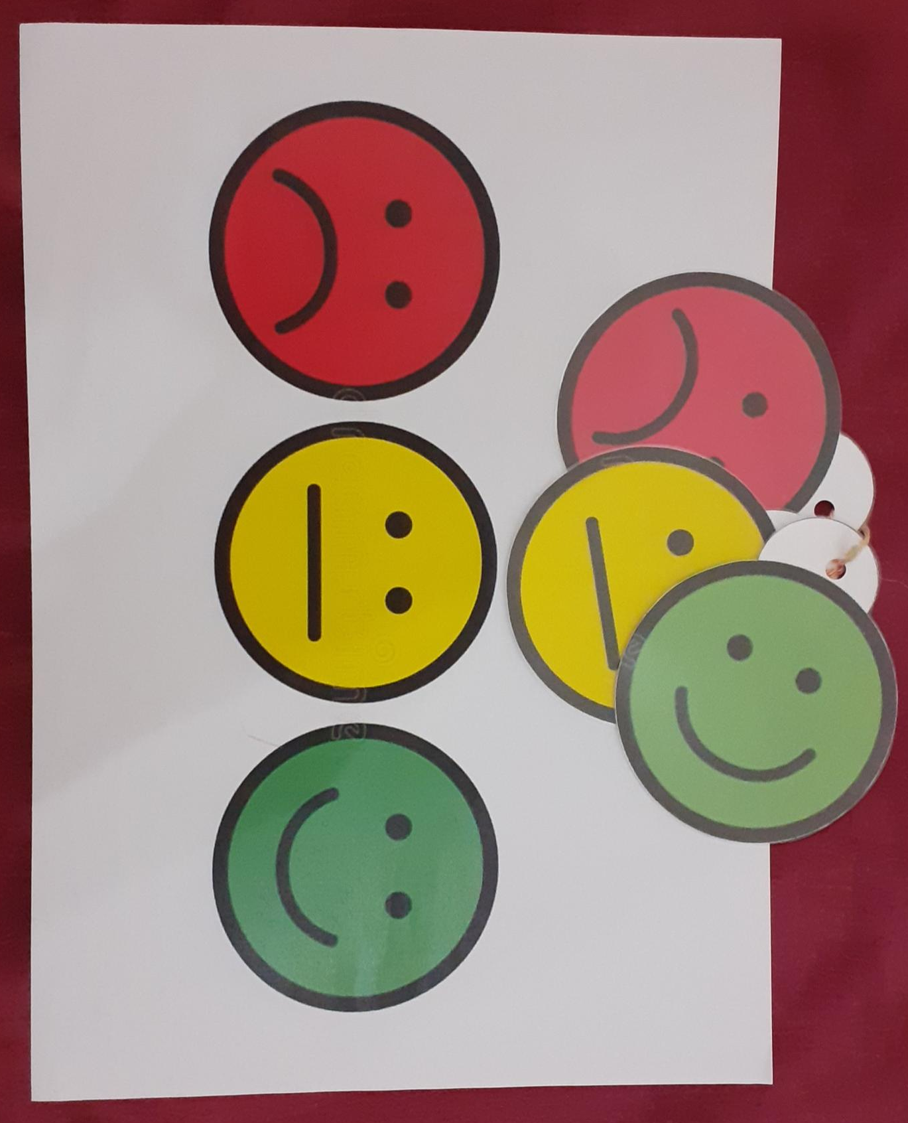
(Appendix 5)

(Appendix 6)
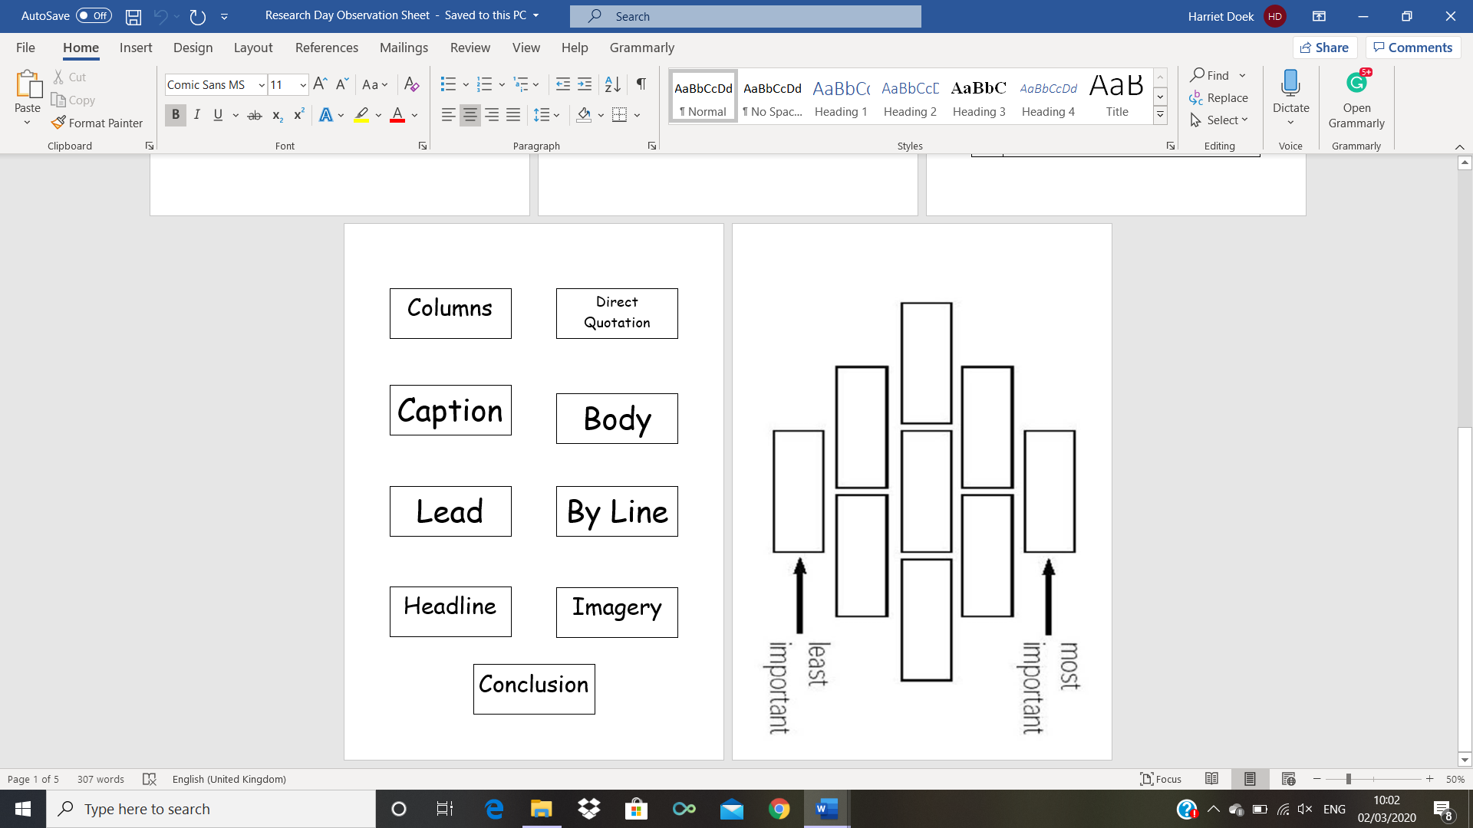
(Appendix 7)

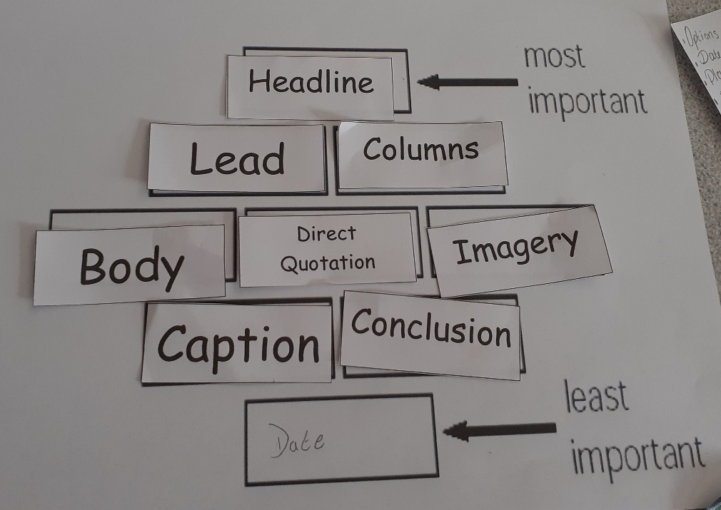
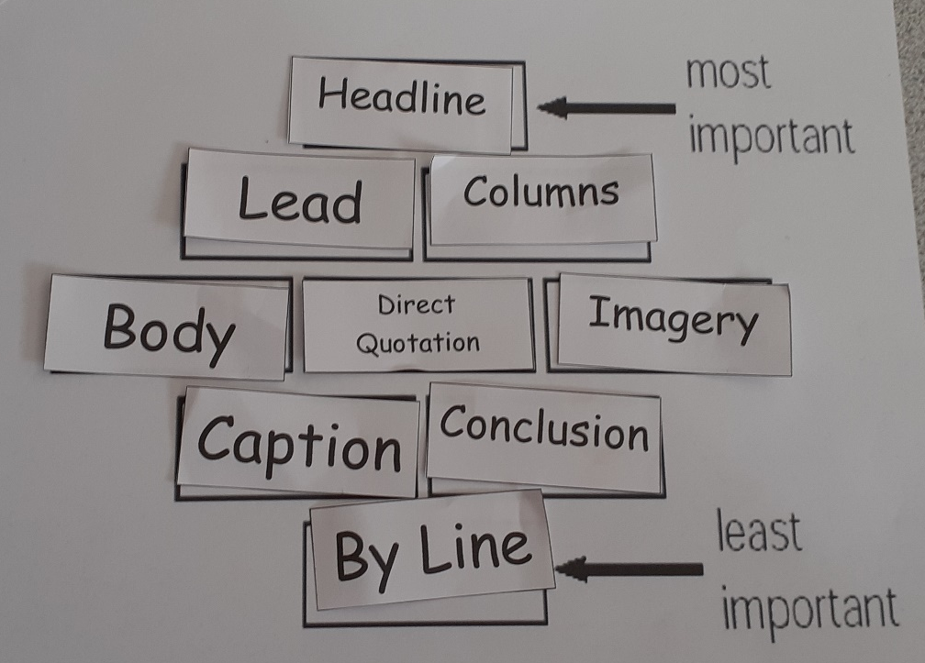

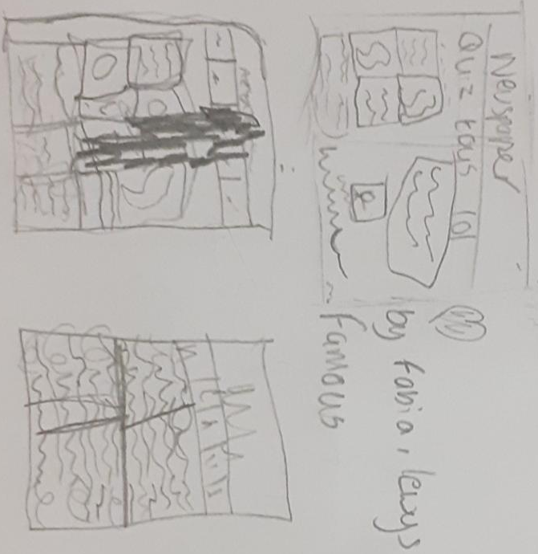

(Appendix 8)
ECAD5010 Research Assignment – Verbal/Visual AFL Strategies Observation
Research Question: What are children’s/teachers’ perceptions and preferences between verbal and visual ‘Assessment for Learning’ Strategies when communicating learning?
Student-Teacher: Harriet Doek 1800795 | Research Day: 02/03/20
Class: Key Stage 2 – Year 6 | Participants: 6 students (1TA)
Time: 11:00-11:30 | Focus: Verbal/Visual AFL Strategies

Structured plan for Observation:
For this observation, I have planned a small activity based on the lessons I completed with the children during my placement. This activity focuses on newspaper features and led by a familiar member of teaching staff i.e. the class teacher or teaching assistant. Students will first need to diamond rank the newspaper features then give their reasoning. Although the diamond will be a physical object the justifications they give can be drawn or explained to the member of staff. What I want to see during this observation is how students prefer to interact and communicate their understanding and learning. Additionally, although I do have some guidance questions for what I need to learn from this observation, I will be allowing myself the freedom to expand and add to these expectations depending on how the observation pans out.

- What AFL strategies does the teacher use?
- How do the students respond to the AFL strategies used?
- Do the strategies demonstrate a positive/negative impact on Student learning?
- Does the teacher change tactics when learning new information through the AFL strategies?

I will be looking at the general well-being of the group, their body language and behaviour and how they respond to the activity.

Observation Notes:

(Appendix 9)
ECAD5010 Research Assignment – Verbal/Visual AFL Strategies Observation
Research Question: What are children’s/teachers’ perceptions and preferences between verbal and visual ‘Assessment for Learning’ Strategies when communicating learning?
Student-Teacher: Harriet Doek 1800795 | Research Day: 02/03/20
Class: Key Stage 2 – Year 6 | Participants: 6 students (1TA)
Time: 11:00-11:30 | Focus: Verbal/Visual AFL Strategies

Structured plan for Observation:
For this observation, I have planned a small activity based on the lessons I completed with the children during my placement. This activity focuses on newspaper features and led by a familiar member of teaching staff i.e. the class teacher or teaching assistant. Students will first need to diamond rank the newspaper features then give their reasoning. Although the diamond will be a physical object the justifications they give can be drawn or explained to the member of staff. What I want to see during this observation is how students prefer to interact and communicate their understanding and learning. Additionally, although I do have some guidance questions for what I need to learn from this observation, I will be allowing myself the freedom to expand and add to these expectations depending on how the observation pans out.

- What AFL strategies does the teacher use?
- How do the students respond to the AFL strategies used?
- Do the strategies demonstrate a positive/negative impact on Student learning?
- Does the teacher change tactics when learning new information through the AFL strategies?

I will be looking at the general well-being of the group, their body language and behaviour and how they respond to the activity.

Observation Notes: Visual / Verbal
- “Look at the words. Do you understand them/remember them?” - TA
- Activate prior knowledge (use APK)
- TA is reading them out one-by-one. Students are giving the definitions for the words they are familiar with. Each child is contributing with what they know.
- Same couple of students are giving suggestions.
- Child A is quiet
- “What is the most important part of an article?” – TA emphasizing question
- Given choice to draw newspaper features but students prefer to discuss it verbally.
- Students are encouraged by TA to give a reason why they have chosen to place a particular feature.
- TA is continually challenging their choices.
- “Do you think those could be moved around?” - TA
- Students debate between the body of a newspaper and the columns, their definitions and their ranking. Students are attempting to use their prior lessons of reading real newspapers as a basis for argument. They start pairing up similar features.
- Child A, B & C are the quietest of the group. They don’t seem upset just disinterested or they think they have nothing useful to add to the discussion.
- TA verbally clarifies definitions for students and some rethink their opinions.
- “What does the feature represent/refer to?” – TA
- “The quote shows that they’ve done the research” - TA
- Students are given the option to add features from their prior knowledge not just from those given. Students are given the option to swap around features on the ranking pyramid. Now that they’ve been given more freedom what do they find to be valuable?
- As they couldn’t remember the name for a particular feature they are given the option to draw it.
- Child D & E to be main contributors to discussions.
- TA makes references to real world news stories and news articles.
- “What is the most important to include in these important articles?” – TA (Where is it happening? When was it published?)
- Students are prompted to think about differences between online and paper newspapers. “Do they differ in features? What could paper newspapers start to include i.e. QR codes to websites?”
- Students are encouraged to think of their personal experiences of research, newspapers and news in general.
- If students are struggling the TA gives students suggestions to build on from.
- TA talks about their own experiences of reading newspapers and news stories students can relate to.
- Child F is quiet and has their arms crossed.
- Child A & B quiet but taking turns to write.
- TA makes sure to reaffirm the knowledge that students demonstrate.
- TA encourages students to be open with their opinions and disagree and argue if they feel the need.
- Students and TA pointing out the differences between the back of the book and newspaper in order to clear up confusion.
- Students and TA briefly mention that different newspapers are of different quality.

(Appendix 10)
ECAD5010 Research Assignment – Teacher Interview Sheet
Research Question: What are children’s/teachers’ perceptions and preferences between verbal and visual ‘Assessment for Learning’ strategies when communicating learning?
Student-Teacher: Harriet Doek 1800795 | Research Day: 02/03/20
Class: Key Stage 2 – Year 6 | Time: 12:00-12:30

Semi-structed plan for Interview:
5-10 minutes are given to summarising the thoughts and feelings from the day of research and giving feedback on how the students conducted themselves throughout the process.

Next, the class teacher and other members of staff will be asked several questions along the theme of Verbal and Visual AFL strategies. These are the main questions I want to ask but I have no specific structure since I don’t know where the teaching staff will lead the conversation. It is explained that they have the freedom to opt out of discussions at any point.

- How do you ensure all children in your class engage in your learning?
- How do you differentiate your questioning/why?
- How do you use the information gained from the AFL strategies?
- How do you think the children respond to verbal AFL strategies?
- How do you think the children respond to visual AFL strategies?
- Which AFL strategies do you think they respond better to: Visual or Verbal?
- Are there any AFL strategies that you would consider your favourite or your go to strategies in any context?

Interview Notes:

(Appendix 11)
ECAD5010 Research Assignment – Student Interview Sheet
Research Question: What are children’s/teachers’ perceptions and preferences between verbal and visual ‘Assessment for Learning’ Strategies when communicating learning?
Student-Teacher: Harriet Doek 1800795 | Research Day: 02/03/20
Class: Key Stage 2 – Year 6 | Time: 11:30-12:00

Semi-structed plan for Interview:
The interview will start with students being given 5-10 minutes to talk freely about how they’ve been doing lately and anything interesting they want to inform me about. They are given a brief reminder of what I am researching i.e. “I am looking at how you like to inform other people of your understanding within a lesson”.

Next, students will be asked several questions along the theme of Verbal and Visual AFL strategies using laminated examples. These are the main questions I want to ask but I have no specific structure since I don’t know where the students will lead the conversation. Using the smiley face traffic light cards, they will always have the option to communicate if they are happy to answer the questions.

- How do you prefer to show your friends and classmates what you have learnt?
- How do you prefer to show your teacher what you have learnt?
- How do you let the teacher know when you are stuck?
- What helps you make your work better?
- What do think about these examples?
- What could they be used for?
- Do you think they could be useful in terms of helping you with your learning?

Interview Notes:

(Appendix 12)
ECAD5010 Research Assignment – Teacher Interview Sheet
Research Question: What are children’s/teachers’ perceptions and preferences between verbal and visual ‘Assessment for Learning’ strategies when communicating learning?
Student-Teacher: Harriet Doek 1800795 | Research Day: 02/03/20
Class: Key Stage 2 – Year 6 | Time: 12:00-12:30

Semi-structed plan for Interview:
5-10 minutes are given to summarising the thoughts and feelings from the day of research and giving feedback on how the students conducted themselves throughout the process.

Next, the class teacher and other members of staff will be asked several questions along the theme of Verbal and Visual AFL strategies. These are the main questions I want to ask but I have no specific structure since I don’t know where the teaching staff will lead the conversation. It is explained that they have the freedom to opt out of discussions at any point.

- How do you ensure all children in your class engage in your learning?
- How do you differentiate your questioning/why?
- How do you use the information gained from the AFL strategies?
- How do you think the children respond to verbal AFL strategies?
- How do you think the children respond to visual AFL strategies?
- Which AFL strategies do you think they respond better to: Visual or Verbal?
- Are there any AFL strategies that you would consider your favourite or your go to strategies in any context?

Interview Notes:
How do you ensure all children in your class engage in your learning?
- Usually start children off with getting students to engage in dialogue with their partner or neighbour about the topic of the lesson. Important to activate prior knowledge (APK) as soon as possible.
- Every lesson needs a good introduction in order to get them interested in the topic. You need to hook them in so that they stay engaged throughout the lesson.
- You can apply the topic matter to a personal context.
- Before moving onto the main activities its good to ask for questions.
- With students its very easy to read body language i.e. do they indicate boredom or excitement?
- For each lesson you must be prepared to differentiate questioning.
- Remember to use students as use students as your mini teachers.
How do you differentiate your questioning/why?
- If you make sure your learning objective is clearly defined in your head it’s much easier to pitch the question to different students.
- You can plan a selection of questions beforehand.
- If you inform yourself properly of the topic and the classroom personalities you should be able to predict the classroom situation i.e. are they likely to be fussy during this activity.
- You can differentiate questions by simply wording things differently.
- Asking students ‘why?’ and to prove they are giving the correct answer should help them demonstrate their deeper understanding of a topic and should show where they should be in terms of differentiation.
How do you use the information gained from the AFL strategies?
- By collecting information through AFL strategies teachers can know where to move forward with lessons.
- Using AFL strategies within a lesson influences future planning i.e. you get an indication of whether you need to revise the topic more or move on.
- The information collected can indicate whether interventions are needed in order to aid learning.
- AFL strategies allow teachers to move away from the original lesson plan/idea.
How do you think the children respond to verbal AFL strategies?
- Benefits students for confidence
- Lower ability students might not understand visual prompts.
- Allows teacher and student to use own wording and context.
- Its easy to link it to a context that they like.
- Talking is an active way of deepening understanding.
How do you think the children respond to visual AFL strategies?
- Focus school doesn’t use smiley faces as it means you have to evidence constantly what you are doing to help. This can be difficult to document. Additionally, students are not always honest with their thoughts and feelings.
- Peer/Self Marking is very difficult as students can get upset because they don’t want to be wrong.
- Visual AFL strategies are useful but students have to be constantly reminded of how and when to use them.
- Students are used to the whiteboards as a visual prompts or learning tool.
- If strategies are imbedded they don’t need visuals to guide them i.e. there are less and less displays as you go further through the school.
- Maths examples are very useful.
- WAGGOLE (What A Good One Looks Like) is imbedded and constantly used within the school.
- Success criteria is discussed and displayed on a whiteboard every lesson.
- Word mats, structure strips and planners are particularly useful strategies.
Which AFL strategies do you think they respond better to: Visual or Verbal? Why?
- Different learners will have different needs therefore the strategies used will vary.
- Both depending on the lesson.
- Walking around the classroom allows for easy verbal dialogue and it is often better to give verbal explanations rather than just give students examples of work.
- When marking teachers use codes such as VF (verbal feedback) or Sp (spelling) to indicate what work has been done and what need to be improved.
- Visual strategies work well for gaining evidence of completed work.
- In the Foundation Phase students are given constant verbal feedback.
- With older year groups and especially when using whole class teaching, you will probably need to use a mix of both.
- It is important to get children to converse with each other.
Are there any AFL strategies that you would consider your favourite or your go to strategies in any context?
- Questioning is the most straight forward strategy.
- Thumbs up is simple to understand.
- Lollipop sticks are good, but teachers need to think twice about it as it can be daunting. Phone a friend can be used additionally to help relieve this stress.
- You must tailor all AFL strategies to suit your class.
- Foundation Phase loves lollipop sticks. Age often effects confidence i.e. social pressure makes an impact.

(Appendix 13)
ECAD5010 Research Assignment – Student Interview Sheet
Research Question: What are children’s/teachers’ perceptions and preferences between verbal and visual ‘Assessment for Learning’ Strategies when communicating learning?
Student-Teacher: Harriet Doek 1800795 | Research Day: 02/03/20
Class: Key Stage 2 – Year 6 | Time: 11:30-12:00

Semi-structed plan for Interview:
The interview will start with students being given 5-10 minutes to talk freely about how they’ve been doing lately and anything interesting they want to inform me about. They are given a brief reminder of what I am researching i.e. “I am looking at how you like to inform other people of your understanding within a lesson”.

Next, students will be asked several questions along the theme of Verbal and Visual AFL strategies using laminated examples. These are the main questions I want to ask but I have no specific structure since I don’t know where the students will lead the conversation. Using the smiley face traffic light cards, they will always have the option to communicate if they are happy to answer the questions.

- How do you prefer to show your friends and classmates what you have learnt?
- How do you prefer to show your teacher what you have learnt?
- How do you let the teacher know when you are stuck?
- What helps you make your work better?
- What do think about these examples?
- What could they be used for?
- Do you think they could be useful in terms of helping you with your learning?

Interview Notes:
How do you prefer to show your friends and classmates what you have learnt?
- The students do enjoy showing their work to the class at the end of the lesson. However, this is dependent on the confidence of the individual and whether this is their choice or not.
- The students are quite used to the idea of helping their neighbour (whoever they are sat next to) and using their own work as an example to help out.
- Sometimes, especially when completing a creative task, the class will walk around the classroom and look at other people’s work i.e. the art gallery AFL strategy.
- At the end of each week at least 2 students are awarded a Golden certificate for good work and behaviour.
How do you prefer to show your teacher what you have learnt?
- Students are very much used to the idea of sitting down with the class teacher/TA and showing their work.
- Through discussions or their activity evidence students demonstrate that they have followed the success criteria.
- If teacher is happy with your work, they might put in on the WOW wall or even outside the headteacher’s office for other teachers, students, visitors and parents to see.
How do you let the teacher know when you are stuck?
- Students are well versed with putting their hands up.
- Teachers are often given an indication that something is wrong by the student(s) moving discussions to a different topic.
- SNOT (Self, Neighbour, Other, Teacher) is used frequently within the classroom.
- The easiest indication would be to ask for help.
What helps you make your work better?
- Being able to look at examples and compare them to their own work.
- Being able to look at other student’s work and compare them to their own.
- WAGOLL (What A Good One Looks Like) is frequently used in different topics. Gives them a base to work off. Does their own work include the same features?
What do think about these examples?
- What could they be used for?
- Do you think they could be useful in terms of helping you with your learning?


- Lets you see clearly what you need to do in order to be successful layout it needs to be in.
- Helps you learn about space, earth, different planets
- Gets you to think of different questions i.e. Can you stand on the rings? What is the disk around it? How many moons does this planet have? What type planet is it? When was it first discovered?
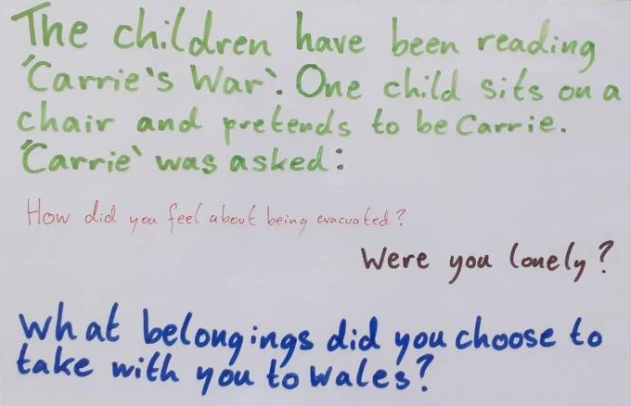
- This type of worksheet can be used in case you forget anything and you can keep adding to it as you learn more and more.
- The students have completed a KWL Grid previously which is a very similar AFL strategy.

- It seems to be a type of role play. People could act out the character.
- Encourages people to come up with questions.
- This would be great for a history lesson.
- It would be a good way to understand the feelings and thoughts of different people. Very good for a PSE lesson.
- This would be a good thing to do when learning about the romans and slavery.
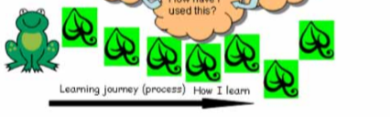
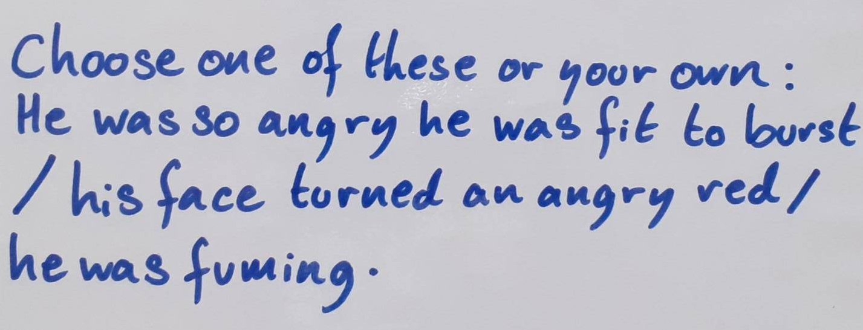

- Would prefer this diagram to the previous strategy.
- This would be good to keep track of what step you are on.
- It also makes it easier to point out what you are stuck on.

- If you were stuck it would help
- They would prefer to create one of their own.
- Could combine or change suggestions and add your own stuff to it.

(Appendix 14)

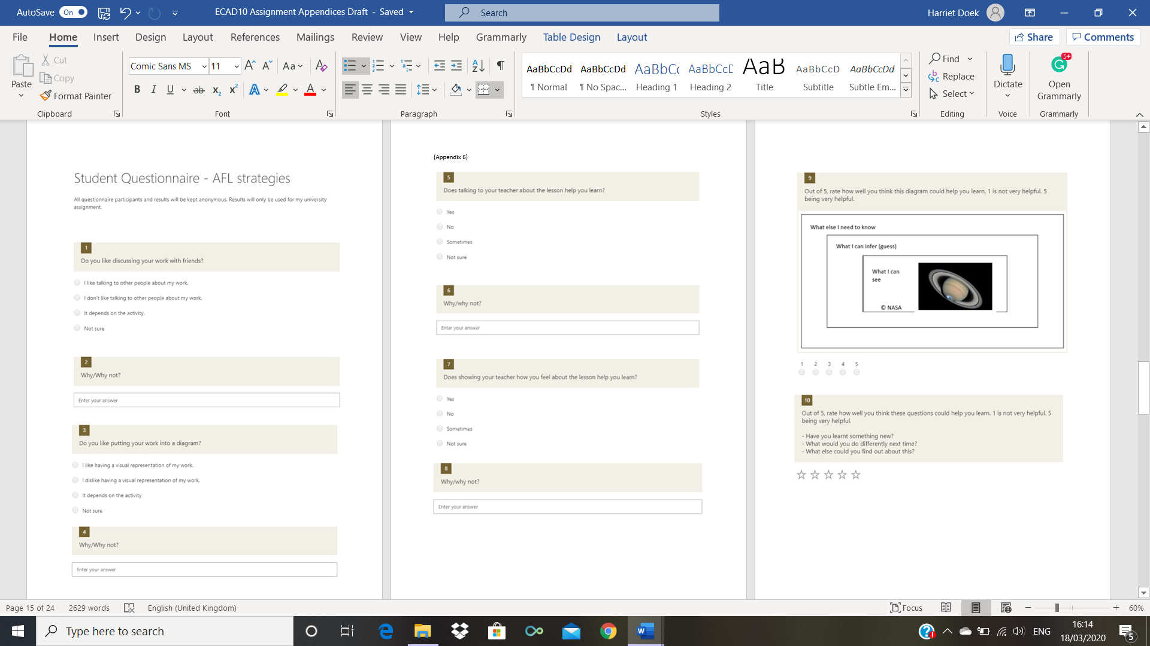

(Appendix 15)

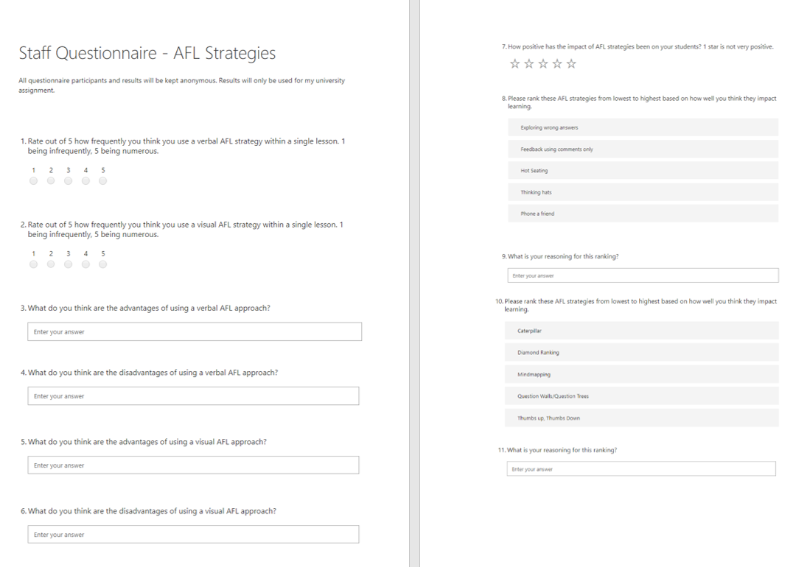

(Appendix 16)
Student Questionnaire Results
5 Responses | 09:41 – Average time to complete

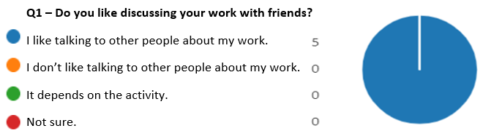
Appendix 16A

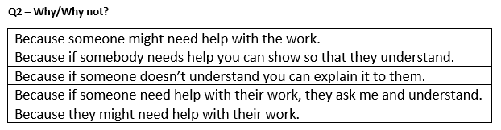
Appendix 16B

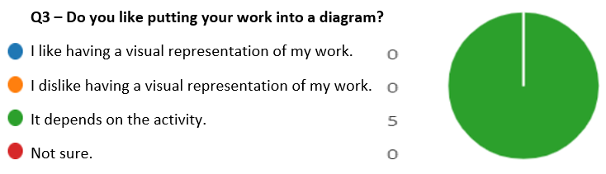
Appendix 16C

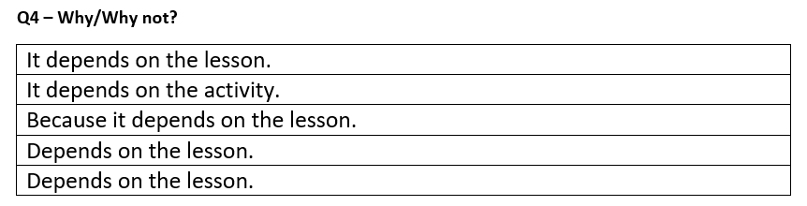
Appendix 16D

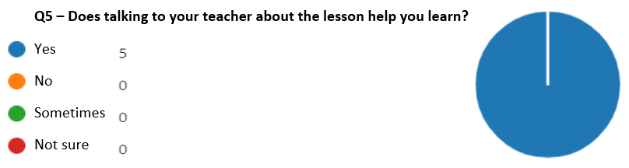
Appendix 16E

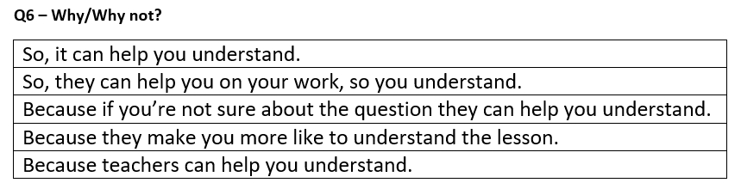
Appendix 16F

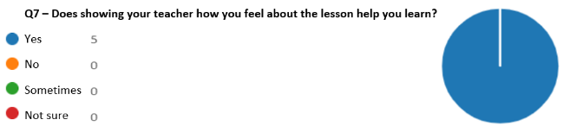
Appendix 16G

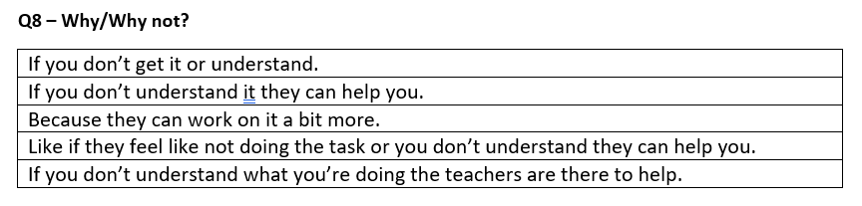
Appendix 16H

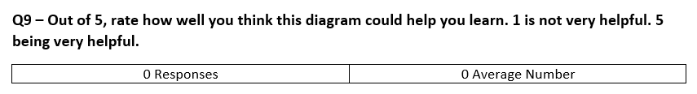
Appendix 16I

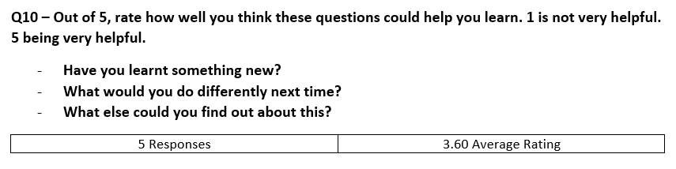
Appendix 16J

(Appendix 17)
Staff Questionnaire Results
4 Responses | 17:17 – Average time to Complete

Appendix 17A
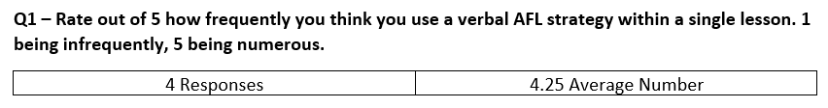

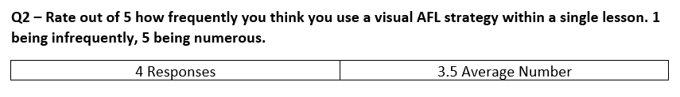
Appendix 17B

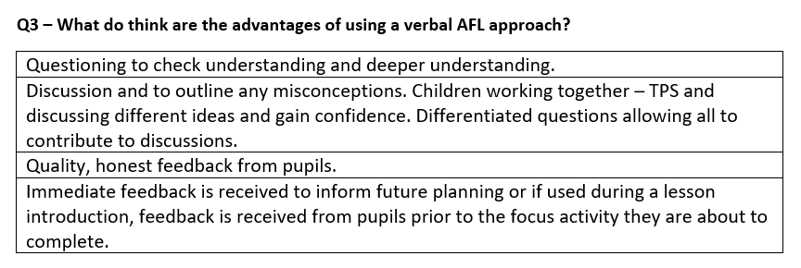
Appendix 17C

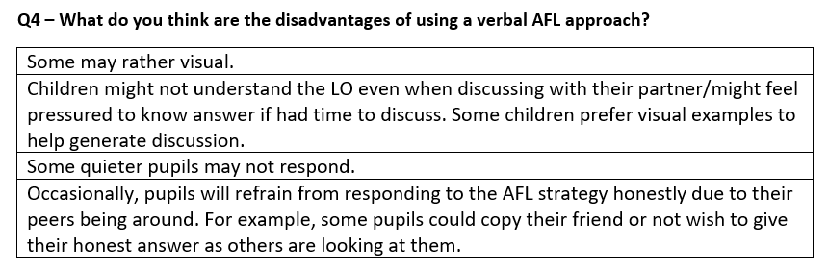
Appendix 17D

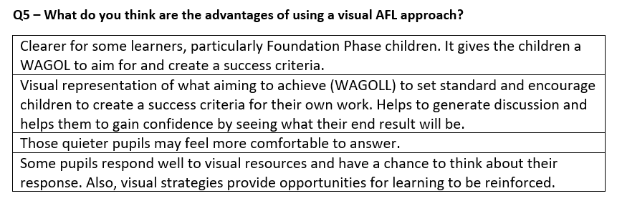
Appendix 17E

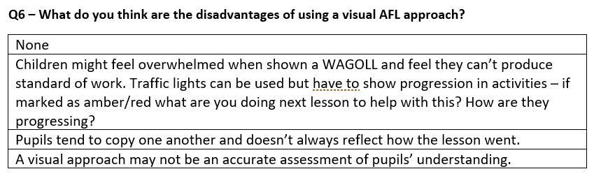
Appendix 17F

Appendix 17G
How positive has the impact of AFL strategies been on your students? 1 star is not very positive.
4 responses | 4 Average Rating

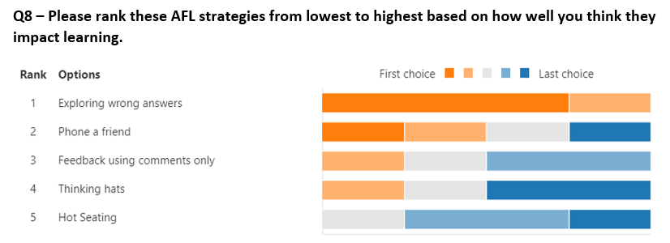
Appendix 17H

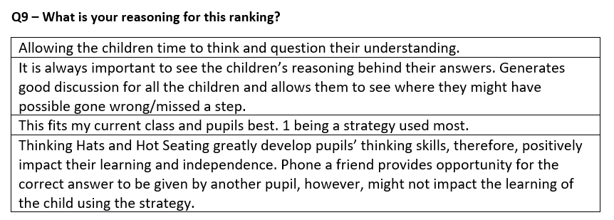
Appendix 17I

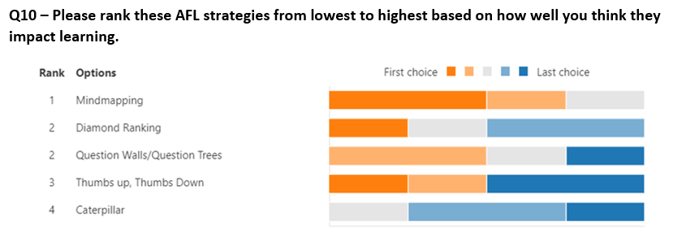
Appendix 17J

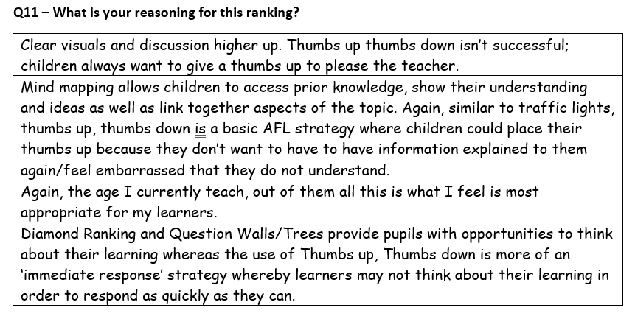
Appendix 17K

