6/15/2023
Name: Carmen Celina Ghorghe
ID number: 2246329
Lecturer name: Scott James

Marketing Essentials Module code: BMIH4005
Assessment Two (Individual Presentation and Supporting Marketing Plan) Component A: Marketing Plan for Hilton Hotel

Table of Contents
Introduction 3
Situation Analysis 3
Objectives 5
Strategy 5
Tactics 6
Action 6
Gannt Chart of marketing activities 6
Justification 8
Control 8
Conclusion 8
References 10
Appendix: Presentation 11

Introduction
The purpose of this marketing plan is to assist in the finding of a potential marketing opportunity for the Hilton Hotel. In accordance with the plan, a comprehensive communications strategy will be devised in order to deal with it. This plan has been prepared with the hotel's management and all of the hotel's stakeholders in consideration. Ansoff matrix, the RACE model, SOSTAC, and the 4Ps are just few of the fundamental concepts and theories that were utilised in the process of formulating the plan.

Situation Analysis
Company
SWOT analysis (Brassington and Pettitt, 2017) helps hotel owners and managers identify the hotel's internal opportunities and threats, as well as its strengths and weaknesses.
- Hilton Hotel's strengths consist of its widespread recognition and its varied collection of hotels.
- High levels of competition and the possibility of service quality variations are weaknesses.
- Opportunities can be found in emerging markets or among a new demographic of consumers.
- Threats can emerge from a variety of sources, including economic downturns and shifting consumer tastes.

Customers
Hilton Hotel can identify certain customer segments and adjust its offers to those segments by using segmentation and targeting tactics (Hooley et al., 2019). Demographic, psychological, and behavioural data can all go towards developing an accurate picture of a target audience. Insights regarding customer behaviour, preferences, and online involvement can be gleaned with the help of tools like SimilarWeb (2023).

Competitors
According to Kotler and Keller (2016), a perceptual positioning map can assist businesses in determining where they stand in comparison to their rivals. One such business is Hilton Hotel UK. Bowman's strategy clock can aid Hilton Hotel to learn more about its competitors' strategies and find ways to stand out (Jobber and Ellis-Chadwick, 2019). Utilising this analysis will help the hotel improve its market placement as well as its ability to differentiate itself from competitors.

Collaborators
Hilton Hotel UK must recognise the importance of business-to-business relationships. Partnerships with travel brokers, event planners, and online travel platforms increase distribution and reach (McDonald and Wilson, 2016). Cross-promotion and package sales are possible with regional companies and tourism bodies.

Climate
According to Brassington and Pettitt (2017), hotels can benefit from conducting a PESTLE analysis to identify potential influences from the macro environment. PESTLE analysis of Hilton Hotel is following below:
- Governmental policies and rules that affect the hotel industry are examples of political factors.
- Tourism can be impacted by macroeconomic variables including currency exchange rates and economic stability (West et al., 2015).
- As a social phenomenon, the preferences and fashions of consumers are always evolving.
- Changes in digital distribution and hosting infrastructure are examples of technological developments (Nozdreva and Churakova, 2021).
- Industry-specific laws are an important part of the legal factors.
- Environmental considerations give attention to conservation and green methods.

Marketing Mix
Improvements and efficiencies in the hotel's operations can be found by analysing the hotel's marketing mix (Kotler et al., 2017).
- Analysing Hilton's offerings, service quality, and amenities is part of the product evaluation.
- Strategy, value perception, and competitiveness are the main aspects of price analysis.
- Distribution methods, internet presence, and physical location tactics are all taken into account throughout the Place Analysis process.
- Reviewing marketing communications, advertising campaigns, and digital marketing initiatives are all part of promotion assessment (Chang et al., 2019).
Hilton Hotel can improve its tactics and better match customer expectations by analysing the strengths and weaknesses of each component of the marketing mix (Mekhruza et al., 2022).

Objectives
Increasing website bookings by 15% over the next six months is the Hilton Hotel's SMART marketing plan objective. The quantity of online bookings made through the hotel's website will serve as the performance indicator. Key performance indicators (KPIs) include website conversion rate, average booking value, and total revenue from online bookings. To increase revenue, the hotel's internet presence and customer engagement will improve.

Strategy
By offering guests personalised experiences, Hilton Hotel will concentrate on improving its value proposition. According to Armstrong and Kotler (2017), the chosen strategy from Ansoff's matrix is market development, which seeks to acquire new customer segments through differentiated offerings and targeted marketing. The company's new value proposition will centre on providing superior service and making the customer's experience memorable (Kotler et al., 2017). Hilton's goal is to win back the trust of customers and establish itself as the go-to hotel chain for sophisticated vacationers by emphasising their needs and providing them with unique, tailored experiences.
Several modifications to the marketing mix will be necessary. As part of its ongoing efforts to improve the hotel-goer experience, Hilton may roll out additional services and perks. The strategy may employ price-cutting techniques to increase the impression of value. Using social media, online reviews, and testimonials, promotion efforts will concentrate on showcasing good visitor experiences.

Tactics
Hilton Hotel will include the RACE framework into its communications mix, which can help to effectively convey the new value proposition and address identified concerns (Fill and Hughes, 2016).
- Reach: Hilton plans to increase its reach by upgrading its social media profiles, focusing on search engine marketing (SEM), and optimising its website for search engines.
- Act: Hilton will encourage customers to take action by providing them with engaging material and eye-catching videos that highlight the hotel's amenities, as well as exclusive deals, discounts, and loyalty programmes.
- Convert: Increasing the rate at which leads are converted into bookings can be achieved by streamlining the booking process, strategically inserting calls-to-action, and delivering a seamless user experience.
- Engage: Hilton will actively monitor and respond to customer reviews and feedback, employ user-generated material, and communicate with customers through personalised email marketing.
Hilton's present communications can be enhanced in several ways, including through more social media involvement, a faster response rate, and more personalised email marketing. Visually appealing content, robust social media engagement, and making use of user-generated content are all ways to improve things.
By taking these measures and adopting the RACE framework, Hilton Hotel hopes to enhance its communications, boost its customers' engagement, and increase its reservations and income.

Action

Gannt Chart of marketing activities
Channels/Activities | Jan | Feb | Mar | Apr | May | Jun | Jul | Aug | Sep | Oct | Nov | Dec
Social Media Ads
Email Marketing
Influencer Marketing
Print Ads
Search Engine Marketing
Content Marketing
Social Media Campaign
Outdoor Advertising
Affiliate Marketing
Events/Sponsorships
Direct Mail Campaign
Referral Program

Channel Metrics | KPIs
Social Media Ads | Increase in website traffic
Email Marketing | Click-through rate, conversion rate
Influencer Marketing | Engagement rate, brand mentions
Print Ads | Brand awareness, reach
Search Engine Marketing | Cost per click, conversion rate
Content Marketing | Organic website traffic, time on page
Social Media Campaign | Follower growth, engagement
Outdoor Advertising | Impressions, brand recall
Affiliate Marketing | Conversions, revenue
Events/Sponsorships | Attendee participation, lead generation
Direct Mail Campaign | Response rate, customer acquisition
Referral Program | Referral sign-ups, customer retention

Justification
There are both online and traditional marketing channels in the Hilton Hotel's marketing strategy. Using these methods, you can make sure you're reaching your intended audience and having a clear conversation with them (Baines et al., 2019). The marketing channel schedule for the hotel is designed to maximise the effectiveness of marketing throughout the year by taking into account the hotel's target demographic, communication goals, key performance indicators, and seasonal factors. In this way, the intended audience receives the message via the most efficient channels, maximising the likelihood of a positive response.

Control
We will employ metrics and key performance indicators (KPIs) to track our Hilton Hotel marketing goals. We'll focus on new customers, brand loyalty, and bottom-line growth.
We'll track metrics like website traffic, booking enquiries, and reservations to measure customer acquisition. These metrics show how well our marketing channels acquire and keep new customers.
We'll monitor metrics like customer reviews, social media sentiment studies, and brand mentions gauging good business sentiment. These metrics can help us evaluate our guest experience improvements.
Revenue per available room and occupancy rate are among metrics we'll examine to increase earnings. These metrics measure the hotel's financial performance and our marketing's revenue impact.

Conclusion
In conclusion, Hilton Hotel's marketing plan overcomes challenges and seizes opportunities to boost positioning, customer engagement, and revenue. After analysing the existing scenario, the plan lists strengths, weaknesses, customer segments, rivals, collaborators, and market aspects. The RACE framework aims to increase online reservations by 15%. Metrics and key performance indicators justify the marketing channel plan. Success is increasing revenue, customers, and company perception. Recommendations include personalising email and social media campaigns and improving channels based on customer feedback. Hilton Hotel strives to improve services and market share.

References
Armstrong, G., and Kotler, P. (2017). Marketing: An introduction (13th ed.). Pearson.
Baines, P., Fill, C., and Page, K. (2019). Essentials of marketing (4th ed.). Oxford University Press.
Brassington, F., and Pettitt, S. (2017). Essentials of marketing (4th ed.). Pearson.
Brassington, F., and Pettitt, S. (2017). Principles of marketing (8th ed.). Pearson.
Chang, Y. C., Ku, C. H., and Chen, C. H. (2019). Social media analytics: Extracting and visualizing Hilton hotel ratings and reviews from TripAdvisor. International Journal of Information Management, 48, 263-279.
Fill, C., and Hughes, G. (2016). Marketing communications: Engagements, strategies, and practice. Pearson.
Hooley, G., Piercy, N. F., and Nicoulaud, B. (2017). Marketing strategy and competitive positioning (6th ed.). Pearson.
Jobber, D., and Ellis-Chadwick, F. (2019). Principles and practice of marketing (8th ed.). McGraw-Hill Education.
Kotler, P., and Keller, K. L. (2016). Marketing management (15th ed.). Pearson.
Kotler, P., Keller, K. L., Brady, M., Goodman, M., and Hansen, T. (2017). Marketing Management (2nd European ed.). Pearson.
McDonald, M., and Wilson, H. (2016). Marketing plans: How to prepare them, how to use them (8th ed.). Wiley.
Mekhruza, V., Malokhat, S., Rustam, T., and Bakhora, R. (2022). PERFORMANCE OF HILTON: HOW HILTON TACKLES THE EPIDEMIC COVID-19 DISEASE. Thematics Journal of Business Management, 5(2).
Nozdreva, R., and Churakova, A. (2021). Digital tools in empirical marketing strategies of global hotel companies. Digital strategies in a global market: Navigating the Fourth Industrial Revolution, 213-227.
SimilarWeb. (2023). SimilarWeb website. Retrieved from https://www.similarweb.com/
West, D., Ford, J., and Ibrahim, E. (2015). Strategic marketing: Creating competitive advantage. Oxford University Press.

Appendix: Presentation

Slide 2

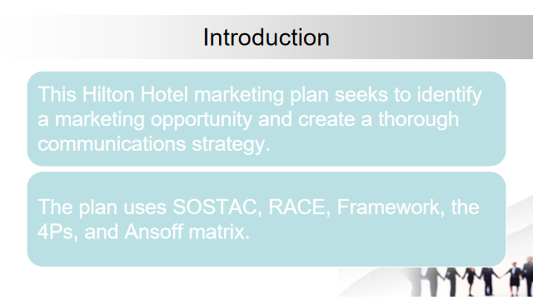
Slide 3
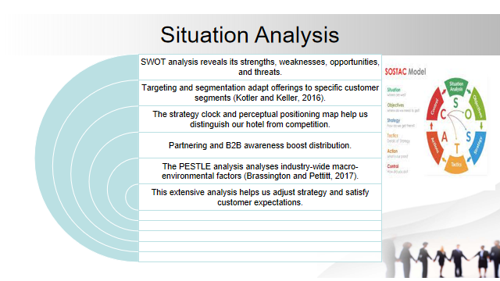

Slide 4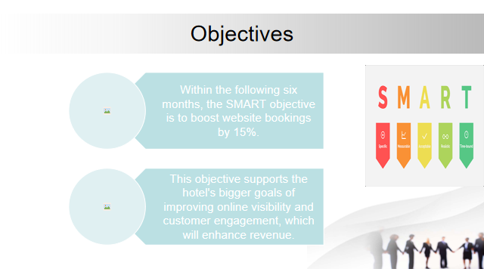
Slide 5
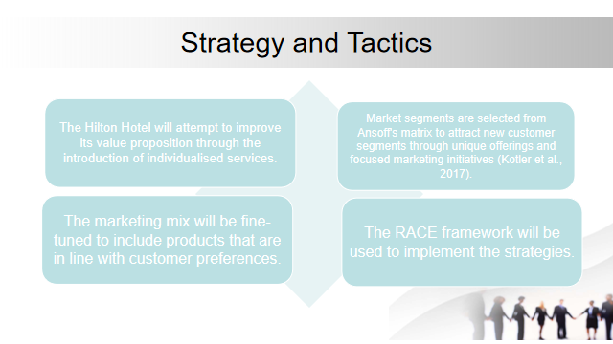
Slide 6
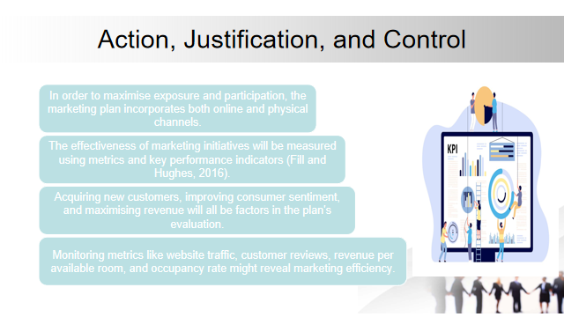
Slide 7
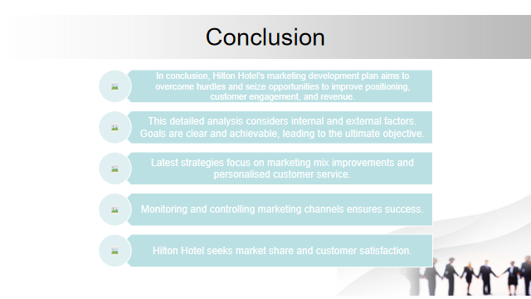

Slide 8


