FOOD & BEVERAGE OPERATIONS

STUDENT NAME: LORINCZ HELMUT BENJAMIN
STUDENT ID NUMBER:2120964
MODULE: FOOD AND BEVERAGE OPERATIONS (BMIH4002)
LECTURER NAME: LAURENCE BLAKE

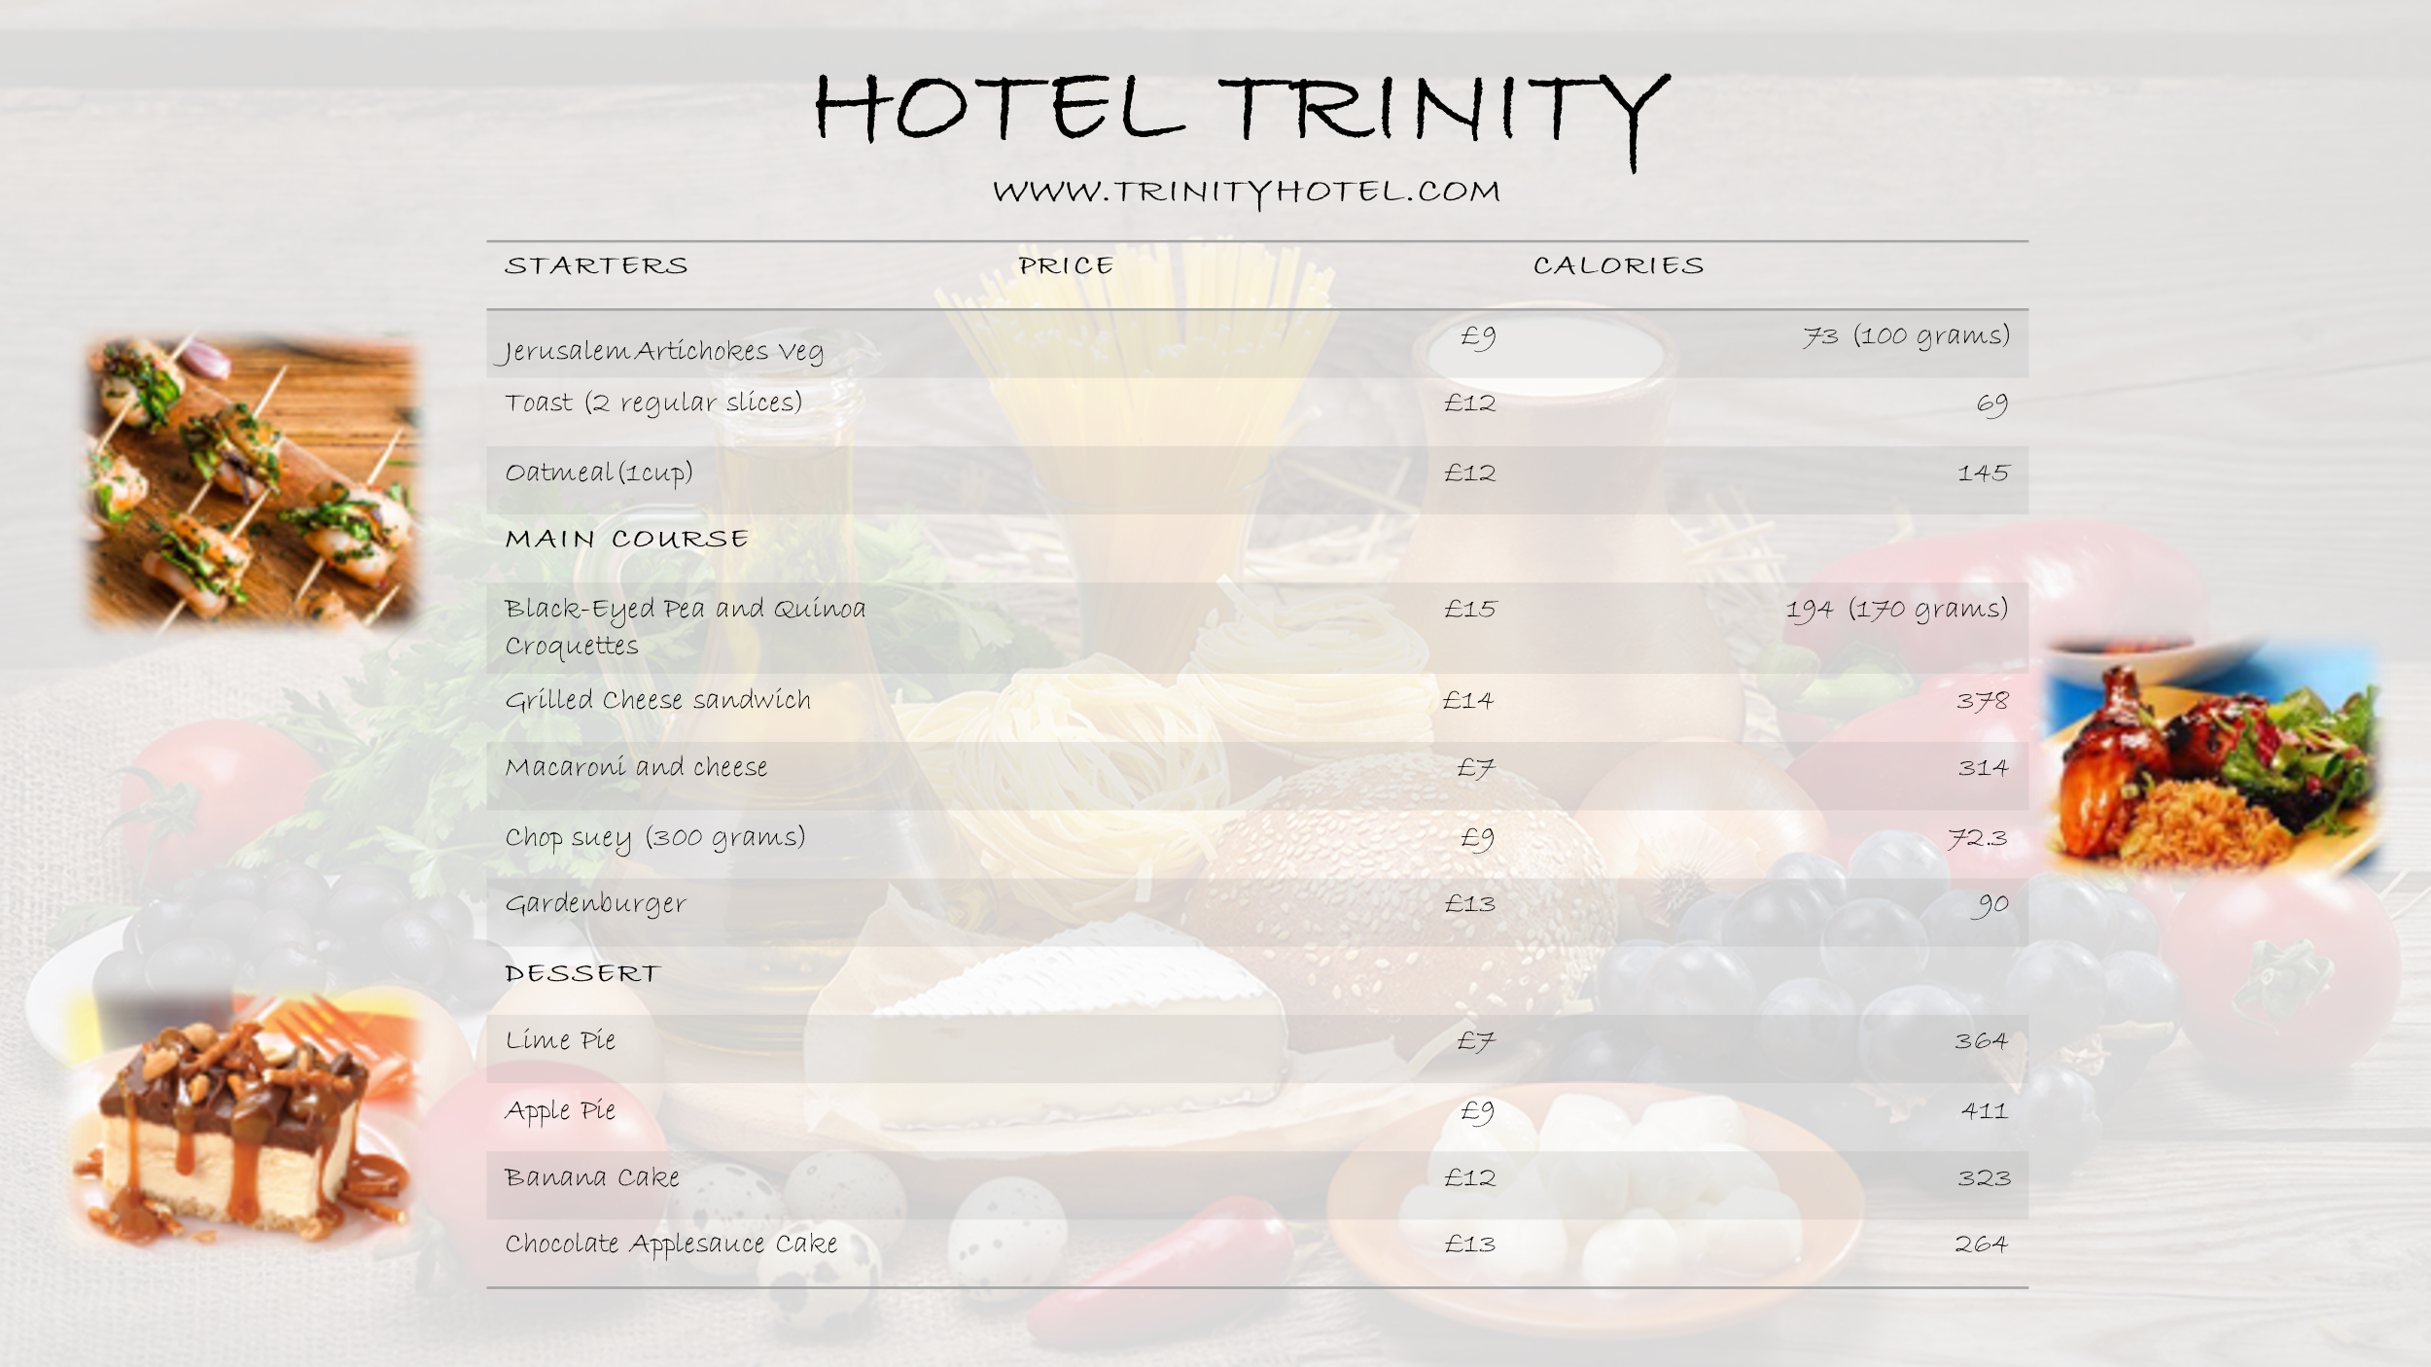

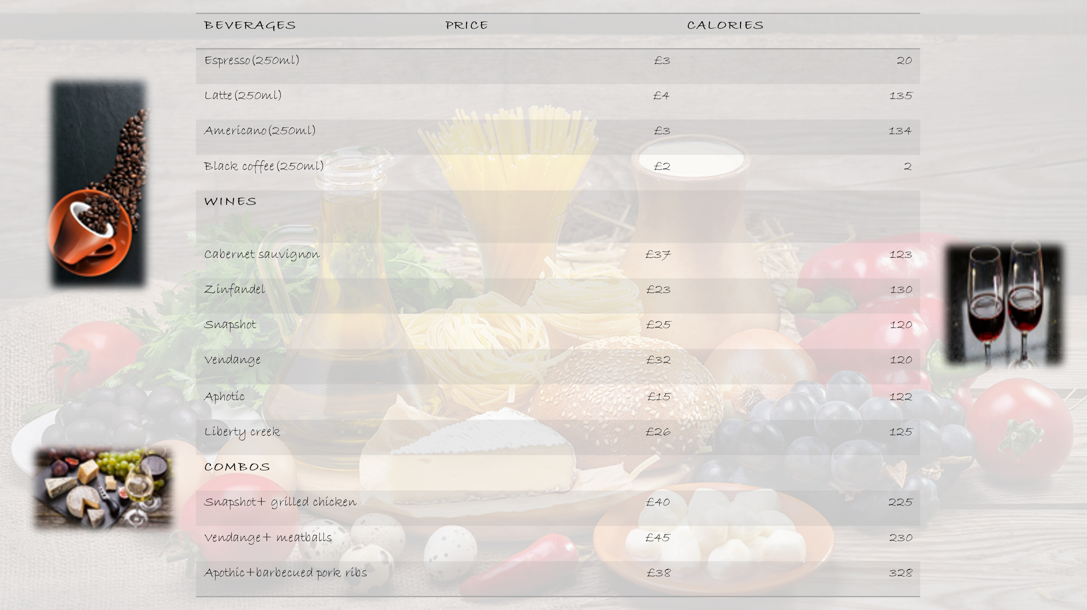

Time Availability of food: full menu list’ items are available at the given time

DAYS | OPENING TIME | CLOSING TIME
MONDAY TO FRIDAY | 1 AM | 11 AM
SATURDAY | 4 PM | 12 AM
SUNDAY | 2 PM | 2 AM

CONTACT US: orders can be placed by the customers on the official website of our Hotel Trinity, or through the contact number that has been given on the website, our hotel services are also available on Uber Eats so the customer can also place an order on Uber Eats application.
INSTRUCTIONS: the order will be placed at the given location with all the safety measures and by following covid guidelines. Payment can be made in any mode. Payment mode includes:
- Cash on delivery (temporarily closed)
- Net banking
- Debit card
- Credit card

CONTACTLESS DELIVERY: for some period of time due to COVIFD-19 hotel trinity is not accepting cash. Only online payment is allowed as per the guidelines of COVID-19 contactless delivery is offered by the hotel by taking online orders and accepting only online payments.

BEVERAGES: The quantity and calories contain per quantity as mentioned in the menu card.

References

Masset, P. and Weisskopf, J.P., 2021. New York Restaurants: A Wine Odyssey Between 1865 and 1920. Cornell Hospitality Quarterly, 62(3), pp.297-312.
Parkin, B.L. and Attwood, S., 2022. Menu design approaches to promote sustainable vegetarian food choices when dining out. Journal of Environmental Psychology, 79, p.101721.

