Callum Cross
Student Number: 1705149
Module Lecturer’s: Mike Dacey \ Tim Bashford

pROGRAMMING ii
Module Code: ACCA4006

Table of Contents
Description problem solving approach 1
Testing 2
Display Fix 2.1
Quit Input Fix 2.2
Number Input Fix 2.3
Implementation 3
Identifying Problems 3.1
Mapping Problem Space to Code 3.2
Create Connect 4 3.3
Appendix 4

Description problem solving approach (1)
Many exercises given to myself from other are put into a systematic approach on how to solve the task they have given me. I will be showing my way on how I approach each and every task and how I think it benefits me to finish with the complete end goal.
The first step I try to look at is the overall problem and figure out what the end goal should be after solving all the problems I also try to add names to the problems to make them simpler and once I figured the out the solution I can then cross the name off my list to do. Once I have looked at the end goal I try to figure out what problems should I try to solve first to last by making a list, the problem at the top is always the easiest and the problem at the bottom of the list is the hardest task.
I do this so I can get a better visual view of how the program will work or how the problem can be fixed in a more layered way. After listing all the problems, I try to look at all the solutions for each problem individually so it’s not such a big task in my head as I know if I get one tasked done I’m inching closer to the target goal overall.
If I’m struggling with a problem and cannot figure it out, I try to make it as simple as possible so it’s easier to understand this makes me more relaxed to create a solution as it looks a lot simpler than having a huge problem. I always try to experiment by both testing solutions in Visual Studio and by using the internet as a lot of people on forums normally have had the same problem as you.
I try to create solutions that can solve multiple problems as it allows flexibility and makes it easier to create a solution and then be able to re-use it over again for a new problem as this can become tedious and annoying if you have to write the same code over and over again.
Once I have looked at all the solutions I could entail, I then start to look at what solutions would be best to use for each problem. Depending on the problem trying different solutions will also show what’s the best performance overall for the task sometimes the easiest isn’t the best solution.
I finally end by adding all my final decisions to a list for each problem and start from the easiest task to the toughest until the program is complete.
Overall, I think this strategy suits me the best because I learn visually from seeing tasks being done and that gives me the extra boost of confidence to get the task done on-time. I also think this task is the best for me because I like to create a plan on how I’m going to do the task before I undertake it, as this allows me to get a sense of what type of problems I will be encountering during the creation of the project.

Testing (2)
Display fix (2.1)
So, after testing the program to see if it was working correctly I came across a bug that would allow the hashes to go off screen ‘#’. This was because there was no function that allowed the program to know how many spaces it should put in between the hashes and numbers, this made the program print the line and make the hashes go off screen.
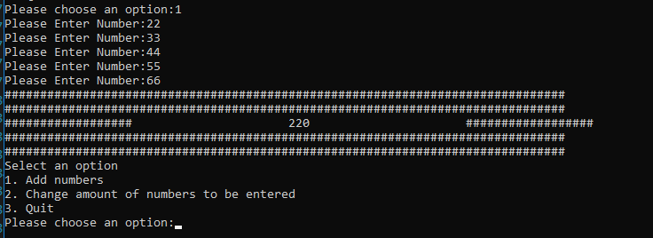
To fix this problem I put together a list that I knew was possible and could be done by the amount of skills I’ve learned this is the list put together from easy to hard.
- Print spaces to screen
- Convert the final number to a string
- Count the number of digits in the final number string
- Calculate how many spaces need to be on each side of the number
- Print spaces to screen with the correct amount on each side.
After compiling this list, I got to work on how the program would be fixed. After completing the task and adding the necessary code to the program it finally was working with the correct number of spaces on each side depending on how long the number of digits was.
This was the final result:
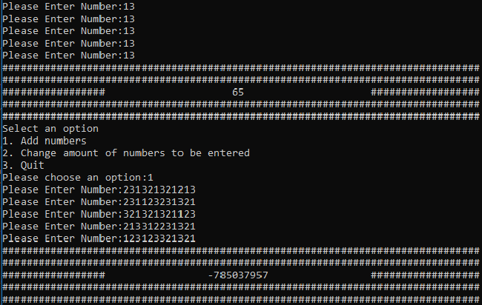
The reason the number in the screenshot ended becoming minus was because the program was running in a 32bit environment. The max number for a 32bit operating system is 2,147,483,647 meaning the program did not know what do with such a high number entered and spat out a random minus number.
Quit Input Fix (2.2)
The next bug I encountered was a bug when the user would type “yes” into the console, after selecting the option “Quit”, the program would not quit and would think it was an incorrect input meaning the program would not exit and carry on with it’s operation of displaying the menu.
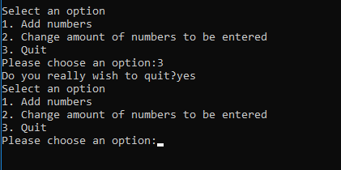
After following through the programs code, I found that the user must have to type “YES” instead of “yes”, this meant the user would only exit the program if the user specifically typed “YES”. Overall this was quite a quick fix as all I had to check for was if the response was “yes” as well as “YES” this allowed the user to type “yes” both ways without getting confused.
I created a list to solve this problem:
- Check user input.
- If user input was equal to “YES” or “yes”.
- The program shall exit.
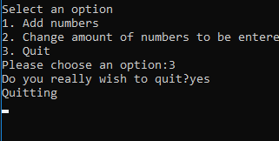
Overall this was a very easy fix as the programs code was very easily laid out and allowed me to solve the problem very quickly. My simple solution for this fix was by using the “OR” Syntax in the “IF” statement that checked if the user’s response was correct before quitting.

Number Input Fix (2.3)
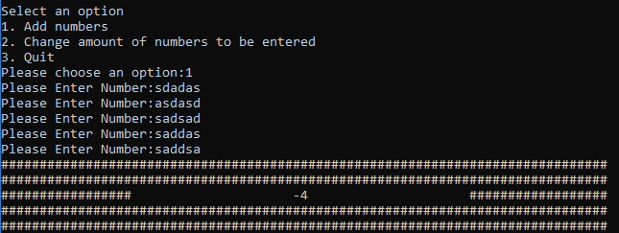
The final bug I found was that when you typed an incorrect numeric number the program would still try to use the value and not ignore the number so the final value outputted from the program would end up being incorrect and the user would probably end up being confused.
To fix this I came up with a list on how to solve this problem.
- Get the value that the user inputted.
- Change the value to a string.
- Check the string through a loop for any non-numeric characters.
- If there was a non-numeric character then return 0 and proceed with a message to the user.
After checking the code, I proceeded to try and find where the program would check the input the user entered and manipulate the program with a safe-fail, if the user would end up typing the incorrect numeric value the function would return 0 with a message to the user.
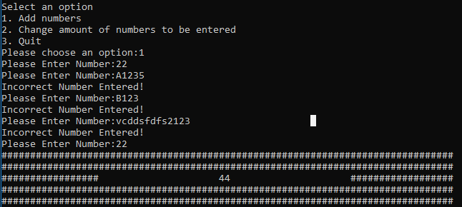
As you can see in the above picture the program will allow the user to enter the non-numeric characters but will not count that number towards the final output and will proceed to message the user that they have typed in an incorrect value.

Implementation (3)
Exercise 1 (3.1) Identifying Problems
A Console game requires the player to guess a number between -20 and +20 that the program selects in secret. The player has five attempts to guess this number, otherwise they lose. To help the player, the game gives the player a new hint every time they fail to guess it correctly.
By looking at the current task I have created a list of problems that I would have to create solutions to from easiest to toughest:
- Display message to user has Won or Lost.
- Ask the user for an input value.
- Create a random number from -20 to +20.
- Check if user number is equal to random number.
- Create a game loop until user has won or lost.
- Check if the user input was a numeric value or not.
- Calculate the difference between the User Value and Random Number.
- Calculate if number is in range for hint to be given.

Exercise 2 (3.2) Mapping Problem Space to Code
After observing the code, I understand the basics of the code and comprehend what the program is trying to do and in what way. The program is first creating a structure called “TestValues” and adding the attributes “value”, “startPos”, “endPos” and finally “expectedResult”. The structure also has a constructor inside it so you can create the structure/object.
In the main part of the code, the program is creating an array called “testValues” and the amount of storage in the array is 4. The program is then creating 4 “TestValues” objects to go inside that array with each object having their own unique arguments.
Once the object array has been created the program then checks each object in the array individually and checks each objects string can be split into numbers, if the object’s string can be split into numbers then the function “ConvertToNumber” will take the string of that object followed with a starting position and ending position in the index of the string so the can be split up from a starting point and ending point.
Finally, the program then checks the result from the function “ConvertToNumber” to check if the result is the same as the expected result in the 4th argument of the object being checked in the array.

Exercise 3 (3.3) Create Connect 4
After watching at how the game works I started listing all the problems I will have to solve from easiest to toughest:
- Display user has won or lost
- Display Coins on Board
- Check if user has won or lose
- Check user input was valid
- Create game loop until user has won
- Display Game Board
- Check whose turn it is
- Loop through game board for any coins and whose coin it is
- Drop coin in specific column and put in the lowest row (if there are no coins in the way)
- Check all sides of coin to see if there are 4 coins in a row
Code can be found in the appendix.

Appendix (4)
## | Display Bug Test
Description |  | The user enters a specific amount of numbers and console will then print the display with the specific indentation.
 |  | Test Steps :
1 | Message displayed to ask user to enter option
2 | User Selects Option 1
3 | User enters specific amount of numbers
4 | Program displays correct amount of numbers and indentation between numbers

Response |  | The display should fit correctly with the correct amount of spaces between the number and hashes.
Status |  |  | Date |  |  | Description
Pass/Fail |  |  | Date and Time  test was run |  |  | Description of failure if code failed
Pass |  |  | 28/03/2018

## | Quit Bug Test
Description |  | The user enters both “YES” and “yes” and the program will then quit.
 |  | Test Steps :
1 | Message displayed to ask user to enter option
2 | User Selects Option 3
3 | User enters response of “yes”
4 | Program quits.

Response |  | The program fully shuts down.
Status |  |  | Date |  |  | Description
Pass/Fail |  |  | Date and Time  test was run |  |  | Description of failure if code failed
Pass |  |  | 28/03/2018
## | Number Bug Test
Description |  | The user enters anything non-numerical and the program will simply skip that user’s response and will carry on asking the user for numbers
 |  | Test Steps :
1 | Message displayed to ask user to enter option
2 | User Selects Option 1
3 | User enters response of “VCDD”
4 | Program skipped the users input and went to the input.

Response |  | The program skipped the response and the program still outputted the final result without adding the input the user incorrectly typed.
Status |  |  | Date |  |  | Description
Pass/Fail |  |  | Date and Time  test was run |  |  | Description of failure if code failed
Pass |  |  | 28/03/2018

Exercise 3 Code
Source.cpp
#include <iostream>
#include <Windows.h>
#include <string>

#include "GameBoard.h"

using namespace std;

void startGame(GameBoard* gameBoard);
int getUserInput();

int main()
{
//Intialise String Variable Names
string playerOneName;
string playerTwoName;

//Ask user for name
cout << "Please enter your name Player One: ";
getline(cin, playerOneName);

//Ask user for name
cout << "Please enter your name Player Two: ";
getline(cin, playerTwoName);

//Create Board
GameBoard* mainBoard = new GameBoard(playerOneName, playerTwoName);

//Start Game
startGame(mainBoard);
}

void startGame(GameBoard* gameBoard)
{
//Intialise UserWon Variable
bool userWon = false;
//Wipe Player Board
gameBoard->WipeBoard();

int columnChosen;
while (!userWon)
{
//Create Game Board
gameBoard->CreateBoard();

//Check who's turn it is
if (gameBoard->getPlayerTurn())
{
cout << "Player One Please type a column: ";
int columnChosen = getUserInput();
gameBoard->DropCoin(columnChosen, 1);

}
else
{
cout << "Player Two Please type a column: ";
int columnChosen = getUserInput();
gameBoard->DropCoin(columnChosen, 1);
}
//Clear Console Window
system("CLS");

//Check if user won!
if (gameBoard->getPlayerWon() == 1 || gameBoard->getPlayerWon() == 2)
{
userWon = true;
}
}

//If a player has won tell them
if (gameBoard->getPlayerWon() == 1)
{
cout << "Winner!! " << gameBoard->getPlayerOneName() << " has won the game!" << endl;
cout << "Closing Game!" << endl;
Sleep(5000);
exit(EXIT_SUCCESS);
}
else if (gameBoard->getPlayerWon() == 2)
{
cout << "Winner!! " << gameBoard->getPlayerTwoName() << " has won the game!" << endl;
cout << "Closing Game!" << endl;
Sleep(5000);
exit(EXIT_SUCCESS);
}
}

//Checks user input is valid
int getUserInput()
{
cin.clear();
int returnValue = 0;
cin >> returnValue;
if (!cin)
{
return -1;
}
else
{
return returnValue;
}
return -1;
}

Gameboard.h
#pragma once
#include <string>

using namespace std;

class GameBoard
{
private:
//Attributes
int _gameBoard[8][8];

string playerOne;
string playerTwo;

bool playerOneTurn;
int playerWon = 0;

//Constructors
public:
GameBoard(string playerOneName, string playerTwoName);

//Properties
bool getPlayerTurn();
int getPlayerWon();

string getPlayerOneName();
string getPlayerTwoName();

//Methods
void WipeBoard();
void CreateBoard();
void DropCoin(int column, int playerNumber);
void CheckWinner(int row, int column, int playerTurn);
};

Gameboard.cpp
#include <iostream>
#include <Windows.h>
#include <string>

#include "GameBoard.h"

using namespace std;

#define ROWS 8
#define COLS 8

//When Gameboard is created
GameBoard::GameBoard(string playerOneName, string playerTwoName)
{
this->playerOne = playerOneName;
this->playerTwo = playerTwoName;
this->playerOneTurn = true;
}

//Create the game board
void GameBoard::CreateBoard()
{
//Check user's turn and print out name at the top
if (playerOneTurn)
{
cout << this->playerOne << endl;
}
else
{
cout << this->playerTwo << endl;
}

//Draw top of board column numbers
for (int i = 0; i < COLS; i++)
{
cout << i << " ";
}
cout << endl;

//Loop through the whole game board for any coins
for (int r = 0; r < ROWS; r++)
{
for (int c = 0; c < COLS; c++)
{
if (_gameBoard[r][c] == 1)
{
cout << "X" << " ";
}
else if (_gameBoard[r][c] == 2)
{
cout << "O" << " ";
}
else
{
cout << "E" << " ";
}
}

//Print Instructions to Screen
if (r == 0)
{
cout << " X = Player One";
}
else if (r == 1)
{
cout << " O = Player Two";
}
else if (r == 2)
{
cout << " E = Empty Space";
}
cout << endl;
}
}

//Clears the board and adds zero to every index
void GameBoard::WipeBoard()
{
for (int r = 0; r < ROWS; r++)
{
for (int c = 0; c < COLS; c++)
{
_gameBoard[r][c] = 0;
}
}
}

//Drops a coin on the specfic slot
void GameBoard::DropCoin(int column, int playerNumber)
{
if (column >= 0 && column <= 7)
{
for (int r = 0; r < ROWS; r++)
{
if (_gameBoard[r][column] == 0)
{
//Check if max row has been hit place coin
if (r == 7 && playerOneTurn == true)
{
_gameBoard[r][column] = 1;
CheckWinner(r, column, 1);
}
else if (r == 7 && playerOneTurn == false)
{
_gameBoard[r][column] = 2;
CheckWinner(r, column, 2);
}
continue;
}
else
{
//If there is a coin on the row/column then place above
if (playerOneTurn)
{
_gameBoard[r - 1][column] = 1;
CheckWinner(r - 1, column, 1);
}
else
{
_gameBoard[r - 1][column] = 2;
CheckWinner(r - 1, column, 2);
}
break;
}
}
}
else
{
cout << "Cannot place coin in that position! You miss a turn!" << endl;
Sleep(2000);
}
this->playerOneTurn = !playerOneTurn;
}

//Check if there are any coins 4 in a row.
void GameBoard::CheckWinner(int row, int column, int playerTurn)
{
//These booleans are so the loop doesn't check the same side twice
bool top = true;
bool bottom = true;
bool left = true;
bool right = true;

bool topLeft = true;
bool topRight = true;
bool bottomLeft = true;
bool bottomRight = true;

int counter = 0;
int maxSides = 8;

for (int i = 0; i < maxSides; i++)
{
//Top
if (_gameBoard[row - 1][column] == playerTurn && row != 0 && top == true)
{
for (int checks = 0; checks < 4; checks++)
{
if (_gameBoard[row - checks][column] == playerTurn)
{
counter += 1;
}
else
{
counter = 0;
top = false;
break;
}
}
}
//Bottom
else if (_gameBoard[row + 1][column] == playerTurn && row != 7 && bottom == true)
{
for (int checks = 0; checks < 4; checks++)
{
if (_gameBoard[row + checks][column] == playerTurn)
{
counter += 1;
}
else
{
counter = 0;
bottom = false;
break;
}
}
}
//Left
else if (_gameBoard[row][column - 1] == playerTurn && column != 0 && left == true)
{
for (int checks = 0; checks < 4; checks++)
{
if (_gameBoard[row][column - checks] == playerTurn)
{
counter += 1;
}
else
{
counter = 0;
left = false;
break;
}
}
}
//Right
else if (_gameBoard[row][column + 1] == playerTurn && column != 7 && right == true)
{
for (int checks = 0; checks < 4; checks++)
{
if (_gameBoard[row][column + checks] == playerTurn)
{
counter += 1;
}
else
{
counter = 0;
right = false;
break;
}
}
}
//Top Left
else if (_gameBoard[row - 1][column - 1] == playerTurn && row != 0 && topLeft == true)
{
for (int checks = 0; checks < 4; checks++)
{
if (_gameBoard[row - checks][column - checks] == playerTurn)
{
counter += 1;
}
else
{
counter = 0;
topLeft = false;
break;
}
}
}
//Top Right
else if (_gameBoard[row - 1][column + 1] == playerTurn && row != 0 && topRight == true)
{
for (int checks = 0; checks < 4; checks++)
{
if (_gameBoard[row - checks][column + checks] == playerTurn)
{
counter += 1;
}
else
{
counter = 0;
topRight = false;
break;
}
}
}
//Bottom left
else if (_gameBoard[row + 1][column - 1] == playerTurn && row != 7 && bottomLeft == true)
{
for (int checks = 0; checks < 4; checks++)
{
if (_gameBoard[row + checks][column - checks] == playerTurn)
{
counter += 1;
}
else
{
counter = 0;
bottomLeft = false;
break;
}
}
}
//Bottom Right
else if (_gameBoard[row + 1][column + 1] == playerTurn && row != 7 && bottomRight == true)
{
for (int checks = 0; checks < 4; checks++)
{
if (_gameBoard[row + checks][column + checks] == playerTurn)
{
counter += 1;
}
else
{
counter = 0;
bottomRight = false;
break;
}
}
}

if (counter >= 4)
{
break;
}
}

if (counter >= 4)
{
this->playerWon = playerTurn;
}
}

//Properties
bool GameBoard::getPlayerTurn()
{
return this->playerOneTurn;
}

int GameBoard::getPlayerWon()
{
return this->playerWon;
}

string GameBoard::getPlayerOneName()
{
return this->playerOne;
}

string GameBoard::getPlayerTwoName()
{
return this->playerTwo;
}

