Computing and information systems Virtual Box screen captures.
Alexandru Mardare (1701698)
Login details for the windows server: Administrator, Password: Uwtsd12345.

Introduction/Representing virtual networks in Virtual Box.

This document has been set out similarly to a guide which explains the process of the task step by step with screen captures and a decent explanation about them. The screen captures represents me creating the network step by step and how everything has been successfully added such as the operating system.

The first screenshot represents the start of the process which is step number one. For this step I am creating a virtual hard disc on the machine. The screen capture represents how an admin person would set up a virtual computer in Virtual. Virtual Box can be smart and it will sometimes allocated the recommended size of storage and also random access memory. Some operating systems need more RAM and storage compared to others which you have to keep in mind that it is important to allocate the right number for each.
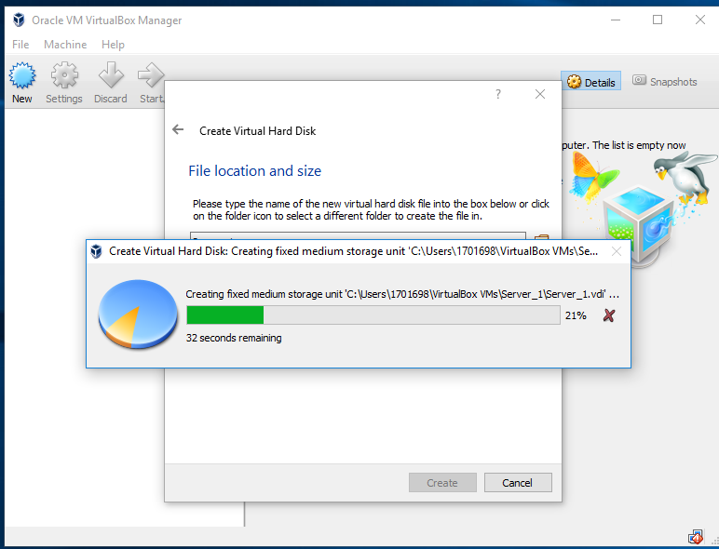

In the image below now you can see that the first server has now been created. I have chosen to instal windows 2008 server on there. The screen capture now explains some of the machines statistics. On virtual box you have the choice to run your machines and shut them down just like you would with a normal real life machine.
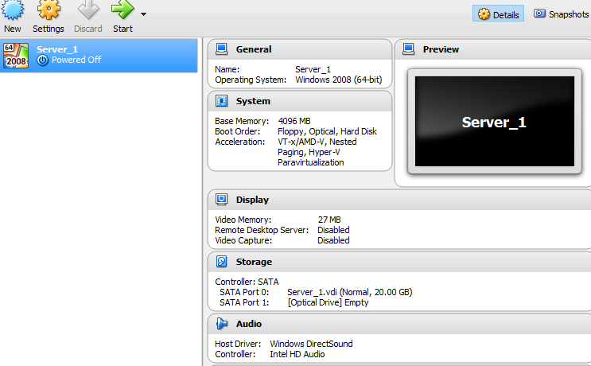
Now at this stage you get to see how an operating system installs! This is windows server 2008 installing. The screen capture represents me installing the correct asked version of windows server to the Virtual Box.

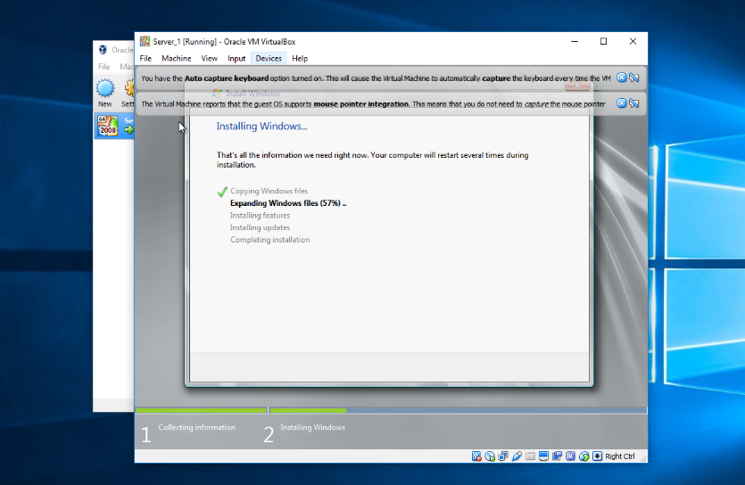
The screen capture below represents how windows server looks like after successfully completing the installation. Now windows server is helpful for creating servers with clients.
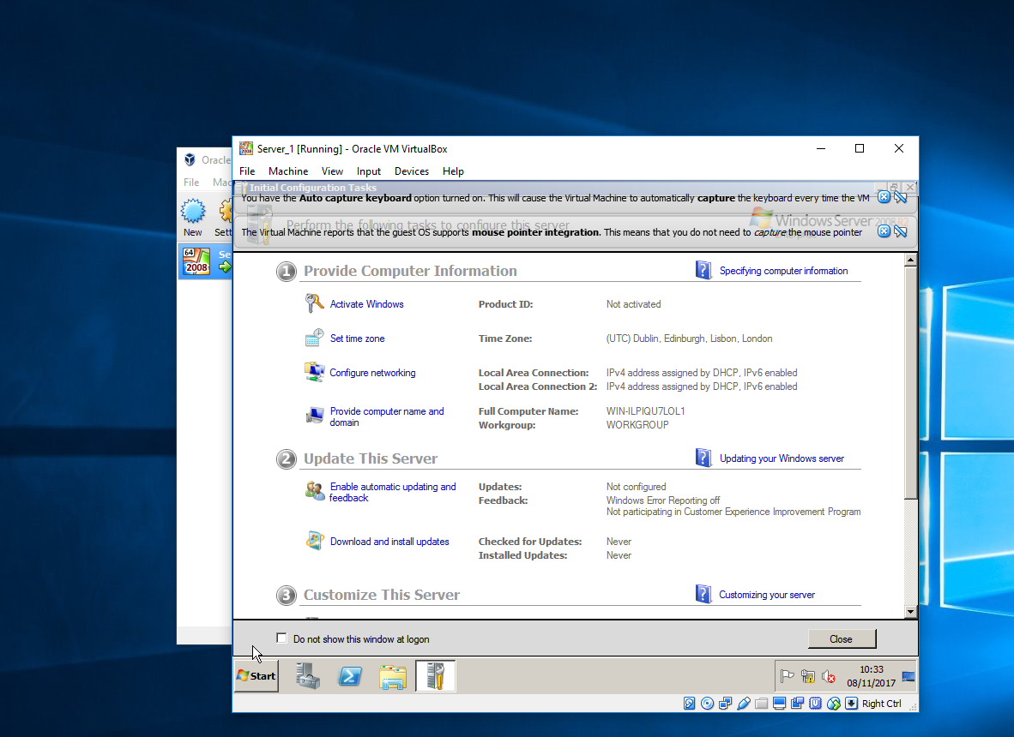

The screen capture below now shows the process of cloning the same machine. We clone because it is easier than just putting the machine all together. Cloning sometimes can go wrong so its a good idea after the machine has cloned just to double check all the specifications are correct.

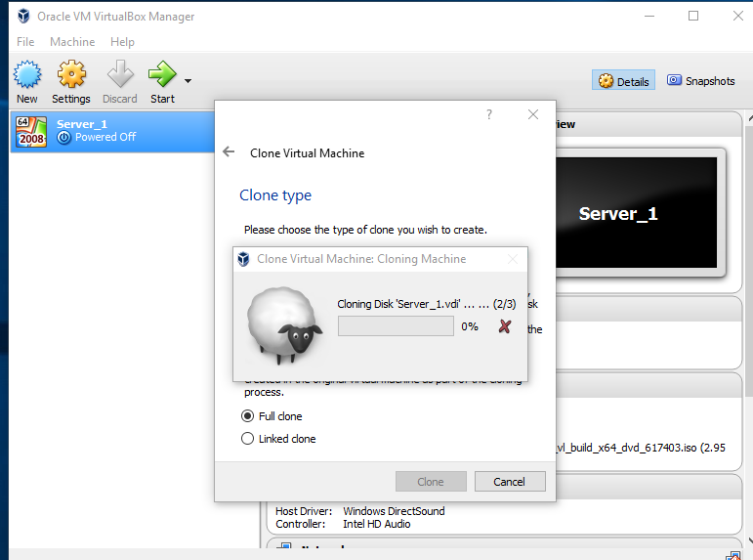
Now that the server has been cloned I had made sure that all the specifications are the same. Now you can see the machines labeled as server_1 and server_2.
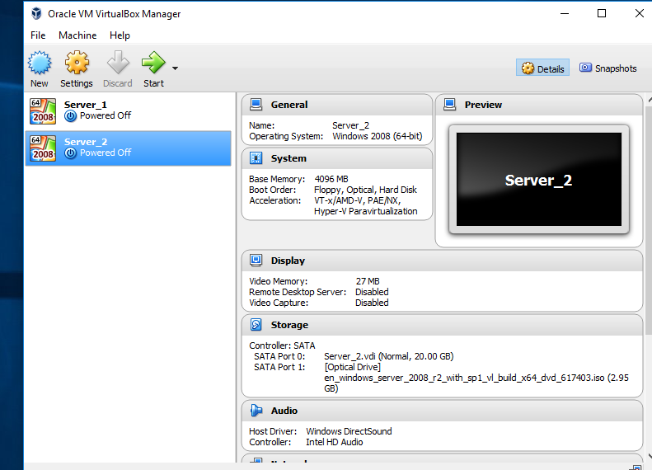

I have now performed the installation for the clients. This time we are installing Windows 7 for out clients.
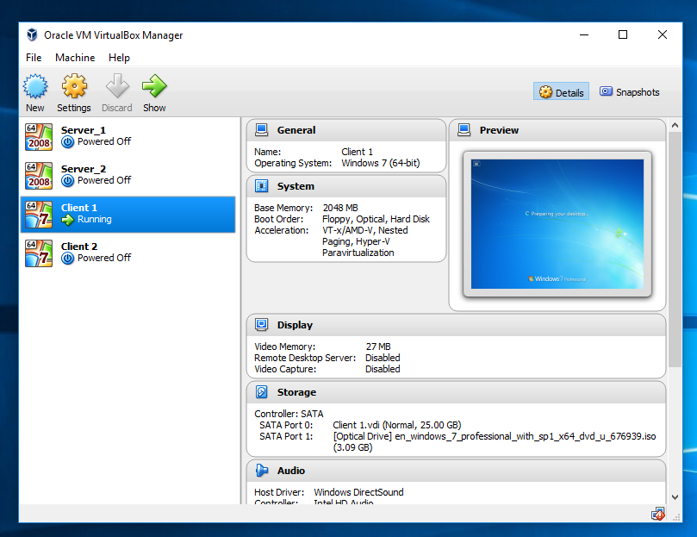

Virtual box also shows the specifications of each machines when you are running them and when they are not running. In the screenshot you can see client 1 is running which means that windows yet again has been successfully installed.

The screenshots below explain that now I have to turn off the firewalls. This is because to allow a successful communication between the client and the server and to make sure that nothing is holding it back. The firewalls have been turned off to allow the system to do the connection operation. This will be done manually later through IP. This will also be done for every other machines which is available to use.

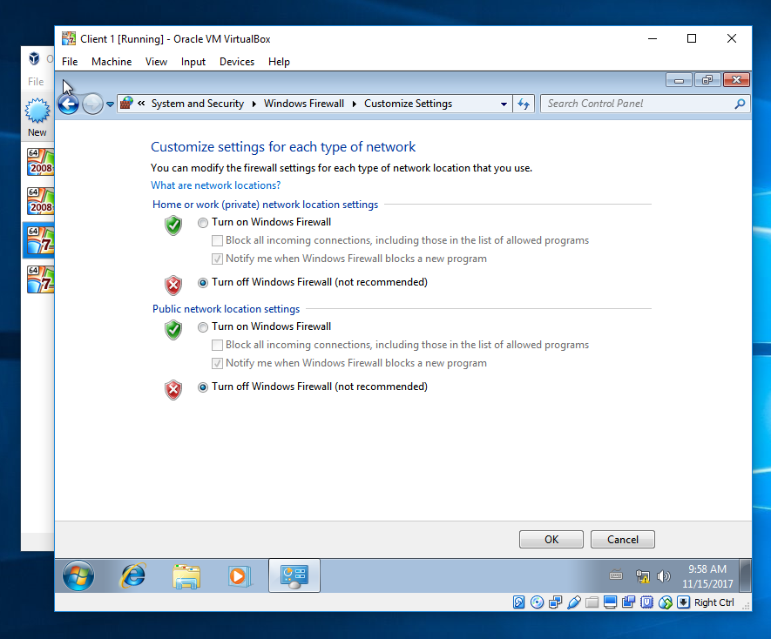

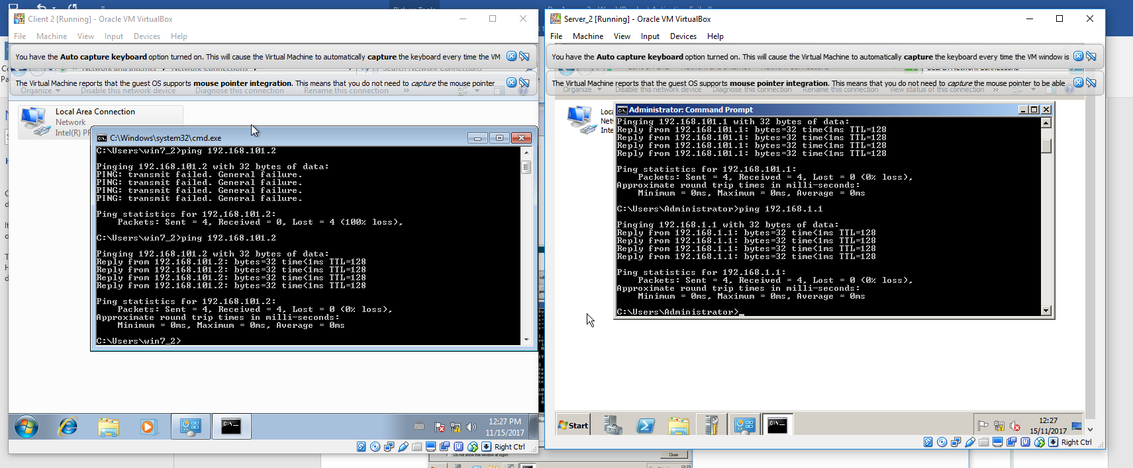
The screenshot below represents me the user making the ping connection which shows that the server and the client are now successfully communicating with each other. Below is a screenshot with both windows 7 the client and windows server 2008 the server successfully communicating.

The screenshot below represents the server communicating. This suggests that everything has been set out correctly and the local area network is now complete and is active too.
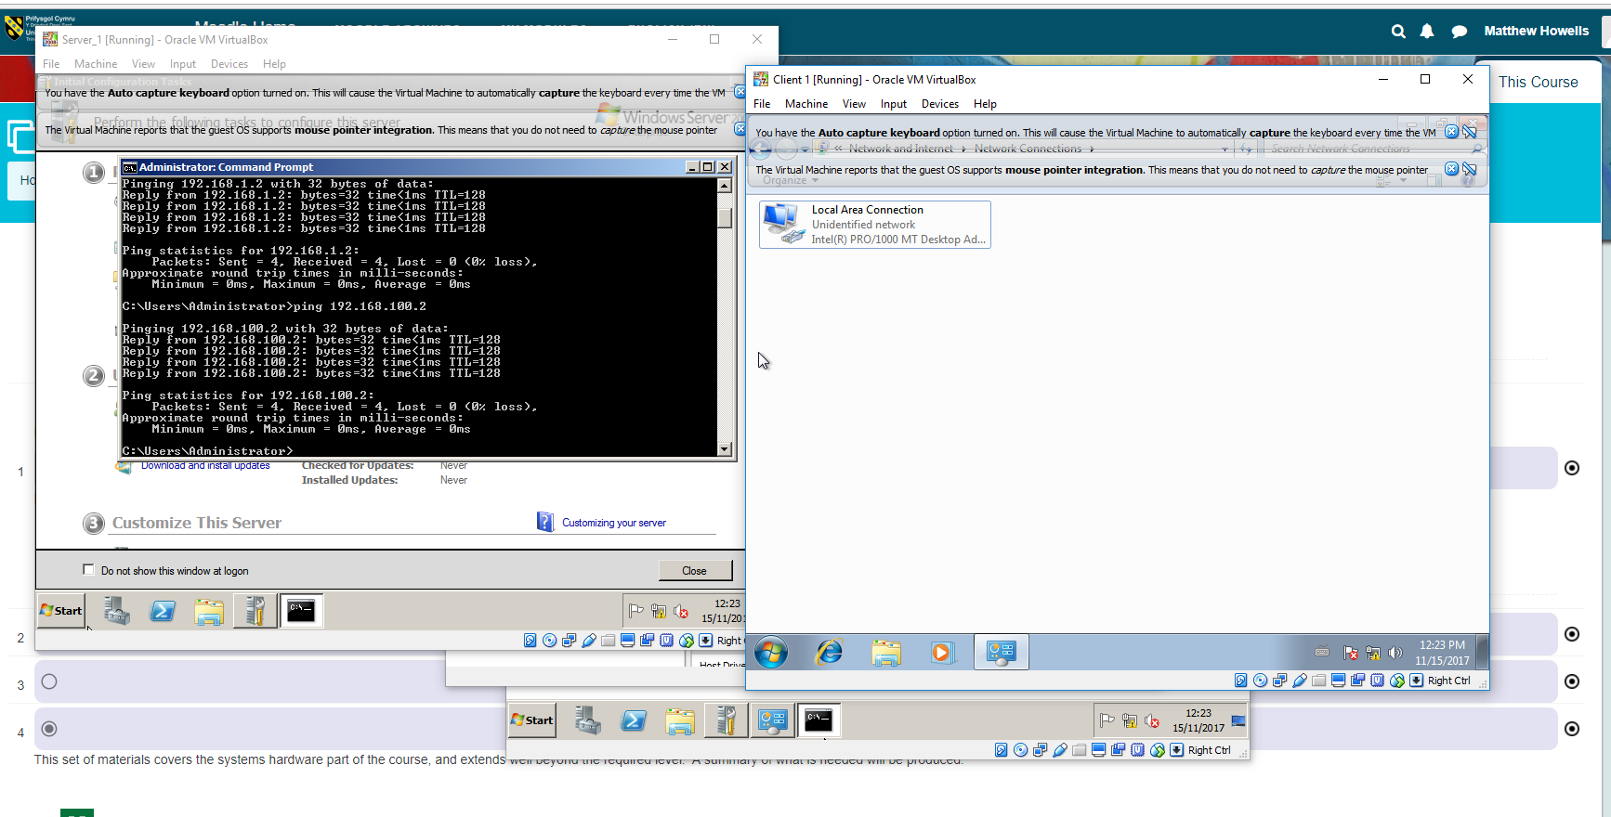

Next below we will be looking at the virtual box network which will be using the DCPROMO.

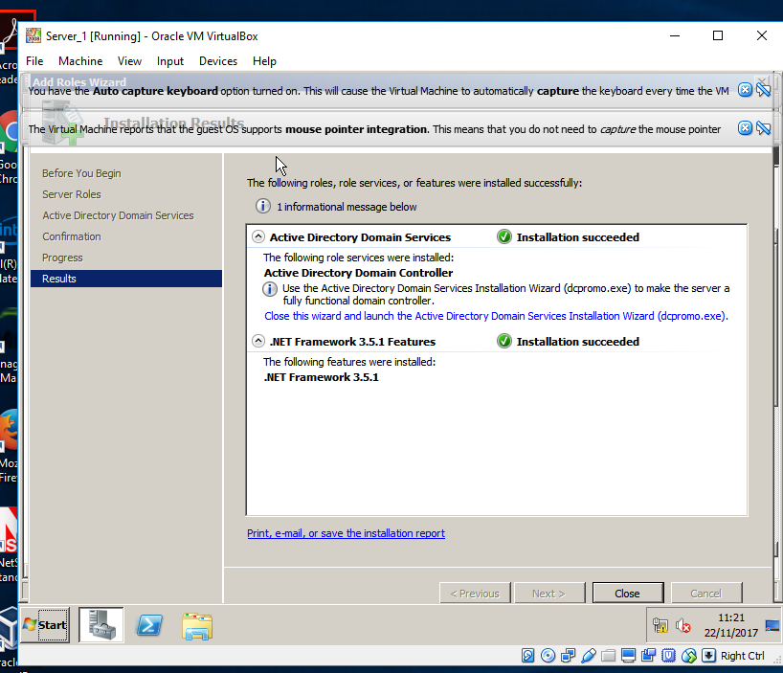

Stage 2- Making the active directory domains.

This stage shows me inputting the IP addresses correctly for the full communication to be successful. Now we can see that the installation is now successful.

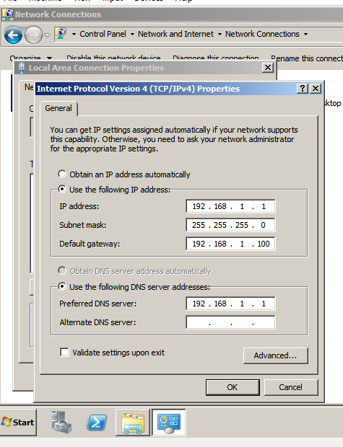

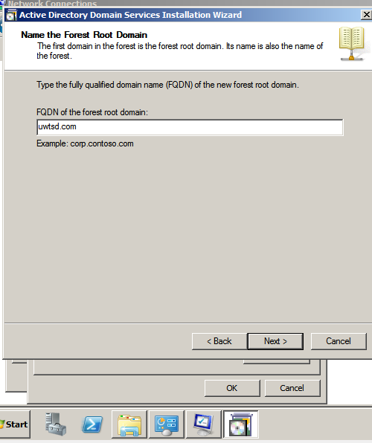
The IP address has been entered manually to allow the connection. The domain has also been given a name too.

We can now clearly see the first domain is the forest room domain and the name for it is uwtsd,com

The screen capture below is now used as proof which shows the active directory which has now been installed on the machine.

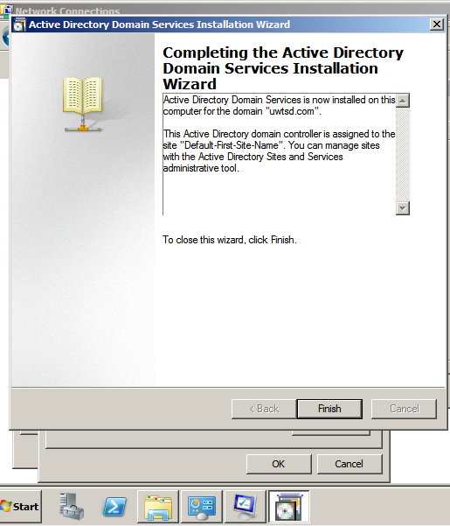

Tasks

Task 1. > State the benefits of using Type 2 Hypervisor virtualisation software in your design. Comment on the strengths and weaknesses of the Virtual Box platform used in your network
Domain/source.
Controller.
Strengths | Weakness
Virtual Box can be downloaded directly from the internet and it is also free of charge! | Some installations might not successfully work or cloning so it is good to double check everything..
RAM is managed good across all of the machines even if all of them is open. This is because I have been using virtual box on a 32GB RAM machine. | Might be difficult or impossible to run all the machines at the same time if you have lower amount of RAM and processing power.
Will virtually represent any machine you want as long as you have the ISO. | ISO’s can be hard to find and some ask for product keys for example windows 2000 will defiantly ask for an activation key if you want to use that.

Task 2

Machines
User
Clients
User
Security of the server

Here is a representation of the domain. Without the domain you wouldn’t be able to control so you wont be able to connect to anything or to do anything. The domain is linked to the users which are the clients.

Task 3/4
The domain directory will provide security to the computers and servers when they are all connected. This also provides authorisation. Account admin can be used to backup everything if something goes wrong such as a power cut or corruption.



