

Student name: Madeleine Marie Melingui Epouse Pem Kamla
Student ID: 2228588

Module name: Psychopathological Classifications and Provisions
Module code: (BMHP6029_LON)
Lecturer’s Name: Dr. Farah Wiita
Academic Year: 2025/2026

Acknowledgement of the use/non-use of AI:
I confirm that I have not used any AI tools in the research and creation of this assignment. I confirm that I have not presented any AI generated materials as my own work. I confirm I have copies of my drafts, notes, and other resources I used, which I may be asked to provide in evidence

Author name: Madeleine Marie Melingui epse Pem Kamla
Introduction  Classification: According to The International Classification of Diseases, 11th Revision (ICD-11), eating disorders are included within chapter 06:; Mental, behavioral or neurodevelopmental disorders. Feeding or Eating disorders are classified as distinct diagnostics entities, including:  -6B80 for Anorexia Nervosa.  -6B81 for Bulimia Nervosa  -6B82 for Binge Eating Disorder (WHO, 2022).  These disorders are characterized by persistent disturbances in eating or related behaviours, such as restrictive intake, avoidance of food, binge-eating episodes, or compensatory behaviors including purging. They involve altered consumption or absorption of food, leading to significant impairment in physical health and/or psychosocial functioning. Importantly, these are not simply dieting behaviors, but enduring, clinically significant patterns that typically require specialist assessment and multidisciplinary intervention (Norris et al, 2014).  Among these conditions, Anorexia Nervosa (AN) is relatively rare compared with other eating disorders, yet it remains one of the most severe due to its high medical risk, chronicity, and elevated mortality rate.  How Common is the Disorder?  - Anorexia Nervosa is less common than Bulimia Nervosa or Binge Eating disorder, but has a much higher severity and mortality  - The Global Burden of Disease ( 2019) estimated 13.6 million people worldwide were living with anorexia or bulimia combined.  - Point Prevalence of AN is typically 0.1-0.5% in high –income countries, with the highest rates among adolescent girls and young women.  - Prevalence is greatest in western Europe, North America, and Australasia, were cultural pressures around thinness are more pronounced.  - Despite its lower prevalence, AN has the highest mortality rate of any psychiatric disorder, driven by medical complications and suicide ( The Lancet, 2020).  Historical perspectives and treatments of Anorexia Nervosa  From Medieval to Early Modern Period (1200s-1600s):  - Behaviours resembling Anorexia Nervosa were not medically recognised.  - Food refusal, particularly among women was interpreted through religious and cultural frameworks.  - Fasting could be viewed as: A sing of spiritual purity or divine devotion for example fasting saints. Alternatively, evidence of demonic influence, moral weakness, or sin. These interpretations reflected the era’s technological worldview, not a biomedical one ( Brumberg, 2000).  From 17th-19th Century: Early Medical Recognition. Physicians began describing Anorexia like presentations in clinical terms.  - Richard Morton (1689),identified cases of “nervous consumption”, recognising severe wasting without physical disease.  - Sir William Gull ( 1873,UK): Coined the term Anorexia Nervosa. Framed it as a nervous disorder with psychological origins rather than a digestive condition.  - Charles Lasegue ( France): Emphasised the social and familial context of the illness. Highlighted how family dynamics could shape or maintain symptoms. This period marks the shift from moral/religious explanation to early psychiatric and medical models (Jessica M., 2015).  Early to Mid-20th Centruty: Psychological and Psychoanalytic Models. Anorexia Nervosa increasingly understood through psychoanalytic and psychological theories. Psychoanalysis viewed AN as:  - A manifestation of unconscious conflict.  - Linked to fear of sexuality, developmental arrest, or symbolic control.  - Often associated with family dysfunction. Treatment centred on long-term psychotherapy, through evidence of effectiveness was limited. So, individuals with AN were sometimes perceived as choosing their behaviours, reflecting persistent stigma and limited clinical understanding ( Michael B. et al, 2017).  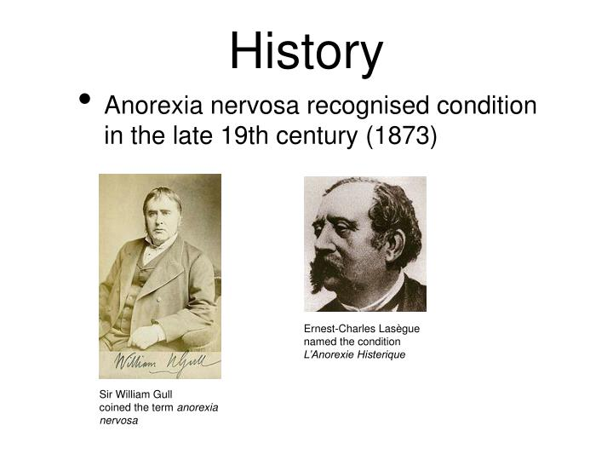 |  | 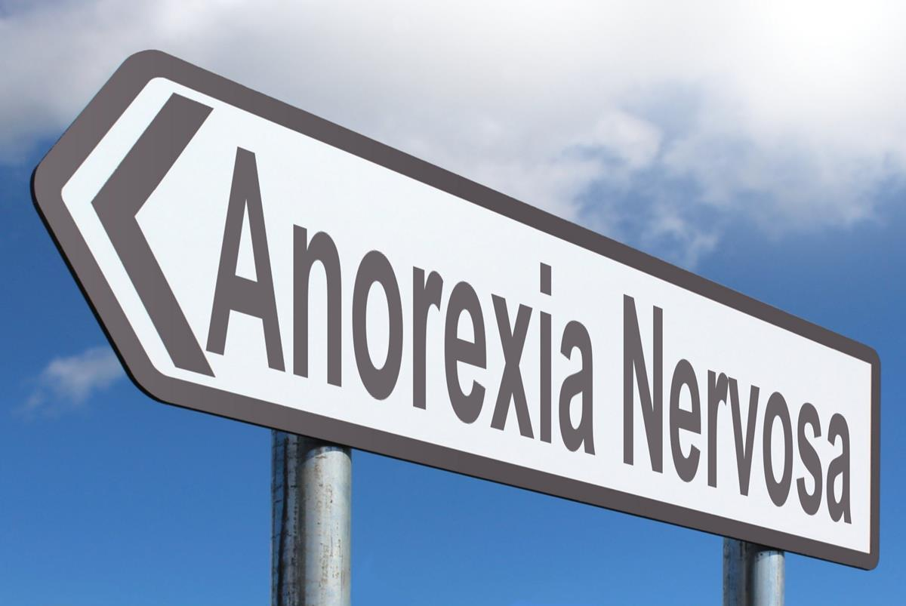  Definition : Anorexia Nervosa is defined as a complex mental health disorder in which individuals:  -Severely restrict food intake despite being underweight.  -Experience intense fear, dread or anxiety about gaining weight or becoming “fat”  -Hold a distorted body image, often perceiving themselves as larger than they are.  -Show persistent behaviors like avoidance of eating or experience significant physical, psychological, and social impairment. So, the disorder is not simply about food, it reflects deep emotional distress and perfectionism ( Treasure, 2020)    Causes: No single cause has been identified!  Therefore, Anorexia Nervosa is understood as a multifactorial disorder involving:  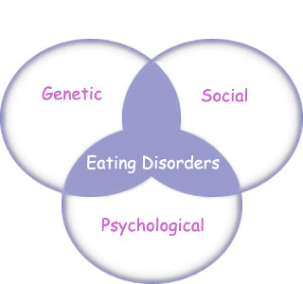  - Biological and Neurobiological /causes risks factors with Genetic vulnerability (twin studies show high heritability 50/60%), or genes related to metabolism and anxiety traits and harm avoidance.  - Psychological causes/risks factors including body image disturbance (distorted perception of body size); emotional and cognitive factors including low self- esteem.  - Sociocultural causes/risks factors including cultural pressures( social thin-ideal) or family and social environment such as high expectation or conflict, or life transitions such as Puberty or starting university (Mental Health Foundation, 2022).  Symptoms Of Anorexia Nervosa:  Individuals with Anorexia Nervosa experience combination of :-psychological distress with intense fear of gaining weight or becoming “fat” even when underweight, disturbed body image or over-evaluation of weight and shape.  Behavioral Symptoms like Severe restriction of food intake or rigid diet rules; avoidance to eat with others or in public, ritualized eating behaviors cutting food into tiny pieces; doing excessive exercise to burns calories, frequent body checking pr use of appetite suppressants like caffeine.  Physical Symptoms: These arise from prolonged malnutrition and low energy intake including low body weight for age, sex and development stage and extreme thinness. Associate at fatigue, weakness, dizziness, cold intolerance, dry skin and constipation or abdominal pain (NHS, Egland 2024).  Diagnosis  Diagnosing Anorexia Nervosa involves a comprehensive clinical assessment that evaluates psychological symptoms including earing behaviors physical health and diagnostic criteria from (DSM-5-TR or ICD-11).  These is NO SINGLE TEST-diagnosis  But, Clinicians use: the DSM-5-TR criteria such as restriction of energy intake, intense fear of gaining weight, disturbance in body. The ICD-11 , more flexible regarding children and adolescent, emphasizes significant low body weight or failure to gain; weight –control behaviors like restriction, exercise or purging; over- concern with weight or shape or not explained by another medical condition. Or Clinical assessment process as well like Measurement of weight, height BMI growth charts for children; control of vital signs like heart rate, blood pressure, temperature; blood test ECG or menstrual history and ormonal changes.  This should help identify medical complications etc( Suzan, 2022) |  | Current services and treatments  There no MEDICATION that treats AN directly.  But medications may be used for :Co-occuring anxiety, depression OCD-type symptoms or Sleep difficulties. Otherwise, the support treatment can be delivered through specialist community eating disorders which include: Psychologists, Psychiatrists, Dietitians, Nurses, Family therapists, Social workers, Occupational therapists. These teams coordinate psychological therapy, medical monitoring, nutritional support and risk management of for example sever malnutrition,medical instability, high suicide risk and focusing on medical stabilisation, meals supervision and intensif therapy if applicable (Mutsuhiro, N. 2021).  Recommendations:  -Early identification and intervention( training of frontline professionals and screaming sensitive groups , especially those suffering from anxiety)  -Involve family and social context to integrate into care ( parents involve in meal support, nutrition education and relapse prevention;  - Strengthen medical and nutritional management like routine physical monitoring for children and young.  -Improve access, continuity, and equity of services ; address inequalities and digital exclusion and ensure services are accessible across socioeconomic groups with flexible options such as in-person, digital, or outreach, that do not disadvantage those with limited digital access.  -Reframe AN as a serious illness, not a lifestyle or choice: use public heath campaign and sensibility including clinical communication and advice from G.P., dieticians, Psychologist and health care workers ( Deanne,J. 2026).  Conclusions  Anorexia Nervosa is a serious, multifactorial illness requiring early identification, compassionate communication, and coordinated specialist care.  Evidence highlights the importance of early intervention, family involvement, and robust medical and nutritional monitoring. Involve Care workers as special team to support children and young people exposed to AN.  Improving equity and access through flexible service medias are essential to reduce disparities. Refraiming AN as a serious medical and psychiatric condition.Promoting campaigns around the benefit of having food intake essential to maintien our homeostasis and well-being ( Treasure, 2020).  References  1-World Health Organization, ( 2022), International Classification of Diseases 11th Revision. The global Standard for diagnostics health information. Publisher or Available at: ICD-11 URL (Accessed: 10 March 2026 ).  2-The Lancet ( 2020) GBD 2019 Diseases and injuries collaborations. Available at: Global burden of 369 diseases and injuries in 204 countries and 2-territories, 1990–2019: a systematic analysis for the Global Burden of Disease Study 2019 - The Lancet URL (Accessed: 10 March 2026 ).  3-Brumberg, J. J. (2000)) Fasting girls. Fasting girls : the history of anorexia nervosa : Brumberg, Joan Jacobs : Free Download, Borrow, and Streaming : Internet Archive: (Accessed 11 March 2026).  4=Jessica, M., (2015) Avances in Eating Disurders). Available at:Jessica, M., (2015) Avances in Eating Disurders). Available at: URL (Accessed: date). URL (Accessed: 11 March 2026).  5-Treasure,J., et al (2010)2 Eating" Disorder" , The Lancet, Issue 10227, 583-589, Eating disorders - The Lancet(Accessed: 14 March 2026).  6-Norris M. D. et al (2015 Change is never easy, but it is possible 'Title of article', Journal of Adolescent, Issue 57 8-9 Change Is Never Easy, but It Is Possible: Reflections on Avoidant/Restrictive Food Intake Disorder Two Years After Its Introduction in the DSM-5:( Accessed: 12 March 2026).  7-Mental Health Foundation ( 2022) Anorexia Nervosa, the Symptoms and causes. Available at: Anorexia nervosa (Accessed: 15 March 2026 ).8-NHS, England, ( 2024) Overview- Anorexia Nervosa. Available at: Overview - Anorexia nervosa - NHS URL (Accessed: 16 March 2026).  9-Suzan, C.( 2022) Very well Mind. Available at: Anorexia Nervosa: Diagnostic Criteria, Symptoms, Causes URL (Accessed: 18 March 2026)).  10-Mutsuhiro, N.. ( 2021) ' Cognitive Behavioral Therapy', PMC," Cognitive–behavioral therapy for management of mental health and stress-related disorders: Recent advances in techniques and technologies - PMC .( Accessed 18 March 2026 )  11-Deanne J., . (2021) 'Anorexia', NCFED, All About Anorexia Nervosa | The National Centre for Eating Disorders (Accessed 18 March 2026)  12-Michael B., et al, ( 2017 ' Cognition in Psychiatric disorders: from Models to Management, Science Direct Issue 3, Page 173-175 Available at Cognition in psychiatric disorders: from models to management - ScienceDirect: ( Accessed Available at Cognition in psychiatric disorders: from models to management - ScienceDirect: ( Accessed;

