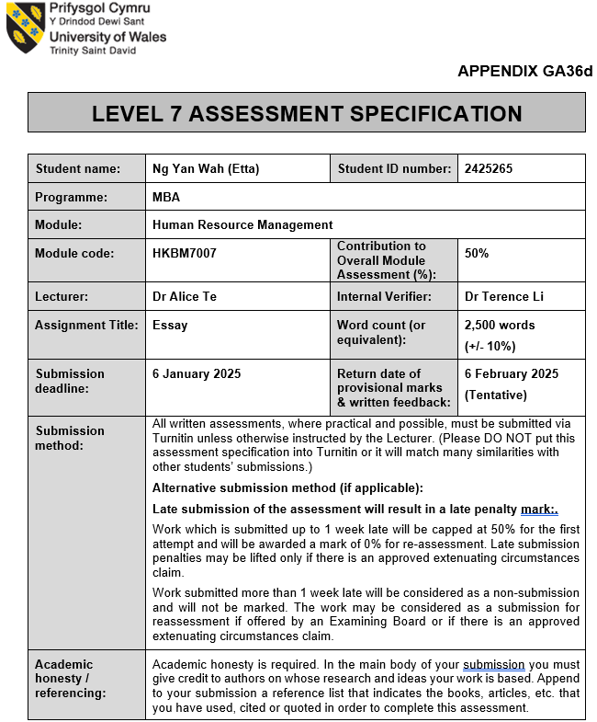

Background of the company
Phillip Wain International owns seven 6-stars health and beauty ladies’ clubs throughout the Asia Pacific region, spreading over Hong Kong, Singapore, Malaysia and Thailand. They offer one-stop fitness and beauty services, the goal of providing their members attentive and comprehensive services in a luxurious private environment. Based in Hong Kong, they have around 400 staff including frontline staff and back-office staff. There are four more brands under Phillip Wain group delivering different types of services to their clients.

Challenges with international expansion (Recruitment & Onboarding)
For the expansion to Thailand, Phillip Wain does not have human resources management professionals working at Thailand, therefore Human Resources Managers in Hong Kong have to recruit and onboard new hires remotely. Due to the remote mode, Human Resources Managers are not able to meet the candidates face-to-face, which may affect the judgement on the candidate's performance. It took much longer processes than local processes as the Human Resources Manager needs to verify candidate’s reference, and qualifications are qualified for the hiring position. (Ruth Stern, 2023)
To focus on the recruitment field, Human Resources Managers will have difficulty in hiring. According to The Economist Intelligence Unit (2020), it summarized that Recruitment is the largest HR-related challenge from company internal expansion. Economist Intelligence Unit conducted research regarding the most common HR challenges to international expansion, which resulted in 46% of respondents claiming that recruiting suitably skilled staff is the most challenging work to international expansion.
Human Resources Managers are required to identify and recruit qualified and skilled candidates in new markets. First step is to identify which positions are required to run the business in Thailand. For Phillip Wain, therapists are the most important role for the business. The company relies on therapists to provide professional services to their clients. To be professional, internationally recognised certifications are required, such as ITEC, CIBTAC, City & Guilds etc. Except for therapists, Human Resources Managers also need to recruit other frontline staff, for example, Club Manager to manage daily operations of the club. Receptionists greet their clients at the first contact point. Cleaner to make sure the company could provide clean and comfortable environments for their clients. Human Resources Managers must be familiar with all roles responsibilities to recruit staff.
For onboarding processes, Human Resources Managers in Hong Kong have to ensure a consistent onboarding experience for remote hires which could be complicated.

Challenges with international expansion (Compensation & Benefits)
Compensation package is lined up with local compliance. Every country has their local labour law to protect the workers that should receive their rights. Economist Intelligence Unit conducted a research regarding the most common HR challenges to international expansion, which resulted in 43% of respondents claiming that maintaining compliance with employment law.

Managing legal compliance across diverse international labour laws is a significant challenge for a Human Resources Manager. They have to keep updated on Thailand’s labour law such as employee rights, notice periods, termination, leave policies and taxation etc. Collaboration with local legal experts in a must to avoid disputes and penalties. (Manyank Bhutoria, 2024)

For compensation and benefits, Human Resources Managers need to understand local salary benchmarks and cost of living to offer competitive compensation packages. To offer attractive compensation packages, Human Resources Managers have to read up local labour laws in Thailand, to avoid failure in maintaining legal compliance which may impact the company's brand image. (Sriram Iyer, 2024)

Human Resources Managers are also required to establish fair and competitive compensation packages for the new hires. To align compensation packages with local standards, the salary package should be competitive regarding salary pay, benefits, incentives and allowance etc. Human Resources Managers must make sure that the compensation and benefit packages align with the industry standards, employee needs and local country norms, at the same time still being cost effective to the company. If the Human Resources Managers are planning to hire overseas workers to work in Thailand, they need to arrange a working visa for the overseas worker’s right to work in Thailand.

Stakeholders being impacted
International expansion significantly impacts various stakeholders within and outside of the company, including Employee, Management, Regulatory, Clients, Business Partners and investors.

Employees included current employees and new hires. For current employees, they may be recommended by the Company to relocate to Thailand due to the internal expansion. This can lead to concerns about job security, relocation opportunities and changes in the company culture. Employees who are going to relocate to Thailand, they need to get used to being away from their hometown, and learn a new country’s culture to survive in Thailand. In order to communicate with Thailand local new hires and clients, current employees may need to learn a new language for better communications.
For the new hires, they will require onboarding, training and integration into the company culture, Human Resources Managers need to manage it effectively at the same time.

Management includes leadership teams and Human Resources Managers. The leaders must adapt to new operational challenges and cultural differences. They need to lead their team effectively and assist teammates to integrate into the new working environment. Human Resources Managers have responsibility for shaping company policies which align with both local laws and company’s goals.

Human Resources Managers experience and approach to solve problems
Human Resources Managers should understand local markets as the beginning step. They should recognize local customs, business practices and local employee expectations. As the Human Resources department has a lot of tasks to manage international expansion, they are recommended to engage partnership with local expertise in international transitions across multiple disciplines. For example, Local recruitment agencies tap into the regional talent pool and reach more potential candidates for the hiring roles. Local outsourced payroll providers and legal advisory services to make sure the company is paying the employees legally. Relocation services to ensure a smooth process of getting the employee work permit in Thailand. (Stuart Beaty, 2023) (HR Zone, 2024) Human Resources Manager should also provide cross-cultural Training to employees which helps them understand the differences between different countries, improve communication with colleagues who come from another hometown. (Aurora Training, 2024)

Human Resources Impact on internal expansion
Positive Impact:
International expansion allows Human Resources Department of the company to tap into a broader talent pool, which enables the recruiter to recruit individuals with varied skills and cultural backgrounds. By entering new markets, in order to promote a cohesive working environment to employees Human Resources Managers can enhance the company’s understanding of the local market by recruiting local talent.
At the same time, Human Resources can promote internal mobility for employees which encourage them to explore different roles in Thailand. This practice could be attractive for Hong Kong employees willing to relocate to Thailand, not only enhancing employee satisfaction but also increasing retention rates. (Shani Jay, 2024) According to LinkedIn’s Global Talent Trends report, 41% of employees are likely to stay in the organization with internal mobility.
There’s also another positive impact for Human Resources in talent management. International expansion requires Human Resources to plan a strategic workplace which is a powerful approach to build team structure, attract professional talents and retain well-trained employees. (Oksana Lavri, 2024)

Negative Impact:
Expanding operations resulted in increased management and Human Resources costs. According to the survey conducted by Economist Intelligence Unit, 51% of the companies claimed that internal expansion increased management costs and 50% of the companies increased Human Resources headcount costs. ((The Economist Intelligence Unit, 2020)
If the Human Resources Department is unable to deliver a well-functioned practice, it may lead to employee disengagement. Employees who feel undervalued or unsupported, will plan to leave the company and seek for other opportunities somewhere else which results in high turnover rates. (Marcin Majka, 2024)
Failing to comply with regulations can lead to legal issues. The Human Resources Managers are responsible for ensuring that the company complies with local employment and labour regulations. The company is important to have a company policy to prevent issues of termination or discrimination etc. If the Human Resources department failed to create clear company rules, the company could face a serious legal problem of an incident. (Kennedy Vince, 2019)

Potential areas of improvement
To better support overseas expansion, there are several areas that can be focused on. For Strategic Human Resource Management, except recruiting the best candidate for the team, Human Resources Manager can create competitive compensation packages and career paths to retain and ensure their long-term commitment. Human Resources Managers should develop a clear global HR strategy to manage the international workforce. The Human Resources Department should ensure the strategy results in Human Resource functions effectively. (Rinaily Bonifacio, 2024)
To lead a better collaboration and communication between different cultural employees, the Human Resources department can provide training programs that educate employees about cultural differences. The training could help employees appreciate and navigate cultural differences, which improves communications, enhances teamwork and reduces misunderstandings. (Rinaily Bonifacio, 2024)
Human Resources Manager can do regular updates on regulations, Human Resources should keep the latest update on their knowledge of employment laws in Thailand to ensure compliance.
In order to make Human Resources processes easier to manage the company, Human Resources can implement a system - HRIS which can facilitate payroll, benefits administration and data management etc. This could enhance management operations effectively. HRIS also allows the Human Resources department to do data analytics, making effective decisions on talent management and compensation packages during the expansion. (The Economist Intelligence Unit, 2020)

Action Plan
Month 1 (Weeks 1-2):
- Review current Human Resources Team ‘s processes and resources
- Organise Human Resources Teammate’s working schedule and responsibility on expansion
- Set up Mid-term and Long-term plan
- Identify challenges during expansion
- Break down content of duties of expansion (Recruitment, Compensation & Benefits, Training, Employee Relations, Compliance)
- Discuss potential ways to achieve Mid-term plan in the next few months
Month 1 (Week 3-4):
- Develop recruitment strategy to recruit experts
- Research on Thailand labour markets to understand talent availability (Job duties, working schedule, compensation package, certification on requirement)
- Create job descriptions that align with local requirements and expectations
- Design attractive compensation package for new hires regarding cost of livings and benchmark salary range and benefits align with competitors in Thailand
- Reach local recruitment agencies for partnership on hiring local workers
Month 2 (Week 5-6):
- Develop training modules focusing on cultural difference and sense of belongings.
- Schedule training sessions of culture in Thailand for relocate employees from Hong Kong
- Plan an orientation session for relocate employees regarding labour laws in Thailand, let the relocate employees have a basic concept on employment law in Thailand. E.g., Applying sick leave requirement, payment calculation of sick leave in Thailand etc
Month 2 (Week 7-8):
- Plan mid-term goals in coming few weeks
- Finalise manpower with position who are required for company’s business
- Conclude requirements on hiring positions
- Confirm compensation package for all hiring positions
Month 3-5:
- Start launching recruitment campaigns (Local and employees who are working in Hong Kong Phillip Wain and willing to relocate to Thailand)
- Partner with Thailand recruitment agency for recruitment in local market
- For recruiting local talents, focused on who understands Thailand’s market dynamics. (iBanFirst, 2024)
- Develop onboarding processes that include cultural acceptance programs to help new hires understand company’s culture (Julian Yew, 2020)
Month 6-9:
- Proceed offer to those candidates who passed the interview
- Apply working visa for Hong Kong employees who will relocate to Thailand
- Prepare materials for relocate employees (e.g., air tickets, place of living in Thailand etc)
- Establish training programs which include technical skills training and culture difference training to new hires (USAID, 2022)
Month 10-12:
- Create company policies with corporate standards which matches Thailand labour laws
- Develop strategies to facilitate communications between Thailand local new hires and relocate staff from Hong Kong
- Ensure employees from different countries understand the company's goals and values.

Year 2:
- Conduct Could-based HR system vendor search
- Implement HRIS for data management, payroll administration, compliance
- Preliminary set up basic information in HRIS (Personal information of employees in Thailand, payroll calculation method of employees e.g., attendance, basic salary, commission, rules of salary deduction etc)
- Provide ongoing training to employees to enhance cultural awareness and sense of belonging, foster collaboration across different teams
- Receive feedback from employee who completed comprehensive training, review training progress at the same time
- Retention program for employees (e.g., team building activities)

Year 3:
- Parallel run payroll calculation with manual calculation and HRIS
- Review company’s policies
- Quarterly gathering among management and employees, receive feedbacks on workplace
- Monitor employees engagement and inform strategic decisions

Year 4-5:
- Plan targets for each department, prize them if they successfully achieved targets.
- Motivate employees brings up new idea to make workplace better
- Create succession plans to ensure the employees targets are reachable

Pros of the action plan
The proactive action plan helps in recruiting the right talent and reduces turnover rates which leads to a stable workforce. During the cultural difference training, the new hires and relocate employees can have smoother cultural integration. This increases employee’s satisfaction and feel supported in adapting new working environments. (Pridesys, 2024) It fosters stronger relationships between management and employees, for those who are satisfied are willing to contribute positively to the company's culture and productivity. (Skye Schooley, 2024)

Cons of the action plan
To implement this action plan requires significant time, financial resources and manpower. During the plan, some unforeseen challenges or changes in the market may appear. The Human Resources Team needs to issue a solution immediately to solve the problem. If the plan fails to gain employees loyalty, it will lead to employee dissatisfaction or disengagement. (Steve Hogarty, 2022)

Required resources and impact
Manpower is required for the action plan, especially the Human Resources Department. They need to study labour laws in Thailand to make sure every term is under Thailand’s regulation. For recruitment, the Human Resources Department may need Applicant Tracking Systems to manage job postings, applications and communicate with candidates efficiently. Besides, training programs require resources on cultural awareness for new hires from Thailand and relocate employees from Hong Kong. (Mauve, 2023) HRIS is required for data management, payroll processes which need to be implemented. Human Resources Team also need compliance management software to keep updated on labour laws and regulations across different competences. International expansion requires a budget for different costs, e.g., recruitment cost, training expenses, technology investments etc. (Links International, 2024)

Potential outcomes of the action plan
The approach can lead to successfully attracting skilled and qualified talent in new markets. With attractive compensation packages with benefits, opportunities for promotion and partnering with local recruitment agencies, can fill in critical positions effectively. The approach also ensures the company is secured by following local laws and regulations, reducing legal risks and improving the company’s reputation in Thailand. (Stuart Beaty, 2023) Achieving short, mid and long-term goals ensure successful outcomes which bring positive outcomes for the company.

Conclusion
To conclude, the Human Resources Department in international expansion plays a crucial role which ensures companies operate smoothly overseas. It brings out numerous challenges for the Human Resources Department. But it offers different opportunities for employees’ contribution and personal growth.



