The Marketing Mix 4P’s and 7P’s Explained
Before we go into all the elements of the marketing mix, and to avoid confusion between the 4p’s, 7p’s and even the 4c’s – you should pay attention at the image below to understand what makes up the entire marketing mix.
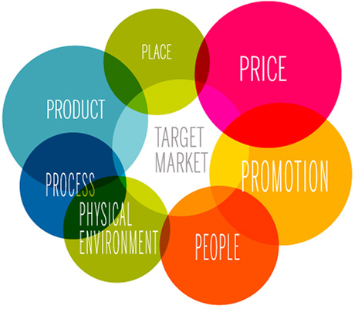
The image above is a simplistic diagram of the elements that are included in a marketing mix.
It is a basic concept, but here’s the cold hard truth…
If you don’t understand it in detail or at all, then there is a fairly certain chance that you are missing out on the key ingredients that will ensure scalable success from the ground up.
It has been said many, MANY times in business that if you don’t know your target market well enough and figured out what they exactly want, you’ll commit entrepreneurial suicide and the business will inevitably fail.
On the other hand, you can be sure to attract mountains of profits when you have a deep understanding of these concepts. Understand this fully and you will know exactly how to maximize profits on your own sustainable business or help become a valuable asset within your company and gain endless promotions.
Sadly, for many existing marketers and aspiring marketers, this concept is glossed over as “everyone seems to know what it is” and is disregarded as basic knowledge. But do you really know what it is? Let’s find out.
Now, what is a marketing mix, exactly?

Marketing Mix Definition:
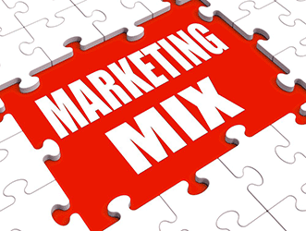
The marketing mix definition is simple. It is about putting the right product or a combination thereof in the place, at the right time, and at the right price. The difficult part is doing this well, as you need to know every aspect of your business plan.
As we noted before, the marketing mix is predominately associated with the 4P’s of marketing.

Here are the principles used in the application of the right marketing mix:

Marketing Mix 4P’s
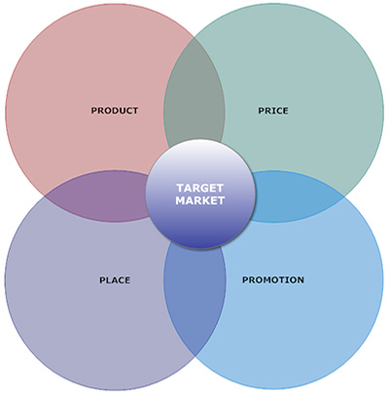
A marketing expert named E. Jerome McCarthy created the Marketing 4Ps in the 1960s. This classification has been used throughout the world. Business schools teach this concept in basic marketing classes.
The marketing 4Ps are also the foundation of the idea of marketing mix. No one element of the mix is more important than the others.
#1 Marketing Mix – Product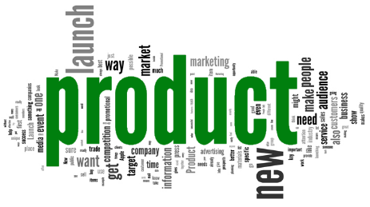
A product is an item that is built or produced to satisfy the needs of a certain group of people. The product can be intangible or tangible as it can be in the form of services or goods.
You must ensure to have the right type of product that is in demand for your market. So during the product development phase, the marketer must do an extensive research on the life cycle of the product that they are creating.
A product has a certain life cycle that includes the growth phase, the maturity phase, and the sales decline phase. It is important for marketers to reinvent their products to stimulate more demand once it reaches the sales decline phase.
Marketers must also create the right product mix. It may be wise to expand your current product mix by diversifying and increasing the depth of your product line.
All in all, marketers must ask themselves the question “what can I do to offer a better product to this group of people than my competitors”.
In developing the right product, you have to answer the following questions:
- What does the client want from the service or product?
- How will the customer use it?
- Where will the client use it?
- What features must the product have to meet the client’s needs?
- Are there any necessary features that you missed out?
- Are you creating features that are not needed by the client?
- What’s the name of the product?
- Does it have a catchy name?
- What are the sizes or colors available?
- How is the product different from the products of your competitors?
- What does the product look like?
#2 Marketing Mix – Price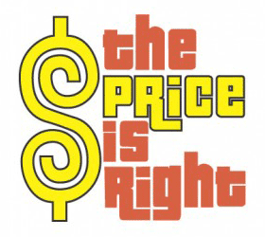
The price of the product is basically the amount that a customer pays for to enjoy it. Price is a very important component of the marketing mix definition.
It is also a very important component of a marketing plan as it determines your firm’s profit and survival. Adjusting the price of the product has a big impact on the entire marketing strategy as well as greatly affecting the sales and demand of the product.
This is inherently a touchy area though. If a company is new to the market and has not made a name for themselves yet, it is unlikely that your target market will be willing to pay a high price.
Although they may be willing in the future to hand over large sums of money, it is inevitably harder to get them to do so during the birth of a business.
Pricing always help shape the perception of your product in consumers eyes. Always remember that a low price usually means an inferior good in the consumers eyes as they compare your good to a competitor.
Consequently, prices too high will make the costs outweigh the benefits in customers eyes, and they will therefore value their money over your product. Be sure to examine competitors pricing and price accordingly.
When setting the product price, marketers should consider the perceived value that the product offers. There are three major pricing strategies, and these are:
- Market penetration pricing
- Market skimming pricing
- Neutral pricing
Here are some of the important questions that you should ask yourself when you are setting the product price:
- How much did it cost you to produce the product?
- What is the customers’ perceived product value?
- Do you think that the slight price decrease could significantly increase your market share?
- Can the current price of the product keep up with the price of the product’s competitors?
#3 Marketing Mix – Place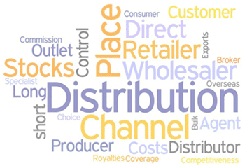
Placement or distribution is a very important part of the product mix definition. You have to position and distribute the product in a place that is accessible to potential buyers.
This comes with a deep understanding of your target market. Understand them inside out and you will discover the most efficient positioning and distribution channels that directly speak with your market.
There are many distribution strategies, including:
- Intensive distribution
- Exclusive distribution
- Selective distribution
- Franchising
Here are some of the questions that you should answer in developing your distribution strategy:
- Where do your clients look for your service or product?
- What kind of stores do potential clients go to? Do they shop in a mall, in a regular brick and mortar store, in the supermarket, or online?
- How do you access the different distribution channels?
- How is your distribution strategy different from your competitors?
- Do you need a strong sales force?
- Do you need to attend trade fairs?
- Do you need to sell in an online store?
#4 Marketing Mix – Promotion
Promotion is a very important component of marketing as it can boost brand recognition and sales. Promotion is comprised of various elements like:
- Sales Organization
- Public Relations
- Advertising
- Sales Promotion
Advertising typically covers communication methods that are paid for like television advertisements, radio commercials, print media, and internet advertisements. In contemporary times, there seems to be a shift in focus offline to the online world.
Public relations, on the other hand, are communications that are typically not paid for. This includes press releases, exhibitions, sponsorship deals, seminars, conferences, and events.
Word of mouth is also a type of product promotion. Word of mouth is an informal communication about the benefits of the product by satisfied customers and ordinary individuals. The sales staff plays a very important role in public relations and word of mouth.
It is important to not take this literally. Word of mouth can also circulate on the internet. Harnessed effectively and it has the potential to be one of the most valuable assets you have in boosting your profits online. An extremely good example of this is online social media and managing a firm’s online social media presence.
In creating an effective product promotion strategy, you need to answer the following questions:
- How can you send marketing messages to your potential buyers?
- When is the best time to promote your product?
- Will you reach your potential audience and buyers through television ads?
- Is it best to use the social media in promoting the product?
- What is the promotion strategy of your competitors?
Your combination of promotional strategies and how you go about promotion will depend on your budget, the message you want to communicate, and the target market you have defined already in previous steps.

