The following encyclopaedia entry shall firstly examine the main features and history of the Berliner Dom (Berlin Cathedral) whilst further analysing some of the theological and practical difficulties which arise from such a place. This encyclopaedia entry would appear in a general encyclopaedia such as Encyclopaedia Britannica.
The Berliner Dom
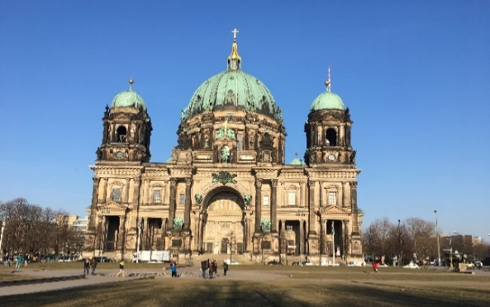
Figure 1: A photograph of the Cathedral’s Exterior (picture taken from author's private collection)
The Berliner Dom (Berlin Cathedral) is the largest Church in Berlin and serves as a major centre for the Protestant church in Germany. It is a major tourist attraction due to its impressive interior and unmistakable exterior and is particularly famous for its underground ‘Hohenzollern crypt’ (the place of the dead) which welcomes thousands of visitors each year.
History of the Berliner Dom
The history of the Cathedral situated on Spree Island originates from the fifteenth century when the chapel of a newly resurrected royal city palace was elevated to the status of a collegiate church (a church where daily services and worship would be maintained by a group of priests or a non-monastic group). The German name for Cathedral ‘Dom’ was used for collegiate churches during this time and continued to be used through the centuries to describe churches of this nature. The ‘Dom’ was influenced by the Reformation in 1539 and as such became a Lutheran church, losing its status as a collegiate church and becoming a major parish church for Berlin.

Plans for a new Cathedral building began in the early 19th Century but didn’t come to fruition until 1893 when the foundations of the new Cathedral began following the demolition of the old Cathedral. The project, costing 11.5 million German Marks was officially consecrated on February 27^{th,} 1905 and would become a landmark of increased significance with an air of scrutiny over the luxurious and possible ostentatious design of the cathedral.
The Cathedral suffered extensive damage during the second World War firstly in 1940 where an air raid caused the loss of the altar windows and in 1944 where further and more extensive damage was caused by a liquid incendiary bomb struck the dome structure. Due to the difficulty in accessing the location of the cathedral, the fire spread to the crypt below and transformed the cathedral into ruins.
Reconstruction work began on the still severely damaged Cathedral in 1975 with the full restoration being completed in 1993. Further significant restoration began much later with the opening of the Hohenzollern crypt to the public in 2002.
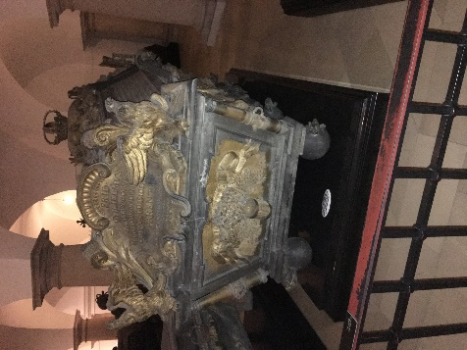
The Hohenzollern Crypt
The Hohenzollern Crypt is a major feature of the Berliner Dom and is placed underneath the Cathedral. It is regarded as ‘the most important dynastic sepulchre (a small room/monument where a dead person is either laid or buried) in Germany, (and) contains nearly 100 sarcophagi (stone coffin’s) and burial monuments from four centuries’. The crypt was damaged during World War two as a result of the collapse of the main dome and the subsequent fire which broke out. The crypt was eventually restored and has been a popular place to visit as one of the most significant places of royal burial in Europe.
Figure 2: A photograph of a Sarcophagi found in the Hohenzollern Crypt (picture taken from author’s private collection)

Architectural/Visual Features
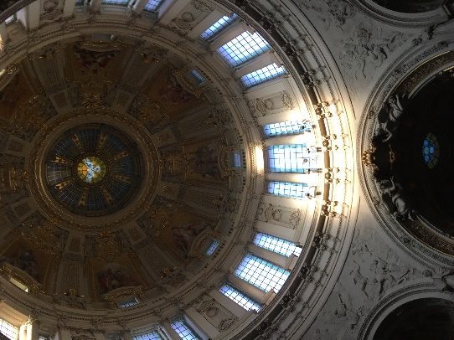
Some of the main features of the Berliner Dom’s include the immense dome structure appearing 70 meters high and immediately capturing the attention of each visitor as they enter the Cathedral. The dome structure features eight spectacular mosaics which depict the Sermon on the Mount, whilst beneath this, there are sandstone sculptures showing the ‘four European reformers (Zwingli, Luther, Melanchthon and Calvin) and the four territorial lords’. Another major feature is the Dome Walkway where visitors to the Cathedral can ascend through the outer walkway of the remarkable dome structure and climb the 270 steps to be rewarded with a sensational view of Berlin.
Figure 3: A photograph of the Cathedral's Dome Structure (picture taken from author’s private collection)

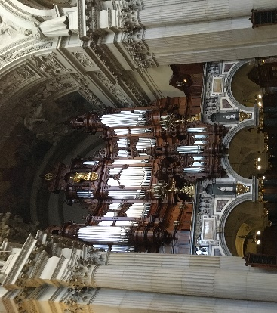
One further prominent feature of the Berliner Dom is its famous Organ which was the largest in Germany at its dedication in 1905 built by Wilhelm Sauer. The legacy and importance of such an organ can be seen today as it is regarded as the largest organ from the German late-Romantic period to have been maintained in its original condition.
Figure 4: A photograph of the famous organ of the Berliner Dom (picture taken from author's private collection)

Details and Offerings of the Berliner Dom
The Cathedral provides a variety of offerings which help to fund the cost of running such a large building. For example, the possibility for guided/audio tours, the rental of the Cathedral space for private events, the Cathedral shop and the Dom- Café.
Church Services:
Naturally, one of the primary functions of the Cathedral itself is its role as an active church and prominent centre for Protestant Christianity therefore, the religious services of the Cathedral must play a central role. As such the Cathedral’s tour and other activities cannot be accessed during the times for religious services.
Other Offerings:
The Cathedral also has an onsite Museum that can be viewed by the general public and presents a variety of pieces such as drawings, designs and models which explain the history involved in the planning and building of the Cathedral which serves as a useful tool for tourists who seek to know more about the Cathedral’s great and long-standing history.
Theological and Practical Difficulties
One theological difficulty that arises as a direct result of the Berliner Dom’s popularity is how does one maintain the religious significance of the Cathedral when it’s such a major tourist attraction. Religious tourism, in general, is a topic of much debate and it is an understandably contentious topic balancing meeting the needs of the tourist with the expectations placed on such a site to maintain its religiosity. It could be argued that for places of religious significance like the Berliner Dom, tourism provides an opportunity to promote their faith and morals to the masses, practising their faith whilst fulfilling the needs of the tourist. It is understandable that many of the visitors to the Berliner Dom would not have any religious motivation to experience the Cathedral but rather visit because of its historical significance, architectural brilliance or popularity. However it could prove difficult for those visiting primarily for its religious significance who may be surrounded by the busy aspects of the Cathedral such as the shop, café, guided tours and picture-taking tourists.
Daniel Levi and Sara Kocher discuss the perceptions of sacredness and argue that ‘The sacredness of these places is defined by the behaviors (behaviours) that occur there, the experience of users and visitors, and the meanings associated with the place by various groups’. This quote could be interpreted to suggest that the sacredness of the site can only be truly maintained through people, action and the fulfilling of an experience for visitors. The sacredness is defined by the user and the significance that the place holds for the individual; therefore, tourism is a matter of religious endeavour for sites like the Berliner Dom as it is vital that it is exposed to more tourists in order to maintain the significance and religiosity of the site.
The Berliner Dom have specific measures in place to ensure that the religious element of the Cathedral does not diminish and states on their website that their services are of central importance for the life of the church and also assert that tours are not available during church services. There is also a booklet available for a small cost which explains the history, a map, several key features and details of the various religious services which take place at the Cathedral.
Another possible theological difficulty for the Cathedral which links to the previous point about maintaining religious significance is the ‘monetising’ of the site with the charging of entry, shop, Café, and other such features which are designed to make money. It provokes questions about the morality of charging money to enter a religious building and the balance between maintaining a large Cathedral and profiting from such ventures. Those who may argue that the ‘monetising’ of the Cathedral is immoral may cite the biblical passage found in Matthew 21:12 where Jesus overturned the tables in the Temple driving out those who were buying and selling claiming it was supposed to be a place of prayer. This passage could be used to state that places of religious significance like the Berliner Dom need to maintain their sacred elements and how can this be done through the monetising of such a place. On the other hand, it is arguable that without the charging of entry and other avenues for making money, maintaining, and upkeeping the Cathedral would be virtually impossible and as a result, it would not have the same religious significance or indeed tourist popularity. The preservation and management of places of religious significance ‘…requires balancing the needs of historic preservation, the maintenance of religious practices and community services, and the quality of the tourist experience’ this therefore ensures that the sacredness of the site is kept, the religious needs are upheld and that this still results in a thriving and pleasurable tourist experience which sustains these religious places throughout the years.
In conclusion, the Berliner Dom has undeniable significance for Berlin both as a tourist destination and as a place of religious significance. The Cathedral serves as a vital centre for Protestant Christianity in Germany and has been a prominent structure for the church there over the years, marking its importance by its bid to be restored after the damages suffered during World War two. The architectural and visual features of the Berliner Dom make it a place of true beauty from the famous organ, the iconic dome mosaics, and sandstone sculptures to the unmistakable beauty of the exterior, it comes as no surprise that the Cathedral is such a major tourist attraction. Perhaps the most famous attraction for the Cathedral is the Hohenzollern Crypt which is highly regarded as one of the most important burial sites in Europe serving as a remembrance of the historical burial culture of Brandenburg- Prussian dignitaries over 500 years. Furthermore, a place of religious significance such as this has a particular duty to preserve the sacred which raises several theological and practical difficulties. It is vital that the Berliner Dom retains elements of the sacred through its secular popularity and the efforts of this can be seen through the fact that there is no entry fee for church services and there are no tours run during these times. The Berliner Dom can seize the opportunity through its tourist popularity to further fulfil its religious duty to provide a religious encounter for the masses whilst maintaining the balance of upkeeping the Cathedral, cataloguing the history, and sustaining both the religious and secular significance of the Cathedral for years to come.

Bibliography
Berliner Dom, Brief Introduction (leaflet) (Date Obtained: 28 February 2018).
Berliner Dom, ‘History’. http://www.berlinerdom.de/content/view/39/120/lang,en/, [Accessed: 13 March 2018].
Daniel Levi and Sara Kocher, ‘Perception of Sacredness at Heritage Religious Site’, Environment and Behavior, Vol. 45, No. 7, 2013. [Online]. Available at: http://journals.sagepub.com/doi/abs/10.1177/0013916512445803, [Accessed: 24 March 2018].
Visit Berlin, ‘Berlin Cathedral’. https://www.visitberlin.de/en/berlin-cathedral, [Accessed: 13 March 2018].

Berliner Dom, ‘History’. http://www.berlinerdom.de/content/view/39/120/lang,en/, [Accessed: 13 March 2018].
Visit Berlin, ‘Berlin Cathedral’. https://www.visitberlin.de/en/berlin-cathedral, [Accessed: 13 March 2018].
Berliner Dom, Brief Introduction (leaflet) (Date Obtained: 28 February 2018).
Daniel Levi and Sara Kocher, ‘Perception of Sacredness at Heritage Religious Site’, Environment and Behavior, Vol. 45, No. 7, 2013, p. 912 (pp. 912-930). [Online]. Available at: http://journals.sagepub.com/doi/abs/10.1177/0013916512445803, [Accessed: 24 March 2018].
Daniel Levi and Sara Kocher, p. 925 [Online]. Available at: http://journals.sagepub.com/doi/abs/10.1177/0013916512445803, [Accessed: 24 March 2018].

