University of Wales Trinity Saint David
BA Business Management
Introducing the Modern Workplace

Individual report
Topic: The role of organisational structure, culture, and managers in motivating employees at the workplace

Student: Vasile Turcanu, Student nr 2127548
Tutor: Dr Buddhi Pathak

Introductory
For a long period of time, companies focused mainly on obtaining profit by selling their products and services, omitting the importance of human resources. All workers were treated equally, and a competent employee was one who did absolutely what he was asked to do.
In the middle of the last century, knowing human behavior at the workplace and what exactly drives them, Abraham Maslow and Douglas McGregor laid the foundation of motivational theories: people are different, they present characteristics that can be identified and even classified in categories.
Years later, people believed in the positive impact of stimulation through earnings, co-interested, external advantages, and premiums of all sorts. The aspect of dignity, respect, and the idea of work was addressed for the first time.
In order to describe how in practice the managerial and motivational process takes place within a concrete entity, I will analyze these aspects within my current job at the Deutsche Post and DHL. I’m working in the supply division as a forklift driver.
DHL is the world’s leading logistics company, founded in 1969 by Adrian Dalsey, Larry Hillblom, and Robert Lynn. Today DHL has around 590,000 employees in over 220 countries, and it is one of the biggest private employers worldwide.
Management theories
Motivation is the set of decisions and activities by which the company's employees are determined to contribute directly and indirectly to the realization of superior overall functionalities and performances based on the correlation of their interests in approaching and achieving its objectives.
The concrete content of motivation in each company reflects the managerial and economic concepts promoted within it.
The most popular management theories developed by scientists in management and human behavior up to now are: Scientific Management Theory, Systems Management Theory, Contingency Management Theory, Theory X and Theory Y. 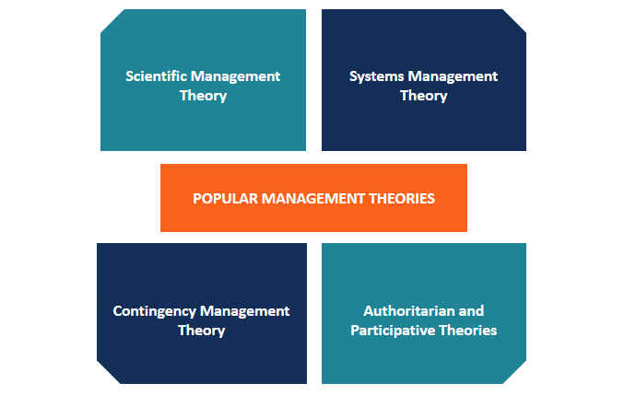

Scientific Management Theory was promoted by the American mechanical engineer Frederick Taylor. He came up with the idea of making people's work easier by dividing it into subtasks , and as a result obtaining higher efficiency. He also created “fair day’s wages for a fair day’s work” concept, which is based on motivating employees through more attractive earnings.
According to Systems management theory, the organization is a unique system whose components can only exist by working together harmoniously. The most important component of this system are the employees, and teamwork is the key to success.
Contingency Management Theory assumes that there are no universal solutions for every situation and every company. This claims that the manager must be flexible and have the ability to adapt to different situations in order to make appropriate decisions.
Douglas McGregor developed Theory X and Theory Y which refer to two management styles: the authoritarian (Theory X) and participative (Theory Y). Theory X assumes that the manager does not trust his own employees, sees them as lazy, irresponsible and disorderly. They must always be checked and stimulated. Theory Y is the opposite of theory X, and it assumes that the manager and the employees have an effective collaboration with mutual trust, and the employees can self-motivate.
The role of managers in motivating employees
Motivation plays an important role in the workers' activity. Managers can achieve success in their activities if they accomplish to understand them well. Motivation leads comportment toward an objective that, once accomplished, will gain the fulfillment of a need. Motivating employees at the right time stimulates obtaining better results and job satisfaction.
A manager must increase the motivation and work satisfaction of his staff, toward induce them to increase their efficiency, ultimately reaching strong results.
The effectiveness and efficiency of the use of material, financial and informational resources depend to a decisive extent on human resources.
Currently, managers create sustainable networks between the motivation and efficiency of an employee to ensure circumstances that the worker's interests coincide with those of the employer. In order to achieve good results and be able to face competitors, an organization must meet certain conditions such as: having competent managers, devoted employees, having a well-defined goal, and being in step with innovations. In front of all these conditions, should be always the motivation of the employees.
The manager's role is crucial and entails choosing the function's content and productivity, which in turn establishes the prerequisites for the implementation of the other managerial qualities, such as forecasting, organization, coordination, control, and assessment. The characteristics and effectiveness of the entire managerial system and organization, on the other hand, are affected by motivation. The effectiveness of organizational methods in the company, accuracy, and flexibility of the information subject, operationalization of managerial methods, techniques, procedures, and general effects are all directly influenced by the staff's motivation. These are the fundamental components of the managerial system.
The role of organisational structure in motivating employees
The organizational structure plays an equally important role in motivating the staff.
Organizational structure lines up and links elements and processes of an organization, helping it to maximize efficiency. The structure adopted influents an organization's performance in accomplishing its strategy and objectives. Leadership should see the characteristics, benefits, and limitations of different organizational structures to understand what motivational techniques will work best for the employees that are part of this system and structure.
A strong organizational structure contributes to the management of daily work, starting with small tasks and ending with more complex processes. The lack of an organizational structure results in disorderly, chaotic work, misunderstandings between colleagues, unfulfilled tasks, low employee motivation, and respectively negative effects on the work result and the relationship with clients.
Organizational structures are classified into several categories, including:
- Divisional.
- Hierarchical.
- Line.
- Flat.
- Tall.
- Functional.

The most popular are flat, tall, and hierarchical structures.
The flat organizational structure is very simplistic and often approached by small organizations with modern visions of management. They are characterized by a small number of levels of managers and are more inclined towards self-management.
The tall organizational structure is similar to the hierarchical structure and is characterized by many levels of managers. The ratio of managers to employees is usually low, that is, a manager is subordinated to a small number of employees.
A hierarchical organizational structure is similar to a pyramid, at the top of which are the managers, and each manager is subordinated to submanagers and finally, to them are subordinated the employees, who represent the base of the pyramid. This type of scheme is often found in large companies with many employees and is characterized by the graduation of several levels of managers.
Due to the big size of the company, DHL’s organisational structure is a divisional one. The company is composed of five main divisions DHL Express, DHL Global Forwarding, DHL Freight, DHL Supply Chain , and DHL eCommerce Solutions. This gives autonomy to the divisions, allows them to manage their own cash flow, to be independent in decision-making, reducing the bureaucracy so that the responsibilities are shared by several managers.
Within each division, you can find all the components of a company, which would allow them to act as independently, such as the marketing team, sales team, IT team, accounting team, and customer service.
This type of organizational structure is best suited to large companies with extensive activity and branches all over the world, such as DHL. Divisional org structure helps DHL to be more flexible and respond more promptly to market changes and consumer demands.
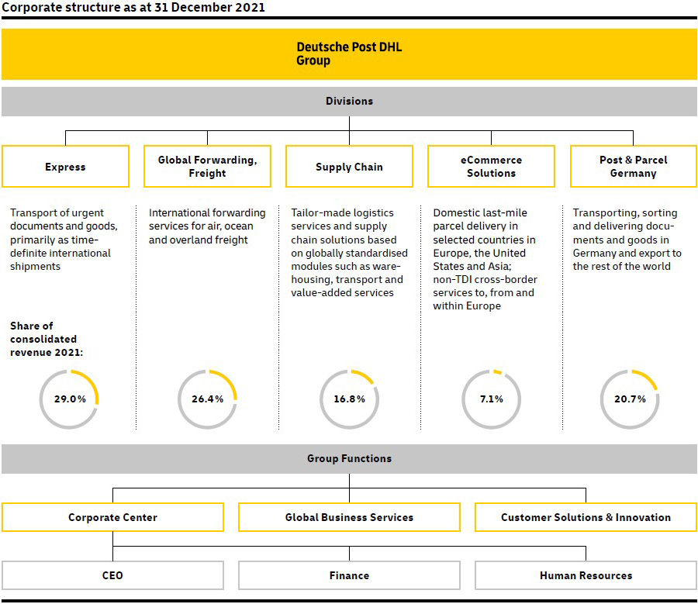
Their success is due to trade, logistics, and well-organized processes, but the most important factor is the desire and passion of the workers for what they do. In every division in any country, regardless of the position held by the employee, everyone has the chance to contribute to the improvement of the environment through the work they do.
The role of organisational culture in motivating employees
Another important element that affects the employee’s motivation is organizational culture. The rules and values that the majority of the people of an organization or firm share are known as organizational culture. The organizational culture faces two important functions: internal integration – which provides employees with an understanding of the flow of processes and their role in this system, and external adaptation – which accommodates the organization to the external environment.
One can encourage, plan, and predict the desired behavior by participating in the development of specific attitudes and value systems among employees within a particular organizational structure, but one should also take into account the corporate culture that has already emerged within the organization.
The organization is inseparable because of tradition and devotion, internally great importance is attached to the moral climate and team cohesion. Success in operations is defined as caring for people and a good feeling for consumers.
Being an international company, DHL's organizational culture is characterized by a diversity of nations, races, gender, and age. The company perceives this as an advantage, because all these people have different capacities, experiences and visions, which, being correctly directed and exploited, and correlated in a single system, create added value for the company.
Deutsche Post and DHL offer a wide range of jobs so that most employees try several functions and have the opportunity to relocate during their activity within the company. The company gives ambitious and hard-working people the opportunity to grow and advance from a junior sales manager in one country to a department head or vice president of sales and marketing in another country.
The DHL employees’ politics are based on the 2 R’s: Respect and Results. This means that they value employees and give them possibilities to realize themselves, thus generating results.
In order to be more responsive to the needs of employees, DHL organizes an annual opinion survey, which gives the employee the belief that he is heard at the company.
The significance of employee motivation
Employees must be inspired to perform at their highest levels and go above and beyond their assigned obligations.
Several factors demonstrate the significance of having happy workers, including the following: efficient workers, workplace satisfaction, the establishment of productive teams, employee retention, increased responsibility among workers, and a positive work environment.
Different types of motivational deficits exist. Most of them are so complex that a manager must know exactly what he is searching for from the start in order to recognize them. Some of them are simple to observe, while others can be misread.
Motivational techniques applied by DHL and suggestions for improvements
Working in one of DHL Automotive's warehouses, I can say from my own experience that the company tries to motivate staff at all levels. Here are several motivational techniques applied within the warehouse/team:
- competent and in-time salary
- overtime hours for employees who perform
- warehouse meetings every 2 weeks
- team meetings every start shift
- modern, clean and tidy workplace
- good facilities for personal hygiene, kitchen and canteen
- free parking for employees
- good communication
- provides training for safety and professional trainings
- Organizes games and interactive activities with employees. To participate in the game, employees pay a symbolic amount. The money collected is donated to charity (children's hospitals). The employee who wins the game benefits from a free day paid for by the employer.
Suggestions for improving motivation among employees from DHL Automotive warehouse
- provide meals to employees
- offer health and life insurance for employees who do more risky work
- offer quarterly, holidays and performance bonuses
- pay to relocate
- give room to grow up
- gives more flexibility to employees to create their own shift or to choose the already existing one (the current shifts are rotative mornings and afternoons)
- provide employees with work clothes

Conclusion
Work must provide an individual with an innate psychological sense of fulfillment, the opportunity to demonstrate his abilities, and the ability to sustain his drive to learn more in order to advance. DHL does care about employees’ motivation and makes sure the work that they do is a good fit for their interests, abilities, and talents. If the employee has the chance to use them, the latter becomes a significant source of satisfaction, affirmation, and human development.

References
- Deutsche Post DHL Group. About company. https://www.dpdhl.com/en/about-us/
- CFI Team. (2022). Management Theories. https://corporatefinanceinstitute.com/
- Hudson, J.R. 2015. Theories of management. Creative Commons Attribution-Non-Commercial-ShareAlike 3.0 Unported Licence
- Williams. S. 7 types of organizational structures. https://www.lucidchart.com/
- Schein,P. and Schein, E.H. 2017. Organizational Culture and Leadership (5TH. Ed.). John Wiley & Sons, Inc
- Indeed Editorial Team.( 2022). Seven motivation techniques to use in the workplace. https://uk.indeed.com/
- Lecture slides. Introduction to Modern Workplace. Bachelor of Arts Business Management. UWTSD.
- Chartered Management Institute. (2015) Understanding organisational culture. Management House. Northants

