

Student Name: Arpit Verma
Student ID: 2532968

Module Name: International Marketing Principles and Practices
Module Code: LCMB7026

Lecturer’s Name: Dr .Tushara Balendran

Topic – International Marketing Strategies of Toyota

Acknowledgement

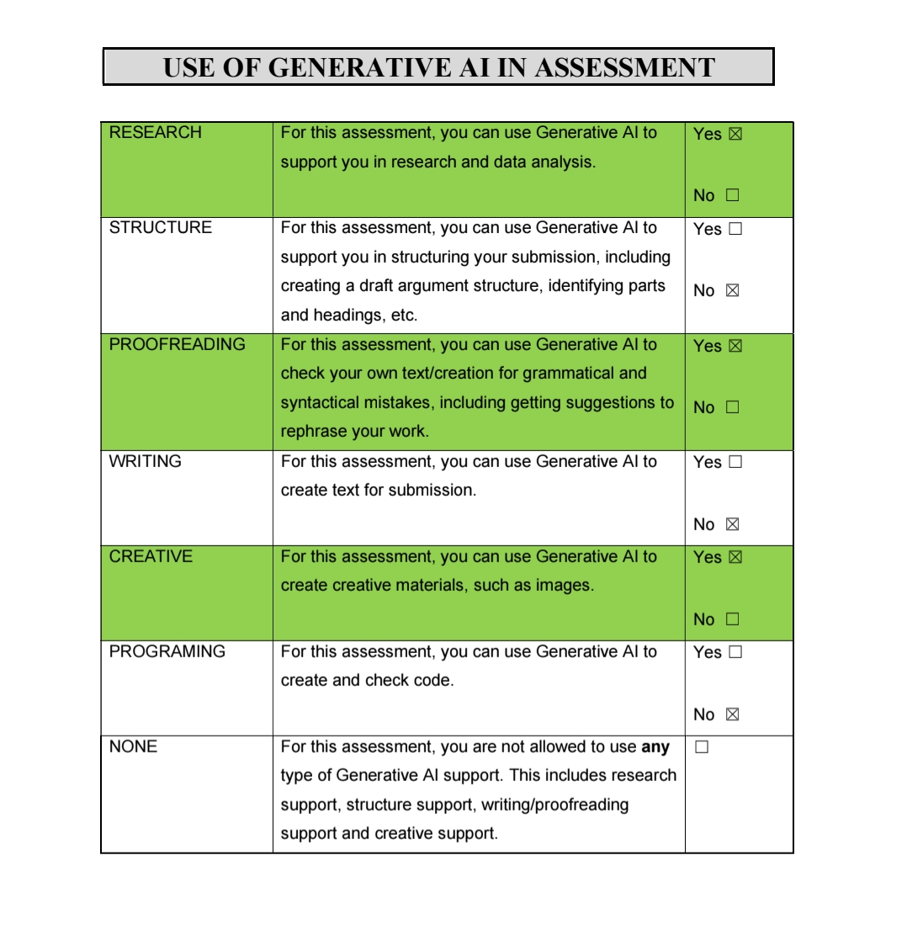

I would like to note the use of Grammarly on in the process of proofreading and improvement of this assessment. This software was used for the purpose of checking the readability, grammar and syntax of the paper, as well as citation and referencing in Harvard style.
Moreover, I would like to note the use of Microsoft 365 Copilot on to assist me in conducting a research on marketing channels.
It is stated that there was no submission of any text created with the help of AI tools as my own. The analysis, arguments, evaluation, conclusions and finally the output of this assessment were completed by me personally.

Table of Contents

S.no | Content | Pg,no
1 | Introduction | 3
2 | Background | 4
3 | Comparative Analysis using PESTEL Model | 6
4 | Comparative Analysis of STP | 11
5 | 7P’s : International Marketing Mix | 15
6 | Gibbs Reflective Account | 25
7 | Conclusion | 29
8 | References | 30

Introduction

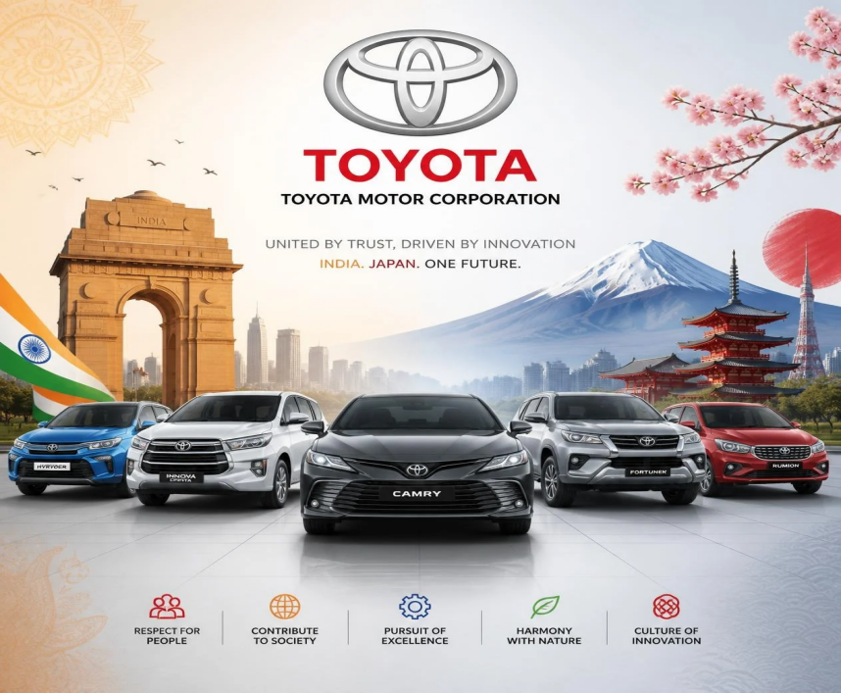
(IMAGE CREATED BY OWN)

With the increasing global presence and activity of organisations and business across national borders the marketing process have become a fundamental concept for attaining sustainable competitive advantages. In an effort to secure future growth beyond their domestic markets, firms and companies has increasingly need to recognize, address and adjust themselves with economic situations, social cultural standards, client choices and preferences, regulations as well as business environments and innovation or technology trends for each distinct market as well as across all different types. Global marketing can support multinational enterprises in adapting to different market environments while simultaneously supporting strong global branding (Hollensen, 2020; Cateora, Gilly and Graham, 2020; Kotler and Keller, 2022). multi-national enterprises in acclimatizing to different market environments while simultaneously supporting worldwide and also strong item branding.
Toyota has produced numerous items and services, consisting of automobiles, lorries, hybrid designs, along with electrical vehicles which have offered the varied requires of consumers and purchasers around the globe. (Toyota Motor Corporation, 2024).
Their business in the international automobile market is quite a remarkable task due to the differences among worldwide, international countries as much as their political or government system, socio-cultural background and atmosphere, technological setting and readiness and the regulations that govern doing service in global markets and also cultures. This paper will critically analyse a Multinational corporations International Advertising approaches by carrying out a comparable study into their activities and marketing. Cultural variations play an important function because the tastes or decisions of purchasers and social habits could significantly vary across the globe which will certainly directly effect marketing and communication.
The report begins by checking out the affect that Political, Financial, Socio-cultural, Technical, Legal as well as Green conditions on Toyota by utilizing the PESTEL frame.
Next, I evaluate that different cultural contexts have had an result on Toyota and exactly how they have modified their approaches by utilising Hofstede s cultural proportions approach. On top of that, I investigate Toyota s Segmentation, Focusing and also Positioning techniques as well as evaluate elements within the worldwide marketing mix or (7Ps) when thinking about its procedure or tasks in the chosen nations. In addition, the report discovers Toyota's entry market approach adopted for one of the countries as well as a study of ethical issues surrounding it's advertising methods; lastly I make recommendations to further promote Toyota s worldwide advertising growth and boost it's aggressive standing in the auto sector.
The report ends using a reflective record examining the entire research study process and also gaining knowledge for the assignment.

BACKGROUND

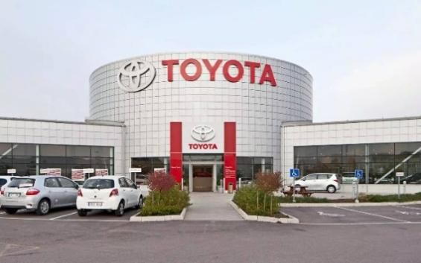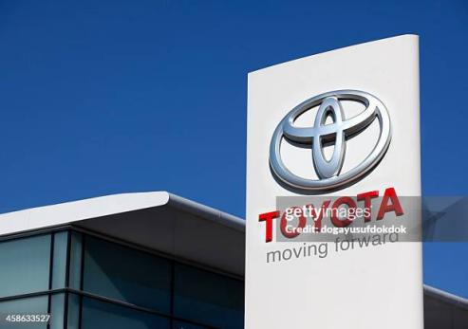
(Image Sourced from Google)
https://www.linkedin.com/posts/pankaj-kumar-571337b5_top-automakers-of-japan-like-toyota-honda-activity-7393478668796211200-k06z

Toyota Motor Corporation (TMC) is a Japanese automotive company (Toyota Motor Corporation, 2025a; Statista, 2025). automotive industry company founded on August 28, 1937, with headquarters located in Toyota City, Aichi Prefecture, Japan. Since December 1, 2020, the company, led by akio Toyoda, represents a public limited company which counts 364,445 employees worldwide. This was established by Kiichiro Toyoda from their fathers company, to enable them to create a new vehicle for industrialised japan.
Toyota's global presence is extensive; they sell about 10, million vehicles around the globe annually, making them one of the biggest car manufacturer.
Vision Of Company- "Toyota will spearhead the future of mobility, bringing more happiness to people and to the planet. Driven by a desire to make the best possible cars through our enduring principles of quality, continuous innovation and deep respect for the planet, we are passionate about delivering more than just the most responsible transportation: we will aim to be rewarding our customers and society with a smile. We will confront challenges by developing outstanding talent and fostering the passion of the people who share our belief that there is always a way to do things better. "
Mission Of Company - This statement was created as the pinnacle of the consolidated "Toyota Philosophy" - the overall purpose of the Toyota Motor Corporation that goes beyond the business operations of making and selling cars. Whereas their vision speaks to their aspirations for a concrete result in "Creating Mobility for All", the mission specifies what they hope that mobility will deliver for people. The Toyota Motor Corporation’s corporate mission statement: "Producing Happiness for All".
From 28 August 1937, to date, Toyota Motor Corporation remains the first company on the globe to have attained the milestone of production. India Toyota is operating in the country as Toyota Kirloskar Motor Private Limited (TKM). The firm is a joint venture of Toyota Motor Corporation and Kirloskar Group. TKM officially came into existence on March 13, 1997, while construction of the manufacturing facility started at Bidadi, near Bangalore, in July 1997.
The first Toyota vehicle was rolled out from the company's manufacturing plant in July 1999, the then, flagship model Corolla.

Part 1 :

Comparative Analysis of the Macroenvironment of Toyota in India and Japan Using the PESTEL Model
In order to be able to explain the strategic choices that Toyota make for the respective market, we first have to breakdown and analyse the general macroenvironmental factors affecting either of these markets according to the PESTEL model.

PESTEL Analysis :
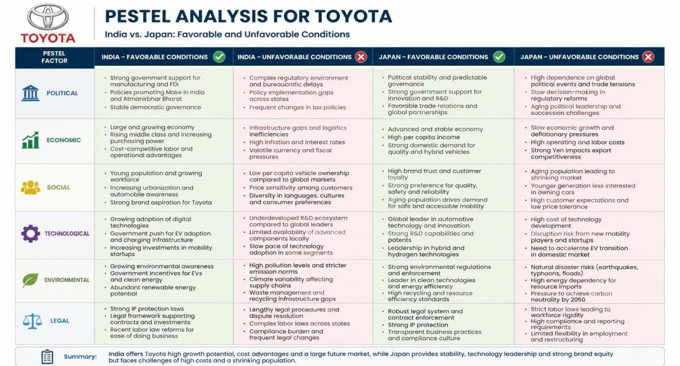
(IMAGE CREATED BY OWN)

- Political Factor
The political environment is supported by broader global competitiveness and economic stability perspectives (World Economic Forum, 2024; OECD, 2024). The political situation is stable and provides ample support from government towards building and supporting innovation and advanced manufacturing, in the push for greener forms of mobility, that can spur innovation. This push in hybrid and electric vehicles is what supported the company locally in Japan, in the current fiscal. (World Bank, 2025; Toyota Kirloskar Motor, 2025).

- Economic Factor
As a large rapidly developing economy, with a large emerging middle class and growing discretionary spending power, India provides considerable long-term opportunities for personal mobility and urbanization in both current urban centers and new locations. However price sensitivity is likely to be a factor in this economy and market size. The company will continue to take economic uncertainty into account in its calculations and decision making process in India. (World Bank, 2025; United Nations, 2024).

- Social Factor
Price, number of family members in the household, and fuel efficiency often dictate preferences of Indian customers. As such, multi-purpose vehicles (MPVs) and sports utility vehicles (SUVs) have proved to be very lucrative for the company. With cultural diversity and diverse income groups existing, Toyota has had to modify its products as well as marketing efforts so as to appeal to local expectations. (Hofstede Insights, 2025).

Hofstede's Six Dimensions
Based on the framework developed by Geert Hofstede, there are six factors that differentiate national cultures from each other:
Power Distance Index (PDI) – how much a society accepts inequality in the distribution of power (high – hierarchical and deferent; low – egalitarian)
Individualism vs. Collectivism (IDV) – individualistic “I” or collective “we”
Masculinity vs. Femininity (MAS) – competitive vs. cooperativeUncertainty Avoidance Index (UAI) – how much ambiguity and uncertainty a society tolerates
Uncertainty Avoidance (UAI) – how comfortable a culture is with ambiguity and unknown situations
Long vs. Short Term Orientation (LTO) – tradition and immediate results vs. pragmatic approach and orientation towards the future
Indulgence vs. Restraint (IVR) – satisfaction of needs or suppression of desires

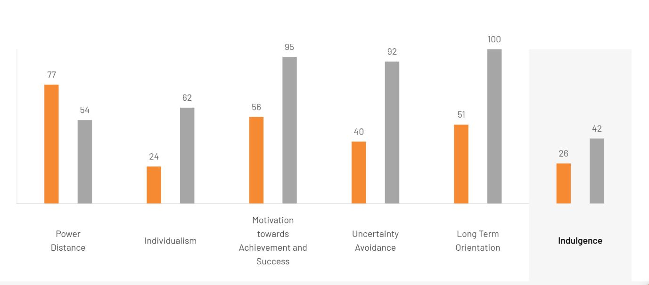
(Image Sourced from Google)
https://www.theculturefactor.com/country-comparison-tool?countries=india%2Cjapan
Advantages
Comparative context: Provides a concrete, measurable means for comparing cultures in various countries good for applications such as international management, negotiation strategies, and marketing.
Strong empirical foundation: Was developed using a large amount of data (initially IBM workers in over 40 countries), making it more empirically solid than many other culture theories.
Disadvantage
Generalization: The theory assumes that there is no individuality among members of the same nation, nor do ethnic subcultures within a country exist. There is a risk of stereotyping here too.

- Legal Factor
In addition, a fair, strict and regulated Japanese system has in place legal and regulatory requirements to safeguard IPR and product standards quality.
ndia’s regulations and legal framework regarding foreign investment and environmental norms have recently tightened up. Even so, complicated taxation schemes, the volatility of new regulations, and the stringent nature of compliance measures make the business legal system more troublesome to navigating in comparison to the Japanese regime.

- Technological Factor
Automotive technological transformation is also highlighted by McKinsey & Company (2024), Deloitte (2024) and PwC (2024).
India is digitally changing rapidly and developing manufacturing sector. Although the technological infrastructure is progressing well India is far behind Japan in terms of research and development intensities. However, with the support of the government and growing digitization India offers a huge scope to Toyota to flourish its smart mobility solutions. (Toyota Motor Corporation, 2024).

- Environmental Factor
And, in terms of pollution and emissions, that's something that also impacts India, increasingly so. So, things such as push toward electric mobility through government policies, emission regulations, as the BS-VI standards, encourage the trend toward sustainability with Toyota." But in India, the situation is still challenging due to the poor charging infrastructure and less customer awareness. (Toyota Motor Corporation, 2025b).

Similarities and Differences

Similarities between India and Japan
- Both governments are encouraging the transition towards hybrid and electric vehicles through environmental regulations and sustainability initiatives.
- Both countries have increasing consumer awareness regarding fuel efficiency, vehicle safety and environmental protection.
- Toyota benefits from its strong global reputation for quality, reliability and technological innovation in both markets.
- Both markets present long-term growth opportunities because consumers increasingly demand sustainable mobility solutions.
Differences between India and Japan
- Japan is a mature, high-income economy, whereas India is a rapidly growing emerging market with greater price sensitivity.
- Japan possesses highly advanced technological infrastructure and R&D capabilities, while India is still developing its EV charging infrastructure.
- Japanese consumers prioritise technological innovation and premium quality, whereas Indian consumers focus more on affordability, fuel efficiency and resale value.
- Regulatory compliance is generally more stable and predictable in Japan, while India experiences more frequent changes in taxation and business regulations.
Critical Evaluation
Overall, although Toyota operates successfully in both countries, the company cannot adopt a standardised marketing strategy. Japan requires an innovation-driven strategy, while India demands localisation, competitive pricing and customer value. Therefore, Toyota follows a glocalisation strategy, combining global brand consistency with local market adaptation.

COMPARATIVE ANALYSIS OF STP

STP allows Toyota to recognize segments of customers with varied requirements, target those customer segments which offer the greatest appeal and formulate a distinct value proposition for each market segment. The example provided for India versus Japan shows how the STP strategy changes based on the differences in demographics, geographics, lifestyles, and consumer expectations. Whereas Japan is considered a developed market, India offers significant growth opportunities and possesses a heterogeneous customer base.(Kotler and Keller, 2022)

Demographic Segmentation
Customers of Toyota are segmented based on their demographic variables like age, income, occupation, and family size. Toyota in Japan segments its customers into middle-aged and aged consumers, affluent professional individuals, and environmentally conscious customers. Models such as Toyota Crown and Toyota Prius can target the customers interested in quality products with innovations and environmental responsibility.
On the other hand, in India, Toyota targets the customers belonging to young professionals, middle-income families, and larger family sizes. Models like Innova HyCross are ideal for the family-oriented customers requiring space and reliability in a car. Also, Fortuner targets the affluent professionals who desire a premium SUV with status. It shows that Toyota uses demographic segmentation to target the consumers having a different market environment. This indicates that the consumer market in Japan is mature, whereas India's consumer market is growing and has a young population.(Toyota Motor Corporation, 2025a; Toyota Kirloskar Motor, 2025)

Geographic Segmentation
Similarly, Toyota's strategy is flexible based on geographic factors such as urbanization and transportation infrastructure.There is a high level of urbanization in the country of Japan. This implies that there is a need for transport infrastructure, and parking space is scarce. As such, small cars are in demand. In this regard, Toyota has compact cars and hybrid cars that will satisfy the market requirements.
However, in the case of India, Toyota is targeting the metropolitan, Tier-2 cities, and even rural markets. There are different geographic requirements for the vehicles as consumers will face varied geographic conditions. In this regard, the Hilux is fit for customers that require increased capability, while Urban Cruiser Hyryder caters to the urban population.Hence, there is a need for diversification of geographic segmentation in the Indian market.(Toyota Motor Corporation, 2025a; Toyota Kirloskar Motor, 2025)

Psychographic Segmentation
Psychographic segmentation looks into consumers' lifestyles, personality, values, and attitude.
In Japan, Toyota has identified innovation-seeking, environment-friendly, and quality-seeking consumers. For example, the Toyota Mirai is an indication of Toyota's focus on innovative modes of mobility, and therefore can be appealing to innovators and consumers of hydrogen fuel-cell technology.
On the other hand, Toyota's psychographic segments in India are families seeking cars, status-conscious consumers, and value-conscious consumers. The Toyota Fortuner can attract the status and capability-conscious consumers, and the Innova HyCross can attract the families who seek comfort and safety.This shows how Toyota modifies the value of its products based on the local consumer motivation.(Toyota Motor Corporation, 2025a; Toyota Kirloskar Motor, 2025)

Targeting Strategy
Targeting strategies adopted by Toyota varies depending on the development stage and nature of individual markets.In Japan, Toyota targets consumer segments such as consumers who need a means of mobility, city consumers looking for practicality and eco-friendly consumers attracted by hybrid and alternative technology cars. In a mature market like Japan, the target is to meet the sophisticated needs of consumers.
In India, Toyota targets aspiring middle-class families, large families, young professionals and consumers looking for practical cars that have reliable features. Therefore, Toyota prioritizes its investment in SUV and MPV cars rather than focusing on affordability, practicality and fuel efficiency.The differences indicate that Toyota adopts a targeting strategy that is innovative and lifestyle oriented in Japan while India calls for a broad-based targeting strategy considering family requirements and practicality.(Kotler and Keller, 2022; Armstrong et al., 2023)

Positioning Strategy
Positioning is the way Toyota will attempt to create its positioning and perception among consumers compared to other brands.
In Japan, Toyota can position itself as a technologically progressive brand, being a reliable national automaker and a manufacturer of hybrid cars. Reliability, quality and technological advancements become key features of positioning.
In India, Toyota can position itself through premium durability, reliability, high resale value and status of certain models. Such models as Fortuner could be positioned as premium SUVs, and Innova HyCross as a reliable family vehicle.On the whole, Toyota preserves its image of reliability and quality worldwide but adapts it to local markets.(Kotler and Keller, 2022; Armstrong et al., 2023)

PERCEPTUAL Map

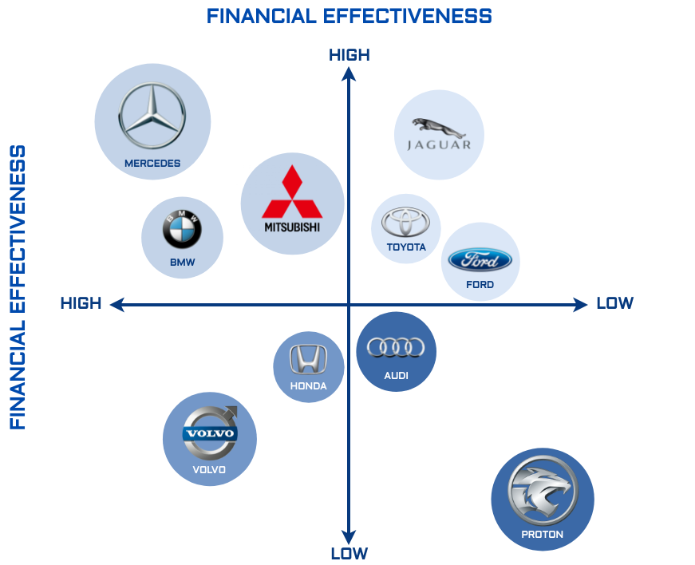
(Image Sourced from Google)
https://share.google/OQsgqOXqHsMTQW6iZ

Toyota's perception map always places the product brand in the "moderate price, high reliability/quality" position, directly competing with Honda but placed under luxury car brands like Mercedes or BMW based on the price aspect but equally matched in terms of reliability and durability. The placement in this position is a result of Toyota's marketing strategies to provide quality products for the masses.

The 7Ps: International Marketing Mix

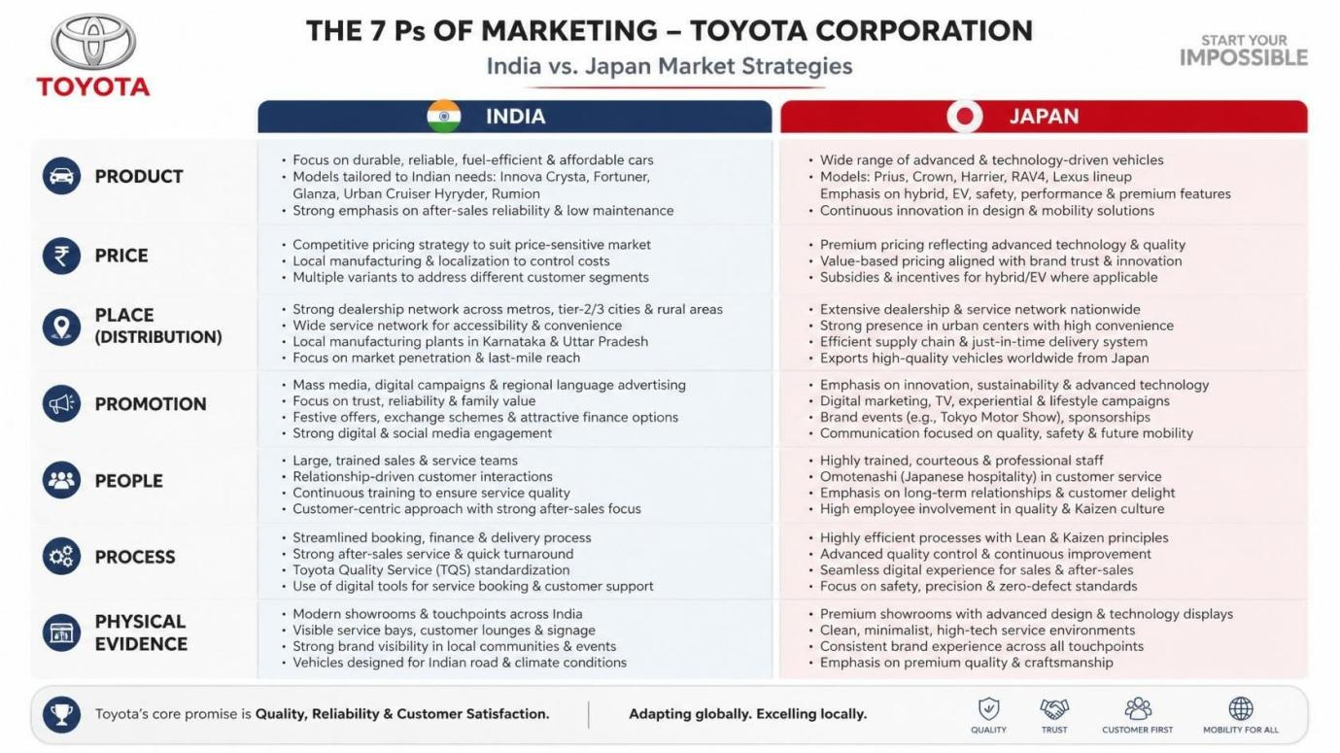
(IMAGE CREATED BY OWN)

1. Product: Integrity of the "Quality" Promise
What’s the Ethical Failing?
- Product “The Japanese company has built its brand on “Kaizen” (continuous improvement) and quality controls; the Toyota’s brand message in Japan centers on a safe product at a fair price for a lifetime. “ The ethical dilemma.
- Toyota mass-produced thousands of cars by falsifying the collision, airbag and engine power test results.
- By not going through the normal certification and tests, the automaker was effectively “marketed to the world on safety assurance” they did not meet.” As an implication.
- Even though vehicles passed subsequent safety tests, the company had mass-produced as well as shipped safety compliant- vehicles while they are not in conformity with the tests they submitted.(Kotler and Keller, 2022)

2. Promotion: Deceptive Positioning
- Safety, Reliability, and Brand Authority. A look at how Toyota, by building up its safety and reliability, justifies market supremacy in Japan.
- Toyota's "Promotion" strategy in Japan relies on this, as most of what is written on Toyota is about how safe, and reliable, they are, which helps build their market position.
- The Ethical Problem: That this “Promotion" strategy relied on misleading consumers with respect to government approved safety metrics was unethical, deceptive.
- By touting "safety," Toyota makes a moral pledge to consumers. Employing phony data to back that pledge up is the essence of the concept we call "ethics washing": sustaining a healthy, safe image of an automobile company by means of administrative fraud.(Kotler and Keller, 2022)

3. Price: Exploitation of Trust
- The Price Variable: This one relates to a "value for money" scenario.
- Consumers are prepared to pay a higher price for a Toyota because they believe the "Toyota standard" to be more stringent and higher than their competitors.
- Ethical Problem: Through cutting tests for a lower price or faster time-to-market,
- Toyota offered an unethical corruption of the value exchange.
- They received a 'reliability premium' from Japanese consumers, while denying consumers the necessary safety tests that command that higher price.(Kotler and Keller, 2022)

Place (Distribution): Cascading Ethical Failure

- Toyota’s “Place” strategy in Japan-“J-ReBORN” project-called for the consolidation of Japanese dealerships into large, regional mobility hubs.
- The ethical problem When the government stopped Toyota from shipping and producing, it was not only Toyota's headquarters that were affected.
- Dealerships-independent or locally connected businesses-now have inventory they cannot use and are also the ones to face customer backlash.
- Internally, the lack of operational rigor on the part of Toyota flowed to dealerships; locally, partners have money they invested based on the promise ofToyota's operational excellence.(Kotler and Keller, 2022)

People

Humans are critical in the case of Toyota since both employees and sales representatives play an important role in the relationship between the firm and customers.
In Japan, Toyota’s human resources management is linked closely with the organisational culture of the company, quality and continuous improvement. Employees are supposed to ensure high standards of engineering, manufacturing and customer services.
For India, it is necessary that employees and dealership workers comprehend the needs of the local consumers concerning family considerations, cost effectiveness and after sales services. It is especially important since there are many segments in the market with different income and geographical requirements.
It implies that global standards of the firm should be maintained while dealing with local customers.(Kotler and Keller, 2022)
Exact Employee Numbers
Toyota Motor Corporation (Global)
As of 31 March 2026, Toyota employed:
390,927 employees worldwide (consolidated).
Reference:
Toyota Motor Corporation (2026) Annual Report 2026.
Toyota Kirloskar Motor (India)
Toyota Kirloskar Motor currently has:
6,466 permanent employees.
(Older sources commonly report around 7,000 employees, but Toyota's latest company information lists 6,466 permanent employees.)

Process

Process can be defined as the systems and processes employed by Toyota for product and service delivery to the customer base.
In Japan, Toyota processes are highly characterized by their quality management and efficiency. This explains the reason behind the efficiency and high quality levels that Toyota is famous for.
In India, processes should balance between Toyota's international quality standards and those of the local market. Efficient dealership processes, vehicle delivery, financing support, servicing and after sales service become highly important because customers might be concerned about the total ownership process.
This is the major strategic challenge facing Toyota processes in the Indian market environment.(Kotler and Keller, 2022)

- Physical Evidence

Physical evidence comprises of the actual factors which the customers relate to the brand, such as dealerships, vehicle design, showrooms, service centers, websites, and others.
In Japan, Toyota's physical evidence might enhance its positioning by adding to the perceptions of technological excellence, reliability, and maturity as an established premium brand. The modern physical facilities and advanced technologies related to mobility can add to the perceptions of Toyota's innovation.
In India, dealerships and service centers have more significance since they are one of the visible aspects which help Toyota demonstrate its reliability and services to customers. Professional showrooms, service centers, and physical appearance of vehicles can add to Toyota's perception as a premium and reliable brand.
Therefore, physical evidence plays a significant role in both countries; however, it has much more importance in India since it demonstrates service availability.(Kotler and Keller, 2022)
Official website in India - www.toyotabharat.com
Toyota Japan Official Website (Toyota.jp)

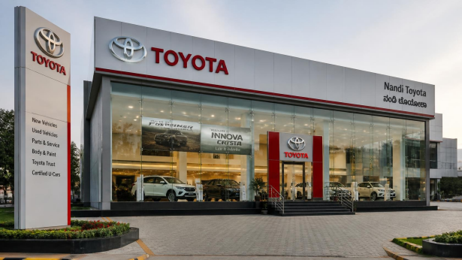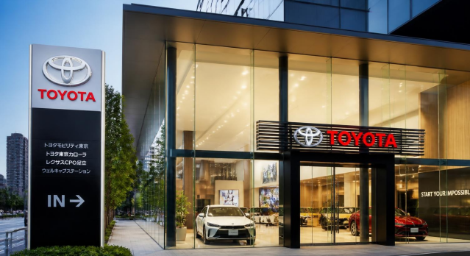
(Toyota showroom in India ) ( Toyota showroom in Japan)
(IMAGE CREATED BY OWN)
Definition of IMC (Integrated Marketing Communications)
Integrated Marketing Communications (IMC) is the strategic process of coordinating all marketing communication tools, channels and promotional activities to deliver a consistent, clear and persuasive brand message to customers across multiple touchpoints (Kotler and Keller, 2022). IMC integrates advertising, sales promotion, public relations, digital marketing, social media, personal selling and direct marketing to improve brand awareness and customer relationships.(Kotler and Keller, 2022; Armstrong et al., 2023)
2. IMC Examples (Toyota)
Japan
Toyota uses an integrated marketing communications strategy by combining:
- Television advertisements
- Toyota Mobility Show
- Social media campaigns
- Toyota Mobility Foundation CSR projects
- Digital applications such as MyTOYOTA+
Example
Toyota's promotion of the Prius Hybrid combines TV advertising, YouTube campaigns, dealership demonstrations and sustainability campaigns to reinforce its environmentally friendly brand image.
India
Toyota integrates:
- Television commercials
- Instagram & YouTube
- Toyota Bharat website
- Dealer events
- Auto Expo exhibitions
- Influencer marketing
- Cricket sponsorships
Example
The Toyota Innova HyCross launch combined:
- Digital advertising
- Social media promotion
- Dealership launch events
- Influencer reviews
- Television commercials
This created a consistent message highlighting premium comfort, hybrid technology and family safety.

Ethical and unethical marketing in Japan and India

Summary of Ethical Critique

If there’s a common theme to Toyota’s scandals – which spans the Japanese carmaker’s recalls in 2010 to its certification shenanigans that surfaced in 2024 – it is this: scheduling took precedence over compliance. In a marketing sense, that’s a failure to uphold one’s Corporate Social Responsibility (CSR) tenets.

By having the “pressure to produce” win over the “responsibility to certify,” the company transferred risk from the brand to the customer, leaving a durable and arguably irreparable damage: brand trust, a much tougher nut to recover from than a hit to market share. The ethical core issue is that its entire marketing mix had been erected upon an “assumed” reliability, even as the corporation undermined that reliability in the shadows.

Japan

Ethical Practices

1. Kaizen (Continuous Improvement)

Toyota follows the Kaizen philosophy, continuously improving product quality, manufacturing efficiency, and customer satisfaction. This strengthens customer trust and long-term brand loyalty.

2. Environmental Sustainability

Toyota promotes hybrid vehicles such as the Prius and invests in hydrogen fuel-cell technology (Mirai), supporting Japan's carbon neutrality goals and reducing environmental impact.

Unethical Practices

1. Vehicle Certification Scandal (2024)

Toyota admitted that several vehicle models were certified using improper testing methods, violating Japanese regulations and damaging consumer trust.

2. Misleading Safety Claims

Toyota promoted vehicles as meeting the highest safety standards while certification procedures were incomplete, creating an ethical issue in product promotion.

Recommendations for Japan
- Strengthen internal compliance and independent safety audits.
- Increase transparency by publishing testing and certification results.
- Improve employee ethics training and whistleblower protection.
- Rebuild trust through CSR campaigns and open communication with customers.

India

Ethical Practices

1. Local Manufacturing and Employment

Through Toyota Kirloskar Motor, Toyota manufactures vehicles locally, creating employment opportunities and supporting the Indian economy.

2. Affordable Hybrid Mobility

Toyota promotes fuel-efficient hybrid vehicles (e.g., Urban Cruiser Hyryder and Innova Hycross), helping reduce emissions while offering economical transportation.

Unethical Practices

1. Premium Pricing

Many Toyota models remain expensive for average Indian consumers, limiting accessibility despite being marketed as practical family vehicles.

2. Limited EV Portfolio

Toyota has been slower than competitors in introducing fully electric vehicles in India, which may delay the country's transition to sustainable mobility.(Reuters, 2024; BBC News, 2024; Nikkei Asia, 2024).

Market Entry Method
1. Capitalize on the "Multi-Pathway" Electrification Message
While everyone else threw all eggs into the BEV basket and now wrestle with consumer EV fatigue and lack of infrastructure, Toyota has maintained a diversified portfolio (hybrids, plug-ins, hydrogen, BEVs).
- The Action: Marketing must aggressively push Toyota’s “1:6:90 philosophy”-the premise that the precious raw materials used for one BEV battery could instead be used to manufacture six PHEVs or ninety HEVs.
- The Positioning: Abandon all defenses for Toyota not building a large array of BEVs. Instead, champion Toyota as the savvy, consumer-focused leader who is delivering immediate carbon reduction globally in a manner that meets current reality on the ground for every locale.
- “Delivering the appropriate sustainable solution for where you are.”

2. Emphasize "Local-to-Local" Economic Contributions
- The Action: As Toyota begins shifting manufacturing into emerging markets and building out capacity in areas like Europe and North America, its messaging will have to downplay the Japanese origin story.
- The Positioning: Ad campaigns must center on a notion of “local-for-local.” By pushing up the benefits of domestic job creation, domestic supply-chain build-outs and "the Toyota you drive was made here," brand will create political support that will offset any rise in protectionism.

3. Rebrand as an "AI and Mobility" Tech Company
- Increasingly the value of a modern car is its digital environment & its AI (Software-Defined Vehicles) In addition Toyota have transitioned their investments in AI, ranging from autonomous robotaxis (China – Pony.ai) to factory robotics (humanoids), from the pilot stage into commercial use.
- The Action: International Marketing needs to reduce the perceived technology lead over more technologically astute car makers (e.g. Tesla, nascent Chinese EV manufacturers).
- The Positioning: Adspend must now emphasize In-Car AI, Driver Assistance, Connected Ecosystem (e.g. KINTO).
- Toyota needs to be communicated as more than a company that welds together large quantities of steel; it’s a comprehensive mobility system provider.

4. Deploy "Radical Transparency" to Rebuild Trust
- The Story: Toyota’s brand has been rooted in Kaizen (continuous improvement) and its legendary reliability. But the local safety certification scandals in Japan have eroded the company’s fundamental value proposition.
- The Action: A risk mitigation tactic that can help offset negative perceptions is to downplay the Japanese scandals.
- Efforts should be made in PR and international marketing campaigns to emphasize quality control processes and procedures.
- The Positioning: Toyota needs to set up its own decentralized Q&S Ethics Boards for each regional market where there would be opportunity for regulators to publicly scrutinize their vehicles and to leverage positive independent reviews of quality assurance standards within those reviews.
- Localized Marketing: Should Heavily Feature Reviews Toyota must advertise how local circumstances that created issues in the past do not impact the vehicles in your market.

Toyota's multi-pathway strategy
- The ’1:6:90’ rule - What does it actually mean and why is it controversial? The ’1:6:90’ rule, as proposed by Toyota’s own scientists, focuses on a particular allocation of battery raw materials for a long-range electric vehicle, according to an investigation by Consumer Reports. (Consumer Reports, 2023).
- Below are a number of explanations for why this rule exists, its core principles, and the carbon math involved.
The Math Behind ’1:6:90’ When scientists at Toyota estimated the total mineral inputs required to build the batteries for one fully electric vehicle - one which offers long-range electric operation - they determined that these inputs would instead be enough to create batteries for: - one BEV - six PHEVs - 90 HEVs The ‘1:6:90’ rule dictates that to maximise environmental benefit from every gram of mineral mined and processed - like lithium, cobalt and nickel - those rare ingredients need to be shared among the 90 HEVs, instead of concentrating it into one car with the greatest benefit at that singular moment. (Toyota Motor Corporation, 2024; Consumer Reports, 2023; McKinsey & Company, 2024; Deloitte, 2024; PwC, 2024). with their international marketing strategies. (Toyota Motor Corporation, 2024; Consumer Reports, 2023).

Part 2: Reflective Account: Gibbs Reflective Cycle

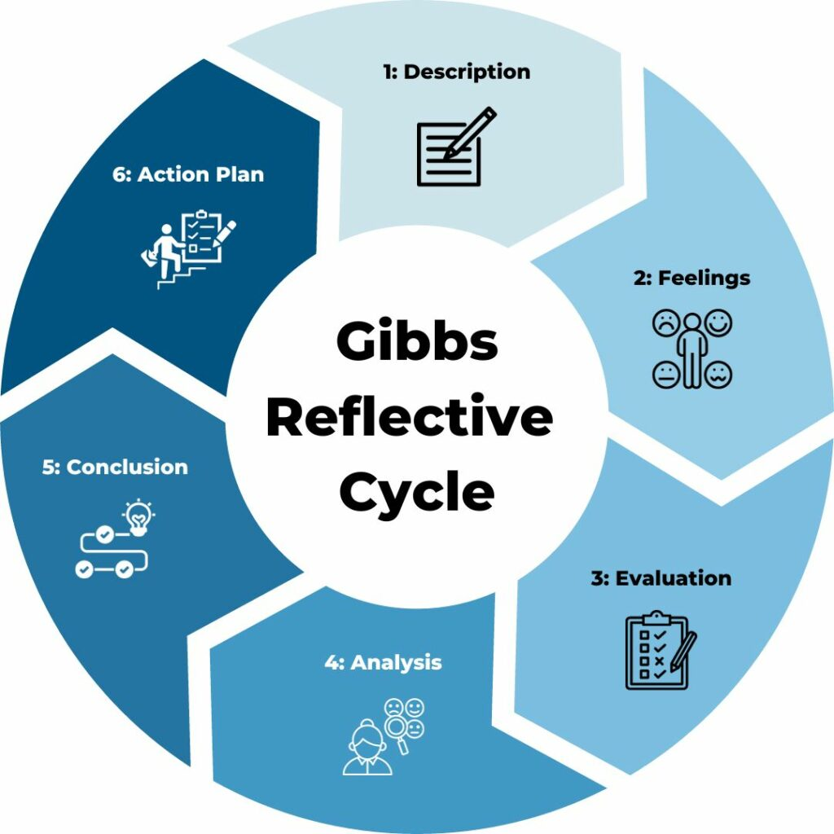

(IMAGE BY GOOGLE)

1. Description

In this reflection, I would like to think about the process that was undertaken in finding out information and preparing my International Marketing coursework. This coursework is for a comprehensive report which investigates the International Market Entry Strategy and Marketing Mix of one brand in two countries of operation; I decided on Toyota and investigated its strategic operations in both India and Japan.

The process was broken down into a number of clear stages:
- Macro-environment analysis: Comparing the Indian and Japanese markets using the PESTEL model.
- Cultural analysis: Analyzing social and cultural similarities and differences between the two markets using Hofstede’s cultural framework.
- Strategic marketing analysis: Comparing the STP (Segmentation, Targeting, and Positioning) and the 7Ps of the International Marketing Mix for both countries.
- Evaluation: Analyzing the international market entry strategy of Toyota into India, specifically looking at joint ventures and the Suzuki partnership.
- Ethical Assessment: Discussing ethical issues regarding Toyota's marketing mix in Japan, notably the recent safety certification controversies.
- Formulation of Recommendations: Giving clear, strategic recommendations (such as the multi-pathway strategy and localized messaging) to aid Toyota’s future international marketing.

2. Feelings

First, I was a little intimidated by the task. In applying macro-environment analysis, as well as culture models, ethical considerations and a 7P analysis for two, large and unique, markets within only 4000 words. I had some reservations as to how well I could demonstrate the “Level 7” systemic understanding and critical awareness required by the assessment.

Nevertheless, my apprehension gradually turned to enthusiasm as the research developed and I particularly enjoyed seeing the application of Hofstede’s culture dimensions, relating them to Cadbury’s differing approaches to promotion in the Indian and US markets. Although I grew increasingly frustrated during the writing process by the stringent word count – a maximum of 25% overshoot carries a 5-mark penalty! I am very pleased to have produced such a comprehensive understanding of how the different theoretical models can be applied to real life global marketing problems.

3. Evaluation

What worked well:

Applying the frameworks - I think the frameworks provided in the brief (PESTEL, Hofstede, STP, 7 Ps) gave me a very solid framework that stop my answer being completely descriptive and force me to compare. Utilisation of resources - Using Generative AI to draft the initial structure and grammar check definitely helped and time-saving. This then meant I could focus my higher thinking toward the critical analysis and synthesis that was required (25 marks for that component).

What was difficult :

balancing Depth vs. Breadth – Trying to give detailed 7 Ps for 2 countries while still having enough space for the critique of ethics was tricky. In the early drafts of the report, the PESTEL was quite descriptive as it stated in the rubric "wholely or almost wholly descriptive work will fail." Synthesis of methodologies – Moving from the macro-level PESTEL to the micro level of the marketing mix was also a challenge and required quite a few redrafts for the arguments to flow coherently with evidence.

4. Analysis
My own experience matches the "Cognitive and Intellectual Skills" for Level 7: to "handle complex problems systematically and imaginatively". My mistake in the first few drafts was to analyse the PESTEL and Hofstede frameworks as separate check-lists rather than interconnected underpinnings of the marketing mix.I identified that the country specific Hofstede "dimensions of culture" determine the "Promotion" and "People" dimensions of the 7Ps. This linkage between cultural factors and the marketing mix was key in moving the report from "satisfactory" to "excellent" on the general assessment criteria. My other difficulty centred on the complexity of international ethics as the brief required me to investigate "ethical considerations with the brand's marketing mix in a country". Researching "contradictory or incomplete" information on the specific brand marketing strategy and Cadbury's supply chain provided a wealth of detailed research opportunities.

5. Conclusion
The main learning outcome was understanding that international marketing should go beyond description and focus on comparison, analysis and critical evaluation. The India–Japan comparison demonstrated that Toyota must adapt its products, pricing, promotion and customer experience according to local market conditions. I also recognised that better planning and earlier organisation of sources would have improved my research and writing process.

6. Action Plan
In future assessments, I will create a detailed structure and word-count plan before beginning my research. I will also connect theoretical frameworks from the start rather than analysing them separately. I will manage references throughout the research process and use more critical evaluation of theoretical models, including their limitations. This approach will help me produce more focused, coherent and academically rigorous international marketing analyses.

CONCLUSION
Looking back, I could have structured it differently. For one, I could have set a specific word count allocation to each section (PESTEL, Hofstede, STP, 7Ps, Entry Strategy, Ethics, Recommendations) before I began to write. I feel this would have helped to reduce the editing time necessary to bring it down so as not to get penalised.
Additionally, I could have considered how I was going to address the academic arguments surrounding the model Hofstede. The marking rubric includes criteria for methodology critically evaluate and construct critique of methodology and, I feel it would have made me look at a higher level of academic understanding if I would have considered the criticisms of the model.Reflection on the Contrasts of Market Choice Looking back at my market choices, I have to admit that it was extremely ambitious of me to select two markets at completely opposing ends of the economic and demographic spectrum. In selecting Japan’s ageing, developed and hyper-tech; versus India’s youthful, cost-conscious and explosive market, my STP and 7Ps analysis became quite naturally challenging. However, in hindsight I conclude that this contrast has created the report which was, I would argue, harder to write, but has provided a much more compelling case to demonstrate how a large multinational needs to transform its marketing mix drastically if it wishes to survive. The Impact of the Ethical Analysis In addition, I conclude that research into the recent Toyota’s safety certification scandal in Japan significantly advanced my understanding of the marketing mix. At the outset I viewed the 7Ps merely as operational instruments, but reviewing how Toyota’s “pressure to produce” ultimately corrupted their “Quality” commitment has demonstrated how product and promotion can and do depend intrinsically on the integrity of the business. I discovered that ethical compromise in the area of certification has the power to devastate brand equity that any marketing strategy strives to build. Reflection on the Research Process
The research process also benefited from established international marketing frameworks (Doole, Lowe and Kenyon, 2022; Johnson, Scholes and Whittington, 2020). Finally, I reflect on my methodology in research, I feel I did well in combining recent press coverage and industry reports for my ethical and market entry analyses. Nevertheless, I conclude that I could have been more effective in managing my sources. It proved to be rather taxing trying to effectively synthesise some 10-15 credible sources and connect the broader macro PESTEL forces to specific micro 7P strategic implications.

REFERENCES

- Cateora, P.R., Money, R.B., Gilly, M.C. and Graham, J.L. (2020) International Marketing. 18th edn. New York: McGraw-Hill Education.
- · Doole, I., Lowe, R. and Kenyon, A. (2022) International Marketing Strategy: Analysis, Development and Implementation. 9th edn. Andover: Cengage Learning.
- · Gibbs, G. (1988) Learning by Doing: A Guide to Teaching and Learning Methods. Oxford: Further Education Unit, Oxford Polytechnic.
- · Hofstede, G., Hofstede, G.J. and Minkov, M. (2010) Cultures and Organizations: Software of the Mind. 3rd edn. New York: McGraw-Hill.
- · Hollensen, S. (2020) Global Marketing. 8th edn. Harlow: Pearson.
- · Kotler, P. and Armstrong, G. (2021) Principles of Marketing. 18th edn. Harlow: Pearson.
- · Kotler, P., Keller, K.L. and Chernev, A. (2024) Marketing Management. 16th edn. Harlow: Pearson.
- · Mintzberg, H., Ahlstrand, B. and Lampel, J. (2009) Strategy Safari: A Guided Tour Through the Jungles of Strategic Management. 2nd edn. Harlow: Pearson.
- · Porter, M.E. (1985) Competitive Advantage: Creating and Sustaining Superior Performance. New York: Free Press.
- · Whittington, R., Regnér, P., Angwin, D., Johnson, G. and Scholes, K. (2020) Exploring Strategy. 12th edn. Harlow: Pearson.
- · Hultman, M. and Oghazi, P. (2024) ‘On the (in)effectiveness of standardized versus adapted international promotion strategies: Evidence from entrepreneurial firms’, Journal of Business Research, 170.
- · Rao-Nicholson, R. and Khan, Z. (2017) ‘Standardization versus adaptation of global marketing strategies in emerging market cross-border acquisitions’, International Marketing Review, 34(1), pp. 138–158.
- · Szymanski, D.M., Bharadwaj, S.G. and Varadarajan, P.R. (1993) ‘Standardization versus adaptation of international marketing strategy: An empirical investigation’, Journal of Marketing, 57(4), pp. 1–14.
- · Theodosiou, M. and Leonidou, L.C. (2003) ‘Standardization versus adaptation of international marketing strategy: An integrative assessment of the empirical research’, International Business Review, 12(2), pp. 141–171.
- · Deloitte (2024) 2024 Global Automotive Consumer Study. Deloitte.
- · International Energy Agency (IEA) (2024) Global EV Outlook 2024: Moving Towards Increased Affordability. Paris: IEA.
- · International Monetary Fund (IMF) (2025) 2025 Article IV Consultation with India. Washington, DC: IMF.
- · International Monetary Fund (IMF) (2025) 2025 Article IV Consultation with Japan. Washington, DC: IMF.
- · OECD (2024) OECD Economic Outlook, Volume 2024 Issue 1: An Unfolding Recovery. Paris: OECD Publishing.
- · United Nations (2024) World Economic Situation and Prospects 2024. New York: United Nations.
- · World Bank (2025) World Development Indicators. Washington, DC: World Bank.
- · Statistics Bureau of Japan (2025) Population Estimates: Population as of 1 October 2024. Tokyo: Ministry of Internal Affairs and Communications.
- · Ministry of Heavy Industries, Government of India (2024) PM E-DRIVE Scheme: Scheme Notification. New Delhi: Government of India.
- · Ministry of Heavy Industries, Government of India (2019) FAME India Scheme Phase II. New Delhi: Government of India.
- · Toyota Kirloskar Motor (2021) Toyota Kirloskar Motor: Government e-Marketplace Corporate Brochure. Toyota Kirloskar Motor.
- · Toyota Motor Corporation (2024) ‘Results of Investigation Regarding Model Certification Applications’. Toyota Motor Corporation, 3 June.
- · Toyota Motor Corporation (2025) Integrated Report 2025. Toyota Motor Corporation.
- · Toyota Motor Corporation (2025) Company Profile. Toyota Motor Corporation.
- · Toyota Motor Corporation (2023) ‘New Management Policy & Direction Announcement’. Toyota Motor Corporation.
- · Reuters (2024) ‘Japan auto safety scandal widens, Toyota halts some shipments’, 3 June.

