MANAGEMENT ETHICS ASSIGNMENT 1 –
CRITICAL DISCUSSION OF CSR THEORY



19th NOVEMBER 2018

MODULE NAME: MANAGEMENT ETHICS

COMPANY NAME: PURDUE PHARMA

NAME: JAMES DE KERCKHOVE

STUDENT NUMBER: 1707439

CONTENTS

TABLE OF CONTENTS:

TABLE OF CONTENTS……………………………………………………………………………………………….………….….2
LIST OF FIGURES…………………………………………………………………………………………………….………….…...2
- INTRODUCTION……………………………………………………………………………………………………..……3
- MAIN FINDINGS………………………………………..………………………………………………………….…….3
  - SHAREHOLDER THEORY………………………….…………………………………………………………….3
  - STAKEHOLDER THEORY………………………….……………………………………………………….……3
  - CSR………………………………………………..………………………………………..…………………….…….5
- RECOMMENDATIONS…………………………………………………………………………………………………8
- CONCLUSION……………………………………..………………………………..…………………………………….9
- REFERENCES………………………………………..……………………………………………………………..….…10
- APPENDICES……………………………………………………………………………………………………………..13

LIST OF FIGURES:

Figure 1. Mendelow’s Power-Interest Matrix (1991)
Figure 2. Carroll’s Pyramid of Corporate Social Responsibility
Figure 3. Purdue Pharma – Code of Ethics
Figure 4. Explanation of Purdue’s Code of Ethics

1. INTRODUCTION

This report investigates Purdue Pharma and the impact of false advertising their drug OxyContin. Purdue lied about its addictiveness and caused a backlash of drug abuse and overdose deaths (Crawford, 2013).

The report investigates Corporate Social Responsibility (CSR), stakeholder theory (Freeman, 1984) and shareholder theories (Friedman, 1962). CSR involves responsibility of a business to society, by how they give back to the community, rather than only taking (Scalet & Kelly, 2010).

2. MAIN FINDINGS

2.1 SHAREHOLDER THEORY

Shareholder theory states that a company only has responsibility to its shareholders (Friedman, 2007). There is logic to its simplicity as, in order to succeed in business, you must make money. This then allows further contribution to society.

Purdue made $1.6 billion in net sales in 2003 from OxyContin (Rosenberg, 2004). Shareholders benefitted but at great cost to society with many now addicted to their medication (Hays, 2004).

2.2 STAKEHOLDER THEORY
Stakeholders are defined as “any group or individual affected by or who can affect the achievement of an organization’s objectives” (Freeman & McVea, pg. 4, 2001).

Differing forms of stakeholder theory include normative, descriptive and instrumental (Crane & Matten, 2010). Normative theory looks for reasons to take account of stakeholders. Descriptive is how businesses realistically take account of stakeholders. Instrumental considers whether it is worthwhile taking stakeholders into account.
Stakeholder management capability is the ability to manage stakeholders. This can be measured on different levels of sophistication. The measurement of the company on these levels shows the involvement with stakeholders (Carroll & Buchholtz, 2000).
Stakeholder corporation is a highly evolved concept for stakeholder management which seeks to include all stakeholders (Wheeler & Sillanpää, 1997). Wheeler and Sillanpää, (1997) state that a good relationship with all stakeholders will lead to profit through gathering support from the individuals who affect the business.
This report seeks to evaluate Purdue’s shareholders, customers and government.
Figure 1. Mendelow’s Power-Interest Matrix (1991)
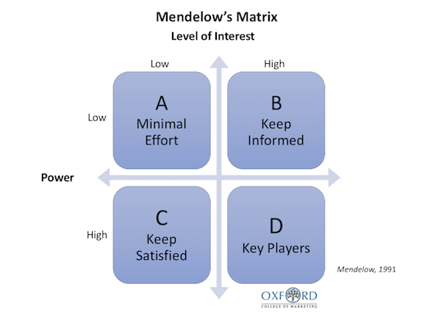
(Eriksen-Coats, 2018)

The government is in group ‘B’ as they have high interest in the running of the business, and low power in how the business is run. Purdue’s major shareholders are in category ‘D’ as key players with high interest and power. Customers are category ‘D’ if they buy in bulk. However, individually, they are category ‘C’.
2.3 CSR

CSR encompasses responsibilities that businesses have to society such as: economic, legal, ethical and discretionary/philanthropic (Carroll, 1979) See Figure 2. Carroll and Buchholtz (2000) discussed the relationship between social responsibility and financial performance showing a positive correlation within large companies.

There is agreement that all businesses have fiduciary responsibilities and rely on this to develop (Macey, 1991). Milton Freidman believes that a company only has responsibility to make money for shareholders (Friedman, 2007). Edward Freeman believes that companies owe it to society to protect and consider all parties involved (Freeman & Velamuri, 2006). Bowen (1953) argues that both sides have validity.

Figure 2. Carroll’s pyramid of corporate social responsibility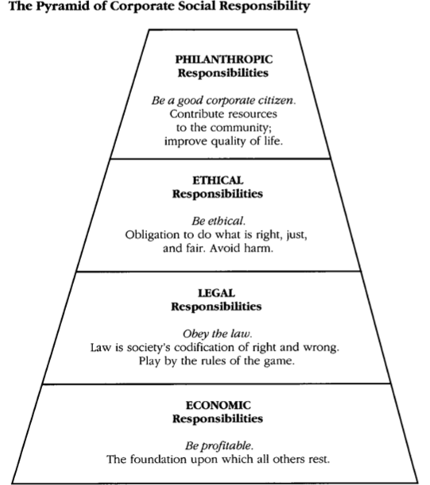(Carroll, 1991, p.42)

This image shows the different responsibilities businesses have to society (Carroll, 1991). The basic responsibility of a business is to make money (Carroll, 1999). Purdue have succeeded in this economic responsibility.

Legal responsibilities denote the legal activities a firm must comply with (Ni & Van Wart, 2015). Purdue Pharma had a lawsuit filed in 2007 for ‘misbranding’ (Van Zee, 2009) therefore all legal responsibilities were not met.

Ethical responsibilities are those that are expected but not enforced (Carroll, 1991). Philanthropic responsibilities are desired (Carroll, 1991). Purdue pharma have not established either responsibility as their business has been producing OxyContin which has had many negative impacts on local areas, including overdose deaths (Manesses Communication Group, 2002).

Corporate social responsiveness is the way companies deal with social issues and standards. Social responsiveness includes reaction, defence, accommodation and pro-action (Crane & Matten, 2010). Purdue have entered this process. They reacted by rejecting responsibility claiming pseudo-addiction, defended by taking minimal responsibility in the lawsuit and accommodated by creating the RADARS team (Cicero, et al., 2007). Purdue then proactively tried to find a solution, albeit as a result of enforcement action.

Corporate accountability is how much a company discloses about their activities to stakeholders (Benn & Bolton, 2011). Purdue did not disclose the addictiveness of OxyContin to stakeholders, which was a failure of corporate accountability. This then led to a class action lawsuit showing that Purdue did not adhere to this requirement (Baumrucker, 2001). There are aspects of corporate accountability that can be influenced by law, as evidenced by Purdue being fined $600 million for ‘misbranding’ (Teo & Bal, 2016).

Corporate Social Performance (CSP) is the performance of business in relation to CSR, measured through social policies, programmes and impacts (Crane & Matten, 2010). Policies could be represented in the form of a ‘code of ethics’. Purdue’s code of ethics is displayed in figures 3 and 4 below. Programmes would be the task force ‘RADARS’. The social impacts can be measured by OxyContin addiction levels.

Figure 3. Purdue Pharma – Code of Ethics



(Purdue Pharma L.P., 2017)

Figure 4. Explanation of Purdue’s Code of Ethics

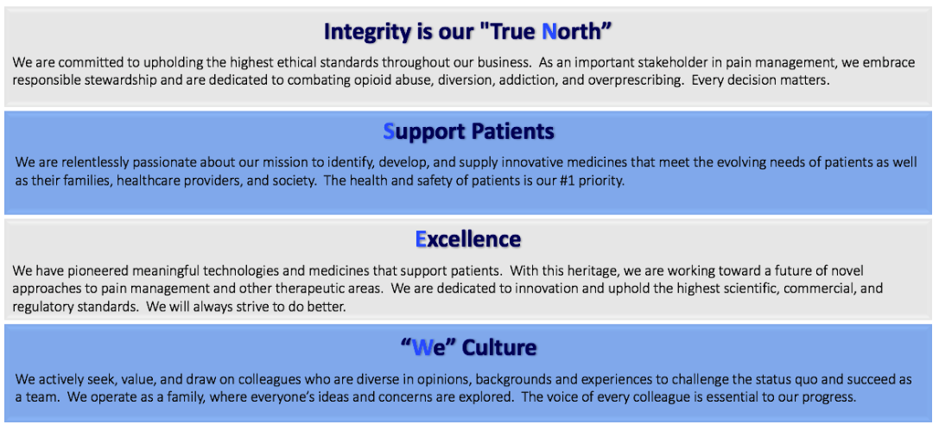

(Purdue Pharma L.P., 2017)

3. RECOMMENDATIONS

The report showed blame on both sides for this ethical issue. Purdue bear responsibility for falsely advertising their product. The American government should also be held responsible for not maintaining safer healthcare. Recommendations would be an enhanced health care system, including physiotherapy rather than painkillers. Companies need profit, however there is a moral boundary, such as not breaking the law and abiding by social responsibility.

4. CONCLUSION

Whilst Purdue have attempted to appear ethical, they have failed in practice, as evidenced by the lawsuit for false advertising and the link between OxyContin and deaths by overdosing. Whilst CSR does encourage companies to act responsibly for the benefit of all, there is danger in the ability of businesses to self-evaluate their CSR achievements (Erneseh, et al., 2010). Whilst it may be argued that a business should serve its shareholders above all else, without applying CSR those shareholders are at risk of failure.

5. REFERENCES:

Baumrucker, S.J., 2001. OxyContin®, the media, and law enforcement. American Journal of Hospice and Palliative Medicine®, 18(3), pp.154-156.

Benn, S., Bolton, D., 2011. Key Concepts In Corporate Social Responsibility. London: SAGE.
Bowen, H. (1953). Social Responsibilities of the Businessman. New York: Harper.

Carroll, A.B., 1979. A three-dimensional conceptual model of corporate performance. Academy of management review, 4(4), pp.497-505.

Carroll, A.B., 1991. The pyramid of corporate social responsibility: Toward the moral management of organizational stakeholders. Business horizons, 34(4), pp.39-48.

Carroll, A.B., 1999. Corporate social responsibility: Evolution of a definitional construct. Business & society, 38(3), pp.268-295.

Carroll, A.B., and Buchholtz, A.K., 2000. Business & Society – Ethics and Stakeholder Management. 4th ed. United States of America: South – Western College Publishing.

Cicero, T.J., Dart, R.C., Inciardi, J.A., Woody, G.E., Schnoll, S. and Muñoz, A., 2007. The development of a comprehensive risk-management program for prescription opioid analgesics: Researched Abuse, Diversion and Addiction-Related Surveillance (RADARS®). Pain Medicine, 8(2), pp.157-170.

Crane, A., and Matten, D., 2010. business ethics. 3rd ed. United States of America: Oxford University Press.

Crawford, M., 2013. Pain pills or chiropractic?. Journal of the American Chiropractic Association, pp.18-21.

Eriksen-Coats, F., 2018. What Is Mendelow’s Maxtrix And How Is It Useful?. Oxford College Of Marketing Blog, [Blog] 23rd April. Available at: <https://blog.oxfordcollegeofmarketing.com/2018/04/23/what-is-mendelows-matrix-and-how-is-it-useful/ > [Accessed 9th November 2018].

Erneseh, E., Ako, R. and Okonmah, P., 2010. Corporations, CSR and self regulation: What lessons from the global financial crisis. German LJ, 11, p.230.

Freeman, R.E. and Velamuri, S.R., 2006. A new approach to CSR: Company stakeholder responsibility. In Corporate social responsibility (pp. 9-23). Palgrave Macmillan, London.

Freeman, R.E. and McVea, J., 2001. A stakeholder approach to strategic management.
Freeman, R. E. 1984. Strategic management: A stakeholder approach. Boston: Pitman.
Friedman, M. 1962. Capitalism and Freedom. Chicago: University of
Chicago Press.
Friedman, M., 2007. The social responsibility of business is to increase its profits. In Corporate ethics and corporate governance (pp. 173-178). Springer, Berlin, Heidelberg.

Hays, L.R., 2004. A profile of OxyContin addiction. Journal of Addictive Diseases, 23(4), pp.1-9.

Macey, J.R., 1991. An economic analysis of the various rationales for making shareholders the exclusive beneficiaries of corporate fiduciary duties. Stetson L. Rev., 21, p.23.

Mendelow, A.L., 1991. Mendelow's Power-interest grid. Ohio: Kent State.

Ni, A. and Van Wart, M., 2015. Corporate Social Responsibility: Doing Well and Doing Good. In Building Business-Government Relations (pp. 175-196). Routledge.

Purdue Pharma L.P., 2017. Code of Ethics. [pdf] Available at: <https://www.purduepharma.com/wp-content/pdfs/CBE.pdf> [Accessed 10th November 2018].

Rosenberg, D., 2004. Kentucky’s pain. Newsweek, 144(12), pp.44-45.

Scalet, S. and Kelly, T.F., 2010. CSR rating agencies: What is their global impact?. Journal of Business Ethics, 94(1), pp.69-88.

Teo, W.Z. and Bal, B.S., 2016. The Law and Social Values: Prescription Pain Killers. Clinical Orthopaedics and Related Research®, 474(9), pp.1924-1929.

Van Zee, A., 2009. The promotion and marketing of oxycontin: commercial triumph, public health tragedy. American journal of public health, 99(2), pp.221-227.

Wheeler, D. and Sillanpää, M., 1997. The stakeholder corporation. London: Pitman.

6. APPENDICES:
Poster – Purdue Pharma



