Mohamed Trissia (1921106)

The impact of workplace culture on Amazon’s performance.

Module: Workplace culture and its impact on organizational efficiency (BMSW5105_LON)

Lecturer: Dr Mohamed Kalam

Table of contents:

Executive summary………………………………………………………………………………….3
Introduction:…………………………………………………………………………………………...3
Main body:………………………………………………………………………………………………4
- Amazon’ background…………………………………………………………………………..4
- Amazon’s external environment…………………………………………………………..5
- Pestel analysis……………………………………………………………………………….5
- Potter’s five force…………………………………………………………………………..6
- Key drivers of change……………………………………………………………………..7
- Amazon’s organizational culture……………………………………………………………8
- Amazon’s culture and external environment…………………………………………10
- Amazon’s culture and performance……………………………………………………….11
- Amazon’s ethical dilemmas……………………………………………………………………12
- Conclusion…………………………………………………………………………………………….13
- References. …………………………………………………………………………………………..14
- Reflective journal………………………………………………………………………………….16.

Executive summary:
This document illustrates the impact of workplace culture on organizational financial and non-financial performance. By taking Amazon’ culture as a case study, this reports critically evaluates the core values and attitudes that have enabled the company to improve efficiency and competitive advantage. To conduct this evaluation and to examine Amazon’s broader environment, this paper involves 3 environmental tools: PESTEL analysis, Potter’s five forces, and Web cultural model. This external environment analysis enables us to identify the key drivers of change and to understand how some external forces of Amazon, such as Covid19, has shaped the company’s culture to improve productivity and profitability. However, Amazon’ organizational culture indicated some unethical problems. Using technology for hiring process (Kodiyan, 2019) and the unhealthy working conditions at Amazon’s warehouses (Johnson, 2021) rise concerns about the unethical issues that the retail giant needs to overcome to help workers resolve workplace ethical dilemmas.

Introduction:
Several theories suggest that organizational culture have significant impact on the overall performance of the organizations. Organizational culture improves the workers’ teamworking and motivation to create strategic plan to achieve both individual and organization goals (Gochhayat et al,. 2017). The same authors insisted that traits of organization cultures such as involvement, consistency, adaptability, and mission help organizations to face all kind of internal and external environments that may affect their performance.
This report entails Amazon.com, Inc as a case study to determine the impact of workplace culture and its efficiency to improve financial and nonfinancial performance. one of the most powerful and dominating e-commerce firm in the world which has been growing significantly in the last decades due to the outstanding cultural values that the company have built (stone, 2013). Amazon’s organizational culture has a variety of principles but this paper but improving innovation and customer experience are the company’s core values (Amazon, 2022). These core values and attitudes have helped Amazon to face challenges and overcome vigorous external (including Covid19) and industrial threats that may negatively impact the achievement of its strategic goals and excellence.

Main Body:

Amazon background:
Amazon.com Inc is an American electronic company founded by Jeff Bezos in 1994 and was created originally for selling books online (Stone, 2013). In the late 90’s and early 2000’s, the company experienced tremendous growth drawbacks due to different factors such as the use of unreliable technology and lack of skilful workers and professional management (Stone, 2013). Mr Bezos found these factors alarming and suggested that new methods and techniques needed to be implemented urgently to solve these issues. He concluded that changing the company’s culture is the ultimate way that can lead Amazon to huge success (Stone, 2013). As result, His business philosophy shifted from short-termed profit to long term customer loyalty. In 1997, the company started to sell music and computer games and 2000 launched Amazon Web Services which include computer cloud systems (Stone, 2013). Now Amazon is called the everything store since all kind of products and services are available on its platform. This culture has led Amazon to thrive significantly in the last 20 years by allowing millions of business customers around the world to use their products and services (Stone, 2013). Consequently, the company net sales recorded over $469bn in 2021 which led the company to make over £33bn as net income (Amazon, 2022).
The significant success of Amazon has not been easily achieved. The company has been constantly analysing the industrial environment to identify the aggressive forces that may affect its performance. By understanding the external environment, Amazon can create effective strategies to outperform its competitors and to identify key driver of change. Hence, the following section highlights the external environment of amazon’s which includes PESTEL and Potter’s five forces models.
Amazon external environment:
External environment refers to the external factors, circumstances, and situations that can pose potential threats to the organizations’ performance (Yuksel, 2012). Two main frameworks are widely used in strategic management to identify organizations’ external environments: PESTEL analysis and Potter’s 5 forces. PESTEL tool examines the macro factors that may affect the business and it stands for Political, Economic, Sociological, Technological, Environmental, and Legal. Yet, Potter’s five forces model is used to analyse the competitive nature of an industry or business (Goyal, 2020).
Despite being the leader of the ecommerce industry, Amazon deals with strong external factors. The following PESTEL and Potter’s five forces tools recognizes these factors:

Amazon’s PESTEL:
Political:
Governmental policies and laws can have impact on organizations’ strategic planning. Factors such as taxation, labour law, and foreign trade agreements can influence the performance of business Onyusheva and Seenalasatapor, 2018. In Amazon case, governments are encouraging ecommerce by improving the cybersecurity and contactless payments and also the political stability of the countries where Amazon operates works in its favour (Onyusheva and Seenalasatapor, 2018). However, Amazon’ brand image can be affected if any breach of users’ privacy as governments around the world have been tightening data regulations to protect consumers’ information from any potential thefts or exploitation (Coos, 2021).

Economic:
Covid19 pandemic hit badly the global economy. High supply chain disruption due to manufacturing premises closures, high rate of unemployment, and decrease of customer buying demand were major consequences of Covid19 pandemic (Amazon, 2022). As result, international organizations have faced immense challenges to achieve to sustain their profitability, however, Amazon’s total net sales has increased by 22 % reaching over 33 billion U.S Dollars up from 21 billion in previous year (Amazon, 2022).
Social:
According to Onyusheva and Seenalasatapor (2018), greater internet use and the fastest growing demographic segments including students and youth have improved Amazon financial performance. in addition, online shopping habits have changed as ecommerce is constantly improving to make it easier and more accessible to users. Also, advertising on social media platforms has significant role in the expansion of online retailers as users connect together to share their feedbacks and reviews about products and services.
Technological:
Automation and innovation awareness are key elements that help organization achieve its excellence (Amazon, 2022). Modern organization need to plan intelligently their future by implementing innovative and technical systems. For instance, Amazon has unique methods that enhance the acquisition and retention of new and existing customers such as live chat and online assistance (Stone, 2013). Also, Amazon’s shipping and delivering strategy have become incomparable as customers can get their products in one day and by drones in some locations. Above it all, Amazon stated in its annual report of 2022 that the company’s main is to continuously improve shoppers’ satisfaction by implementing more sophisticated and modern technological systems (Amazon, 2022).
Environmental:
Governments in developing countries are imposing new policies and regulations to tackle pollution and climate changes issues. For instance, British government has been enforcing congestion charges and low emission zone tax in major cities such as London, Birmingham, and Manchester (Department for Environment, Food & Rural Affairs, 2022). Abdullah (2021) argues that Amazon’s waste strategy is still having negative impact on environment. He added that Amazon is shredding millions of usable products annually which are directed to green places and oceans. Adding to the waste crisis, Amazon’s power cloud in Virginia use as much electricity as 1.4 million American homes (Abdullah, 2021).

Legal:
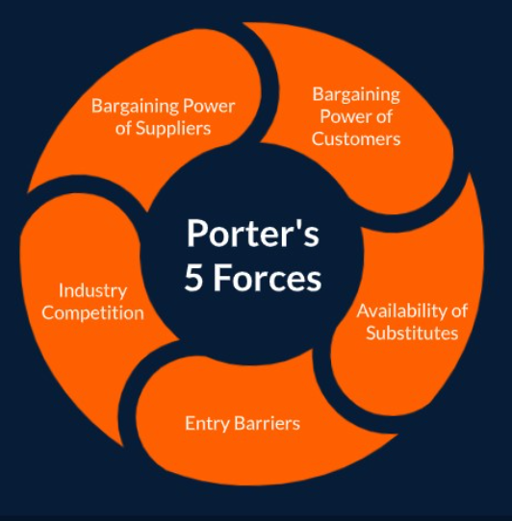
Organizations must abide by the laws such as industry regulation, health & safety of the employees, and consumer law. Amazon faces several challenges in the legal aspects. For instance, Amazon’ employees complain about working overtime, less shift breaks, unfairness in wages, and safety matters (Sainato, 2020). Also, the company’s security shortfalls expose customers information to potential breaches as the company use different methods for payments.
Amazon Potter’s Five forces: (Figure1)
Entry Barriers: Low.
This force cannot rise any threat to Amazon. Although, Potential new market entrants may copy Amazon’ business model, it is very challenging to achieve the level of the ecommerce giant market position. It would require enormous investment in marketing, logistics, distribution, and other factors (Amazon, 2022).
Availability of Substitutes: High.
Figure 1: Potter’s 4 Forces, Analysis Guide (UKEssays, 2018).
The availability of finding other competitors like Alibaba, eBay, and other online stores is high. Bad customer experience or lower prices of competitors may impact Customers’ retention (Amazon, 2022). Also, Amazon needs to consider that many people still prefer to shop in physical stores rather than online. All this can create high threats of substitutes.
Bargaining power of customers: High.
This is strong force that the company faces. Online buyers are well informed due to the availability of all products and services information including the price. Also, the absence of switching costs and the intense online retailers’ competition give the buyers a bargaining advantage to find alternatives.
Bargaining power of suppliers: low to moderate.
Although suppliers can affect the prices of products sold online, the retail giant has its own pricing strategy. For instance, in its 2021 annual report, amazon stated the following: “To decrease our variable costs on a per unit basis and enable us to lower prices for customers, we seek to increase our direct sourcing, increase discounts from suppliers, and reduce defects in our processes” (page18). Also, Amazon has a large number of suppliers who need to follow strict rules laid out by Amazon. The power of suppliers can increase from low to moderate when small proportion of products is supplied.
Industry competition: High.
Ecommerce has been growing so fast in the recent years and the number of online retailers is increasing rapidly. This creates intense competition between Amazon and other ecommerce giants such as eBay and Alibaba which both have powerful and aggressive strategies to expand in the market (Amazon, 2022). Low switching costs impose a serious threat for the company as consumers can switch from amazon to other available competitors easily. Also, high street and physical stores give further competition to Amazon since many people prefer to encourage local businesses.
Key drivers of change:
By analysing Amazon PESTEL and Potter’s five forces tools, Amazon needs to deeply focus on strategies and methods that can help her overcome external challenges and major forces that may affect its excellence. Based on these two analyses, the following key drivers of change are essential for the success of Amazon:
- Economic: the effect of the pandemic is still affecting the international trade systems. Global economy is still not stable and it is difficult for organizations such as Amazon to predict the long-term impact of Covid19 although the pandemic has increased the company profits. In its annual report, Amazon stated that sudden economic changes may rise risks of the company profitability (Amazon, 2022).
- Environmental: Amazon need to focus more on environmental-friendly waste strategies to help the fight against the ecological challenges otherwise it will face major risks if it constantly fails to achieve its sustainability goals. for instance, prioritizing plans which can accelerate achieving zero carbon commitment and decreasing energy consumption in Amazon’s cloud locations is a great approach to fulfil sustainable goals.
- Legal: the emphasis about consumers data protection has been rising significantly. Amazon needs to intensify its efforts to tackle bogus transactions and payments. Also, enhancing workplace safety and employees’ satisfaction can improve the company’s reputation.
- Forces of competition, buyers, and substitutes are serious threat for Amazon. The company need to constantly improve competitive advantages by enhancing the brand image and imposing suppliers’ pricing policies. Additionally, things such improving the users’ experience developing service quality will help the company to acquire and retain customers.
Amazon’s organizational culture:
An organization's culture can be defined as the deeply rooted values and beliefs shared between workers in an organization (Mullins and McLean, 2019). The same authors argues that these shared beliefs and values can be established by management and then communicated and reinforced through various methods to shape the employee perceptions, behaviors and understanding. Organizational culture can have significant impact on workplace performance. It can improve the employees’ motivation and good will, develop creativity and innovation, and boost productivity and efficiency (Kassam et al, 2018).
As discussed above, Amazon needs to change its culture to improve competitiveness. Therefore, it is important to conduct the cultural analysis to understand the company’s culture and to create effective strategies to implement changes. Accordingly, using cultural WEB model is appropriate tool that can be used for this purpose.
Developed by Gerry Johnson and Kevan Scholes in 1992, WEB cultural model investigates the organizational culture from 6 different perspectives (Figure2).
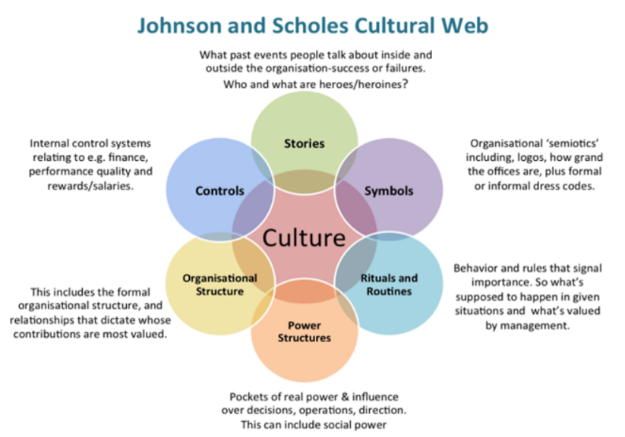
Figure 2: Organizational culture: Composition and influences (Abdeen, 2022).

- Amazon’s diagram (shown as Culture in Figure2) can be defined as: the most customer-focused company in the world, improving growth from selling products and cloud services, creative and innovative are key attributes of the company.
- Stories: concerns of data breach, outstanding Prime delivery services, more focus needed for environmental sustainability, workplace safety concerns.
- Organizational structure: based on Amazon annual report 2021, the company has hierarchical structure with elements of function-based structure and geographic divisions.
- Controls: sophisticated systems to measure employees’ performance, customer relationship management (CRM) to constantly improve customers’ experience.
- Power structure: power is distributed from top to bottom level.
- Rituals and routines: workforce diversity, no experience is needed to get hired, focus on high standards (Amazon, 2021).
Figure 3: Amazon logo and its history (logomyway, 2022).


- Symbols: Amazon has changed its logo several times since it was launched in 1995 (figure 3). the current logo has a yellow arrow forming a smile meaning customers’ experience can be enjoyable with Amazon. Also, the arrow is coming from A to Z which signifies people can find everything on the company platform.
Based on WEB analysis, Amazon’s culture focus on strategies that prioritize consumers’ needs and expectations. For instance, the use of CRM and creating prime delivery play significant in improving customer experience. moreover, innovation is another core value of Amazon. the implementation of sophisticated automation artificial intelligence for hiring staff indicates Amazon desire to continuously outperform its competitors by improving its technological expertise. Nevertheless, measuring employee’s performance and stories about poor working conditions can impact Amazon’s culture which can be influenced by external factors as well.
Amazon’s culture and external factors:
To face unpredictable environmental challenges, organizations need to create a flexible and innovative culture. For instance, Mr Bezos has been constantly developing Amazon’s culture to adapt better to the fast-changing external environment of new markets, regulations, and technology (Amazon, 2022). The following examples highlight the impact of few forces on Amazon’s culture:
Covid19 pandemic:
While global organizations were fighting for survival, covid19 has been positive for Amazon. Lockdowns and social distance rules changed the public perception towards ecommerce which forced Amazon to align its strong culture with the surge of online purchases. For example, the ecommerce giant increased the capacity of its warehouses to boost productivity and used drones for delivery to limit the contact with covid shoppers (Amazon, 2022). Prime delivery is reduced from 2 days to one day delivery to fulfil the consumers’ urgent needs to essential products. In addition, Amazon supported its workers during the pandemic by facilitating the vaccination roll outs and conducting covid19 awareness training (Amazon, 2022). Amazon also changed its working policy to offer its office employees more flexibility when lockdowns were eased.
All these examples emphasise that Amazon hybrid culture was vital for facing Covid19. Amazon changing behaviour helped the giant to boost profitability, enhance customer experience, and improve brand image.
Legal factor:
According to Amazon annual report 2021, the company stated that users’ information is subject to potential breaches. In fact, the company was fined $888.6 million by the European commission for breaking data protection laws in 2021 (BBC, 2021). This incident was a game changer for Amazon behaviour towards implementing sophisticated automation which can improve security of information. For instance, today the company uses proven encryption protocols and software to protect the security of your personal data during payments, and all its devices offer security features that protect against unauthorized access and loss of data.
Economic factor:
Amazon recognized the impact of supply chain disruption in its annual report of 2021. Inflation of raw materials and transportation costs are major consequences for the supply chain issues. Amazon need to ensure the readiness of supply by stocking up more inventory. Also, improving technical systems to overcome spikes in orders can help Amazon not only to overcome the supply problem but to boost performance as well.
Amazon’s culture and performance:
According to Mullins and McLean (2019), organizational culture has deep impact on the variety of organizations process, employees, and its performance. they further insisted that a strong organizational culture could improve employees’ skills to achieve personal and organizational goals whereas outstanding employee could be demotivated and less engaged by a weak culture.
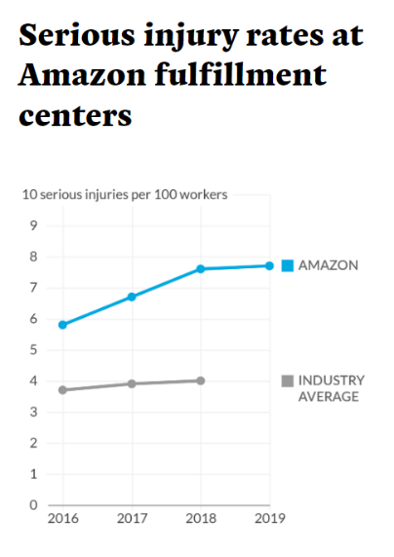
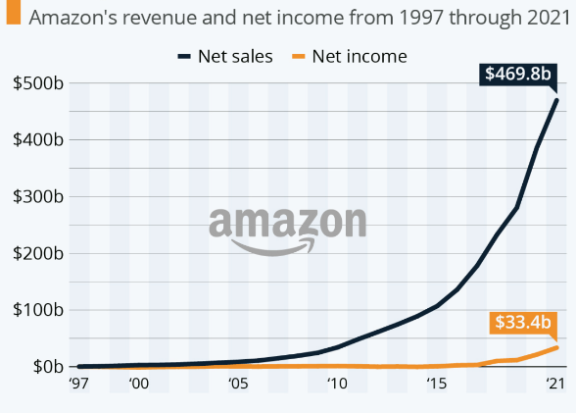
Conforming to the company’s official culture which emphasizes customer obsession and innovation, Amazon’s financial performance has significantly progressed. Amazon’s profits have been increasing enormously in the last 10 years (figure…). The company net sales jumped from under $1bn US in 1997 to almost 470bn in 2021. This significant profitability has been achieved by strong culture that Mr Bezos has created which mainly focus on innovation (Richter, 2021). Amazon’ annual report supported this theory as it clearly stated that the company’s approach to innovation improves customer’s experience and brings incredible value to stakeholders.
Figure 5: How Amazon hit its safety crisis (Evans, 2020)
Figure 4: Amazon’s Incredible long-term Growth (Richter, 2022).
On the other hand, the company non-financial performance has indicated some downsides. According to Scammel (2021), Amazon’s core values prioritize customer satisfaction over its employees’ fulfilment. He further added that Amazon has one of the lowest employee retention rates due to poor working conditions and safety concerns. Similarly, Evans (2020) claimed that employees’ injury increased by 33% between 2016 and 2019 at Amazon warehouses due to the rise implementation of robots (figure 5). All these factors have created ethical dilemmas at Amazon’s workplace and not resolving these issues can affect the company’s efficiency.
Amazon’s ethical dilemmas:
Known also as ethical paradox or moral dilemma, ethical dilemma refers to a conflict between two decisions in which some ethical principles will be compromised. The relationship between organizational culture and ethics is that the organizational culture guides employees when faced with ethical dilemmas, and not following the ethical standards can negatively impact the organization’s reputation and brand image, hence overall performance.
Today, business environment involves a wide array of ethical problems which some of them are covered by law (e.g., sexual harassment, unethical accounting) and others are investigated by the organization management to decide if the behaviour is ethical or not (e.g., abuse of leadership authority). For this reason, it’s crucial for every organization to create a code of ethics which can help building trust between employees and ensuring that the organization is legally operating.
According to Kodiyan (2019), Amazon’s culture involves few moral dilemmas. for instance, the company uses artificial intelligence (AI) systems for recruitment process instead of selecting the candidates by the traditional way. This approach has caused serious questions about how amazon ensures fair hiring of individuals who come from different background or have different gender. Accordingly, the author claimed that amazon’ AI systems often were bias in their selection of candidates in many cases which needed to be corrected to avoid the discriminatory behaviour.
As stated above, employees rise alarming conditions about amazon’s warehouse working conditions. workplace safety lays a foundation for organizational excellence and is considered major aspect of value for human life ethical principle (Johnson, 2012). Evans (2020) claimed that 14,000 serious injuries were recorded in the company’s warehouses. Yet more, amazon’s workers have been constantly complaining about mistreatment and lack of hygiene working environment (Peter, 2021). He further added that Amazon tried to enhance its brand image concerning workplace issues by faking social media accounts. This approach underlines amazon’s unethical culture towards its employees and can create more ethical dilemmas at workplace.

Conclusion:
Powerful and empowering culture is a surer route to organizational success. A strong organizational culture not only can accommodate with all kinds of challenges but helps improving individual and organizational performance. Organizations needs to constantly evaluate their business environments to help identifying key drivers that affect their performance, and to shape their culture accordingly to develop effective strategies which can boost efficiency, improve reputation, and resolve employees’ ethical dilemmas.

References:
Abdeen, M. 2022. Organizational culture: Composition and influences. Available[online]: Organisational culture: Composition and influences - IT Strategy (itpedia.nl).

Abdullah, K. 2021. Amazon Is Still Missing the Mark on Environmental Sustainability. [online]: Amazon Is Still Missing the Mark on Environmental Sustainability | RealClearMarkets.
Amazon. 2022. Annual reports, proxies and shareholder letters. [online]: Amazon.com, Inc. - Annual reports, proxies and shareholder letters (aboutamazon.com).

BBC, 2021. Amazon hit with $886m fine for alleged data law breach. [online]: Amazon hit with $886m fine for alleged data law breach - BBC News

Coos, A. Data Protection Legislation Around the World in 2021. [online]: Data Protection Legislation Around the World in 2021 | Endpoint Protector
Department for Environment, Food & Rural Affairs, 2022. Clean Air Zones. Available[online]: Clean air zones - GOV.UK (www.gov.uk).
Evans, W. 2020. How Amazon hid its safety crisis. Available[online]: Amazon’s internal records show its worker safety deception (revealnews.org).

Gochhayat, J., Giri, V. N. and Suar, D. (2017) ‘Influence of Organizational Culture on Organizational Effectiveness: The Mediating Role of Organizational Communication’, Global Business Review, 18(3), pp. 691–702. [online]: https://doi.org/10.1177%2F0972150917692185.
Goyal, A. 2020. A Critical Analysis of Porter’s 5 Forces Model of Competitive Advantage. JETIR. Vol7, iss7. [online]: A Critical Analysis of Porter’s 5 Forces Model of Competitive Advantage by Anchit Goyal :: SSRN

Johnson, A. Safety ethics: Black and white? Or shades of Gray?. Available[online]: Safety ethics | Safety+Health (safetyandhealthmagazine.com).

Kassem, R. Ajmal, M. Gunasekaran, A & Helo, P. (2018). Assessing the impact of organizational culture on achieving business excellence with a moderating role of ICT: an SEM approach. An International Journal. Available [online]: (PDF) Assessing the impact of organizational culture on achieving business excellence with a moderating role of ICT: An SEM approach (researchgate.net).
Kodiyan, A.A. 2019. An overview of ethical issues in using AI systems In hiring with case study of Amazon’s AI based hiring tool. Available[online]: (PDF) An overview of ethical issues in using AI systems in hiring with a case study of Amazon's AI based hiring tool (researchgate.net).
Mullins, L. McLean, J. 2019. Mullins: Organisational Behaviour in the Workplace. Pearson Education, Limited. Harlow. Available [online]: ProQuest Ebook Central - Detail page
Onyusheva, I. V, Seenalastaporn, T. 2018. STRATEGIC ANALYSIS OF GLOBAL E-COMMERCE
AND DIVERSIFICATION TECHNOLOGY: THE CASE OF AMAZON.COM INC. journal on global socio-economic dynamics”. Vol 1. Iss8. [online]: https://www.euraseans.com/1(8).

Peter, B. 2021. A Closer Look at Amazon: Are Unethical Working Conditions on the Rise?. Available[online]: A Closer Look at Amazon: Are Unethical Working Conditions on the Rise? - The Geopolitics.
Richter, F. Amazon's Incredible Long-Term Growth. Available[online]: • Chart: Amazon's Incredible Long-Term Growth | Statista.
Sainato, 2020. ‘I'm not a robot’: Amazon workers condemn unsafe, gruelling conditions at warehouse. [online]: ‘I'm not a robot’: Amazon workers condemn unsafe, grueling conditions at warehouse | Amazon | The Guardian.
Stone, B. (2013). The Everything Store: Jess Bezos and the Age of Amazon. Transworld. United Kingdom.

UKEssays, 2018. Potters’ 5 Forces Analysis and Guides. Available[online]: Porter's 5 Forces Analysis Guide (ukessays.com).

Reflective journal of my learning experience (Gibbs reflective cycle)
Description:
I found the module very informative and involved various elements that can improve students’ skills which are core elements to become a successful manager. For instance, the module critically discussed the importance of understanding the workplace culture and analysing its external environment in order to create strategies which can improve the organizational financial and non-financial performance. Accordingly, the module highlighted few management models and theories that can be used to identify the external forces which may affect the organizational culture such as PESTEL, SWOT, Potters’ five forces, and WEB cultural models. Also, I was introduced to various types of organizational structures and their relationships to workplace culture. The culture dictates how the organization should be structed, while structure is a model how the culture should be implemented (Janicijevic, 2013).

The module was informative and precise by examining the key factors that can create and sustain a successful culture such as hiring professionals who believe with the organizations’ founder and socializing the organization’s values and attitudes to new employees. Also, it explained the relationship between the ethical behaviour of organization and its performance by giving examples of organizational ethical dilemmas facing modern business such as sexual harassment and corruption.

Feeling:
I experienced a mixture of feeling throughout the course of study. I was annoyed that I could not attend the university and meet face to face my classmates due to personal circumstances as i missed the feeling to socialize and exchanging opinions which I consider paramount to improve my skills and knowledge. Also, the virtual learning was effective and smooth but lack of socializing and communication affected my excitement. This feeling supported the arguments of Arkorful and Abaidoo (2015) who claimed that Difficulties in communication and lack of conditions for developing social interactions skills are among the limitations of eLearning

Moreover, I felt confused and off track in the middle of the term. I found myself less focused on the subjects and not engaged with the class. After making some research, I realized that pressure of the assignments created stress and discomfort. Exam pressure can affect academic performance (Deb et al,. 2015). in fact, I remembered the lecturer mentioning that 5000 words essay requires maximum 3 days. This statement increased the anxiety and make me think that I needed to improve my writing skills immediately. Nevertheless, the negative feeling faded gradually as I started to get back to the teaching recording which helped me taking important notes and examine further theories concerning all subjects. Once I completed the report, I felt that i gained great knowledge that not only could help me with the assignment but also future career.

Evaluation:
The learning the module of workplace culture and its impact on organizational efficiency was enjoyable and challenging. The module was more applicable than theoretical as students needed to understand and apply tools and techniques which can help them critically identify and accommodate with the culture of their future jobs. Although I was familiar to using PESTEL and Potter’s five forces models, introducing WEB cultural technique added more knowledge of business environment analysis. Also, the module included various theories related to organizational performance such as Beer’s model, McKinzies’s Organizational health index, and Hennan and Freeman’s theory. Understanding and implanting these models helped me to recognize the barriers that could affect organizational performance and acknowledge the key attributes to sustain an ethical culture.

Analysis:
The whole module took 10 weeks to be completed. The learning was gradually progressed from week to another. staring from the first week, it was important to define the meaning of organization, culture, structure, and external environment. This approach enabled me to fully understand the topics and gradually advance in my learning.
Also, it’s important to mention that using case studies, class activities, and videos facilitated the learning. for instance, Specsavers’ case study highlighted the positive impact of hierarchical structure and the implementation of both centralization and decentralization approaches on the efficiency of the company.

Looking back at the PowerPoints of the module, I recognized the lack of referencing slides in most of them. It would be helpful to put links of the sources from where the charts and graphics are obtained to assist students in finding reliable sources which can be included in their assignments. Also, adding more in-class activities can be beneficial for students. Students group work can improve students’ understanding about their learning and develop personal and academic skills such as communication and critical thinking which are paramount for career development (McDonald, 2020).

One important thing I need to highlight is the assessment’s requirements. The module entails significant theories and models that need to be critically assessed.
I found it hard to include everything in 3500 words, therefore, I fairly think that increasing the number of words is needed.

Conclusions:
This module has made me realize the relationship between the workplace culture and the organizational efficiency. Creating and sustain a successful culture involves a wide array of elements. For instance, sharing organizational core values with new workers and helping them during the socialization process can facilitate their engagement which can accelerate their performance. Also, a constant evaluation of the external forces that may affect the culture by using industrial tools is necessary to sustain the values and attitudes of organization. Another vital approach to improve effectiveness and sustain culture is identifying barriers and obstacles which are preventing the organizations’ adaptation to change such as poor management or unethical cultural behaviour.

Plan of action:
Several things were learned from learning this module. For instance, attending classes at university will be top priority as the environment is more enjoyable and effective. Also, learning all the module’s theories and techniques has improved my knowledge of managerial skills such as research, critical thinking, and effective analysis. These skills will be very useful to improve my current business strategies and future goals. My business performance has negatively impacted in the last two years. An implementation of external business analysis and organizational health questionnaire will broadly help me identify the weaknesses and the key factors affecting the business overall performance.

References:

Arkorful, V. Abaidoo, N. 2015. The role of e-learning, advantages and disadvantages of its adoption in higher education. international Journal of Instructional Technology and Distance Learning. vol 12. No1. Available[online]: Jan15.pdf (itdl.org).
Deb, S. Strodl, E. Sun, J. 2015. Academic Stress, Parental Pressure, Anxiety and Mental Health among Indian High School Students. International Journal of Psychology and Behavioral Sciences. 5(1), pp 26-34. Available[online]: Academic+stress+of+school+students+2015.pdf (qut.edu.au).
Janicicevic, N. 2013. THE MUTUAL IMPACT OF ORGANIZATIONAL CULTURE AND STRUCTURE. Economic Animals. Available[online]: http://www.doiserbia.nb.rs/img/doi/0013-3264/2013/0013-32641398035J.pdf.

McDonald, L. 2020. Benefits of Group Work. Available[online]: Benefits of Group Work - TeachHUB.

