HOMETOWN ARCHITECTURE
KEIRAN THOMAS
1650739

Context and Historical Background

Within Llanelli an abundance of prominent architectural identity is located, the two standouts, from a personal perspective, are the grade one listed, early Georgian townhouse Llanelly House. Built in 1714 by Sir Thomas Stepney with restorative efforts by Carmarthenshire Heritage Regeneration Trust, completed in 2013. (Comisiwn Brenhinol Henebion Cymru, 2021) In contrast, the grade two streamline moderne and art deco, Theatr Elli or Old Odeon Cinema built in 1938 by Harry Weedon (Comisiwn Brenhinol Henebion Cymru, 2021), currently under restoration by Calon Llanelli Ltd. (Ratti, 2021) Both are located in the town centre and represent the ever growing change and reminiscence of the past of the town, warped from a community driven and lively town centre in the eighteenth century, the aftermath and glamour of post-first world war Britain through the art deco movement in the twentieth century, to the twenty-first century shops relocating to retail parks and social activity is now essentially desolate. Emphasising the poverty stricken and the anti-social dilemma that has engulfed the town. (Welsh Assembly Government, 2020) This essay will explore the juxtaposition of both sites through two historical points in architecture, and the unique styles they individually represent in the placement of modern-day Llanelli.

On-Site Visit and Analysis;
Llanelly House
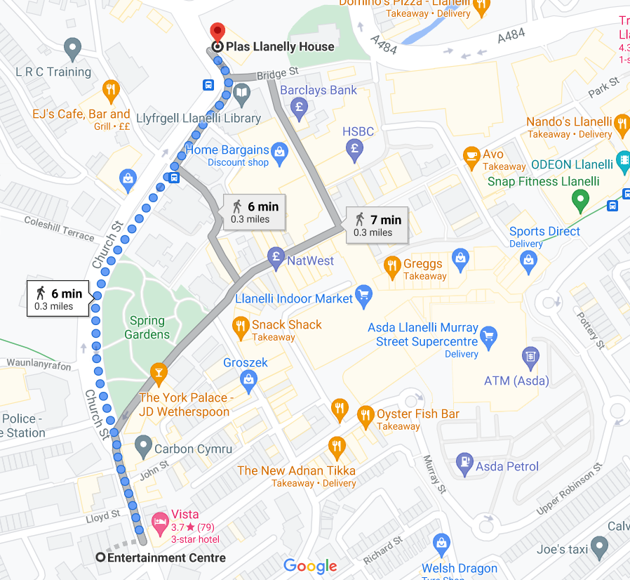
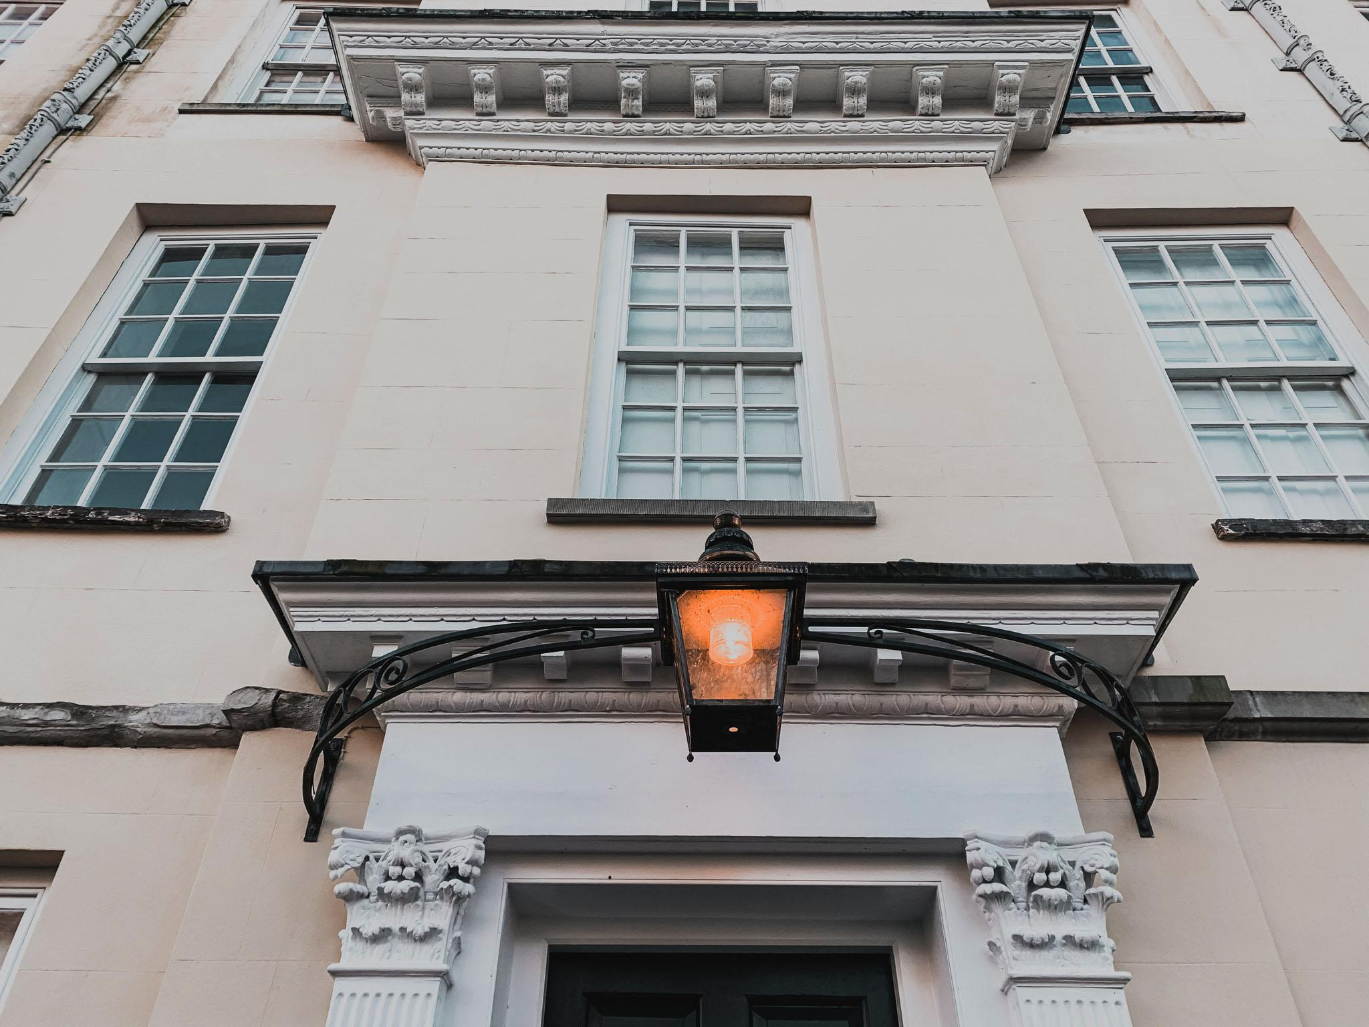
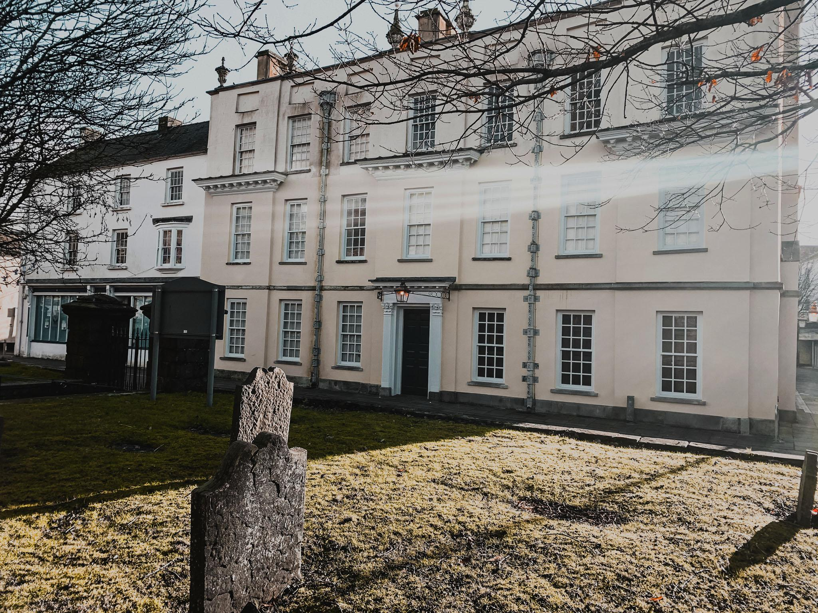
Georgian architecture, which Llanelly House boasts is considered ‘the most outstanding domestic building of its early Georgian type to survive in South Wales’ (Hatto, 2011). The uniqueness of Georgian architecture is through the influence and imitation of Palladian styles. The journey and development of the style through the architects Andrea Palladio (1508-1580), Colen Campbell (1676-1729) through to James Gibbs (1682-1754) and then considered the most influential architect of the era Inigo Jones (1573-1652). The glimpses of Romanesque architecture are slightly visible but are constrained to a simplistic nature. (Summerson, 1993) Through the eyes of my childhood, it has seen the disrepair and the ultimate despair, in which the house was reflecting back into the community and the community back to the house. This mirrors the sustained social and economic decline of Llanelli town, which now has hit rock bottom. (Welsh Assembly Government, 2020) Yet in the now, it emphasises an ironic tone of certain elegance and prestige which cannot be said for the surrounding area. Possibly this will inspire a much-needed reform in the town through future architects and developers in the hands of Carmarthenshire Council.

Figure 1.a On-site Photography © Keiran Thomas Figure 1.b

The identity of classic Georgian architecture, symmetry, balance, and proportion (Hocker, 2000) is most prevalent here from the front facade. (figure 1.a) The specific detail of each element must conform to the rules of Georgian architecture, as with each townhouse the design principles are identical or similar as elaborated by the presence of Inigo Jones. (Summerson, 1979) The front doors’ decorative characteristics follow ancient Greek and Roman architecture with a Roman Doric pilaster on either side and a pediment and entablature feature, architrave, and cornice. (Summerson, 1993) An elaborate fanlight stretching over the frame is also present. (figure 1.b) Stock bricks create the facade as they are typically yellow in colour from the yellow clay used, most likely transported from London as that is the Stepney family origins. (.gov et al, 2021) Atypically the long, rectangular windows do not seem to feature a window arch, possibly hidden behind the facade as you can get an arch that is flat, not necessarily arched in shape. (figure 1.c)

The influential presence of Inigo Jones within the eighteenth century.
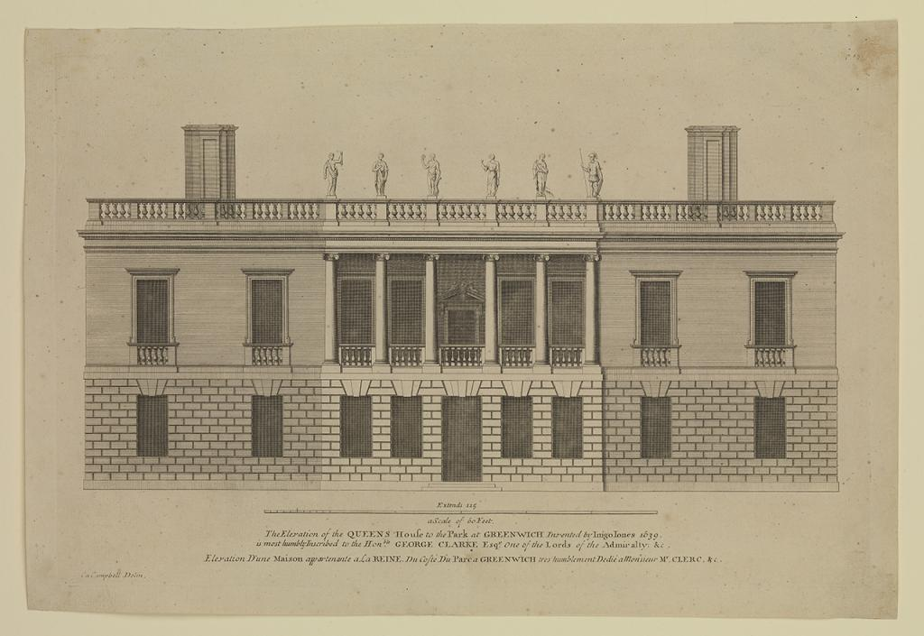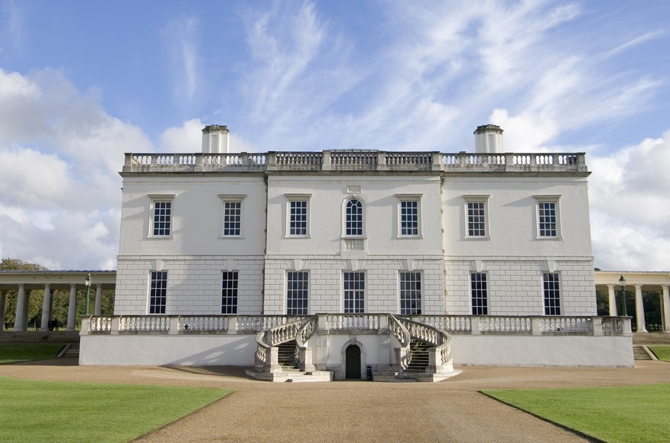
Figure 2.a (Royal Museums Greenwich, 2021) Figure 2.b (Architect Magazine, 2016)

The sleek and consistent proportions are based on squares, three window bays wide, the space between the first and second floor form a square. At the center of the house, the windows are vertically parallel with the front door. An atypical sill band is present just below the first floor windows, as a sill band usually connects each window sill together, presumably a decorative preference from Stepney himself. On the second floor, there are three separate cornices below the windows. Above the second floor, windows appear to be an indent or possibly a third measurement of a blind window. In addition, there is an approximate eighteen-inch parapet wall with a cornice, this makes the appearance of a flat roof, which relates back to the precise symmetry desired by Georgian architecture. (figure 1.a)
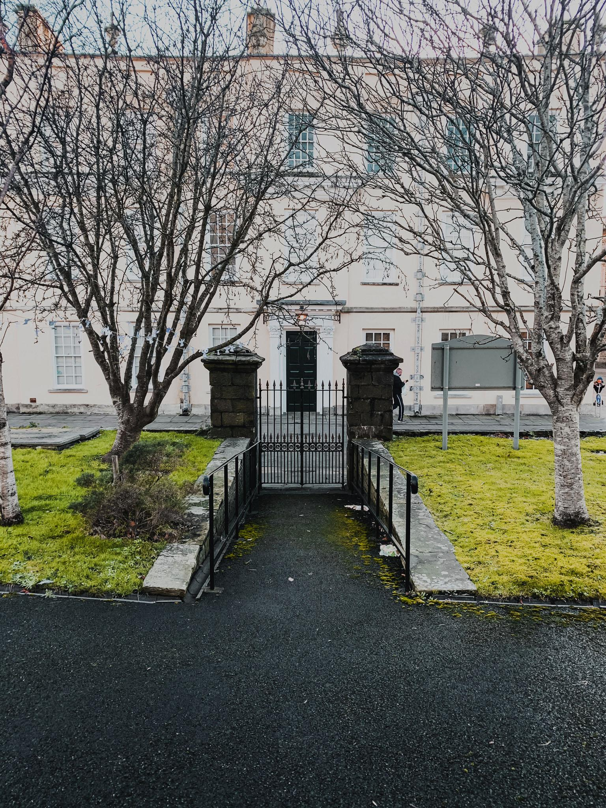
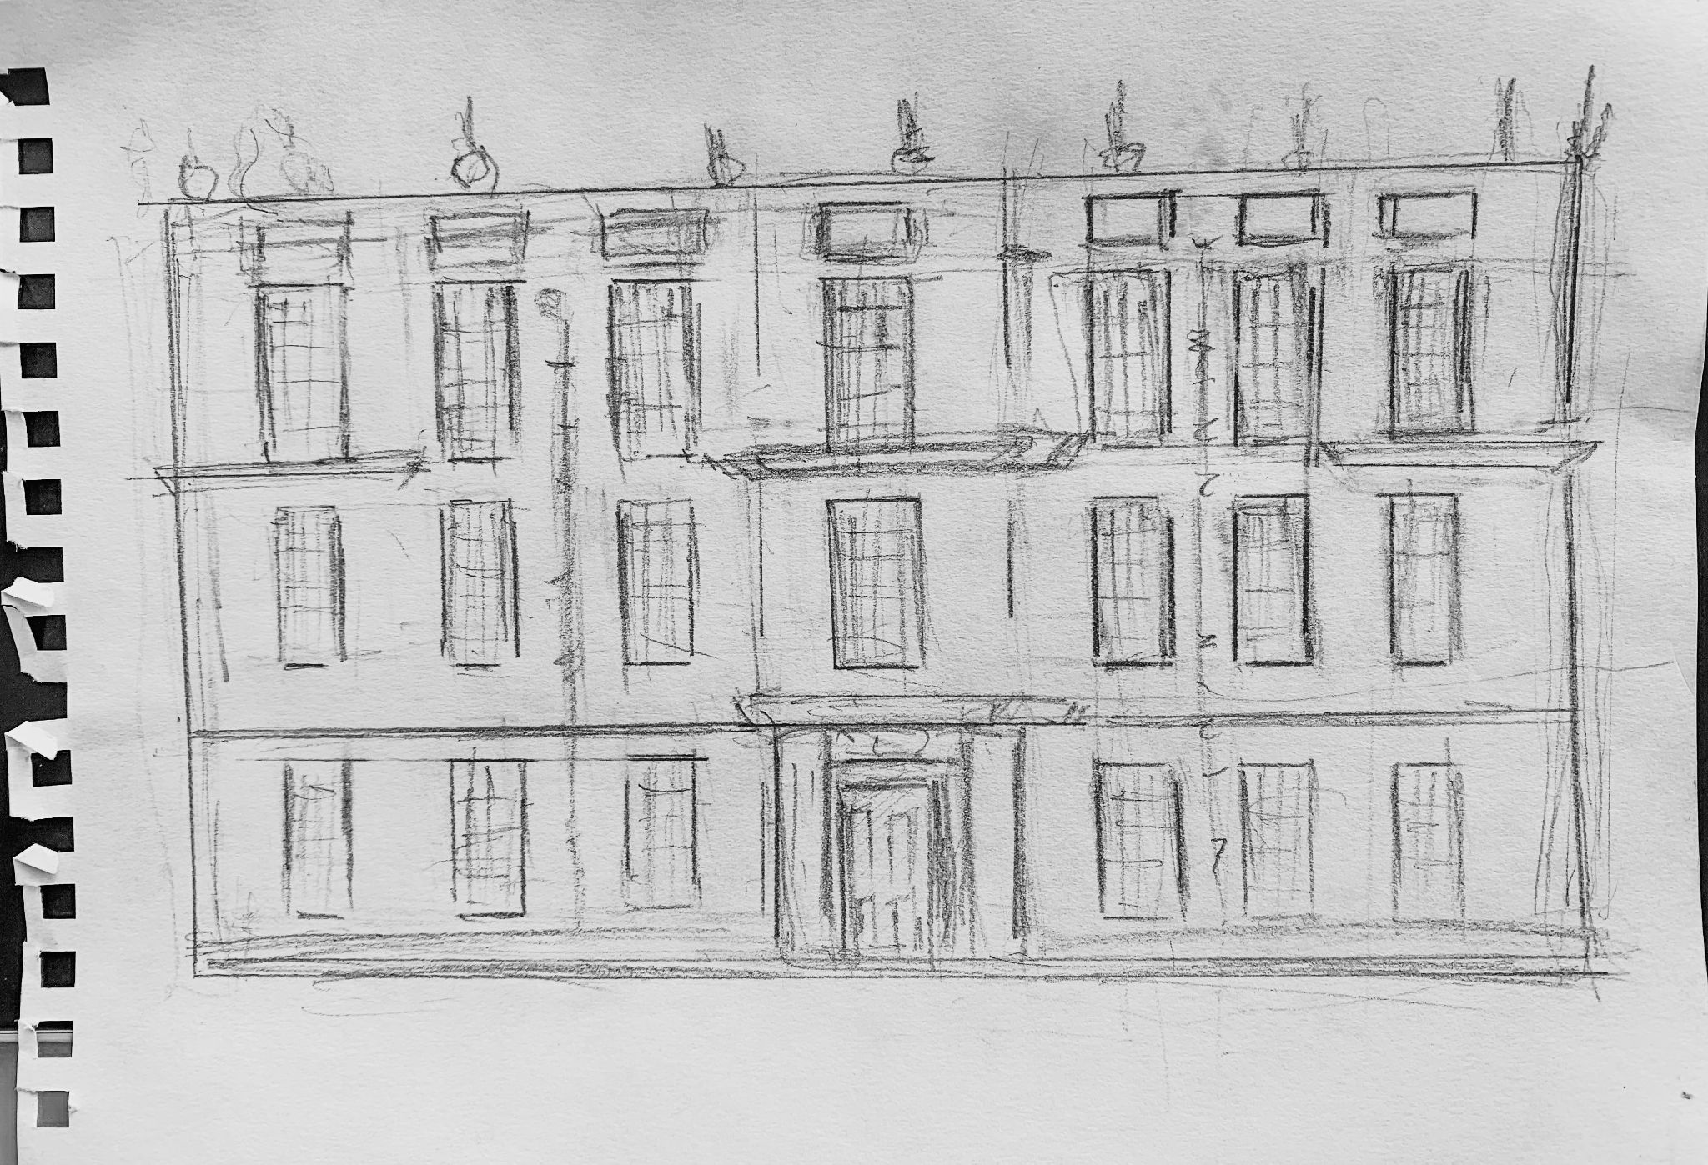

Figure 1.c, 1.d, © Keiran Thomas

Plans, Sections, and Elevations for Llanelly House
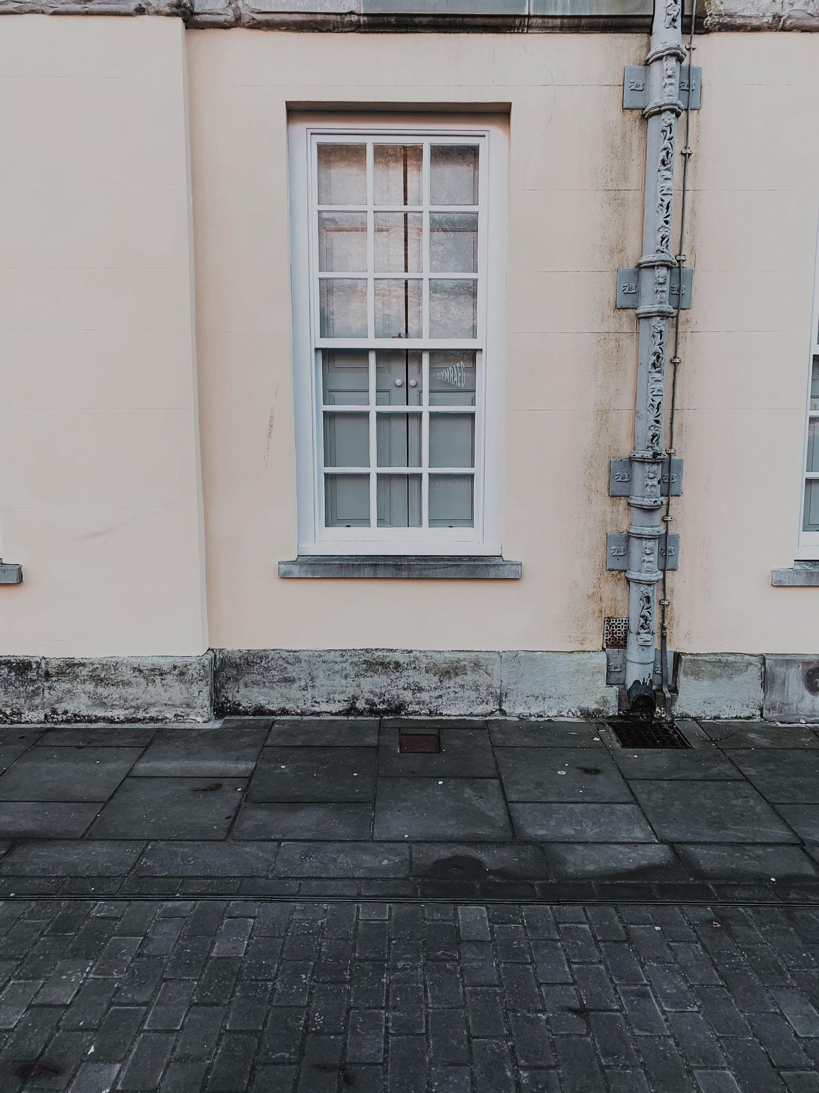
Furthermore, through analysis of these elevations’ pre-restoration, the unique characteristics of each element are emphasised. The understanding of how houses functioned to accommodate the specific needs of the wealthy, whereas today it is utilised as a Bistro, Event Space, and Wedding Venue. (Carmarthenshire Heritage Regeneration Trust, 2021) These elevations are pre-restoration. Provided by Richard Scott Davies through Archeology Wales.

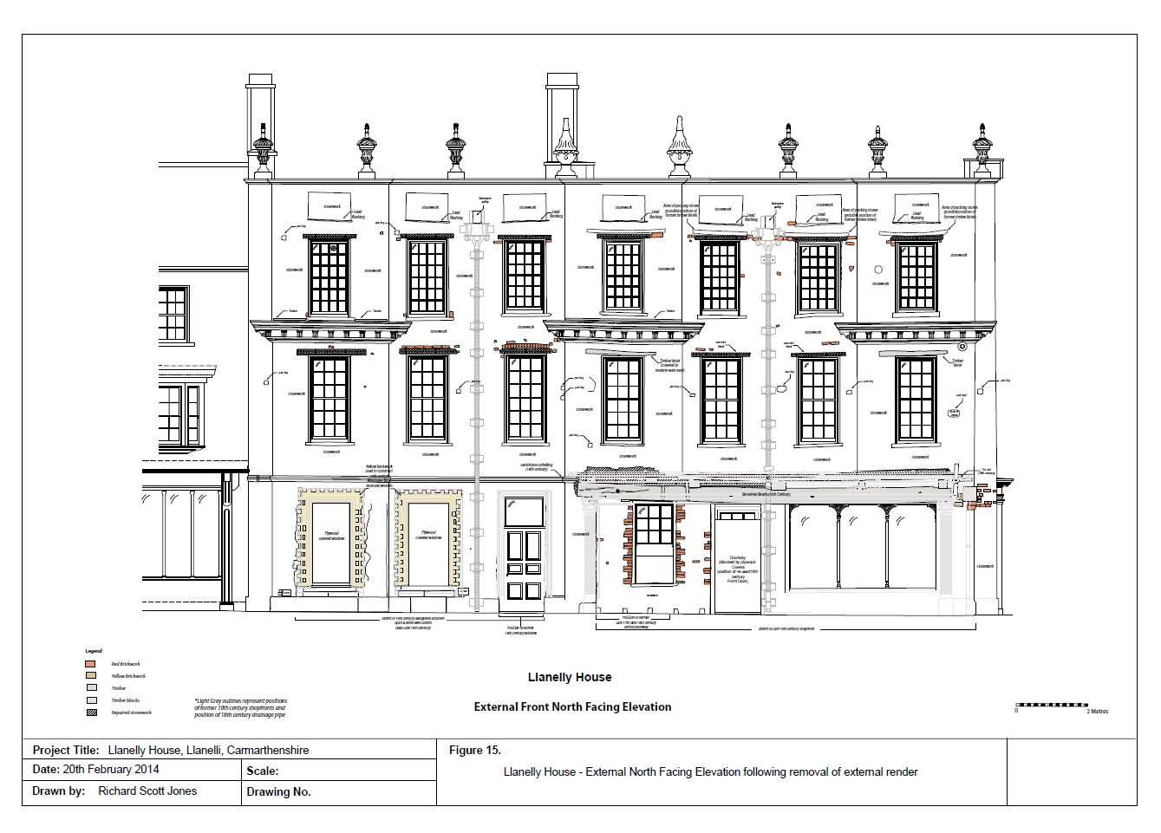

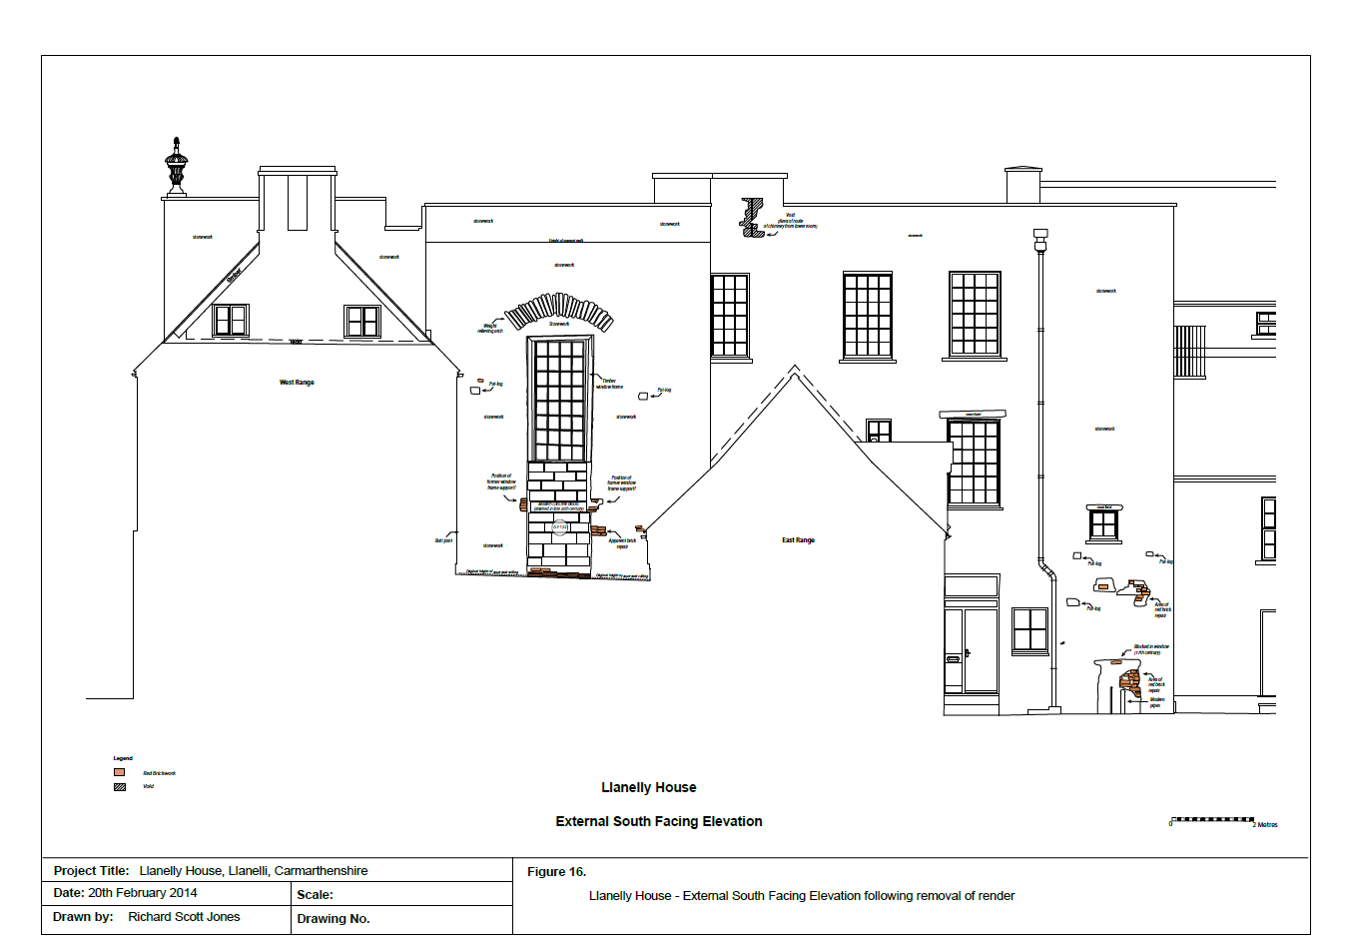
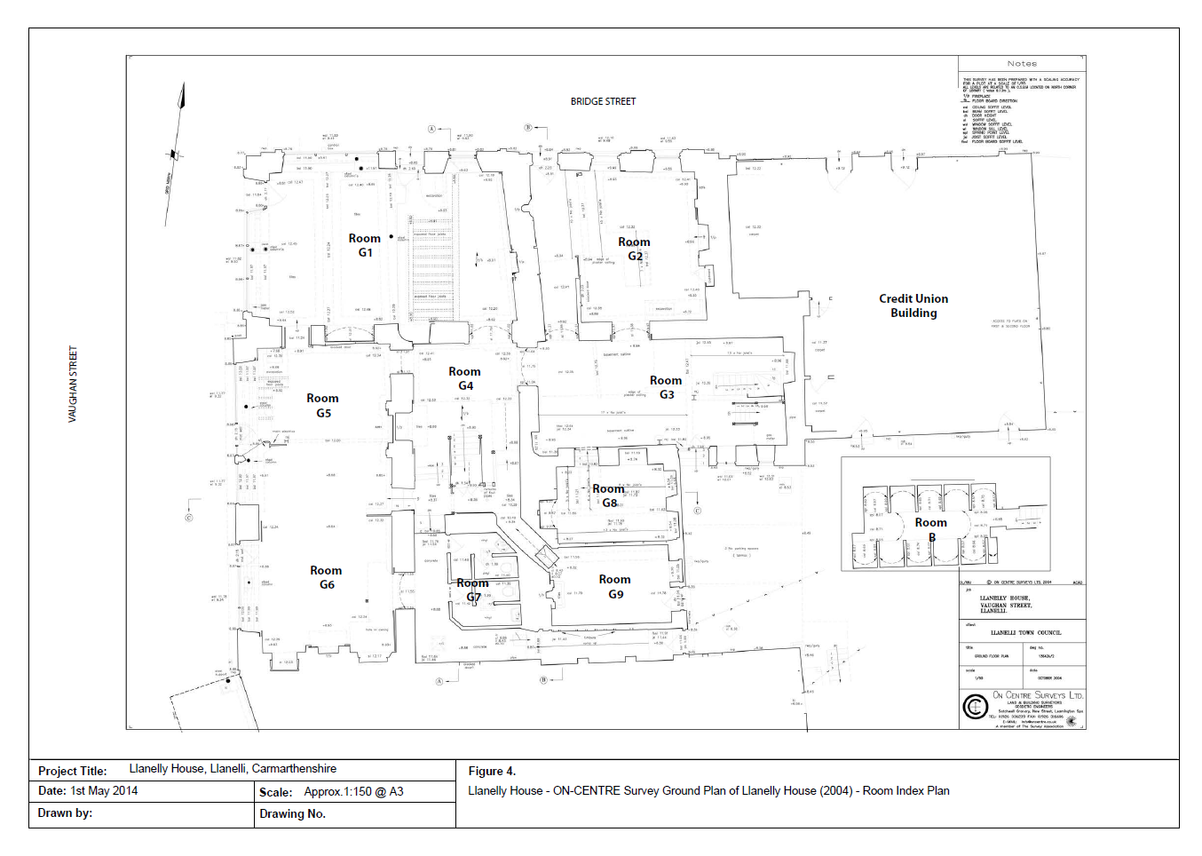
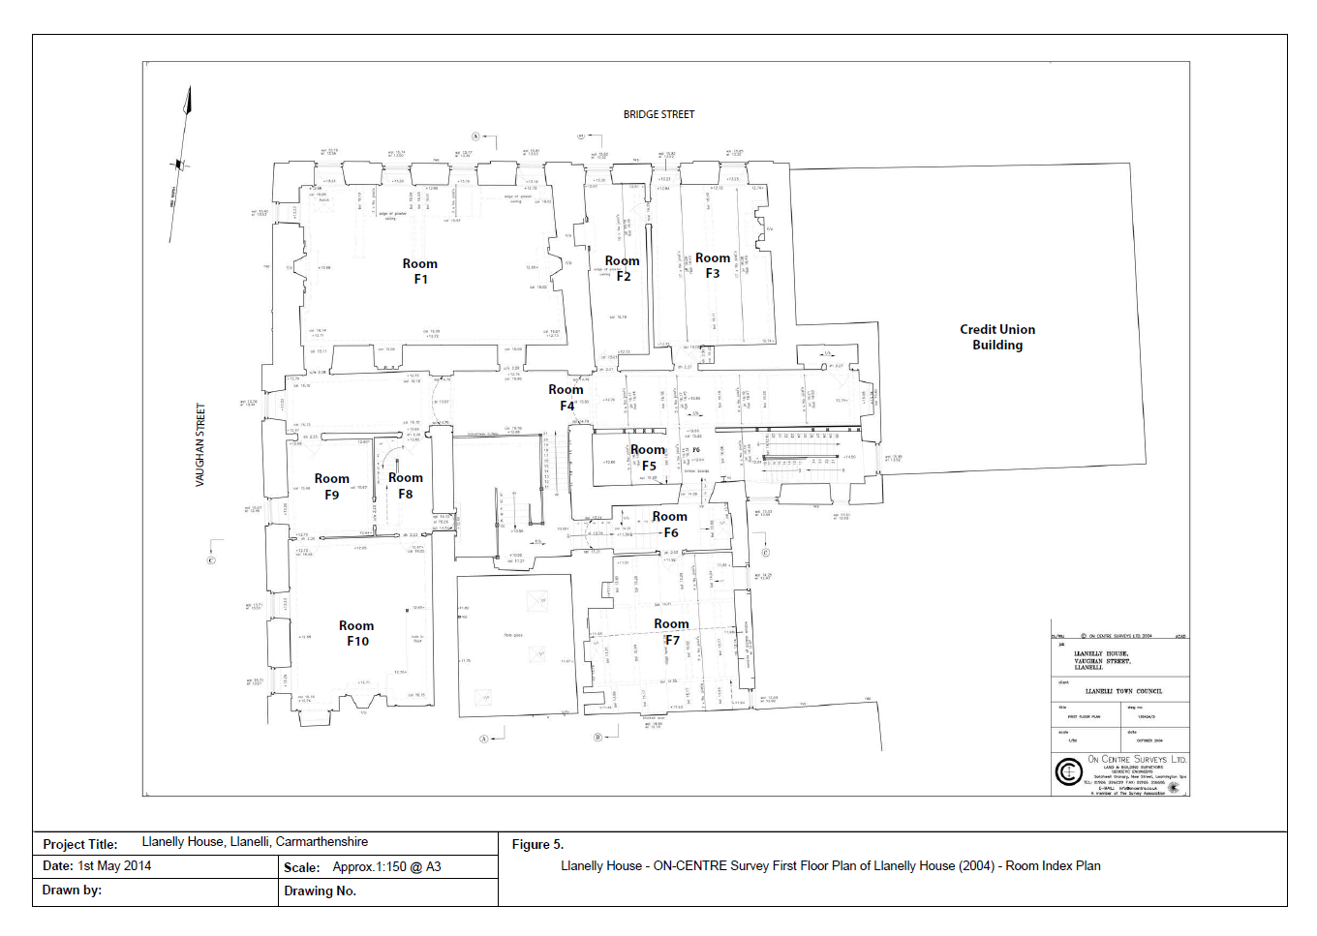

Theatr Elli

The prevalent juxtaposition of the Old Odeon Cinema represents the glamour art deco desires whilst also emphasising how two sophisticated buildings are situated in a town full of neglect. In the modern-day, it is showing age from the facade to within, through time, but still has a certain charm and elegance about it. The sleek white tile contrasting with the black and green emphasises a Bahaus inspired production. (figure 2.1) Defiantly, the Bahaus was reluctant to give art deco any credit, the result of possibly the manipulation of pure solid form against functionalism. (Philadelphia Museum, 2021)

The shapes are reluctantly in harmony with each other until the perspective changes and the oval shape of where the staircase resides is seen. The disruption of seemingly a systematic square design with curved ornamental elements evokes what art deco is. Art deco evolved from the first world war, the utopian nature of what human loss can evoke. (Benton, Benton, and Wood, 2003)

Comparison of Photography;
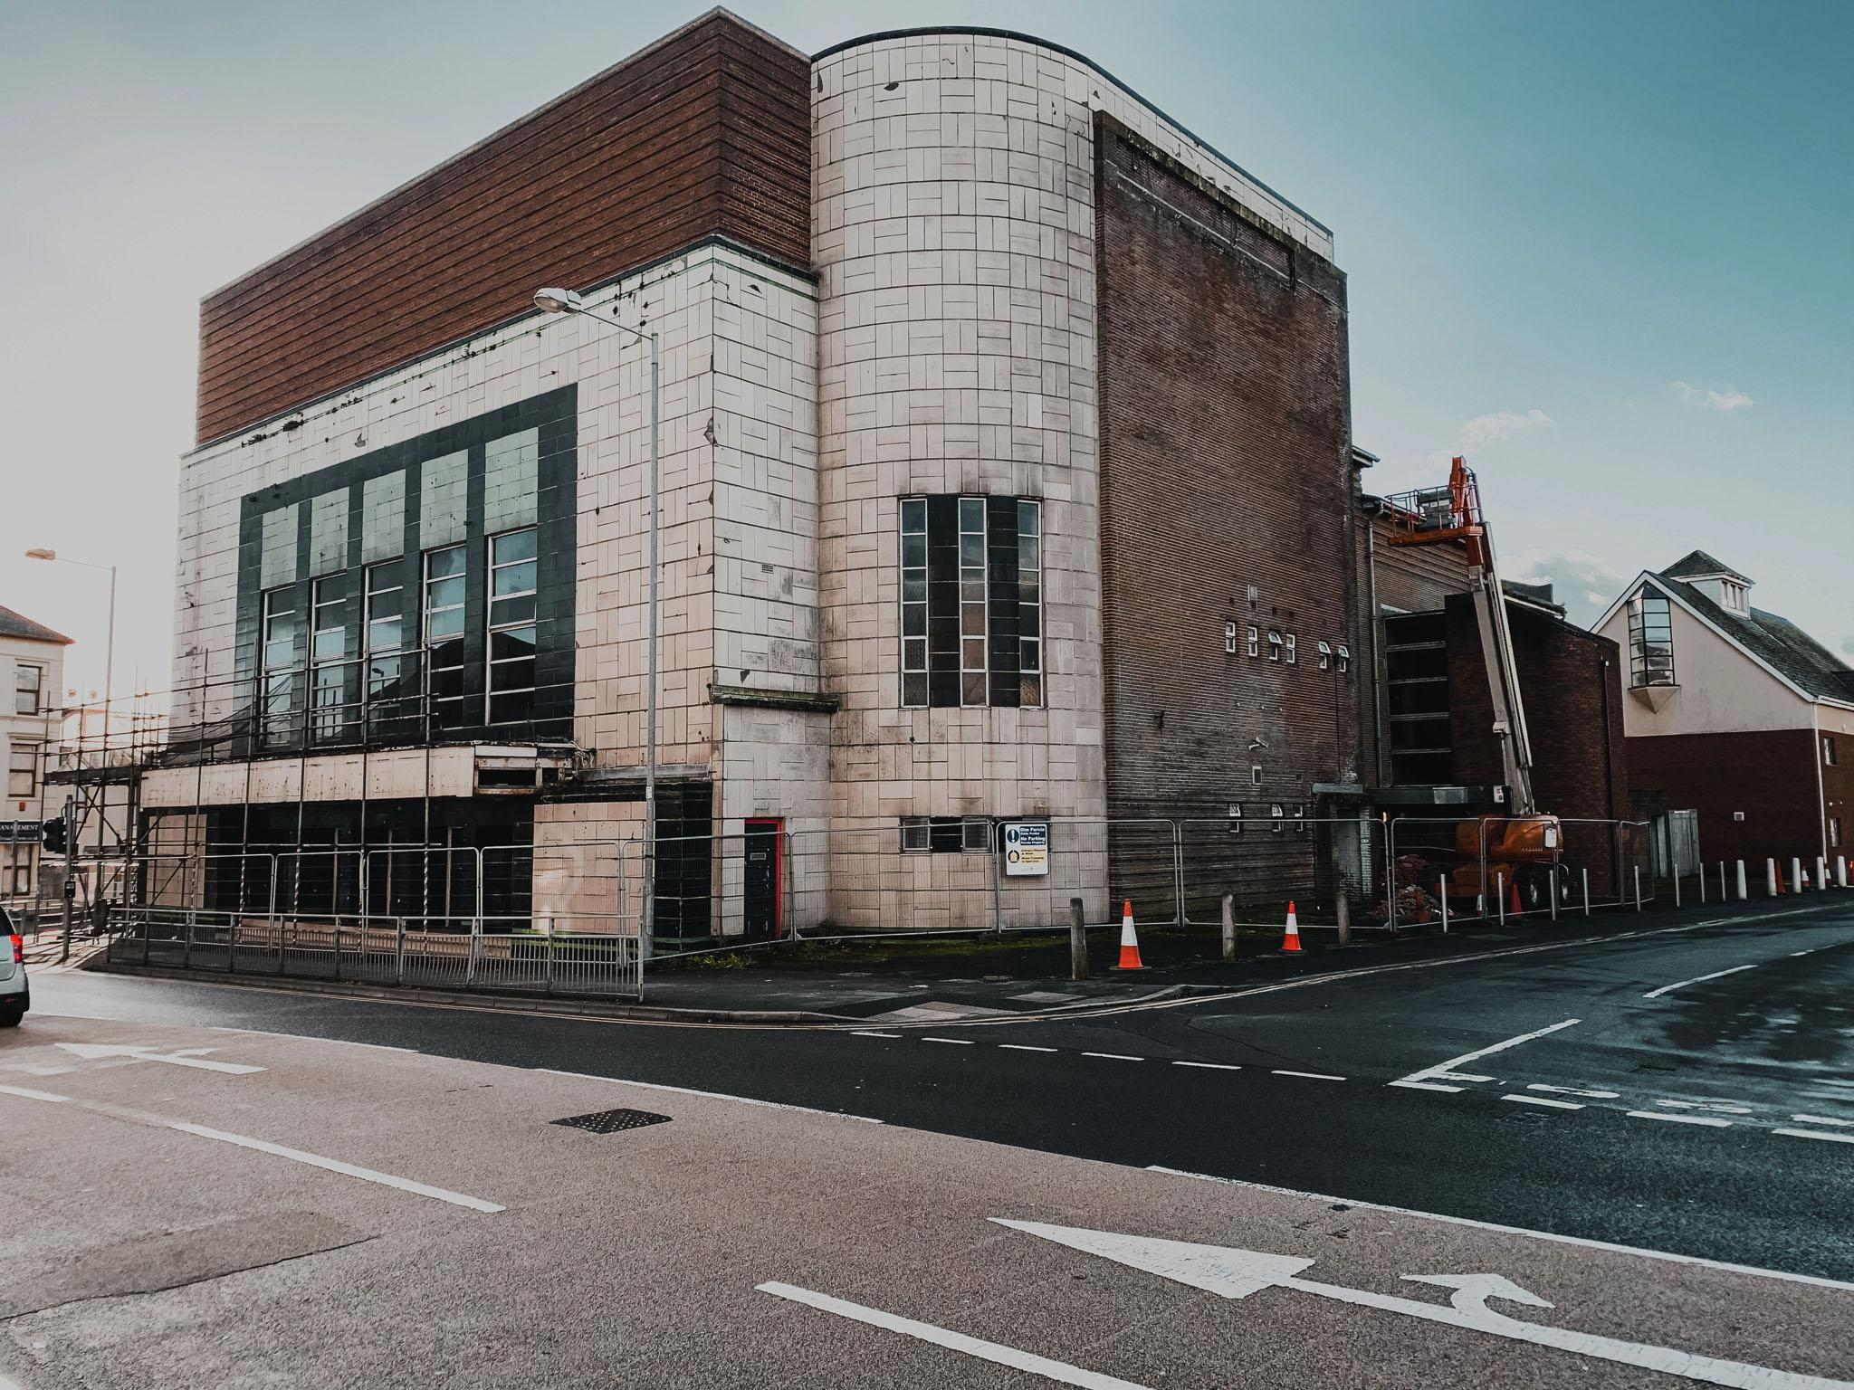
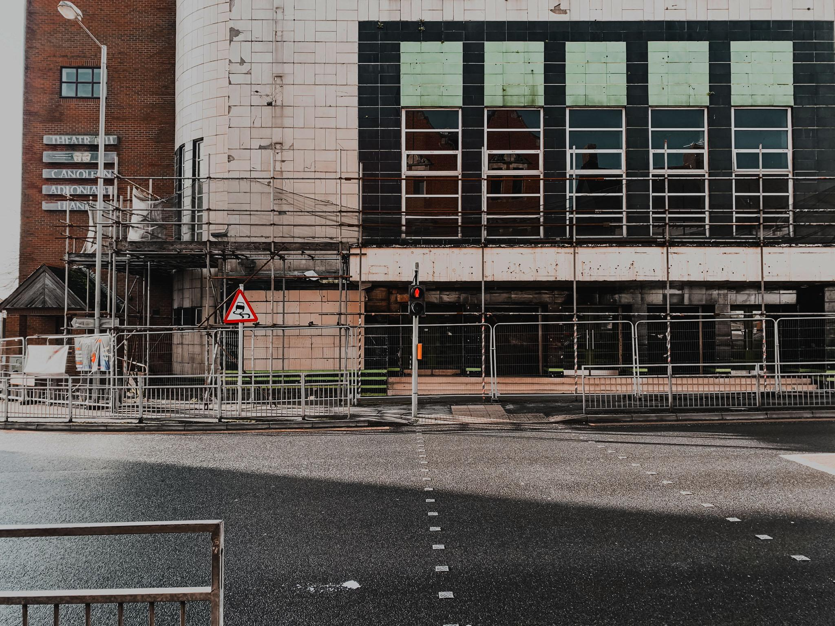
Figure 2.a On-site Photography © Keiran Thomas Figure 2.b
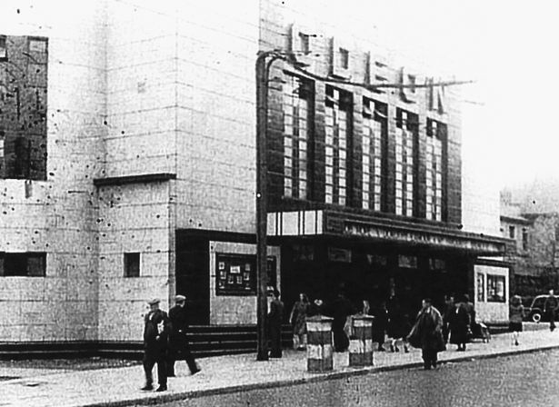

Figure 2.c Courtesy of © Calon Llanelli Ltd. Figure 2.d

The windows are arranged in continuous horizontal bands of either square and rectangular shape. (figure 2.c) The aesthetic of disrupted symmetry is again emphasised where the curves are asymmetric on either side

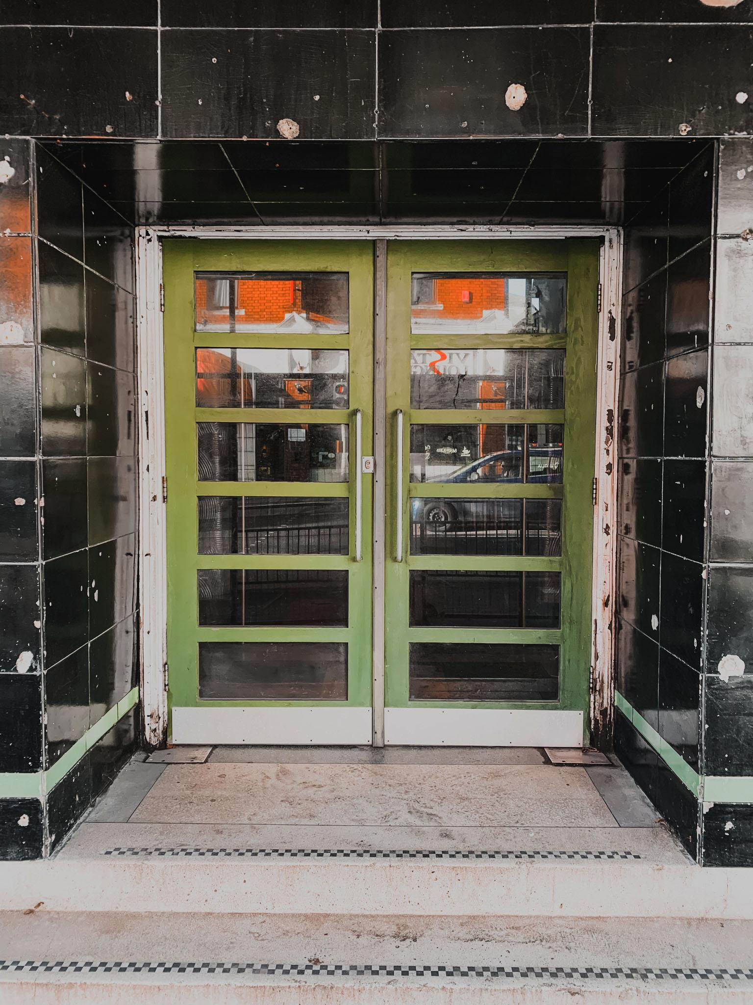
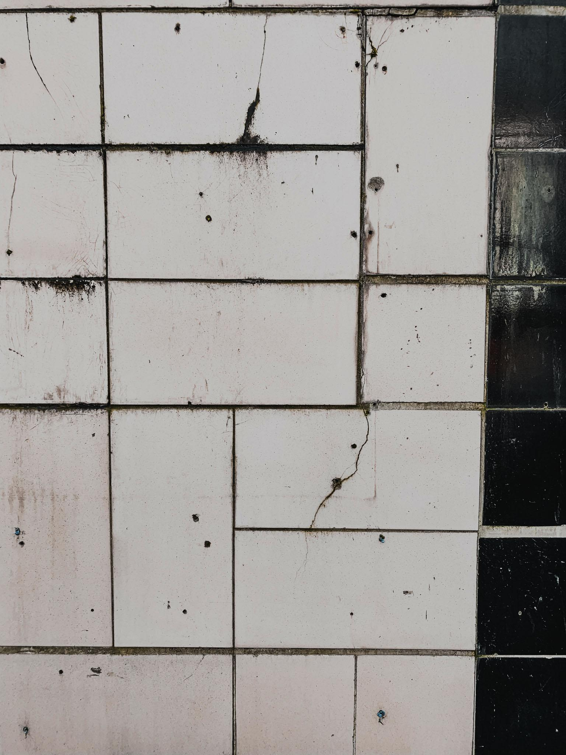
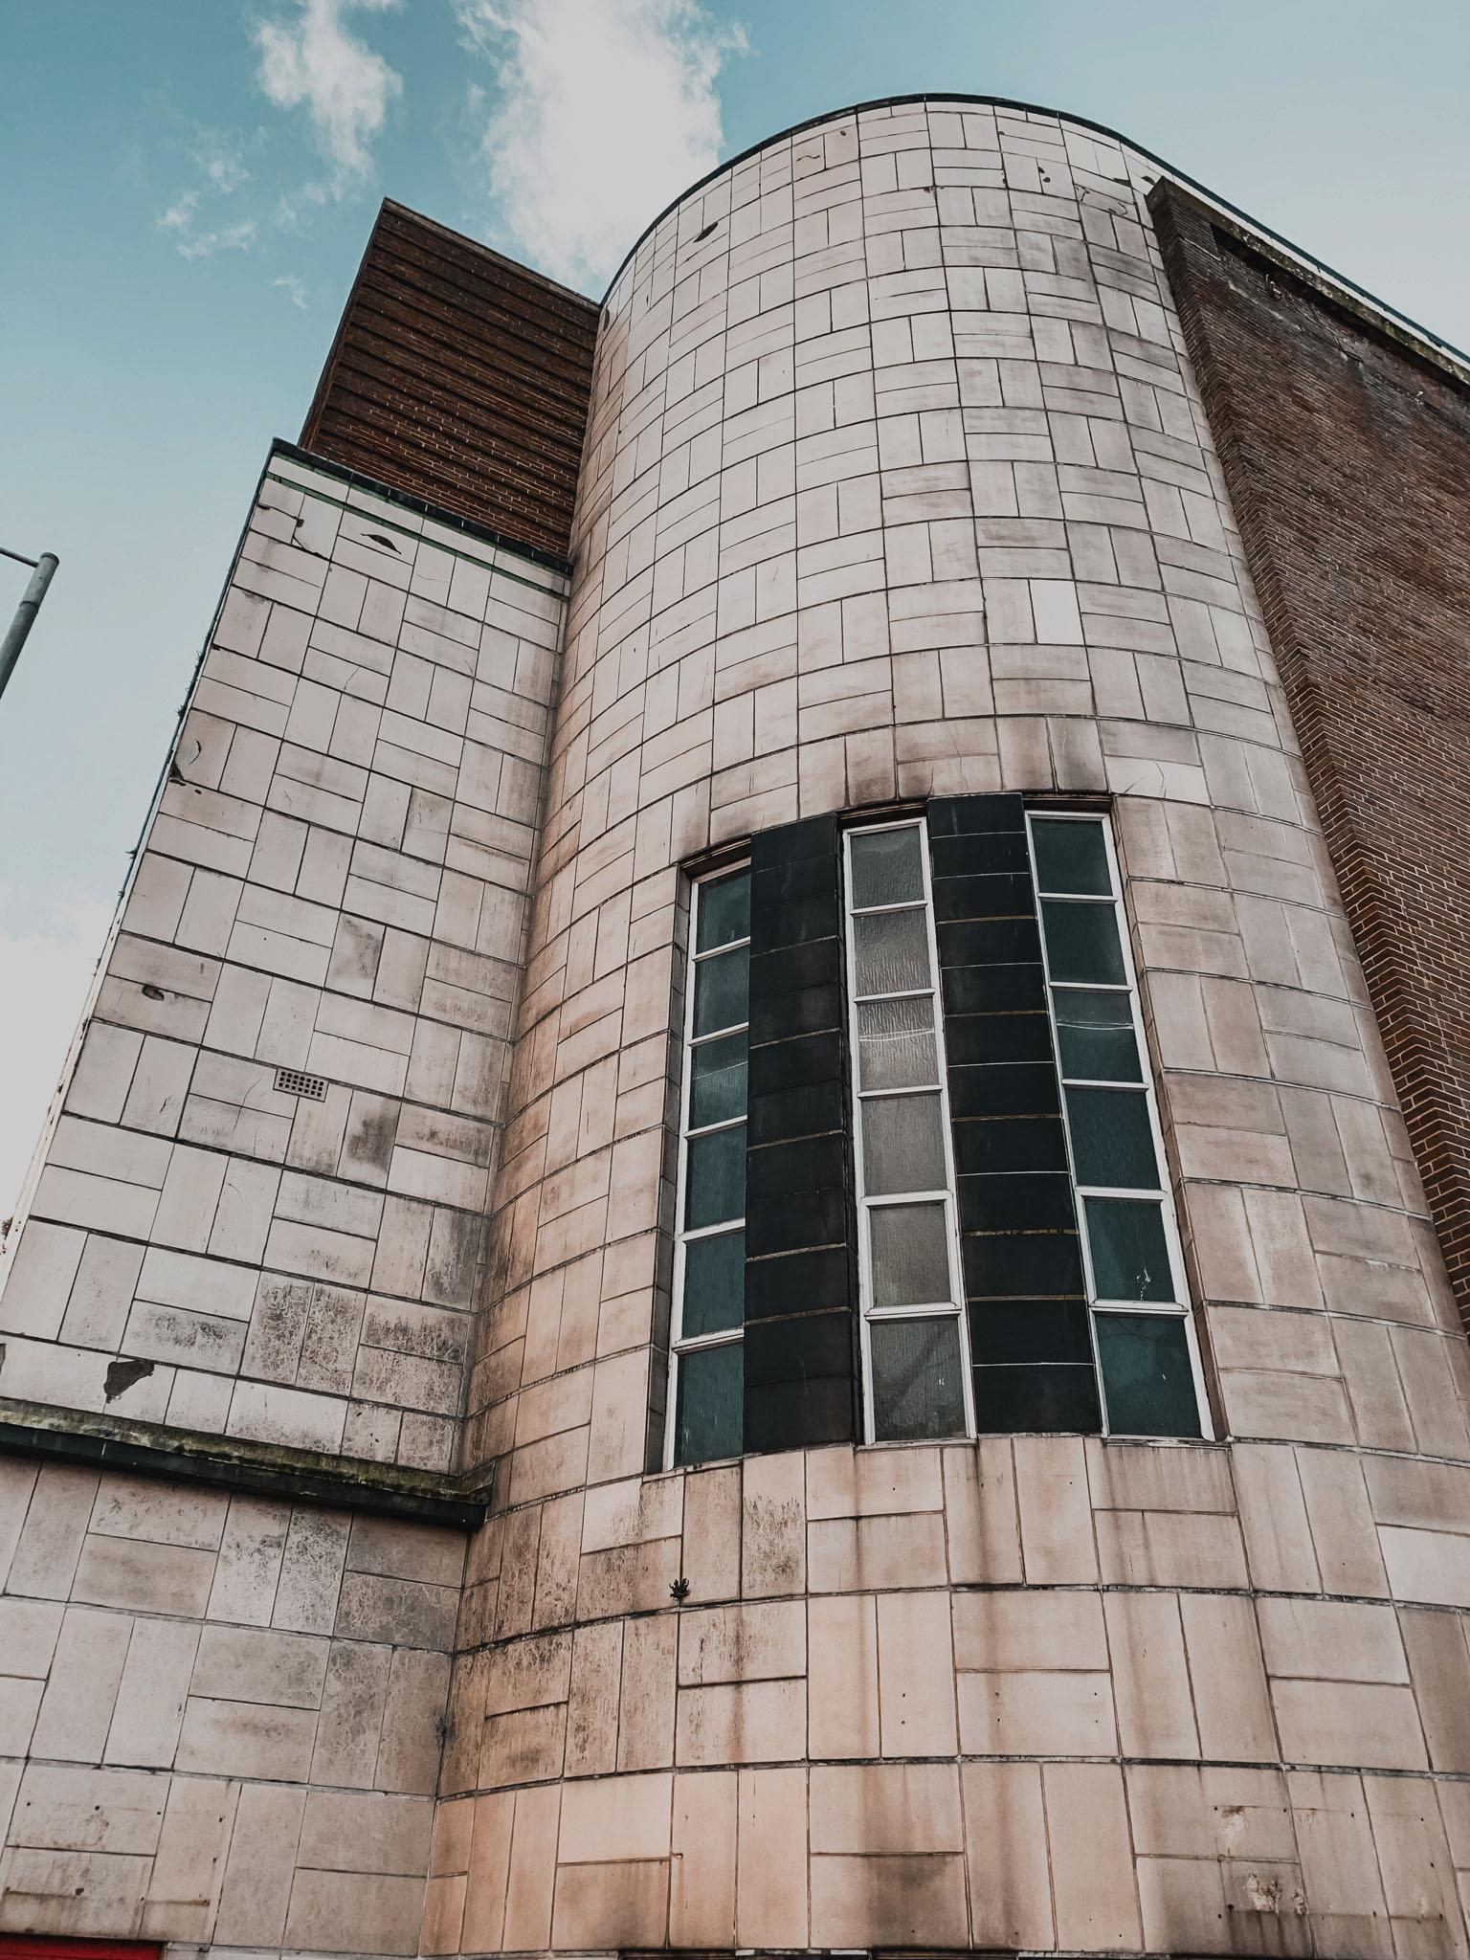
On-Site Photography © Keiran Thomas

Plans, Sections, and Elevations of Theatr Elli

Courtesy of Calon Llanelli Ltd.

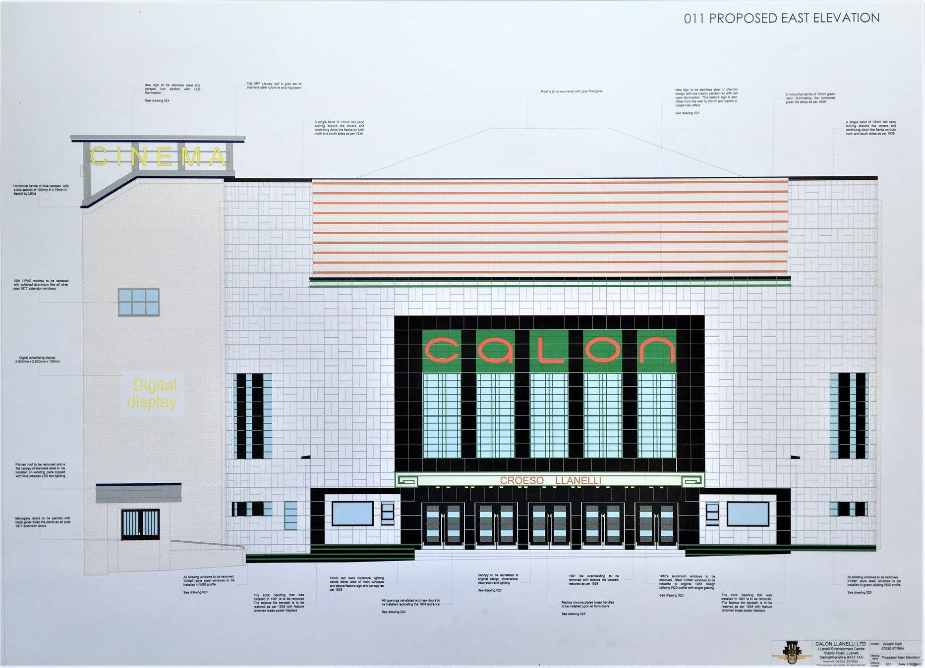

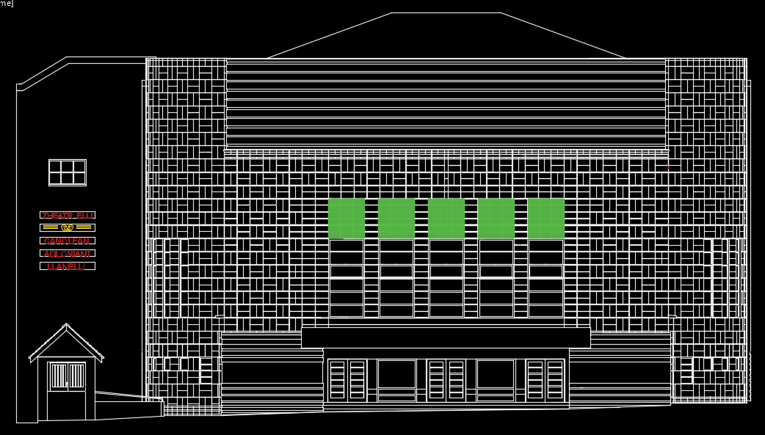

Conclusion
In conclusion, the realisation of how all architecture has a journey and is slowly connected through each architectural era, morphing from one characteristic to the next, is inspiring to see how we can influence and learn from each other. Architecture is first and foremost the most influential art form around us. It is unfortunate that in the now Brutalism and Modernism is prevalent over a more dramatic and artistic direction. To challenge Corbusier’s ‘a house is a machine’ narrative is the duty of future architects, and it will be exciting to see how we progress in the modern era.

Keiran Thomas

References.

.gov et al, 2021. Cowell-Stepney family, baronets, of Llanelli | The National Archives. [online] Discovery.nationalarchives.gov.uk. Available at: <https://discovery.nationalarchives.gov.uk/details/c/F20238> [Accessed 14 April 2021].
Architect Magazine, 2016. Queen's House Restoration. [image] Available at: <https://www.architectmagazine.com/project-gallery/queens-house-restoration_o> [Accessed 15 April 2021].
Benton, C., Benton, T. and Wood, G., 2003. Art Deco: 1910-1939. 1st ed. London: V&A Publications.
Carmarthenshire Heritage Regeneration Trust, 2021. Visit Llanelly House. [online] Llanelly House. Available at: <https://www.llanelly-house.org.uk/visit/> [Accessed 15 April 2021].
Comisiwn Brenhinol Henebion Cymru, 2021. Llanelly House. [online] Coflein. Available at: <https://coflein.gov.uk/en/site/17510/> [Accessed 15 April 2021].
Comisiwn Brenhinol Henebion Cymru, 2021. Theatr Elli, Station Road. [online] Coflein. Available at: <https://coflein.gov.uk/en/site/409221/> [Accessed 15 April 2021].
Hatto, C., 2011. £6m work to start this year on Llanelly House. [online] WalesOnline. Available at: <https://www.walesonline.co.uk/news/wales-news/6m-work-start-year-llanelly-1850807> [Accessed 15 March 2021].
Hocker, C., 2000. Architecture: A Concise History. 1st ed. London: Laurence King Publishing, pp.95-98.
Kostof, S., 2010. A History of Architecture: Settings and Rituals. 2nd ed. New York: Oxford University Press Inc.
Museum, P., 2021. Philadelphia Museum of Art - Exhibitions - Designing Modern: 1920 to the Present. [online] Philamuseum.org. Available at: <https://philamuseum.org/exhibitions/2008/272.html?page=2> [Accessed 14 June 2021].
Ratti, W., 2021. Clarification of overage exempt works. 1st ed. [ebook] Llanelli: Calon Llanelli Ltd. Available at: <https://democracy.carmarthenshire.gov.wales/documents/s15273/Appendix.pdf> [Accessed 15 April 2021].
Royal Museums Greenwich, 2021. The Elevation of Queen's House to the Park. [image] Available at: <https://www.rmg.co.uk/stories/topics/inigo-jones-queens-house> [Accessed 15 April 2021].
Summerson, J., 1979. Architecture in Britain 1530-1830. 6th ed. Harmondsworth: Penguin Books Ltd., pp.119-127, 320-325, 355, 359-356, 381-389.
Summerson, J., 1993. The Classical Language of Architecture. London: Thames and Hudson, pp.103-123.
Welsh Assembly Government, 2020. Tackle Poverty. 1st ed. [ebook] Llanelli: Welsh Assembly Government. Available at: <https://www.carmarthenshire.gov.wales/media/1223557/5tackle-poverty.pdf> [Accessed 15 April 2021].

