
University of Wales
Trinity Saint David
Anthony Burns
SBMA 7122D
International
Business
Arfan Hashmi
1602403
Module 5 – Assignment 2
2017 / 2018
MBA General Management
    Assignment 2 | Due | 23:59 GMT
 |  | Sunday 30 April, 2018
You have been given the green light by the CEP / senior management team to pursue the idea and go ahead with further research and write an international business plan. You will need to put together the foreign market entry plan and consider all steps that must be taken in order to succeed in international business and prepare an International Business Plan.

An international business Plan typically consists of:
- Executive summary of the international business plan
- Corporate Global Vision and Goals
- International Business / Organisational Structure
- Foreign Market Research (from Task 1)
- Risk Assessment (from Task 1)
- International Business Strategy (exporting, joint venture, FDI, franchising/licencing, etc.)
- International Marketing Plan
- Recommendations

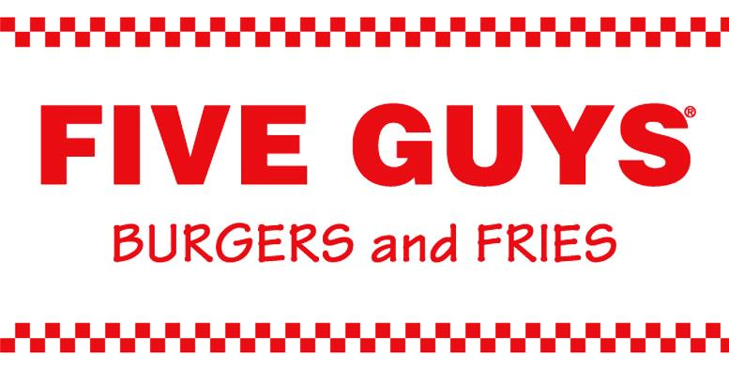

International Business Plan

for

Pakistan

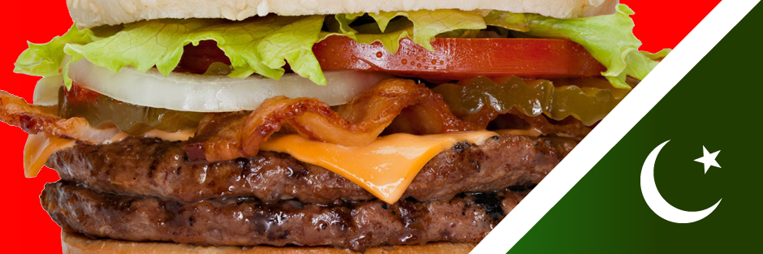
Contents
Executive Summary 5
Corporate Global Vision & Goals 6
Mission 6
Goal 6
International Business / Organisational Structure 7
International Business 7
Organisational Structure 8
Market Research: Pakistan 9
Risk Assessment 13
PESTEL Analysis 13
Political 13
Economic 14
Social 15
Technological 15
Environmental 15
Legal 16
SWOT Analysis 16
Strengths 17
Weaknesses 17
Opportunities 17
Threats 18
Five Forces Analysis 19
Supplier Power 19
Rivalry 19
Buyer Power 20
Threat of Substitution 20
Barriers to Entry 20
International Business Strategy 21
Marketing Plan 22
4Ps – Marketing Mix 22
Products 22
Place 22
Promotion 23
Price 24
Recommendations 25
References 27

Executive Summary
Founded in 1986, Five Guys is a new style of burger restaurant, setting itself apart from the McDonald’s type model which provides fast food with minimal waiting for the patrons. Five Guys, provides the customer a “fast-casual” restaurant where the food is cooked to order from beef patties that are not delivered frozen beforehand. This has led to a cult-type following (Tice, 2010) for the organisation with over 1 million followers on its Twitter page.
The company never set to take on McDonald’s, because it couldn’t financially or physically, but wanted to offer something slightly different and better (Burke, 2012). In so doing, they are changing the way the customer looks at the humble burger.
Now 30 years later, Five Guys has 1,500 restaurants in a dozen countries and looking to double both stores and territories.
Pakistan is unique offering, where the dramatic increase in the middle classes, greater disposable income and more brand awareness can create the ideal market for the company to expand into through franchising the brand. The country is well accustomed to burgers since the time of the British Raj and unlike India, Pakistan has no qualms about beef as a source of meat as it’s not against their religion to consume the animal.
Finally, the opportunities for Five Guys to try out new procedures and technologies, like McDonald’s innovative “McDelivery” (mcdonalds.com.pk) and Telenor’s “e-Paisa”, the first in mobile-phone wallets (easypaisa.com.pk), can increase their target market without further outlays in restaurants.

Corporate Global Vision & Goals
Five guys was founded by the Jerry Murrell and his sons in 1986 and over the past 30 years it has established over 1,500 eateries globally with a further 1,500 planned in the next 10 years (www.fiveguys.com).
The company has a very simple principle; to sell the tastiest, freshest burgers around (Sozzi, 2015) and to achieve this, they cook non-frozen, hand shaped beef patties directly behind the cashiers but still in view the customer so they [the customer] can view the process until delivered.
The mission statement and goals of the company are also as simple as their burgers; there is no mention of stopping wars or saving the planet, just a focus to excel at what they do and how to achieve this. An added advantage of having the statement so succinct is that both the customer and the company are entirely aware of the end product when a transaction takes place – a good “hand prepared, old fashioned, tasty burger” (www.fiveguys.com).

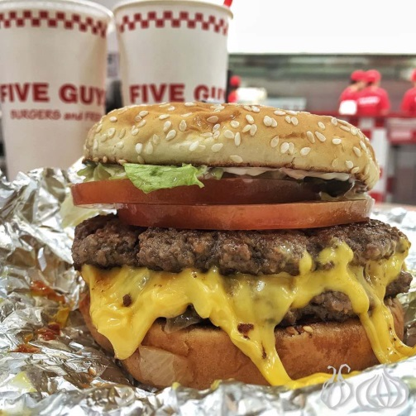
Mission
We are in the business of selling burgers.

Goal
Five Guys goal is to sell the best quality burgers possible. To sell the best burger possible we focus on Quality, Service and Cleanliness.

International Business / Organisational Structure

International Business

Fig 1: Five Guys global presence

Currently established in 12 countries across North America, Europe, Asia, the Middle East and Australia (Hope, 2017), Five Guys plans to take this number to beyond 28 within the next 5 years as part of the strategic plan.
Being a premium product, it is important to individually select the markets to ensure the customer profile fits and is receptive to the product being offered. McDonalds, for example, offers fast food and was the pioneer in this business from when it was founded in 1955 under the name McDonald’s System Inc by Ray Kroc (Kroc & Anderson, 2012). Today, McDonald’s has revenue over $25billion/annum globally.
Outside the US/Canadian markets, the UK was the first international exposure for the company with Charles Dunstone, founder of the Carphone Warehouse & current MD of Freston Road Investments, aiming to open approximately 300 stores within 10 years (Burke, 2012). This was followed shortly after by mainland Europe and the Middle East.

Organisational Structure
Five Guys is still very much a family run structure and each of the 7 members of the family (mother, father and the 5 sons) have equal shares in the company accounting for 75% of the total value. The remainder is taken by Miller Investments (20%) and 5% by Jerry Murrells’ college friends who contributed towards setting up the first restaurant.
Any new franchisees need to meet the company’s strict financial and expansion requirements with an emphasis on delivering the same quality and experience as the US stores.
For foreign markets a new procurement and logistics system is also created as, in the case of Europe for example, US beef and ingredients fail to meet the EU standards. This then requires the CEO, Paul Reynish, to perform “product calibration” to ensure the same taste as the US burgers (Hope, 2017). Similar “calibrations” are undertaken for the Middle Eastern markets to ensure the company adheres to the “no frozen patty” policy and will, no doubt have to be undertaken if the new markets are too distant from the current supply chain.

Market Research: Pakistan
Burgers are not a new concept in Pakistan; they’ve been around since the British Empire but had taken a local twist. Those sold on food carts across the metropolitan centres, were always called “Bun Kebabs”, essentially a local kebab with the usual herbs and spices placed within a bun and more often than not topped with an omelette.
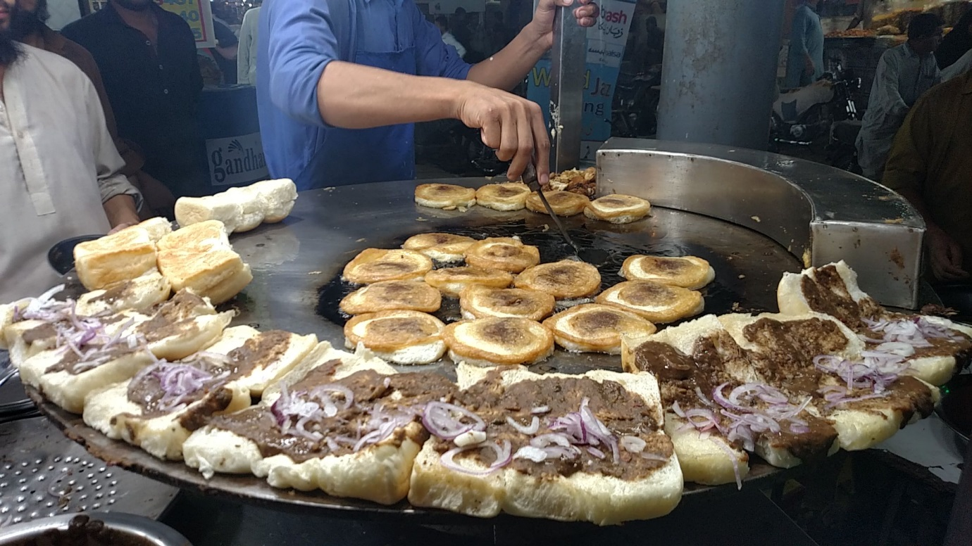
A street vendor preparing “Bun-Kebabs” (courtesy Imgur)
In the late 1970’s, a local, well-travelled entrepreneurial family, the Raza’s, approached McDonald’s and Burger King for franchising in Pakistan after witnessing their success in the UK and USA. However, their excitement was soon dashed when both showed no interest as both reverted with the similar response; “Pakistan was not ready for burgers” (Rizwan, 2016). This negative, says Rizwan, urged the brothers to prove the market leaders wrong.
Very soon after their arrival back to Pakistan, the brothers, with virtually no experience of the food industry, set up “Mr Burger” in the port metropolis of Karachi. “We Pakistanis are very conservative and don’t take to new concepts very easily, but food is completely different,” recalls Raza.
What they had managed to achieve was to change the mind-set from the traditional family meal to “fast food dining” and with this the “Burger Generation” was born. 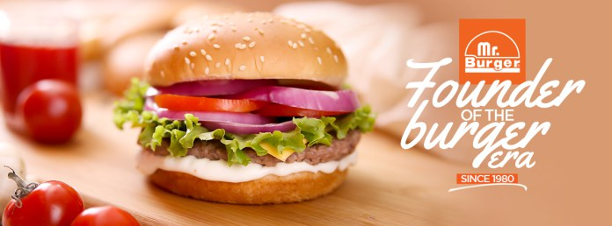
This generation was to symbolise an upwardly mobile middle (and upper) class of the population (Tahir, 2012) who could afford the luxury of a burger that was prepared in a clean, hygienic, air conditioned environment as compared to the street vendor and his bun-kebab.
What this proved was the complete lack of insight and knowledge market leaders had of the market. Though in this case it was Pakistan (McDonald’s finally entered in 1998), the same could be said for India (in 1997), China (in 1992) and other Asian countries; it took McDonald’s more than 20 years to enter the emerging markets of Asia after Europe.
However, what this delayed entry allowed was for Mr Burger to gain a strong footing in the market (Graph 1).
On the flip side however, it also demonstrates that the local market has the appetite and ability to pay more for a product, if it’s perceived to be better in value or quality – the latter usually follows an international brand; something that has been discussed for numerous years in the marketing works (Buzzell 1968, Levitt 1983, Jain 1989, Boddewijn, Soelh and Picard 1986, Huszagh et al 1986, Douglas and Wind 1987, Craig and Douglas 2000).
In Graph 1, even though KFC is the overall market leader in the fast food business, it’s not in the same category as Five Guys, given KFC focuses on chicken as its principal food item and not beef.
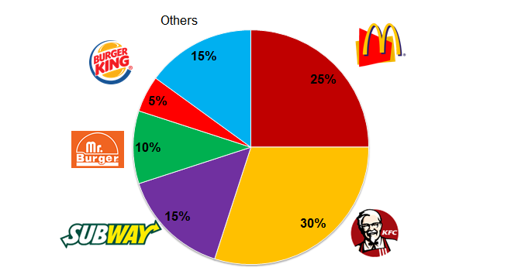
Graph 1: “Bun-Shares” in Pakistan

Another important note for Five Guys here is that Pakistanis have the appropriate financial capacity to afford the product to be offered. Another important fact is that the country also has the market and potential that can sustain adequate growth.
The demographic make up of the country (as per the Pakistan Bureau for Statistcs) are:
Total population: 209,000,000
Aged 16 – 49 51.6%
Middle Class: 57.3%
Urbanised: 45.7%
Urbanised Middle Class: 81.6%
What this means for Five Guys in simple numbers is that the target market is approximately 25 million – which is greater than the total population of Australia (Australian Bureau of Statistics, 2017).
Also, to compliment this substantial potential market is analysis undertaken by Mangi et al (2017) for Bloomberg, which suggests that Pakistan leads the growth rate for fast food consumption across most Asian and African states:
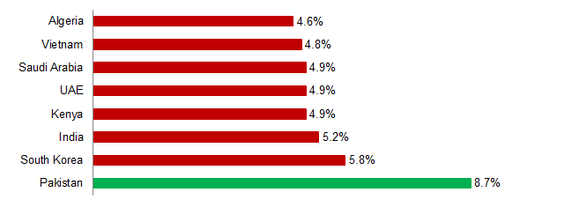
Graph 2: Annual growth rate for global fast food consumption

These facts, combined with that the local custom of sitting and eating within a family / friendship unit fits perfectly within the Five Guys concept of “fast-casual” (Burke, 2012) where the emphasis is on “food” and not “fast”.

Risk Assessment

PESTEL Analysis
The following highlights elements from the PESTEL Analysis for Five Guys for Pakistan:
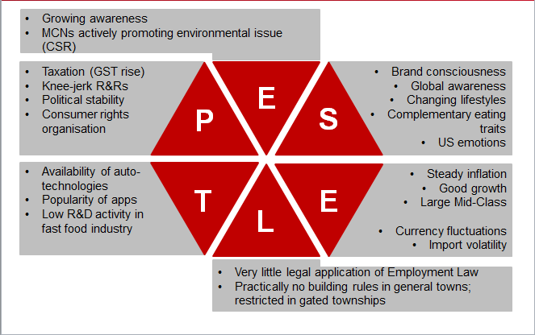

Political
- With an increased borrowing by the Federal government as recent increase in the local taxes was introduced, this one also included prepared foods for the first time.
- Governments are notorious for knee-jerk reactions and this is also the case when passing new rules and regulations
- Though technically the country is ‘democratic’ in as much as a elections are held (and observed) by external monitors, the governments are still quite unstable
- Though some consumer rights organisations exist, they don’t have the power as their European counterparts. Instead, it’s very common to be promoted (or demoted?) by social media and word of mouth – both coincidently, being Five Guys preferred method of marketing (Miller, 2015)

Economic
- Inflation over the past 5 years has remained relatively stable within the 3-4% region (World Bank, 2017)
- Growth wise, Pakistan has achieved over 4%/annum over the past 5 years (Tradingeconomics.com, 2017) which demonstrates a sound economic growth
- The factors above have led to an increased percentage of the population who fall into the middle class bracket and by definition have more disposable income.
- The only down side would be if there was some unforeseen set of circumstances which could upset the current economic situation and adversely affect the Pakistani Rupee against the US Dollar. This in turn could cause import costs to increase which the company may have to absorb or pass directly onto the customer. That said, with a large domestic supply chain possible given the availability of cattle and other ingredients for the Five Guys menu, this can be put aside.

Social
- With a brand conscious and well-travelled middle class, Pakistanis are familiar with renowned global brands.
- Changing life styles of the millennials is also reflected by their eating habits and going one step further than the local Burger Generation, or internationally referenced Generation X.
- One local social contentious issue maybe “US Branding”. As with many Middle Eastern countries, this is quite a touchy topic given the politics involved. However, as witnessed by McDonald’s in the early 2000’s when Iraq was invaded, a distinction was made between the “US Government” and “US Companies” and they suffered no negative consequences.

Technological
- Many food apps and online ordering facilities are available across this very connected country. McDonald’s even changed their restaurant model for Pakistan; introducing “McDelivery” (home delivery service) for the first time (Maher, 2016).
- Given the many technologies already available on line, or if necessary creating new ones locally, the development costs for these should be minimal.

Environmental
- Many multinational companies within the country have either a global or local CSR.
- Given the situation regards water and trees within the country (WWF, 2012), many citizens are increasing becoming more environmentally concerned.

Legal
- Even though there is very little Employment Law, social media again drives many MCNs and major local employers to act ‘favourably’ (Farooq, 2017).
- Regards building standards, there are very few rules to determine where and where not any business can be located.

SWOT Analysis
Using this framework, we will be able to analyse the organisation’s strengths, weaknesses, opportunities and threats that it may face. This will also help focus on the strengths, minimise threats, and take the greatest possible advantage of opportunities available.
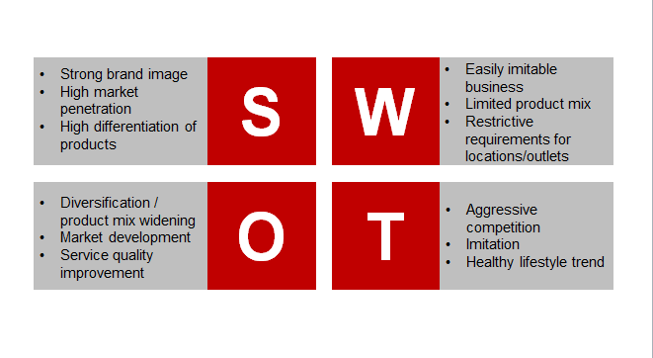

Strengths
- Five Guys has a very simple yet strong brand image
- The marketing plans from franchisees demand rapid and massive penetration
- Specialising in only the core products, with a very limited menu allows Five Guys to stand out from the competitors.

Weaknesses
- The business is easily imitable as the only unique selling point is the brand and associated quality and taste.
- Having a limited menu maybe a strength, but it’s also a weakness
- The restrictive and demanding requirements for setting up the franchise may also adversely affect the performance of the company, especially as it heads towards more of the emerging markets of Asia and South America.

Opportunities
- Coming to a cuisine-rich country like Pakistan, may afford the company to diversify and experiment with local flavours to either add another ‘localised’ burger (e.g. McArabia for McDonald’s) or the toppings for the burger.
- Having no real competitor, the company stands in good stead to differentiate itself from the ‘cheaper’ McDonalds offering a more quality product – much like Mr Burger did when it set up in the early 1980’s against the local ‘Bun Kebab’ vendors.
- Improve service qualities for this sector by offering rewards for all employees of the best performing and quality stores; like Murrell’s still do in their stores (Burke, 2012). Thus making it not only about speed, but also quality for the employees.

Threats
- As with the rest of the world, there is an increase trend towards healthy foods and with the regular burger coming in at 920 calories and the large at over 1300 calories (Upton, 2018) that’s almost a days’ worth for an average female (2000 calories according to UK’s NHS)
- Easily imitable – as discussed earlier

Five Forces Analysis
We use Porter’s Five Forces Analysis to understand the forces that shape competition within the industry.
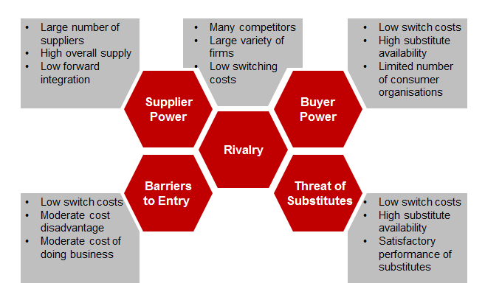

Supplier Power
In a country like Pakistan, where there is potentially a substantial number of suppliers, their influence is very restricted throughout the supply chain.

Rivalry
As previously discussed there are many competitors within the market; some large multinationals; McDonalds and KFC, while others are local; Mr Burger. They are all players and contribute towards competition and segmenting the market.

Buyer Power
With such a large variety to choose from, the buyer in Pakistan, is very much the same anywhere and can opt where to spend his/her dollar.

Threat of Substitution
Quality of service and product will be imperative to ensure the Five Guys cult gains momentum in Pakistan as it has in the US and now Europe. Any failure in any aspect will give the consumer reason to go elsewhere who may perform less satisfactorily but the cost-v-benefit aspect may allow the customer to forgive them and not Five Guys.

Barriers to Entry
Much like Five Guys acting as a disruptive force to the current model, new entrants may also do the same and for the customer, the costs are minimal while for any entrant they range from low to moderate as the lions share will be the franchise fee for a multinational brand.

International Business Strategy
Five Guys standard policy is to offer franchises per geographical location. This is usually done by states in the US and country wide internationally. As mentioned previously, for the UK this has been granted to the former owner of Carphone Warehouse with an agreed target of setting up 300 eateries in the next 10 years (Burke, 2012).
These targets are, undoubtedly assessed on a country by country basis; it may be neigh impossible for the UAE franchisees to open 300+ across their territory because they physically may not have enough space to do so. They currently have 3 between the 7 Emirates; 2 in Dubai and 1 in Abu Dhabi.
The Murrell family, holding 75% of the shares, have the final say in who is awarded the franchise and where the company expands to.
Currently, Five Guys looks for a franchisee to have a net worth of at least USD 1.5 million and liquidity of USD 500,000. An upfront fee of USD 20,000 for the franchise will also be levied and thereafter USD 75,000 per store that’s opened.
From experience, the typical franchisee will have approximately 10 restaurants, which cost USD 350,000 to USD 500,000 to open with average annual revenue of USD 1.2 million. From the gross annual revenue, Five Guys pockets a further 6%. Another 1.5% is collected but given directly to the employees for what the company calls their audits, in which external auditors monitor the stores for quality of service, safety and cleanliness. Crews that score well collect USD 1,000 – which is awarded weekly (fiveguys.com)

Marketing Plan

4Ps – Marketing Mix
The 4Ps (or the Marketing Mix) is a crucial tool to help understand what the product (or service) can offer and how to successfully plan for the it’s offering. This usually involves products, place, promotion and price and are addressed in no particular order.

Products
Five Guys, operates a fast-casual service restaurant business with burgers as practically its core product and signature fries fried in peanut oil. In this section, I will focus on the marketing mix to present organisational outputs offered to target and attract customers. Five Guys main lines are:
- Burgers
- Hot Dogs
- Sandwiches
- Fries
- Milkshakes

Place
Five Guys’ products are the same worldwide and in this component we refer to how the company can use the means/venues to interact with the target customers. Listed below are the places Five Guys can use to distribute its products:
- Restaurants
- Mobile app (not currently used anywhere)
- Website for deliveries (Five Guys don’t currently deliver)
Apart from restaurants, customers in Pakistan are very app-savvy and would prefer to use mobile apps to access special offers; even though in the UK special offers are unheard of (www.fiveguys.co.uk). Customers could also use the company’s website (or third party sites; FoodPanda, JustEat etc) to place their orders for home delivery. The current model for Five Guys, in this component of the mix, restaurants are the principal source of presence with no ‘virtual’ presence in either app or home-delivery service.

Promotion
Five Guys employs very little by means of modern tactics to promote its products. In this component I’ll look at the strategies used to connect with the target market. Five Guys uses the following marketing campaigns and communications tools, arranged according to significance:
- Personal selling
- Personal selling
- Personal selling
Five Guys relies only on personal selling; selling the experience, the quality and the product. From the moment the customer walks into the door through to receiving the product in his/her hand. There is no pushy sales person behind the counter trying to upsell you products you don’t need – just a simple person taking your order and shouting it across to the chef. This is very unusual in the 21st century given the tools that are available to marketers but accordingly to Molly Catalano, the company’s spokesperson, “..they invest more in secret shoppers and rewarding excellent staff who’re already on a salary way above the competitors..” (York, 2009).

Price
The company’s pricing strategy is based on its strategy of quality products at a good price. In this component, the consideration is towards how appropriate the pricing of products is. For Five Guys, the pricing strategy is very simple as it uses a market-oriented strategy as its primary (and only?) approach. This strategy involves setting prices based on prevailing market conditions, as well as supply and demand conditions. By not directly competing with any of the other brands, e.g. McDonald’s or Burger King, Five Guys is able to set the prices itself and thereby differentiate it’s offering as a premier alternative. This image is further enhanced as the company offers no ‘bundle pricing’ – a strategy commonly used by McDonald’s etc. for their kids’ meal which makes buy multiple products cheaper than if purchased individually.

Conclusions / Recommendations
Having studied the country in much detail and being cognisant of its economic situation, it would very appropriate for Five Guys to look at franchising in Pakistan. Naturally, there may be an issue with the bacon components of the meal, given that Pakistan is Muslim majority nation, but like existing models in Saudi Arabia, UAE, Qatar and Kuwait, this can easily be accommodated.
Of benefit for Five Guys, while they undertake their “product calibration” is that Pakistan is much better placed, to supply all the raw ingredients to ensure the quality of meat and grains required for the Five Guys experienced can be met. Further, given it’s proximity to the other 4 Middle Eastern markets, it could in turn supply them also, thereby streamlining the whole supply chain; ultimately increasing corporate revenue.
As discussed during the Marketing Plan, the Pakistani market is very receptive to novel and if at times ‘counter-concept’ facilities. For example, the local franchisee for McDonald’s initiated McDelivery – a revolution for the fast food giant, enabling the restaurants to increase revenue and customer reach (mcdonalds.com.pk). This too, is potentially viable, especially in the 25 million megatropolis of Karachi where middle classes would rather order a delivery than fight through the traffic.
What Five Guys has is a unique concept and as Reis (2005) so aptly writes:
A laser is a weak source of energy. A laser takes a few watts of energy and focuses them in a coherent stream of light. But with a laser you can drill a hole in a diamond or wipe out a cancer.
When you focus a company, you create the same effect. You create a powerful, laser-like ability to dominate a market. That's what focusing is all about.
Five Guys has stayed laser focused on providing a great dining experience around a very simple offering. That focus is reflected in their Mission and Goal statement from their website (as shown above).
Another factor contributing to the success of the company is their steadfast pledge to customer service. They shout out a greeting when you arrive and politely move you through the order and pickup process. Even today, after all those years of refinement, they still appear to be somewhat chaotic in how they prepare a meal.
Even through marketing, Five Guys believe their greatest assets are the crew (their employees) and the customer. After all, a satisfied customer very often becomes the brand ambassador – whether knowingly or not. Using social media to run campaigns, instead of the traditional print or TV are definitely a great way to generate a buzz amongst the target market. It’s also a great way to attract sharable content from an audience that know you, the products and services – your contented and satisfied customers.

References
- Ali, S; 2014. Fast Food consumption in Pakistan. Retrieved from brandsynario.com: http://www.brandsynario.com/fast-food-consumption-in-pakistan/
- Boddewyn, J.J. , Soehl, R. and Picard, J. (1986), "Standardisation in International marketing: Is Ted Levitt in fact right?", Business horizons, November-December, 68-75.
- "Britain’S Favourite Fast-Food Restaurants And Coffee Shops Revealed | Market Force Information, Inc.." Marketforce.com. N.p., 2018. Web. 4 Mar. 2018.
- Burke, Monte. "Forbes Welcome." Forbes.com. N.p., 2012.
- Buzzel, R.D. (1968), “Can you standardise Multinational Marketing?”, Harvard Business Review, November- December, 102-113.
- Byrne, C, "A Mission Statement That Gets Right Down To Business." Early To Rise. N.p., 2008.
- Davis, G. "Strategy: Keeping It Simple." N.p., 2007.
- Dominici, G. (2009). From marketing mix to e-marketing mix: a literature overview and classification. International Journal of Business and Management, 4(9), 17-24.
- Farooq, Asad. "Khaadi Faces Social Media Rage Amidst Allegations Of Inhumane Work Conditions." DAWN.COM. N.p., 2017.
- Farrell, Jeff. "Pakistan Just Planted 1 Billion Trees." The Independent. N.p., 2017.
- Ghani, Jawaid. "The Emerging Middle Class In Pakistan: How It Consumes, Earns, And Saves." International Conference On Marketing. Karachi: IBA, 2014.
- Hope, Katie. "How The 'Better Burger' Is Taking Over The World." BBC News. N.p., 2017.
- Huszagh, S. et al (1986), “ Global marketing: An empirical investigation ”, Columbia Journal of World Business, 21, 31-44.
- Jain, S. C. (1989), "Standardisation of international marketing strategy: Some research hypothesis", Journal of Marketing, Vol. 53, January, 70-79.
- Kroc, R. & Anderson, R. Grinding It Out. St. Martin's Paperbacks, 2012. Print.
- Levitt, T. (1983), "The globalisation of markets", Harvard Business Review, Vol. 61, May-June, 92-108.
- Maher, Sanam. "The Rise Of Pakistan's 'Burger' Generation." Aljazeera.com. N.p., 2018.
- Mangi, Fasih, and Chris Kay. "Pakistan Develops A Taste For Fast Food." Bloomberg.com. N.p., 2017.
- Maqsood, Ammara. "Opinion | Meet Pakistan’S Modern Middle Class." Nytimes.com. N.p., 2018.
- Melichar, David. "SWOT Analysis." ManagementMania.com. N.p., 2006
- Miller, Shannon. "Social Media Marketing, The Five Guys Way." Hootsuite Social Media Management. N.p., 2015. Web. 29 Apr. 2018.
- "Pakistan Beef and Veal Meat Production By Year (1000 MT CWE)." Indexmundi.com. N.p., 2017.
- "Pakistan Bureau of Statistics | 6th Population And Housing Census." Pbscensus.gov.pk. N.p., 2018.
- "Pakistan Is One Of The Fastest Growing Fast Food Industries In The World." Propakistani.pk. N.p., 2017. "Self-Employed - Total (% Of Total Employed) In Pakistan." Tradingeconomics.com. N.p., 2009.
- "Population - Australian Bureau of Statistics." Abs.gov.au. N.p., 2018.
- Rizwan, S. "Mr. Burger - Pakistan’s First Fast Food Chain." Brandsynario. N.p., 2008
- Sozzi, B. "What Struggling McDonald’s Could Learn From Shake Shack And Five Guys." TheStreet. N.p., 2015.
- Tahir, K. "The Elite and Burger Generation of Today." kinza tahir. N.p., 2012.
- Tandon, S. "Indians aren't loving it as McDonald's shuts 20% of its outlets down." Quartz. N.p., 2017.
- Tice, C. "5 Reasons Five Guys Burgers And Fries Is The New Cult Fave." Cbsnews.com. N.p., 2010.
- Tradingeconomics.com, "Pakistan GDP Growth Rate | 1952-2018 | Data | Chart | Calendar | Forecast." Tradingeconomics.com. N.p., 2017.
- Upton, J. "The 4 Healthiest Things To Order At Five Guys, According To A Nutritionist." Health.com. N.p., 2018. Web. 29 Apr. 2018.
- "Water Security." Wwfpak.org. N.p., 2012. Web. 29 Apr. 2018.
- "What Should My Daily Intake Of Calories Be? - Health Questions - NHS Choices." Nhs.uk. N.p., 2016. Web. 29 Apr. 2018.
- World Bank, "Inflation, Consumer Prices (Annual %) | Data." Data.worldbank.org. N.p., 2017.
- York, E. "Five Guys: An America's Hottest Brands Case Study." Adage.com. N.p., 2009.

“Form 10K: McDonald’s Corporation (McDonald’s Corporation 2016 Annual Report), US Securities & Exchange Commission, Commission File nUmber 1-5321

