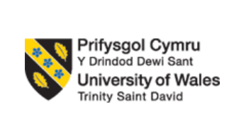

Student Name: Vrunda Natvarbhai Parmar
Student Number: 2418330
Module Name: Strategic management
Module Code: LCMB7003
Lecture Name: Jia Mao
Assignment Title: Report
Company: Lloyds Bank

Table of Contents
Introduction 3
Overview of the company and the country 3
Comprehensive Strategic Analysis 5
PESTLE Analysis Framework 5
Competitive Analysis: Porter's Five Forces Framework 8
Strategy Development and Formulation 11
Strategic Market Entry Framework: Digital Partnership Model 11
Phased Market Entry Strategy 12
Competitive Differentiation Strategy 14
Competitive Positioning Against Market Competitors 15
Risk Mitigation Framework 15
Performance evaluation framework 18
Balanced Scorecard Design 18
Triple Bottom Line Performance Framework 20
Conclusion 22
References 23

Introduction
Strategic management is referred to as the process of managing and overseeing the long-term strategy of the company to achieve its goals and objectives (Lynch, 2021). SM involves a wide range of concepts that help the brand to evaluate its strategy to move ahead with a strategic plan of action to stay in competition with the other brands and make decisions on the basis of its strategic objectives and targets. The use of different strategic tools and models is done in this context to evaluate the firm's business performance, position and analysis of the business environment of the company (Grant, 2021). One of the key functions of conducting strategic analysis for any brand is related to assessing how the brand can achieve a competitive edge within the complex and competitive business environment.
The purpose of the report is to conduct a strategic analysis, focus on strategic development as well as the implementation of the new expansion strategy for the brand selected, and lastly, to evaluate its performance using relevant and appropriate strategic management frameworks and models. The present report is based on an analysis of the strategic position of the Lloyds Bank, which is a prominent banking institution established in the UK. The report will focus on conducting a strategic analysis of the brand and developing a strategic plan for the brand to expand its global operations and enter the Indonesian market.

Overview of the company and the country
Lloyds Bank is a UK-based bank that operates across both retail and commercial banking operations and offers a wide range of services to its clients. The bank was established in 1975 and has significantly evolved over the period of time since then. Currently, Lloyd's Bank is also recognised as one of the largest providers of financial services in the UK. The different banking services that are provided by the brand to its retail and corporate customers involve digital or online banking, mortgage, insurance services and retail or private banking services (Lloyd’s bank, 2025). The brand also has a strong base of loyal customers in the markets of the UK, USA and some other European countries.
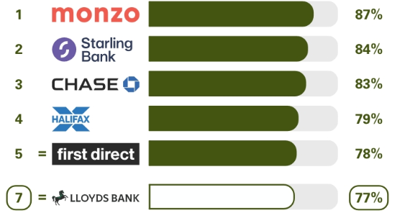
Figure 1: Popularity of Lloyd's Bank in the UK
(Source: Lloyds bank, 2025)
The chart above reflects the popularity of the online and digital banking services provided by the different banking institutions in the UK to their customers. It can be found that Lloyd Bank has secured 7th rank in this dimension, with 77% of customers willing to recommend the banking services of Lloyd to their known ones (Lloyds bank, 2025). The rising popularity, brand awareness and recognition in the market of the UK make it feasible for the brand to expand its operations geographically and explore the opportunities available in the new markets. Lloyds Bank can therefore adopt a market expansion approach for achieving this strategic goal in the times ahead.
The chosen country for the expansion of Lloyd Bank will be Indonesia. Indonesia is one of the emerging Asian countries with a huge young population and a favourable digital environment for the brand to expand into. The selected country is also renowned for its tech-savvy population and transformation towards digitalisation in the current times (Andrian et.al 2022). The expansion of the operations in Indonesia will offer a wide range of opportunities for the management of Lloyd Bank, as the adoption of digital banking services in this market is constantly rising, and there is a huge demand for high-quality digital banking services in the nation.
The banking and financial service industry in Indonesia is growing rapidly and has emerged as one of the leading and most profitable among the other ASEAN countries in terms of net interest margin. The GDP contribution of this industry in Indonesia is growing at a 4.7% CAGR as of 2024 (Statista, 2025). Thus, the growing market demand and opportunities in the selected market are one of the major reasons why Indonesia can be selected as a potential market for expansion for the management of Lloyd Bank. Not only is this the overall socio-cultural environment as well as the growing economic position of the brand, but also one of the major reasons why it is selected as a potential market for the international expansion of Lloyd Bank. The rapidly growing population, advanced technological infrastructure and growing need for digital banking services in the country and strong resources in the country are some of the major factors that make Indonesia the most feasible option for the expansion in the times ahead (Puspitasari et.al 2021).

Comprehensive Strategic Analysis

PESTLE Analysis Framework
Political Environment
The political environment in Indonesia offers a very stable base of international banking development (Rachmad, 2024). The nation is a presidential system of government with authentic democratic institutions that has managed to hold general elections in October 2024. The government has shown a clear interest in the development of the financial sector by presenting several policy projects, as evidenced by the fact that the Project Garuda of developing Central Bank Digital Currency is planned by Bank Indonesia, and the adoption of the National Open API Payment Standard (SNAP), which aims to promote fintech development and the improvement of digital banking infrastructure (Sakti and Utami, 2024). However, geopolitical factors should be taken into consideration. The impact of global trade dynamics, especially its immediate debate that surrounds international tariffs and protectionism may pose macroeconomic uncertainty, which may affect currency values and international banking business.
Economic Fundamentals
The economic trend of Indonesia offers attractive growth opportunities which are completely different as compared to advanced developed economies. The forecast of the Gross Domestic Product growth 4.9-5.1% in 2025 can be regarded as the continuation of the positive trend in the largest economy in Southeast Asia. Banking is especially an industry that has seen good credit growth (McKinsey & Company, 2025).
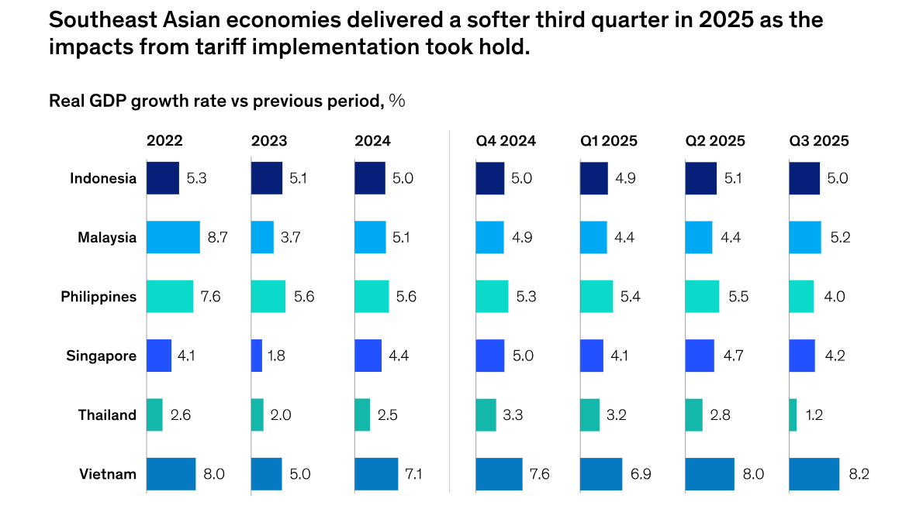
Figure 2: Southeast Asian Economies Development
(Source: McKinsey & Company, 2025)
The impact of the financial services industry on the national GDP has grown to USD 77 billion in 2022, with forecasts of USD 130 billion in 2025, which means that the industry gains momentum (EY, 2022). Also, by 2029, net interest income of digital banks is expected to be USD 3.63 billion (Statista, 2024). However, economic weaknesses should be taken into account. The nature of interest rates has posed tremendous pressure on the cost of funds. Furthermore, the narrowing of net interest margins has posed some competition especially to small financial institutions, which do not have access to low-cost deposit bases.
Sociocultural Characteristics
The sociocultural environment of Indonesia evidences superior attributes that favor the growth of digital banking. The digital adoption trends in the population are extraordinary characters that define the market unlike traditional emerging market characteristics. The frequency of using digital banking rose 158% in 2018-2023, which is indicative of major transformations in consumer preferences in financial services. The existing digital banking rates include around 31 percent of the population, and it is projected to reach 39 percent (around 75 million users) in 2026 (Market Research Indonesia, 2025). Additionally, Generation Z has especially high standards when it comes to digital-native banking experiences, with 57 per cent specifically favouring digital-native experiences with banking over traditional banking. The given demographic values the ability to have a streamlined mobile onboarding, a well-designed interface, and integrated digital ecosystems that would include banking, payments, and shopping and transportation services.
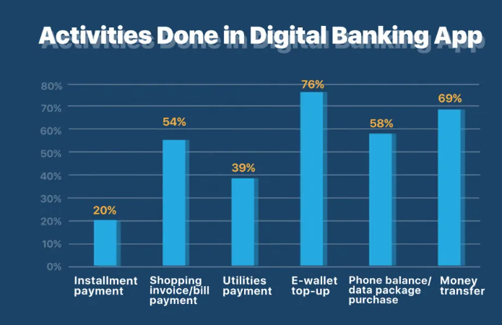
Figure 4: Activities done in digital banking
(Source: Market Research Indonesia, 2025)
Technological Infrastructure
The technological environment in Indonesia indicates the presence of growing capabilities that promote banking innovation and digital transformation. Mobile phone penetration is ever rising and mobile savvy populace presents populations with strong grounds to carry out digital banking expansions. The next-generation financial system programs that Bank Indonesia has launched are the National Open API Payment Standard (SNAP) and Project Garuda, which aims to promote ecosystem cooperation between legacy banks and fintech innovators as well as strengthening the financial system infrastructure (Jameaba, 2020). Application of blockchain technology in banking sector is being actively discussed to simplify the operations taking place on the back-end, clearing and settlement procedures, and increase efficiency in international transactions and financing small businesses within supply chains.
Environmental
Global sustainability has become more significant in the banking industry in Indonesia and this has been fuelled by regulation and environmental sustainability demands. One of the major regulatory improvements is Regulation No. 18/POJK.03/2025 on Bank Transparency and Publication of Reports which obliges banks to publish a wide range of ESG information (de Leede and Fisher, 2022). This is an inclusive disclosure system that requires the publication of financial statements, risk exposure reports, capital adequacy information, sustainability practices and implementation of governance. Banks are required to publish both quantitative and qualitative data on credit risk, market risk, operational risk, liquidity risk, legal risk, reputational risk, strategic risk, compliance risk and governance structures.

Competitive Analysis: Porter's Five Forces Framework
Threat of New Entrants: Moderate to High
The banking market in Indonesia portrays both the presence of significant entry barriers to the market and the persistence of opportunities in the sector. The licensing procedure via the OJK is formal and places substantial regulatory obstacles such that approvals are required throughout and substantial capital and compliance standards must be demonstrated. However, the fintech ecosystem has grown exponentially, with the OJK issuing licenses to 127 non-compliant lenders in a 2024-wide purge of licenses, which amounts to market share concentrated on well-capitalised firms with the ability to meet high capital and cybersecurity standards (ICLG, 2025). There are 106 commercial banks in Indonesia, which have more than 24,300 commercial bank offices spread across the archipelagos. Bank Rakyat Indonesia, Bank Mandiri, and Bank Negara Indonesia are the largest banks that dominate the markets due to their comprehensive branch network and support of the government, despite a considerable level of penetration into the market by the digital banks and fintech operators (Ken Research, 2025).
Bargaining Power of Suppliers: Moderate
The suppliers of banking technology infrastructure in Indonesia are both international technology providers and emerging domestic fintech startups. Fintech companies also have a growing relationship with traditional banks, and more than 150 fintech operators are licensed to operate and compete on the market offering payment services, lending services, and data analytics services. The concentration between suppliers is moderate, and there are several competitive substitutes that ensure that the dependence on a single supplier is not made. Go To Go Pay, Grab OVO and DANA have large volumes of payment processing but have many other specialised players with competitive offerings (Widjojo, 2020). The legacy banks have established strategic joint ventures and invested heavily in untapped fintech and technology firms to hasten digital transformation and use the established institutional benefits. Pilot projects with state-owned lenders indicate strategic development in the direction of direct competition to symbiotic relationships with a focus on ecosystem collaboration. The medium bargaining power of suppliers is in response to the rising technological potential and supplier competitive environments of the emerging market.
Bargaining Power of Customers: High
Competitive substitutes and digital innovation also result in a high bargaining power of Indonesian banking customers, especially in the retail and digital customer segments. The use of digital banking has raised the expectation of customers towards mobile-first applications that incorporate financial planning, real-time portfolio management, and customized advisory offerings (Sultana and Faisal, 2024). The customer migration trends have shown that there is rising use of digital alternatives where Indonesians feel that the technology brands provide better products and services that are more innovative than the traditional banking institutions. Super-app platforms Partnerships between digital banks and e-commerce platforms offer fully digitalized ecosystems that combine banking, payment, shopping, and transport in well-integrated settings. Time deposit stagnation is also observed in comparison with the Current and Savings Accounts (CASA) which undergo a booming growth, which is a preference of customers towards convenient and liquid digital products (Sultana and Faisal, 2024). Micro, small, and medium enterprise (MSME) customers show a specific risk in relation to credit availability challenges, as a threat and an opportunity to develop new services delivery innovations.
Threat of Substitutes: High
The Indonesian fintech environment poses significant competitive risks to the ancient banking service delivery. In the fintech market, digital payment platforms were in control of 73.44% of transaction value in 2024, but this leadership is insignificant when compared with decreasing margins driving strategic bundling of analytics and supply-chain lending services (Market Research Indonesia, 2025). The emerging segment is neo banking, which is the most rapid-growing segment with a revenue forecast of 10.04% compound annual growth rates. The wider fintech sector is showing a fast rate of growth, and financial technology services in Indonesia are expected to increase to USD 20.93 billion in 2025 and USD 32.67 billion in 2030 (Mordor Intelligence, 2024). Namely, GoPay (GoTo Holdings) and OVO (Grab Holdings) are considered specific substitute competitors, as well as DANA and LinkAja, as well as a number of emerging peer-to-peer lending platforms, investment management applications, and insurance fintech providers.
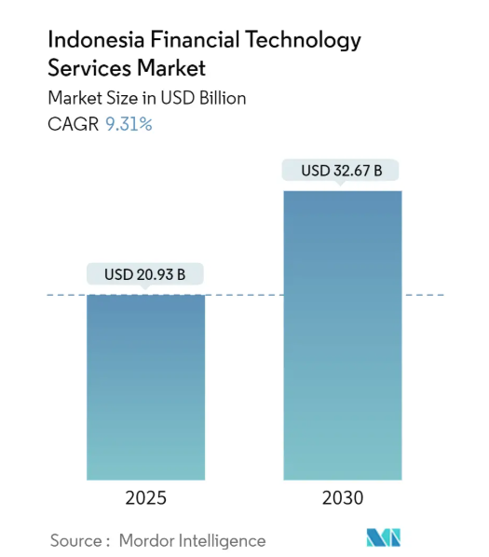
Figure 5: Indonesia Financial Technology Service Market
(Source: Mordor Intelligence, 2024)
Super-app integration of financial services via ride-hailing, food delivery, and e-commerce apps form holistic banking alternatives, especially in relation to payments and lending necessities, especially to younger demographic groups. Financial services and cryptocurrency exchanges based on blockchains are the new alternative, and they have been especially popular with younger digital-natives who pursue decentralized financial options.
Competitive Rivalry: Very High
The banking industry in Indonesia faces a stiff competitive rivalry that is informed by several supportive factors. The bigger banks still dominate in the growth of loans and deposits, with the smaller banks still struggling significantly especially because of increasing non-performing loans ratio in the micro, small and medium enterprises lending segments. The competition over low price funding has also increased significantly and the growth of the deposit has been highly reliant on the current and savings accounts since the growth of the time deposit has been stagnant. Funds cost rose by 100 plus basis points, between August 2022 and April 2024, and liquidity management and deposit competition became highly important strategic considerations (Loyttyniemi, 2025). However, analysts foresee the aggressive competition within the loan business will moderate in 2025 with the continued pressure on funding costs limiting the ability to generate profit. The development of digital banking has become a major competitive arena with banks such as Bank Mandiri and Bank Central Asia investing intensively in mobile apps and online banking offering as a way of competing with digital-native players (Abdul Hakim, 2025). The intensity of market competition is truly extraordinary, and the established banks are taking advantage of technology alliances and digital subsidiaries to compete with pure fintech and neobank contenders.

Strategy Development and Formulation

Strategic Market Entry Framework: Digital Partnership Model
Considering the high level of digitalization and the presence of advanced artificial intelligence systems at Lloyds Bank, as well as the market conditions in Indonesia, the best market entry approach would be a Strategic Partnership and Hybrid Distribution Approach as opposed to the conventional branch-based market expansion strategy. This plan takes advantage of the technological strengths of Lloyds and deals with the complexity of regulations and capital efficiency barrier.
Strategic Foundation and Competitive Rationale
The capability of Lloyds Banking Group to transform digitally has been exceptional and has resulted in immense competitive advantages in the digital first Indonesia market. The bank used Generative AI (Athena) to make the time of searching customer service drop 59 seconds to 20 seconds, which is an example of operational change that can be measured (Finextra, 2025). The group-wide data science capability of Lloyds includes the information on data scientists and AI developers and hosts advanced analytical functions to evaluate credit, customer segmentation, and frauds. The recent financial investment of the bank, to digital transformation of 4 billion pounds, with a 50 percent migration of cloud applications and the implementation of 50 applications of generative AI in the year 2025, place the bank in a favourable position to be competing in digital first markets (Lloyds Banking Group, 2025).
But branch expansion and branching are a massive challenge when entering the market directly. Indonesia has 106 commercial banks that have extensive customer relationships where most of them are run by state companies that enjoy implicit government support and wide networks of institutions. Instead of confronting retail branch banking where established advantages in the industry structure remain significant, Lloyds must consider strategic alliance with complementary ecosystem members to generate fast market penetration without high capital levels and regulatory burdens.

Phased Market Entry Strategy
Phase | Timeline | Core Strategy | Key Activities | Outcomes
Phase 1: Digital-First Banking | Year 1–2 | Enter market via digital partnerships | Embedded neobanking, AI credit scoring, data analytics, revenue-sharing | 500k users & IDR 300 bn deposits (Y1); 3m users & IDR 1.8 Tn deposits (Y3)
Phase 2: MSME & Commercial Lending | Year 2–4 | Expand into MSME and commercial finance | Fintech partnerships, supply-chain finance, CRE lending, FX & treasury | MSME credit expansion and diversified revenue
Phase 3: Licensed Banking Subsidiary | Year 4–5 | Establish full-service bank | Corporate banking, wealth management, Islamic finance, cross-border services | Long-term market consolidation and premium growth

Phase 1: Digital-First Financial Services (Year 1-2)
Building a basic presence by engaging in digital banking relationships with the most popular e-commerce services (Tokopedia or Shopee) or super-app (Grab or Go To) in Indonesia (PLATFORM and AN, 2022). The strategy used here is the offering of underlying banking infrastructure, AI-based credit assessment, and advanced risk management systems by Lloyds. The structure of the partnership would involve:
- White-label neobanking services embedded into the ecosystem of super-applications of the partner, which allow the customer to easily access the solution through trusted platforms.
- Leveraged by the capability of Lloyds to process applications in seconds (similar to days) using the most advanced artificial intelligence mining of mortgage applications) and credit rating (Mashetty et al., 2024).
- Detailed customer data analytics of high-value micro-segments such as young professionals, e-commerce sellers and emerging MSME entrepreneurs.
- Revenue sharing models: Under these models, Lloyds will earn fees on deposits, lending originations and payment processing.
This is a strategy that takes advantage of the advanced data science that Lloyds has and does not require the heavy capital intensity and regulatory complexity of becoming a licensed bank overnight.
Phase 2: Targeted Commercial and MSME Lending (Year 2-4)
Growing market share into commercial banking through forming strategic relationships with business-oriented fintech solutions and supply-chain financing solution providers. This expansion encompasses:
- Collaborations with peer-to-peer lending sources (Modalku, Investree, Akseleran) or lending technology providers serving MSME population groups that are not already served by traditional banking organizations (Suryani et al., 2023)
- Organized financing of the supply chain of e-commerce sellers based on transaction history analytics and platform data.
- Commercial real estate financing that is in Favor of the extensive infrastructure development in Indonesia, especially the Nusantara capital relocation, in which considerable commercial financing is required.
- Treasury and foreign exchange services that meet the requirements of the Indonesian importers and exporters involved in international trade.
The widespread experience of Lloyds in sustainable finance and structured lending fills market niche areas in MSME financing and mid-market commercial services that the current banking institutions fail to meet.
Phase 3: Licensed Banking Subsidiary (Year 4-5)
After achieving a successful entry and development of a good relationship with the regulators, develop a licensed commercial bank with a focus on high-value corporate and wealth management markets. This phase would encompass:
- Corporate treasury, trade finance, and investment banking of multinational companies in Indonesia and regional enterprises that need the use of international banking services.
- It has developed private banking and wealth management solutions which cater to the high-net-worth individual markets (The market size of the private banking in Indonesia is estimated at USD 2.3 billion in 2035 with the compound annual growth rate of 12.7) (Expert Market Research, 2025).
- Islamic financial services that target the rapidly increasing demand in Indonesia on Sharia-compliant financial services that are in tandem with the high number of Muslims in Indonesia and the rising interest in the Islamic finance.
- International banking experience and intermediary payment facilities utilizing the global correspondent banking systems of Lloyds.

Competitive Differentiation Strategy
Value Proposition Development
- Superior Digital Banking Experience: Lloyds Artificial intelligence-driven interfaces would deliver quicker loan applications (mortgage applications cut down to seconds), personalized financial guidance by the use of agentic AI systems, and mobile-first banking akin to the most advanced neobanks across the world (Finextra, 2025). This is the ability to directly respond to the demand of digital-native financial services by customers.
- Advanced Credit Risk Assessment: The 92.6% credit risk management efficiency coupled with sophisticated machine learning models developed by Lloyds would allow its credit risk management models to be more inclusive of lending to underserved MSME segments, which is a vital market constraint since the growth in MSME lending is significantly lower than other types of credit (Hossain, 2023).
- International Standards and Institutional Credibility: Lloyds offers unmatched standards of safety and regulatory compliance as a FTSE 100 bank with A- credit rating by Standard and Poor, which directly responds to the issue of trust in financial services in the emerging markets.
- Ecosystem Integration Architecture: This structure of partnership allows integration with the favorite shopping, payment and transporting platforms of customers, which will minimize switching costs and help to quickly enter the digital-native groups of users.

Competitive Positioning Against Market Competitors
Lloyds will beat state-owned banks (BRI, Bank Mandiri, BNI) in areas of better digital innovation, quicker product development, and service-oriented design. Although state-owned banks have cost-of-capital benefits and a large number of branches, they are generally slow in digital transformation because of bureaucratic limitations and outdated technology networks (Li, 2022). Compared to domestic private banks, the international capital, high levels of data science, and global treasury Lloyds offers, the local competitors do not, yet local competitors are more informed about the regional preferences and regulatory specifics. In contrast to online-native competitors (neobanks, pure fintech), the partnership business model at Lloyds offers unique benefits: a combination of conventional banking infrastructure, well-developed compliance systems, and customer confidence with innovation that is digital first.

Risk Mitigation Framework
Risk Category | Risk Description | Likelihood | Impact | Overall Risk Level | Key Mitigation Strategies
Regulatory Risk | Strict disclosure, governance, and compliance requirements enforced by the Indonesian Financial Services Authority (OJK) under Regulation No. 18/2025 (Kusnawirawan et al., 2025) | Medium | High | High | Establish dedicated compliance teams with OJK expertise.  Implement robust reporting and governance systems.  Maintain continuous engagement with OJK on regulatory updates
Foreign Exchange & Economic Risk | Volatility of the Indonesian Rupiah due to global trade tensions, tariff policies, and macroeconomic fluctuations | High | High | High | Apply natural hedging through rupiah-denominated assets and liabilities.  Include FX protection clauses in partnership agreements.  Maintain capital buffers above regulatory minimums (Candra, 2025)
Credit & MSME Risk | Higher non-performing loan (NPL) ratios within MSME lending segments due to economic vulnerability | Medium | High | High | Deploy advanced AI-driven credit scoring models using supply-chain and e-commerce data. hold higher-than-required capital reserves.  Partner with trade credit insurance providers
Geopolitical & Macroeconomic Risk | Global trade instability, political transitions, and policy uncertainty affecting market conditions (Zulkarnain, 2024) | Medium | Medium | Medium | Maintain flexible capital allocation strategies. Diversify into recession-resilient revenue streams.  Utilise dedicated market intelligence and geopolitical monitoring functions

Performance evaluation framework

Balanced Scorecard Design
Balanced Scorecard framework offers a thorough performance measurement in four strategic perspectives that are defined below:
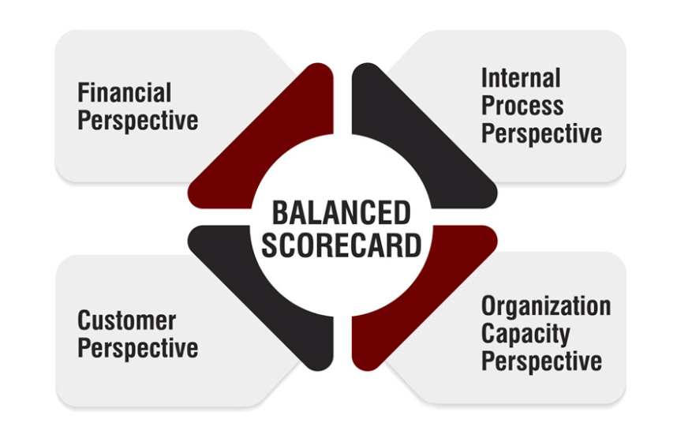
Figure 6: Balance Score card
(Source: The Strategy Institute, 2024)
Financial Perspective:
The financial view will be concerned with the ability to provide sustainability to the financial profitability of the expansion of the Lloyds Banking Group to Indonesia without affecting the high capital efficiency and shareholder value (Hidayat et al., 2025). The ultimate goal is to achieve incremental revenues based on digital-based banking services and manage the expenses in an extremely competitive emerging market. Financial success is measured using key performance indicators like revenue growth, cost -income ratio, and Return on Tangible Equity (RoTE). These are in line with the Group 2026 strategic commitments of Lloyds which focus on disciplined capital allocation and a RoTE of more than 15%. The stage-based development plan will enable Lloyds to widen its operations over time, lowering the risk on the financial front once it enters the market. Also, robust financial management and performance tracking helps to create long-term value through making sure that digital investments in cloud infrastructure, artificial intelligence, and analytics can be converted into real financial returns. All in all, financial perspective helps to ensure that the strategic expansion goals are affordable and connected to the expectations of shareholders.
Customer Perspective:
Customer perspective will be measuring the capability of Lloyds to attract, satisfy, and keep customers in Indonesia that is a fast-growing digital banking sector. Since the mobile penetration rate is high, and more people are shifting to digital financial services, customer-centric measures like digital banking usage, mobile application use, Net Promoter Score (NPS), and customer retention rates are key measures of success (Baquero, 2022). Customer growth and engagement targets indicate the high digital adoption trend in Indonesia and the successful experience of provision of high-quality digital banking demonstrated by Lloyds. Automation and AI-enhanced credit checking help to reduce the time of loan approval, making customers more convenient and trustful, which are important aspects of differentiators in the competitive banking sphere. Lloyds expects to achieve a powerful and trusted brand image in the Indonesian market because it concentrates on customer satisfaction and long-term relationship building in the market. Such an outlook will make sure that the creation of customer value will be directly related to the revenue growth and penetration targets.
Internal Process Perspective:
Internal process approach will be concerned with operations efficiency, technological perfection and regulatory compliance that is essential to the successful banking operations in Indonesia. Lloyds tries to use its competitive advantages in the field of artificial intelligence, cloud computing, and sophisticated data analytics to optimize its business operations and improve the delivery of its services. The useful measures, including the number of artificial intelligences uses cases implemented, adoption of cloud infrastructure, and accuracy of credit risk models, are important indicators of how committed the organisation is towards innovation and risk management (El-Mansouri, 2023). It is especially crucial to ensure high regulatory compliance scores in the context of strict financial regulations in Indonesia and reputational risks of not complying with them. The increase in operational efficiency will help show that Lloyds has the capacity to provide scalable and low-cost digital banking services without sacrificing the level of good governance. This outlook will help the internal processes to be effective in supporting customer expectations and financial performance, and this will allow Lloyds to gain competitive advantage through operational excellence.
Learning and Growth Perspective:
Learning and growth perspective will be focusing on the building of organisational capabilities needed to ensure a long-term success in the Indonesian banking market. It entails the investment in the local talent acquisition, the ongoing employee training, the development of leadership, and the diversity programs (Ibrahim, 2024). Development of local human resource improves culture and regulatory awareness that will be crucial when running the business in Indonesia. The number of training hours per worker and management succession preparation markers is a guarantee that employees have the technical and managerial skills required to facilitate digital transformation. Besides, building collaborations with fintech companies and technology vendors further develops the innovativeness at Lloyds and enhances the creation of new digital solutions. The emphasis on innovation pipeline projects shows the dedication of the organisation to the constant improvement and flexibility.

Triple Bottom Line Performance Framework
Here is the same section rewritten explicitly around People, Planet and Profit.

Figure 7: Triple Bottom Line
(Source: author)
People (Social Value)
The essence of the people-oriented goal will be to financial inclusivity, and a goal of having 500,000 new bank account holders by Year 3, focusing on underserved and unbanked communities. Social value is also improved by the IDR 1.5 trillion cumulative MSME lending by Year 5, which would empower the entrepreneurs and local employment. The target of community development programs is to educate 1,000 people on the topic of financial literacy annually, employment targets to be 450 direct local employees and over 1,200 indirect employees by the Year 5 (Lloyds Banking Group2025). Indonesia will have inclusiveness and sustainable development agenda by at least 25% of its lending portfolio in support of socially and environmentally friendly projects.
Planet (Environmental Value)
Environmental performance focuses on minimizing the environmental impact of the operations and financing processes. The aim of the operational emissions is to reduce it by 40% by 2030 based on the broader group of 36.2% since 2018. The green finance targets are IDR 800 billion in sustainable lending which is a direct support to the climate and energy-transition commitments made by Indonesia (Lloyds Banking Group, 2025). A digital first operating model aims at 95% cloud-based infrastructure to cut down on physical data centre emissions and a responsible procurement policy also includes screening all fintech and ecosystem partners against sound environmental, social and governance standards.
Profit (Economic and Governance Value)
An integrated performance and review system manages profitability and good governance. Key indicators are monitored monthly as the management reviews the real time indicators in order to detect deviations in time so that tactical actions can be made to ensure the protection of revenue growth and cost containment. The Balanced Scorecard is used in quarterly strategic reviews to align the expansion strategy with market and competitive changes so that the Indonesia business is on target to achieve financial targets.

Conclusion
It is concluded that Indonesia will prove to be the most significant market for the expansion of Lloyd Bank in any international market. The key evidence for this can be associated with the evaluation of the internal and external business environment. In terms of external factors, economic growth and social factors majorly affect the brand's decision to enter the market. It is also concluded that the digital banking services and infrastructure in the country can also help the brand to expand into new markets, as it is favourable in the context of Lloyd Bank to expand its operations in the selected market. In addition to this, it is also concluded that political stability and complicated legal requirements are some of the major factors that might affect the brand's expansion plan in the market of Indonesia. The technological infrastructure in the country has been growing, which can make the expansion strategy of Lloyd Bank in the Indonesian market more feasible. The use of different strategic management tools was done to evaluate the current strategic position and performance of Lloyd Bank.

References
Abdul Hakim, S. N. N. A. H. (2025). Industrial training report: Bank Rakyat/Siti Nurfatin Nabihah Abdul Hakim. https://ir.uitm.edu.my/id/eprint/113166/1/113166.pdf
Andrian, B., Simanungkalit, T., Budi, I. and Wicaksono, A.F., (2022). Sentiment analysis on customer satisfaction of digital banking in Indonesia. International Journal of Advanced Computer Science and Applications, 13(3). https://www.researchgate.net/profile/Bramanthyo-Andrian/publication/359684655_Sentiment_Analysis_on_Customer_Satisfaction_of_Digital_Banking_in_Indonesia/links/6247cad68068956f3c61a229/Sentiment-Analysis-on-Customer-Satisfaction-of-Digital-Banking-in-Indonesia.pdf
Baquero, A. (2022). Net promoter score (NPS) and customer satisfaction: relationship and efficient management. Sustainability, 14(4), 2011. https://www.mdpi.com/2071-1050/14/4/2011
Candra, K. (2025). The Impact of Exchange Rate Fluctuations on Indonesia's Export-Import Performance. Available at SSRN 5258411. https://papers.ssrn.com/sol3/Delivery.cfm?abstractid=5258411
de Leede, J. and Fisher, S. (2022) Hybrid working and well-being: Results of the well-being study among UT employees, Wave 1 (of 2) 2022. University of Twente, June 2022. [PDF]. Available at: https://ris.utwente.nl/ws/portalfiles/portal/289304258/report_wellbeing_2022_wave_1_final_07_07_2022.pdf [Accessed on: 15/12/2025].
El-Mansouri, F. (2023). AI-Driven Financial Risk Analytics in Multi-Cloud Environments: A Distributed Computing Perspective. International Journal of AI, BigData, Computational and Management Studies, 4(4), 9-19. https://ijaibdcms.org/index.php/ijaibdcms/article/download/54/49
Expert Market Research. (2025) Indonesia Private Banking Market Size, Share, Trends, Analysis, Report and Forecast 2025–2034. [Online]. Available at: https://www.researchandmarkets.com/reports/6176278/indonesia-private-banking-market-size-share [Accessed on: 15/12/2025]
EY. (2022) Riding the wave of Indonesia’s financial services growth. [Online]. Available at: https://www.ey.com/en_id/insights/banking-capital-markets/riding-the-wave-of-indonesias-financial-services-growth [Accessed on: 15/12/2025].
Grant, R.M., (2021). Contemporary strategy analysis. John Wiley & Sons. http://111.68.96.114:8088/get/pdf/Contemporary%20Strategy%20Analysis_%20Text%20and%20Cases%209th.ed%20-%20Robert%20M.%20Grant_5844.pdf
Hidayat, G., Affandi, A., and Anwar, M. (2025). The Influence of Corporate Governance, Capital Structure, and Profitability on Firm Value in Banking Sector in Indonesia. International Journal of Business, Law, and Education, 6(1), 160-169. http://www.ijble.com/index.php/journal/article/download/991/883
Hossain, N. (2023). A comparative analysis of conventional and modern methods of credit risk assessment in financial institutions: implications for micro, small and medium enterprises (MSMEs). https://dspace.bracu.ac.bd:8443/xmlui/bitstream/handle/10361/22883/20104023_BBA.pdf?sequence=1&isAllowed=n
Ibrahim, Y. (2024). Best practices and strategies for talent acquisition, retention and development in Egypt. Leadership, 9(1), 35-49. https://pdfs.semanticscholar.org/62db/585e5bf811fadcc14448dae9408679644819.pdf
ICLG. (2025) Fintech Laws and Regulations Report 2025: Indonesia. [Online]. Available at: https://iclg.com/practice-areas/fintech-laws-and-regulations/indonesia [Accessed on: 15/12/2025].
Jameaba, M. S. (2020). Digitization revolution, FinTech disruption, and financial stability: Using the case of Indonesian banking ecosystem to highlight wide-ranging digitization opportunities and major challenges. FinTech Disruption, and Financial stability: Using the Case of Indonesian Banking Ecosystem to highlight wide-ranging digitization opportunities and major challenges (July 16 2, 2020). https://papers.ssrn.com/sol3/Delivery.cfm?abstractid=3529924
Ken Research. (2025) Indonesia Neobanking & Digital Lending Market: Future Outlook, Key Drivers, and Financial Inclusion Opportunities. [Online]. Available at: https://www.kenresearch.com/indonesia-neobanking-digital-lending-market [Accessed on: 15/12/2025].
Kusnawirawan, I., Syarkani, Y., Hernayati, H., and Waluyo, I. (2025). Safeguarding Investor Rights: OJK’s Regulatory Framework Including Management and Challenges in Indonesia’s Capital Market. Jurnal Multidisiplin Indonesia, 4(3), 193-201. https://jmi.rivierapublishing.id/index.php/rp/article/download/2243/965
Li, H. (2022). Absorptive, adopted and agile: A study of the digital transformation of Africa carriers (Doctoral dissertation, Middlesex University). https://repository.mdx.ac.uk/download/7cd677ee500b0fda6029cc7cfdf13a9b9c592e65ae564d9ca2ea493169a2bdf8/2651768/HLi%20thesis.pdf
Lloyds Banking Group. (2025) Artificial Intelligence at Lloyds Banking Group: Our AI Journey. [Online]. Available at: https://www.lloydsbankinggroup.com/who-we-are/group-overview/artificial-intelligence.html [Accessed on: 15/12/2025].
Lloyds Banking Group. (2025) Our operational emissions: Operational climate pledges and progress towards net zero. [Online]. Available at: https://www.lloydsbankinggroup.com/sustainability/climate-and-nature/our-operational-climate-pledges.html [Accessed on: 15/12/2025]
Lloyds Banking Group. (2025) Supporting customers with their financial wellbeing. [Online]. Available at: https://www.lloydsbankinggroup.com/who-we-are/our-strategy/financial-wellbeing.html [Accessed on: 15/12/2025]
Lloyds Banking Group. (2025), Lloyds trumpets GenAI knowledge hub’s impact. [Online]. Available at: https://www.finextra.com/newsarticle/46301/lloyds-trumpets-genai-knowledge-hubs-impact [Accessed on: 15/12/2025].
Lloyds bank, (2025). About us. [Online]. Available through: < https://www.lloydsbank.com/about-us.html > [Accessed on: 12th December, 2025].
Lloyds bank, (2025). CMA results. [Online]. Available through: <https://www.lloydsbank.com/current-accounts/cma-results.html> [Accessed on: 12th December, 2025].
Löyttyniemi, T. (2025). Financial Instability and Public Backstops during 2022-2023. Available at SSRN 5057446. https://papers.ssrn.com/sol3/Delivery.cfm?abstractid=5057446
Lynch, R., (2021). Strategic management. Sage. https://books.google.com/books?hl=en&lr=&id=MyAMEAAAQBAJ&oi=fnd&pg=PP1&dq=Lynch,+R.,+(2021).+Strategic+management.+Sage.&ots=lzgytVLlp_&sig=PfRmkWq9HZGWRIEkOaXK3RFIe8g
Market Research Indonesia. (2025) Indonesia Digital Banking Expansion Accelerates Fast. [Online]. Available at: https://marketresearchindonesia.com/insights/articles/indonesia-digital-banking-expansion-growth [Accessed on: 15/12/2025].
Mashetty, S., Challa, S. R., ADUSUPALLI, B., Singireddy, J., and Paleti, S. (2024). Intelligent Technologies for Modern Financial Ecosystems: Transforming Housing Finance, Risk Management, and Advisory Services Through Advanced Analytics and Secure Cloud Solutions. Risk Management, and Advisory Services Through Advanced Analytics and Secure Cloud Solutions (December 12, 2024). https://papers.ssrn.com/sol3/Delivery.cfm?abstractid=5210755
McKinsey & Company. (2025) Southeast Asia quarterly economic review: Q2 2025. [Online]. Available at: https://www.mckinsey.com.br/our-insights/southeast-asia-quarterly-economic-review [Accessed on: 15/12/2025]
Mordor Intelligence. (2024) Indonesia Financial Technology Services Market Size & Share: Trends & Growth Forecast (2024–2030). [Online]. Available at: https://www.mordorintelligence.com/industry-reports/indonesia-financial-technology-services-market [Accessed on: 15/12/2025].
PLATFORM, O., and AN, T. (2022). ECONOMY IN INDONESIA. https://caribou.global/wp-content/uploads/2025/04/Indonesia-report-Final-Master-for-Web-1.pdf
Puspitasari, E., Sudiyatno, B., Aini, N. and Anindiansyah, G., (2021). The relationship between net interest margin and return on asset: Empirical study of conventional banking in Indonesia. Academic Journal of Interdisciplinary Studies, 10(3), pp.362-374.
Rachmad, Y. E. (2024). Danantara and National Economic Resilience: Strengthening Indonesia’s Financial Stability. The United Nations Global Compact. https://www.researchgate.net/profile/Yoesoep-Rachmad/publication/397430322_Danantara_and_National_Economic_Resilience_Strengthening_Indonesia's_Financial_Stability/links/6917e946de81430982716289/Danantara-and-National-Economic-Resilience-Strengthening-Indonesias-Financial-Stability.pdf
Sakti, M., and Utami, K. (2024). THE URGENCY OF STANDARDIZING THE OPEN APPLICATION PROGRAMMING INTERFACE IN IMPLEMENTATION OF OPEN BANKING FOR CUSTOMER PROTECTION. Jurnal Hukum Samudra Keadilan, 19(1), 29-44. https://ejurnalunsam.id/index.php/jhsk/article/download/7471/4625
Statista. (2024) Digital banks – Indonesia. Statista Market Forecast. [Online]. Available at: https://www.statista.com/outlook/fmo/banking/digital-banks/indonesia [Accessed on: 15/12/2025].
Sultana, R., and Faisal, N. A. (2024). The Role Of Digital Banking Features In Bank Selection An Analysis Of Customer Preferences For Online And Mobile Banking. Available at SSRN 5049165. https://papers.ssrn.com/sol3/Delivery.cfm?abstractid=5049165
Suryani, I. P., Suri, A. G., and Shafira, Z. (2023). How fintech peer to peer lending affected MSMEs financial access: Case study Amartha. InFestasi, 19(2), 166-181. https://journal.trunojoyo.ac.id/infestasi/article/download/22921/8985
The Strategy Institute. (2024) A comprehensive guide to implementing the Balanced Scorecard framework. [Online]. Available at: https://www.thestrategyinstitute.org/insights/a-comprehensive-guide-to-implementing-the-basslanced-scorecard-framework [Accessed on: 15/12/2025].
Widjojo, R. (2020). The development of digital payment systems in Indonesia: a review of go-pay and ovo e-wallets. Economic Alternatives, 3, 384-395. https://www.unwe.bg/doi/eajournal/2020.3/EA.2020.3.03.pdf
Zulkarnain, M. A., Hayat, A., and Juniar, A. (2024). The Influence of Demographic and Economic Factors on Non-Performing Loans of MSMEs in Regional Development Banks. Asian Journal of Management, Entrepreneurship and Social Science, 4(04), 410-422. http://www.ajmesc.com/index.php/ajmesc/article/download/986/701

