Restaurant Roles and Responsibilities

Iris P.Barreiro Ekoro
Student #: 2127100
Food & Beverage Operation (BMIH 4002)
Tristan Hawkins

Restaurant Roles and Responsibilities
The restaurant roles and responsibility topic is really important in order to manage a good business. These responsibilities are not just for the front of house staff (FOH), it also applies for all the other things customers do not see, back of house (BOF) “ all the behind the scenes areas.” A restaurant is created by many members who form a working group to be able to offer an excellent customer service.
At the back of house, we can find the kitchen staff, chefs, in charge of preparing the delicious dishes. Washers or kitchen porters, in charge of the duties in the kitchen like wash dishes, and organise the kitchen. Also, they do administrative work in this area. What the customer is used to see everyday is the front of the house, they are the ones who welcome them to the establishment, such as the hostess, in charge of escorting us to the table and being the first to give us the menu. Bartenders, with notion of mixology when it comes to preparing our drinks. Waiters or servers in charge of take our orders, food or drinks, take payments. Also, helps with the cleaning. Last but not least, the restaurant manager. A restaurant consists of this and much more, but for me the most important role is the restaurant manager role.
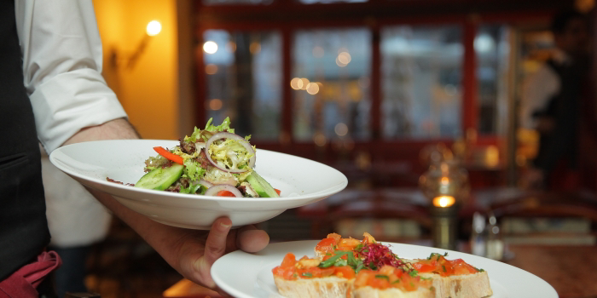
We all know that the restaurant manager is one of the most important roles to a restaurant. A restaurant manager has to be able to lead a group of people where everyone has to give a perfect work result. This entails a series of skills that are obtained throughout the experience. This can be hard or soft skills. Hard skills are the ability you learn through skills acquire at school. For instance a college degree. In the other hand, soft skills are abilities that you acquire through experiences. For example, problem solving. That is why it is very important to take into account at the time of promoting or hiring someone for the position. Everybody can work in a restaurant, but not everyone have the ability to manage one.
They have many responsibilities, apart from monitoring the restaurant accounts, making sure that orders arrive on time, inventory, customers complains. But, the most important role is to ensure the health and safety of the restaurant. In my opinion, a good restaurant manager is a leader, not a boss. A leader cares about all aspects, if necessary pushes the car with you. In the other hand, a boss only cares about money without caring about the interests of those who make the team. Throughout these weeks, I have learned that there are several functions that characterise a manager but the most important are: planning, organising, leading, staff and controlling. First of all, a manager should be able to plan, to choose appropriate goals to pursue and be able to find a strategy to reach them. Secondly, organising workers to be able to work together with each other it is very important. It is important that workers get along with each other. It is way to be able to facilitate a harmonious workplace. Both, those who are facing the public and those who are not. Thirdly leading, a vision a motivation for workers, inspiring words. Followed by staffing recruiting outsiders or promote people from the team. This point is very important, because here is where you see the hard and soft skills of your workers. Finally, controlling the phase where comparing and decisions are made to improve and take actions.
Although manager work is one of those that requires a lot of responsibility, it is also important to be able to identify duties and responsibilities of a restaurant such as; clean and tidy at all times, great and seat customers, provide a excellent customer service. This is the responsibility of all those who create the work team, to fulfil these tasks.To be able to provide professional service to the customer. As a result of this, a training is needed which should be given correctly by the mananger. Also, to run a successful restaurant we need consistency, team up with locals to offer a fresh product, minimum waste, practical and understandable menu’s. Social media, is taking a big part nowadays in the industry and gives possibility to expand. Regardless we are managing a big or small restaurant we should take all mentioned above in consideration.
In conclusion, roles and responsibilities are very important in a restaurant. But, for me the most important as I mentioned in my paper, is the role of a restaurant manager. From my experience, I rather work with a manager with soft skills, due the experience. In my opinion working from different areas of the company helps to have a better approach with your worker. This is a sector that innovates each year and having someone with the experience in charge of it with a prepared team is very important.
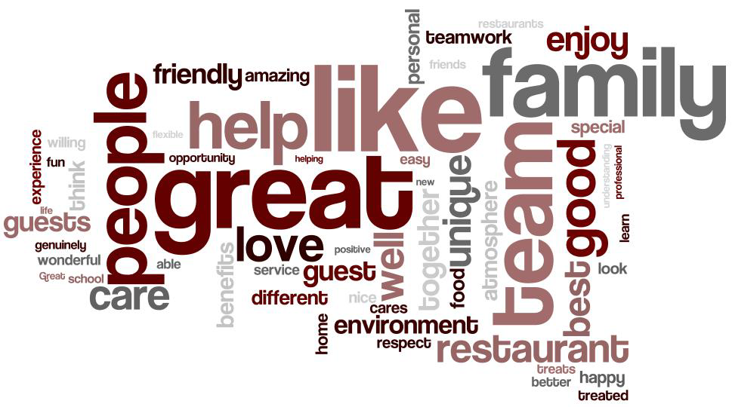
References
- Betterteam (2022) Job Description – Hospitality and Tourism Job Descriptions. Server job Description. Available at: https://www.betterteam.com/server-job-description.
- Chef recipe,I. (2017) Duties and responsibilities of a restaurant manager. Slideshare. Available at: https://www.slideshare.net/indianchefrecipe/duties-and-responsibilities-of-a-restaurant-manager.
- CultureAmp (2022) Employee Development – what makes a good mananger?. Available at: https://www.cultureamp.com/blog/what-makes-a-good-manager.
- Finedininglovers (2017) Food Infographics. 18 Fine job Roles Explained. Available at: https://www.finedininglovers.com/article/18-fine-dining-job-roles-explained.
- Hiringpeople (2021) Updated 7th September 2022. Blog. Key Roles and Responsibilities in a Bar and Restaurant. Available at: https://www.hiringpeople.co.uk/blog/key-bar-and-restaurant-roles/.
- Institute of Hospitality (2022) Hard skills and soft skills – what’s the difference? Available at: https://www.instituteofhospitality.org/professional-development/hard-and-soft-skills-whats-the-difference/.
- Kanishkatanwar (2018) Careers as hotel manager. Slideshare. Available at: https://www.slideshare.net/kanishkaTanwar/career-as-hotel-manager.
- Resources For Employers (2012- 2022) Restaurant Manager job description. Available at: https://resources.workable.com/restaurant-manager-job-description.
- Talentlyft (2022) Restaurant Server job description template. Picture. Available at: https://www.talentlyft.com/en/resources/restaurant-server-job-description.
- Tanji, H. (2014) Food & Beverage Service Training Manual With 225 SOP. United States: Createspace Independent Pub.

