Module Name- Problem Solving and Innovation
Student Name Dorina Whittingham
Student ID 2421723

Executive Summary
The key findings of this report imply that the UK High Street Retailers are under mounting pressures from external factors like rapid e-commerce growth, shifting preferences of the consumers, along with high business rates. In addition, many retailers struggle with outdated stores and formats along with workforce shortage and lack of innovation, which further weakens their competitiveness. To thrive in these aspects, the businesses must embrace market strategies and invest in technology to achieve positive outcomes. In addition, strong leadership and data-driven decision making, along with agility, are critical to sustain the relevance and profitability in an evolving retail environment that is shaped by economic uncertainty and changing shoppers’ expectations.
Table of Contents
Introduction 4
Findings 5
Conclusion 17
Recommendations 18
References 20

Introduction
The UK High Street retail is undergoing a profound transformation that is driven by shifting the behaviour of the consumers, along with maintaining economic uncertainty and technological disruptions. The traditional retailers, once central to community life, are now facing intense competition from e-commerce giants and rising operational costs, along with evolving societal values that aim towards maintaining convenience and sustainability. The aftermath of Brexit, the impact of COVID-19 19 and growing inflationary pressures have only intensified these challenges and are prompting many established brands the downsize or close together.
In addition, this report also aims to critically analyse the external factors influencing the performance and survival of the High Street retailers using strategic tools like PESTLE and SWOT. It will also explore how the PESTLE factors intersect to shape the retail landscape and will also analyse the internal strengths and weaknesses along with the external threats and opportunities to offer strategic recommendations to support retailers in coping with the dynamics of the changing environment.

Findings
Identification and analysis of the external factors impacting the High Street retailers
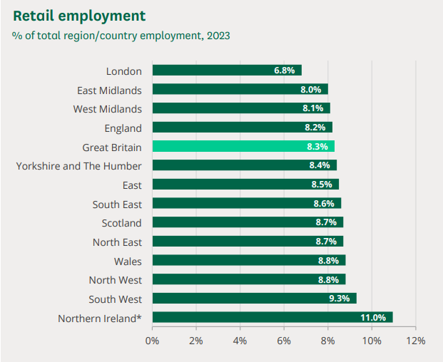
Figure- Retail employment of high street, UK
Source- (Ward, 2025)
The UK high Street, once the heartbeat of urban social and commercial life, is undergoing a profound transformation. From the collapse of well-known brands like Debenhams to the rapid growth of e-commerce, the retail terrain has become unpredictable and complex. In addition, the convergence of global events like Brexit, the COVID-19 pandemic, along climate change has generated a new reliability for brick-and-mortar businesses.

PESTLE Analysis
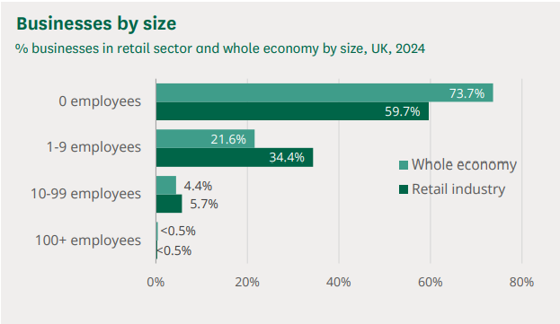
Figure- Analysis of the business of the high street by size
Source- (Ward, 2025)
Criteria Examples | Political | Economic | Criteria Examples
- Political Stability  - Trade regulations  - Government policies or legislation | The aspects of Brexit marked a seismic shift within the market of the UK’s international trade environment, and the introduction of tariffs, customs delays, along with the regulatory divergence, have also disrupted the establishment of the supply chains, along with the increased cost of imported goods. Therefore, the retailers importing fashion, electronics or food products from the EU now face heightened uncertainties. In addition, the political aspect emphasises local tourism and regeneration, which has prompted urban planning interventions aimed at revitalising town centres. Therefore, the government scheme, like the “Future High Street Fund”, also offers financial aid, but their long-term effectiveness also remains to be seen, and the aspects of political instability also rely on shifts in trade policies or election outcomes that also plays a crucial role in shaping the confidence of the business (Mintel, 2024). | The UK’s high rate of inflation and stagnant wages have eroded the purchasing power. In the years 2022 to 2024, inflation peaked at over 10% which was driven by the prices of energy aligning with post-pandemic disruptions. Therefore, as a household budget tightens, the shoppers have become more cautious and favour value-driven purchases. The retailers with physical outlets are also burdened by high operational costs and especially with the rate of business that disproportionately impacts the town centre stores compared to out-of-town retail parks or online warehouses (Dolega and Lord, 2020). | - Inflation and interest rates  - Consumer Purchasing Power  - Employment rates and wage levels
 | Social | Technological
- Changing consumer preferences  - Attitudes toward sustainability and ethics  - Demographics trends | The shopping habits within the UK have changed drastically, and modern consumers also prioritise convenience, sustainability, along digital engagement. Ethical concerns like supply chain transparency, carbon footprints, along labour practices are also influencing the purchasing decisions. Therefore, the rise of flexible arrangements has also further impacted the high street market as people spend more time working from home, and the commuter-based footfall has also declined, weakening the demand for fast fashion and convenience retailers in the city centres. On the positive side, localism has also encouraged consumers to support the independent shops along with the opening of differentiated and community-focused retail experiences. | The retail sector is undergoing a rapid technological transformation, and the expansion of e-commerce and m-commerce has also enabled consumers to shop anywhere and anytime. The retailers are unable to provide an integrated online and offline experience, which results in a decline in the market share. In addition, technologies like AI, AR and automated checkout systems are reshaping retail norms. While large retailers like M&S or Next are investing in the digital infrastructure and the small players generally lack the capital or expertise to compete within the dynamics of the business market (Langton et al., 2021). | - E-commerce development  - Mobile and contactless payment systems  - Innovation in customer experience
Criteria Examples | Legal | Environmental | Criteria Examples
- Data protection regulation  - Health and safety laws  - Employment and labour laws | Retailers are subject to a complex web of regulations, and the General Data Protection Regulation (GDPR) requires a transparent and secure handling of the data of the consumers along with secure handling of the data of consumers, particularly as digital engagement intensifies, especially in the wake of COVID-related adaptations. The employment disputes and regulations around the zero-hour contract also shape the hiring techniques and strategies (Orr et al., 2023). | Consumers and regulators are likely to push retailers to adopt more sustainable practices, from banning single-use plastic to requiring supply chain carbon footprint audits, and the environmental expectations are increasing (Bolet, 2021). | - Climate change and extreme weather impacts  - Sustainability and environmental impacts  - Green supply chain initiatives

SWOT analysis
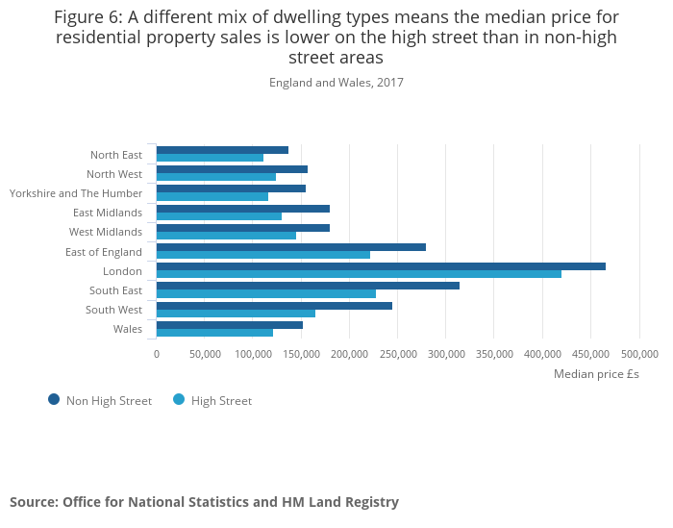
Figure- Internal analysis graph of High Street retail in the UK
Source- (ONS.gov.UK, 2019)
Strengths
Many UK high street enjoys high consumer trust that has been built over decades of consistent services. In addition, the stores also provide a tangible consumer experience that digital-only brands struggle to emulate, especially crucial for high-involvement purchases like fashion or electronics.
Weaknesses
The aspect of high fixed costs and the traditional retailers have been historically slow in adopting digital strategies or responding towards shifting consumer preferences (Costa Dias et al., 2020).
Opportunities
Leveraging tech towards the delivery of a seamless market experience, along with click and collect. The virtual try-ons, along with mobile exclusive discounts, can also differentiate the high street brands. In addition, strong sustainability credentials can also attract younger, purpose-driven audiences (Henry, 2022).
Threats
The fast and efficient online retail platforms set a high consumer expectation that brick-and-mortar stores struggle to match. In addition, the reduced consumer confidence, along with increased unemployment, also creates volatility in spending patterns (Anderson et al., 2021).

Conclusion
The high street faces unprecedented turbulence, and the interplay of political gifts along with economic constraints and sociocultural evolutions continues to rewrite the rules of retail. While the traditional retailers have some competitive edges, their grading heritage and face-to-face engagement, along with their survival, hinge on how they respond to the external factors. The tools like SWOT and PESTLE also support in diagnosing the state of play and informing the strategic responses, as the resilient High Street retailers have been those who embrace the changes and cope with the dynamics of the business market more by valuing the future of the UK high street retailers that might not resemble the past but can still thrive and it also provides the aspects of creativity, adaptability and purpose.

Recommendations
To gain knowledge of how the high-street retailers can navigate the evolving landscape, the examination of the external factors is conducted with the use of the PESTLE framework, consisting of political, economic, social, technological, legal and environmental factors. Therefore, the SWOT also used to assess the internal strengths and weaknesses related to external opportunities and threats of the UK high street retailers (Mintel, 2024). Furthermore, the over-reliance on footfall and the decline in in-store visits also expose vulnerabilities in business models that depend on volume-based revenues and as the population ages and moves away from city centres, the retailers might lose their traditional customer base unless they adapt their product and service offerings (Hunt and Rolf, 2022).
As an example, the seasonal products can become a liability if unexpected weather disrupts traditional shopping patterns, and the company's failure can also result in hefty fines along with reputational damage. The labour laws have also become a focal point, and the change in the minimum wage legislation, diversity, along with the requirements of inclusion and health and safety protocols, needs constant attention (Sarder, 2022). Therefore, climate change also presents physical threats that can impact both the availability of the product and the consumers' behaviour (Sesa and Hasnawati, 2023). Therefore, the recommendations also rely on the factors of PESTLE and the weaknesses and threats of the High Street retailers in the UK.
It is recommended to invest in an integrated market experience to remain competitive against digital-only brands, as the Highstreet retailers must blend physical and digital shopping experiences seamlessly. This aspect is related to the use of mobile applications that offer real-time stock visibility and expanding click-and-collect services. In addition, the consumers also expect a consistently honest experience, whether shopping online through mobile, would be authentic and proving their authenticity would also generate more consumer attraction and boost the sales volume of the business up to a certain percentage (Elmghaamez and Parajuli, 2022).
Additionally, it is also suggested to prioritise sustainability as the core strategy and the consumers' demand for ethical and eco-conscious communities, as the retailers should also audit their supply chains and reduce packaging waste along wth communicating clear and sustainability goals. The initiatives, like garment recycling schemes along with local sourcing and energy-efficient store operation, can also strengthen the brand reputation and foster trust. As an example, the launch of a green label, collection or showcasing carbon-neutral logistics can also provide a competitive edge while aligning with the national environmental goals (Jouan et al., 2022).

References
Anderson, P., O'Donnell, A., Kaner, E., Llopis, E.J., Manthey, J. and Rehm, J., (2021). Impact of minimum unit pricing on alcohol purchases in Scotland and Wales: controlled interrupted time series analyses. The Lancet Public Health, 6(8), pp.e557-e565.
Bolet, D., (2021). Drinking alone: local socio-cultural degradation and radical right support—the case of British pub closures. Comparative Political Studies, 54(9), pp.1653-1692.
Costa Dias, M., Joyce, R., Postel‐Vinay, F. and Xu, X., (2020). The challenges for labour market policy during the Covid‐19 pandemic. Fiscal Studies, 41(2), pp.371-382.
Dolega, L. and Lord, A., (2020). Exploring the geography of retail success and decline: A case study of the Liverpool City Region. Cities, 96, p.102456.
Elmghaamez, I.K. and Parajuli, M.A., (2022). Evaluating the failure of British Home Stores: a case study using Taffler Z-score model and SWOT analysis. International Journal of Teaching and Case Studies, 13(3), pp.241-258.
Henry, J., (2022). Writing at the crossroads: a linguistic analysis of academic business report writing at a modern UK university (Doctoral dissertation, University of Birmingham).
Hunt, W. and Rolf, S., (2022). ARTIFICIAL INTELLIGENCE AND AUTO MATION IN RETAIL. Friedrich Ebert Stiftung.
Jouan, N., Ogden, T., Black, J., Wood-Donnelly, C. and Coulson, S., (2022). UK strategy for the High North.
Langton, S., Dixon, A. and Farrell, G., (2021). Six months in: pandemic crime trends in England and Wales. Crime science, 10(1), p.6.
Mintel, (2024). Retail Trends: Navigating the Future of the UK Retail Industry. [Online] Available at: https://www.mintel.com/insights/retail/retail-trends-navigating-future-of-uk-retail-industry/#:~:text=Mintel's%20Retail%20Rankings%202024%20Report,protect%20prices%20for%20the%20consumer. [Accessed 25 06 2025].
ONS.gov.UK, (2019). High streets in Great Britain. [Online] Available at: https://www.ons.gov.uk/peoplepopulationandcommunity/populationandmigration/populationestimates/articles/highstreetsingreatbritain/2019-06-06 [Accessed 25 06 2025].
Orr, A.M., Stewart, J.L., Jackson, C. and White, J.T., (2023). Not quite the ‘death of the high street’in UK city centres: Rising vacancy rates and the shift in property use richness and diversity. Cities, 133, p.104124.
Sarder, M.M., (2022). Marketing plan for Mixmart: Marketing communication perspective.
Sesa, P.G.E. and Hasnawati, H., (2023). Analysis Of Financial And Non-Financial Performance Of The 3 Largest Companies In The United Kingdom’s Apparel Retail Industry For 2018-2022. Enrichment: Journal of Multidisciplinary Research and Development, 1(9), pp.610-629.
Ward, M., (2025). Retail sector in the UK. [Online] Available at: https://researchbriefings.files.parliament.uk/documents/SN06186/SN06186.pdf [Accessed 25 06 2025].

