Jacob C – 2420842 – Embedded Electronics
2420842@student.uwtsd.ac.uk
Abstract
A project proposal for an ammunition and misfire tracker aimed to be used within airsoft.
Providing players with tactical insight into the condition of their equipment and current situation.
Airsoft ammunition and misfire tracker
Project Proposal – Engineering Project Management

1. Summary 2
2. Introduction 2
3. Project Aims and Objectives 3
4. Device Description and Specifications 3
5. Project Tasks and Works Breakdown 5
6. Gannt Chart 6
7. Critical Path Analysis 7
8. Milestones and Deliverables 8
9. Risk Management 8
9.1. Identified Risks 8
9.2. Risk Mitigation Strategies 9
10. Environmental and Societal Impact 10
11. Ethical Considerations 10
12. Quality Management 11
13. Equality, Diversity, and Inclusion. 11
14. Conclusion 12
References 13

Summary
The proposed device is a custom magazine to be used in airsoft, designed in such a way to enable the user to view their current BB count in real time, granting the player a tactical advantage over their opponent.
This device would also be paired with a barrel attachment to enable the player to track any potential misfires within their weapon, providing insight into the condition of their equipment. The counter display would also be detachable from the magazine unit, allowing the player to fit the counter to wherever it would be more convenient for play.
The product is estimated to take 12 weeks to produce, providing ample time for any redesigns required for the product, with the product expected to be completed before this 12-week deadline. The breakdown of the timeframes are as follows:
- Design/Prototyping: 2 weeks
- Production: 4 weeks
- Assembly and Redesign: 4 weeks
- Testing: 2 weeks

Introduction
Within the tactical sport of airsoft, many players are left in ambiguity as to the current state of their equipment, being unaware as to when they may possibly need to reload, or if there is potentially a problem with their equipment.
This project aims to introduce a new tool into the airsoft atmosphere, assisting players in making key tactical decisions by providing them with essential information to do with the status of their equipment, enabling them to make the split-second choice between delving further into enemy territory or falling back to resupply, instead of continuing in ignorance of any potential problems that could be approaching.
The following sections will outline the steps involved in implementing a new system in airsoft equipment, including the project timeline, constraints and expected outcomes.

Project Aims and Objectives
The overall aim of this project is to create a custom ammunition magazine, to be used in Airsoft to keep track of the players’ current ammunition count at a glance, with an optional toggle to allow players to track any potential misfires within their weapon highlighting any potential faults within the weapon. The product is aimed at being discreet and hidden within what would appear as a regular magazine. However, it would have a removable display on the side to be fit wherever else the user would deem fit, and the magazine would be designed to be in a format that would support most standard airsoft rifles.

Device Description and Specifications
The product will show the current ammo count for the weapon whilst also tracking any potential misfires within the magazine, displaying misfires as separate statistics. Featuring a push button on the side of the device which would switch the statistic display between datasets using a single small display.
The display used will be a 4-digit display using seven segment displays to show each individual digit, featuring multiple colour potential to allow the user to see which dataset is being displayed showing red for misfires, blue as the current BB count, and green as the current low ammunition threshold.
The display will flash when the remaining BBs pass below a set percentage to alert the user when BBs need to be refilled, this threshold will be set using a rotary encoder, which will protrude from the magazine as a dial. This threshold will show on the display when being set, holding the display in this state for 2 seconds without input, before returning to the previous state.
Minimum ammo count will be determined using a custom airsoft magazine set to a specific capacity, built for specific weapons, using the industry standard BB size of 6mm with a weight of 0.2g-0.25g.
Misfires will be tracked using a barrel attachment to work wirelessly with the magazine to detect when the trigger airsoft gun is pulled and the weapon fires and then checks with a sensor attached to the end of the barrel which will detect when a BB leaves the barrel, if no BB is detected when the weapon is fired, a misfire will be counted.
The display module will be removable, enabling the user to place it wherever is convenient to them, switching to a direct connection when placed on the magazine.
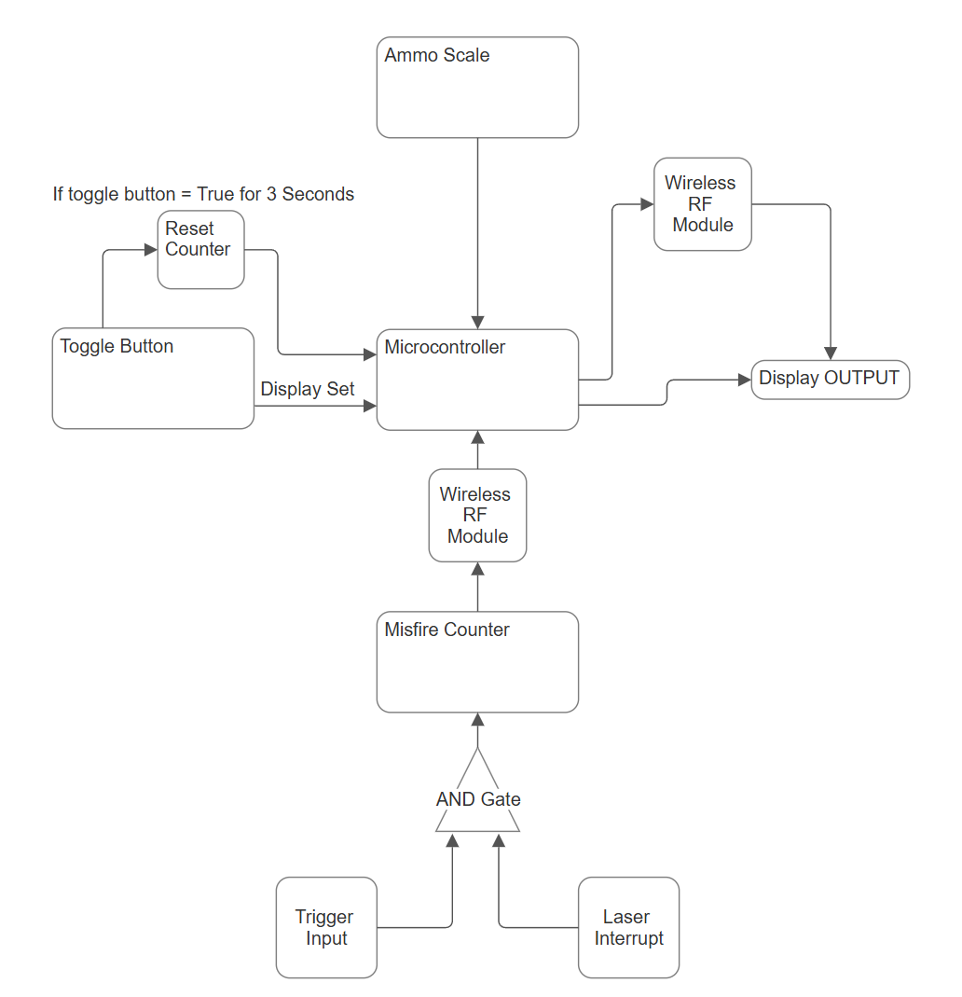
Figure 1: A block diagram showing the internal workings of the product

Project Tasks and Works Breakdown
The figure below highlights the expected works to be carried out within the project broken down into four levels to complete the overall project.
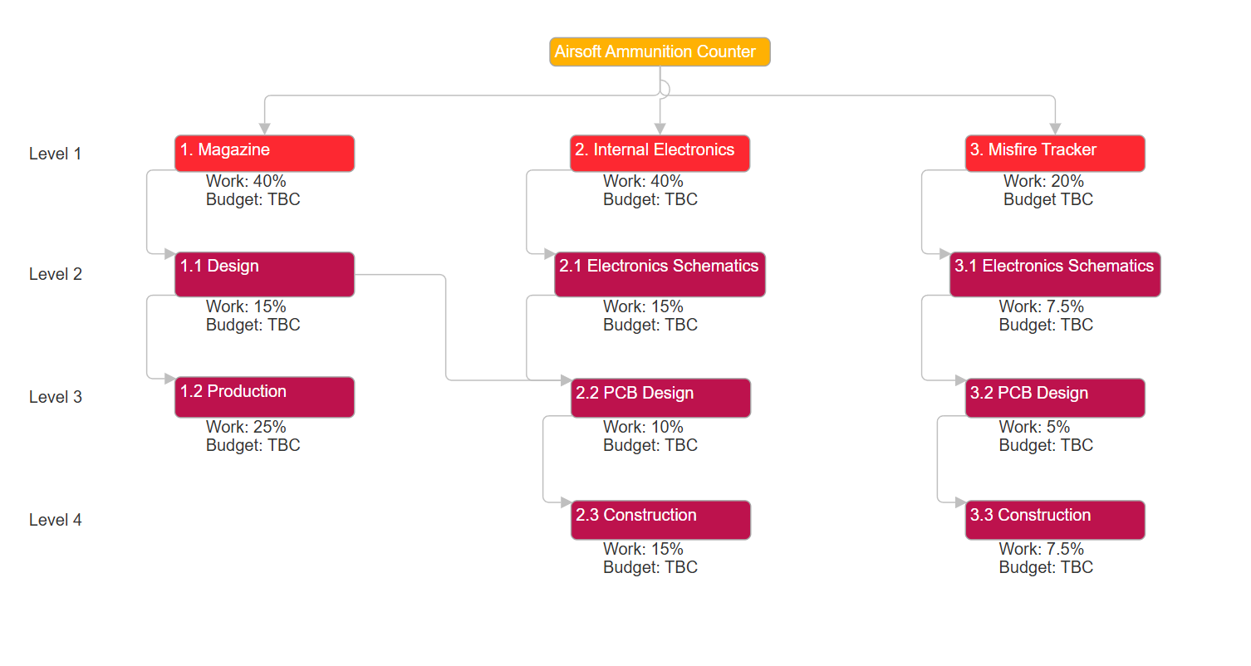
Figure 2: A work breakdown diagram outlining the steps and works involved in the design and production of the product, with predicted workload percentages.
Level 1 highlights the key areas of work required to be done, with ‘1.’ Showing the Magazine, this would be the production of the shell which would house all of the components and mechanisms. ‘2.’ Details the steps involved in production of the internal electronic components to be housed within the magazine, and ‘3.’ Details the steps involved in the production of the misfire tracking module, which sits at the end of the barrel.
Level 2 covers the first step in the production of each stage, with the work allocation being a percentage of the initial value shown at level 1. ‘1.1’ is the design stage for the magazine, where the initial technical drawings would be designed in order to begin production, these drawings would have to be accurate to standard airsoft magazines, whilst also leaving enough space to house all of the electronic components. This design would also be required to be at a certain level of complexity so that when the design is sent to production later in the process, the design is not so complex that it cannot be cheaply produced in larger quantities, which would cause production fees to increase massively.
‘2.1’ and ‘3.1’ show the electronics schematics design phase, where a designer would be responsible for outlaying the circuit schematics so that the PCBs could be designed and constructed in the later phases. When the PCBs enter the design stage, the designers would be required to keep the PCBs to a small enough size so that the boards can fit inside the required modules whilst leaving space for the mechanical components.
Upon the completion of all of the works laid out above, it would be possible to enter the assembly phase where all of the individual parts would be collated to a single piece where it would be sent to testing for final checks.

Gannt Chart
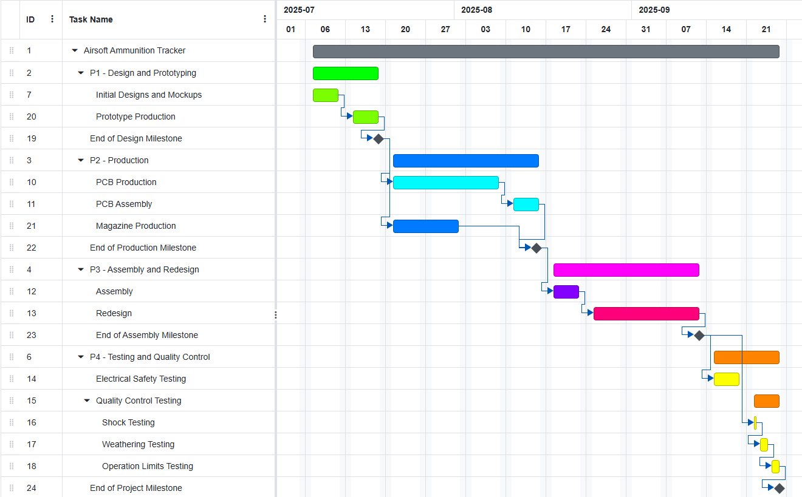
Figure 3: A Gannt Chart outlining the overall predicted project timeline
The above Gannt chart outlines the overall predicted project timeline, broken down into four phases, over the course of 12 weeks. Milestones are set to the end of each phase to allow for review of the project progress.

Critical Path Analysis
Job No. | Description | Immediate Predecessors | Time (Days)
A | Start |  | 0
B | Product Magazine Shell Design | A | 3
C | Electronics schematic Design | A | 2
D | PCB Design | C | 3
E | Magazine Prototyping | B | 5
F | PCB Production | D | 15
G | PCB Assembly | F | 5
H | Magazine Production | E | 10
I | Product Assembly | G, H | 5
J | Product Redesigns/Touchups | I | 15
K | Electrical Safety Testing | J | 5
L | Shock Testing | K, J | 1
M | Weathering Testing | L | 2
N | Operating Limits Testing | M | 2
O | Finish | N | 0
Table 1: A table highlighting the critical path analysis of the project
These times were calculated based on the complexity of the task required and the typical time taken to complete the task, with additional time added to allow for any potential reworks required for the product.

Milestones and Deliverables
Milestones are set to be measured at the end of each project phase, allowing for timeline revisions wherever necessary. The first milestone is set to be completed at the 2 week point from project start, the second at week 6, the third at week 10, and the final milestone at week 12.
The first phase milestone will be acknowledged as complete upon the finalization of the designs and prototypes, where production is ready to begin. The second phase milestone will be completed upon the successful production of the magazine shell and the electronic assemblies. The third phase will be completed upon the successful assembly of the product, where everything is in a working state fitted together, redesigning where necessary, ready for testing. The final milestone will mark the completion of the project, wherein the product will have been fully assembled, tested, and verified to be working and safe for use.

Risk Management
The following sections address any potential identified risks and the strategies taken in mitigating them.

Identified Risks
LIKELIHOOD | SEVERITY
LIKELIHOOD | ACCEPTABLE  Little to no effect on event | TOLERABLE  Effects are felt, but not critical to outcome | UNDESIREABLE  Serious impact to the course of impact and outcome | INTOLERABLE  Could Result in disaster
IMPROBABLE  Risk is unlikely to occur | Delays to manufacturing due to error. | The product could draw too much current from battery. | Product could damage attached equipment, i.e. the airsoft rifle. | Battery Failure resulting in harm.
POSSIBLE  Risk will likely occur | Loss of product during manufacture. | Product could be unfit for use in competitive play. | Unit cost could be too great vs return. | Internal Mechanisms could get damaged and stop functioning.
PROBABLE  Risk will occur | Shipping issues. | Users could misuse the product to threaten others. | Product could wear to a point causing mechanical failure. | Users could come to harm from impacting with product.
Table 2: A risk management chart showing different risks and their potential severities.

Risk Mitigation Strategies
Some risks, depending on the severity of the threat, could be accepted as a potential variable that could happen due to lack of risk in the risk, the acceptable risks will be treated as such.
INTOLERABLE:
- Battery Failure – This risk could be reduced by using a different type of battery instead of lithium, potentially reducing capacity but preventing battery failure.
- Internal Mechanisms damage – This risk could be reduced by minimizing the amount of moving parts within the product, and potentially by lining the interior of the product to reduce shock impact.
- User Harm from impacting with the product – Due to the nature of user error, this risk is nearly unavoidable, however the chances of the risk occurring could be mitigated through using softer materials.
UNDERSIREABLE:
- Product could damage attached equipment – This risk is best avoided by ensuring that the product is designed in such a way that it would not damage the equipment it is designed to fit into.
- Unit cost vs Return – This risk can be reduced by evaluating the materials used in construction of the product, using cheaper materials where possible.
- Product wear – Product wear is an unfortunate certainty due to the nature of the product and the amount of handling involved in use; however, the product longevity could be extended by being designed in such a way that extends the products use.
TOLERABLE:
- Product Current Draw – This risk can be prevented in the design phase by using components and systems that require as little current draw as possible, extending product life on a single charge
- Product Unfit for Competitive Play – Due to the nature of competitive play, some organizations could forbid the use of the product, this is an acceptable risk due to the risk not being our responsibility.
- Users could misuse the product to threaten others – To prevent this the product will be designed in such a way that makes it look as unthreatening as possible, however due to human nature, this risk cannot be fully mitigated.

Environmental and Societal Impact
Potential environmental impacts of this product include:
- Battery sustainability
- Use of plastics
- Use of metals within the product
- Product Lifespan
To address these challenges, steps have been taken to minimize the environmental impact of the product.
The first step taken would be the use of rechargeable batteries within the product, allowing users to plug the product in via a power connection, saving the need to open the product to replace the battery.
The second step would be to utilize biodegradable plastics within the product, allowing the product, in the event of disposal, to degrade along with other biodegradable products and reduce the impact on the environment.
The third step would be the use of metals, where possible the use of metals would be kept at a minimum, allowing for easier separation of the product from other materials in the event of disposal.
The final step is the product lifespan, wherein the product would be designed to last as long as possible before failure to keep waste to a minimum.

Ethical Considerations
Steps have been taken to reduce the potential ethical ramifications involved in the production of the product, such as the use or misuse of the product outside of the intended scope, such as using the product in conjunction with an airsoft weapon outside of a game to threaten or intimidate members of the public, to assist in counteracting this the product will be designed with a blaze orange finish, to show that the weapon it is used with is not a real weapon. This is in line with the US code of federal regulations. [1]
As per the Modern Slavery Act of 2015 [2], any persons involved in the production of the product will be treated fairly and correctly as outlined in UK law, and in the event of processes being outsourced to external companies abroad, steps will be followed to ensure the safe and fair treatment of workers involved in the project.

Quality Management
Quality Management systems will be put in place for the production of this product, to ensure that the product meets the desired specifications, whilst also achieving a satisfactory level of quality.
Electronics testing is required due to the presence of electronics within the product, this includes electrical safety testing, which ensures the product meets safety standards to prevent electric shock, compliance testing, which verifies the product meets the requirements for safety and performance set by various regulatory bodies, and flammability testing, which assesses the products resistance to ignition and fire spread.
Electromagnetic compatibility testing is also required, where various variables will be measured, such as electromagnetic emissions from the product and connected cables, and the radiated electromagnetic interference from the product, to ensure the product does not interfere with other electronic devices. The product’s immunity to incoming electromagnetic fields will also be tested alongside the products resistance to electrostatic discharge.
Environmental testing is also required to ensure the product can survive various conditions and impacts without affecting the performance of the product. This testing includes temperature and humidity testing, vibration and shock testing, and corrosion testing.
Finally, functional testing is required to ensure that the product performs to the required standards whilst also verifying that all of the required specifications have been met.

Equality, Diversity, and Inclusion.
Equality, diversity and inclusion have been taken into consideration for this project. As such any people involved in this project will be treated fairly and without prejudice, this is in line with the UK Equality Act of 2010 [3]. Procedures will also be taken to ensure all people have their needs and requirements catered for, such as accessibility considerations, or gender-neutral toilets.

Conclusion
To conclude, the overall scope of this project is to introduce a new tool into the Airsoft community, to assist players in making key tactical decisions, whilst also ensuring that this tool is implemented in a way that is both sustainable to the environment, but is also socially acceptable, and is developed in a way that encourages these practices.
The overall timescale for this project is 12 weeks, with a budget awaiting calculation pending approval of the project. This 12-week time frame accounts for any potential reworks required for the design throughout manufacturing whilst also providing an overhead for any delays within production, with any potential risks being accounted for with mitigation strategies in place to prevent any damages, both financially and to the company.

References

[1] | Code of federal regulations, "Code of federal regulations," 11 May 2023. [Online]. Available: https://www.ecfr.gov/current/title-16/chapter-II/subchapter-B/part-1272. [Accessed 11 07 2025].
[2] | "Modern Slavery Act 2015," 26 March 2015. [Online]. Available: https://www.legislation.gov.uk/ukpga/2015/30/data.pdf.
[3] | U. Government, "Equality Act 2010," 08 04 2010. [Online]. Available: https://www.legislation.gov.uk/ukpga/2010/15/contents. [Accessed 13 07 2025].

Appendices

Appendix A – PREVENT Training Certificate

Appendix B - Equality, Diversity, and Inclusion Certificate


