Azora Hurd
BMHP5014_BIRM

Creativity and Value

Mind Map.
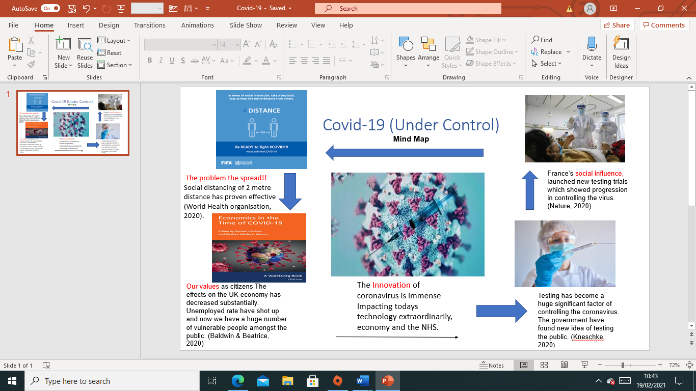

Blog.
The Coronavirus Pandemic
The covid -19 pandemic shocked the entire nation with deaths reaching to immense numbers, struck the world! The spread of the virus was the root of all caused!
The passion to stop the spread!! New creative idea’s came into play when the covid-19 vaccine was distributed all over the world and was considered mandatory to stop the spread. (NHS, 2021).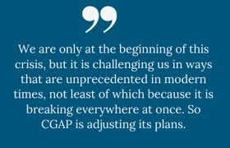
(Essay, 2020)
The Innovation of Covid-19 – Newer technology idea’s such as ‘Microsoft teams’, as well as testing and vaccines, has expanded and become the most popular way of meeting and discussing without face-to-face contact and risking the spread, implementing a safer way to keep contact and working with employees and others whilst being responsible (Jarmai, 2020).
Government and scientists really thought about how this huge world-wide pandemic can be reversed. Idea’s and creativity such testing sites started to unfold all over the world. The statistics of the number of deaths especially those coming in and out of the country, prove how deadly and fast spreading the virus is. 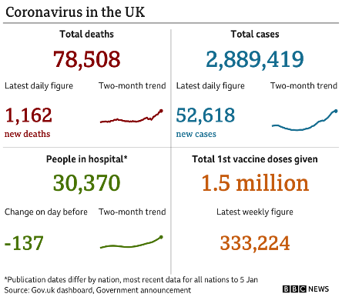(BBC, 2021). What can we do now to stop the spread and gain control over the virus!
New ideas to gain control: With new idea’s thought of by people who care about the spread of the virus and the affect it has had on people losing their family members, and also the passionate individuals who want to see the back of this virus and allow us to live a normal life again (Turner, 2020). Social distancing – Testing – Education – Hospitals – Economy. The creativity of the solutions to gain control over the virus has a had a huge impact of the number of deaths recorded. Social distancing has made a huge impact on gaining control over the spread, with rules applied by the government to stay home has shown immense results. Testing centres have broadened providing free test kits for everyone. The government decided that the idea of home school learning will decrease the numbers and the spread. Hospitals are to follow all strict protocol and wear all PPE at all times. The economy has been affected but with new ideas to keep business’s going, it seems to be above critical and new creative ideas are working.
The practical process of the Creativity of covid-19 ‘quarantine’ although social distancing was a critical idea, quarantine become the creative value of keeping our distance and staying home to SAVE LIVES. 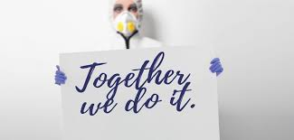(Innovation Origins, 2021). Ironically although we are keeping our distance and staying apart the value of quarantine is the thought process that we in fact all in this together and we will see the light at the end of the tunnel. This is how innovation creates creativity and value is added to implement solutions.
References
Baldwin, R. Mauro, B. (2020) ‘Economics in the time of the Covid-19’, CEPR press.
BBC (2021). Available at: Covid-19: Travellers to UK will need to show negative test result - BBC News (Accessed 16th February 2021).
Health Organisation (2020) Available at: Health organization - Google Search (Accessed 16th February 2021).
Essay. (2020) CGAP. Available at: Covid-19 blog - Google Search (Accessed 15th February).
European Commission (2020) Available at: European commission on Covid-19 - Google Search (Accessed 16th February).
France 24 (2020) Available at: France 24 Covid 19 - Google Search (Accessed 16th February). Innovation Origins (2021) Available at: pics of creativity of Covid-19 - Google Search (accessed 19th February).
Jarmai, K. (2020) Responsible Innovation – Business opportunities and strategies for implementation. Springer.
Nature (2020) Available at: nature covid 19 pics - Google Search (Accessed 16th February).
NHS (2021) Available at: Coronavirus (COVID-19) vaccine - NHS (www.nhs.uk) (Accessed 15th February).
Turner, E. (2020) Be Less Zombie: How great companies create dynamic innovation, fearless leadership and passionate people. Wiley.

