Identifying, adopting and assessing a software product to improve collaboration, communication and co-operation between health and care organisations in order to provide seamless care.
Introduction
Public Health Wales (PHW) are an all-Wales National Health Service (NHS) Trust, set up alongside many other trusts, health authorities and health board organisations to form NHS Wales. PHW work towards seven strategic priorities with the purpose of securing a healthier future for the people of Wales (Public Health Wales, 2018).
PHW recognises that the health, well-being and inequalities of patients are influenced by economic, social and environmental issues and with the organisation having a sway on local and national polices dealing with these areas, will be able to identify and suggest improvements (Public Health Wales, 2018 p.14).
PHW collaborate very closely with many other organisations and since the global pandemic in 2020, there has been a noticeable increased recognition that improved levels of communication and sharing between organisations and staff are necessary.
PHW host the NHS Wales Health Collaborative, who were setup in 2015 to deploy teams to work across organisational boundaries to improve the level of NHS care for patients in Wales by making recommendations on planning and shaping the NHS services for all of Wales.
The Collaborative consists of Programmes, Networks and Implementation Groups, covering a wide range of functional support for al-Wales programmes and projects, as well as clinical programmes.
Health Collaborative - Programmes
The programmes focus on teams collaborating with all NHS Wales stakeholders and partners. Priority is attributed to improving and prioritising benefits for healthcare staff and especially outcomes for patients.
Health Collaborative - Networks
These all-Wales networks bring together a focus for clinicians and other health professionals to work together. This provides input from appropriate experts in the relevant fields to advise on service-improvement and seamless patient pathways, by influencing the development and delivery of services.
Health Collaborative - Implementation groups
The groups deliver administrative and managerial support and guidance to major condition implementation groups across Wales. The groups were identified then the Together for Health (Welsh Government; NHS in Wales, 2011) strategy and was intended to underpin and delivery plans.
Despite the presence of technology within healthcare for forty years or more, its prevalence is only likely to increase even further, given the impact it’s had on delivering and improving increasingly-seamless healthcare.
Most organisations already have tools for sharing which had been deemed secure, but there was no recognised, unified tool in place to enhance the facility, thus offering far improved support to the font-line, patient-facing NHS staff, who need quicker responses to queries, without the frustrating complications of a multitude of differing software packages and varying technologies.
Technology, hardware and software, has historically played a critical role in supporting clinical and administrative support within the NHS in Wales and has helped staff increase the effectiveness and efficiency of patient healthcare (Ammenwerth et al.,2006).
There is also a tradition of a lack of confidence in changes in information systems, possibly due to evidence saying that 60%-70% of software projects fail, often due to the conflicting objectives of stakeholders (Ammenwerth et al.,2006).
Unfortunately, technological change can be difficult within the NHS and adopting new software isn’t always met with open arms. Driving this forward should be carried out with care, consideration and an abundance of planning and retrospective evaluation.
Staff within the NHS usually work in a way which requires three skills:
- Do
- Know
- Communicate
The “Do” refers to the work they need to carry out. The “Know” is the information they have and may refer to. The “Feel” is the necessity to communicate with other staff and organisations.
The following table is a matrix (Figure 1) of the functionality of Microsoft Teams (MS Teams) and how it fits into the Do – Know – Communicate skillsets:

DO  (Work) |  | KNOW  (Information) |  | FEEL  (Communication)
Personal productivity | Group productivity | Work information | Practical communications | Engagement | Inspiration
Office suite | Teams sites | Teams files / Wiki | SharePoint Online |  | Sway
OneDrive | Teams | SQL services | File services | Praise | Survey
Tasks | Forms | Delve |  | Yammer | Social media channels
Power Automate | Power Apps and Power BI (Communicator, Dashboards etc…) |  |  |  | Live Event
Approve App | Dynamics |  | Azure synapse | Traditional communications | Traditional intranet
Security and compliance
Figure 1, Microsoft Teams functionality matrix
Sometimes, the problem NHS staff experience is the lack of ‘joined-up’ working or the ability to use the information they have to work with other organisations in the interest of patient care. Timeliness and lack of emphasis on detail can make a huge difference to the speed and level of care a patient will receive.
MS Teams, built upon the same software modelling as Skype, can bring all of this into one place, avoiding the use of multiple applications simultaneously.
Microsoft Teams features and functionality
Effective and targeted communication and co-ordination forms the basis of successful collaboration between staff and organisations.
MS Teams employs an underlying framework for multi-organisational collaboration and co-ordination success.
Woods, Blunden, Elis & Webster outline “10Ps” (Woods, Blunden, Elis & Webster, 2019) which will influence how individuals use MS Teams, with the following benefits:
- Improved awareness of situations
- Enhanced focus time
- Increased levels of security when sharing documents
- Control of notifications from groups
- A method of conveying information to other individuals on their use of MS Teams
Finding a piece of software that is equally as useful to a nurse, as well as an IT technician or call-centre worker would be a daunting task, but MS Teams, alongside the plugin features achieves this.
10 Ps:
- Problem
  - Clarity of a problem makes clear the need to work collaboratively using Teams;
  - Teams avoid the situation of trying to solve multiple problems in the same ‘thread’ even if it has the same team stakeholders
- Purpose
  - Teams created with the goal/purpose at the crux
  - Rather than being based on organisational structure
  - Multiple Teams can have discrete purpose
  - Team names can identify the purpose, offering clarity for all participants
- People
  - All Team members can have a common purpose of solving the discrete problem
  - Teams with the small numbers of people will likely keep all conversation on task
  - Following approval, direct roles and responsibilities can be allocated within Teams conversation, with training outlined.
  - Additional moderators or Owners can be assigned to a Team
- Priorities
  - Satellite conversations and files need only be shared with a subset of people, allowing everyone to focus on their own priority areas
  - Full control of the number of channels/priorities within a Team
  - Numbers may be used to control order of sub-channels
- Principles
  - Discussions can take place around how individual members are expected to participate, and should last for the lifespan of the Team
  - Team members’ behaviours can encourage new behaviours and ways of working, to include sharing links, video-enabled meetings, personal profile updates and notifications settings. This can embed a culture of support and success
- Plugins
  - Teams can have customised tabs and bookmarks for ease of access to relevant common information or locations
- Permissions
  - Invitations may be sent to individuals in other organisations, which will not only give them access to participant in the chat, but also to the files being shared
  - More than one owner may be applied to a Team
  - Owners should be made aware that they have additional responsibility of managing Team members (joiners, movers and leavers)
- Performance
  - Success may be measured by observing not only individuals’ contribution and engagement within a Team, but also in the number of Team members
  - New skills of Team members will be visible to line-management
  - Relationships formed within a Team may facilitate other ‘breakaway’ Teams for collaboration on other tasks
  - Moving to using Teams may lend itself to staff development and improvement, with individuals potentially gaining a better sight of organisational values and goals, proposing new models of working in order to achieve them
- Provisioning
  - Most frustration may be around having sufficient elevated permission in order to be able to create a Team of your own. It may be necessary to approach IT for help
  - Minimum requirements will likely be in place when requesting or creating a Team, to retain control on duplicate Teams names or perhaps naming conventions or Team labelling
- Perishability
  - The closing of tasks will not make them lost. Learnings will always be available with key learned, which should be taken away and shared with organisations an stakeholders
  - SharePoint hosts all Teams and so they may be archived, but not deleted. Deleting a Team will permanently remove all content
Other collaboration benefits:
- Connecting users across organisations on areas of interest
- Access files held securely in the cloud from any enabled device.
- Direct video and voice meetings, messaging and the ability to share screen with anyone inside the tenancy host or with whitelisted third parties
- Host a custom team website, including document hosting and management to allow for smart access for all authorised users

Methods
Research, projects and studies report that approximately 60-70% of Information Technology (IT) projects fail, mainly due to low quality requirements analysis during initial project scoping to enable bringing a project to completion successfully, meeting full requirement, on time and within budget (Krigsman, 2019)
Krigsman goes into detail to outline that half of the failed projects were also labelled as “Runaways”, comprising combinations of the following shortcomings:
- Companies didn’t deploy staff with the capability of a sufficient standard of business analysis
- Projects exceeded the deadline by over 80% of what was expected
- Budgets were stretched to 60% of what was initially planned
- Projects only delivered 70% of the functionality of what was expected

There have been several methods devised for analysing the level of success of adopting an IT system. Information Systems Success (ISS) model, Technology Acceptance Model (TAM) and Task-Technology Fit model (TTF) and The Fit between Individuals, Task and Technology (FITT) framework are just a few examples.
In an attempt to address the issue of high volumes of IT project failures and recognizing the lack of acknowledgment that system adoption is rarely straightforward in the health and social sectors within the TAM and TFF frameworks, Ammenwerth developed the Fit between Individuals, Task and Technology (FITT) framework (Ammenwerth et al.,2006), focusing on trying to ensure that any intended benefits of adopting new IT systems are realised, taking into account socio-technical elements in order to achieve technical excellence and performance, particularly in the health sector.
Fit between Individuals, Task and Technology (FITT) framework
All models and tools used to measure ISS prior to Fit between Individuals, Task and Technology (FITT) have demonstrated limitations when it comes to accounting for the socio-organisational settings (Ammenwerth et al.,2006).
There will usually be different approaches to adoption, workflow patterns and patients across most organisations, and there will largely have varying levels of history of IT system adoption, which will in turn bring about differing levels of IT support. This can heavily impact the motivation of staff both positively and negatively.
Staff attitudes are also influenced by the level of management support which may be provided.
These differences and approaches undoubtedly account for wide-ranging acceptance and effects of systems adopted and Ammenwerth et al. raise queries around system adoption within specific medical settings.
The queries are expressing the necessity to be able to identify the “socio-organizational factors that influence adoption of an IT system.” (Ammenwerth et al.,2006 p.2) and using the findings to attempt to predict success/failure of system adoption within the settings.
The FITT framework necessitates identifying the actions of and differentiating between users (motivation and reluctance/nervousness to use computers), technology (features/functions and performance) and tasks (simple or complex?) when adopting IT systems (Figure 2).
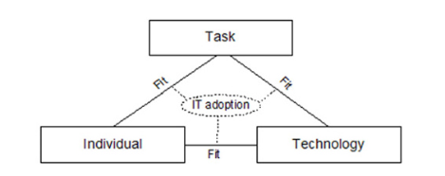
Figure 2, Fit between Individuals, Tasks & Technology (FITT) framework diagram
The framework also distinguishes that the task in question encompasses all that is to be achieved, using not just technology in terms of computers but also manual, paperwork. The user may be an individual or group of individuals.
The outcome of identifying these aspects is that it’s now possible to pinpoint that successfully carrying out the necessary task is now dependent on the motivation, skill and capability of the individual as well as functionality of the technology.
Applying the FITT framework
In order to apply the FITT framework, it’s necessary to gather data from users about their use of the adopted system. Sources of the data can range, or be a combination of:
- Surveys
- Interviews with user(s)
- Literature
- Observation
- Personal experience
- Any alternative source
Using a combination of the techniques above and following system adoption, PHW sought feedback, from users occupying several roles. These techniques included the System Usability Scale (SUS) survey, the IT Service desk call logging system and an interview with a Microsoft Customer Success Manager & Trainer, specialising in MS Teams.
The System Usability Scale (SUS)
The System Usability Scale (SUS) was created by John Brooke in the mid-1980s, developed to be able to quickly assess how individuals were using any particular system, with a view to identifying opportunities for improvement.
The questionnaire was designed to be “quick and dirty” (Brooke, 2013 p.34) comprising 10 questions. There are 5 questions with positive (odd) and 5 negative (even) statements, which users respond to using a choice of 5 scoring responses, ranging from “Completely Disagree” to “Completely Agree.” These scores are then converted into a score between 0 and 100, which was to fit in with project engineering project and programme managers (Brooke, 2013 p.34.)
The tool proved to be so reliable, that in 1986, Brook decided to release it to colleagues with no charge, with the licence to pass it on to any others whom were deemed to potentially find it useful.
SUS hasn’t been through any formal certification process, but both Brook and Bloom et. al refer to it as an “industry standard.” (Brooke, 2013 p.410.)
In order to determine which method to use to measure MS Teams usability, SUS is particularly suitable, since it was originally designed to evaluate a system called “ALL-IN-1”, which supported email messaging, word processing as well as to-do lists and a system for managing time (Brooke, 2013), not overly dissimilar to Teams itself.
When comparing validity of questionnaires, the simplicity of the SUS questionnaire showed to return fair results, relating to responder’s overall reaction to a product, rather than specifying more narrow areas for feedback (Tullis & Stetson, 2006.)
Service desk call-logging software reports
An organisation’s Service desk software is a tool often used to indicate how many service requests or incidents require IT support.
A service request is when a user contacts the IT department to ask for something where there’s a need to provide information around the nature of what they’re requesting. This is often a change to something, or perhaps access to something they don’t already have.
More commonly, an incident is usually unplanned, when users need support with the functionality or need to report the unavailability of a product or service.
Qualitative interviews
Direct interviews will usually provide qualitative information and will likely highlight relevant themes or areas to emerge, yet retaining control of the subject area.
The interviewee will be encouraged to submit their own views and offer more detail and explanation around these.
Responses can trigger additional questions, as happened with research into replacing hand-written documentation with electronic versions for physicians (Embi et al.,2004.)
Results
It must be noted that there were 42 SUS participants who:
- Operate in different areas of the organisation
- Have varying requirements of frequency and complexity of using MS Teams
- Work in an environment where global collaboration is essential
- Maintain multi-organisational all-Wales responsibility
Appendix A shows the questionnaire and possible responses used in this study.
SUS Grades
In order for the SUS responses to make sense to those more familiar with percentages, the SUS score may be converted appropriately, with grades ranging from A to F, but with no grade E (Figure 3.)
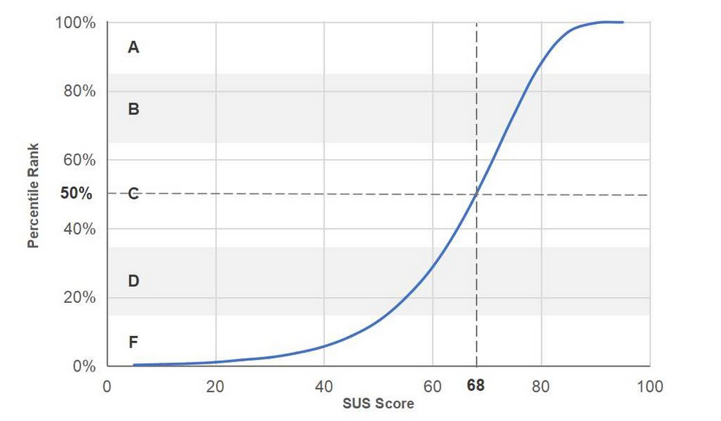
Figure 3, System Usability Scale (SUS) grade/percentage scale
The MS Teams SUS percentage was calculated as 70.8% within PHW, resulting in being classified as a grade B (OK – Good), and above the average score of 68%.
Service desk calls
Having run a report for the recent-most quarter, only 60 calls out of over 7,000 were found to be logged relating to MS Teams, with varying issues highlighted. Tis is under 1% and offers confidence that there is a high likelihood of successful deployment and usage.
Interview
During the interview with the Microsoft representative, as expected, many themes emerged, which triggered additional areas for thought, especially around using staff to help others in the organisation.
Analysis and commentary
Bar charts are an effective and easily tangible method of showing how the questionnaire was responded to:
Odd question average raw score chart
Figure 4 below shows the average score for each odd question alongside a horizontal line representing the overall average for all odd questions.

Figure 4, Average score for each odd SUS question

Odd question average raw score chart
Figure 5 shows the average score for each even question alongside a horizontal line representing the overall average for all odd questions.

Figure 5, Average score for each even SUS question

Gathering feedback for FITT
Whilst statistical reporting offers valuable knowledge, more information may be gathered from actually collecting and analysing the information, which in turn offer more qualitative feedback the SUS score itself.
Fit between task and technology
SUS feedback
The software is written with the intention of improving collaboration and co-operation amongst organisation staff, so responses from this area likely reflect on the functionality of the product in this area.
There were high scores on the positive questions of SUS, indicating that most users were satisfied with the software and that it was meeting the functionality that was expected, without becoming a negative, time-consuming burden.
Notably, fewer than 10% of users who responded said that they would require more help using the software to do their work.
Service desk feedback
Given so few service desk calls get raised around functionality of MS Teams, staff appear to be very comfortable with how the product helps complete the necessary tasks.
Interview feedback
A major factor of developing MS Teams was to bring a single pane of glass approach to developing it, where many other applications functionality has been brought into a single package.
This allows users to use just one tool to seamlessly carry out what previously required multiple, with the additional benefit of a single sign-on. eg. File-sharing, messaging, email, calendars etc…
Fit between individual and task
SUS feedback
Responses from this area reflect on the approach and attitude of the staff or whether sufficient opportunity was given for improving skillsets in order to use the product.
There were signs that users felt that the software was a little inconsistent to meet their needs, but this was again offset by the very high response values where staff considered the software easy to learn.
Service desk feedback
This is an area where, as expected following the hurried deployment, staff are more inclined to ask for help with how to do something, due to lack of specific training.
Approximately 30% of service desk calls related to this, which is lower than anticipated.
Interview feedback
Feedback from Microsoft was that efficiency had significantly increased in most organisations following the adoption of MS Teams, echoed by the Forrester report:
“Employees earn back on average 65 to 108 hours per year with the Microsoft Teams platform.” (Forrester, 2020 p.8.)
Fit between individual and technology
SUS feedback
Responses from this area reflect on the users’ skillset and availability of the software.
There was a very good response when querying the product’s ease of use. Further to this, staff responded in a positive way when commenting on confidence in using the product.
Service desk feedback
The IT Servicedesk experienced a significantly lower volume of calls relating to file management, which would imply a more readily-available and approachable system was now in place, with everyone having the tools to access things.
In addition to this, just having the tools isn’t necessarily enough, the minimal skill levels required for individuals to carry out tasks is underpinned by the intuitive software design.
Due to the relative familiarity of Microsoft products, most team members were evidence the ability to adapt very quickly to the new adoption.
Interview feedback
The Success Manager at Microsoft was very keen to point out that there were many situations where the culture of the staff of an organisation was to resist change in technology.
When challenged further, he commented that it was encouragement for staff to reach out to colleagues who were indeed able to embrace the change and to discuss how this affected them, thus creating a peer-to-peer learning approach within organisations.

Discussions
Initially at PHW, there was a technical strain on rolling out MS Teams. Whilst the requirement for adopting the software was acknowledged, the plan was to deploy the software much later, but the global pandemic forced not only PHW’s, but many organisations’ hands in moving quicker.
This increased both technical and consequential reputational risk, as the mobilisation planning phase wasn’t fully scoped for technical readiness, as was initially planned:
- Local technical delegation model & administration tools
- IT support model
- Staff technical training needs and resources
- Network capacity and configuration
- Hardware capability, including all mobile devices
Other major transitional works intended to follow this were also very rushed and many staff felt very uncomfortable as a result. Amongst others, the major areas here were:
- Installing/migrating software clients and data on all PCs
- Storage migrated to OneDrive
- Information Governance around file retention periods and sharing outside of the organisation
- Security and compliance

FITT discussions and limitations
Each of the three areas of FITT require the following attributes, which determine the quality of suitability:
User(s) require
- IT skills and knowledge
- Motivation and sufficient interest in the task
- Flexibility to change
- Adaptability
- Teamwork
- Compliance with organisation ways of working and strategic priorities
Task(s) include:
- Prioritisation and organisation
- Documentation and knowledge around interdependence
- Sufficient knowledge of complication
Technological
- Reliable and usable tool (software or hardware)
- Budgetary requirements
- Appropriate feature-set
- Suitable infrastructure model/support
- Availability of all necessary tools
The fit between all three of these areas can be directly affected by managerial changes.
Examples of this would be that documentation may improve the task-technology fit, training would enhance user-technological expertise and a dual-change might be adding a feature into a piece of software, which would alter the individual’s relationship with technology as well as improve the technology’s ability to carry out the task required.
Changes outside of management control, such as staff turnover or absenteeism, organisational priorities or technological breakthroughs or risks, may also positively or negatively change the fit.
Where the IT adoption fit is poor, there will be likelihood of problems. An example of this might be where poor scoping and communication of a software development might lead to low application functionality and a poor fit between technology and task. The causal effect of this may well be low motivation of staff due to the fit between user and technology also being poor.

Only data from within one organisation was used as a dataset, meaning a limited view of collaboration success will be presented. Whilst an effort was made to spread the survey across different operational positions, not all levels of seniority was covered.
It should be noted that the framework doesn’t specify the perspective from which success is being judged, nor does it employ a timeframe for the evaluation. There’s also little or no knowledge when it comes to comparison with other health organisations, other than the all-Wales tenancy standpoint, where it is known that all Health Boards will have access to MS Teams.
According to Ammenwerth and Rigby, how to best handle the findings of any stakeholder analysis is critical in allowing for planning and implementation when knowledge is limited (Ammenwerth et. al 2016.) The authors go on to say that differing perspective of users may well be less challenging with this consideration, but there must also be deliberation for the environmental differences which may also be present.
Indeed, this was also the major finding and proposal of Prgomet in 2019, when even when the FITT framework demonstrated fit between all three areas, other factors which were environmentally related also influenced how technology is used (Prgomet, 2019.)
Collaboration between organisations can encounter these environmental issues and an individual’s tasks may vary enormously when carried out under differing circumstances.
Email exchange, sharing documents electronically and smartphones are just a couple of areas which are suggested by Coiera as being critical to helping the patient care pathway, not only between organisations, but also between primary care and other specialist services (Coiera, 2013.)
Other available methods which may have been used to evaluate the adoption
Many other frameworks are available to evaluate a system’s usability, but they don’t offer the same level of consideration to the relationship between the user and the task.
Information Systems Success (ISS)
In order to compose their original ISS model (Figure 6), DeLone and McLean identify the following 6 areas as determining success. It’s recognised that they are not independent of each other, but rather, inter-related.
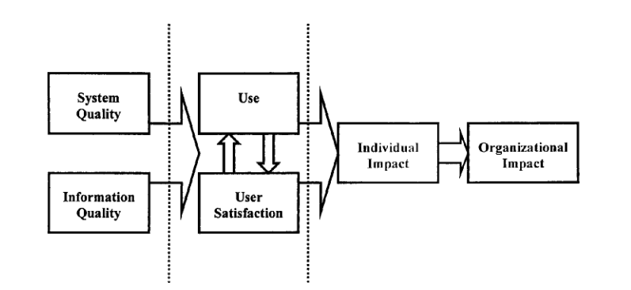
Figure 6: 1992 Information Systems Success (ISS) model (DeLone and McLean, 1992.)
DeLone and McLean also organise evidence of their 180 studies and citings into an approachable format as well as go about explaining the inconsistencies which appears in the content.
Other aspects of the paper highlight the areas where significant work was done so that others can concentrate their efforts effectively, but also notes areas where further research may be required, especially relating to the performance of an organisation.
In 2003, following a review and evaluation of their paper of ten years earlier, DeLone and McLean published an update to their ISS model.
The primary conclusion, based on empirical studies confirming the original as being useful, but requiring minor enhancements, was an updated mode (Figure 7.)
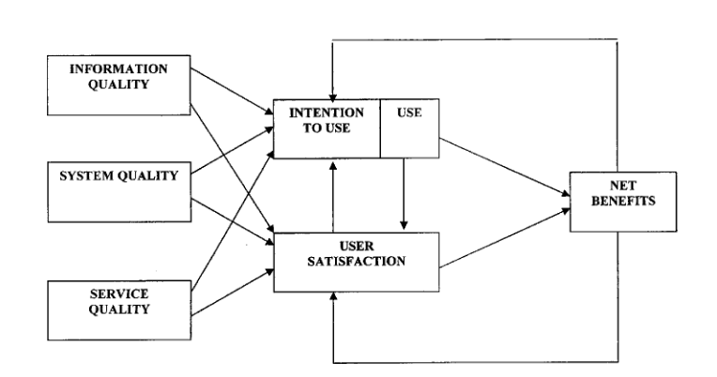
Figure 7: Model of Information Systems Success: A Ten-Year Update (DeLone and McLean, 2003, p.16)
The only changes in the operating model are the addition of “Service quality” and the merging of both impact outcomes into “Net benefits”, which the authors claim suggests little change from the original work, but were necessary given the support requirements of newer systems.
Technology Acceptance Model (TAM)
Prior to the publication of the Technology Acceptance Model (TAM) model, it was widely broadcast that the success of an adopted IT system was related to the design features and function of the application itself.
TAM outlines that there can be causal affects following changes to any IT system, stemming between any of these areas (Figure 8):

TAM model:
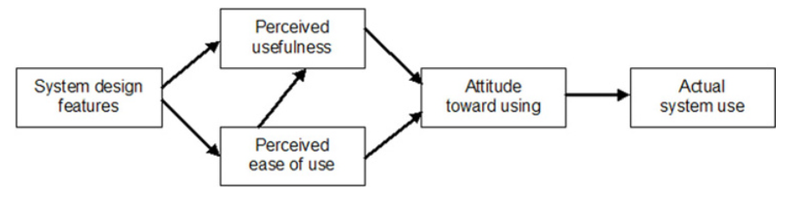
(Figure 8, Technology Acceptance Model (TAM) mode)
Concluding, TAM highlights how choices in software design are an informative guide as to the level of likely user acceptance and could be used as a prediction tool for this.
Task-Technology Fit (TTF)
Goodhue and Thompson’s TTF (Figure 9) model draws conclusions which state that IT systems are either voluntary or mandatory. Factors determining the success or failure of the former are widely measured in the usage of the system, whilst the latter focusses on how well the users accept the system (Goodhue and Thompson, 1995.)
TTF model:
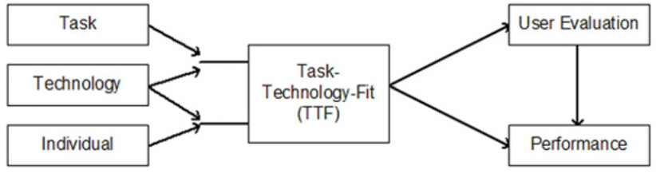
Figure 9, Task-Technology Fit (TTF) model

SUS discussions and limitations
A SUS is only an at-the-time snapshot and should be perceived as such. Conducting another survey at a specified time may offer other metrics if, for example, plans to provide enhanced or intense training opportunities for staff.
Other comparative usability methods which may have been used as a measure included “QUIS (Questionnaire for User Interface Satisfaction)”, “CSUQ (Computer System Usability Questionnaire)” and “Words (adapted from Microsoft’s Product Reaction Cards), but these were more complicated and time-consuming (Tullis & Stetson, 2006.)
Even though a final SUS percentage can be arrived at, consideration has been given to whether this is too vague without adjectives to help interpretation (Bangor, Kortum,and Miller, 2009.)
The Bangor, Kortum,and Miller research in 2009 drew upon previous work in this area by Bangor (Bangor, A. W., 2000) and Olacsi (Olacsi, G. S., 1998) concluded that adding an adjusted adjective scale to the SUS found the following:
- The SUS is still reliable and versatile
- The addition of the rating reflected very closely the same as the original measures
- Whilst the adjective scale would help understanding of the score, the choice of adjectives was questionable, as the variable connotations of “OK” was considered potentially too vague
- The adjectives improved the ability to convey feedback to users who don’t have the ‘hands-on’ knowledge of the tools and tasks being evaluated
- Consideration might be given to no longer use numbers at all, but to only use adjectives as an eleventh question (Figure 10.)
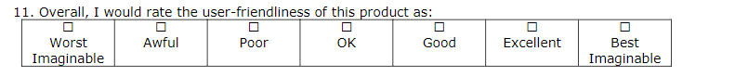
Figure 10, adjectives as an eleventh SUS question
A final point should be made regarding multiple question, multiple-choice surveys, which is that user don’t necessarily highlight the truth of a situation on them, nor do they allow for interpretation or nuance within a particular area of satisfaction or dissatisfaction (Oshagbemi, T., 1999.)
Service desk discussions and limitations
The MS Teams software was forced on staff with short notice and very limited training and support documentation. This included the service desk staff, who were expected to offer immediate support on a product even they’d never used.
Because of this, some of the feedback and attitudes of individuals was less than favourable.
It’s also been observed that the number of user raising support calls is far lower than the number of calls themselves, meaning that the same users are raising multiple calls.
On the face of it, this might imply that their skillsets are lower, but it may also mean that they are satisfied that the service desk will be able to offer appropriate levels of support.
Of course, given the very low call volumes, it may mean that users are turning to each other for help and guidance, which fits into the culture that Microsoft would encourage, creating a lesser burden on the service desk staff.
It could also be that staff aren’t carrying out the tasks at all, due to a poor fit between the task and technology and a causational negative effect on the user’s motivation and confidence with technology.
Interview discussions and limitations
The interview with the Microsoft employee was conducted over MS Teams itself, but it wasn’t recorded and should be remembered that the representative works for Microsoft themselves, which may offer a sway to agenda or responses.
During the first 18 months of the global pandemic, there was a requirement to issue 450 feature updates to MS Teams. Users were frustrated constantly trying to keep up with the developments and changes. Justification was that Teams was intended to be an “evergreen” product, evolving alongside operating systems.
From observations and queries raised with the IT service desk, this certainly caused frustration amongst early adopters.
Teams is also built on an old software model (MS Skype) and lacks some of the usability and requirements of competitor software, eg. Slack, but it mostly makes up for this by its integration with other applications within the Microsoft 365 suite.
Traditional behaviours amongst organisational staff was leading to most of the objections to adopting the software, with failure to change established cultures usually attributing to negative user responses in shifts to the platform.
General discussions and limitations
Unquantifiable benefits, highlighted in the Total Economic Impact™ Of using Microsoft Teams as a platform and Teams with Power Platform document (Forrester, 2020), which should also be noted when adopting MS Teams include:
- Increased employee engagement
  - Frustration was triggered for staff when having to switch between applications prior to using Teams, with the entire experience improving by having plugins and tabs at their fingertips
- Improved insights to influence decision making
  - Immediate access to shared data within a Teams channel allows for staff to feel engaged an empowered
- Better business outcomes
  - A familiar interface for hosing work-streams, even when collaborating with other organisations increases visibility and efficiency
A final point to make about a less-visible advantage of MS Teams is the avoidance of employees using 3rd party, publicly available apps and the security risks which comes with them to communicate with others.
Next steps
Using MS Teams to host regular meetings, to distribute widely what would otherwise be an email attachment, or to respond to someone’s query or meet on a video chat rather than a phone call will inevitably and significantly enhance co-ordination, communication and collaboration worldwide. In the health sector, this will unquestionably speed up and improve the patient’s pathway across all areas.
In November 2021, Microsoft also announced that collaboration in the metaverse will be rolling out to MS Teams during 2022 (https://news.microsoft.com/innovation-stories/mesh-for-microsoft-teams). This will see holograms immersed into the MS Teams experience, but still allow the full feature-set of collaboration benefits. They say this move comes after seeing that the tool has achieved improved effectiveness and engagement for users.

References
Ammenwerth, & Rigby. (2016). EVIDENCE-BASED HEALTH INFORMATICS.
Bangor, A., Kortum, P., & Miller, J. (2009). Determining What Individual SUS Scores Mean: Adding an Adjective Rating Scale.
Beynon-Davies, P., Williams, M., Beynon-Davies Bsc, P., Lloyd-Williams, M., & Ceng, M. (1999). When health information systems fail. Retrieved from https://www.researchgate.net/publication/12762077
Brooke, J. (2013). SUS: A Retrospective.
Delone, W., & Mclean, E. (2003). The DeLone and McLean Model of Information Systems Success: A Ten-Year Update.
Enrico Coiera. (2013). Guide To Health Informatics (Third ed.).
Goodhue, D., & Thompson, R. (1995). Task-Technology Fit and Individual Performance.
Honekamp, W. (2011). Application of the FITT framework to evaluate a prototype health information system Simulation-based Capacity Planning of Police Forces View project HITS-Moni View project. Retrieved from http://hmirc.de/index.php?id=77
Institute of Medicine (U.S.). Committee on Quality of Health Care in America. (2001). Crossing the Quality Chasm: A New Health System for the 21st Century. National Academy Press.
Irawati, A., & Mustofa, K. (2012). Measuring Software Functionality Using Function Point Method Based On Design Documentation. Retrieved from www.IJCSI.org
Kohn, L., Corrigan, J., & Donaldson, M. (2000). To Err is Human: Building a Safer Health System.
Lawson, E. (2021). NHS England NHS Improvement Meetings in Common of the Boards of NHS England and NHS Improvement Meeting Date: Thursday 27 September.
NHS Wales., & Wales. Welsh Government. (2011). Together for Health : A five year vision for the NHS in Wales. Welsh Government.
Public Health Wales. (2018). Working to achieve a healthier future for Wales - Long Term Strategy 2018-30.
Public Health Wales. (2020). Our workforce to achieve a healthier future for Wales.
Public Health Wales. (2021). Quality and Improvement Strategy.
Tullis, T., & Stetson, J. (2006). A Comparison of Questionnaires for Assessing Website Usability. Retrieved from https://www.researchgate.net/publication/228609327
Woods, P., Blunden, H., Elias, B., & Webster, D. (2019). Adopt and Embrace Microsoft Teams.

Appendix A
These are the statements taken from the standard SUS model which were issued to all participants, but referencing the system being assessed:
- I think that I would like to use Microsoft Teams more frequently
- I find Microsoft Teams unnecessarily complex
- I think Microsoft Teams is easy to use
- I think that I need assistance to be able to use Microsoft Teams
- I find the various functions in Microsoft Teams are well integrated
- I think there is too much inconsistency in Microsoft Teams
- I would imagine that most people would learn to use Microsoft Teams very quickly
- I find Microsoft Teams very cumbersome/awkward to use
- I feel very confident using Microsoft Teams
- I need to learn a lot of things before I can get going with Microsoft Teams
The scoring system of SUS offers a range of responses, scoring as follows:
Response | Strongly disagree | Disagree | Neutral | Agree | Strongly agree
SUS raw score | 1 | 2 | 3 | 4 | 5

