Object Analysis

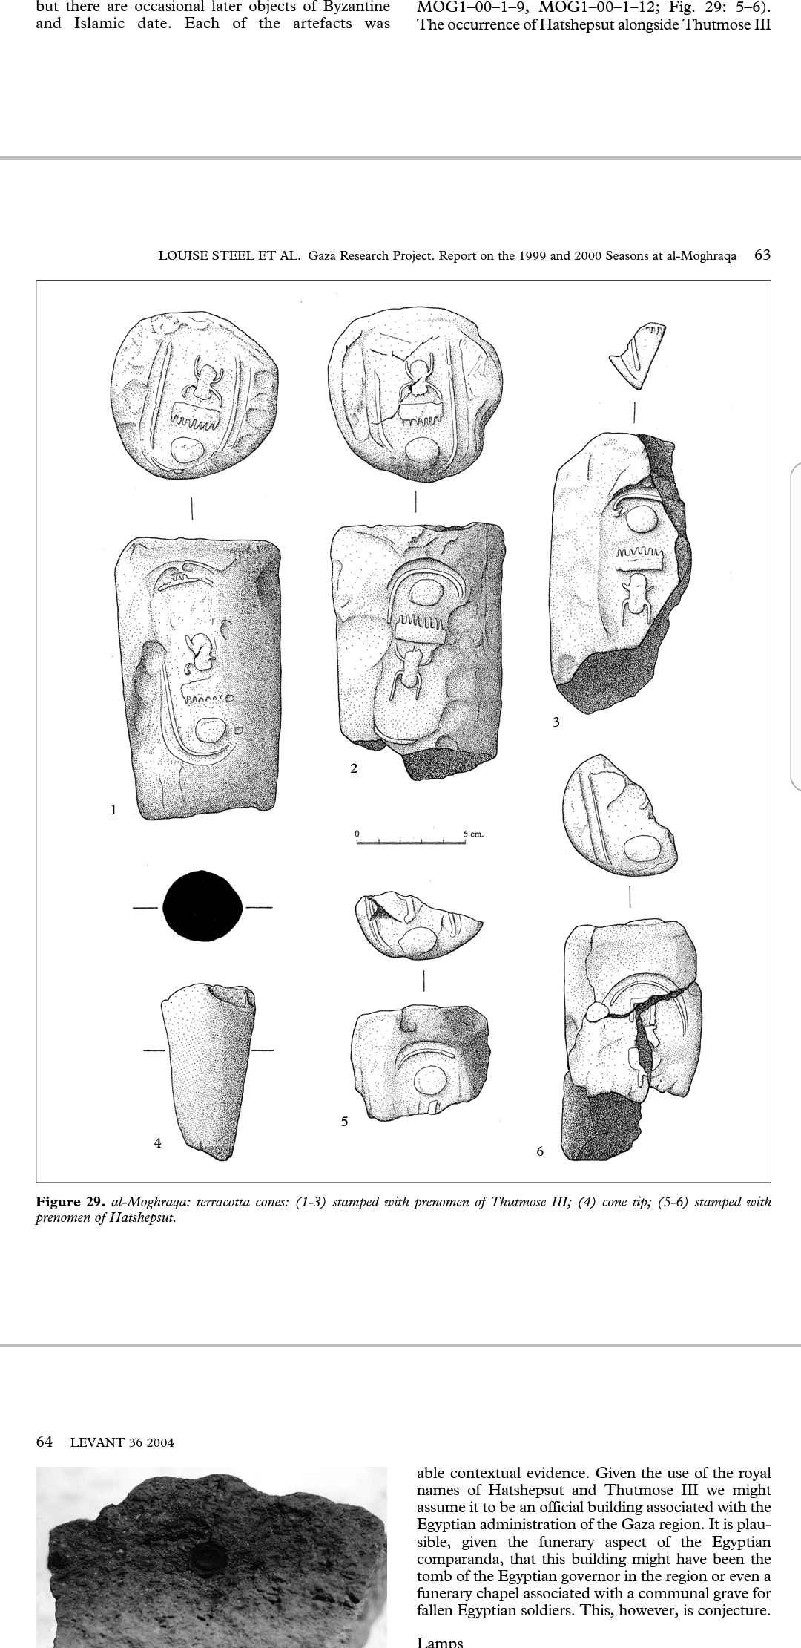
Terracotta Cone

Material: Clay
Length: 12.6 cm
Diameter of Base: 7.1 - 7.6 cm
Minimum Diameter: 6.1 cm
Site: Gaza, al-Moghraqa
Time period: Late Bronze Age

This terracotta cone is made of clay that was very dense in composition. Furthermore the cone was “badly fired and very soft” (Steel et al., 2004: 62). As can be seen in Figure 1 the cone has a flat base that slightly tapers down to a smaller circumference. Other than this cartouches of the prenomen of Thutmose III can clearly be observed on both the upper side and base of the cone, as well as the finger impressions left by the craftsmen that created this cone. With the prenomen of Thutmose III, on this cone and the prenomen of Hatshepsut on other cones found at al-Moghraqa, it can be assumed that these cones where created during their co-regency, around 1473-1458 BC.

There are two ways to interpret this “introduction of elite Egyptian practices to Gaza”(Steel, 2016: 5), either the cone was used in a batch “as the funerary equipment of an Egyptian official in Gaza” (Steel, 2016: 5), or this cone along with others found at al-Moghraqa were created for a Canaanite, perhaps one who had visited Thebes where Egyptian Funerary cones are prominent in the 18th Dynasty, “who consequently had some understanding of Theban demonstrations of status and wished to emulate them” (Steel, 2016: 6). If we take on the narrative of the Egyptian in Gaza then the dismantling of his tomb, assumed by the fact the cones were broken in antiquity, and the burying of the cones could mean that there was “as a deliberate act of resistance against the Egyptian administration” (Steel, 2016: 5). The burial of the cones would have been seen as a form of ‘social death’ by those that follow the biographical theory of objects, however myself along with Joyce and Gillespie would argue that these objects have experienced a period of stasis, with the excavation of them being their introduction into new social contexts. This new social context is our observation and interpretation of them, while they also become social agents that have the ability to influence us. An example of their influence as social agents would be the reconstruction of the object, and the how this was able to change or open us up to new ideas about the original objects. Reconstructing this cone raised questions on how the experience could have been different if we had the materials that were used to create the originals. Perhaps the clay, being different to the clay used in Gaza, influence how the shape was made, and it could also have influenced how the stamp transferred onto the clay. As I experienced it was very difficult to transfer the prenomen onto the clay, however this could be due to not having the correct technique, or the difference in materials. Moving on to the second interpretation of how this practice came to be in Gaza, we have evidence that these cones were made by individuals that “did not have the cultural competence to fully understand their signification and function” (Steel, 2016: 6). This evidence comes in the form of the doubled stamp of the kings prenomen, this practice is not done in Egypt, the cones are normally inscribed with the “name of the tomb owner, his titles and sometimes his parentage” (Steel, 2016: 6), and it is never stamped on the side. Showing that perhaps the individual that took the concept of the cones to Gaza was less concerned with exactitude, but with the prestige that the object promoted.
Figure 1: Terracotta cone with the prenomen of Thutmose III stamped on the base and side. Gaza, al-Moghraqa site. (Steel et al., 2004: 63).

To conclude, what this cone from al-Moghraqa is showing us is that “as things move across cultural and national borders, they become recontextualised, acquiring innovated values and relations with people and other things” (Joyce and Gillespie, 2015: 10), and that this object is not perhaps one that has been hybridised as such, but the idea of it within the cultural sphere has been altered.

Bibliography
- Heersmink, R. (2017). The narrative self, distributed memory, and evocative objects. Philosophical Studies. [online] Available at: https://link.springer.com/article/10.1007%2Fs11098-017-0935-0#copyrightInformation [Accessed 11 Mar. 2018].
- Joyce, R. and Gillespie, s ed., (2015). Things in Motion. Santa Fe: School for Advanced Research Press.
- Knappett C. (2014) Materiality in Archaeological Theory. In: Smith C. (eds) Encyclopedia of Global Archaeology. Springer, New York, NY
- Kopytoff, I. (1986). The cultural biography of things: commoditization as process. In: A. Appaduria, ed., The social life of things: Commodities in cultural perspective. Cambridge University Press.
- Ryan, D. (1988). THE ARCHAEOLOGICAL ANALYSIS OF INSCRIBED EGYPTIAN FUNERARY CONES. Varia Aegyptiaca.
- Steel, L. (2016). Shifting relations in Bronze Age Gaza. In: T. Clack, ed., Archaeology, Syncretism and Creolisation. Oxford: Oxbow: In Press.
- Steel, L., Clarke, J., Sadeq, M., Manley, B., McCarthy, A. and Munro, R. (2004). Gaza Research Project. Report on the 1999 and 2000 Seasons at al-Moghraqa. Levant, 36(1), pp.37-88.
- Steel, L., Manley, B., Clarke, J. and Sadeq, M. (2002). Late Bronze Age Gaza: prestige production at el-Moghraqa. Antiquity, 76(294), pp.939-940.

